AUTOWASH PRIORITY BOOKING ENGINE
Course: Data Structures and Algorithms (CSD201)
Semester: SU2026

STUDENT INFORMATION
Field | Details
Full Name | Ngô Hoàng Thái Dương - SE190177
 | Ngô Gia Long - SE190732
 | Nguyễn Anh Kiệt - SE190095
Instructor | Huỳnh Công Việt Ngữ
Report Number | Report 4
Class | SE2019
Project Topic | AutoWash Priority Booking Engine

REPORT 4 — Full Implementation & IEEE Mini-Report Draft
Objective: Complete the mini project implementation. Finalize the AI Audit Log. Write the IEEE-format mini report draft.

4.1 Complete System Implementation
4.1.1 Final System Architecture Overview
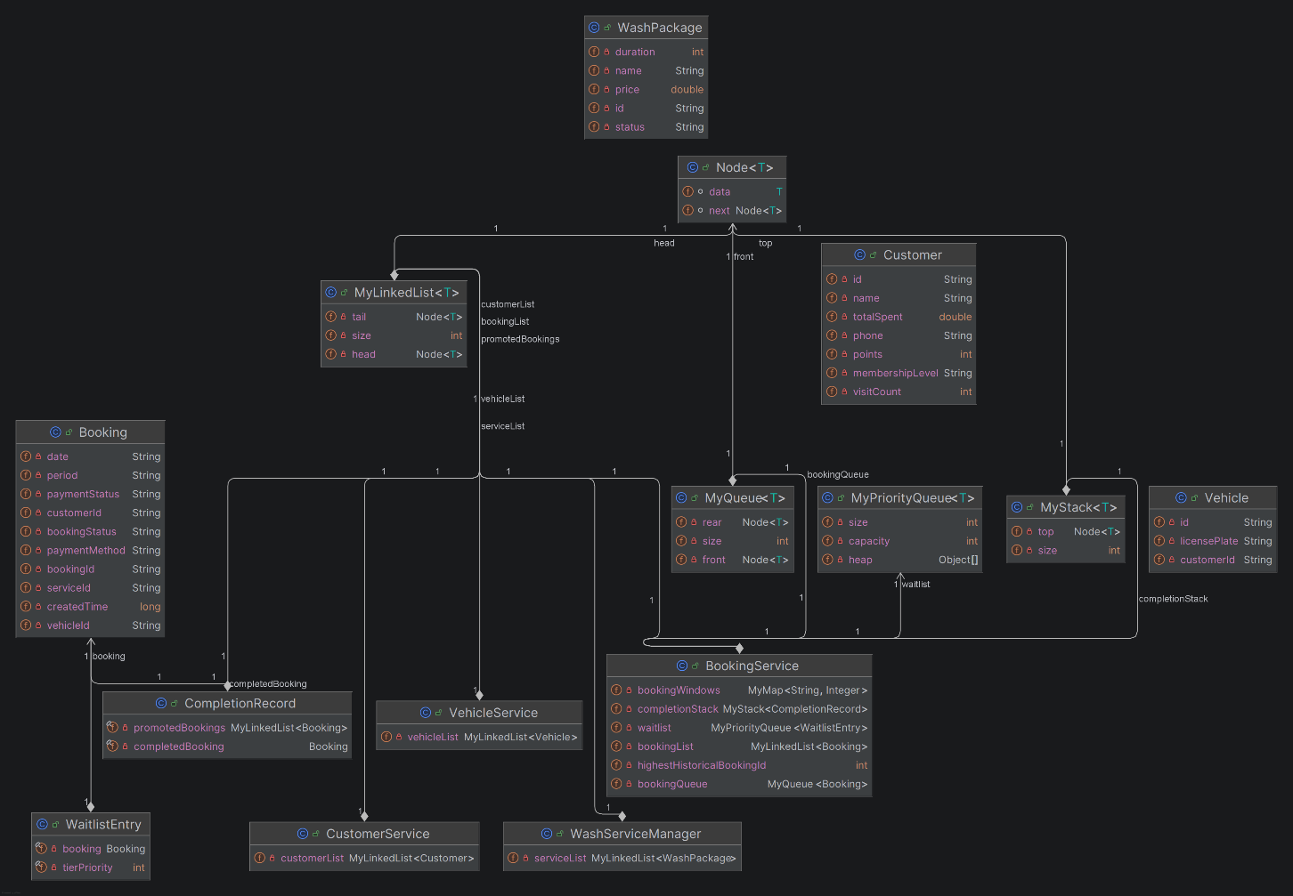
Figure 1. Core Class Diagram of the AutoWash Priority Booking Engine.
4.1.2 Source Code Summary
Class / File | Lines of Code | Responsibility
Main.java | 683 | CLI entry point, Customer menu, Admin menu, input flow and system integration
BookingService.java | 765 | Booking validation, queue allocation, priority waitlist, period capacity and service-time checks
MyLinkedList.java | 315 | Generic linked-list storage for system collections
MyQueue.java | 155 | FIFO main booking queue
MyPriorityQueue.java | 327 | Max-heap priority waitlist
MyStack.java | 197 | Undo storage for completed bookings
CompletionService.java | 162 | Completion, loyalty recalculation, history recording and waitlist promotion
CancellationService.java | 77 | Booking cancellation and waitlist promotion
UndoService.java | 84 | Restore the most recently completed booking
Total | 5,662 | 37 Java files across app, datastructure, model, service and util packages

4.1.3 Feature Completion Checklist
Feature | Status | Notes
Customer management | ✅ Complete | Add, search, update and delete customers
Vehicle management | ✅ Complete | Ownership validation and vehicle lookup by ID/license plate
Wash-package management | ✅ Complete | Add, update, delete, search and Selection Sort
Booking creation and validation | ✅ Complete | Validates customer, vehicle, package, date, period and booking window
Main booking queue | ✅ Complete | FIFO processing with MyQueue<Booking>
Priority waitlist | ✅ Complete | Max-heap ordering by membership tier and booking creation time
Period activation | ✅ Complete | Allocates future bookings into queue, waitlist or overflow
Capacity and service-time validation | ✅ Complete | Checks slot capacity and remaining period minutes
Payment and completion | ✅ Complete | Updates payment, loyalty and history
Cancellation and promotion | ✅ Complete | Cancelling a booking may promote the highest-priority waitlist entry
Undo last completion | ✅ Complete | Uses MyStack<CompletionRecord>

4.2 Performance Experiment Results

Input Size (n) | Algorithm MyQueue<Booking> Time (ms) | MyPriorityQueue<WaitlistEntry> (ms)
100 | 0.0267 | 0.1116
500 | 0.0618 | 0.3041
1000 | 0.1000 | 0.3597
5000 | 0.1293 | 1.0196
10000 | 0.1956 | 2.3566

Caption: Execution Time Comparison: FIFO Queue vs Priority Queue..
Analysis:
The results show that MyQueue was faster than MyPriorityQueue for all input sizes. This is expected because MyQueue performs FIFO insertion and removal in approximately O(1) time, while MyPriorityQueue maintains a max-heap and requires approximately O(log n) time for insert and poll operations. However, MyPriorityQueue remains necessary for the priority waitlist because it ensures that customers with higher membership priority are served before lower-priority customers. Therefore, the system accepts a small performance cost in exchange for membership-based booking fairness.

4.3 Final AI Audit Log — Human Delta Analysis (Submit Separately)
Human Delta Summary
Component | AI-Generated Version | My Final Version | Human Delta (What I Changed) | Why I Changed It
Booking validation | Initial validation logic and general booking flow suggestions. | Validation checks customer, vehicle ownership, active service package, booking window, service period, slot capacity, and remaining service time. | I reviewed the requirements, connected the validation rules to the real model classes, and refined the conditions for the current and future periods. | The system must reject invalid bookings while keeping the booking workflow consistent with the SRS.
Priority waitlist | A general priority-queue approach based on membership tier. | A custom max-heap priority queue orders waitlist entries by membership tier and booking creation time. | I implemented and tested the comparison rules, heap operations, and integration with booking allocation. | Higher-tier customers must receive priority, while earlier bookings must be preferred when tiers are equal.
Waitlist promotion | A simple idea to promote the first waiting booking when a slot becomes available. | The final system scans the priority waitlist and promotes a booking that fits both remaining slots and remaining service time. | I refined the promotion logic to avoid wasting available time when the highest-priority booking cannot fit. | A strict “top entry only” approach could leave usable service time unused.
Loyalty recalculation | Basic point accumulation after a completed booking. | Loyalty is recalculated from eligible completed bookings within the rolling 365-day period | I aligned the calculation with the final business rules, including visit count, total spending, points, and membership tier updates. | This prevents outdated bookings from permanently determining a customer’s current tier.
Undo operation | A generic stack-based undo suggestion. | MyStack<CompletionRecord> restores the most recently completed booking, history state, and customer loyalty data. | I defined the data needed for rollback and verified that only the latest completion can be undone. | Undo must preserve data consistency between bookings, history, queues, and loyalty information.

Overall Human Delta Reflection:
AI was used as a supporting tool for brainstorming, drafting, and reviewing implementation ideas. However, the final system required substantial human work to interpret the SRS, integrate the classes, validate business rules, test edge cases, and correct behavior that did not match the project requirements. The most important human contribution was transforming general suggestions into a consistent Java CLI application using custom data structures and persistent file storage. Human review was also necessary to ensure that queue allocation, waitlist promotion, loyalty recalculation, and undo behavior remained logically correct after integration.

4.4 IEEE Mini-Report Draft

Abstract
This paper presents the design and implementation of the AutoWash Priority Booking Engine, a Java command-line application developed to manage car-wash bookings under limited service slots and service-time constraints. The system supports customer, vehicle, and wash-package management; booking creation and validation; service-period activation; payment, completion, cancellation, history reporting, loyalty recalculation, and undo operations. To satisfy the Data Structures and Algorithms course objectives, the application uses custom implementations of a linked list, FIFO queue, max-heap priority queue, stack, and map rather than Java collection classes for the core logic. The FIFO queue manages the main service queue, while the priority queue manages the waitlist according to membership tier and booking creation time. Performance experiments show that the FIFO queue performs faster than the priority queue for all tested input sizes because its primary operations are approximately O(1), whereas heap operations are approximately O(log n). Nevertheless, the priority queue is necessary to preserve fair membership-based booking priority. The completed system demonstrates how fundamental data structures can be integrated into a practical, persistent CLI application.
I. Introduction
Car-wash businesses often face scheduling difficulties when many customers request the same service period. Because the number of service slots, available working time, and staff capacity are limited, the business must decide which bookings can be served immediately and which bookings should remain on a waitlist. A simple first-come, first-served approach is insufficient when membership tiers must be considered. At the same time, the solution must remain understandable and appropriate for an academic data-structures project.
This project develops the AutoWash Priority Booking Engine, a Java command-line application for managing customers, vehicles, wash packages, bookings, service periods, payment status, wash history, and customer loyalty. The system applies custom data structures to represent the main queue, priority waitlist, undo history, and in-memory collections. It also validates booking windows, capacity, and remaining service time before accepting a booking. Persistent data is stored in pipe-delimited text files so that the system can be restarted without losing its operational data.
The research question of this work is: How can custom data structures be integrated into a Java CLI booking system to provide efficient queue management, membership-based priority, and reliable operational features under limited service capacity?
The remainder of this paper is organized as follows. Section II describes the system design, selected data structures, algorithms, and experiment setup. Section III presents the performance results. Section IV discusses the findings and limitations. Finally, Section V concludes the work and suggests future improvements.

II. Methodology
A. System Design
The AutoWash Priority Booking Engine is a monolithic Java CLI application. Main manages menus, user input, and service calls. The model package defines entities such as Customer, Vehicle, WashPackage, and Booking. The service package handles booking validation, queue allocation, completion, cancellation, loyalty, and undo operations. Utility classes manage file storage and input processing. Data is loaded from pipe-delimited text files at startup and saved after each update. Fig. 1 shows the core class relationships.
B. Data Structures Selected
Data Structure | Java Implementation | Use Case in System | Time Complexity (Key Operation)
Linked List | MyLinkedList<T> | Stores customers, vehicles, wash packages, and history records | Search: O(n)
Queue | MyQueue<Booking> | Maintains the main service queue in FIFO order | Enqueue/Dequeue: O(1)
Priority Queue | MyPriorityQueue<WaitlistEntry> | Orders the waitlist by membership tier and booking time | Insert/Poll: O(log n)
Stack | MyStack<CompletionRecord> | Stores completed bookings for the undo function | Push/Pop: O(1)
Map | MyMap<K, V> | Stores booking-window configuration by membership tier | Lookup: O(1) average
C. Algorithms Implemented
The system implements several core algorithms. Linear search is used to find customers, vehicles, services, and bookings in linked-list collections. Selection Sort is used to arrange wash packages by price or duration. The priority waitlist uses max-heap operations, including heapify-up and heapify-down, to insert and remove the highest-priority booking efficiently. Booking allocation and waitlist promotion also check both slot capacity and remaining service time before accepting or promoting a booking.
D. Experiment Setup
The performance experiment compared MyQueue<Booking> and MyPriorityQueue<WaitlistEntry>. For each structure, insertion and removal operations were measured with input sizes of 100, 500, 1,000, 5,000, and 10,000 records. Execution time was recorded in milliseconds. The queue experiment measured FIFO enqueue and dequeue operations, while the priority-queue experiment measured max-heap insertion and poll operations. The results were then compared with the expected time complexities of O(1) for queue operations and O(log n) for heap operations.
III. Results
Table I and Fig. 2 show that MyQueue was faster than MyPriorityQueue for every tested input size. At n = 100, the queue required 0.0267 ms, compared with 0.1116 ms for the priority queue. At n = 10,000, the queue required 0.1956 ms, while the priority queue required 2.3566 ms. The gap increased as the input size grew. This result is consistent with the theoretical complexity: queue enqueue and dequeue operations are approximately O(1), whereas priority-queue insert and poll operations require approximately O(log n). However, the priority queue remains necessary because it correctly prioritizes waitlist bookings by membership tier and booking time
IV. Discussion
The experimental results matched the expected time complexity of the selected data structures. MyQueue is faster because it performs simple FIFO operations, while MyPriorityQueue incurs extra heap-maintenance cost to preserve booking priority. This trade-off is acceptable because the waitlist requires fair ordering based on membership tier and booking time. The main limitations are the CLI-only interface, text-file storage, and a benchmark limited to in-memory operations. Future work could add a graphical interface, database storage, automated tests, and larger-scale performance experiments.
V. Conclusion
This project developed the AutoWash Priority Booking Engine as a Java CLI application using custom data structures. The system manages bookings, service queues, priority waitlists, payments, loyalty updates, cancellation, history, and undo operations with persistent text-file storage. The results show that custom data structures can be integrated effectively into a booking system: MyQueue provides efficient FIFO processing, while MyPriorityQueue provides membership-based fairness for the waitlist. Therefore, the research question is answered positively. Although the priority queue requires more processing time, its prioritization benefit is necessary for the system requirements. Future improvements may include a graphical interface, database storage, automated testing, and more extensive performance evaluation.
References
[1] T. H. Cormen, C. E. Leiserson, R. L. Rivest, and C. Stein, Introduction to Algorithms, 4th ed. Cambridge, MA: MIT Press, 2022.
[2] AutoWash Priority Booking Engine Team, “Software Requirements Specification (SRS),” version 4.0.0, Jul. 2026.
[3] AutoWash Priority Booking Engine Team, “Product Requirements Document (PRD),” version 2.0.0, Jul. 2026.
[4] AutoWash Priority Booking Engine Team, “AutoWash Priority Booking Engine: Java Source Code Repository,” GitHub, 2026. [Online]. Available: https://github.com/NgaiLong49423/autowash-priority-booking-engine. [Accessed: Jul. 21, 2026].

