AUTOWASH PRIORITY BOOKING ENGINE
Course: Data Structures and Algorithms (CSD201)
Semester: SU2026

STUDENT INFORMATION
Field | Details
Full Name | Ngô Gia Long - SE190732
 | Nguyễn Anh Kiệt - SE190095
 | Ngô Hoàng Thái Dương - SE190177
 | Nguyễn Tuấn Minh - SE204693
Instructor | Huỳnh Công Việt Ngữ
Report Number | Report 1
Class | SE2019
Project Topic | AutoWash Priority Booking Engine

REPORT 1 — Case Study Analysis & Problem Decomposition
Objective: Perform case study analysis focused on a specific data structure problem. Apply Computational Thinking tools (Decomposition, Pattern Recognition) and formulate a Research Question.

1.1 Case Study Overview
Project Title: AutoWash Priority Booking Engine
Problem Statement: A car wash shop has limited service capacity in each morning, afternoon, and evening period. Customers may book in advance or request a slot during the active period, while higher membership tiers deserve earlier booking access and priority when capacity is limited. The system must manage customers, vehicles, wash packages, bookings, waiting queues, and completed-service history without using a database. The core data-structure challenge is to balance FIFO service order with tier-based priority and reliable rollback of the latest completion.
Scope of the System:
- Customer, vehicle, and wash-package management with validation and file persistence.
- Booking creation with membership booking-window and capacity validation.
- Main Queue and priority Waitlist management for each service period.
- Payment confirmation, completion, loyalty recalculation, history, cancellation, and undo.

1.2 Decomposition — Breaking Down the System
Apply Decomposition to identify core data structures and functional modules within the system.
1.2.1 Core Data Structures Identified
Module | Data Structure Used | Justification
Customer, Vehicle and Service Storage | MyLinkedList<T> | Stores dynamic entities and supports sequential CRUD operations without built-in collections.
Main Service Queue | MyQueue<Booking> | Preserves FIFO order for bookings accepted into the guaranteed service slots.
Priority Waitlist | MyPriorityQueue<Booking> | Selects the highest tier first; earlier-created bookings break ties.
Undo Completion | MyStack<Booking> | Supports LIFO rollback of the most recently completed booking.
Booking-Window Configuration | MyMap<String, Integer> | Maps a membership tier to its allowed number of booking days.

1.2.2 Functional Modules Breakdown
- List all functional modules of your system:
- Module 1 - Customer and Vehicle Management: maintains customer profiles, membership data, and owned vehicles.
- Module 2 - Service Management: manages wash packages, prices, durations, search, and sorting.
- Module 3 - Booking and Validation: creates bookings and checks ownership, dates, booking windows, and capacity.
- Module 4 - Period and Queue Management: activates a period and allocates bookings to Main Queue or Waitlist.
- Module 5 - Service Operations: processes, records payment, completes or cancels bookings, and promotes waitlisted customers.
- Module 6 - History, Loyalty and Undo: stores completed services, recalculates loyalty, and rolls back the latest completion.

1.3 Pattern Recognition
Identify recurring data organization patterns applicable to your system.
Patterns Identified:
Pattern | Description | Applied Where in System
FIFO Queue | First accepted, first served processing. | Main Queue for guaranteed service slots.
Priority Queue | Tier-based ordering with creation time as a tie-breaker. | Waitlist and allocation during period activation.
LIFO Stack | The most recent operation is reversed first. | Undo for the last completed booking.
Linear Search and Selection Sort | Sequential lookup and comparison-based sorting. | Entity search and wash-package sorting by price or duration.

Justification: The system needs two different ordering policies. A FIFO queue keeps the guaranteed-service process predictable, while a priority queue ensures that waitlisted Platinum, Gold, Silver, and Member customers are treated according to the stated business rule. A stack is appropriate because an undo request always targets only the latest completed booking. Linear search and selection sort are suitable for this academic CLI scope and demonstrate fundamental data-structure operations.

1.4 Flowchart & Mind Map
1.4.1 System Mind Map
draw.io
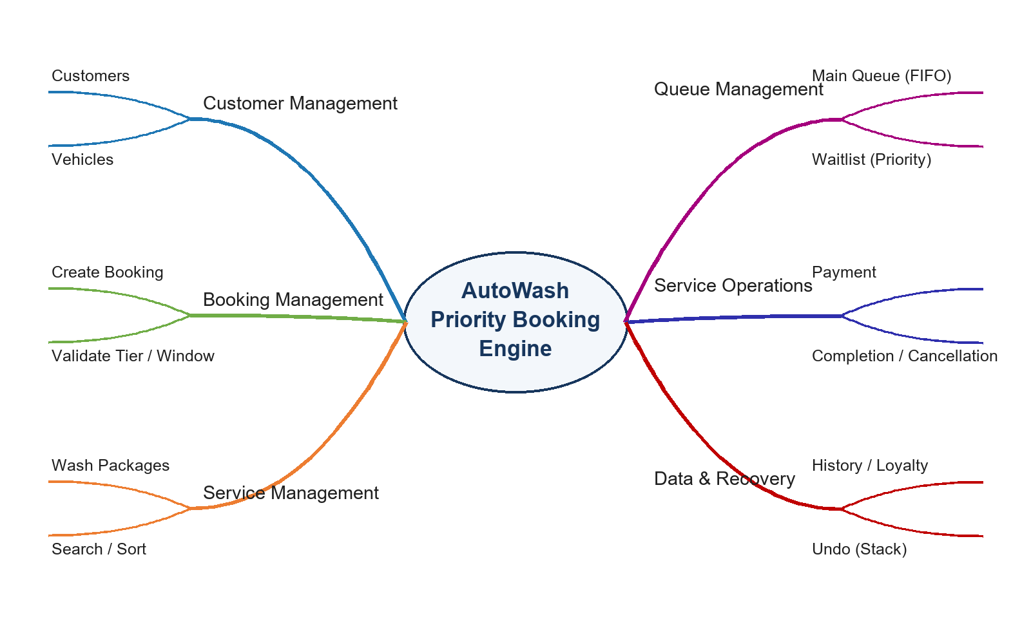
Caption: Mind map of the AutoWash Priority Booking Engine modules and their relationships.
1.4.2 Initial Logic Flowchart

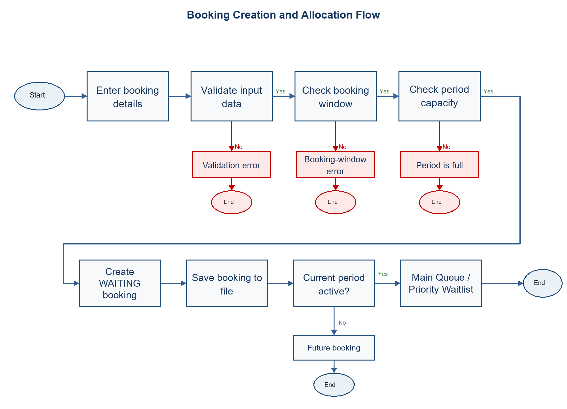
Caption: Initial logic flow for creating and allocating a car-wash booking.

1.5 Research Question (RQ)
Formulated Research Question: How does using a priority queue instead of a standard FIFO queue affect booking fairness and processing efficiency when a car-wash waitlist contains customers with different membership tiers?
(Write your RQ here. Example: "How does the choice between ArrayList and LinkedList affect the time complexity of insertion and deletion operations in a library management system with n > 10,000 records?")
Why this RQ matters: The question directly examines the central trade-off in this project: arrival order is simple and predictable, but membership priority is necessary when capacity is scarce. Investigating the two approaches helps justify the use of a max-heap priority queue and explains how the chosen structure supports faster retrieval of the highest-priority waitlisted booking.

