Agenda

* UI Overview
* View Class
* Using View
* Graphical User Interfaces
  + Android Layouts
  + Input Controls
  + Toast, Dialog and Snackbar
  + Navigation, ActionBar and Menus
* Assignments

UI Overview

* All user interface elements in an Android app are built using View and View Group objects.
* A View is an object that draws something on the screen that the user can interact with.
* A ViewGroup is an object that holds other View (and ViewGroup ) objects in order to define the layout of the interface.
* Android provides a collection of both View and ViewGroup subclasses that offer you common input controls (such as buttons and text fields) and various layout models (such as a linear or relative layout).

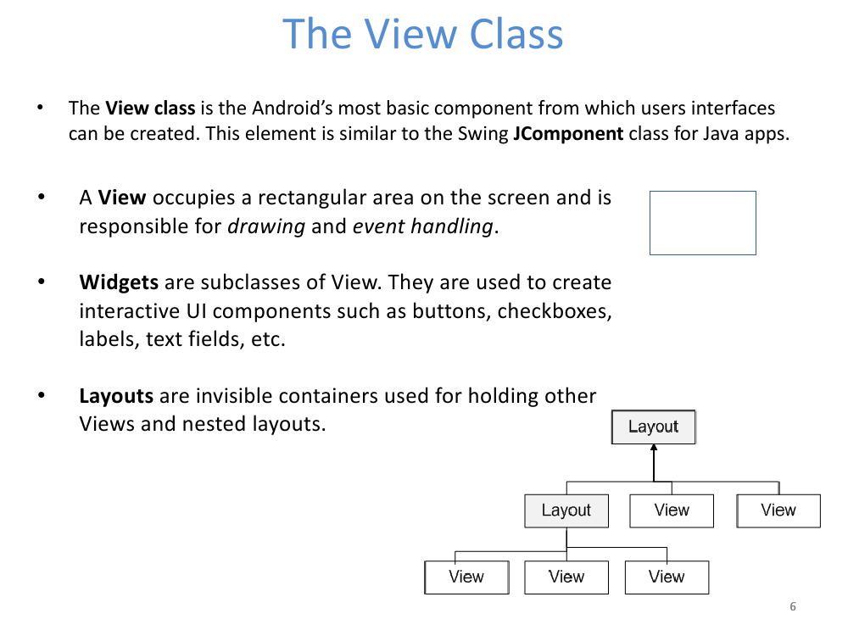

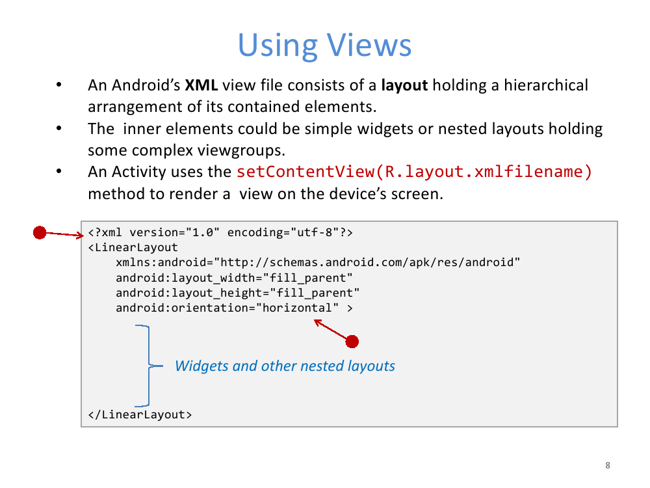

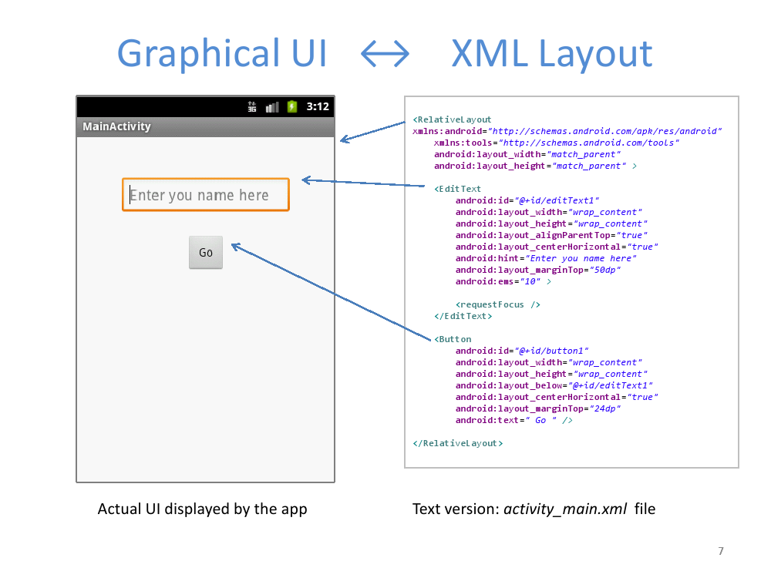

Common Layouts

* Linear Layout
* Relative Layout
* Table Layout
* Frame Layout
* Absolute Layout
* Scroll View (Vertical)
* Horizontal Scroll View
* Simple List View
* List View in Android

Graphical User Interface: Input Controls

* Android Button
* Image Button
* Edit Text
* Check Box
* Radio Button
* Switch Button
* Toggle Button
* Rating Bar
* Spinner Example
* Date Picker
* Time Picker

**Toast, Dialog and Snackbar**

* Toast Message
* Alert Dialog
* Snackbar

**Android User Interface Design: Navigation, ActionBar and Menus**

* Navigation Drawer
* Sliding Menu with WebView
* Dropdown Menu
* Action Bar/App Bar
* Toolbar
* Action Bar Tabs

Linear Layout

* Linear Layout is a layout which aligns the widgets or elements in a linear (Straight) fashion. Linear Layout consists of two types of orientation:
* Vertical Orientation,
* Horizontal Orientation.
* Vertical Orientation is shown above where the widgets such as Text View, Edit Text, and Button are aligned in a Vertical manner.

