**Relative Layout**

* Relative Layout is a view group that displays child views in relative positions. The position of each view can be specified as relative to sibling elements (such as to the left-of or below another view) or in positions relative to the parent Relative layout area (such as aligned to the bottom, left or center).
* In a relative layout every element arranges itself relative to other elements or a parent element.

**Positioning Views**

* Relative Layout lets child views specify their position relative to the parent view or to each other (specified by ID).
* So you can align two elements by right border, or make one below another, centered in the screen, centered left, and so on.
* By default, all child views are drawn at the top-left of the layout, so you must define the position of each view using the various layout properties available from Relative Layout. LayoutParams.

Positioning Views.

* Relative Layout example picture

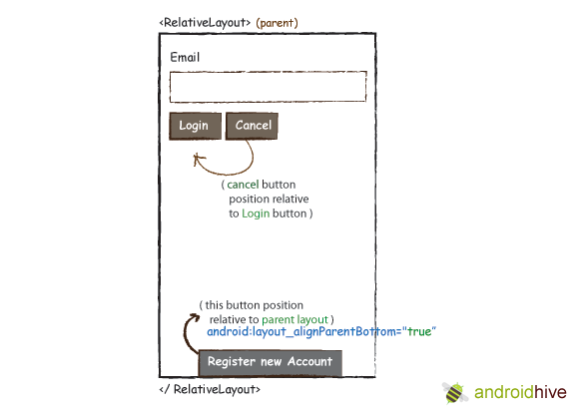

**Relative Layout – About the container**

The following positioning use boolean properties(true/false)

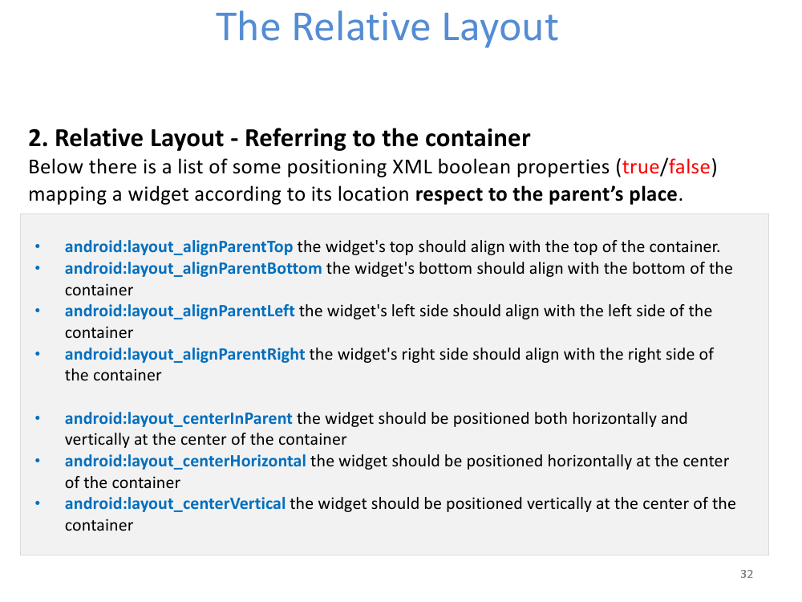

**Relative Layout – About other widgets**

The following positioning respect other widgets

