**REPORT**

**I/ Exercise 1**

- To load Json from 2 file json (sample_users_online.json, sample_users_vendor.json)

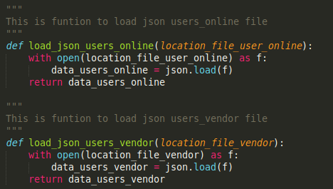

- Using dictionary in python

- Using datetime to pare date info in json

- To run this exercise:

Need more 2 argv:



**II/ Exercise 2**

- Using selenium to get screenshot

+ Location of chromedriver



+ Using driver.get() to get url

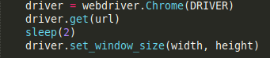

+ Using driver.save_screenshot() to save image and driver.get_screenshot_as_png() to get 1 image which was saved.



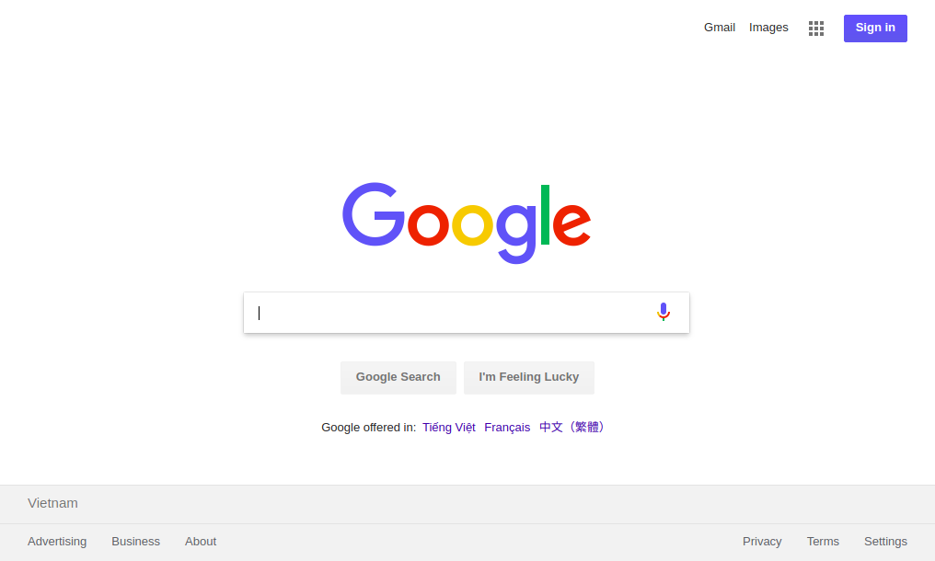picture_screenshot

- Using Django framework to create web page

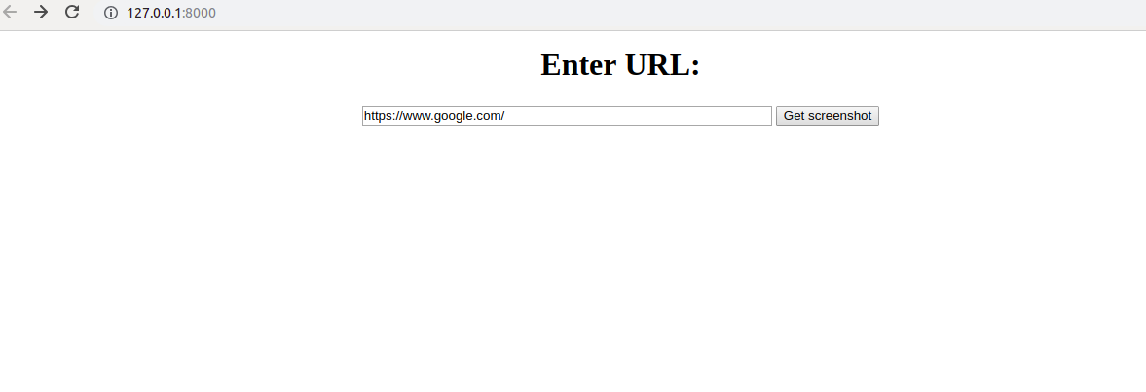

And this is result

