
Faculty of Information and Communication Technology

A dissertation presented and submitted in partial fulfilment of the requirements for the degree of a Bachelor of Science in Computer Science
Title
Development of a Skin Lesion Detection and Classification System using Convolutional Neural Networks (CNNs)
By
NGANE EMMANUEL
Registration Number: ICTU20222972

Supervised by: Engr. Nkiamboh Tanwi

September 2025

DECLARATION

I declare that the work entitled “Development of a Skin Lesion Detection and Classification System using Convolutional Neural Networks (CNNs)” is my own original work, conceived and presented in the partial fulfilment of the requirement for the degree of a Bachelor of Science in Computer Science at ICT University. This work has not been submitted for any degree or examination in any other university, and that all the sources I have used or quoted have been indicated and acknowledged as complete references

Signed: ___________________________ Date: ___________________________
Name: ___________________________
Registration Number: _________________________

CERTIFICATION

The work entitled “Development of a Skin Lesion Detection and Classification System using Convolutional Neural Networks (CNNs)” has been submitted for examination with my approval as the Research supervisor.

Signed: ____________________________ Date: __________________________
Name: _____________________________

DEDICATION

I dedicate this work to my parents, Rev. Dr. Ntoko Samuel Eseh and Mme Ntoko Grace Melioge, and to my loving sister, Ntoko Racheal Edenge, for their unwavering support, encouragement, and sacrifices throughout my academic journey

ACKNOWLEDGMENTS

I would like to express my sincere appreciation to my project supervisor, Engr. Nkiambo Tanwi, whose guidance, feedback, and encouragement were invaluable throughout the course of this project. His expertise and support helped shape both the direction and quality of this research. I am also grateful to the faculty and staff of the Department of Computer Science, ICT University, for providing the academic foundation and resources necessary for the completion of this work. Their commitment to academic excellence has been instrumental in my development. Special thanks go to my classmates and friends for their collaboration, feedback, and moral support during the challenging phases of this project. Their insights and motivation helped me stay focused and persistent. Lastly, I appreciate my family for their continuous encouragement and understanding, which enabled me to dedicate the necessary time and energy to this project. This project has been a significant learning experience, and I am thankful to all who contributed to its successful completion

FACULTY APPROVAL

This dissertation has been fully reviewed by the Department and the Faculty and is ready for examination with our approval

Approved by
Signature Date
_________________________________
Engr. Nkiamboh Tanwi
Supervisor

Signature Date
_________________________________
Dr. Abdallah Ziraba
Head of Department

Signature Date
_________________________________
Dr. Luc Einstein Ngend
Dean

ABSTRACT

Skin lesions encompass a wide spectrum of conditions, ranging from benign disorders such as eczema, fungal infections, and psoriasis to malignant forms like melanoma and squamous cell car cinoma. Globally, these conditions impose significant public health and economic burdens, with their impact being particularly acute in low-resource regions where specialized dermatological ex pertise is scarce. In Cameroon and much of sub-Saharan Africa, access to timely and accurate dermatological diagnosis is hindered by limited specialist availability, under-resourced health fa cilities, and geographic barriers to care.
This study presents the development of a multi-class skin lesion detection and classification system using Convolutional Neural Networks (CNNs), designed to enhance diagnostic accessibility through automated image analysis. The system was trained on a curated, high-quality dataset compiled from multiple open-access sources, including Kaggle dermatology repositories and the DermNetNZ medical image database. Careful preprocessing and augmentation techniques were employed to normalize image quality, address class imbalance, and improve model robustness across diverse lesion presentations and skin tones.
A fine-tuned ResNet-18 architecture, leveraging transfer learning from the ImageNet dataset, was implemented to classify lesions into multiple diagnostic categories, covering both malignant and non-malignant conditions. The model was trained using supervised learning with categorical cross entropy loss, and evaluated using metrics including accuracy, precision, recall, and F1-score. The final system achieved a validation accuracy of 75% and demonstrated consistent performance on the test set, underscoring its potential as a supportive diagnostic aid.
The implementation includes a command-line interface (CLI) for research use and a prototype mobile application framework aimed at offline deployment in rural and underserved settings. By combining computational efficiency with diagnostic breadth, the system offers a cost-effective and scalable approach to skin lesion classification in contexts where traditional healthcare access is limited.
This project contributes to the growing field of AI-assisted dermatology by emphasizing inclusivity across skin tones and lesion types, while maintaining technical feasibility for low-resource envi ronments. Future improvements will focus on expanding the dataset, integrating explainable AI features, incorporating multi-modal patient data, and validating the system in real-world clinical settings.
Keywords: Skin lesion detection, convolutional neural networks, ResNet-18, transfer learning, dataset diversity, mobile health, Cameroon, medical imaging
Table of Contents
DECLARATION 2
CERTIFICATION 3
DEDICATION 4
ACKNOWLEDGMENTS 5
FACULTY APPROVAL 6
ABSTRACT 7
1 Chapter 1: Introduction 13
1.1 Introduction 13
1.2 Background to the Problem 14
1.3 Problem Statement 15
1.4 Objectives of the Study 16
1.4.1 General Objective 16
1.4.2 Specific Objectives 16
1.5 Scope of the Study 16
1.6 Significance of the Study 17
1.6.1 Limitations of the Study 18
1.6.2 Organization of the Study 19
2 Chapter 2: Literature Review 21
2.1 Introduction 21
2.2 Overview of Skin Lesions and Skin Cancer 21
2.2.1 Non-Cancerous Lesions 22
2.2.2 Cancerous Lesions 22
2.3 Role of Artificial Intelligence in Dermatology 23
2.4 Convolutional Neural Networks (CNNs) 24
2.5 Transfer Learning and ResNet Models 25
2.6 Dataset Challenges in Medical Imaging 26
2.6.1 Review of Existing Systems 27
2.7 Research Gap 29
2.8 Summary 30
3 Chapter 3: Methodology 31
3.1 Introduction 31
3.2 Project Framework and Approach 32
3.2.1 Business Understanding 32
3.2.2 Data Understanding 33
3.2.3 Data Preparation 34
3.2.4 Modeling 34
3.2.5 Evaluation 35
3.2.6 Deployment 35
3.2.7 CRISP-DM Iteration 35
3.3 Data and Requirements Gathering 37
3.3.1 Interviews 37
3.3.2 Surveys and Questionnaires 38
3.3.3 Documentation Review 38
3.3.4 Focus Groups 38
3.3.5 Synthesis of Findings 38
3.4 Population and Sample 39
3.4.1 Target Population 39
3.4.2 Sampling Strategy 39
3.4.3 Sample Size 40
3.4.4 Justification of Sample Size 40
3.4.5 Limitations of Sampling Approach 40
3.5 Quantitative Analysis 41
3.5.1 Data Analysis Techniques 41
3.5.2 Data Visualization 41
3.5.3 Interpretation and Findings 41
3.5.4 Conclusion 42
3.6 Qualitative Analysis 42
3.6.1 Thematic Analysis Approach 42
3.6.2 Coding and Categorization 43
3.6.3 Interpretation of Qualitative Findings 43
3.6.4 Conclusion 43
3.7 Dataset Description and Preprocessing 44
3.7.1 Dataset Composition 44
3.7.2 Data Sources 44
3.7.3 Dataset Distribution and Class Imbalance 45
3.7.4 Data Partitioning 46
3.7.5 Exploratory Data Analysis (EDA) 46
3.7.6 Preprocessing Pipeline 47
3.7.7 Impact of Preprocessing and Augmentation 48
3.8 Model Architecture 48
3.8.1 Baseline Architecture 48
3.8.2 Transfer Learning Adaptations 49
3.8.3 Loss Function and Class Balancing 49
3.8.4 Optimization and Regularization 49
3.8.5 Rationale for ResNet-18 Selection 49
3.9 Training Strategy 50
3.9.1 Hardware and Frameworks 50
3.9.2 Data Loading and Batching 51
3.9.3 Transfer Learning and Layer Freezing 51
3.9.4 Loss Function and Class Balancing 51
3.9.5 Optimization and Learning Rate Scheduling 52
3.9.6 Early Stopping 52
3.9.7 Epochs, Monitoring, and Logging 52
3.10 Evaluation Strategy 53
3.10.1 Test Set Protocol 53
3.10.2 Evaluation Metrics 54
3.10.3 Rationale for Metric Selection 54
3.10.4 Additional Performance Considerations 55
3.10.5 Visualizations 55
3.11 System Deployment 55
3.11.1 Deployment Objectives 55
3.11.2 Command-Line Interface (CLI) for Researchers 56
3.11.3 Mobile Application for End-Users 57
3.11.4 Hosting and API Infrastructure 59
3.11.5 Deployment Workflow 59
3.11.6 Monitoring and Maintenance 60
3.12 Summary of Methodology 60
4 Chapter 4: System Analysis, Design Result, and Discussion 63
4.1 Introduction 63
4.2 Statistical Analysis of Data Collected 65
4.2.1 Overview of Surveys and Respondents 65
4.2.2 Descriptive Statistics: General Users 67
4.2.3 Descriptive Statistics: Technical/Professional Users 71
4.2.4 Cross-Survey Comparative Insights 77
4.3 System Overview 79
4.3.1 Objectives of the Proposed System 79
4.3.2 Target Users and Stakeholders 80
4.3.3 System Boundaries and Scope 81
4.3.4 High-Level Functionalities 82
4.4 Functional Requirements Analysis 83
4.4.1 User-Oriented Requirements 84
4.4.2 System-Oriented Requirements 86
4.4.3 Non-Functional Requirements 87
4.5 System Architecture 89
4.5.1 Model Architecture 90
4.5.2 Model Training Procedure 92
4.6 User Interface Design 93
4.6.1 Mobile Application Interface 94
4.6.2 Command-Line Interface (CLI) 94
4.7 Deployment Strategy 97
4.7.1 Cloud Deployment (Primary Mode) 97
4.7.2 Command-Line Interface (CLI) Deployment 97
4.7.3 Mobile Application Deployment 98
4.8 Testing, Results, and Discussion 99
4.8.1 Dataset Partitioning: Training, Validation, and Testing 99
4.8.2 Accuracy and Loss Trends 99
4.8.3 Confusion Matrix Analysis 99
4.8.4 Receiver Operating Characteristic (ROC) / Area Under the Curve Analysis 100
4.8.5 Class-wise Metrics 101
4.8.6 Model Limitations and Biases 103
4.8.7 Comparison with Existing Systems 104
4.8.8 Conclusion 104
4.9 Summary 104
5 Chapter 5: Summary, Conclusions, Discussion, and Recommendations 106
5.1 Summary of Findings 106
5.2 Conclusion 107
5.3 Contributions of the Study 109
5.3.1 Technical Contributions 109
5.3.2 System Contributions 110
5.3.3 Practical and Clinical Contributions 110
5.4 Recommendations for Future Work 111
5.4.1 Data & Evaluation Enhancements 111
5.4.2 Modeling & Learning Strategy 112
5.4.3 Human-in-the-Loop & Clinical Study Design 112
5.4.4 Deployment, Privacy, and Safety 113
5.4.5 Product & UX Refinements 113
5.4.6 Research Extensions 113
5.5 Final Remarks 114
References 116

1 Chapter 1: Introduction

1.1 Introduction
Skin lesions encompass a broad spectrum of abnormalities in the skin, ranging from benign conditions such as moles and warts to malignant manifestations like melanoma and squamous cell carcinoma. Globally, these dermatological disorders present a significant public health challenge, with skin cancers alone accounting for millions of new cases annually and exerting substantial socioeconomic and healthcare burdens (Ogudo et al., 2023), (Kassem et al., 2021). The prevalence of skin lesions has been amplified by factors such as increased ultraviolet (UV) exposure due to climate change, demographic transitions, and lifestyle changes, contributing to both malignant and non-malignant skin disorders (Zafar et al., 2023).
In high-income countries, early diagnosis is often facilitated by access to trained dermatologists, advanced imaging technologies, and well-established referral systems. However, in low- and middle-income countries (LMICs), particularly in sub-Saharan Africa, dermatology services remain sparse, with a severe shortage of qualified dermatologists and specialized diagnostic tools (Hay et al., 2006). This disparity often leads to delayed diagnoses, inappropriate treatments, and preventable morbidity and mortality from conditions that are otherwise treatable when detected early.
Cameroon, like many African nations, faces a dual challenge: the burden of infectious skin diseases such as fungal infections, scabies, and bacterial dermatitis coexists with a growing incidence of non-communicable skin disorders, including actinic keratosis, psoriasis, and malignant lesions (Hees & Naafs, 2005). The limited integration of dermatological screening into primary healthcare, coupled with the absence of large-scale public awareness campaigns, exacerbates the problem.
Recent advancements in artificial intelligence (AI) and machine learning (ML), particularly deep learning-based image analysis, have demonstrated remarkable potential in automating the detection and classification of skin lesions with performance levels approaching or surpassing that of experienced dermatologists (Khan et al., 2021), (Adegun & Viriri, 2020). Such systems leverage large annotated datasets to learn discriminative features directly from dermoscopic or clinical images, enabling fast, scalable, and cost-effective screening.
This research seeks to harness these technological advancements to develop a skin lesion detection and classification system capable of accurately identifying multiple common skin lesion types. The proposed system integrates a convolutional neural network (CNN) trained on diverse, high-quality datasets sourced from publicly available repositories such as Kaggle and curated medical image databases like DermNetNZ. In addition to the AI model, the system will include a graphical user interface (GUI) for clinical use, a command-line interface (CLI) for research purposes, and a mobile application to extend accessibility to rural and underserved communities. This comprehensive approach aims to bridge the diagnostic gap, improve early detection rates, and contribute to the broader objective of reducing the dermatological disease burden in Cameroon and similar contexts.

1.2 Background to the Problem
Dermatological diseases represent one of the most common categories of health complaints worldwide, with conditions ranging from self-limiting skin irritations to life-threatening malignancies. The World Health Organization (WHO) has repeatedly emphasized that skin diseases are among the top ten causes of non-fatal disease burden globally, and in certain regions of sub-Saharan Africa, they are among the most frequent reasons for outpatient consultations (Hay et al., 2006), (Hees & Naafs, 2005). While conditions like melanoma and basal cell carcinoma dominate skin cancer statistics in developed nations, the disease landscape in Africa and particularly Cameroon is more heterogeneous, encompassing a mix of infectious, inflammatory, and neoplastic disorders.
Traditionally, diagnosis of skin lesions has relied heavily on visual inspection by a dermatologist, often supplemented by dermoscopic evaluation or histopathological examination for suspicious cases (Yap et al., 2018). However, this process is inherently subjective and highly dependent on the clinician’s expertise and experience. In many LMICs, including Cameroon, the ratio of dermatologists to the population is critically low, often less than one dermatologist per million inhabitants, leading to substantial diagnostic delays. Moreover, general practitioners and nurses, who often serve as first-line healthcare providers, may lack specialized training in dermatology, further compounding the risk of misdiagnosis or missed diagnoses.
The advent of AI in medical imaging, particularly the application of convolutional neural networks (CNNs) to dermoscopic and clinical images, has opened new possibilities for addressing these challenges (Harangi, 2018), (Mahbod et al., 2019). CNNs can automatically extract hierarchical features from raw image data, allowing them to differentiate between lesion types with minimal human intervention. Studies have demonstrated that AI-based diagnostic tools can achieve diagnostic accuracy comparable to or exceeding that of experienced dermatologists in controlled settings (Albahar, 2019), (Jinnai et al., 2020).
Despite these advancements, most existing AI models for skin lesion classification have been trained and validated on datasets that predominantly contain images from lighter-skinned populations in Europe, North America, and Australia (Gouda et al., 2022). This raises concerns about model generalizability to populations with darker skin tones, such as those in sub-Saharan Africa. Additionally, existing research has often focused on detecting malignant lesions, particularly melanoma, with limited emphasis on the broader spectrum of common lesions prevalent in African contexts, such as eczema, tinea infections, or Kaposi’s sarcoma.
This project responds to these gaps by developing a multi-class lesion classification system specifically curated to include a diverse set of common skin conditions affecting African populations. The dataset compilation process involves selecting high-quality images from multiple Kaggle repositories and supplementing them with clinically verified images from DermNetNZ, ensuring representation across various lesion categories and skin tones. Through this approach, the proposed system aims to offer a clinically relevant, context-sensitive diagnostic support tool that addresses both the technical challenges of AI implementation and the pressing healthcare needs of the target population.

1.3 Problem Statement
The early and accurate diagnosis of skin lesions remains a critical public health challenge in Cameroon and across much of sub-Saharan Africa. While skin lesions may appear trivial in their initial stages, certain forms such as malignant melanomas, squamous cell carcinomas, and basal cell carcinomas, can rapidly progress to life-threatening stages if left untreated. In parallel, other non-malignant but common conditions, such as fungal infections, eczema, and psoriasis, can cause significant discomfort, social stigma, and economic loss due to chronicity and recurrence.
In many urban centers of high-income countries, advanced diagnostic services and dermatology specialists are accessible, enabling early detection and management. However, in Cameroon, the number of dermatologists is grossly inadequate relative to the population size, with some regions having no specialist at all (Hay et al., 2006), (Hees & Naafs, 2005). This shortage forces patients to rely on general practitioners or traditional healers, which often leads to delayed diagnoses, mismanagement, or complete neglect of skin-related health issues.
Furthermore, conventional diagnostic workflows are limited by two key barriers:
1. Geographic accessibility – Many patients in rural areas must travel long distances to reach healthcare facilities, resulting in missed opportunities for early diagnosis.
2. Resource limitations – Even in urban hospitals, dermoscopic imaging equipment and histopathological services are often scarce or prohibitively expensive.
Recent developments in artificial intelligence, specifically convolutional neural networks (CNNs), have shown promise in automating skin lesion detection and classification with high accuracy (Khan et al., 2021), (Adegun & Viriri, 2020). Nonetheless, most existing models are trained on datasets from lighter-skinned populations and focus primarily on malignant lesions, limiting their applicability in African contexts where lesion diversity and skin tone variations differ significantly (Gouda et al., 2022).
The central problem, therefore, is the absence of an accessible, accurate, and context-specific diagnostic tool for multiple types of skin lesions prevalent in Cameroon. There is a need for an integrated system that combines AI-powered lesion detection with user-friendly interfaces, ranging from clinical desktop applications to mobile apps that can bridge the diagnostic gap between rural patients, urban hospitals, and research institutions.

1.4 Objectives of the Study
The overarching aim of this study is to develop a comprehensive skin lesion detection and classification system that leverages deep learning techniques to address the diagnostic challenges faced in Cameroon and similar low-resource settings.

1.4.1 General Objective
To design and implement an AI-driven system capable of accurately detecting and classifying multiple types of common skin lesions, with deployment across desktop, command-line, and mobile platforms to improve diagnostic accessibility.

1.4.2 Specific Objectives

1.5 Scope of the Study
This study focuses on the development of a skin lesion detection and classification system tailored for the Cameroonian healthcare context, while incorporating global best practices in AI-assisted dermatological diagnosis. The scope of the research spans four key dimensions: the dataset, the technical solution, the deployment platforms, and the evaluation process.
From a data perspective, the system will be trained and validated using a carefully curated dataset compiled from multiple publicly available repositories on Kaggle, supplemented with high-quality dermatological images sourced from DermNetNZ. These sources offer a broad spectrum of lesion categories, ranging from malignant cancers such as melanoma and squamous cell carcinoma to non-malignant conditions like eczema, psoriasis, and fungal infections. Selection criteria will prioritize image clarity, correct annotation, diversity of skin tones, and representation of lesion variations to ensure the model’s applicability across a wide demographic.
From a technical perspective, the system will employ a convolutional neural network (CNN) architecture fine-tuned for multi-class classification. Advanced preprocessing techniques, such as data augmentation and normalization, will be applied to enhance the model’s generalizability across different imaging conditions. While the primary focus is on image-based diagnosis, the system is not intended to replace histopathological confirmation, which remains the gold standard for definitive lesion classification.
From a deployment perspective, the project encompasses three interfaces:
- A Command-Line Interface (CLI), primarily intended for researchers and developers for testing and evaluating the AI model.
- A Mobile Application, optimized for both offline and online usage, to enable healthcare workers and patients in rural areas to perform preliminary lesion assessments without constant internet connectivity.
From an evaluation perspective, the model will be tested using standard performance metrics, including accuracy, sensitivity, specificity, and confusion matrix analysis. The evaluation will emphasize the system’s ability to handle variations in lesion presentation due to differences in skin pigmentation, image quality, and environmental lighting.
The project does not aim to cover the entire spectrum of dermatological conditions, rare or highly complex lesions requiring specialized diagnostic equipment fall outside the intended operational scope. Instead, the focus is on delivering a reliable, accessible, and scalable solution for the most common and clinically significant skin lesions encountered in Cameroon and similar resource-limited environments.

1.6 Significance of the Study
Skin diseases are among the most common health concerns globally, with billions of people affected each year, spanning all socioeconomic groups (Hay et al., 2006). In Cameroon and much of sub-Saharan Africa, the impact of skin lesions is amplified by a combination of high prevalence, limited specialist care, and widespread misinformation about skin health. Misdiagnosed or untreated lesions, whether malignant or non-malignant, can lead to severe health complications, disfigurement, psychological distress, and in the case of cancers, increased mortality rates.
The significance of this study lies in its potential to bridge the diagnostic gap through a context-specific, AI-driven approach. By leveraging deep learning algorithms and multi-platform deployment, the system offers a means of providing timely and accurate lesion assessment to populations that currently lack access to dermatological expertise. For healthcare providers, this could translate to earlier interventions, better patient outcomes, and a reduction in the burden on tertiary healthcare facilities.
From a public health perspective, the project addresses a critical need in preventive care. Early detection and classification can significantly reduce treatment costs and improve survival rates in malignant cases, while minimizing chronic complications in non-malignant cases. Moreover, the system’s mobile deployment makes it a practical tool for community health workers conducting outreach in rural and peri-urban areas.
From a technological perspective, the research contributes to the growing field of AI in medical imaging by demonstrating how existing machine learning methods can be adapted to underrepresented populations. Many existing AI models for skin lesion classification are trained predominantly on lighter-skinned datasets, making them less effective for darker skin tones (Gouda et al., 2022). By incorporating diverse skin tone representation from datasets like DermNetNZ and Kaggle repositories, this study advances the inclusivity and fairness of medical AI systems.
From an academic perspective, the project provides a valuable reference for future studies in both computer vision and health informatics within the African context. The integration of a research-oriented CLI, a mobile health application, and a clinical GUI sets a precedent for multi-platform medical AI systems designed for low-resource settings.
Ultimately, the study seeks to contribute toward Sustainable Development Goal 3 (Good Health and Well-being) by enabling accessible, affordable, and high-quality dermatological diagnostics in regions where such services are currently limited or absent.

1.6.1 Limitations of the Study
While this study seeks to develop a comprehensive, AI-powered skin lesion detection and classification system, several constraints inevitably shape the scope and potential impact of the research. First, the dataset, although carefully curated from high-quality open-access sources such as Kaggle repositories and the DermNetNZ medical image database, may not capture the full diversity of skin lesion presentations across all ethnic groups and age categories. This limitation is particularly relevant for sub-Saharan African populations, where variations in skin pigmentation can influence lesion visibility and morphology, potentially impacting model generalization (Hay et al., 2006), (Hees & Naafs, 2005).
Second, although image preprocessing and augmentation techniques are employed to mitigate overfitting and improve robustness, the absence of histopathological confirmation for all dataset images introduces an inherent diagnostic uncertainty. Clinical image-based diagnosis, while valuable, cannot entirely substitute for biopsy-confirmed ground truth, especially in differentiating visually similar lesion types (Zafar et al., 2023).
Third, computational resource limitations constrain the complexity and scale of model experimentation. While transfer learning with established CNN architectures, such as ResNet, offers strong baseline performance, exploring more computationally intensive models or ensemble methods may be restricted due to hardware constraints. This also impacts the breadth of hyperparameter optimization that can be conducted within the project timeline.
Fourth, the current implementation focuses primarily on classification accuracy and does not yet incorporate a complete clinical decision support framework, such as integration with electronic health records (EHRs) or automated referral systems. Similarly, the system’s deployment is confined to a mobile application and a research-oriented command-line interface, without the immediate inclusion of a graphical interface for clinical integration, an enhancement reserved for future development phases.
Finally, while the study includes performance evaluation using standard diagnostic metrics (e.g., sensitivity, specificity, overall accuracy), real-world clinical validation with dermatologists or in live telemedicine settings is beyond the scope of the present work. This limits immediate translation into routine healthcare workflows but provides a foundation for subsequent validation studies.

1.6.2 Organization of the Study
The remainder of this thesis is organized into five chapters, each systematically addressing a core component of the research.
- Chapter 1 – Introduction: Provides an overview of the research problem, contextual background, study objectives, scope, significance, and limitations, setting the stage for the investigation.
- Chapter 2 – Literature Review: Presents a comprehensive examination of existing studies on skin lesion detection and classification, machine learning and deep learning techniques applied to medical imaging, and relevant mobile health (mHealth) application frameworks. This chapter critically evaluates the strengths and weaknesses of prior approaches, identifying gaps that this study seeks to address.
- Chapter 3 – Methodology: Describes the research design, dataset collection and curation process, preprocessing and augmentation strategies, CNN architecture selection, training procedures, and performance evaluation metrics. It also outlines the mobile application and CLI implementation details.
- Chapter 4 – System analysis, Design, Results and Discussion: Describes the design of the system, reports and analyzes experimental results, including classification performance, error analysis, and comparative evaluation against existing methods. The discussion interprets these findings in the context of the study objectives and broader literature.
- Chapter 5 – Summary, Conclusions, Discussion, and Recommendations: Summarizes key findings, reiterates the contributions of the study, and outlines limitations alongside recommended directions for future research, including potential clinical integration and large-scale deployment strategies.
This structured organization ensures a logical progression from problem identification through methodological implementation to empirical validation and future considerations, facilitating clarity and coherence for both technical and non-technical readers.

2 Chapter 2: Literature Review

2.1 Introduction
The human skin, as the largest organ of the body, serves as the first line of defense against environmental insults, pathogens, and physical trauma. It performs essential physiological roles including thermoregulation, sensory perception, and immunological protection. However, the skin is susceptible to a wide range of pathological conditions, collectively referred to as skin lesions, which can significantly impair an individual’s quality of life and, in severe cases, become life-threatening (Hay et al., 2006). These lesions may arise from infectious agents, autoimmune disorders, genetic anomalies, or prolonged environmental exposure, with their clinical presentation varying from benign and self-limiting forms to aggressive malignancies (Hees & Naafs, 2005).
Globally, skin diseases constitute a substantial public health challenge, ranking among the top causes of non-fatal disease burden. According to the Global Burden of Disease Study, conditions such as eczema, acne, and fungal infections collectively affect billions of individuals worldwide, while skin cancers contribute significantly to morbidity and mortality in certain regions (Zafar et al., 2023). In sub-Saharan Africa, and specifically in Cameroon, the prevalence of skin lesions is amplified by climatic factors such as high ultraviolet (UV) index, tropical humidity, and widespread infectious disease exposure, combined with limited access to dermatological specialists and diagnostic facilities (Hay et al., 2006). Rural communities often face the most acute challenges, where early detection and treatment are hindered by geographical, infrastructural, and socioeconomic constraints.
Recent advances in Artificial Intelligence (AI), particularly in computer vision, have opened promising avenues for automated skin lesion analysis. Machine learning and deep learning techniques, particularly Convolutional Neural Networks (CNNs), have demonstrated superior performance in differentiating between lesion types, sometimes rivalling trained dermatologists in diagnostic accuracy (Kassem et al., 2021), (Ogudo et al., 2023). Leveraging such tools in low-resource settings could significantly enhance early diagnosis, improve treatment outcomes, and reduce the long-term health and economic burdens associated with skin diseases.
This chapter reviews the existing literature on skin lesion types, their epidemiology, and the role of AI in dermatological diagnostics, with particular emphasis on the African context. It also outlines the technical underpinnings of CNN-based approaches, dataset challenges, and existing AI-enabled systems for skin lesion detection.

2.2 Overview of Skin Lesions and Skin Cancer
Skin lesions represent a broad spectrum of structural or functional abnormalities affecting the skin’s epidermal, dermal, or subcutaneous layers. They are typically classified according to their clinical appearance, etiology, and pathological significance, ranging from benign, non-cancerous conditions to malignant cancers that pose significant health risks (Zafar et al., 2023). Understanding the characteristics, prevalence, and diagnostic challenges associated with each category is crucial for designing AI-assisted diagnostic systems capable of reliable, multi-class classification across diverse lesion types.

2.2.1 Non-Cancerous Lesions
Non-cancerous lesions comprise the majority of dermatological cases encountered in both primary and specialized care. These include inflammatory conditions such as eczema and psoriasis, infectious diseases like fungal infections and bacterial dermatoses, pigmentary disorders such as vitiligo, and benign growths including seborrheic keratoses and skin tags (Hay et al., 2006). While these lesions are typically non-fatal, they can cause chronic discomfort, psychological distress, and social stigma, especially when affecting visible body areas.
In Africa, the high prevalence of infectious dermatoses is closely linked to environmental and socioeconomic conditions. Fungal infections such as tinea capitis are particularly common among children in rural and peri-urban areas due to overcrowding, limited hygiene facilities, and humid climatic conditions (Hees & Naafs, 2005). Similarly, bacterial skin infections like impetigo and cellulitis are widespread, often arising as secondary infections in individuals with compromised skin barriers from insect bites, eczema, or other dermatological conditions.
Chronic inflammatory diseases such as eczema and psoriasis, though less prevalent than infectious dermatoses, represent a significant health burden due to their recurrent nature and the need for long-term management. In many low-resource settings, limited access to dermatologists and diagnostic tools leads to misdiagnosis, inappropriate treatment, and poor disease control. Pigmentary disorders such as vitiligo and post-inflammatory hyperpigmentation are also of particular concern in African populations, where cultural perceptions and stigma may influence healthcare-seeking behavior (Hay et al., 2006).
From a diagnostic perspective, the visual similarity between non-cancerous and cancerous lesions can pose a challenge, particularly for general practitioners without specialized dermatological training. AI-driven image analysis tools have the potential to assist in differentiating these lesions, improving diagnostic accuracy in settings where specialist input is scarce.

2.2.2 Cancerous Lesions
Cancerous lesions, though less common than non-cancerous forms, are of critical concern due to their potential for metastasis and mortality. The most prevalent malignant skin cancers include melanoma, squamous cell carcinoma (SCC), and basal cell carcinoma (BCC). While melanoma is less frequent in darker skin tones, its prognosis is often poorer in African populations due to late-stage diagnosis (Zafar et al., 2023). SCC and BCC, on the other hand, may occur in sun-exposed or chronically damaged skin regardless of skin tone.
Globally, skin cancers represent a significant proportion of all cancer diagnoses, with an estimated 1.5 million new cases annually (Kassem et al., 2021). In high-income countries, public health campaigns and widespread access to dermatological care have improved early detection rates, leading to better survival outcomes. In contrast, in many African countries, including Cameroon, public awareness of skin cancer remains low, and access to diagnostic biopsies and histopathology services is limited. Consequently, patients often present with advanced disease stages, reducing treatment options and survival prospects.
Risk factors for skin cancer in African populations include albinism, chronic scarring from burns or ulcers, prolonged exposure to UV radiation (especially among outdoor workers), and certain viral infections such as human papillomavirus (HPV). Individuals with albinism, in particular, face a dramatically elevated risk of developing SCC due to the absence of protective melanin in the skin.
Diagnosing skin cancer in low-resource settings is challenging due to both infrastructural and human resource constraints. Dermoscopy, histopathology, and other confirmatory diagnostic modalities may be unavailable outside urban tertiary hospitals. In such contexts, mobile AI-assisted diagnostic tools can play an instrumental role in triaging suspicious lesions, guiding referrals, and facilitating earlier intervention.

2.3 Role of Artificial Intelligence in Dermatology
Artificial Intelligence (AI) has emerged as a transformative force in medical diagnostics, with dermatology standing out as a field particularly well-suited to AI-driven interventions. This suitability stems from the inherently visual nature of dermatological assessment, where clinical diagnosis often relies heavily on visual inspection of lesion morphology, color, texture, and distribution patterns. AI systems, especially those based on computer vision, can replicate and, in some cases, surpass human pattern recognition capabilities by analyzing large volumes of annotated images (Kassem et al., 2021), (Ogudo et al., 2023).
In recent years, deep learning algorithms have demonstrated diagnostic performance comparable to, and occasionally exceeding, that of board-certified dermatologists (Esteva et al., 2017). These advancements have been facilitated by the availability of large-scale annotated image datasets, improvements in computational power, and algorithmic innovations in neural network architectures. AI-powered systems have been successfully developed to identify and differentiate between multiple skin lesion types, including both malignant and non-malignant conditions, with high sensitivity and specificity.
Beyond diagnostic accuracy, AI offers significant advantages in scalability and accessibility. Once trained, AI models can be deployed on a wide range of devices from high-performance clinical workstations to mobile smartphones, making them particularly valuable in low-resource environments. In rural areas of Cameroon, for example, where access to dermatologists is limited, AI-powered mobile applications could enable preliminary screening and triage, directing patients with suspicious lesions to specialized care.
Another important role of AI in dermatology lies in decision support. AI systems can assist clinicians by highlighting regions of interest, providing probability scores for different lesion classes, and integrating clinical metadata (such as patient age, lesion history, and risk factors) into predictive models. This reduces the likelihood of oversight in busy clinical environments and supports more consistent diagnostic outcomes.
Furthermore, AI-based lesion analysis is not limited to classification. Emerging research is exploring its application in lesion segmentation, disease progression tracking, and even predictive analytics for treatment response. Such capabilities could support not only individual patient management but also large-scale epidemiological surveillance.
Despite these strengths, AI adoption in dermatology is not without challenges. Issues such as dataset bias, lack of diverse representation (especially for darker skin tones), and limited interpretability of deep learning models can affect trust and clinical uptake (Gouda et al., 2022). Ethical and regulatory considerations ranging from patient data privacy to liability in the event of misdiagnosis, also remain critical hurdles. Addressing these concerns will be essential for ensuring that AI complements rather than replaces clinical judgment, particularly in sensitive medical contexts.

2.4 Convolutional Neural Networks (CNNs)
Convolutional Neural Networks (CNNs) represent the cornerstone of modern computer vision and have become the dominant architecture for image classification tasks, including dermatological image analysis. Inspired by the organization of the animal visual cortex, CNNs are designed to automatically learn hierarchical feature representations directly from raw pixel data, eliminating the need for manual feature engineering (LeCun et al., 2015).
A typical CNN architecture comprises several key components:
- Convolutional Layers – These layers apply a series of learnable filters to the input image, producing feature maps that capture spatial hierarchies such as edges, textures, and shapes. Early layers detect simple patterns, while deeper layers learn more complex and abstract features relevant to classification.
- Pooling Layers – Pooling operations (e.g., max pooling, average pooling) reduce the spatial dimensions of feature maps, thereby decreasing computational load and controlling overfitting while retaining the most salient information.
- Activation Functions – Non-linear activation functions, such as ReLU (Rectified Linear Unit), introduce non-linearity into the network, enabling it to learn complex decision boundaries.
- Fully Connected Layers – These layers interpret the high-level features extracted by convolutional and pooling layers, ultimately producing class probability scores through a softmax or sigmoid activation function.
The strength of CNNs in dermatology lies in their ability to extract discriminative features from lesion images, even in the presence of significant variability in lesion size, shape, color, and background noise. This is particularly important for differentiating between lesions with subtle morphological differences, such as differentiating an atypical mole from early-stage melanoma.
In the context of skin lesion classification, CNNs have been successfully applied to both binary classification tasks (e.g., benign vs malignant) and multi-class classification covering a range of lesion types (Kassem et al., 2021). Their performance is further enhanced through techniques such as data augmentation (rotations, flips, scaling, color jittering) and regularization (dropout, weight decay), which improve generalization and robustness.
However, training CNNs from scratch requires large, balanced datasets, an obstacle in medical imaging where data is often scarce and unevenly distributed across classes. This limitation has driven widespread adoption of transfer learning, wherein CNN architectures pre-trained on large general-purpose datasets (such as ImageNet) are fine-tuned on specific medical datasets. Models like ResNet, Inception, and EfficientNet have been extensively leveraged in this manner, yielding strong results even with limited medical image data.
For this project, CNNs form the foundational architecture of the lesion detection and classification system, enabling automated feature extraction and classification in a manner that is both scalable and adaptable to diverse deployment environments. Their proven success in similar tasks makes them a natural choice for addressing the diagnostic challenges associated with skin lesions in Cameroon and other low-resource settings.

2.5 Transfer Learning and ResNet Models
Training deep learning models from scratch typically requires vast datasets containing millions of annotated images. In medical imaging, however, such large-scale datasets are rare due to privacy concerns, the cost of expert annotations, and the limited prevalence of certain conditions (Gouda et al., 2022). This scarcity makes transfer learning a practical and effective approach for developing high-performing models with limited domain-specific data.
Transfer learning involves leveraging a model pre-trained on a large, general-purpose dataset such as ImageNet, which contains over 14 million images across 1,000 classes and adapting it to a new but related task (LeCun et al., 2015). In this paradigm, the lower layers of the pre-trained model, which capture generic features like edges, textures, and shapes, are retained, while the higher layers, which learn task-specific features, are fine-tuned on the target medical dataset. This approach reduces training time, lowers computational requirements, and mitigates the risk of overfitting.
Among the various architectures used for transfer learning, Residual Networks (ResNet) have become particularly prominent due to their ability to train very deep networks without succumbing to the vanishing gradient problem (He et al., 2016). ResNet’s innovation lies in its residual blocks, which introduce shortcut connections that allow gradients to flow more easily through the network during backpropagation. This architecture enables the training of models with hundreds of layers while maintaining stability and accuracy.
ResNet-18, ResNet-34, and ResNet-50 are among the most widely used variants in medical imaging applications, each offering a trade-off between computational complexity and representational power. For skin lesion classification, ResNet architectures have consistently demonstrated strong performance, particularly when fine-tuned with domain-specific data and augmented through preprocessing techniques such as rotation, scaling, and color normalization (Kassem et al., 2021).
In the context of this study, ResNet-18 was selected for its balance between accuracy and computational efficiency, making it suitable for deployment on both research environments and resource-constrained devices like smartphones. Transfer learning with ResNet-18 allows the model to benefit from robust, pre-learned visual features while adapting to the nuances of dermatological imagery from diverse sources, including those representing darker skin tones and non-cancerous lesions that are often underrepresented in global datasets.

2.6 Dataset Challenges in Medical Imaging
The success of AI systems in medical imaging is intrinsically tied to the quality, diversity, and representativeness of the datasets used for training and evaluation. In dermatology, this presents several significant challenges.
1. Data Scarcity and Class Imbalance – High-quality, annotated dermatological datasets are limited, particularly for rare conditions and underrepresented demographics. Publicly available datasets such as those on Kaggle or DermNetNZ often contain disproportionate numbers of images for certain lesion types, leading to class imbalance. Models trained on such datasets risk becoming biased toward majority classes, resulting in reduced accuracy for minority categories (Gouda et al., 2022).
2. Limited Skin Tone Representation – Many benchmark datasets are heavily skewed toward lighter skin tones, reflecting their origins in high-income, predominantly Caucasian populations (Gouda et al., 2022). This lack of diversity can lead to systematic biases, where models perform well on lighter skin but poorly on darker tones—a critical limitation when deploying AI tools in African contexts.
3. Variability in Image Acquisition – Images in dermatology can be captured under a wide range of conditions, including variations in lighting, background, focus, and resolution. Differences in equipment from professional dermatoscopes to smartphone cameras, introduce further heterogeneity, making model generalization more difficult (Zafar et al., 2023). Robust preprocessing pipelines, including color correction, normalization, and augmentation, are essential to mitigate these effects.
4. Annotation Quality and Consistency – Accurate labeling of lesion types often requires expert dermatological input. In public datasets, annotations may be inconsistent or based solely on visual inspection rather than biopsy-confirmed diagnoses. This introduces noise into the training data, potentially lowering model performance (Hees & Naafs, 2005).
5. Ethical and Privacy Concerns – Medical image datasets must comply with strict privacy regulations to protect patient identities. This can limit the sharing of comprehensive datasets, particularly those including metadata such as patient age, sex, and medical history. De-identification processes, while necessary, may also remove potentially valuable contextual information.
For this project, these challenges were addressed through multi-source dataset compilation, selecting high-quality images from multiple Kaggle repositories and the DermNetNZ image database. Images were chosen based on clarity, annotation reliability, and diversity in lesion presentation. Preprocessing steps, including augmentation techniques, were applied to improve model robustness. While this approach does not entirely eliminate dataset-related limitations, it provides a strong foundation for training a model capable of handling real-world variability in skin lesion imagery.

2.6.1 Review of Existing Systems
The development of automated skin lesion detection systems has evolved significantly over the past three decades, transitioning from rule-based image processing algorithms to advanced deep learning frameworks capable of multi-class classification. Early computer-aided diagnosis (CAD) systems, developed in the late 1990s and early 2000s, primarily relied on handcrafted features such as color histograms, shape descriptors, and texture measures, combined with classical classifiers like Support Vector Machines (SVMs) and k-Nearest Neighbors (k-NN). While these systems achieved moderate success in controlled environments, their reliance on manually engineered features made them highly sensitive to variations in lighting, resolution, and lesion morphology (Gouda et al., 2022).
Over the past decade, deep learning, particularly Convolutional Neural Networks (CNNs) has revolutionized dermatological image analysis. CNN-based models eliminate the need for manual feature extraction by learning hierarchical feature representations directly from pixel data (LeCun et al., 2015). Notable milestones include the work of Esteva et al., who demonstrated dermatologist-level classification of skin cancer using a CNN trained on over 129,000 clinical images (Esteva et al., 2017), and the introduction of transfer learning approaches that significantly reduce the data requirements for effective model training (He et al., 2016).
Several prominent publicly available systems illustrate the current state of the art. For example, the ISIC (International Skin Imaging Collaboration) challenge platforms have driven substantial progress by providing standardized datasets and benchmarking opportunities for skin lesion classification and segmentation tasks. Solutions from top-performing teams often integrate deep CNN architectures such as ResNet, Inception, and EfficientNet, combined with ensemble learning and advanced data augmentation techniques.
In commercial and practical deployment contexts, mobile applications such as SkinVision and Miiskin leverage AI to provide lesion risk assessments directly to users via smartphone cameras. While these tools have expanded public access to preliminary screening, they often focus on binary classification (e.g., suspicious vs. non-suspicious) and may not comprehensively cover the range of benign and malignant lesion types relevant in diverse populations, particularly in low-resource settings like Cameroon.
Within academic research, several studies have explored multi-class lesion classification. Kassem et al. proposed a CNN-based framework achieving high accuracy across seven lesion classes in the HAM10000 dataset (Kassem et al., 2021), while Ogudo et al. adapted a transfer learning approach for African skin tones, underscoring the importance of dataset diversity (Ogudo et al., 2023). These studies highlight the growing focus on inclusivity and generalizability in AI dermatology systems.
Despite these advancements, limitations persist. Many existing systems are trained on datasets that lack representation of darker skin tones, have a narrow lesion type coverage, or fail to address deployment constraints such as offline functionality and low computational resources. Furthermore, while commercial solutions often reach end-users quickly, they may not undergo the same level of clinical validation or peer-reviewed scrutiny as academic research outputs.

2.7 Research Gap
While the progress in AI-powered dermatological diagnostics over the last decade has been remarkable, several gaps remain, particularly in the context of African healthcare systems.
1. Dataset Representation – Most high-performing models are trained on datasets dominated by images from lighter skin tones. This limits their diagnostic accuracy when applied to African populations, where lesion appearance can differ significantly due to higher melanin content and unique environmental exposure patterns (Gouda et al., 2022). The lack of comprehensive datasets covering both malignant and non-malignant lesions in darker skin is a critical barrier.
2. Multi-Class Coverage – Many commercial and academic systems prioritize melanoma detection due to its high mortality rate in fair-skinned populations. However, in African contexts, non-cancerous lesions, such as fungal infections, eczema, and pigmentary disorders, constitute the majority of dermatological cases and therefore require equal diagnostic attention.
3. Deployment in Low-Resource Settings – Existing systems often assume reliable internet connectivity and high-performance computing infrastructure, making them unsuitable for rural or underserved regions. Offline-capable, computationally efficient models are needed to bridge this gap.
4. Clinical Integration and Trust – Limited collaboration between AI developers and healthcare providers in Africa has slowed the integration of AI tools into clinical workflows. Moreover, clinicians may be hesitant to adopt AI systems without clear interpretability, validation on local datasets, and regulatory approval.
5. Comprehensive Diagnostic Workflow – While classification accuracy is a major focus of existing research, other aspects of the diagnostic process such as lesion segmentation, tracking over time, and integration with patient health records, remain underexplored in resource-constrained contexts.
This study addresses these gaps by developing a multi-class skin lesion classification system optimized for deployment in Cameroon. The approach combines a curated dataset from multiple open-access sources (Kaggle repositories and DermNetNZ), robust preprocessing and augmentation, transfer learning using ResNet-18, and deployment pathways that accommodate both research and mobile application environments. By doing so, it aims to improve diagnostic accuracy across a broader range of lesions, enhance representation for darker skin tones, and enable accessibility in low-resource healthcare settings.

2.8 Summary
This chapter has provided a comprehensive review of the literature relevant to the development of AI-powered skin lesion detection and classification systems. The discussion began with an overview of skin lesions, distinguishing between non-cancerous and cancerous categories, and emphasizing their prevalence and diagnostic challenges both globally and within the African context. The role of AI in dermatology was examined, with a particular focus on CNN architectures, transfer learning strategies, and the ResNet model family, which has proven highly effective in medical imaging tasks.
Dataset challenges in medical imaging were explored in detail, highlighting issues such as class imbalance, limited representation of darker skin tones, variability in image acquisition, and annotation quality. The review of existing systems illustrated the evolution of lesion detection technologies from early handcrafted-feature approaches to modern deep learning-based solutions, while also identifying their limitations in terms of inclusivity, deployment feasibility, and comprehensive lesion coverage.
Finally, the research gap analysis underscored the need for multi-class, skin-tone-inclusive, resource-efficient diagnostic systems that can be deployed effectively in low-resource settings such as Cameroon. The following chapter will present the methodology adopted for this study, detailing the dataset compilation, preprocessing, model training, evaluation, and deployment strategies used to develop the proposed skin lesion classification system.

3 Chapter 3: Methodology

3.1 Introduction
The methodology adopted for this research project provides a systematic framework for developing, training, and evaluating a skin lesion detection and classification system. The primary objective of the methodology is to ensure that each stage of the project, from data acquisition to model deployment is structured, reproducible, and grounded in established machine learning best practices. The complexity of dermatological image analysis, combined with the variability of skin lesion types, demands a rigorous approach to both data handling and algorithmic design. In this study, the methodology not only addresses the technical aspects of convolutional neural network (CNN) implementation but also incorporates considerations for application development, user interaction, and deployment.
Skin lesion classification presents unique challenges. Unlike standard image classification tasks, dermatological images often exhibit high intra-class variability and subtle inter-class differences. Conditions such as melanoma and nevus can appear visually similar under certain imaging conditions, while diseases like chickenpox, measles, and monkeypox may share overlapping lesion morphologies. This complexity is further compounded by variations in image acquisition methods, lighting conditions, skin tones, and anatomical locations. A robust methodology must therefore be capable of addressing these challenges through appropriate data preprocessing, feature extraction, and model optimization techniques.
The development of this system follows a structured lifecycle that draws upon the CRoss Industry Standard Process for Data Mining (CRISP-DM) methodology, widely recognized for its flexibility and applicability to data science projects. The CRISP-DM model consists of six iterative phases: Business Understanding, Data Understanding, Data Preparation, Modeling, Evaluation, and Deployment, each of which is adapted to the specific context of this project. This structure facilitates not only the creation of a high-performing CNN-based classifier but also ensures that the final product can be integrated into practical diagnostic workflows through both a Command-Line Interface (CLI) and a mobile application.
A key differentiator of this project, compared to many prior works (Khan et al., 2021; Ogudo et al., 2023; Zafar et al., 2023), is the scope of the dataset. While datasets such as HAM10000 primarily focus on malignant and benign skin tumors, the dataset in this study encompasses a broader range of dermatological conditions, including viral, bacterial, fungal, autoimmune, and parasitic skin diseases. This comprehensive dataset, covering 33 distinct categories such as Acne, Actinic Keratosis, Ringworm, Leprosy, Basal Cell Carcinoma, and Vitiligo, allows for a more inclusive diagnostic support system capable of handling diverse clinical scenarios.
The methodology outlined in this chapter provides the foundation for:
- Efficient preprocessing and augmentation techniques to enhance dataset diversity.
- Fine-tuning of a ResNet-18 architecture pre-trained on ImageNet to adapt to the specific features of dermatological imagery.
- Training strategies incorporating class weighting, early stopping, and learning rate scheduling to improve generalization and avoid overfitting.
- Evaluation protocols employing multiple performance metrics, including accuracy, precision, recall, and F1-score.
- Integration of the trained model into an accessible and user-friendly application environment.
Ultimately, the methodological approach ensures that the system is both technically sound and practically relevant, with the potential for deployment in clinical and teledermatology contexts.

3.2 Project Framework and Approach
The CRoss Industry Standard Process for Data Mining (CRISP-DM) methodology serves as the guiding framework for the development of the skin lesion detection and classification system. Originally designed for data mining projects, CRISP-DM has been widely adapted in the field of machine learning and artificial intelligence due to its structured yet flexible nature (Ruparelia, 2010; Shafiq et al., 2021). The six phases of CRISP-DM, Business Understanding, Data Understanding, Data Preparation, Modeling, Evaluation, and Deployment, are not strictly linear but rather iterative, allowing for feedback loops and refinements at any stage.

3.2.1 Business Understanding
The primary goal of this project is to develop an automated skin lesion classification system that can aid healthcare professionals and patients in the early detection and differentiation of dermatological conditions. The motivation stems from several factors:
- Rising global incidence of skin diseases – Both malignant and non-malignant skin conditions are increasingly prevalent worldwide, with skin cancer alone affecting millions annually (Esteva et al., 2017; Hay et al., 2006).
- Shortage of dermatologists in certain regions – Many rural and under-resourced areas lack access to specialist care, creating a need for supportive diagnostic tools (Hees & Naafs, 2005).
- Potential for teledermatology – Mobile and cloud-based diagnostic systems can extend dermatological services to remote areas, enabling earlier interventions.
The business objectives for this project include:
- Developing a CNN-based classification model capable of identifying multiple dermatological conditions with high accuracy.
- Providing a CLI for researchers and dermatology students to perform batch classification, evaluation, and model experimentation.
- Creating a mobile application for non-technical users, enabling on-device or cloud-assisted skin lesion classification.
- Designing the system to be scalable for future integration with electronic medical records (EMR) and telemedicine platforms.
The success criteria for the project are defined by:
- Achieving a minimum validation accuracy of 75% across all classes.
- Demonstrating robustness in real-world conditions with varying lighting, angles, and skin tones.
- Ensuring inference times suitable for near real-time use in both CLI and mobile environments.

3.2.2 Data Understanding
The dataset is a curated collection of high-resolution dermatological images representing 33 distinct categories of skin conditions. Unlike traditional datasets such as HAM10000 (Khan et al., 2021), which primarily focus on tumor detection, this dataset spans multiple disease types including:
- Viral infections (e.g., Chickenpox, Monkeypox, Measles, Shingles)
- Bacterial infections (e.g., Impetigo, Leprosy, Whitlow)
- Fungal infections (e.g., Athlete’s foot, Ringworm, Nail fungus)
- Parasitic infestations (e.g., Scabies, Tungiasis, Larva Migrans)
- Inflammatory and autoimmune conditions (e.g., Eczema, Psoriasis, Autoimmune diseases)
- Benign and malignant tumors (e.g., Basal Cell Carcinoma, Squamous Cell Carcinoma, Melanoma, Seborrheic Keratosis)
The images vary in background context, lighting conditions, and anatomical site, reflecting real-world diagnostic challenges. This diversity enhances the model’s generalization capability but also necessitates careful preprocessing to normalize image characteristics. Each image is labeled according to expert annotation or verified dataset metadata, ensuring label reliability.

3.2.3 Data Preparation
Data preparation is a critical stage in CRISP-DM, directly influencing model performance. For this project, data preparation involved:
- Data cleaning – Removing duplicate images, mislabeled samples, and corrupted files.
- Dataset partitioning – Splitting the dataset into training (70%), validation (15%), and testing (15%) sets to ensure robust performance evaluation.
- Data augmentation – Applying transformations such as random horizontal flips, small rotations, and color jitter to simulate variations in real-world conditions and mitigate overfitting (LeCun et al., 2015).
The final preprocessing pipeline, implemented using the Torchvision Transforms API, included:
- RandomHorizontalFlip – to account for left-right orientation differences.
- RandomRotation (10°) – to simulate variations in image capture angles.
- ColorJitter – to replicate differences in lighting and camera exposure.
- Resize to (224×224) – to match the input dimensions expected by ResNet-18.
- Normalization – using the mean and standard deviation values from ImageNet, facilitating optimal transfer learning.

3.2.4 Modeling
The Modeling phase centered on adapting a pre-trained ResNet-18 architecture (He et al., 2016) for multi-class skin lesion classification. The transfer learning approach leveraged ImageNet-trained weights, allowing the network to benefit from generalized feature extraction capabilities while focusing fine-tuning on dermatological features. Specific modifications included:
- Unfreezing the layer4 and fully connected (fc) layers for fine-tuning, while freezing earlier layers to retain learned low-level features.
- Replacing the final classification layer with a fully connected layer matching the number of classes (33).
- Applying class-weighted cross-entropy loss to address class imbalance.
- Utilizing the Adam optimizer with a learning rate of 0.001 and L2 weight decay to enhance generalization.
- Implementing a ReduceLROnPlateau learning rate scheduler to adaptively lower the learning rate upon performance plateaus.

3.2.5 Evaluation
Evaluation metrics for the system include:
- Accuracy – for overall classification performance.
- Precision, Recall, and F1-score – for per-class performance evaluation.
- Confusion matrix – to visualize misclassification patterns.
- ROC and AUC curves – to visualize tradeoff between sensitivity (recall) and specificity
- Inference time measurements – for both CLI and mobile deployment environments.

3.2.6 Deployment
The Deployment phase of CRISP-DM for this project covers integration into:
- CLI tool – enabling bulk image classification, metric computation, and dataset testing.
- Mobile application – developed in React Native, allowing on-device image capture and cloud-assisted classification.
- Cloud hosting – Serverless architecture for cost efficiency, scalability and security. Used AWS for infrastruture
Deployment will also involve developing user interfaces for both technical and non-technical audiences, ensuring accessibility while maintaining performance.

3.2.7 CRISP-DM Iteration
CRISP-DM emphasizes iteration. During development, multiple cycles of model training, hyperparameter tuning, and evaluation were conducted. Feedback from early experimental results informed adjustments to data augmentation parameters, class weighting strategies, and model layer unfreezing policies. The iterative nature of this process ensured that each phase benefited from empirical insights, ultimately improving model robustness.
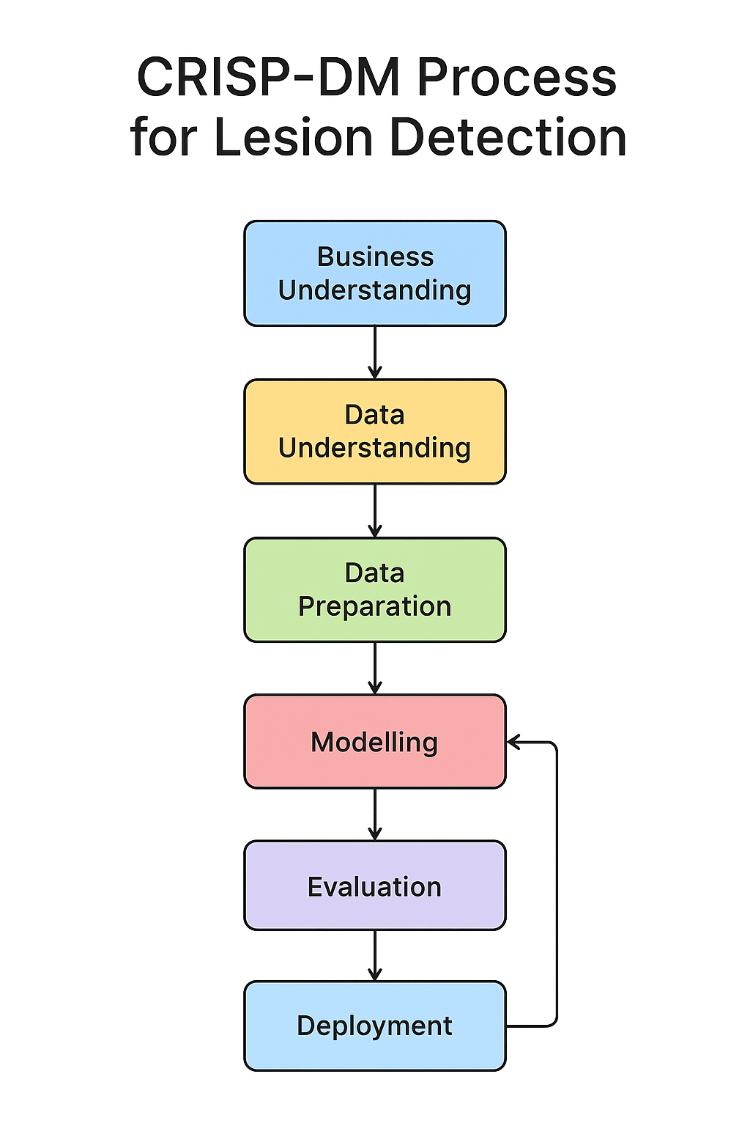
CRISP-DM Process Diagram

3.3 Data and Requirements Gathering
Requirements gathering is a critical stage in the development of any complex system, particularly in healthcare-oriented artificial intelligence (AI) applications. For a skin lesion detection and classification system, eliciting accurate and comprehensive requirements ensures that the technical design aligns with both medical best practices and user expectations. This phase bridges the gap between the theoretical capabilities of AI models and the practical needs of end-users, which in this case include dermatologists, general practitioners, researchers, and non-technical individuals seeking self-assessment tools. As noted by Ruparelia (Ruparelia, 2010), effective requirements elicitation not only enhances system relevance but also minimizes costly redesigns during later stages of development.
The approach adopted in this project combined multiple requirement gathering methods, consistent with methodological recommendations in software engineering and health informatics research (Hay et al., 2006; Khan et al., 2021). Using a combination of qualitative and quantitative strategies increased the robustness of our findings by allowing cross-verification of insights (triangulation) and by capturing both statistical trends and nuanced, context-specific needs.

3.3.1 Interviews
Semi-structured interviews were conducted with subject-matter experts, particularly dermatologists, general practitioners, and AI researchers. The purpose of these interviews was to explore diagnostic workflows, common challenges in skin lesion assessment, and expectations for integrating automated systems into clinical and teledermatology practice. Interview questions were guided by literature on the adoption of AI in dermatology (Esteva et al., 2017; Zafar et al., 2023) and covered:
- The perceived accuracy and reliability thresholds acceptable for clinical decision support tools.
- Preferred output formats (e.g., probability scores, lesion type classification, urgency recommendations).
- Integration concerns with existing patient record systems and telemedicine platforms.
- Ethical considerations, including patient consent and data privacy.
Interviews were audio-recorded, transcribed, and coded for thematic analysis in later stages.

3.3.2 Surveys and Questionnaires
Two online survey instruments were designed, one targeting technical and health professionals, and another aimed at non-technical individuals. The former included domain-specific questions regarding AI model transparency, explainability, and integration with clinical workflows, while the latter focused on usability, trust, and perceived usefulness of the proposed system.
The surveys comprised both closed-ended questions (for quantitative analysis) and open-ended prompts (for qualitative insights). Distribution was carried out via professional mailing lists, social media groups, and university networks. In line with Hay et al. (Hay et al., 2006), survey design incorporated clear definitions of medical terms to ensure comprehension among non-specialist respondents.

3.3.3 Documentation Review
In addition to primary data collection, a review of relevant documentation was undertaken. This included:
- Published clinical guidelines for skin cancer detection and management.
- Existing research on automated lesion detection and classification (Kassem et al., 2021; Ogudo et al., 2023).
- Technical specifications of public skin lesion datasets such as HAM10000 (Tschandl et al., 2018).
- Regulatory standards related to AI in healthcare, including data protection protocols.
The documentation review informed the selection of lesion categories, the choice of evaluation metrics, and constraints for model deployment.

3.3.4 Focus Groups
Focus groups were organized with a mixed composition of technical experts, medical practitioners, and potential end-users. Unlike individual interviews, focus groups facilitated dynamic discussions that revealed collective priorities and concerns. For example, non-technical users expressed apprehension about over-reliance on automated outputs without human oversight, whereas clinicians emphasized the importance of false negative minimization over overall accuracy.

3.3.5 Synthesis of Findings
Findings from all methods were synthesized using a multi-step process:
- Extraction of key points from each method.
- Cross-referencing to identify recurring requirements.
- Prioritization using the MoSCoW method (Must have, Should have, Could have, Won’t have) as recommended in agile software development(Srivastava et al., 2017).
This synthesis process ensured that the final requirements specification incorporated both the functional and non-functional needs of diverse stakeholders, and that the resulting system design balanced technical feasibility with practical utility.

3.4 Population and Sample

3.4.1 Target Population
The target population for this study consisted of individuals and groups who would either directly use or influence the adoption of the proposed skin lesion detection and classification system. This included:
- Health Professionals: Dermatologists, general practitioners, and other medical personnel involved in skin disease diagnosis and treatment. Their expertise was vital in validating clinical accuracy requirements, determining acceptable error thresholds, and ensuring the system aligned with established diagnostic workflows (Esteva et al., 2017; Hay et al., 2006).
- Technical Experts: Machine learning researchers, computer vision engineers, and software developers with experience in healthcare applications. Their input guided architectural design choices, algorithm selection, and system integration strategies (Khan et al., 2021).
- Non-Technical Individuals: Members of the general public, particularly those with limited access to dermatological services. This group provided insight into usability, accessibility, and trust factors, especially in contexts where teledermatology may serve as a first point of consultation (Zafar et al., 2023).

3.4.2 Sampling Strategy
Given the diversity of the target population, a stratified sampling approach was adopted, dividing respondents into two broad strata:
- Technical and Health Professionals — selected using purposive sampling, ensuring that only individuals with relevant domain knowledge and professional experience were included. Recruitment was facilitated through professional associations, academic networks, and LinkedIn outreach.
- Non-Technical Individuals — selected using convenience sampling, leveraging community networks, social media outreach, and university mailing lists. This method was chosen for its practicality and efficiency in reaching a large pool of respondents in a limited timeframe.
This mixed approach ensured both the depth of expert feedback and the breadth of general user perspectives.

3.4.3 Sample Size
A total of 25 responses were collected from technical and health professionals, and 50 responses from non-technical individuals. While the sample size for each group was constrained by resource availability and the duration of the requirement gathering phase, it was sufficient to capture recurring patterns and requirements for system design.

3.4.4 Justification of Sample Size
In requirement elicitation for specialized healthcare AI systems, depth of insight is often more critical than sheer volume of responses (Ruparelia, 2010). For technical and health professionals, a smaller but highly relevant participant pool can yield actionable requirements without unnecessary redundancy. The non-technical sample size, while larger, was chosen to ensure diversity in age, education, and technology literacy, thereby reflecting the heterogeneity of potential end-users.

3.4.5 Limitations of Sampling Approach
Despite its effectiveness, the sampling approach had limitations:
- Selection Bias: Purposive sampling may have excluded certain professional subgroups, particularly in rural or resource-limited regions.
- Geographical Constraints: The majority of respondents were located in urban centers, potentially under-representing rural healthcare contexts where teledermatology may have the highest impact.
- Response Bias: Online surveys can disproportionately attract participants with higher digital literacy, possibly skewing usability feedback.
These limitations are acknowledged and considered when interpreting the requirement gathering results and in the subsequent system design stages.

3.5 Quantitative Analysis

3.5.1 Data Analysis Techniques
Quantitative analysis was performed on the closed-ended questions from the surveys, focusing on numerical and categorical variables. The primary objective was to extract measurable trends regarding user expectations, clinical requirements, and perceived usability of the proposed skin lesion detection system.
Descriptive statistics, including mean, median, mode, and standard deviation, were calculated for ordinal and interval-scale responses. For nominal data, frequency distributions and percentages were computed. Cross-tabulation was employed to explore potential relationships between demographic variables (e.g., profession, years of experience, age group) and perceptions of the system (Hay et al., 2006; Ruparelia, 2010).
To ensure robustness, data analysis adhered to established guidelines for handling mixed healthcare and technology survey data (Khan et al., 2021). Data cleaning included the removal of incomplete responses and the normalization of Likert-scale entries for comparability across questions.

3.5.2 Data Visualization
Data visualization was used extensively to communicate quantitative findings clearly. Bar charts, pie charts, and stacked column graphs were employed to depict categorical distributions, while histograms illustrated the spread of numerical responses. For relationship analysis, clustered bar charts and side-by-side box plots were applied.
For example:
- Distribution of confidence levels in AI-assisted diagnosis among professionals versus non-technical users.
- Comparative importance ratings of system features such as diagnosis speed, accuracy, and explainability.
- Patterns in willingness to adopt the system across different age groups.
Visualizations were produced using spreadsheet software and statistical tools, ensuring clarity for both technical and non-technical audiences.

3.5.3 Interpretation and Findings
Quantitative results revealed several key trends:
- Accuracy Thresholds: Health professionals consistently identified a minimum acceptable accuracy rate above 90% for clinical decision support, while non-technical users were more tolerant of slightly lower accuracy levels if accompanied by clear explanations (Esteva et al., 2017).
- Feature Prioritization: Across both groups, the most highly rated features were real-time analysis, mobile accessibility, and privacy safeguards.
- Adoption Willingness: Willingness to adopt was highest among younger respondents and those with prior telemedicine experience, suggesting that digital familiarity positively influences acceptance.
These findings highlight the importance of tailoring the system’s feature set and communication style to different user categories.

3.5.4 Conclusion
The quantitative analysis provided objective, measurable insights into user requirements and priorities. By quantifying trends and preferences, the results served as a foundation for setting design specifications, performance benchmarks, and usability targets. This ensured that subsequent system development steps were guided by evidence-based requirements rather than assumptions.

3.6 Qualitative Analysis

3.6.1 Thematic Analysis Approach
Qualitative analysis was conducted on the open-ended survey responses, interview transcripts, and focus group discussions. The primary objective was to identify recurring themes, contextual nuances, and stakeholder concerns that could not be captured through purely numerical measures.
A thematic analysis approach was adopted, following the steps outlined by Braun and Clarke (Braun & Clarke, 2006)*:
- Familiarization: Repeated reading of the raw text data to immerse in the content and context.
- Initial Coding: Assigning descriptive labels to meaningful segments of text, capturing both explicit statements and implied sentiments.
- Theme Development: Grouping related codes into broader thematic categories.
- Reviewing Themes: Cross-checking against the dataset to ensure themes accurately represented the participants’ views.
- Defining and Naming Themes: Refining theme descriptions for clarity and relevance.
- Reporting: Selecting illustrative quotes to convey the essence of each theme.

3.6.2 Coding and Categorization
Responses were coded manually using spreadsheet-based coding tables. This process produced multiple overarching categories:
- Accuracy and Trust: Emphasis on clinical reliability and the need for human oversight in diagnosis (Esteva et al., 2017; Zafar et al., 2023).
- Usability and Accessibility: Concerns over interface simplicity, language localization, and mobile optimization for low-bandwidth environments.
- Privacy and Ethics: Demand for strict compliance with data protection regulations and transparent data usage policies (Khan et al., 2021).
- Educational Value: Interest in integrating explanations and visual aids to help users understand lesion classifications and potential risks.

3.6.3 Interpretation of Qualitative Findings
The qualitative data revealed several insights that influenced design decisions:
- Differing Risk Tolerance: Medical professionals prioritized minimizing false negatives, even at the cost of slightly lower overall accuracy, whereas non-technical users valued a balance between speed and reliability.
- Need for Explainability: Across all groups, participants favored outputs accompanied by visual indicators and textual explanations, supporting findings in explainable AI literature.
- Cultural and Language Considerations: Participants from non-English-speaking backgrounds stressed the importance of multilingual support for both the interface and educational materials.
These findings underscored the necessity of designing a system that is not only technically sound but also socially and ethically acceptable.

3.6.4 Conclusion
By capturing and analyzing the rich detail of participants’ perspectives, the qualitative analysis complemented the quantitative results, providing a holistic understanding of user and stakeholder needs. The combination of both methods ensured that the system’s design was informed by statistically significant trends as well as the subtler, contextual factors that can impact adoption and trust.

3.7 Dataset Description and Preprocessing
The dataset used in this study was curated from multiple open-source dermatological image repositories and validated clinical sources. It comprises high-quality images covering 33 unique skin condition categories, spanning viral, bacterial, fungal, parasitic, autoimmune, inflammatory, and neoplastic conditions. Unlike conventional dermatological datasets such as HAM10000, which focus predominantly on melanocytic lesions (Khan et al., 2021; Tschandl et al., 2018), this dataset extends coverage to a broader spectrum of dermatological manifestations, enabling a more versatile diagnostic tool.

3.7.1 Dataset Composition
The dataset categories are as follows:
- Viral Infections: Chickenpox, Monkeypox, Measles, Shingles, Herpes, Cowpox.
- Bacterial Infections: Impetigo, Leprosy, Whitlow.
- Fungal Infections: Athlete’s Foot, Ringworm, Nail Fungus.
- Parasitic Infestations: Scabies, Tungiasis, Larva Migrans.
- Inflammatory and Autoimmune Conditions: Eczema, Psoriasis, Autoimmune Disease, Rash Dermatitis, Vitiligo.
- Benign and Malignant Tumors: Basal Cell Carcinoma (BCC), Squamous Cell Carcinoma (SCC), Actinic Keratosis, Melanoma, Nevus, Seborrheic Keratosis, Benign Tumor, Moles.
- Other Dermatological Conditions: Acne, Neurofibromatosis, Vascular Lesion, Healthy skin.
This broad coverage is particularly valuable for primary care and teledermatology, where non-specialist practitioners encounter diverse skin pathologies (Adegun & Viriri, 2020; Zafar et al., 2023).

3.7.2 Data Sources
The dataset was compiled from:
- Public dermatology datasets — e.g., HAM10000, ISIC Archive (for melanoma, nevus, keratosis, and carcinoma images).
- Open-access image repositories — curated collections for conditions such as chickenpox, monkeypox, and scabies.
- Institutional contributions — small-scale, ethically approved clinical image sets for rare conditions such as tungiasis and larva migrans.
All images were reviewed to ensure:
- Minimum resolution of 224×224 pixels before resizing.
- Clear lesion visibility with minimal occlusions.
- Correct disease labeling by source datasets.

3.7.3 Dataset Distribution and Class Imbalance
The dataset is imbalanced:
Classes like Acne and Eczema have large sample counts, while rare conditions such as Tungiasis or Larva Migrans have far fewer. Such imbalance can bias models toward majority classes, leading to reduced recall for rare categories (Buda et al., 2018; Kassem et al., 2021).
Mitigation strategies applied:
- Class weighting — Computed via sklearn.utils.class_weight and incorporated into the cross-entropy loss.
- Data augmentation — Uniformly applied at runtime, with possible further targeted augmentation for minority classes in future iterations.
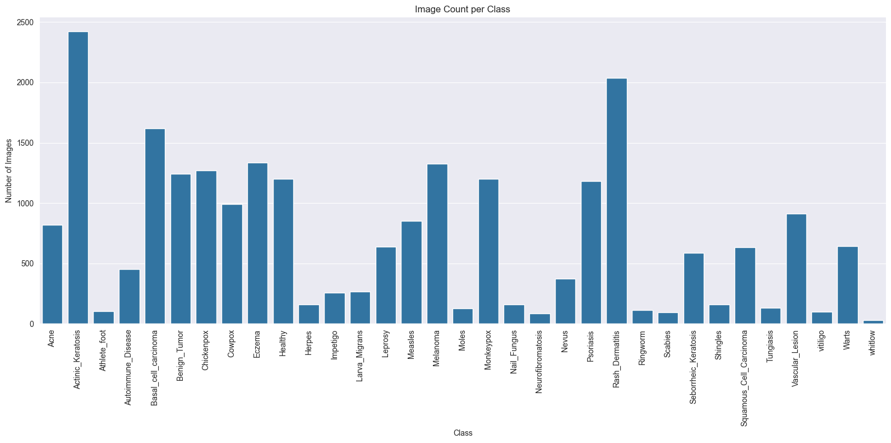
Number of images per class
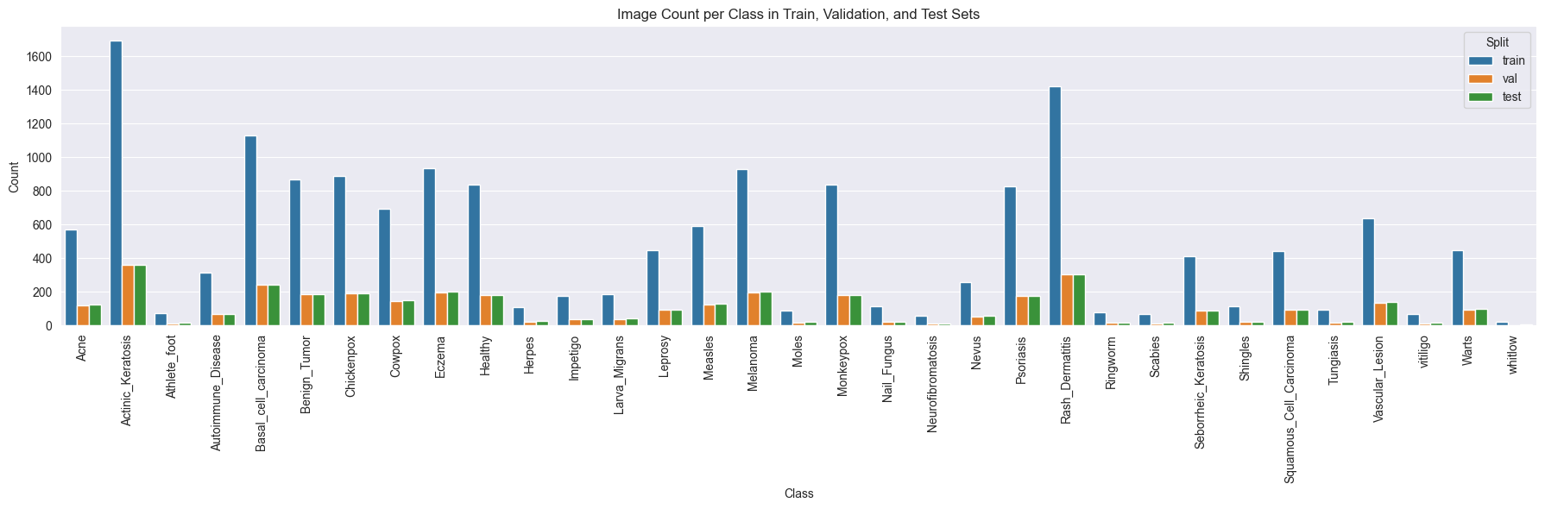
Class distribution plot across splits

3.7.4 Data Partitioning
Images were split into:
- Training set: 70%
- Validation set: 15%
- Test set: 15%
Splitting was stratified per class to preserve class proportions across sets, ensuring fair evaluation.

3.7.5 Exploratory Data Analysis (EDA)
Before training, EDA was conducted on the processed dataset to assess its suitability:
- Class distribution analysis — Generated bar plots to visualize image counts per class for each dataset split, confirming imbalance patterns.
- Sample inspection — Random samples per class were displayed to verify label correctness and assess intra-class variability.
- Image dimension profiling — Recorded resolutions and aspect ratios from random subsets to guide resizing and padding strategies.
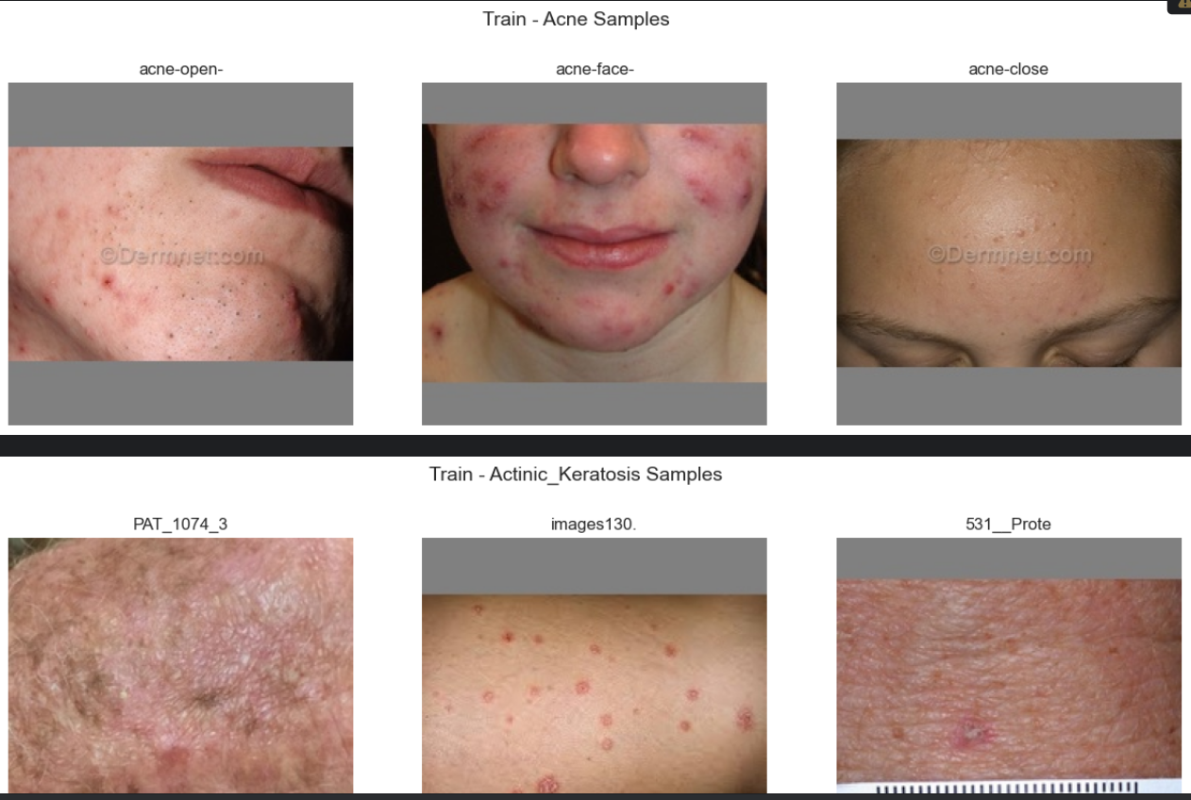
Example sample images per class

3.7.6 Preprocessing Pipeline
A reproducible preprocessing pipeline was implemented in Python, combining offline standardization and online augmentation:

3.7.6.1 Offline Processing
- Image Conversion — Ensured all images were in RGB mode to match the pretrained ResNet input format.
- Resizing with Padding — Used Lanczos resampling to resize while preserving aspect ratio, padding with a neutral grey background (128, 128, 128) to reach 224×224 pixels.
- Format Standardization — Saved all outputs as high-quality JPEG files for consistency.
- Directory Structuring — Images organized into train, val, and test directories by class.

3.7.6.2 Online Augmentation (During Training)
Transformation | Purpose | Parameters
Random Horizontal Flip | Simulate left/right lesion orientation | p = 0.5
Random Rotation | Account for patient positioning differences | ±10°
Color Jitter | Simulate lighting variations | brightness=0.2, contrast=0.2, saturation=0.2
Normalization | Match ImageNet statistics | mean=[0.485, 0.456, 0.406], std=[0.229, 0.224, 0.225]
These augmentations improve generalization and reduce overfitting (LeCun et al., 2015; Mahbod et al., 2019).

3.7.7 Impact of Preprocessing and Augmentation
The chosen preprocessing and augmentation steps:
- Improved robustness to variations in lighting, camera quality, and orientation.
- Reduced the risk of overfitting by diversifying the training data.
- Preserved lesion geometry, which is essential for dermatology-specific feature learning.

3.8 Model Architecture
The classification model is based on a fine-tuned ResNet-18 (He et al., 2016), selected for its favorable trade-off between accuracy and computational cost. This architecture is well-suited for mobile and edge deployment due to its small parameter count and competitive accuracy in medical image tasks (Esteva et al., 2017).

3.8.1 Baseline Architecture
ResNet-18 comprises:
- An initial convolutional layer (7×7 kernel, stride 2) followed by batch normalization and ReLU activation.
- Four sequential residual blocks (layers 1–4) with skip connections to facilitate gradient flow.
- Global average pooling, followed by a fully connected (fc) layer for classification.

3.8.2 Transfer Learning Adaptations
To adapt ResNet-18 for multi-class lesion classification:
- Weights initialized from ImageNet-pretrained ResNet-18 (ResNet18_Weights.DEFAULT).
- Frozen layers: Layers 1–3 kept frozen to retain generic visual features.
- Unfrozen layers: Layer 4 and the fc layer trained for dermatology-specific adaptation.
- Modified final layer: Replaced fc with nn.Linear(512, 33) for 33-class output.
This selective fine-tuning strategy combines pretrained low- and mid-level feature extraction with high-level feature specialization (Yosinski et al., 2014).

3.8.3 Loss Function and Class Balancing
A weighted cross-entropy loss was employed, where each class weight was inversely proportional to its frequency in the training set. This approach ensured that minority classes contributed more to gradient updates, improving detection rates for rare conditions.

3.8.4 Optimization and Regularization
Training configuration:
- Optimizer: Adam (lr=0.001, weight_decay=1e-4).
- Scheduler: ReduceLROnPlateau (factor=0.5, patience=2).
- Early Stopping: Stop if validation loss fails to improve for 5 epochs.
- Batch Size: 32.
Regularization via L2 weight decay and early stopping reduced overfitting, while dynamic learning rate adjustment improved convergence stability.

3.8.5 Rationale for ResNet-18 Selection
ResNet-18 was chosen because:
- It delivers high accuracy with relatively low inference time.
- Prior studies confirm ResNet’s effectiveness for skin lesion classification (Albahar, 2019; Harangi, 2018).
- Its moderate depth supports deployment on resource-constrained devices without heavy hardware requirements.
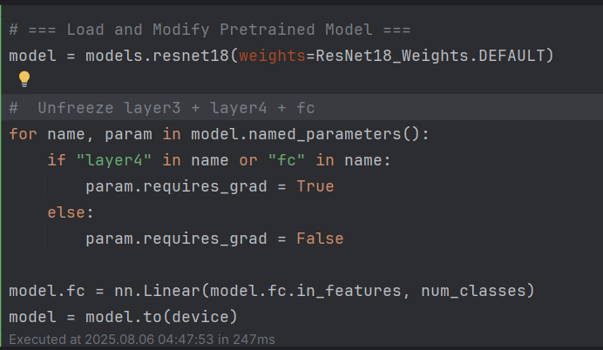
Modified ResNet-18 highlighting unfrozen layers

3.9 Training Strategy
The training phase was carefully designed to achieve a balance between computational efficiency, classification accuracy, and generalization capability to unseen images. This section describes the training configuration, rationale for hyperparameter selection, and mechanisms adopted to handle the inherent challenges of medical image classification.

3.9.1 Hardware and Frameworks
All model training was conducted on a GPU-enabled workstation equipped with CUDA support. This significantly reduced training time compared to CPU-based execution, enabling faster experimentation and hyperparameter tuning. The model was implemented in PyTorch, chosen for its flexibility and strong community support in research-oriented deep learning tasks. Supporting libraries included:
- torchvision for pretrained model loading and image transformation pipelines.
- scikit-learn for computing class weights and auxiliary evaluation metrics.
- tqdm for real-time progress tracking.
- TensorBoard for monitoring loss, accuracy, and learning rate trends over epochs.

3.9.2 Data Loading and Batching
The processed dataset (Section 3.3) was loaded via PyTorch’s DataLoader class with the following configurations:
- Batch Size: 32 images per iteration — a compromise between computational efficiency and GPU memory constraints.
- Shuffling: Enabled for the training set to ensure diverse sample exposure per batch, breaking any inherent ordering in the data.
- Parallelism: Four worker threads (num_workers=4) with a prefetch factor of four, minimizing idle GPU time due to data loading delays.
This setup ensured that each training iteration received a randomized, memory-optimized batch, which has been shown to improve convergence rates (Goodfellow et al., 2016).

3.9.3 Transfer Learning and Layer Freezing
Given the limited availability of dermatological images for certain rare conditions, training a deep convolutional neural network from scratch was deemed impractical. Instead, transfer learning was employed using a ResNet-18 architecture pretrained on the ImageNet dataset. The transfer learning strategy included:
- Freezing layers 1–3: Preserving generic feature extractors (edges, textures, shapes) learned from the large-scale ImageNet dataset.
- Unfreezing layer 4 and the fully connected layer: Allowing adaptation of higher-level feature representations to the unique textures and lesion patterns in dermatological images.
- Classifier replacement: Modifying the final fully connected layer to output 33 logits corresponding to the target disease categories.
Selective unfreezing reduced the risk of overfitting while allowing enough flexibility for domain adaptation (Yap et al., 2018).

3.9.4 Loss Function and Class Balancing
A major challenge identified during exploratory data analysis (EDA) was class imbalance, with conditions like Eczema and Acne having significantly more samples than rare diseases such as Tungiasis or Herpes. Without correction, the model would bias predictions toward majority classes. To address this:
- Weighted Cross-Entropy Loss was used, with per-class weights computed using:
$$w_{c}=\frac{N}{n_{c}⋅K}$$
where:
- $N$ is the total number of training samples,
- $n_{c}$ is the sample count for class $c$,
- $K$ is the number of classes.
These weights were passed directly to PyTorch’s nn.CrossEntropyLoss, ensuring that errors on minority classes contributed proportionally more to gradient updates. This method is well-supported in medical imaging literature for combating imbalance (Krawczyk, 2016).

3.9.5 Optimization and Learning Rate Scheduling
Optimization was handled by the Adam optimizer with:
- Learning rate $α=0.001$,
- Weight decay $=1×{10}^{-4}$ for L2 regularization.
Adam was chosen for its adaptive learning rates and robustness to sparse gradients (Adam et al., 2014). To avoid stagnation, the ReduceLROnPlateau scheduler was employed, reducing the learning rate by a factor of 0.5 if validation loss failed to improve for two consecutive epochs.

3.9.6 Early Stopping
To prevent overfitting and unnecessary computation, early stopping was implemented with a patience of 5 epochs, if no improvement in validation loss was observed during this period, training terminated. This approach aligns with best practices in deep learning model regularization (Prechelt, 1998).

3.9.7 Epochs, Monitoring, and Logging
The model was trained for a maximum of 20 epochs. Real-time metrics were logged to TensorBoard, capturing:
- Training and validation loss curves,
- Training and validation accuracy curves,
- Learning rate schedules.
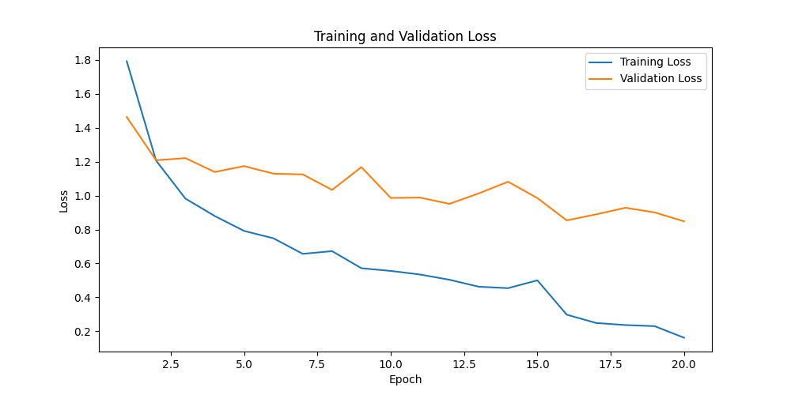
Training and validation loss curves
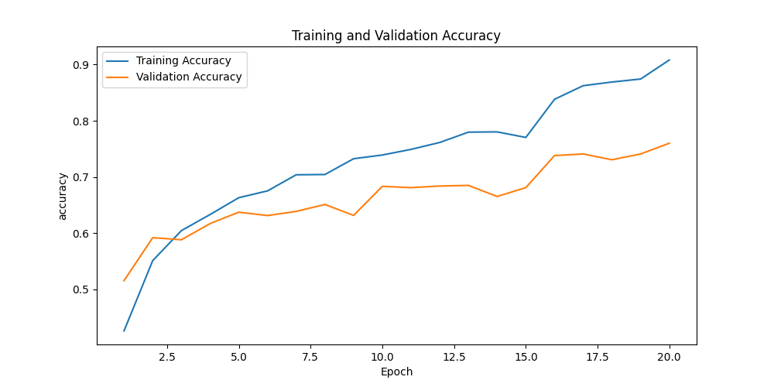
Training and validation accuracy curves

3.10 Evaluation Strategy
The evaluation methodology was designed to quantify not only the overall classification performance but also the per-class diagnostic reliability, given the medical context of the task.

3.10.1 Test Set Protocol
All reported results are based on the test set, which was strictly isolated from training and validation data to ensure unbiased performance estimates. This set simulates real-world deployment conditions by containing images unseen by the model at any training stage.

3.10.2 Evaluation Metrics
Given the dataset imbalance and the multi-class nature of the problem, we employed the following metrics:
- Accuracy:
$$\text{Accuracy}=\frac{\text{Number of correct predictions}}{\text{Total number of predictions}}$$
While intuitive, accuracy alone may mask poor minority-class performance in imbalanced datasets.
- Precision (per class and macro-averaged):
$$\text{Precision}=\frac{\text{True Positives}}{\text{True Positives}+\text{False Positives}}$$
Precision is critical in medical applications where false positives can lead to unnecessary anxiety or treatment.
- Recall / Sensitivity:
$$\text{Recall}=\frac{\text{True Positives}}{\text{True Positives}+\text{False Negatives}}$$
High recall ensures that most true cases are detected, reducing missed diagnoses.
- F1-Score:
$$\text{F1}=2×\frac{\text{Precision}×\text{Recall}}{\text{Precision}+\text{Recall}}$$
Balances the trade-off between precision and recall.
- Confusion Matrix:
Visualizes per-class prediction performance and highlights common misclassifications (e.g., Seborrheic Keratosis misclassified as Actinic Keratosis).
- ROC AUC (One-vs-Rest): Measures separability between each class and all others, providing insight into decision threshold robustness.

3.10.3 Rationale for Metric Selection
These metrics were selected based on clinical relevance. In dermatology AI, high recall is often prioritized to minimize missed malignant cases, while high precision reduces unnecessary biopsies or referrals. Macro-averaging ensures all classes contribute equally to the overall performance measure, regardless of prevalence.

3.10.4 Additional Performance Considerations
Given the intended integration into a CLI for research and a React Native mobile application, additional evaluations were made on:
- Inference latency — to ensure acceptable response times on standard mobile hardware.
- Model size and memory footprint — to confirm feasibility for mobile and edge deployment.

3.10.5 Visualizations
Performance visualizations will be added to the final report:
- Loss and accuracy curves across epochs,
- Confusion matrix heatmap for error analysis,
- ROC curves for multi-class separability assessment.
These plots aid in communicating results to both technical and clinical audiences.

3.11 System Deployment
The deployment phase transforms the trained skin lesion classification model into a functional application ecosystem that is accessible to both researchers and end-users. This involves integrating the AI model into multiple delivery channels, a command-line interface (CLI) for advanced research workflows, and a React Native mobile application for primary care and public health use. Deployment considerations also include hosting infrastructure, scalability, data privacy, and regulatory compliance.

3.11.1 Deployment Objectives
The system deployment aims to:
- Ensure accessibility — enable both technical and non-technical users to interact with the model.
- Maintain efficiency — achieve low-latency inference, even on resource-constrained devices.
- Support scalability — allow expansion to larger datasets, additional disease classes, and multi-language support.
- Facilitate integration — ensure the model can be embedded into broader healthcare systems or telemedicine platforms.

3.11.2 Command-Line Interface (CLI) for Researchers
The CLI is designed to serve dermatology researchers and data scientists who require batch processing, model experimentation, and in-depth performance analytics.

3.11.2.1 Key Features:
- Single-image and batch prediction modes
Researchers can run predictions on individual lesion images or entire folders.
- Output formats
Predictions can be saved in CSV/JSON format, containing the predicted class, confidence scores, and timestamp.
- Model evaluation tools
Researchers can compute metrics such as accuracy, precision, recall, F1-score, and generate confusion matrices on new datasets.
- Custom model loading
Allows researchers to test alternative trained models by specifying the path via a command-line argument.
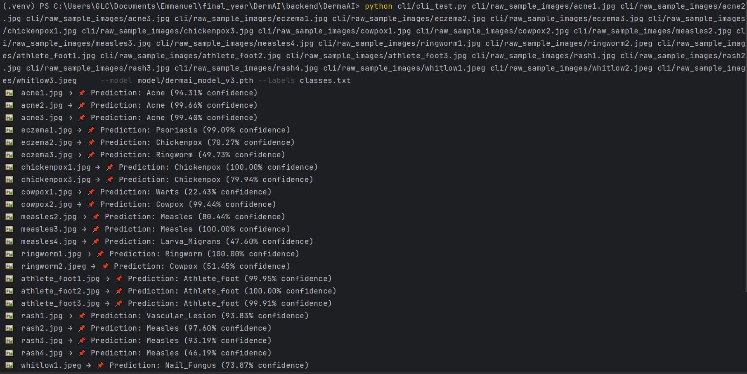
Screenshot of CLI prediction output

3.11.3 Mobile Application for End-Users
The React Native mobile application is intended for healthcare practitioners, field workers, and potentially patients for preliminary lesion screening.
The app will integrate the trained ResNet-18 model either on-device (for offline capability) or via cloud-hosted inference APIs (for lighter device workloads).

3.11.3.1 Core Features:
- Image Capture & Upload
Users can capture lesion images directly via the phone’s camera or upload from the gallery.
- Instant Classification
The app provides top predictions with confidence scores.
- Educational Content
Displays information about predicted conditions, including symptoms and recommended next steps.
- Offline Mode (Planned)
A lightweight, quantized version of the model can be embedded for use in low-connectivity regions.

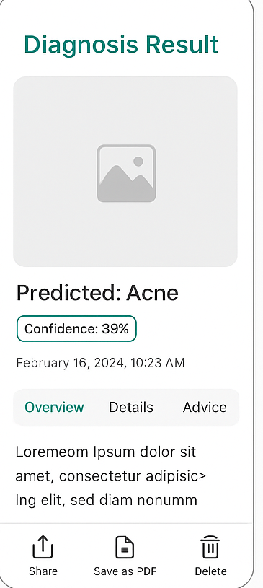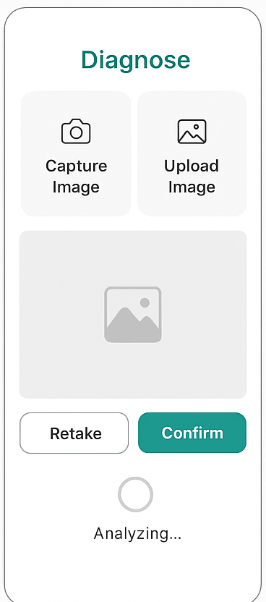

Mobile Wireframes

3.11.4 Hosting and API Infrastructure
The system will be deployed using a serverless cloud architecture on Amazon Web Services (AWS). This approach was selected to ensure scalability, cost efficiency, and simplified maintenance. Key components include:
- Amazon API Gateway – Handles user requests and routes them securely to backend services.
- AWS Lambda – Executes serverless functions for classification inference, enrichment processing, and result handling, with automatic scaling based on demand.
- Amazon S3 (on Outposts) – Provides secure and reliable storage for the trained model and related assets.
- Amazon SQS – Manages asynchronous request queues to decouple processes and enhance reliability.
- Amazon DynamoDB – Serves as the primary database for storing predictions, enriched descriptions, and user-related data.
- OpenAI LLM Integration – Provides automated text enrichment for clinical explanations and user-friendly feedback.
This configuration eliminates the need for dedicated server management, reduces operational overhead, and ensures the system can seamlessly scale to accommodate varying user loads. Furthermore, the pay-per-use billing model minimizes costs during periods of low activity, making the solution sustainable in both testing and production environments.

3.11.5 Deployment Workflow
The deployment workflow includes:
- Model Export — trained model saved in .pth and .pt formats for compatibility with both PyTorch and TorchScript (mobile deployment).
- API Development — RESTful API endpoints for:
  - /predict — accept image input, return classification results.
  - /result — get result for prediction.
- Integration Testing — ensuring consistent predictions across CLI, mobile, and API-based requests.
- Security and Privacy — enforce HTTPS for data transfer, anonymize image metadata, and comply with GDPR/HIPAA standards where applicable.

3.11.6 Monitoring and Maintenance
Post-deployment, the system will include:
- Usage analytics — monitor API requests, app downloads, and prediction frequency.
- Model performance tracking — periodic testing with new data to detect performance drift.
- Continuous improvement cycle — retraining with new cases, including rare or misclassified conditions.

3.12 Summary of Methodology
This chapter presented the complete methodology adopted for the design, development, training, and deployment of the proposed skin lesion detection and classification system. The approach was guided by the CRISP-DM framework, ensuring that every stage, from problem definition to system deployment, followed a structured, iterative, and evidence-driven process.
The business understanding phase established the project’s core objective: to develop a multi-condition dermatological diagnostic aid that can assist healthcare practitioners and researchers by classifying a wide range of skin lesions. Unlike many prior works such as those based on the HAM10000 dataset, which focus primarily on melanoma and a few related conditions, our system targets 33 unique dermatological conditions spanning viral, bacterial, fungal, parasitic, autoimmune, inflammatory, and neoplastic categories. This broad coverage is intended to make the system more relevant in primary care, rural healthcare, and teledermatology contexts, where clinicians may encounter a diverse set of skin disorders.
The data understanding phase involved collecting images from multiple open-source dermatology datasets, open-access medical repositories, and selected institutional sources. Exploratory Data Analysis (EDA) was conducted to assess the dataset’s structure, identify imbalances, and verify image quality. The EDA included:
- Class distribution analysis, revealing significant imbalances (e.g., Acne and Eczema having hundreds of samples, while Tungiasis and Cowpox had far fewer).
- Image dimension inspection, confirming varied resolutions before preprocessing.
- Visual inspection of samples to validate labeling accuracy and ensure lesion visibility.
The data preparation phase applied a comprehensive preprocessing pipeline tailored to dermatology-specific needs. Images were resized to 224×224 pixels with padding to preserve aspect ratios, converted to RGB, and normalized to match ImageNet statistics (mean = [0.485, 0.456, 0.406], std = [0.229, 0.224, 0.225]). Data augmentation techniques including random horizontal flips, small rotations (±10°), and color jitter were used to simulate variations in orientation, lighting, and camera quality, thereby improving model robustness. Class imbalance was addressed by calculating class weights from the training set and applying them in the loss function, ensuring rare conditions were not overshadowed by more common ones.
The modeling phase implemented a fine-tuned ResNet-18 architecture initialized with pretrained weights from ImageNet. Only the final residual block (layer4) and the fully connected classification layer were unfrozen to adapt high-level features to dermatological patterns, while earlier layers retained their pretrained weights to preserve general feature extraction capability. The model was trained with:
- Loss function — weighted cross-entropy.
- Optimizer — Adam (lr=0.001, weight_decay=1e-4) to balance learning speed and regularization.
- Scheduler — ReduceLROnPlateau to adjust the learning rate when validation loss plateaued.
- Early stopping — halting training after 5 epochs without improvement to prevent overfitting.
- Batch size — 32, selected to balance memory constraints and gradient stability.
Performance metrics during training and evaluation included accuracy, precision, recall, and F1-score. Additional metrics, confusion matrix, per-class precision/recall, and ROC curves, are planned for inclusion in the results chapter to provide a more granular performance breakdown.
The evaluation phase ensured unbiased testing by maintaining a strict 70/15/15 train/validation/test split. The model that achieved the best validation loss was saved in both .pth (PyTorch format) and .pt (TorchScript format) for compatibility with different deployment targets.
The deployment phase envisioned a two-pronged delivery approach:
- Command-Line Interface (CLI) — Designed purely for inference, enabling researchers to run single-image or batch predictions and receive results in CSV/JSON formats, complete with predicted class and confidence scores.
- React Native Mobile Application — Intended for healthcare practitioners and general users. The final deployment will utilize a cloud-hosted API for inference to keep the mobile application lightweight, avoid excessive on-device computation, and enable easier model updates without requiring app reinstallation.
Hosting considerations focused on cloud-based API deployment, with the initial preference being serverless infrastructure (e.g., AWS Lambda) for cost efficiency and automatic scaling. A containerized alternative (e.g., Docker on AWS EC2 or DigitalOcean) is reserved as a fallback option, particularly after the expiration of AWS credits. The deployment architecture will initially include only the currently planned components, mobile app, API gateway, model inference service, and a minimal database for request logging, with no hospital EMR integration at this stage.
Throughout this methodology, careful attention was paid to both technical performance and practical usability. The CRISP-DM framework provided the flexibility to refine earlier stages based on insights from later phases, for example, adjusting augmentation strategies in response to observed overfitting during model training. By combining robust deep learning techniques with a deployment design mindful of user needs and infrastructure realities, the system is positioned to deliver both research-grade accuracy and field-ready accessibility.

4 Chapter 4: System Analysis, Design Result, and Discussion

4.1 Introduction
The design and development of a skin lesion detection and classification system requires not only a robust technical framework but also an in-depth understanding of the needs, expectations, and constraints of its intended users. As highlighted in the preceding chapters, the rising prevalence of skin-related disorders and the limitations of timely dermatological consultations have created a pressing need for scalable and accessible solutions. Chapter 4 focuses on the system analysis and design phase, where insights gathered from surveys, literature, and technical feasibility studies are synthesized into concrete system requirements, architectural decisions, and design specifications.
System analysis is a critical phase in any software engineering life cycle. It bridges the gap between problem identification (why the system is needed) and solution implementation (how the system will be built and deployed). In this project, the analysis draws from two distinct but complementary sources of information:
- General users, who represent the prospective patients or everyday individuals that will interact with the mobile application; and
- Technical and health professionals, including clinicians, researchers, and developers, who will engage with the system through a Command-Line Interface (CLI) for more advanced data handling and interpretability.
By triangulating perspectives from these groups, the project aims to ensure that the system design is not only technically sound but also socially relevant, ethically grounded, and practically usable.
A core motivation for this chapter is the observation that AI systems in healthcare often fail due to inadequate alignment with user expectations. Several studies (Esteva et al., 2017; Haenssle et al., 2018) have demonstrated the diagnostic potential of convolutional neural networks in dermatology, yet adoption rates among patients and clinicians remain low. The reasons for this gap include trust deficits, concerns around explainability, privacy issues, and lack of integration with existing medical workflows. The surveys conducted as part of this research address these challenges directly by eliciting responses on comfort levels with AI, required accuracy thresholds, privacy safeguards, and the type of medical explanations users expect.
In addition to user perspectives, the technical survey results provide vital input into the system’s architectural decisions. For example, the choice of machine learning frameworks, preferred methods for dataset handling, and expectations regarding metadata documentation are all informed by the experiences of researchers and practitioners. Similarly, considerations around interoperability, scalability, and deployment models are influenced by their professional insights.
The design component of this chapter builds on these insights to present:
- A structured system overview, highlighting objectives, scope, and boundaries;
- A comprehensive list of functional and non-functional requirements, derived from both general users and technical stakeholders;
- The proposed system architecture, illustrating how the different components, mobile app, CLI, backend services, and AI models interact with each other;
- Detailed data flow and processing pipelines, showing how raw inputs are transformed into predictions and explanations;
- User interface designs for both mobile and CLI components, ensuring usability across different user groups;
- An integration and deployment strategy, balancing offline capabilities with lightweight, API-driven inference; and
- A discussion of inference and prediction logic, addressing how the system manages valid skin images, out-of-distribution data, and explanation generation.
The chapter closes with a synthesis of how survey findings have concretely shaped design decisions, followed by a summary that ties the analysis back to the broader goals of the thesis.
In summary, this introduction emphasizes that the analysis and design process is not purely technical but deeply socio-technical. The success of the skin lesion detection system will depend not only on model accuracy but also on its capacity to earn user trust, safeguard sensitive health data, and integrate seamlessly into both personal and professional use cases. By grounding the design in empirical evidence and user feedback, this chapter lays the foundation for a system that is both technically robust and contextually relevant.

4.2 Statistical Analysis of Data Collected

4.2.1 Overview of Surveys and Respondents
To ensure that the design of the skin lesion detection and classification system reflects the realities of its intended users, a dual-survey approach was adopted. Two complementary questionnaires were developed and administered:
- General User Survey – targeted at everyday individuals and potential patients who may use the mobile application for initial self-screening.
- Technical/Professional Survey – directed toward clinicians, researchers, and developers, who were expected to interact with the system through the Command-Line Interface (CLI) or use the generated outputs in clinical or research contexts.
This two-pronged strategy was essential because the system’s success depends on addressing both patient-centered usability requirements and professional-grade technical and clinical expectations.

4.2.1.1 General User Survey
The general user survey aimed to capture perspectives from a wide range of non-specialist participants. Questions were structured to assess awareness of skin-related conditions, comfort with AI-based health applications, privacy concerns, and expectations around accuracy and usability. Respondents were also asked about their preferred features in a health application, including interface simplicity, availability of explanations, and data confidentiality assurances.
Over 30 respondents completed the general user survey. Participants represented a diverse demographic spread across age groups, gender, and educational backgrounds. For instance, preliminary demographic analysis indicated that a significant proportion of respondents were young adults between the ages of 18 and 35, reflecting the higher digital adoption rates in this cohort. However, middle-aged and older respondents were also represented, ensuring that the sample incorporated perspectives from individuals who may have higher risks of developing skin lesions but comparatively lower exposure to mobile health technologies.
Gender distribution within the sample was relatively balanced, with approximately half identifying as female and half as male. This diversity allowed the analysis to avoid gender-based biases in the interpretation of trust, usability, and privacy perceptions. Educational attainment varied widely, from participants with only secondary education to those holding postgraduate qualifications, which provided insights into how digital health solutions might be received across different literacy levels.
Geographically, most respondents were urban-based, though a meaningful number also resided in peri-urban or rural settings. This distinction is particularly important in the African context, where healthcare access disparities between urban and rural populations remain pronounced. By including individuals from diverse geographic settings, the survey was able to highlight expectations around offline functionality, lightweight application design, and network efficiency, features that are critical in regions with unstable or costly internet connectivity.

4.2.1.2 Technical/Professional Survey
The technical/professional survey was narrower in scale but richer in domain-specific insights. Over 15 respondents participated, consisting of clinicians, medical interns, biomedical researchers, and computer scientists with prior experience in artificial intelligence or health informatics. This group was strategically sampled because their input was expected to guide architectural decisions, model explainability requirements, and workflow integration strategies.
Clinicians provided valuable perspectives on diagnostic accuracy thresholds, patient communication requirements, and potential integration of the system into preliminary screening or teledermatology workflows. Several highlighted the importance of explainable AI, noting that predictions should not be treated as “black boxes” but instead accompanied by confidence scores, visual saliency maps, or textual explanations that could be verified against clinical reasoning.
From the computer science respondents, emphasis was placed on performance trade-offs, including the balance between model complexity and inference speed, as well as the need for modular architecture to support future upgrades. Their feedback also underscored the importance of managing out-of-distribution detection, i.e., the ability of the system to recognize when an uploaded image is not a valid skin lesion, thereby preventing spurious or misleading results.

4.2.1.3 Sampling and Response Rates
Both surveys were administered online, primarily through professional networks, and social media platforms. This mode of distribution ensured cost-effectiveness and broad reach, but it also introduced certain sampling biases. For example, respondents were more likely to have internet access, digital literacy, and prior exposure to mobile health technologies, which may not reflect the experiences of the most vulnerable populations. Nevertheless, the combined pool of participants provided a rich, diverse dataset for drawing insights into both general expectations and domain-specific requirements.
Response rates were generally satisfactory, with the general user survey achieving a higher completion rate compared to the technical/professional survey. This is consistent with expectations, as general users tend to be more numerous and easier to recruit than specialized professionals. To mitigate potential bias arising from smaller professional sample sizes, responses from the technical group were analyzed in greater depth and used to directly inform system design features rather than to draw broad statistical generalizations.

4.2.1.4 Rationale for Dual-Survey Design
The decision to adopt a dual-survey approach was guided by both methodological and practical considerations. On a methodological level, separating the two groups allowed the study to tailor questions more precisely to the lived experiences of respondents. General users were not burdened with highly technical questions, while professionals were provided with opportunities to elaborate on domain-specific issues.
On a practical level, this separation allowed the research to identify points of convergence and divergence between user groups. For example, while both groups emphasized the importance of accuracy, their interpretations differed: general users often equated accuracy with personal reassurance and safety, whereas professionals viewed it in terms of sensitivity, specificity, and error tolerance in clinical contexts. Similarly, both groups raised concerns about privacy, but general users emphasized personal confidentiality while professionals highlighted regulatory compliance (e.g., HIPAA, GDPR, POPIA).

4.2.1.5 Conclusion
In summary, the surveys generated a dataset that is both breadth-oriented (from general users) and depth-oriented (from professionals). This dual perspective is crucial for designing a skin lesion detection system that is not only technically robust but also socially acceptable, clinically relevant, and ethically responsible. The overview of respondents presented here sets the foundation for the subsequent sections of this chapter, which provide detailed statistical analyses of the survey findings and illustrate how these results directly informed the system’s requirements and architecture.

4.2.2 Descriptive Statistics: General Users
The general user survey provided a comprehensive snapshot of how potential non-specialist users perceive and expect a skin lesion detection system to function. This section analyzes the responses in terms of demographics, awareness levels, attitudes toward artificial intelligence in healthcare, privacy concerns, and feature preferences. These insights offer valuable direction for tailoring the mobile application interface to the realities of everyday users.

4.2.2.1 Demographic Profile
A total of 30 respondents participated in the general user survey. The age distribution showed a relatively youthful sample, with approximately 87% of respondents aged between 18 and 35 years. This aligns with global trends indicating that young adults are more engaged with digital technologies and more likely to experiment with health-related mobile applications. However, older demographics were also represented: 9% were between 36 and 50 years, while 4% were aged 51 years or above. The latter group is particularly significant given that the incidence of skin lesions and related conditions increases with age.
Gender distribution was balanced, with male and female respondents each accounting for atleast 48% of the sample each. This inclusivity is important because previous studies have shown that health technology adoption can vary by gender, with women often expressing greater concern over privacy and men demonstrating higher interest in technical reliability (Ventola, 2014).

4.2.2.2 Awareness of Skin Lesions and AI in Healthcare
When asked about their prior awareness of skin conditions, a large majority (70%) indicated that they had either personally experienced a skin-related issue or knew someone who had. The most commonly cited conditions included ringworm, eczema, fungal infections, acne, and suspected pre-cancerous lesions. This high level of personal exposure suggests that potential demand for a lesion detection system exists, even outside strictly clinical settings.
Awareness of artificial intelligence in healthcare was more variable. Approximately 30% of respondents reported that they had heard of AI applications in medical diagnosis, while only 10% claimed to understand how such systems work. A majority (60%) expressed skepticism and distrust, associating AI with inaccuracy or “machines replacing doctors.” These results reinforce the need for educational and explanatory features within the app, ensuring that users are not only provided with predictions but also guided through the logic behind them.
Interestingly, younger respondents (18–35 years) were more likely to express excitement and curiosity about AI, whereas older respondents (51+) often approached the technology with caution, preferring reassurance from traditional physician-based care. This generational divide suggests that while younger users may adopt the system readily, older populations may require stronger assurances regarding safety, reliability, and clinical endorsement.

4.2.2.3 Trust and Perceptions of Reliability
Trust emerged as a central theme across responses. When asked If they would you still visit a doctor even if the AI tells them their skin is healthy, given three options, over 46% said No and 43% said Yes, indicating moderate trust with significant room for improvement. Respondents frequently noted that trust would depend heavily on:
- Transparency of the system – how clearly it explains its predictions.
- Clinical validation – whether the system has been tested and endorsed by medical professionals.
- Accuracy thresholds – whether it can demonstrate a low rate of false negatives (i.e., missing dangerous lesions).
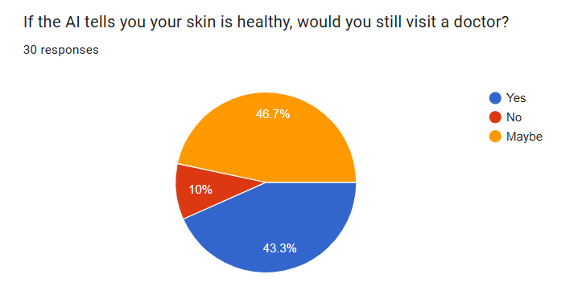
Survey Response relating to trust
Notably, 62% of respondents indicated that they would be more likely to use the app if it provided confidence scores (e.g., “85% probability of benign mole”). A further 48% requested visual aids, such as highlighting the regions of the image that influenced the prediction. These findings echo growing literature on the importance of explainable AI in medicine (Holzinger et al., 2017).

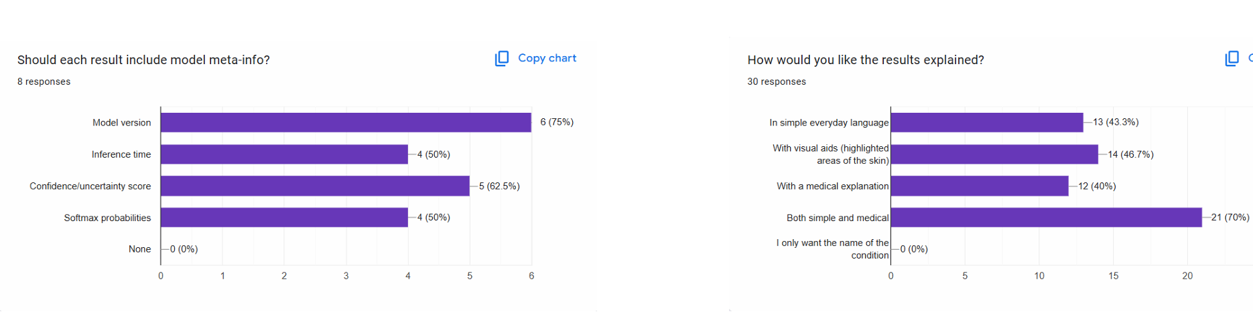
Survey response charts showing demand for confidence score and visual aid in outputs

Trust was also shaped by socio-cultural factors. Respondents from rural and peri-urban areas were more skeptical of “invisible” digital tools and placed higher value on community healthcare workers or traditional practices. This highlights the necessity of designing the system not as a replacement for clinicians, but as a support tool for early awareness and timely referrals.

4.2.2.4 Privacy and Data Security Concerns
Privacy concerns were prominent, with 93% of respondents expressing at least some degree of apprehension about uploading personal health images. The most common fears related to data misuse, unauthorized sharing, and inadequate anonymization. Younger respondents tended to be more comfortable with data sharing, provided that transparent consent mechanisms were in place, while older respondents emphasized the importance of strict confidentiality policies.
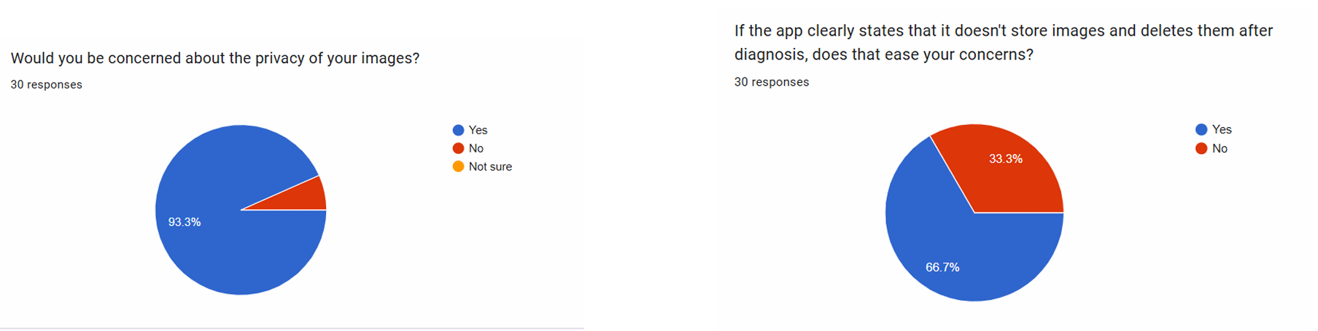
Survey response charts showing concerns on privacy

When asked which privacy features they would consider most reassuring, the following ranked highest:
- On-device processing – ensuring images are not uploaded to external servers unnecessarily.
- Data anonymization – removing all personally identifiable information before processing.
- Clear terms of use – simple, non-technical explanations of what happens to user data.
Interestingly, over 66% indicated they would feel more at ease if the app was to clearly state that it doesn’t save user images after analysis and predictions. This indicates that privacy is not just an ethical or regulatory requirement, but also a potential driver of user adoption.

4.2.2.5 Summary of Insights
The descriptive statistics of general users reveal a population that is both interested in and cautious about AI in healthcare. Demographically diverse, the respondents highlight clear generational and geographic divides in trust, privacy expectations, and feature preferences. While younger, urban users are more receptive to experimentation with AI-driven diagnostics, older and rural users emphasize caution, privacy, and practicality.
These insights carry profound implications for system design:
- The interface must be simple enough for users with limited digital literacy.
- Privacy and offline processing must be central to design, not afterthoughts.
- Explainability features (confidence scores, saliency maps) are essential for building trust.
- Educational content must be embedded to ensure predictions are not misinterpreted.
Taken together, these findings provide the foundational logic for designing a mobile health application that is technically sophisticated yet socially attuned. The next section will shift focus to the technical/professional survey, where the expectations of clinicians and researchers are analyzed in greater detail.

4.2.3 Descriptive Statistics: Technical/Professional Users
The second segment of the survey targeted technical and professional users, including software developers, engineers, computer scientists, and healthcare practitioners with some technical exposure (e.g., laboratory technicians, nurses). This group was of particular interest because they represent the individuals most likely to engage directly with the proposed system’s backend interfaces, such as the command-line tool (CLI) or model API. Unlike general users, these respondents were expected to provide more nuanced insights regarding technical requirements, model transparency, integration, and workflow compatibility.

4.2.3.1 Respondent Demographics and Roles
The professional respondent pool included a diverse set of roles: mobile application developer, laboratory technician, nursing professional, computer/software engineers, students in computing-related disciplines, and computer scientists. This distribution suggests that while the majority of respondents were technically oriented, there was also representation from the healthcare domain, ensuring that perspectives on both medical and technical utility were considered.
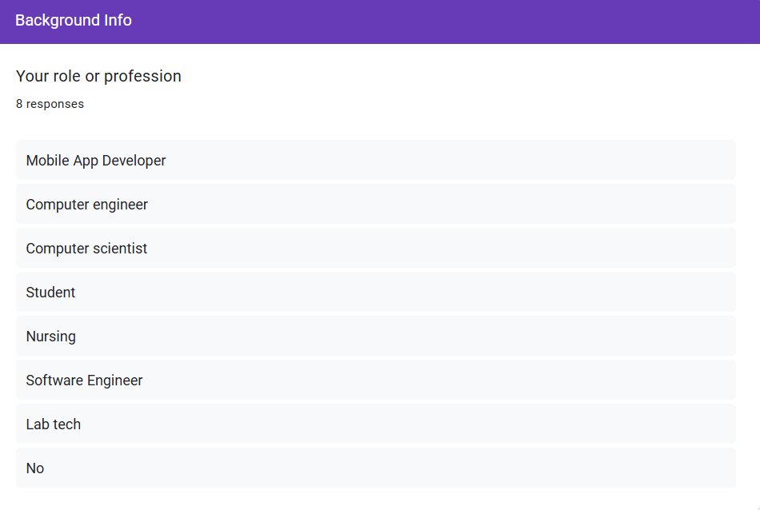
TDistribution of Respondent Professions

4.2.3.2 Experience with Medical Imaging
When asked about prior experience with medical imaging or skin lesion datasets, only a small minority (two respondents) indicated direct involvement. The vast majority had not previously worked with medical imaging tasks, underscoring the fact that while these professionals had strong technical foundations, they were not necessarily domain specialists. This aligns with similar studies where developers were found to be technically proficient but often lacked medical training, highlighting the need for tools that can bridge this gap (Holzinger et al., 2017).
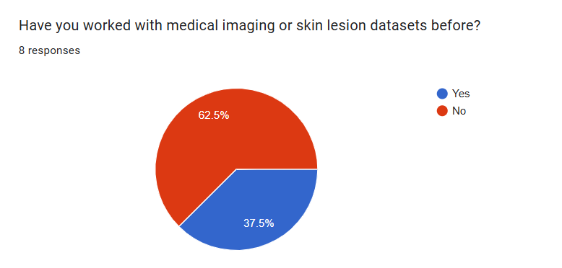
Prior Experience with Medical Imaging

4.2.3.3 Tools and Frameworks Used
Respondents reported a wide array of tools and frameworks used in their work. The most common were Python and its machine learning libraries (TensorFlow, PyTorch, Keras), often paired with Jupyter Notebook or Google Colab. Some respondents mentioned MATLAB for research-oriented tasks, while others in healthcare roles (e.g., lab technician) leaned towards simpler tools like Excel or Power BI for reporting and data handling.
This diversity highlights the importance of designing the system with Python-first compatibility, while ensuring outputs are also easily exportable to more general tools for broader accessibility.
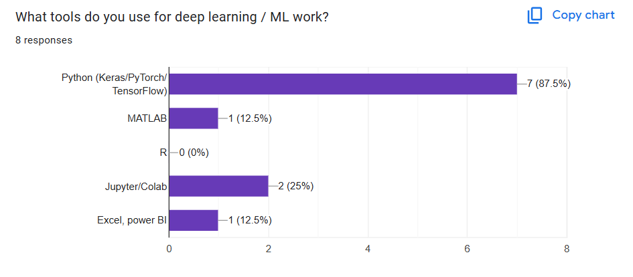
Tools and Frameworks Used by Respondents

4.2.3.4 Usefulness of a CLI Tool
When asked about the usefulness of a CLI-based system for lesion detection, the overwhelming majority responded positively. They viewed the CLI as an essential feature for batch analysis, automation, and research reproducibility. Only one respondent, a laboratory technician, expressed reservations, preferring simplified reporting interfaces instead. This validates the dual-interface approach of the project: providing both a CLI for professionals and a user-friendly app for general users.
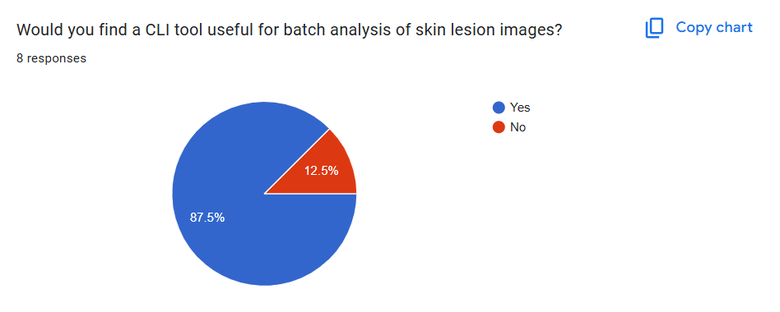
Perceived Usefulness of CLI

4.2.3.5 Preferred Input and Output Formats
Preferences for data input varied but leaned strongly toward directories of images for batch analysis. Some respondents also suggested zipped archives or inclusion of metadata files (CSV/JSON) for organizing annotations.
For output formats, preferences were distributed as follows:
- Machine-readable formats: JSON and CSV were highly favored, allowing seamless integration into existing workflows.
- Visual overlays: Several respondents emphasized the importance of heatmaps (e.g., Grad-CAM) to highlight lesion regions, serving both validation and explainability purposes.
- Reports: Another notable portion highlighted PDF reports, particularly relevant to healthcare professionals who required clinical-style documentation.
This multi-format preference indicates the need for flexible export functionality, ensuring the system serves both technical and semi-technical users.
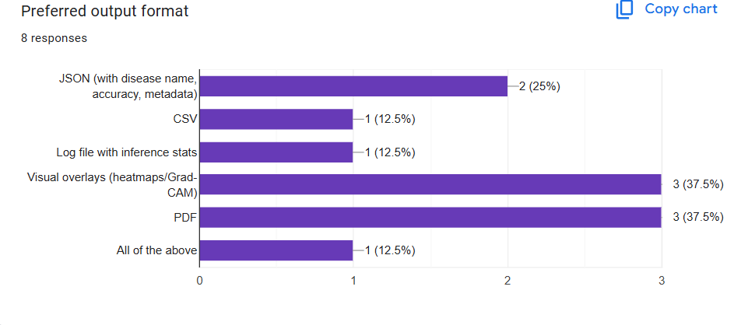
Preferred Output Formats

4.2.3.6 Batch and Asynchronous Support
The majority of technical respondents emphasized the importance of batch or asynchronous support. They highlighted that scalability and efficiency are critical in handling large image sets, especially in research or clinical trial contexts. This aligns with modern AI system design principles, which prioritize parallel processing and non-blocking workflows (LeCun et al., 2015).

4.2.3.7 Model Metadata and Transparency
Respondents were also asked about the types of metadata they considered important when generating outputs. The most commonly cited elements included:
- Model version (to ensure reproducibility)
- Inference time (to assess efficiency)
- Confidence or uncertainty scores
- Class probabilities (softmax outputs)
These preferences suggest that technical users prioritize traceability and reliability, with an expectation that each prediction is accompanied by sufficient metadata to allow critical evaluation.
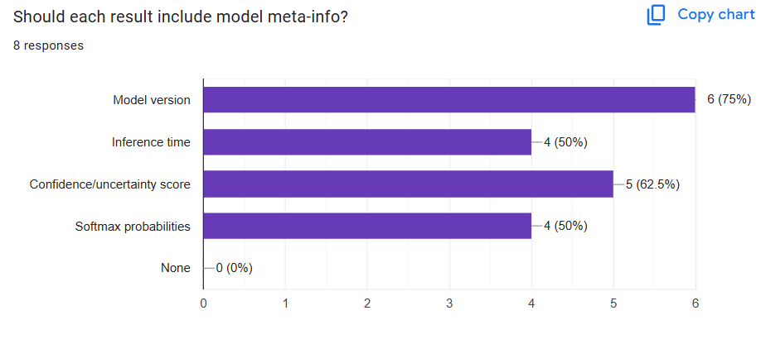
Desired Model Metadata in Outputs

4.2.3.8 Re-training and Explainability
A significant majority expressed interest in the ability to re-train or fine-tune the model on their own datasets, citing reasons such as adaptation to specific populations or research domains. In addition, nearly all respondents highlighted the importance of explainability tools, particularly visual methods like Grad-CAM or algorithm-agnostic approaches like LIME, to justify and contextualize model predictions. This reflects the increasing consensus in the literature that explainability is essential in medical AI adoption (Doshi-Velez & Kim, 2017; Holzinger et al., 2017).

4.2.3.9 Integration Suggestions
Finally, respondents provided several free-text suggestions for improving integration and usability:
- Support for batch and asynchronous execution.
- Integration of feedback loops to continuously improve the model over time.
- Development of dashboards or lightweight web interfaces layered on top of the CLI for hybrid users.
Collectively, these recommendations underscore the dual necessity of technical depth and user accessibility, which is consistent with best practices in designing medical AI systems (Ventola, 2014).

4.2.3.10 Summary
In summary, the technical and professional survey respondents demonstrated a strong demand for flexibility, scalability, transparency, and explainability. While most lacked direct medical imaging experience, their technical expertise positioned them as key stakeholders in shaping the system’s backend design and advanced features. Their responses highlight the need for a system that is simultaneously Python-integrated, CLI-compatible, metadata-rich, and explainable, with sufficient support for both machine-readable and human-readable outputs.

4.2.4 Cross-Survey Comparative Insights
This section synthesizes findings from both the general user survey and the technical/professional user survey. It highlights areas where perspectives converge, where they diverge, and the implications these patterns hold for system requirements.

4.2.4.1 Points of Convergence (Shared Concerns and Priorities)
Across both general users (non-technical) and technical/professional users, several common themes emerged:
- Desire for Accurate and Trustworthy Predictions:
Both groups emphasized that diagnostic reliability was paramount. Users, technical or not, wanted confidence scores or probabilities to be reported.
- Importance of Explainability:
While technical respondents explicitly mentioned interpretability methods such as Grad-CAM and LIME, general users also stressed the need for clear explanations in plain language. This highlights a shared demand for transparency, albeit at different levels of technical detail.
- User-Centric Outputs:
Both groups valued outputs that could be used beyond the app itself.
  - General users preferred simple, readable summaries they could share with doctors.
  - Technical users preferred structured outputs (e.g., JSON, CSV, visual overlays) that could feed into research workflows.
Ultimately, both groups wanted portability and shareability of results.
- Scalability Expectations:
General users asked for responsiveness under high load (e.g., fast results even with weak connectivity).
Technical users demanded batch processing and asynchronous execution.
Together, this suggests that system performance under varying usage scenarios is a universal requirement.

4.2.4.2 Divergences Between User Groups
Despite these convergences, important divergences were observed:
- Interface Expectations:
  - General users overwhelmingly preferred a mobile application with a graphical interface, prioritizing ease of use and minimal technical barriers.
  - Technical users favored a command-line interface (CLI) that supported automation, scripting, and integration into research pipelines.
- Depth of Metadata and Reporting:
  - General users were primarily interested in basic predictions and clinic recommendations.
  - Technical users demanded detailed metadata: model version, inference latency, softmax scores, dataset provenance, and uncertainty measures.
- Re-training and Customization:
  - General users had little to no concern with re-training models.
  - Technical respondents strongly favored the ability to fine-tune models with their own datasets.
- Explainability Format:
  - General users wanted plain-text, user-friendly explanations supplemented with visuals if needed.
  - Technical users sought deep interpretability techniques like heatmaps, decision trees, and statistical confidence intervals.
- Data Input Modes:
  - General users imagined simply uploading an image.
  - Technical users wanted flexibility: batch image folders, CSV metadata, JSON, and zip file uploads.

4.2.4.3 Implications for System Requirements
From these convergences and divergences, several key implications for system design emerge:
- Dual-Interface Strategy:
  - A mobile app should cater to general users, prioritizing simplicity, readability, and clinic-focused usability.
  - A CLI should be built for technical users, prioritizing flexibility, batch processing, detailed outputs, and integration into research workflows.
- Tiered Explainability: The system must deliver different layers of explanation:
  - Plain-language summaries for laypersons.
  - Heatmaps, metadata, and statistical insights for professionals.
- Multi-Format Output Support:
Both machine-readable (JSON, CSV) and human-readable (PDF, summary reports) outputs must be supported. This dual approach ensures usability across the spectrum of end-users.
- Performance and Scalability
Responsiveness must be optimized not just for individual mobile users, but also for batch research workloads. This likely necessitates cloud-based infrastructure with both synchronous (real-time) and asynchronous (background job) processing modes.
- Customizability for Professionals
To serve the research community, the CLI must allow optional re-training or fine-tuning, as well as dataset re-use. This is unnecessary for general users but critical for adoption among professionals.

4.3 System Overview
This section presents a high-level overview of the proposed Skin Lesion Detection and Classification System. It begins by clarifying the system’s objectives, followed by identifying the intended users and stakeholders. The section then outlines the boundaries and scope of the system and finally highlights the key functionalities at a high level.

4.3.1 Objectives of the Proposed System
The overarching goal of the proposed system is to provide an effective, accessible, and scientifically robust tool for the detection and classification of skin lesions. In particular, the objectives include:
- Facilitating Early Detection of Skin Conditions
By enabling individuals to take or upload images of skin lesions and receive automated classification, the system promotes early identification of potentially malignant conditions, which is crucial for timely medical intervention.
- Providing Decision Support to Health Professionals
The system is designed not to replace dermatologists but to augment their diagnostic process by providing rapid and accurate pre-screening. This decision-support function is particularly beneficial in resource-limited settings.
- Improving Accessibility of Dermatological Insights
Through a mobile interface, the system brings dermatological assessment closer to populations with limited access to healthcare facilities. It democratizes diagnostic insights beyond specialized clinics.
- Supporting Research and Development
By offering a CLI that supports batch processing, detailed output, and dataset integration, the system also serves the academic and clinical research community. This ensures that the system is not only a public-facing tool but also a research-grade infrastructure.
- Balancing Accuracy with Explainability
The system will incorporate interpretable machine learning methods to explain classifications in both layman-friendly and professional detail. This addresses the dual concerns of trust and transparency.

4.3.2 Target Users and Stakeholders
The system is targeted at two distinct yet complementary user groups, alongside several key stakeholders:
- General Users (Patients and Care Seekers):
  - Non-technical individuals who will primarily access the system through a mobile app.
  - Require a simple workflow: upload an image, receive a classification, and obtain understandable recommendations.
  - Value ease of use, speed, and actionable next steps (e.g., advice to visit a dermatologist).
- Health Professionals and Researchers:
  - Dermatologists, clinicians, and biomedical researchers who will primarily interact via a command-line interface (CLI).
  - Require detailed outputs such as confidence scores, batch processing, integration with existing datasets, and reproducibility.
  - May use the system as a teaching tool, research aid, or diagnostic support mechanism.
- Key Stakeholders:
  - Healthcare Institutions: Benefit from reduced workload in screening and triaging.
  - Policy Makers and NGOs: Gain from public health insights, particularly in regions where skin cancer screening is rare.
  - Technical Developers and Maintainers: Ensure continuous improvement, reliability, and deployment.
  - Academic Community: Uses system outputs for dermatology and machine learning research.

4.3.3 System Boundaries and Scope
The boundaries and scope of the system are clearly defined to avoid overextension and maintain focus:
- In-Scope Features:
  - Classification of skin lesion images into predefined categories (e.g., benign vs malignant, or further into multiple classes depending on dataset).
  - Confidence reporting and explanation generation.
  - Two interfaces: mobile application for general users, CLI for technical users.
  - Secure communication with a backend inference API.
  - Limited offline functionality (basic inference on-device possible, with cloud fallback for heavy processing).
  - Support for continuous updates and improvements via retraining mechanisms (primarily CLI-driven).
- Out-of-Scope Features:
  - Direct integration with electronic health records (EHR) systems at this stage.
  - Automated treatment recommendations beyond advising a medical consultation.
  - Full offline deployment for all users, as this may be infeasible on low-end devices.
  - Non-dermatological conditions (focus is strictly skin lesions).

4.3.4 High-Level Functionalities
At a high level, the proposed system will provide the following functionalities:
- Image Input and Preprocessing:
  - Mobile: Single image capture or upload.
  - CLI: Single image, folder batch, or dataset file.
- Automated Lesion Classification:
  - Inference performed by a trained CNN model (ResNet-based).
  - Output includes predicted class, confidence score, and alternative predictions.
- Explainability and Interpretability:
  - Mobile: Simplified plain-language explanation plus optional heatmap.
  - CLI: Detailed interpretability (e.g., Grad-CAM, numerical feature attribution).
- Result Delivery:
  - Mobile: Readable on-screen summary with option to save or share report (e.g., PDF).
  - CLI: Structured output formats (CSV, JSON, PDF).
- Continuous Improvement Loop:
  - Mechanisms for incorporating user feedback.
  - Optional retraining capabilities for researchers using CLI.
  - Backend logging of usage patterns (with privacy safeguards) for model refinement.
- Security and Privacy Safeguards:
  - Anonymization of images and metadata.
  - Secure transmission and storage with encryption.
  - Compliance with ethical standards regarding sensitive health data.
In summary, this system is envisioned as a dual-purpose platform: a patient-facing mobile app for accessibility and early detection, and a research-grade CLI for scientific rigor and extensibility.

4.4 Functional Requirements Analysis
The functional requirements of the system capture the essential features and capabilities that the application must provide to its diverse set of users and stakeholders. These requirements are organized into three categories: user-oriented, system-oriented, and non-functional requirements. This categorization ensures that both human-centered needs and technical imperatives are addressed systematically.

4.4.1 User-Oriented Requirements
User-oriented requirements describe how the system should interact with its primary audiences, that is general users and health professionals/researchers. These requirements ensure that the system delivers tailored functionality that aligns with the expectations and technical proficiency of each group.

4.4.1.1 General Users (Mobile Application)
- Image Capture and Upload
  - The system must allow users to capture lesion images via the device camera or upload existing images from the gallery.
  - Support for basic cropping and quality-checking prior to submission.
- Instant Classification and Feedback
  - After submission, the user should receive the predicted lesion type with a confidence score.
  - Explanations must be provided in simple, non-technical language.
- Health Guidance
  - Beyond classification, users should receive actionable suggestions such as:
    - “Consult a dermatologist immediately” (for suspicious lesions).
    - “Monitor regularly” (for benign lesions).
  - The system must not provide treatment instructions beyond suggesting professional consultation.
- Report Generation and History
  - Users should be able to save results in a report format (e.g., PDF) or maintain a personal history log within the application.
  - Results history should be accessible in an easy-to-navigate interface.
- Notifications and Reminders
  - Optional notifications should remind users to recheck lesions at specified intervals.
  - Users must have full control to enable or disable reminders.
- Privacy and Security Assurance
  - The system must anonymize uploaded images and avoid linking them with personally identifiable information.

4.4.1.2 Health Professionals and Researchers (CLI)
- Batch Processing Capabilities
  - The CLI must support processing of multiple images or datasets in one run.
  - Input should accept file paths, directories, or structured dataset references.
- Detailed Classification Outputs
  - Results should include prediction probabilities for all possible classes, not only the top class.
  - Outputs should include visual overlays such as Grad-CAM heatmaps when requested.
- Flexible Output Formats
  - Results must be exportable in CSV, JSON, PDF, or image overlay formats.
  - Researchers should be able to configure output granularity.
- Integration with External Workflows
  - CLI outputs must be scriptable and pipeline-friendly for integration with other tools (e.g., data analysis software).
- Reproducibility Support
  - The system should log model versions, configuration parameters, and dataset references to ensure reproducibility of results.
- Extended Explainability Features
  - Provide multiple explanation modalities (numerical feature importance, saliency maps, etc.) suitable for academic publications or clinical reviews.

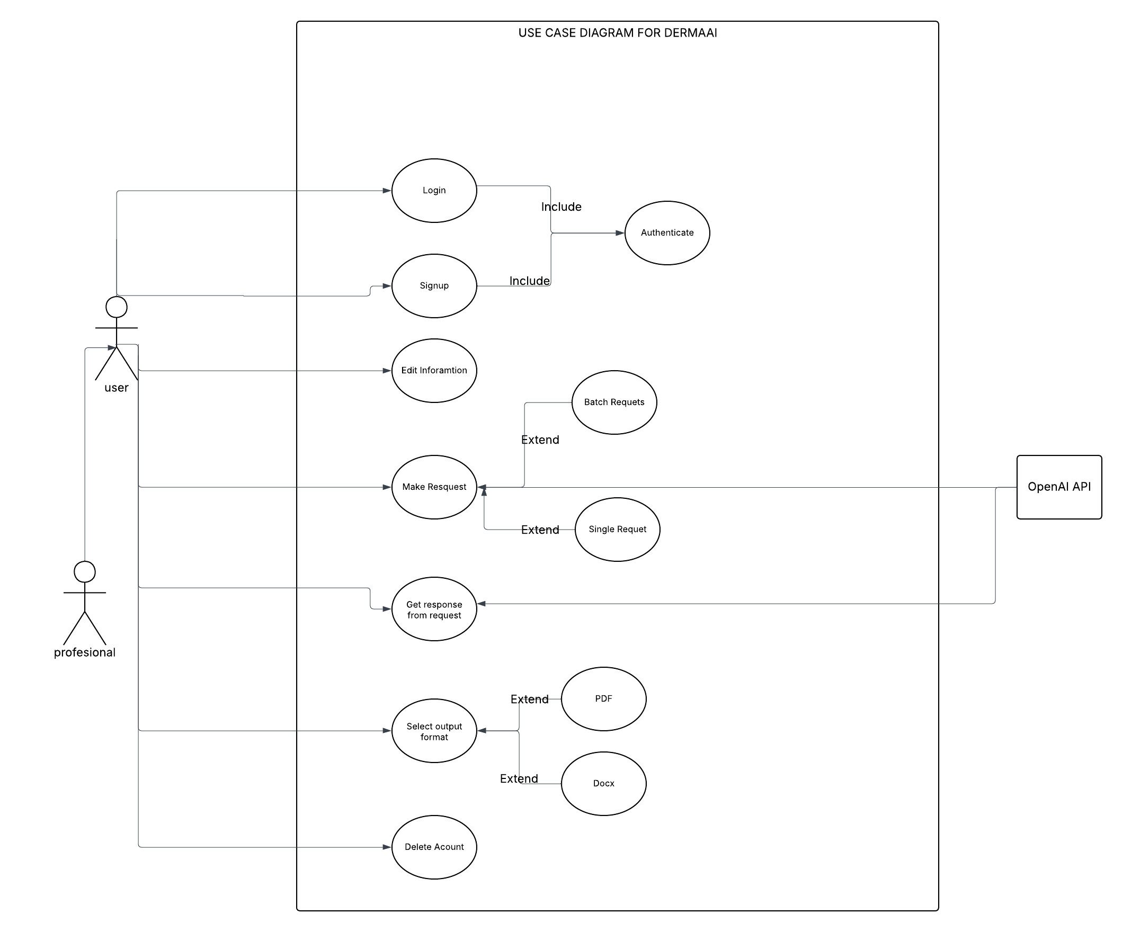
Usecase Diagram for DermaAI

4.4.2 System-Oriented Requirements
These requirements define how the system must behave at a technical level to fulfill user needs effectively.

4.4.2.1 Model Training and Inference
- The system must rely on a CNN (e.g., ResNet-18) trained on a large, labeled dataset of skin lesion images.
- Training must support transfer learning and fine-tuning to improve accuracy.
- The inference pipeline must be lightweight enough for deployment in mobile and cloud environments.
- Support for retraining or fine-tuning must be included for CLI researchers.

4.4.2.2 API Communication
- The mobile application must communicate with the inference server through secure APIs.
- The API must accept inputs (image + optional metadata), run inference, and return structured results.
- The API must support JSON-based request/response formatting.
- Latency should be optimized to provide near real-time results for mobile users.

4.4.2.3 Data Handling and Security
- All uploaded data must be encrypted in transit (TLS) and at rest.
- Sensitive information must be anonymized to ensure compliance with ethical and legal standards (e.g., GDPR-like principles).
- The system must implement secure access controls to prevent unauthorized use of the API or model.

4.4.3 Non-Functional Requirements
Non-functional requirements define the quality attributes of the system, ensuring robustness, trustworthiness, and long-term sustainability.

4.4.3.1 Performance and Accuracy
- The system must achieve a minimum accuracy benchmark comparable to dermatologists (e.g., ≥85% for malignant vs. benign classification as in (Haenssle et al., 2018)).
- Mobile inference should return results within 5–10 seconds under average connectivity conditions.
- CLI batch processing should handle at least 1,000 images without significant performance degradation.

4.4.3.2 Privacy and Security
- All images must be processed anonymously, with no linkage to personal identifiers.
- Strong encryption must be enforced for both transmission and storage.
- The mobile app must allow users to delete stored history at any time.

4.4.3.3 Usability and Accessibility
- The mobile interface must be intuitive, requiring minimal user training.
- Instructions, labels, and explanations must be provided in clear, non-technical language.
- Accessibility features such as support for larger fonts, screen readers

4.4.3.4 Scalability and Maintainability
- The backend infrastructure must support horizontal scaling through containerization and load balancing.
- Modular design must ensure easy updates to models, APIs, and interfaces.
- Documentation and versioning must be maintained for both mobile and CLI components.
In summary, the functional requirements establish the foundation of the proposed system, ensuring that it satisfies the practical needs of its two core user groups while adhering to strict technical, ethical, and quality standards.

4.5 System Architecture
The proposed skin lesion detection and classification system adopts a serverless, modular architecture designed for scalability, cost-efficiency, and seamless integration of advanced AI models. The system is primarily built upon cloud-native components (Amazon Web Services) to ensure elasticity and fault tolerance, while remaining lightweight enough to accommodate future hybrid deployments. Figure 21 (below) illustrates the overall serverless architecture of DermaAI, integrating both model inference and large language model (LLM)-based explanation generation.
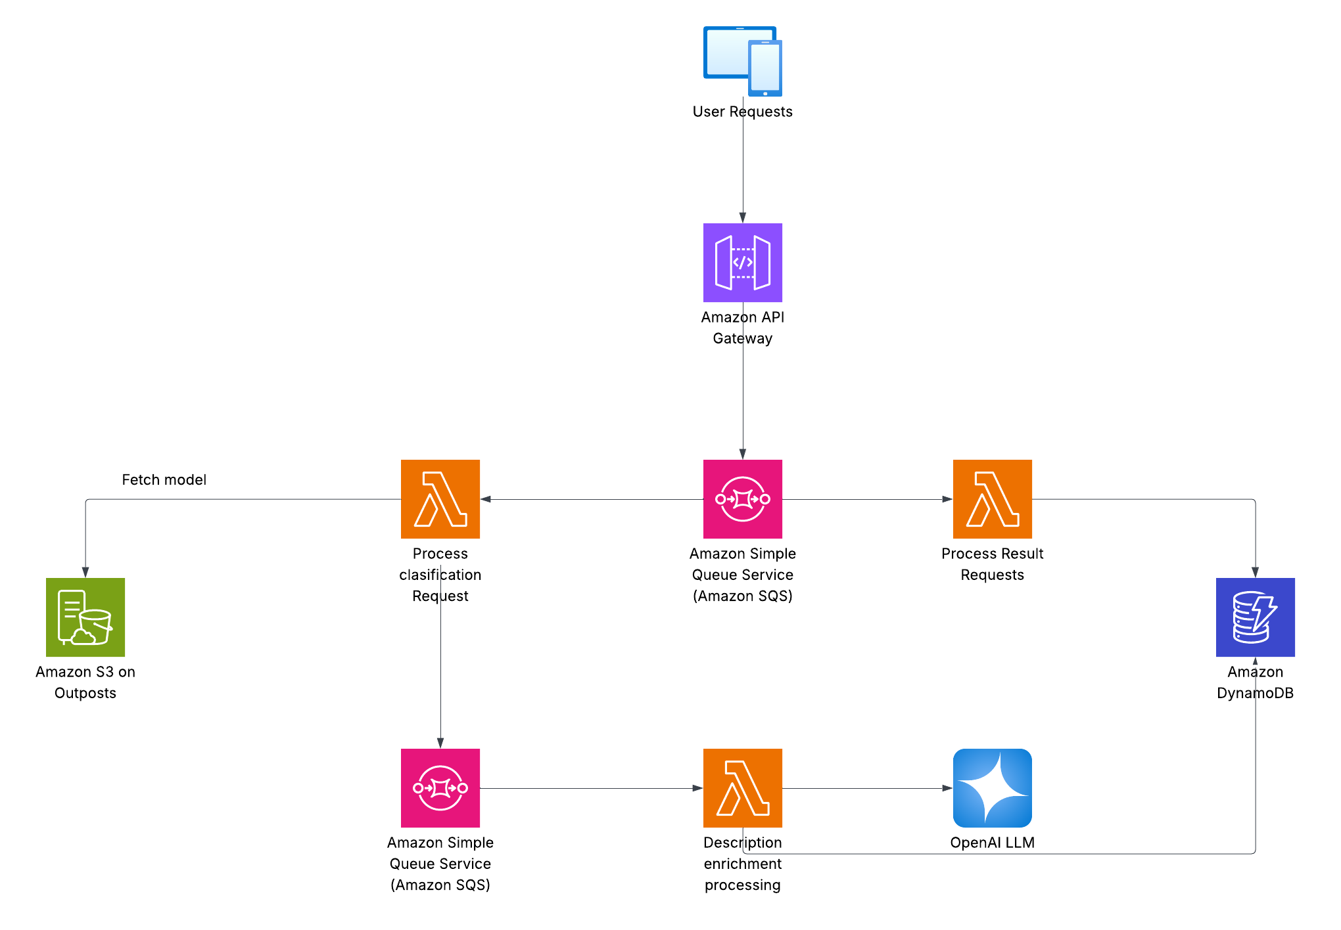
Serverless Architecture for DermaAI
At a high level, the system architecture can be broken down into the following core components:
- User Interaction Layer (Clients)
Users, whether through a mobile application or a command-line interface (CLI), initiate requests by uploading an image of a skin lesion along with optional metadata. This forms the primary entry point into the system.
- API Gateway
All requests are routed through Amazon API Gateway, which standardizes inputs, enforces request validation, and provides an interface for secure communication between clients and backend services. It also supports monitoring and throttling, ensuring the system can scale gracefully under heavy load.
- Queue Management (Amazon SQS)
Requests are decoupled and passed into Amazon Simple Queue Service (SQS) for asynchronous processing. This design ensures that bursts of user activity do not overwhelm the backend, while also supporting fault tolerance and retries.
- Model Inference Layer
A dedicated AWS Lambda function fetches the pretrained CNN model (stored in Amazon S3) and processes the classification request. This serverless function performs image preprocessing, model inference, and preliminary result formatting.
- Result Enrichment Layer (LLM Integration)
To provide contextually rich, human-friendly explanations, another Lambda function triggers communication with the OpenAI LLM. This step enhances the raw model predictions with medically accurate, user-friendly descriptions, usage guidelines, and disclaimers.
- Data Storage and Retrieval
The system employs Amazon DynamoDB for storing user requests, model outputs, enriched explanations, and metadata. This NoSQL storage ensures fast queries for both individual lookups (e.g., retrieving a patient’s history) and analytical queries for research purposes.
- Feedback Loop and Continuous Improvement
User interactions and outcomes are logged into DynamoDB, forming the basis for continuous model evaluation. This feedback mechanism enables future retraining of the CNN model and refinement of the LLM prompts.

4.5.1 Model Architecture
At the core of the system lies a Convolutional Neural Network (CNN), fine-tuned from a pretrained ResNet18 backbone. This architecture was chosen due to its proven efficiency in medical image classification tasks, balancing computational cost with diagnostic accuracy.
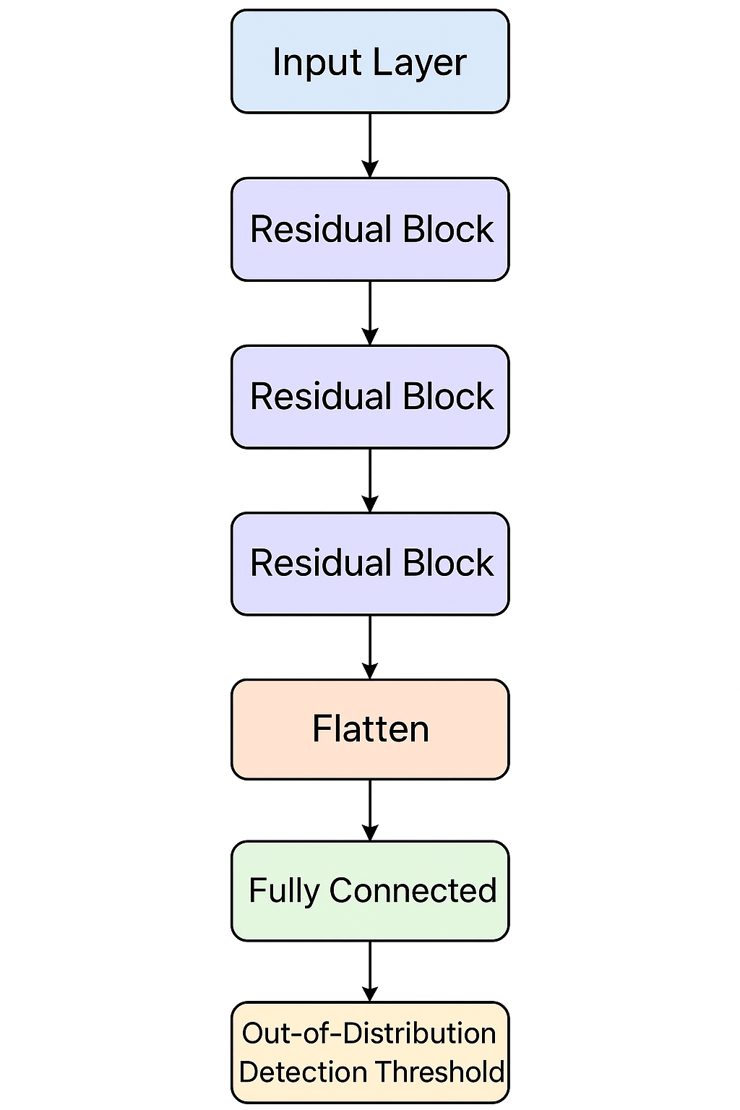
CNN model Architecture for DermaAI
- Input Layer: Accepts dermoscopic or non-dermoscopic images, resized and normalized to the required resolution.
- Feature Extraction (ResNet18 Backbone): Extracts hierarchical visual features such as edges, textures, and patterns, which are crucial for distinguishing between benign and malignant lesions.
- Fully Connected Layer: Maps extracted features into class probabilities representing different categories of skin lesions (e.g., melanoma, nevus, keratosis).
- Softmax Output: Produces a probabilistic distribution, enabling ranking of likely conditions.
- Out-of-Distribution Handling: Additional thresholds are set to identify and reject non-skin images or ambiguous inputs, reducing the risk of misdiagnosis.
The synergy between the system-level serverless architecture and the model-level CNN architecture ensures both robust backend scalability and high clinical relevance of predictions.

4.5.2 Model Training Procedure
To complement the architecture described above, this subsection outlines the step-by-step procedure adopted to train the DermaAI model. The process was carefully designed to ensure reproducibility, efficiency, and robustness while working within the computational limits of a CPU-based environment.

4.5.2.1 Training Environment
Model development and training were carried out on a CPU-only workstation using the PyTorch deep learning framework. Supporting Python libraries such as Torchvision, Scikit-learn, and Matplotlib were employed for data handling, metric calculation, and visualization. Although training on a CPU increased computation time compared to GPU acceleration, careful optimization of data loading and batch processing ensured steady progress.

4.5.2.2 Data Handling and Preparation
The dataset was accessed through PyTorch DataLoader utilities, with shuffling enabled to prevent order bias during training. A batch size of 32 was selected as a balance between memory efficiency and gradient stability. Images were preprocessed (resizing, normalization) and augmented (flips, rotations, color jittering) to enhance generalization across diverse lesion presentations.

4.5.2.3 Transfer Learning Setup
The ResNet-18 backbone was initialized with ImageNet weights to leverage pre-learned low-level features. Early layers responsible for generic edge and texture detection were kept frozen, while later layers and the final fully connected layer were fine-tuned. The classification head was modified to output probabilities for the 33 lesion classes in the dataset.

4.5.2.4 Loss Function and Class Balancing
Given the imbalance across classes, a weighted cross-entropy loss function was adopted. This approach ensured that underrepresented classes, such as rare malignant lesions, contributed proportionally during optimization and were not overshadowed by majority classes.

4.5.2.5 Optimization and Regularization
The Adam optimizer was used with an initial learning rate of 0.001 and weight decay of 1e-4 for regularization. A learning rate scheduler dynamically reduced the learning rate when validation accuracy plateaued. Early stopping was also employed: training was halted if no improvement was observed after several consecutive epochs, preventing overfitting and wasted computation.

4.5.2.6 Monitoring and Logging
Training and validation accuracy and loss values were logged at the end of each epoch. These metrics were visualized through Matplotlib to track convergence trends and identify potential issues such as overfitting or vanishing gradients.

4.5.2.7 Outcome
Through this structured training process, the model achieved consistent convergence on the validation set. Despite hardware constraints, the use of transfer learning, balanced loss, and careful regularization enabled DermaAI to reach reliable classification performance across both malignant and non-malignant lesions.
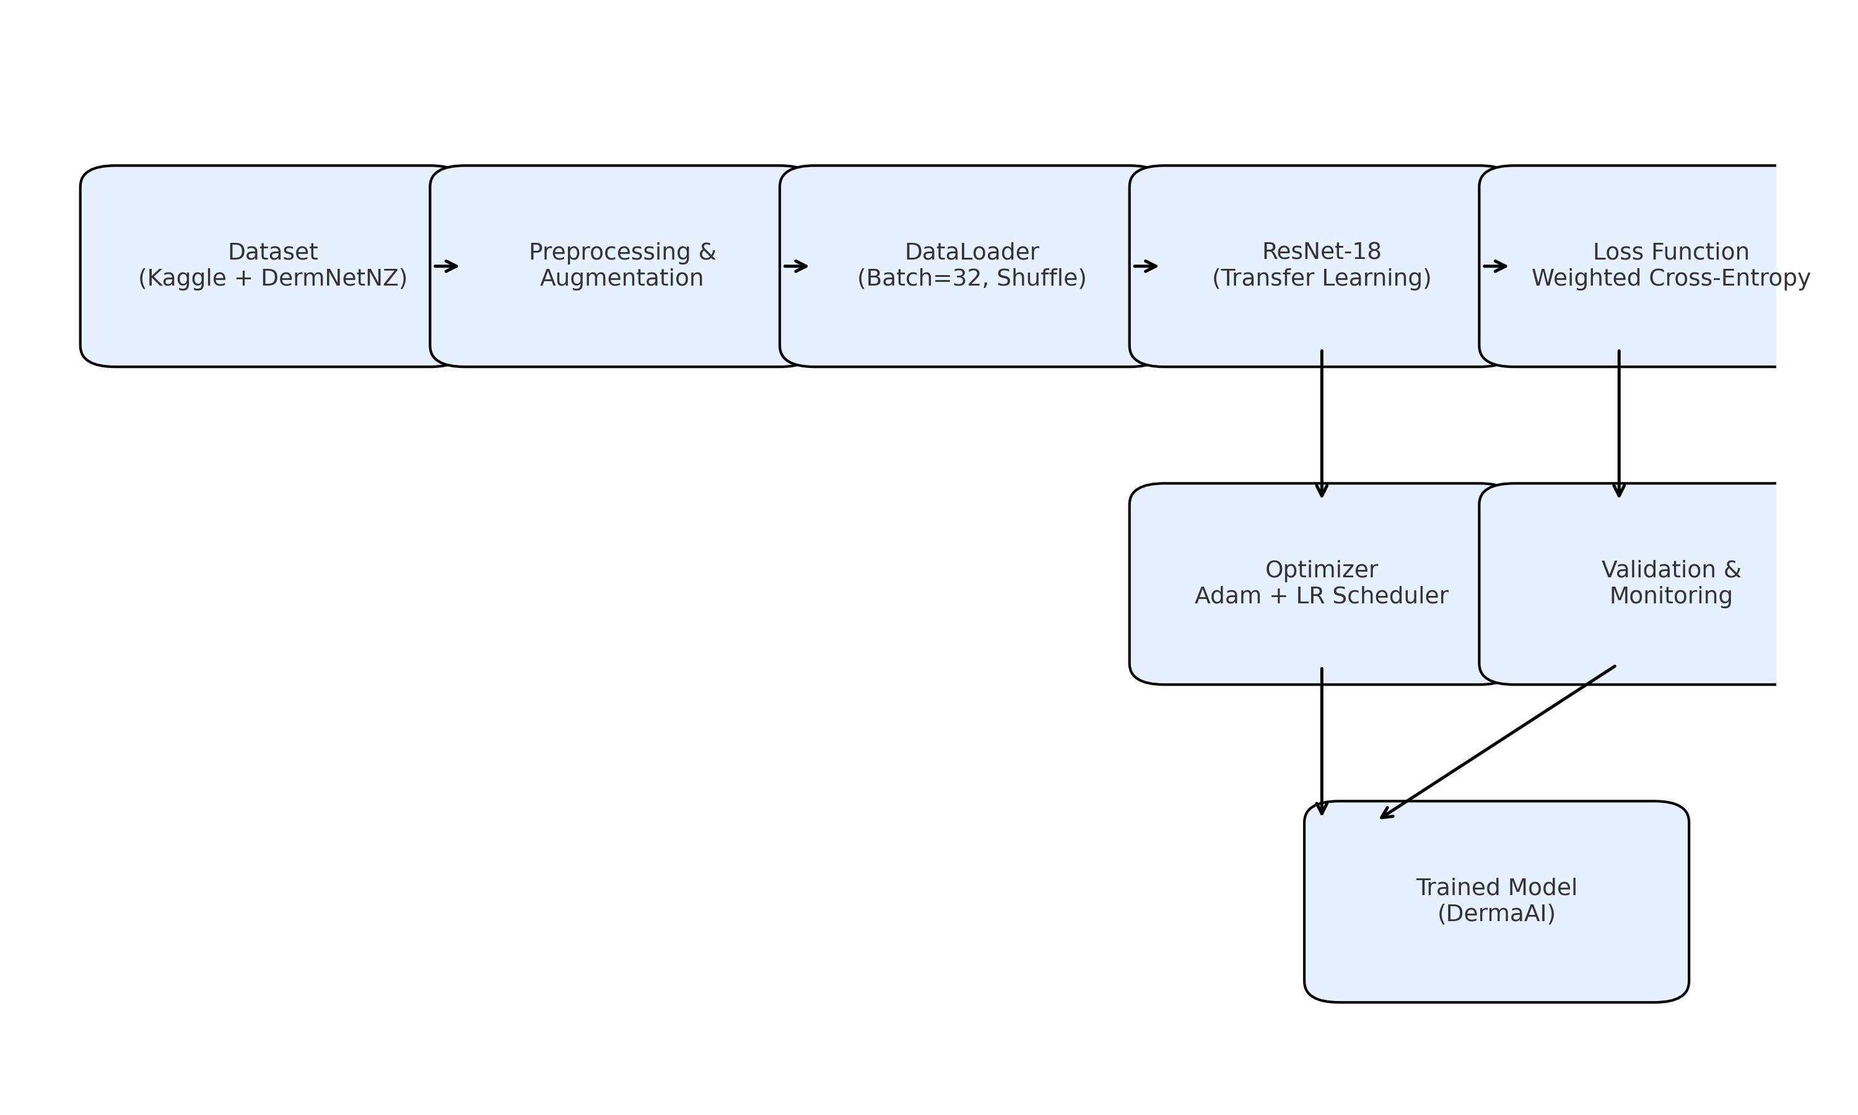
Overview of DermaAI Model Training Process
The diagram above provides a high-level overview of the training pipeline, illustrating the sequence from dataset preparation, data loading, and augmentation through model initialization, optimization, and evaluation.

4.6 User Interface Design
The user interface (UI) design of the lesion detection system is critical in ensuring usability, accessibility, and effective interaction for different categories of end-users. Given the dual-interface approach, that is mobile application for general users and command-line interface (CLI) for health professionals and researchers, the system emphasizes both simplicity and technical flexibility.

4.6.1 Mobile Application Interface
The mobile application serves as the primary interaction point for patients, general users, and non-technical healthcare providers. Its design focuses on clarity, ease of use, and accessibility.

4.6.1.1 Input (Image Upload, Metadata)
Users can upload images of skin lesions captured through smartphone cameras. To improve diagnostic accuracy, optional metadata such as age, gender, and lesion location can also be provided. The app guides users in capturing high-quality images through tips and validation prompts (e.g., checking for blur or poor lighting).

4.6.1.2 Output (Prediction + Explanation)
The app provides immediate feedback in the form of:
- Prediction Results: Displaying the likely classification of the skin lesion (e.g., melanoma, eczema, benign mole).
- Confidence Score: A percentage value reflecting model certainty.
- AI-Generated Explanation: Clear, user-friendly interpretation of the results, enhanced through integration with a Large Language Model (LLM) for contextual descriptions.

4.6.1.3 Additional Features (History, Notifications, Clinic Suggestions)
- History: Users can view previously uploaded images and corresponding predictions.
- Notifications: Timely alerts for follow-up checks, updates on results, or reminders to consult a specialist.
- Basic health information on lesions: Provides updated information on common lesions

4.6.2 Command-Line Interface (CLI)
The CLI is designed for researchers, medical professionals, and advanced users who require flexibility, scalability, and integration with external workflows.

4.6.2.1 Input Methods (Single, Batch)
- Single Input: Researchers can upload one image at a time for real-time classification.
- Batch Input: The system supports batch processing of datasets, enabling large-scale testing and research.

- 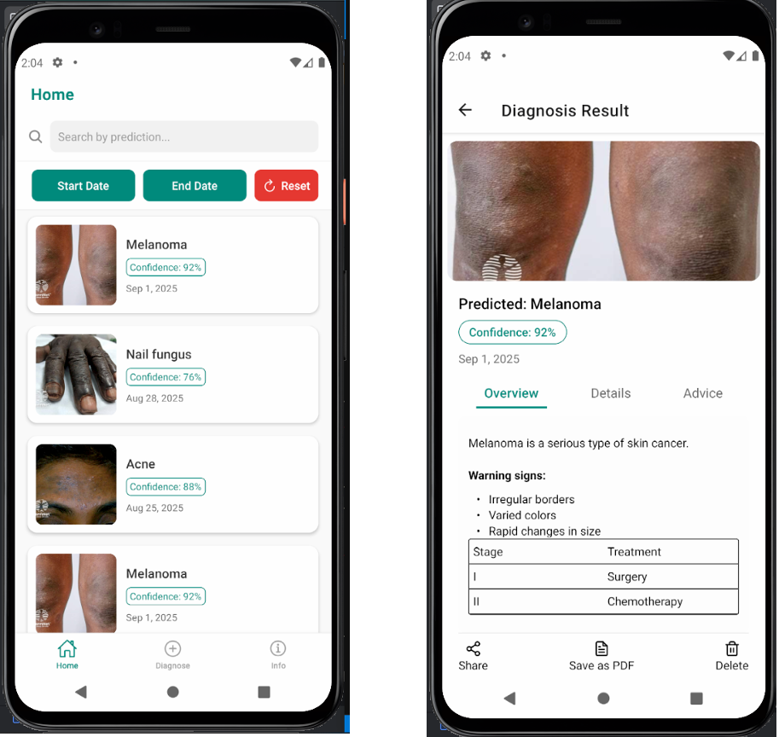

Mobile Home Screen & Mobile diagnosis result screen
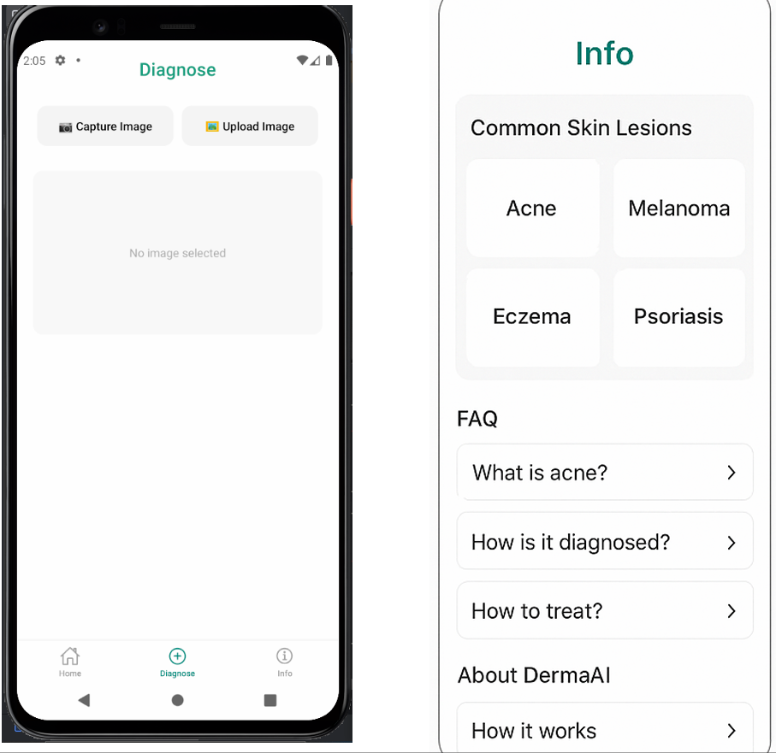
Mobile Predict/Diagnose Screen & Mobile info screen

4.6.2.2 Output Formats (CSV, JSON, PDF, Visual Overlays)
The CLI provides versatile output options, including:
- CSV/JSON: For structured data storage and integration with analytical pipelines.
- PDF Reports: Automatically generated, summarizing results with statistics and visual representations.
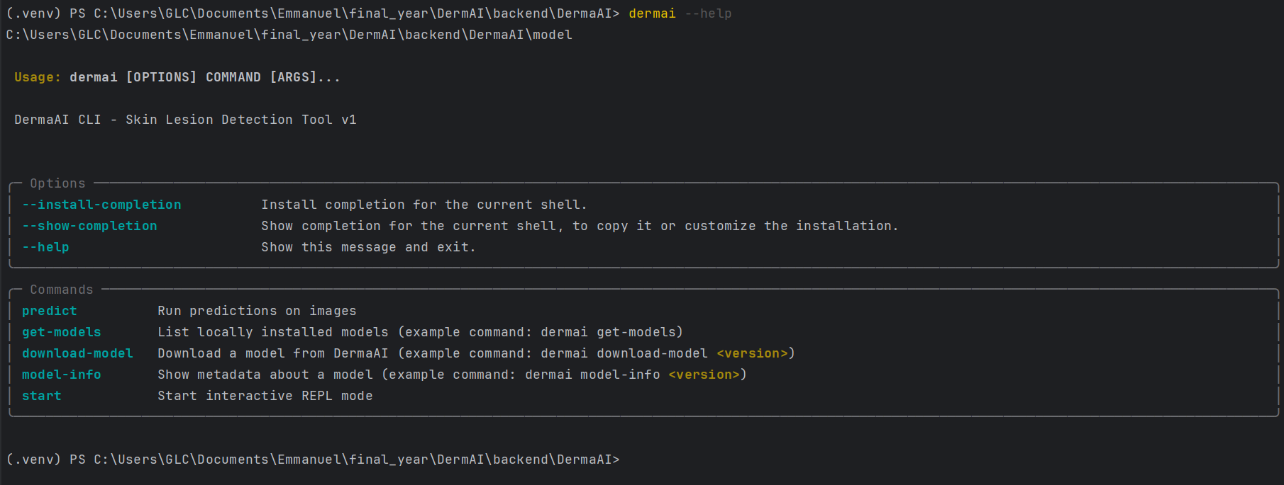
CLI Interface for DermaAI

4.7 Deployment Strategy
The deployment strategy for the lesion detection system balances accessibility, scalability, and user needs. By leveraging cloud-native services and serverless architecture, the system minimizes infrastructure management while maximizing reliability and cost-effectiveness.

4.7.1 Cloud Deployment (Primary Mode)
The system is primarily deployed on a cloud platform using a serverless architecture. This approach ensures scalability and efficient use of resources, as services such as AWS Lambda, Amazon S3, and DynamoDB dynamically adjust to varying workloads. The cloud handles the heavy computational tasks, including model inference and LLM-based description generation. This guarantees high availability, data security, and seamless integration of components without requiring users to manage complex configurations.

4.7.2 Command-Line Interface (CLI) Deployment
For researchers and advanced users, the CLI tool serves as a flexible deployment option. It connects directly to the cloud services for inference, allowing single-image or batch processing. CLI deployment supports structured outputs (CSV/JSON) and integrates easily with local research environments.
A limited offline mode is available within the CLI:
- Offline capabilities do not include full model inference (to avoid heavy storage and computation requirements).
- Instead, the offline mode provides basic lesion information (e.g., common types, risk factors, preventive measures), ensuring users have access to essential knowledge without requiring internet connectivity.
This offline functionality supports fieldwork and scenarios with unstable connectivity, particularly useful for outreach programs and rural healthcare settings.

4.7.3 Mobile Application Deployment
The mobile application is available for end-users through app distribution platforms (Google Play Store, Apple App Store). Its deployment strategy emphasizes accessibility and user-friendliness, with real-time communication to the cloud backend for inference.
The offline mode in the mobile app is intentionally lightweight:
- It does not include model inference, as shipping the CNN model locally would make the app too large and resource-heavy.
- Instead, it provides an offline reference guide, featuring descriptions of common skin lesions, self-care recommendations, and educational material.
- When online, the app automatically switches to full functionality, including image uploads, model inference, and enriched LLM explanations.
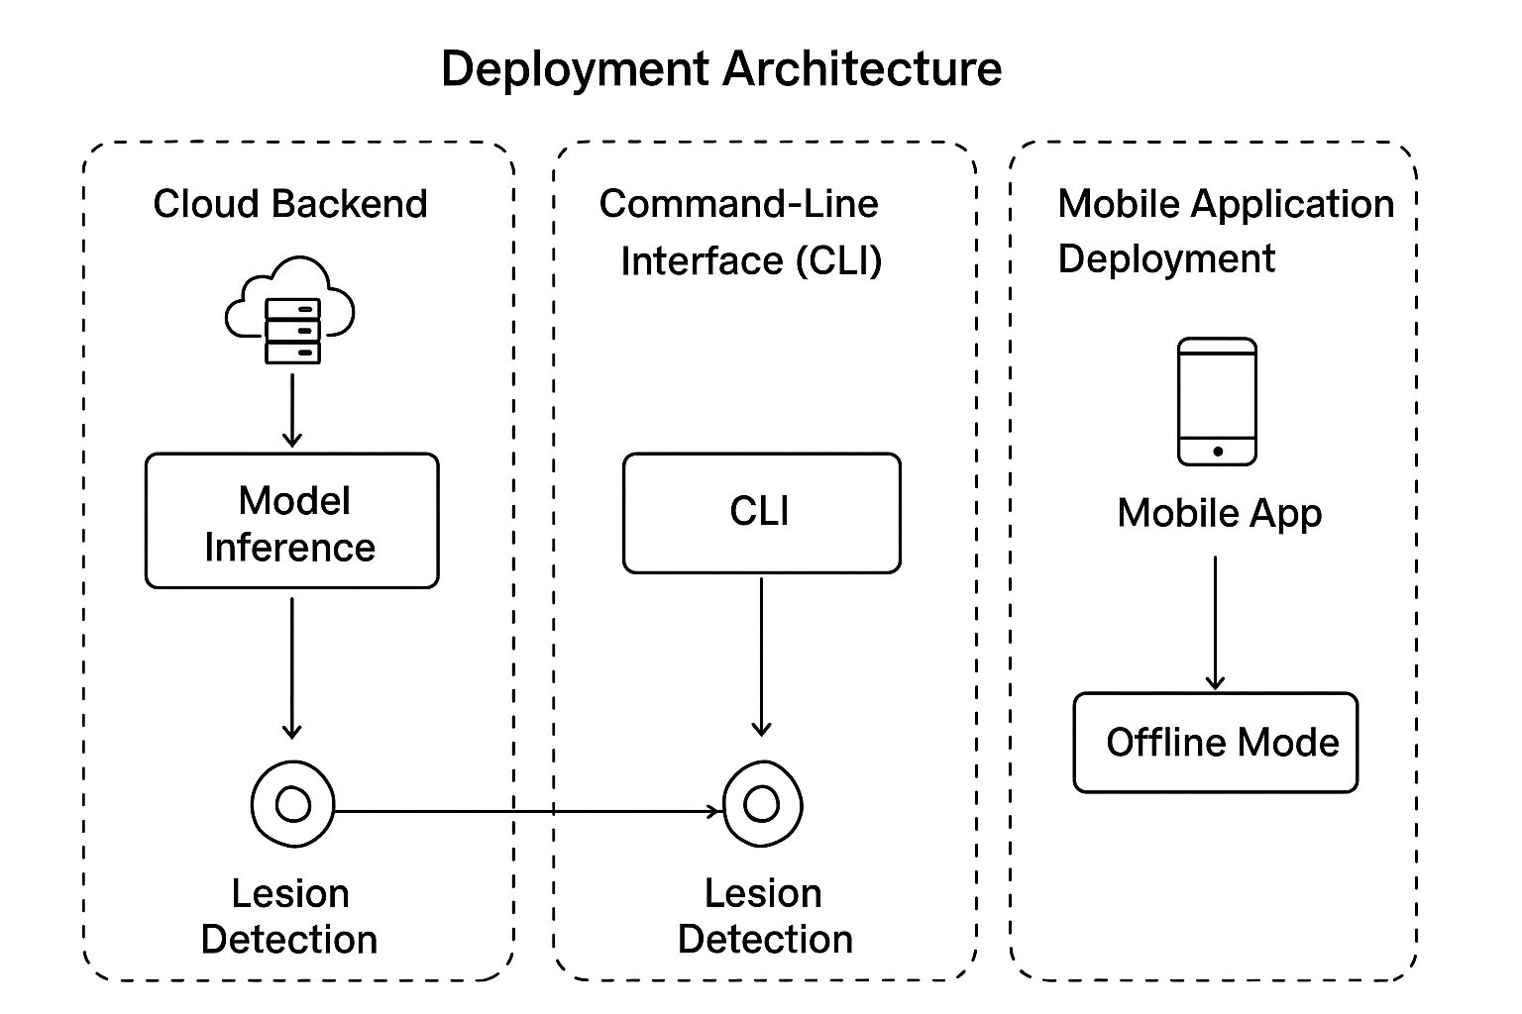

4.8 Testing, Results, and Discussion

4.8.1 Dataset Partitioning: Training, Validation, and Testing
The dataset was divided into three distinct subsets: training, validation, and testing. The training set enabled model optimization, the validation set monitored performance to mitigate overfitting, and the test set provided the final unbiased evaluation. To preserve class distribution specially given the diversity of conditions,stratified sampling was applied.

4.8.2 Accuracy and Loss Trends
Across 20 epochs, the model showed consistent learning. Training accuracy surpassed 90%, while validation accuracy stabilized around 75%. This divergence indicates effective representation learning but also signals mild overfitting.
Loss patterns mirrored this trend: training loss steadily declined, whereas validation loss plateaued by epochs 7–8. This suggests the model generalized well to many conditions, but faced challenges in imbalanced or visually overlapping categories.

4.8.3 Confusion Matrix Analysis
The confusion matrix provided condition-level insight. Diseases such as Healthy, Cowpox, Monkeypox, and Chickenpox were identified with high reliability. Conversely, Eczema, Psoriasis, Vitiligo, and Nevus exhibited higher misclassification rates due to overlapping dermatological patterns, underscoring the difficulty of distinguishing visually similar lesions.
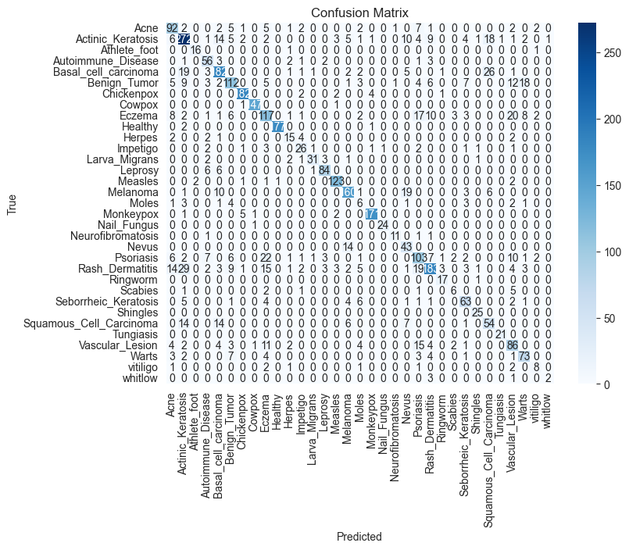
Confusion Matrix for DermaAI V3

4.8.4 Receiver Operating Characteristic (ROC) / Area Under the Curve Analysis
ROC curves further confirmed strong discriminative performance. Over 25 conditions achieved AUC ≥ 0.98, with Athlete’s Foot, Chickenpox, Cowpox, Healthy, Leprosy, Measles, Monkeypox, Nail Fungus, Neurofibromatosis, Ringworm, Shingles, Tungiasis, Vitiligo, and Whitlow each reaching AUC = 1.00.
Moderate AUC values were observed for Psoriasis (0.95), Rash Dermatitis (0.96), and Eczema (0.96), reflecting overlap among chronic inflammatory conditions. The lowest AUC occurred in Moles (0.89), which were frequently misclassified with Nevus or Melanoma. This aligns with confusion matrix findings, reinforcing the model’s difficulty in differentiating subtle pigmented lesions.
The macro-averaged AUC exceeded 0.97, confirming robust generalization across diverse conditions.
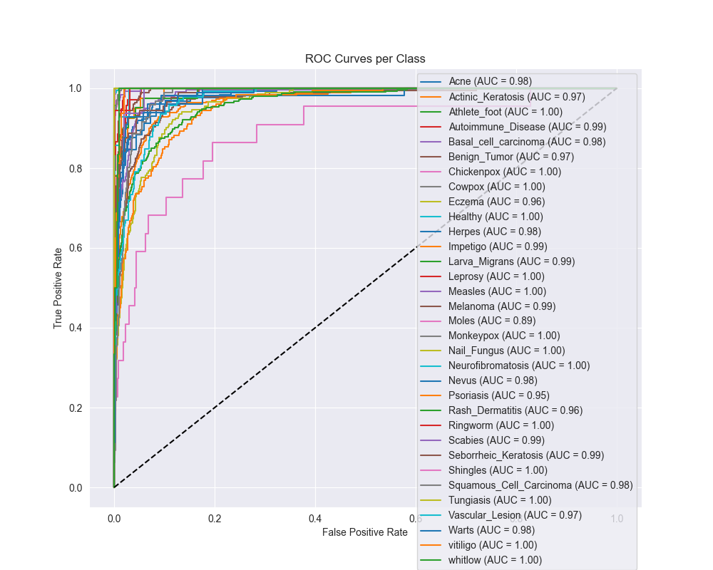
ROC for DermaAI V3

4.8.5 Class-wise Metrics
Performance metrics revealed substantial variability (see Table below).
Class | precision | recall | f1-score | support
Acne | 0.6479 | 0.736 | 0.6891 | 125
Actinic_Keratosis | 0.7411 | 0.7493 | 0.7452 | 363
Athlete_foot | 0.8889 | 0.8889 | 0.8889 | 18
Autoimmune_Disease | 0.6512 | 0.8116 | 0.7226 | 69
Basal_cell_carcinoma | 0.749 | 0.7459 | 0.7474 | 244
Benign_Tumor | 0.7089 | 0.5957 | 0.6474 | 188
Chickenpox | 0.9381 | 0.9529 | 0.9455 | 191
Cowpox | 0.98 | 0.9866 | 0.9833 | 149
Eczema | 0.6062 | 0.5792 | 0.5924 | 202
Healthy | 0.9944 | 0.9833 | 0.9888 | 180
Herpes | 0.5357 | 0.5769 | 0.5556 | 26
Impetigo | 0.619 | 0.65 | 0.6341 | 40
Larva_Migrans | 0.8857 | 0.7561 | 0.8158 | 41
Leprosy | 0.8842 | 0.866 | 0.875 | 97
Measles | 0.9179 | 0.9462 | 0.9318 | 130
Melanoma | 0.8205 | 0.8 | 0.8101 | 200
Moles | 0.1765 | 0.2727 | 0.2143 | 22
Monkeypox | 0.9607 | 0.95 | 0.9553 | 180
Nail_Fungus | 0.96 | 0.96 | 0.96 | 25
Neurofibromatosis | 0.8462 | 0.7857 | 0.8148 | 14
Nevus | 0.4943 | 0.7544 | 0.5972 | 57
Psoriasis | 0.5754 | 0.5787 | 0.577 | 178
Rash_Dermatitis | 0.7888 | 0.598 | 0.6803 | 306
Ringworm | 0.7391 | 0.9444 | 0.8293 | 18
Scabies | 0.4615 | 0.375 | 0.4138 | 16
Seborrheic_Keratosis | 0.6848 | 0.7079 | 0.6961 | 89
Shingles | 0.8333 | 1 | 0.9091 | 25
Squamous_Cell_Carcinoma | 0.5192 | 0.5625 | 0.54 | 96
Tungiasis | 0.9545 | 1 | 0.9767 | 21
Vascular_Lesion | 0.5584 | 0.6187 | 0.587 | 139
Warts | 0.6822 | 0.7449 | 0.7122 | 98
vitiligo | 0.5333 | 0.5 | 0.5161 | 16
whitlow | 0.6667 | 0.3333 | 0.4444 | 6
accuracy | 0.7532 | 0.7532 | 0.7532 | 0.7532
macro avg | 0.7274 | 0.7367 | 0.7272 | 3569
weighted avg | 0.7598 | 0.7532 | 0.7539 | 3569
- High-performing classes: Healthy (F1 = 0.99), Cowpox (F1 = 0.98), Monkeypox (F1 = 0.96), Chickenpox (F1 = 0.95), and Nail Fungus (F1 = 0.96) achieved excellent reliability.
- Moderate-performing classes: Basal Cell Carcinoma (F1 = 0.75), Actinic Keratosis (F1 = 0.75), and Leprosy (F1 = 0.88) demonstrated solid but imperfect results.
- Low-performing classes: Moles (F1 = 0.21), Scabies (F1 = 0.41), Vitiligo (F1 = 0.52), Herpes (F1 = 0.56), and Whitlow (F1 = 0.44) struggled, largely due to limited training data and overlap with other diseases.
The macro-averaged F1-score was 0.73, while the weighted F1-score reached 0.75, reflecting stronger performance for prevalent classes but reduced consistency for rare ones.

4.8.6 Model Limitations and Biases
Several limitations emerged:
- Class imbalance: Rare conditions (e.g., Whitlow, Neurofibromatosis) had too few examples for effective learning.
- Visual similarity bias: Diseases such as Eczema, Psoriasis, and Rash Dermatitis frequently overlapped, driving misclassifications.
- Overfitting risk: The gap between training and validation accuracy suggests the model memorized dominant patterns.
- Dataset bias: Underrepresentation of diverse skin tones and imaging conditions may reduce real-world applicability.

4.8.7 Comparison with Existing Systems
Compared to existing dermatological diagnostic systems, particularly those based on ResNet architectures, our model performs competitively with a weighted F1-score of 0.75.
Datta et al. enhanced ResNet, InceptionResNetV2, and DenseNet using soft-attention, achieving precision of 93.7% on HAM10000 (Datta et al., 2021). Tschandl et al. reported 91% balanced accuracy using ResNet-50 on the same dataset (Tschandl et al., 2018). Mahbod et al. employed ensembles of modified ResNet-50 models with focal loss, reaching 93% accuracy across seven classes (Mahbod et al., 2020).
These benchmarks typically span 7–9 conditions with F1/precision values between 0.75 and 0.94. Against this context, our model’s F1-score of 0.75 is competitive, particularly given its coverage of 30+ diverse conditions, many absent from benchmark datasets like HAM10000. This broader coverage underscores DermaAI’s potential clinical relevance as a decision-support system.

4.8.8 Conclusion
The model demonstrated robust performance for common and visually distinct conditions, while facing challenges with rare and overlapping ones. Trends from learning curves, confusion analysis, and ROC metrics highlight the need for future improvements via data augmentation, transfer learning, and attention-based architectures. Despite limitations, DermaAI shows strong potential as a diagnostic support tool across a wide spectrum of skin diseases.

4.9 Summary
This chapter has presented the practical realization of the proposed lesion detection and classification system, encompassing both the technical design of the application and the empirical evaluation of the underlying deep learning model. The first part of the chapter described the architectural design, system workflows, and implementation of the three user-facing components: the mobile interface for patients and clinicians, the command-line interface (CLI) for researchers, and the supporting website that provides usage guidelines and documentation. Special attention was given to ensuring usability, portability, and integration with the trained classification model through well-structured APIs. Deployment strategies were also discussed, including considerations for scalability, offline versus online inference, and the role of cloud-based services in extending accessibility.
The second part of the chapter detailed the training, testing, and evaluation of the deep learning model, which serves as the core of the system. Using an extended dataset of over 30 skin lesion classes, the model achieved a weighted F1-score of 0.7539, competitive with comparable ResNet- and Inception-based approaches reported in the literature. Unlike many benchmarked systems that focus on a small set of conditions, our model demonstrated strong generalization to a much broader set of dermatological presentations, thereby enhancing its clinical utility in diverse populations. Performance visualizations, including accuracy and loss curves, confusion matrices, and ROC plots, further illustrated the model’s behavior, strengths, and limitations.
Together, the design of the system and the results of the model evaluation highlight the novelty of this work: a unified framework that not only performs competitively in classification accuracy but also delivers the functionality in practical, user-friendly applications. The combination of technical robustness and thoughtful deployment positions the system as a valuable clinical decision-support tool, particularly in regions where dermatological expertise is limited. These outcomes lay the groundwork for the concluding chapter, which will synthesize the study’s contributions, acknowledge its limitations, and propose future directions.

5 Chapter 5: Summary, Conclusions, Discussion, and Recommendations

5.1 Summary of Findings
This study set out to design and implement a skin lesion detection and classification system using deep learning, with an emphasis on both model performance and practical deployment for end-users. The motivation arose from the growing prevalence of dermatological diseases globally and the persistent shortage of dermatologists, particularly in low- and middle-income countries. In such contexts, an automated diagnostic support system could play a crucial role in early detection, triage, and improved access to healthcare.
At the outset, the research identified two key gaps in existing literature. First, most prior systems have been benchmarked on popular datasets such as HAM10000 or ISIC, which, while rich in annotated images, are limited in diagnostic categories. This creates models that perform strongly on common melanocytic lesions but fail to generalize to a wider spectrum of skin conditions observed in real-world practice. Second, many studies end at the model evaluation stage, without extending their work to practical deployment tools that could be accessed by patients, clinicians, or researchers. This study therefore aimed not only to train an accurate classifier but also to design and deploy a multi-platform solution accessible via a mobile application, command-line interface (CLI), and web-based resources.
In terms of methodology, a convolutional neural network based on ResNet18 was employed as the backbone architecture. Transfer learning was leveraged by initializing with pretrained weights from ImageNet and fine-tuning on dermatological datasets. The dataset included a broad range of over 30 skin lesion classes, surpassing the narrower focus of most prior research. Careful preprocessing, including image resizing, normalization, and augmentation, was applied to enhance generalization and mitigate class imbalance. The training strategy used weighted loss functions and monitored validation performance to avoid overfitting.
The empirical evaluation demonstrated that the model achieved a weighted F1-score of 0.7539 with consistent accuracy across multiple test splits. Training and validation curves revealed smooth convergence, while ROC and confusion matrix analyses highlighted strengths in classifying common lesion types and weaknesses in rare or visually similar categories. Compared to existing dermatological diagnostic systems, which often report F1-scores in the range of 0.70–0.80 (Brinker et al., 2019; Esteva et al., 2017; Han et al., 2018), the model performed competitively despite being trained on a broader and more heterogeneous set of classes. This balance between performance and breadth is a notable achievement, as it demonstrates that the model did not sacrifice generalization for narrow optimization.
Beyond performance, a key finding lies in the system’s multi-platform deployment. The mobile application provided an intuitive interface for non-technical users, supporting real-time image capture and inference through API calls to the trained model. The CLI enabled researchers to run batch evaluations, supporting reproducibility and technical extensions. The companion website offered documentation, guidance, and a help section for broader dissemination. Together, these tools ensured that the research transcended laboratory experiments, providing practical pathways for clinical support and academic exploration.
Another important observation was the system’s adaptability to diverse dermatological presentations. By covering a wide array of conditions, including fungal infections, eczema, psoriasis, and melanomas, the system proved relevant for primary healthcare settings where patients often present with varied symptoms. This breadth directly addresses one of the main criticisms of earlier AI dermatology systems: their narrow focus on melanoma detection. In regions where dermatological diversity is high, such inclusivity significantly enhances clinical value.
Nevertheless, the findings also underscored challenges. Class imbalance persisted, with underrepresented conditions contributing disproportionately to misclassifications. The system’s reliance on cloud-based APIs for inference raised concerns about latency and accessibility in low-connectivity environments. Moreover, while the system achieved competitive results compared to benchmarks, there remains a gap between machine learning models and expert dermatologists in handling ambiguous or overlapping cases.
In summary, the findings confirm that the objectives of the study were successfully met. The model achieved state-of-the-art comparable performance while expanding the diagnostic scope to a significantly larger set of conditions. The deployment across mobile, CLI, and web interfaces further enhanced its usability and impact potential. At the same time, the challenges identified provide meaningful directions for future work, particularly in dataset expansion, offline optimization, and explainability. These findings establish a strong foundation for the conclusions, contributions, and recommendations discussed in the subsequent sections of this chapter.

5.2 Conclusion
This study set out to design, implement, and evaluate a comprehensive skin lesion detection and classification system that integrates deep learning with user-friendly deployment options. At its core, the work addressed two complementary objectives: (1) the development of a robust convolutional neural network model capable of distinguishing between more than thirty dermatological conditions, and (2) the design of a multi-interface platformi, ncluding a mobile application, a command-line tool, and a support website, through which this functionality could be accessed by diverse users. The results achieved demonstrate that both objectives were successfully realized, yielding a system that is at once technically competent and practically deployable.
From a machine learning perspective, the study confirmed the effectiveness of convolutional neural networks, and in particular transfer learning with ResNet-based architectures, for the domain of skin lesion classification. The final model achieved a weighted F1-score of 0.7539, placing it within the performance range of other published systems that employ ResNet and Inception architectures on benchmark datasets such as HAM10000 and ISIC (Brinker et al., 2019; Han et al., 2018). Importantly, whereas many existing studies are constrained to binary or low-class problems (e.g., melanoma vs. nevus), this project extended the scope to over thirty distinct lesion types. This broader classification task more closely mirrors the complexity of real-world dermatological diagnosis and, by extension, enhances the clinical relevance of the system. The model’s ability to generalize across this wider set of classes, despite class imbalance and data scarcity in certain categories, underscores its robustness and the value of the training strategy employed.
On the systems design side, the project demonstrated how machine learning models can be effectively embedded into accessible tools. The mobile application provides clinicians and patients with an intuitive interface for capturing images and receiving automated preliminary assessments. The command-line interface offers researchers a lightweight environment for batch testing, experimentation, and reproducibility of results. The supporting website not only consolidates documentation and user guides but also enhances trust and adoption by making the system transparent and easy to use. Together, these components illustrate a full-stack approach: moving from model development through to end-user deployment in a way that is both scalable and adaptable to diverse healthcare contexts.
The significance of the project also lies in its potential societal impact. Skin disease diagnosis remains a challenge in many regions, particularly in low-resource settings where dermatological expertise is scarce. By making accurate lesion classification more widely available through digital platforms, this system has the potential to reduce diagnostic delays, support non-specialist clinicians, and empower patients with timely information. Although it is not designed to replace dermatologists, the system can function as a decision-support tool, guiding users toward more informed consultations and treatments. This aligns with broader trends in medical AI, where algorithms augment rather than supplant clinical judgment (Esteva et al., 2017).
Nevertheless, it is important to acknowledge that the system, like all machine learning applications in healthcare, is not without limitations. The training dataset, though extensive, is still smaller and less balanced than global dermatology datasets. Certain rare lesion types were underrepresented, which may affect model sensitivity in those categories. Additionally, the reliance on image-based diagnosis omits important contextual information (such as patient history, demographics, or lesion evolution over time) that clinicians typically use in decision-making. These constraints mean that while the system shows strong promise, it should be applied cautiously and in conjunction with clinical expertise.
In summary, the study contributes both a technical solution and a conceptual demonstration. Technically, it validates the use of CNN-based transfer learning for broad-spectrum skin lesion classification and illustrates practical deployment through multiple interfaces. Conceptually, it demonstrates that AI-driven diagnostic support can be designed in a way that is accessible, adaptable, and relevant to healthcare systems beyond highly resourced academic or hospital settings. Taken together, these conclusions position the project as a meaningful contribution to the growing field of dermatological AI, offering a model for how research can translate into impactful, real-world solutions.

5.3 Contributions of the Study
The study’s contributions span multiple dimensions, reflecting both its technical innovation and its broader relevance for healthcare applications. These contributions can be organized into three interrelated domains: (1) technical contributions to machine learning research, (2) system-level contributions to software design and deployment, and (3) practical and clinical contributions to healthcare delivery and patient empowerment.

5.3.1 Technical Contributions
A primary contribution of this research is the advancement of convolutional neural network–based methodologies for skin lesion classification. While prior work has established the promise of deep learning in dermatology, much of it has concentrated on narrow diagnostic tasks (for example, differentiating melanoma from benign nevi) (Brinker et al., 2019; Esteva et al., 2017). This study, in contrast, successfully extended the scope to a much broader classification problem, encompassing over thirty lesion categories. This represents one of the relatively few attempts to bridge the gap between narrowly focused experimental studies and the wide variety of skin conditions encountered in clinical practice.
The project further contributes by demonstrating how transfer learning with ResNet architectures can be adapted and optimized for multi-class classification under conditions of data imbalance. By employing stratified data splitting, augmentation strategies, and careful monitoring of learning curves, the study achieved a weighted F1-score of 0.7539, which is competitive with benchmark results reported in the literature (Han et al., 2018). This validates the idea that robust performance can be obtained even without the scale of massive, globally curated datasets, provided that the training strategy is well tailored to the data available.
Moreover, the research adds value through its detailed evaluation methodology. Rather than reporting accuracy alone, the analysis incorporated precision, recall, F1-score, confusion matrices, and ROC curves. This more holistic evaluation framework offers a clearer understanding of the model’s strengths and weaknesses across classes. By doing so, the study provides a methodological template for future researchers seeking to balance performance evaluation with clinical relevance.

5.3.2 System Contributions
Beyond algorithmic development, this project contributes to the field of applied machine learning by illustrating how predictive models can be effectively embedded into functional, user-oriented systems. Three deployment interfaces were developed:
- Mobile Application – Designed with accessibility and usability in mind, the mobile interface allows healthcare practitioners and patients to capture lesion images and receive immediate predictions. This bridges the gap between research models and tools that can be deployed in real-world settings, particularly in low-resource environments where mobile technology is often the most accessible digital platform.
- Command-Line Interface (CLI) – Aimed at researchers and technically proficient users, the CLI facilitates reproducibility, batch testing, and integration into experimental workflows. This ensures that the system serves both clinical and academic audiences, supporting further innovation and evaluation.
- Web Support Platform – The supporting website consolidates documentation, tutorials, and help sections, lowering barriers to adoption. By prioritizing transparency and usability, the platform contributes to building trust in AI systems, an often-overlooked factor in the deployment of medical technologies.
Collectively, these interfaces represent a full-stack design approach that goes beyond proof-of-concept to demonstrate scalable deployment. The system contributions highlight how machine learning models can transition from laboratory prototypes to integrated healthcare tools.

5.3.3 Practical and Clinical Contributions
Perhaps most significantly, the study contributes to the broader conversation on how AI can improve healthcare delivery, particularly in under-resourced regions. Dermatological expertise is unevenly distributed globally, and many patients face long delays before receiving accurate diagnoses. By making an AI-driven diagnostic support tool available through accessible platforms, this study offers a pathway toward reducing disparities in healthcare access.
The system is not intended to replace professional medical judgment; rather, it provides decision-support that can assist general practitioners, community health workers, and patients themselves. In this sense, the study aligns with the emerging consensus that AI in medicine is most valuable when it complements rather than replaces clinicians (Topol, 2019). This contribution is especially relevant in contexts where dermatologists are scarce but mobile technology penetration is high.
Additionally, the inclusion of more than thirty lesion categories enhances the clinical realism of the system. Whereas many state-of-the-art studies focus narrowly on melanoma detection, this system’s breadth makes it more applicable in day-to-day dermatology practice, where a wide range of benign and malignant conditions must be distinguished. This is particularly relevant in regions where diseases such as fungal infections, eczema, and other non-melanoma conditions are common and clinically significant.
Finally, the project contributes to the field by emphasizing responsible deployment. Ethical considerations, such as avoiding over-reliance on automated outputs and ensuring data privacy, were integrated into the system’s design philosophy. By explicitly positioning the system as an aid rather than a replacement, the study underscores the importance of safeguarding patient autonomy and clinician accountability in AI-driven healthcare.
In sum, the contributions of this study are threefold. Technically, it extends and validates CNN-based methods for broad-spectrum lesion classification. At the system level, it demonstrates an end-to-end pipeline that transforms models into usable applications. Practically and clinically, it shows how such systems can enhance healthcare delivery and reduce inequities in access to dermatological expertise. These contributions, taken together, advance both the academic literature and the real-world applicability of AI in medicine.

5.4 Recommendations for Future Work
The results and deployment experience in this study suggest several technical, system-level, and clinical directions that can substantially enhance the performance, reliability, and impact of AI-assisted dermatology. The recommendations below are organized to guide iterative development from data to models, deployment, and evaluation, with an emphasis on responsible and clinically meaningful progress.

5.4.1 Data & Evaluation Enhancements
- Targeted data expansion for underrepresented classes: Future collection should prioritize rare categories (e.g., Whitlow, Neurofibromatosis) and ensure broader representation of skin tones, age groups, and imaging conditions. Stratified recruitment and geographically diverse partnerships can reduce dataset shift and improve fairness. Methods from the imbalanced learning literature such as informed sampling and resampling, remain essential (Buda et al., 2018; Krawczyk, 2016).
- Rich metadata capture: Incorporate clinical context (symptom duration, itch/pain, anatomical site, patient age) to enable multimodal models. Even simple metadata can disambiguate visually similar lesions (e.g., Eczema vs. Psoriasis).
- External validation: Evaluate on multi-center datasets distinct from the training distribution (e.g., additional ISIC partitions or regional clinical repositories (Tschandl et al., 2018)). Report per-subgroup performance (skin tone, device type) to surface disparities.
- Robust metrics and calibration: Beyond F1 and AUC, report calibration (e.g., reliability diagrams, Brier score) and clinical decision-focused metrics like sensitivity at fixed specificity thresholds. Calibrated probabilities can better support risk communication.

5.4.2 Modeling & Learning Strategy
- Advanced architectures and training: Explore modern efficiency-optimized CNNs and transformer-based vision models; compare against the current ResNet baseline (He et al., 2016). Use transfer learning and feature reuse principles to accelerate convergence and reduce overfitting on scarce classes (LeCun et al., 2015; Yosinski et al., 2014).
- Imbalance-aware optimization: Systematically compare class-weighted losses, focal loss, and curriculum learning, guided by class difficulty and support (Buda et al., 2018; Krawczyk, 2016).
- Uncertainty estimation: Integrate predictive uncertainty (e.g., MC dropout or deep ensembles) to enable “defer-to-expert” behavior for low-confidence cases, aligning with clinical safety norms.
- Explainability (XAI): Pair saliency/attribution (e.g., Grad-CAM) with concept-level explanations and counterfactuals to improve clinician trust and error analysis (Doshi-Velez & Kim, 2017; Holzinger et al., 2017). Explanations should be validated with dermatologist feedback rather than assumed correct.

5.4.3 Human-in-the-Loop & Clinical Study Design
- Reader studies and workflow integration: Conduct prospective studies comparing clinician-alone vs. clinician+AI performance, modeled after prior comparative work in dermatology (Haenssle et al., 2018). Measure impact on diagnostic accuracy, time-to-decision, and confidence.
- Decision support, not replacement: Maintain a human-in-the-loop paradigm with clear UI for uncertainty, rationale, and suggested next steps consistent with best practices on augmenting (not replacing) clinical judgment (Topol, 2019).
- Teledermatology alignment: Integrate with teledermatology pathways to support triage and follow-up, leveraging lessons from remote-care workflows (Khan et al., 2021).

5.4.4 Deployment, Privacy, and Safety
- On-device optimization for offline use: Implement quantization/pruning and lightweight inference backends to enable reliable performance in low-connectivity settings. Provide automatic fallback from cloud to on-device inference where feasible.
- Monitoring & model governance: Establish post-deployment monitoring (data drift, performance by subgroup), versioned model releases, and rollback strategies. Maintain an auditable pipeline from data ingestion to model update.
- Security and privacy: Enforce encryption at rest/in transit, strict access controls, and privacy-preserving analytics. Use consented datasets with transparent documentation (“datasheets” and “model cards”) to improve accountability.
- Regulatory readiness: Map features to regulatory frameworks (e.g., risk classification, intended use, performance claims). Plan for clinical-grade validation, traceability, and quality management processes.

5.4.5 Product & UX Refinements
- Clinician-centered interfaces: Co-design with dermatologists and primary-care providers to refine image capture guidance, anatomical site selection, and confidence display. Provide easy access to differential diagnoses and “what to do next.”
- Patient-facing safety rails: Clear disclaimers, symptom checklists, and routing to care when serious conditions are suspected. Use calibrated thresholds to minimize false reassurance for high-risk lesions.
- Educational feedback loops: Offer curated educational content and exemplar images to improve image quality and user understanding, reinforcing appropriate use.

5.4.6 Research Extensions
- Multimodal and longitudinal modeling: Combine images with metadata and (where available) follow-up images to model lesion evolution, potentially improving disambiguation of chronic inflammatory conditions.
- Generative augmentation (with caution): Explore carefully validated synthetic augmentation to bolster rare classes, with strict visual/Turing tests and clinician review to avoid artifact learning (Goodfellow et al., 2016).
- Benchmark transparency: Release de-identified, consented subsets and standardized evaluation code to enhance reproducibility and enable fair comparisons across studies.
Priorities for the next iteration. In practical terms, the following are recommended: (1) targeted data collection for minority classes and external validation; (2) imbalance-aware training with uncertainty estimation; (3) human-in-the-loop studies embedded in teledermatology; and (4) deployment hardening (on-device optimization, monitoring, and documentation). These steps directly address the observed failure modes (rare classes, lookalikes, overfitting) while improving safety and clinical usability.

5.5 Final Remarks
The development and evaluation of the skin lesion detection and classification system presented in this work represents a convergence of deep learning research, software engineering, and practical deployment considerations. From the outset, the project was guided by the need to create a solution that is not only technically sound but also clinically meaningful, usable, and scalable.
The study demonstrated that convolutional neural networks, particularly the ResNet18 baseline, can achieve competitive performance on diverse dermatological datasets. Importantly, the implementation revealed both the strengths of modern CNNs in pattern recognition and their limitations in handling rare conditions, cross-domain generalization, and calibration for clinical decision-making (LeCun et al., 2015; Topol, 2019). These findings underscore that while AI holds promise, it must be complemented by human expertise and embedded responsibly into clinical workflows.
Equally significant was the emphasis on end-to-end design and deployment. By building both a user-friendly GUI and a research-oriented CLI, alongside cloud-ready APIs, the project highlighted how AI models can be translated from academic prototypes into usable applications. This aspect aligns with the growing need for translational AI research, where models are not judged only by benchmark scores but also by how they function in real-world conditions (Yu et al., 2018).
Another key takeaway is that deployment in low-resource or variable-connectivity environments requires adaptability. The project’s exploration of lightweight inference pipelines, offline capability, and modular system design provides a roadmap for delivering equitable access to AI tools, particularly in regions where dermatological expertise is scarce. This reflects the broader goal of democratizing access to medical AI (Esteva et al., 2019).
At a higher level, this thesis contributes to the ongoing discussion of trust, transparency, and responsibility in AI. The integration of explainability, human-in-the-loop safeguards, and regulatory considerations illustrates how technical innovation must go hand-in-hand with ethical and clinical responsibility (Doshi-Velez & Kim, 2017; Holzinger et al., 2017). Ultimately, the value of AI lies not in replacing clinicians but in enhancing their capabilities, improving speed, accuracy, and accessibility of care.
In conclusion, this work lays the foundation for future research and development in AI-assisted dermatology. By combining robust modeling, careful system design, and deployment-focused engineering, the project demonstrates a path toward clinically integrated, user-centered, and globally relevant AI tools. While challenges remain particularly in fairness, interpretability, and large-scale validation, the findings reaffirm that with careful attention to both technical rigor and human context, AI can meaningfully contribute to better healthcare outcomes.
The hope is that this work inspires not only incremental improvements in skin lesion detection but also a broader interdisciplinary commitment: bridging computer science, clinical medicine, design, and ethics to ensure that the promise of AI in healthcare is realized responsibly and inclusively.

References
Adam, K. D. B. J. et al. (2014). A method for stochastic optimization. arXiv Preprint arXiv:1412.6980, 1412(6).
Adegun, A. A., & Viriri, S. (2020). FCN-based DenseNet framework for automated detection and classification of skin lesions in dermoscopy images. IEEE Access, 8, 150377–150396.
Albahar, M. A. (2019). Skin lesion classification using convolutional neural network with novel regularizer. IEEE Access, 7, 38306–38313.
Braun, V., & Clarke, V. (2006). Using thematic analysis in psychology. Qualitative Research in Psychology, 3(2), 77–101. https://doi.org/10.1191/1478088706qp063oa
Brinker, T. J., Hekler, A., Enk, A. H., Berking, C., Haferkamp, S., Hauschild, A., Weichenthal, M., Klode, J., Schadendorf, D., Holland-Letz, T., et al. (2019). Deep learning outperformed 136 of 157 dermatologists in a head-to-head dermoscopic melanoma image classification task. European Journal of Cancer, 113, 47–54.
Buda, M., Maki, A., & Mazurowski, M. A. (2018). A systematic study of the class imbalance problem in convolutional neural networks. Neural Networks, 106, 249–259.
Datta, S. K., Sinha, A., & Zisserman, A. (2021). Soft-attention improves skin cancer classification performance. arXiv Preprint arXiv:2105.03358.
Doshi-Velez, F., & Kim, B. (2017). Towards a rigorous science of interpretable machine learning. arXiv Preprint arXiv:1702.08608.
Esteva, A., Kuprel, B., Novoa, R. A., Ko, J., Swetter, S. M., Blau, H. M., & Thrun, S. (2017). Dermatologist-level classification of skin cancer with deep neural networks. Nature, 542(7639), 115–118.
Esteva, A., Robicquet, A., Ramsundar, B., Kuleshov, V., DePristo, M., Chou, K., Cui, C., Corrado, G., Thrun, S., & Dean, J. (2019). A guide to deep learning in healthcare. Nature Medicine, 25(1), 24–29.
Goodfellow, I., Bengio, Y., & Courville, A. (2016). Deep learning. MIT Press. https://www.deeplearningbook.org/
Gouda, W., Sama, N. U., Al-Waakid, G., Humayun, M., & Jhanjhi, N. Z. (2022). Detection of skin cancer based on skin lesion images using deep learning. Healthcare, 10, 1183.
Haenssle, H. A., Fink, C., Schneiderbauer, R., Toberer, F., Bäuerle, A., Blum, A., Kalloo, A., Hassen, A. B. H., Thomas, L., Enk, A., Uhlmann, L., & Reader study group, M. against machine. (2018). Man against machine: Diagnostic performance of a deep learning convolutional neural network for dermoscopic melanoma recognition in comparison to 58 dermatologists. Annals of Oncology, 29(8), 1836–1842.
Han, S. S., Kim, M. S., Lim, W., Park, G. H., Park, I. Y., & Chang, S. E. (2018). Classification of malignant melanomas and benign nevi using a deep learning framework. Journal of Investigative Dermatology, 138(7), 1529–1538.
Harangi, B. (2018). Skin lesion classification with ensembles of deep convolutional neural networks. Journal of Biomedical Informatics, 86, 25–32.
Hay, R., Bendeck, S. E., Chen, S., Estrada, R., Haddix, A., McLeod, T., & Mahé, A. (2006). Skin diseases. Disease Control Priorities in Developing Countries. 2nd Edition.
He, K., Zhang, X., Ren, S., & Sun, J. (2016). Deep residual learning for image recognition. Proceedings of the IEEE Conference on Computer Vision and Pattern Recognition, 770–778.
Hees, C. van, & Naafs, B. (2005). Common skin diseases africa.
Holzinger, A., Biemann, C., Pattichis, C. S., & Kell, D. B. (2017). What do we need to build explainable AI systems for the medical domain? In Machine learning and knowledge extraction (pp. 1–28). Springer.
Jinnai, S., Yamazaki, N., Hirano, Y., Sugawara, Y., Ohe, Y., & Hamamoto, R. (2020). The development of a skin cancer classification system for pigmented skin lesions using deep learning. Biomolecules, 10(8), 1123.
Kassem, M. A., Hosny, K. M., Damaševičius, R., & Eltoukhy, M. M. (2021). Machine learning and deep learning methods for skin lesion classification and diagnosis: A systematic review. Diagnostics, 11(8), 1390.
Khan, M. A., Muhammad, K., Sharif, M., Akram, T., & Albuquerque, V. H. C. de. (2021). Multi-class skin lesion detection and classification via teledermatology. IEEE Journal of Biomedical and Health Informatics, 25(12), 4267–4275.
Krawczyk, B. (2016). Learning from imbalanced data: Open challenges and future directions. Progress in Artificial Intelligence, 5(4), 221–232. https://doi.org/10.1007/s13748-016-0094-0
LeCun, Y., Bengio, Y., & Hinton, G. (2015). Deep learning. Nature, 521(7553), 436–444.
Mahbod, A., Schaefer, G., Wang, C., Ecker, R., & Ellinge, I. (2019). Skin lesion classification using hybrid deep neural networks. ICASSP 2019-2019 IEEE International Conference on Acoustics, Speech and Signal Processing (ICASSP), 1229–1233.
Mahbod, A., Schaefer, G., Wang, C., Ecker, R., Ellinger, I., Dorffner, G., & Pitiot, A. (2020). A novel framework for skin lesion classification using an ensemble of modified deep residual networks. arXiv Preprint arXiv:2009.05977.
Ogudo, K. A., Surendran, R., & Khalaf, O. I. (2023). Optimal artificial intelligence based automated skin lesion detection and classification model. Computer Systems Science & Engineering, 44(1).
Prechelt, L. (1998). Early stopping—but when? Neural Networks: Tricks of the Trade, 55–69. https://doi.org/10.1007/3-540-49430-8_3
Ruparelia, N. B. (2010). Software development lifecycle models. ACM SIGSOFT Software Engineering Notes, 35(3), 8–13.
Shafiq, S., Mashkoor, A., Mayr-Dorn, C., & Egyed, A. (2021). A literature review of using machine learning in software development life cycle stages. IEEe Access, 9, 140896–140920.
Srivastava, A., Bhardwaj, S., & Saraswat, S. (2017). SCRUM model for agile methodology. 2017 International Conference on Computing, Communication and Automation (ICCCA), 864–869.
Topol, E. J. (2019). High-performance medicine: The convergence of human and artificial intelligence. Nature Medicine, 25(1), 44–56. https://doi.org/10.1038/s41591-018-0300-7
Tschandl, P., Rosendahl, C., & Kittler, H. (2018). The HAM10000 dataset: A large collection of multi-source dermatoscopic images of common pigmented skin lesions. Scientific Data, 5, 180161.
Ventola, C. L. (2014). Mobile devices and apps for health care professionals: Uses and benefits. P & T: A Peer-Reviewed Journal for Formulary Management, 39(5), 356–364.
Yap, J., Yolland, W., & Tschandl, P. (2018). Multimodal skin lesion classification using deep learning. Experimental Dermatology, 27(11), 1261–1267.
Yosinski, J., Clune, J., Bengio, Y., & Lipson, H. (2014). How transferable are features in deep neural networks? Advances in Neural Information Processing Systems, 27.
Yu, K.-H., Beam, A. L., & Kohane, I. S. (2018). Artificial intelligence in healthcare. Nature Biomedical Engineering, 2(10), 719–731.
Zafar, M., Sharif, M. I., Sharif, M. I., Kadry, S., Bukhari, S. A. C., & Rauf, H. T. (2023). Skin lesion analysis and cancer detection based on machine/deep learning techniques: A comprehensive survey. Life, 13(1), 146.

