Njungle Nges Brian

FE14A169

CEF305 ASSIGEMENT
TITTLE:
A CLIENT SERVER PROGRAM WITH A GUI DONE IN SOCKET PROGRAMING AND
GTK.

PROPERTIES OF MECHINE
Operating system:Kali Linux 64bits
Labtop properties :Dell Latitude 6410,Hard drive,320Gb, 5processors,RAM=4Gb
Pictures of the interface
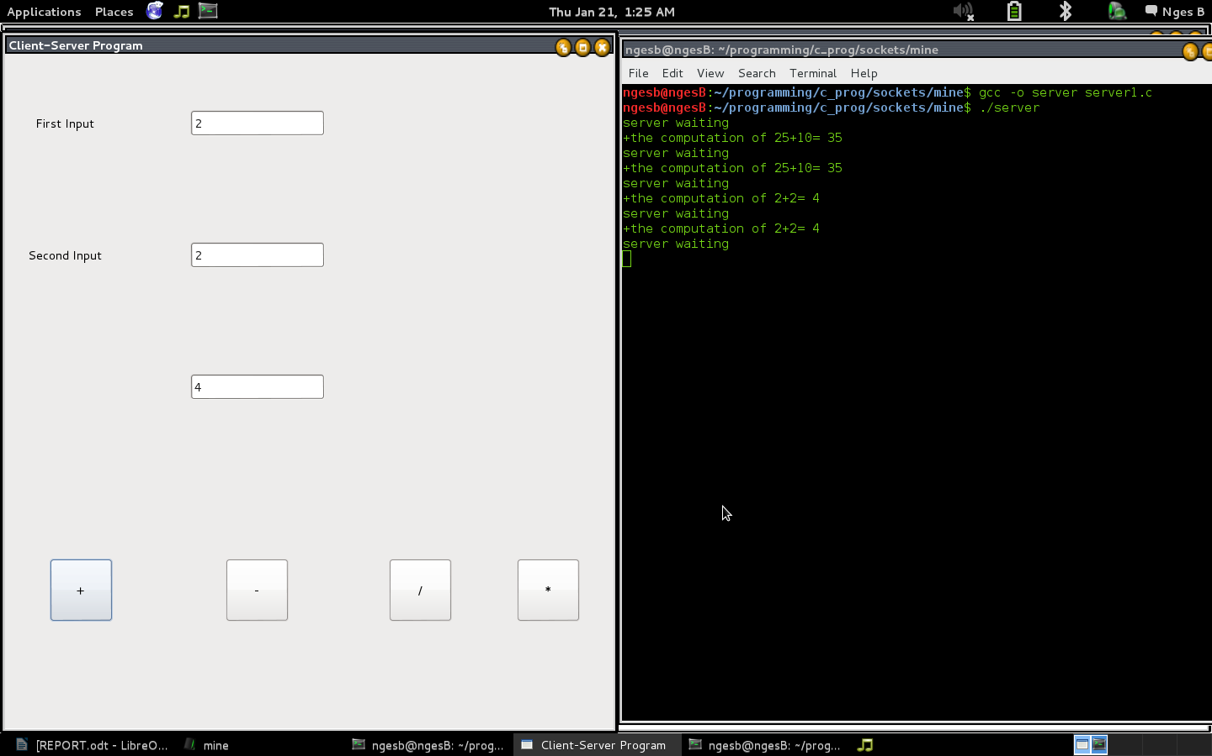
The Souce Code for the Client

#include <stdio.h>
#include <sys/types.h>
#include <sys/socket.h>
#include <sys/un.h>
#include <unistd.h>
#include <stdlib.h>
#include <gtk/gtk.h>

int Delete(GtkWidget *widget ,GtkWidget *event ,gpointer data);
void addi( );
void subt( );
void divi( );
void multi( );

struct data
{
int values[2];
int result;
char operate;

}input;
struct sockaddr_un address;
int len,con;
int sockfd;

GtkWidget *window,*table,*num1,*num2,*add,*sub, *divide,*mul, *result,*lab1,*lab2;

int main(int argc,char *argv[]){

gtk_init (&argc, &argv);

window=gtk_window_new(GTK_WINDOW_TOPLEVEL);
gtk_window_set_title(GTK_WINDOW(window),"Client-Server Program");
gtk_widget_set_size_request(window,500,400);
gtk_container_set_border_width(GTK_CONTAINER(window),0);
g_signal_connect(G_OBJECT(window),"delete_event",G_CALLBACK(Delete),NULL);

num1=gtk_entry_new();
num2=gtk_entry_new();
result=gtk_entry_new();

add=gtk_button_new_with_label("+");
gtk_widget_set_size_request(add,75,75);
sub=gtk_button_new_with_label("-");
gtk_widget_set_size_request(sub,75,75);
divide=gtk_button_new_with_label("/");
gtk_widget_set_size_request(divide,75,75);
mul=gtk_button_new_with_label("*");
gtk_widget_set_size_request(mul,75,75);

lab1=gtk_label_new("First Input");
lab2=gtk_label_new("Second Input");

table=gtk_table_new(20,20,FALSE);

gtk_table_attach(GTK_TABLE(table),lab1,2,5,2,4,1,1,0,0);
gtk_table_attach(GTK_TABLE(table),lab2,2,5,5,7,1,1,0,0);
gtk_table_attach(GTK_TABLE(table),num1,6,10,2,4,1,1,0,0);
gtk_table_attach(GTK_TABLE(table),num2,6,10,5,7,1,1,0,0);
gtk_table_attach(GTK_TABLE(table),result,6,10,8,10,1,1,0,0);
gtk_table_attach(GTK_TABLE(table),add,2,6,10,14,1,1,0,0);
gtk_table_attach(GTK_TABLE(table),sub,6,10,10,14,1,1,0,0);
gtk_table_attach(GTK_TABLE(table),divide,10,14,10,14,1,1,0,0);
gtk_table_attach(GTK_TABLE(table),mul,14,18,10,14,1,1,0,0);

char a,s,m,d;

g_signal_connect(G_OBJECT(add),"clicked",G_CALLBACK(addi),NULL);
g_signal_connect(G_OBJECT(sub),"clicked",G_CALLBACK(subt),NULL);
g_signal_connect(G_OBJECT(divide),"clicked",G_CALLBACK(divi),NULL);
g_signal_connect(G_OBJECT(mul),"clicked",G_CALLBACK(multi),NULL);

gtk_container_add(GTK_CONTAINER(window),table);
gtk_widget_show_all(window);

gtk_main();
return 0;
}

//the function delete.This function destroy the window when called.
int Delete(GtkWidget *widget ,GtkWidget *event ,gpointer data){
gtk_main_quit();
return FALSE;
}

void addi( ){

int num;
char pt[2];
input.values[0]=atoi(gtk_entry_get_text(GTK_ENTRY(num1)));

input.values[1]=atoi(gtk_entry_get_text(GTK_ENTRY(num2)));
input.operate='+';
//create a socket for the client
sockfd=socket(AF_UNIX,SOCK_STREAM,0);

//name the socket
address.sun_family=AF_UNIX;
strcpy(address.sun_path,"server_socket");
len=sizeof(address);

//connect our socket to the server
con=connect(sockfd,(struct sockaddr *)&address,len);
if(con==-1){
perror("ooops the serveer could not connect\n");
exit(1);
}

write(sockfd, &input,sizeof(input));
read(sockfd,&input,sizeof(input));
sprintf(pt,"%d",input.result);
printf("\n\t\t the computation of %d%c%d= %d as done by the server. \n\n\n",input.values[0],input.operate,input.values[1],input.result );
gtk_entry_set_text(GTK_ENTRY(result),pt);
close(sockfd);

}

void subt( ){

int num;
char pt[2];
input.values[0]=atoi(gtk_entry_get_text(GTK_ENTRY(num1)));

input.values[1]=atoi(gtk_entry_get_text(GTK_ENTRY(num2)));
input.operate='-';
//create a socket for the client
sockfd=socket(AF_UNIX,SOCK_STREAM,0);

//name the socket
address.sun_family=AF_UNIX;
strcpy(address.sun_path,"server_socket");
len=sizeof(address);

//connect our socket to the server
con=connect(sockfd,(struct sockaddr *)&address,len);
if(con==-1){
perror("ooops the serveer could not connect\n");
exit(1);
}

write(sockfd, &input,sizeof(input));
read(sockfd,&input,sizeof(input));
sprintf(pt,"%d",input.result);
printf("\n\t\t the computation of %d%c%d= %d as done by the server. \n\n\n",input.values[0],input.operate,input.values[1],input.result );
gtk_entry_set_text(GTK_ENTRY(result),pt);
close(sockfd);

}

void divi( ){

int num;
char pt[2];
input.values[0]=atoi(gtk_entry_get_text(GTK_ENTRY(num1)));

input.values[1]=atoi(gtk_entry_get_text(GTK_ENTRY(num2)));
input.operate='/';
//create a socket for the client
sockfd=socket(AF_UNIX,SOCK_STREAM,0);

//name the socket
address.sun_family=AF_UNIX;
strcpy(address.sun_path,"server_socket");
len=sizeof(address);

//connect our socket to the server
con=connect(sockfd,(struct sockaddr *)&address,len);
if(con==-1){
perror("ooops the serveer could not connect\n");
exit(1);
}

write(sockfd, &input,sizeof(input));
read(sockfd,&input,sizeof(input));
sprintf(pt,"%d",input.result);
printf("\n\t\t the computation of %d%c%d= %d as done by the server. \n\n\n",input.values[0],input.operate,input.values[1],input.result );
gtk_entry_set_text(GTK_ENTRY(result),pt);
close(sockfd);

}

void multi( ){

int num;
char pt[2];
input.values[0]=atoi(gtk_entry_get_text(GTK_ENTRY(num1)));

input.values[1]=atoi(gtk_entry_get_text(GTK_ENTRY(num2)));
input.operate='*';
//create a socket for the client
sockfd=socket(AF_UNIX,SOCK_STREAM,0);

//name the socket
address.sun_family=AF_UNIX;
strcpy(address.sun_path,"server_socket");
len=sizeof(address);

//connect our socket to the server
con=connect(sockfd,(struct sockaddr *)&address,len);
if(con==-1){
perror("ooops the serveer could not connect\n");
exit(1);
}

write(sockfd, &input,sizeof(input));
read(sockfd,&input,sizeof(input));
sprintf(pt,"%d",input.result);
printf("\n\t\t the computation of %d%c%d= %d as done by the server. \n\n\n",input.values[0],input.operate,input.values[1],input.result );
gtk_entry_set_text(GTK_ENTRY(result),pt);
close(sockfd);

}

The Sorce Code for the Server

#include <sys/types.h>
#include <sys/socket.h>
#include <sys/un.h>
#include <stdio.h>
#include <unistd.h>
#include <string.h>

int main(){

int server_sockfd,client_sockfd;
int server_len,client_len;
struct sockaddr_un server_address;
struct sockaddr_un client_address;

//remove any old socket and create a new unnames socket
unlink("server_socket");
server_sockfd=socket(AF_UNIX,SOCK_STREAM,0);

//naming the socket
server_address.sun_family=AF_UNIX;
strcpy(server_address.sun_path,"server_socket");
server_len=sizeof(server_address);
bind(server_sockfd,(struct sockaddr *)&server_address,server_len);

//create a connect queue and wait for clients
listen(server_sockfd,5);
while(1){
struct data
{
int values[2];
int result;
char operate;
}input;

char wrong[15];
strcpy(wrong,"wrong operator");

printf("server waiting\n");

//accept connection

client_len=sizeof(client_address);
client_sockfd=accept(server_sockfd,(struct sockaddr *)&client_address,&client_len);

//read and write to client
read (client_sockfd,&input,sizeof(input));
printf("%c",input.operate);
if(input.operate=='+'){
input.result=input.values[0]+input.values[1];
printf("the computation of %d+%d= %d\n",input.values[0],input.values[1],input.result );
}
else if(input.operate=='-')
input.result=input.values[0]-input.values[1];
else if(input.operate=='*')
input.result=input.values[0]*input.values[1];
else if (input.operate=='/')
input.result=input.values[0]/input.values[1];
else
write(client_sockfd,&wrong,20);
write(client_sockfd,&input,sizeof(input));
close(client_sockfd);
}

}

