PHONE BOOK MANAGEMENT SYSTEM

Task Sheet
Name | Task | Status | Start date | End date
Huỳnh Đại Nghĩa | Funcitional & Non-functional,  Interface design desc | Completed | 22/10/2025 | 23/10/2025
Nguyễn Thành Duy | Usecase diagram | Completed | 23/10/2025 | 26/10/2025
Phạm Đình Chương | Class diagram,Entity Relationship diagrams | Completed | 23/10/2025 | 26/10/2025
Nguyễn Quốc Huy | Data flow diagram | Completed | 23/10/2025 | 26/10/2025

- Functional Requirements

- User Management
  - User Registration
- Users can create a new account by entering: Fullname ,Email,Username,Password
- The system checks for duplicate emails or usernames before saving to the database.
- Passwords are encrypted (hash) before being stored.
  - User Login
- User logs in with username and password.
- The system verifies the information, if correct → goes to Dashboard.
- If incorrect → displays an error message.
  - Profile Management
- Users can view and edit personal information: Full name, Email, Phone number, Address, Password.
- The new password is re-authenticated before updating.
  - Logout
- User can log out of the system
- After logging out, return to the login interface
- Contacts Management
  - Add New Contact
- Users can add new contacts with the following fields:
- Full name (First name, Last name)
- Phone number (Phone number)
- Email (optional)
- Address (optional)
- Notes (optional)
- Data is checked for validity (correct phone number and email format) before saving.
  - View Contacts
- The system displays a list of all the user's contacts.
- Contacts can be sorted, searched, or filtered by name, group, or tag.
  - Update Contact
- Người dùng có thể chọn một liên hệ và chỉnh sửa thông tin.
- Sau khi cập nhật, danh sách tự động hiển thị lại.
  - Delete Contact (Soft Delete)
- When deleting a contact, the system only marks it as “deleted” (soft delete), not permanently deleting it from the database.
- Users can restore deleted contacts.
- Trash
  - View Deleted Contacts
- Users can open the Trash page to see a list of soft deleted contacts.
- Each entry displays: Full name, phone number, date deleted, and the option to Restore
or Delete Permanently
  - Restore Contact
- Users can select one or more contacts in the Trash to restore to the main list.
- When restoring, the “deleted” status of the contact is reset to “active”.
3.3 Permanently Delete Contact
- Users can select contacts in Trash and permanently delete them from the MySQL database.
- Once permanently deleted, contacts cannot be recovered.
- Group/Tag Management
  - Create Group/Tag
- Users can create groups or tags to categorize contacts.
- Enter a name and a short description for the group/tag.
- The system prevents duplicate names within the same account.
  - Assign Contacts to Group/Tag
- Users can assign one or more contacts to a selected group/tag.
- A contact can belong to multiple tags but only one main group.
  - View and Manage Group/Tag
- Users can view a list of all existing groups/tags.
- Can filter contacts by group or tag.
  - Update Group/Tag
- Users can edit the name or description of an existing group/tag.
- System checks for duplicate names before saving changes.
  - Delete Group/Tag
- When you delete a group/tag, the contacts in it are not lost , only the category association is lost.
- Dashboard and Statistics
- The main screen displays the total:
- Total Contacts
- Number of Groups
- Number of Tags in Use
- Simple figures help users grasp information quickly.

- Non-Functional Requirements

- System Environment
- Programming Language: Python 3.10+
- Database Management System: MySQL 8.0+
- GUI Framework: Tkinter
- Architecture: Model–View–Controller (MVC)
- Operating System: Windows 10/11
- Performance Requirements
- The application starts up in ≤ 5 seconds.
- The main operations (add, edit, search, login) respond in ≤ 2 seconds.
- The system handles smoothly with a minimum of 1,000 contacts without freezing.
- Security Requirements
- User passwords must be encrypted with bcrypt before being stored in MySQL.
- The application performs input validation to avoid formatting errors.
- Each account can only access its own data
- After the user logs out, the login session must be completely deleted from memory.
- Usability Requirements
- The user interface is built with Tkinter, friendly and easy to understand.
- The entire interface is displayed in Vietnamese.
- The buttons, menus and icons are clearly labeled.
- There are notifications when the user performs a successful or failed operation.
- Reliability Requirements
- When MySQL connection is lost, the system displays a warning instead of crashing the application.
- Soft Delete mechanism helps to avoid permanent data loss.
- Data between tables (User, Contact, Group/Tag, Trash) is guaranteed to be consistent.
- The system logs errors to the error_log.txt file for easy checking.
- Backup and Recovery
- Users can export contact data to CSV file for manual backup.
- Data can be restored from CSV file when recovery is needed.
- User Interface Requirements
- Main interface includes:
- Dashboard: Displays an overview of contacts.
- Contacts: Manage contacts, support searching, adding, editing, deleting, restoring (Trash).
- Groups/Tags: Classify contacts.
- Profile: Update personal information.
- Sidebar helps to move quickly between screens.
- Soft colors, easy-to-see layout, easy-to-read fonts

- UseCase Diagram
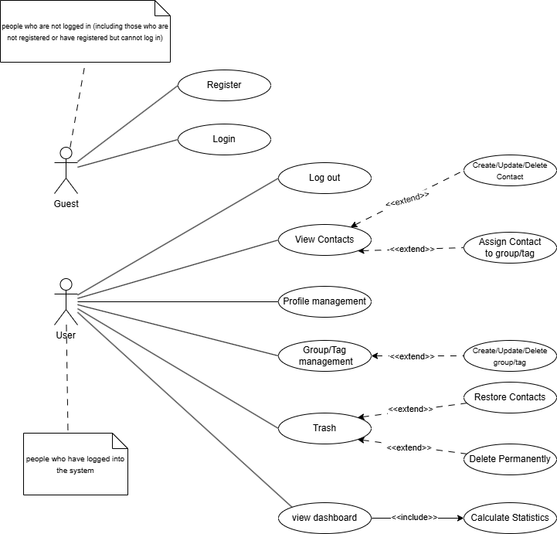
- Data Flow Diagram
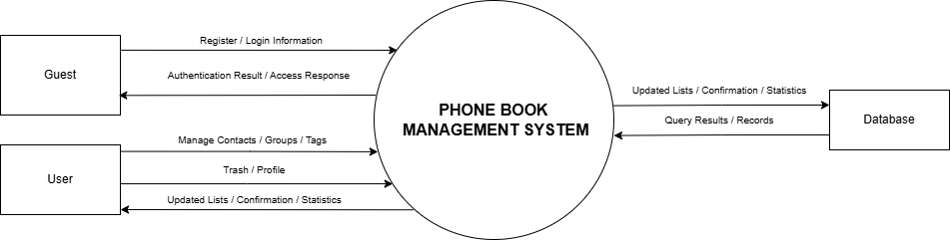

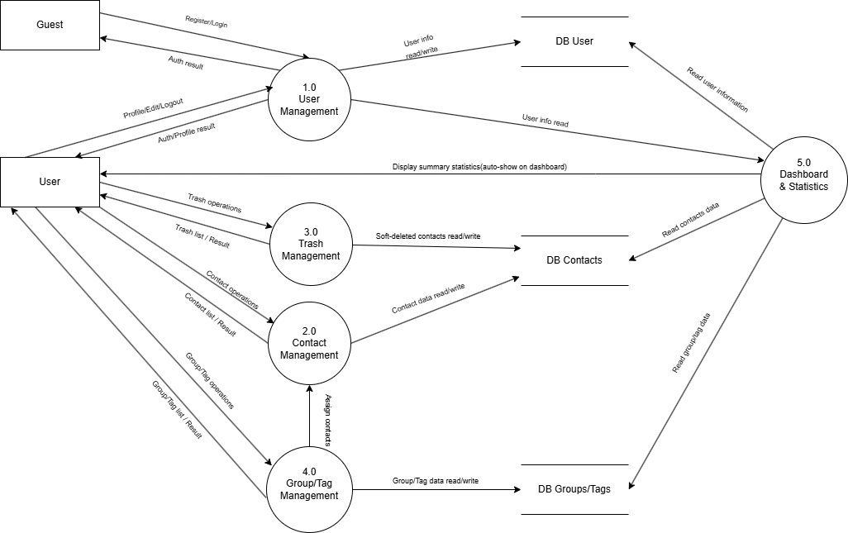
- Class Diagram
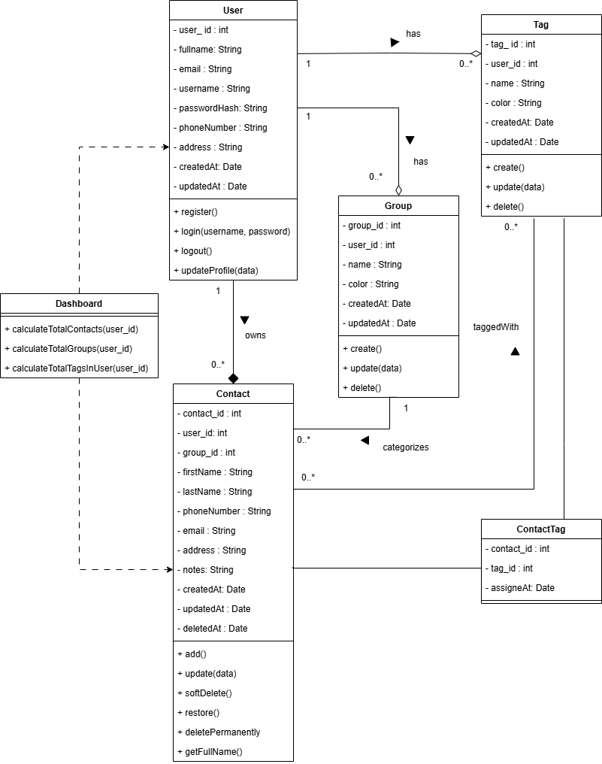

- Entity Relationship Diagrams
