1.



2. The Boolean Expression: Z= (A’ \* B) + (A \* B’).

Z= (NOT A AND B) OR (A AND NOT B).



3.

Truth Table:

A B C | Out

--------|----

0 0 0 | 0

1 0 0 | 1

0 1 0 | 1

0 0 1 | 1

1 0 1 | 0

1 1 0 | 0

0 1 1 | 0

1 1 1 | 0

Boolean expression:

Z = (NOT A AND NOT B AND C) OR (NOT A AND B AND NOT C) OR (A AND NOT B AND NOT C).

Z= (A’ \* B’ \* C) + (A’ \* B \* C’) + (A \* B’ \* C’).

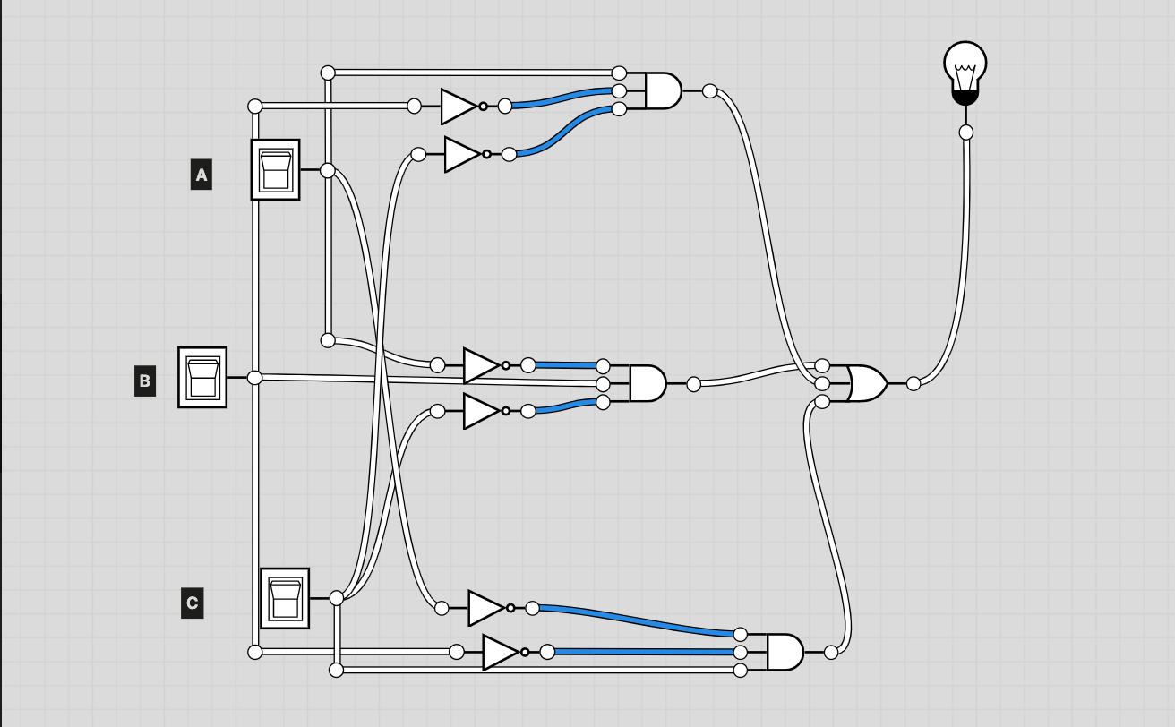

4.

