1. The FSA will accept the string 0010.

2.Two other strings that the FSA machine will also accept: 1010; 0000.

3.Two strings that the FSA machine will reject: 1111; 1011. (reject anything that ends with 1).

4.The FSA would go to accept those strings that end with 0.

5.The machine accepts 1010 and rejects 01010, 1010110.

6.Two additional strings that this FSA will accept are: 10101; 1010101.

7.Two strings that this FSA will reject are: 1111; 0101.

8. The strings that this FSA will accept starts with 1 and repeats either combination 01 or 10 over the whole string.

9.

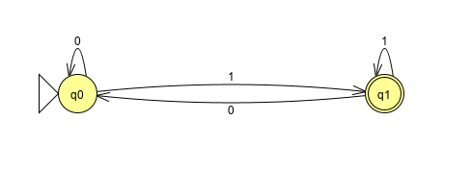

10.

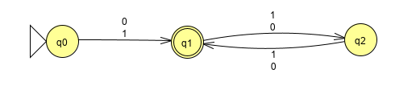

11.This expression does match with the string 00101100, but not with the string 0000.

12. Strings that this expression matches are strings that starts with repetitions of 0, then number 1, then repetition of either 1 or 0.

13.

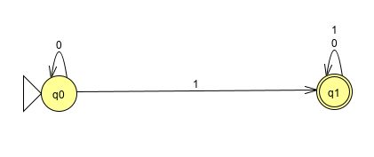

14. The expression for strings that start with 1 and ends with 1: 1(1+0)\*1.

15. ((1+0)\*0)\*

16. (1(01)\*) + (10(10)\*)