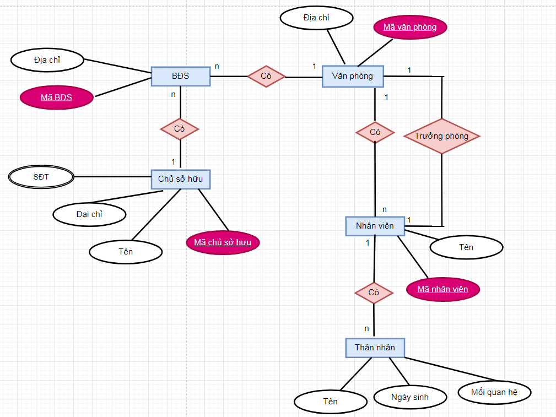

ChuSoHuu(MaCSH, Ten, Diachi)

SDT(MaCSH, SDT)

BĐS(MaBDS, Diachi, MaCSH, MaVP)

VanPhong(MaVP, Diachi)

NhanVien(MaNV, Ten, MaVP)

TruongPhong(MaNV, MaNV)

ThanNhan(Ten, MaNV, NgaySinh, MoiQH)