Software Requirements Specification

for

Smart Clinic Operating &
Diabetes Monitoring System
Version 1.0 approved
Prepared by Nguyễn Văn Ánh and Project Team
SWR302
18/06/2026
Table of Contents

1. Introduction 1
1.1 Purpose 1
1.2 Document Conventions 1
1.3 Project Scope 1
1.4 References 2
2. Overall Description 2
2.1 Product Perspective 2
2.2 User Classes and Characteristics 2
2.3 Operating Environment 3
2.4 Design and Implementation Constraints 3
2.5 Assumptions and Dependencies 3
3. System Features 4
3.1 AI-Assisted Patient Interaction and Appointment Booking 9
3.2 General Reception, Queue and Billing Management 10
3.3 Clinical Examination, Laboratory and Doctor AI Support 11
3.4 Administration and Management Reporting 12
3.5 Automated Laboratory Data Synchronization 13
4. Data Requirements 14
4.1 Logical Data Model 14
4.2 Data Dictionary 16
4.3 Reports 17
4.4 Data Acquisition, Integrity, Retention, and Disposal 17
5. External Interface Requirements 18
5.1 User Interfaces 18
5.2 Software Interfaces 18
5.3 Hardware Interfaces 19
5.4 Communications Interfaces 19
6. Quality Attributes 19
6.1 Usability 19
6.2 Performance 19
6.3 Security 20
6.4 Safety 20
6.5 Availability, Reliability and Scalability 20
7. Internationalization and Localization Requirements 21
8. Other Requirements 21
Appendix A: Glossary 23
Appendix B: Analysis Models 23
Revision History
Name | Date | Reason For Changes | Version
Project Team | 18/06/2026 | Refactored for the S-COMS topic, layered payment gates, automated laboratory synchronization, Doctor AI activation, and server-side clinical privacy controls. | 1.0

Introduction
This introduction provides an overview of the Software Requirements Specification (SRS) for the Smart Clinic Operating & Diabetes Monitoring System (S-COMS), helping readers understand the project objectives, structure, operational workflow, and intended use.

Purpose
This document specifies the functional, data, interface, and quality requirements for Version 1.0 of the Smart Clinic Operating & Diabetes Monitoring System. The intended audience includes:
- Developers: To implement the system consistently with the approved workflow, database constraints, and integration architecture.
- Project Managers: To define scope, plan iterations, assign resources, and control changes.
- Business Analysts: To validate that the requirements accurately represent patient, receptionist, doctor, administrator, AI, and laboratory operations.
- Testers: To derive test conditions, test cases, acceptance criteria, and traceability records.
- Medical Staff and Stakeholders: To confirm that the system supports the expected clinical and operational process without transferring final medical responsibility to AI.

Document Conventions
The following conventions are used throughout this document:
- Requirement Identifiers: Patient requirements use FR-PAT-xx, receptionist requirements use FR-REC-xx, doctor requirements use FR-DOC-xx, administrator requirements use FR-ADM-xx, and system-automation requirements use FR-SYS-xx.
- Normative Language: The term “shall” indicates a mandatory requirement for Release 1.0; “should” indicates a recommended requirement that may be refined during design.
- Business Rules: Business constraints are referenced using BR-xx identifiers.
- Technical Terminology: Database table names, field names, Background Worker, SignalR, WebSocket, and API terms are retained in English to remain consistent with implementation artifacts.

Project Scope
The Smart Clinic Operating & Diabetes Monitoring System (S-COMS) is a web-based clinic operating platform specialized in diabetes-oriented patient monitoring. Release 1.0 supports a closed and auditable clinical workflow: AI-assisted symptom interaction or counter registration; Appointment creation with status = Waiting and queue_number; administrative verification and examination-fee payment at General Reception; clinical examination; payment-gated laboratory orders; automated biochemical-result synchronization; Doctor AI risk analysis; physician-confirmed diagnosis; and controlled publication of the electronic medical record.
S-COMS eliminates routine bulk routing by the Administrator. Appointment is the authoritative source for queue progression, Invoice is the authoritative payment gate, Healthy_Record is the controlled laboratory-receipt state machine, the Background Worker performs device synchronization, Doctor_AI provides diabetes decision support, and the treating Doctor retains exclusive responsibility for the final diagnosis and result visibility.
- Patient Services: AI consultation, AI conversation history, appointment booking by time slot or doctor, online payment, and electronic health record viewing.
- General Reception: Phone-based lookup, walk-in registration, queue coordination, insurance deduction, payment processing, and invoice export.
- Doctor Services: Queue reception, AI symptom summary, clinical examination, laboratory orders, real-time read-only results, Doctor AI risk support, final diagnosis, prescriptions, and result visibility control.
- Administration: Account and role management, medical catalog configuration, doctor schedule capacity, and revenue/visit reporting.
- Automation: Payment-gated laboratory activation, background data synchronization, real-time notifications, and automatic generation of diabetes, pre-diabetes, and normal probabilities.

References
- Business Workflow and Database Architecture, “Luồng nghiệp vụ”, Version supplied on 18/06/2026.
- Functional Requirements Specification for Smart Clinic Operating & Diabetes Monitoring System, project source document.
- Software Requirements Specification Template, Karl Wiegers and Seilevel structure.
- Software Requirements Specification for Dental Clinic Management System, Group 3, Version 1.0, used as the formatting reference.

Overall Description

Product Perspective
S-COMS is a centralized smart-clinic operating and diabetes-monitoring application that connects a patient portal with role-specific dashboards for General Receptionists, Doctors, and Administrators. It integrates an AI Engine for symptom interaction, SQL Server for transactional clinic data, payment providers for examination and laboratory charges, authorized laboratory analyzers for biochemical measurements, Doctor_AI for three-class diabetes-risk estimation, and SignalR/WebSocket for real-time clinical notification.
The system is structured around four logical database groups: Authentication; Operations; Billing & Catalog; and Clinical & AI. This separation supports role-based access, reliable queue control, payment traceability, clinical integrity, and automated laboratory processing.

User Classes and Characteristics
- Patient: Uses AI consultation, books visits, pays invoices, and views permitted health records. Patients may be registered users or walk-in patients without an application account.
- General Receptionist: Performs high-frequency operational tasks including patient lookup, counter registration, queue coordination, insurance deduction, collection, and invoice export.
- Doctor: Receives patients from a personal queue, reviews history and AI summaries, issues laboratory orders, examines synchronized results, consults Doctor AI, and makes the final medical decision.
- Administrator: Manages resources and exceptional configuration. The Administrator does not perform routine bulk routing of normal visits.
- AI Engine: Processes natural-language conversations, summarizes symptoms, and produces decision-support probabilities from clinical data. It does not replace the doctor.
- Automated Lab Data Sync: A Background Worker that receives device measurements, validates eligibility, updates Healthy_Record, and publishes a real-time event.

Operating Environment
- The application shall be deployed as a web-based system accessible through current versions of Chrome, Edge, Safari, and compatible mobile browsers.
- Internal staff shall use desktop computers or tablets connected to a secure clinic network or protected internet connection.
- Patients shall access the portal from personal mobile or desktop devices.
- The application server and SQL Server database may be hosted on-premises or in an approved cloud environment.
- The laboratory integration service shall operate continuously as a server-side Background Worker.
- All scheduling, logging, and timestamps shall use Indochina Time (ICT, UTC+7).

Design and Implementation Constraints
- Database Technology: The target relational database is SQL Server and shall enforce primary keys, foreign keys, unique constraints, check constraints, and transactional consistency.
- Queue State Constraint: Appointment.status shall be restricted to Waiting, In_Progress, Completed, or Cancelled.
- Payment State Constraint: Invoice.status shall be restricted to Pending or Paid.
- Laboratory Activation Constraint: A Healthy_Record linked to a Lab_Test service shall remain Pending_Payment and shall not accept device results until the containing Invoice is verified as Paid and the record is transactionally changed to Activated_Ready.
- Visibility Constraint: Medical_record.result_visibility is a Doctor-controlled BIT field. Patient access shall be enforced on the server through ownership validation and WHERE result_visibility = 1 before response serialization.
- Clinical Responsibility Constraint: AI output is decision support only; the doctor remains responsible for the final diagnosis.
- Capacity Constraint: Bookings shall respect Doctor_Schedule.max_patients and shall not be created in a Full or Cancelled slot.

Assumptions and Dependencies
- AS-01: Patients and staff have stable network access and valid identification information.
- AS-02: Medical service prices and insurance deductions are configured by authorized staff before billing.
- AS-03: Laboratory devices or their integration gateway provide a stable test identifier that can be mapped to invoice_detail_id or another unique integration key.
- DE-01: Online payment depends on available Momo, VNPay, or banking integration services.
- DE-02: AI consultation and risk analysis depend on the configured AI model/API and its service availability.
- DE-03: Real-time result delivery depends on SignalR/WebSocket infrastructure.
- DE-04: The accuracy of risk analysis depends on complete, valid, and correctly mapped laboratory measurements.

System Features
- Use case diagram:
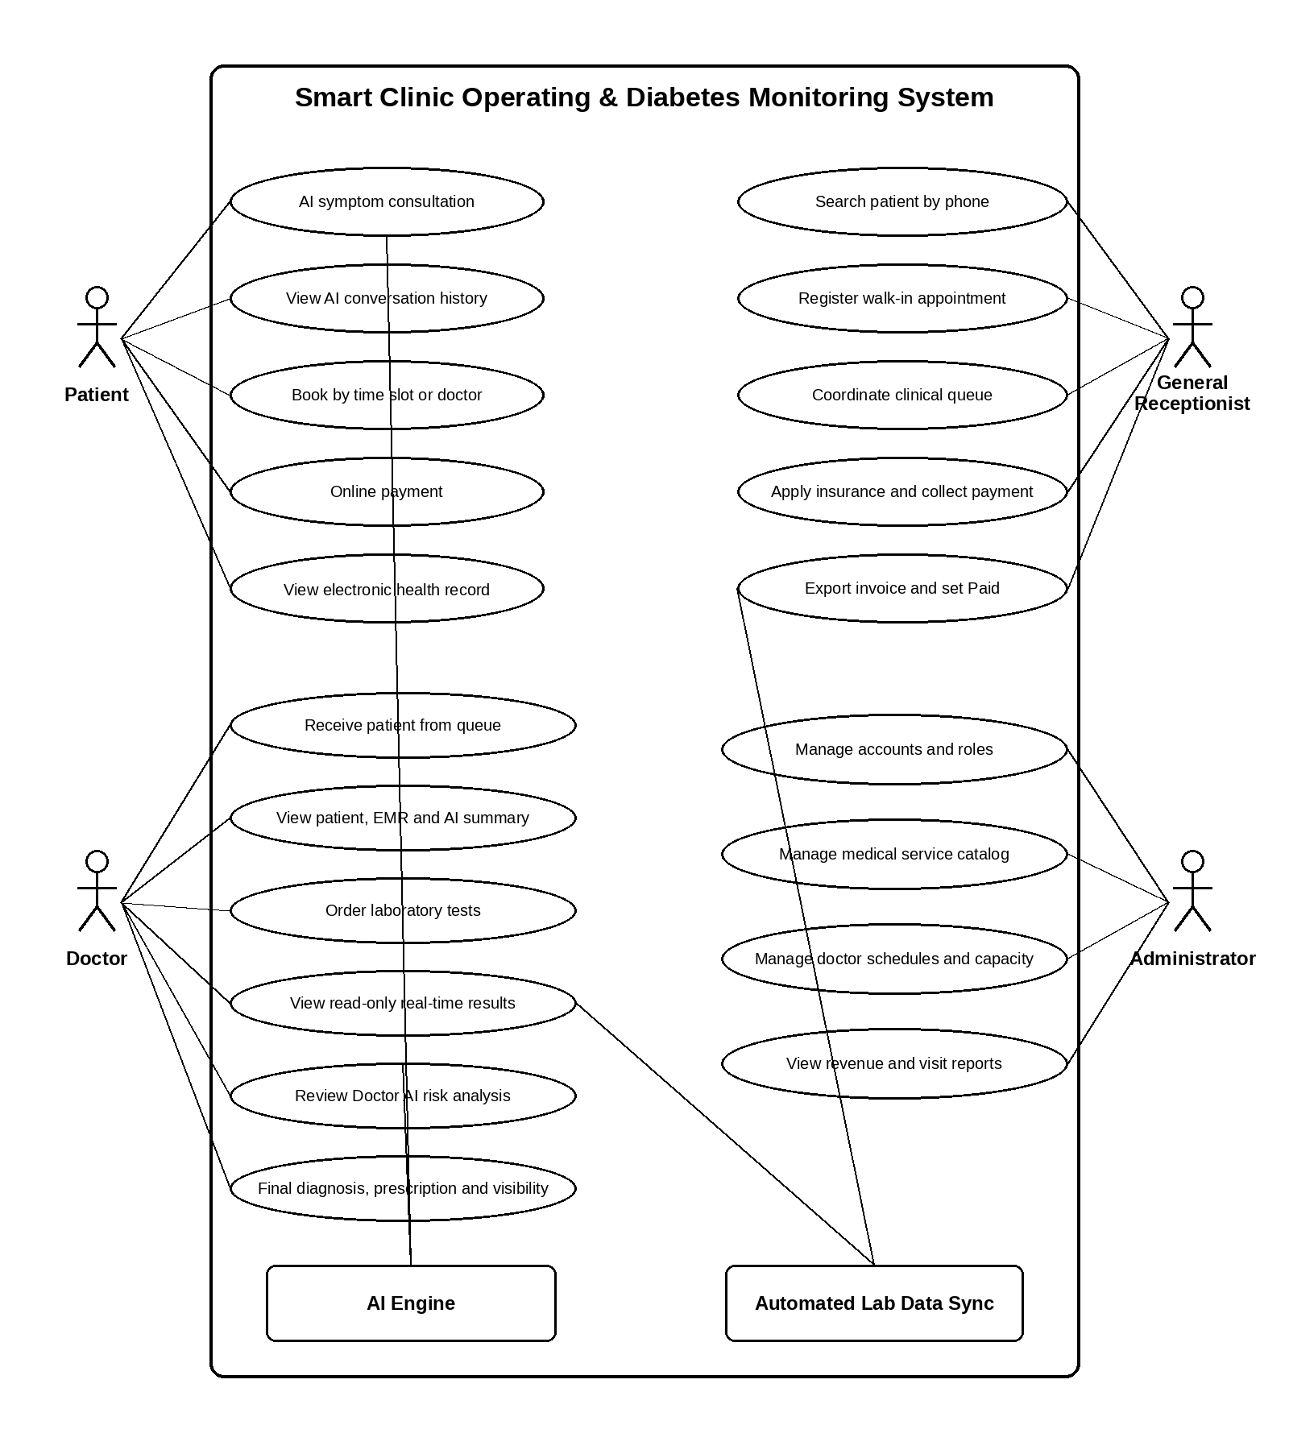
Use Case Diagram - Authoritative Step-by-Step Operational Flow
- Step 1 - Intake record: A Patient books online or the General Receptionist registers a walk-in visit. S-COMS creates Appointment.status = Waiting and assigns queue_number. Appointment is the authoritative source for the intake queue.
- Step 2 - Reception checkpoint: Before entry to the Doctor room, the Patient passes through General Reception for identity and administrative verification, BHYT deduction where approved, and examination-fee collection.
- Step 3 - Examination payment gate: The examination Invoice must be verified as Paid before the Waiting Appointment is eligible for the Doctor queue. The Administrator does not perform routine bulk routing.
- Step 4 - Clinical start: The Doctor calls the next eligible queue_number and changes Appointment.status from Waiting to In_Progress. S-COMS creates or opens the unique Medical_record for that Appointment.
- Step 5 - Layered Lab_Test charge: When the Doctor orders a Lab_Test, S-COMS creates Invoice_Detail and the linked Healthy_Record with status = Pending_Payment. No analyzer data may be accepted in this state.
- Step 6 - FR-REC-11 activation: Cash collection by the General Receptionist or verified online payment changes Invoice.status to Paid. In the same controlled transaction, Healthy_Record changes from Pending_Payment to Activated_Ready.
- Step 7 - FR-SYS-02 ingestion gate: Automated Lab Data Sync accepts a device payload only when Invoice.status = Paid and Healthy_Record.status = Activated_Ready; otherwise the payload is rejected or quarantined.
- Step 8 - Automated synchronization: The Background Worker maps urea, cr, hba1c, chol, tg, ldl, hdl, vldl, and bmi directly to the database, then sets status = Completed, is_synced_automatically = 1, and synced_at.
- Step 9 - Doctor AI and real-time delivery: After the database transaction commits, S-COMS triggers Doctor_AI to calculate diabetes, pre-diabetes, and normal probabilities and pushes the completed result to the assigned Doctor through SignalR/WebSocket.
- Step 10 - Final decision and Patient privacy: The Doctor records the final diagnosis and sets result_visibility. Patient APIs return a record only after ownership validation and WHERE result_visibility = 1; a value of 0 produces no clinical payload on the Patient device.
- System feature tree:
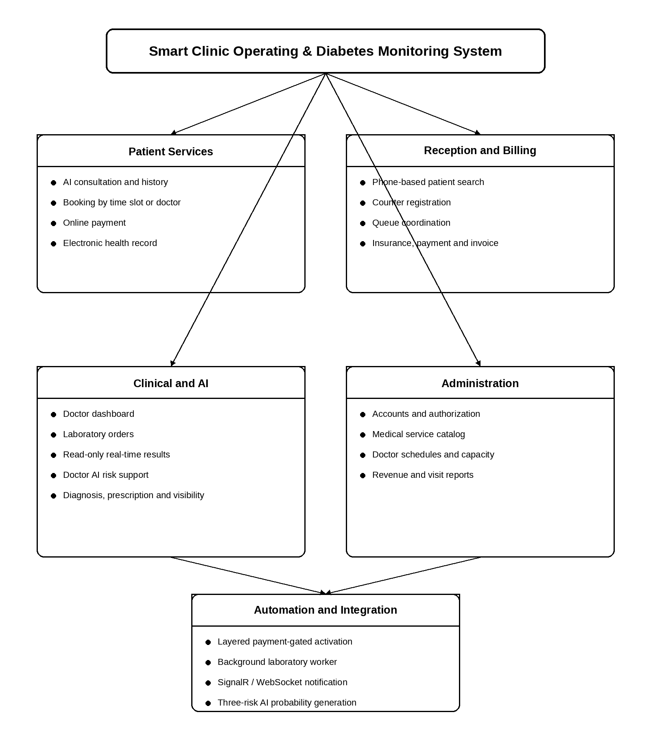
System Feature Tree - Authoritative Functional Decomposition
- Patient Services: AI symptom interaction, conversation history, booking by Doctor or time slot, online payment, and server-filtered electronic health record access.
- Reception and Billing: Indexed phone lookup, counter registration, Waiting-queue control, BHYT deduction, examination and Lab_Test payment, invoice export, and the FR-REC-11 activation transition.
- Clinical and AI: Doctor queue reception, patient and AI summary dashboard, Lab_Test ordering, read-only synchronized results, Doctor_AI three-class risk support, final diagnosis, and visibility control.
- Administration: Account and role governance, medical-service catalog, Doctor_Schedule capacity, and day/month/year revenue and completed-visit reporting; routine bulk queue routing is excluded.
- Automation and Integration: The payment-gated Healthy_Record state machine, Background Worker device synchronization, transactional Doctor_AI activation, and authenticated SignalR/WebSocket delivery.
- Context diagram:
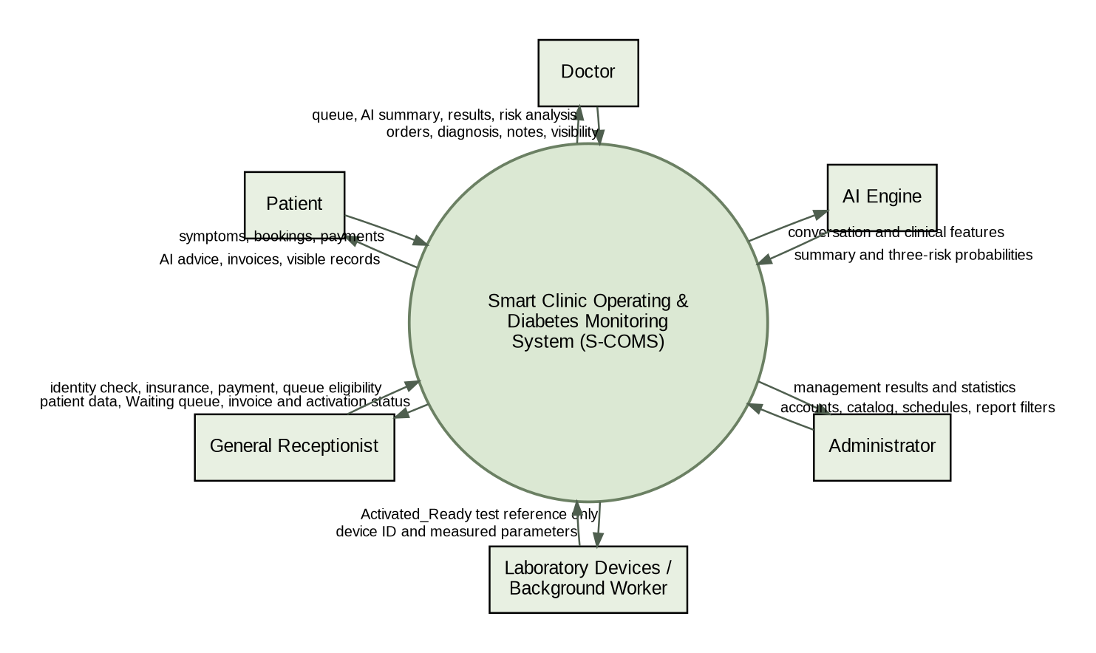
Context Diagram - Authoritative Data-Flow Interpretation
- Patient boundary: The Patient submits symptoms, booking selections, and verified online payments. S-COMS returns AI guidance, appointment and invoice information, and only records that pass authenticated ownership plus result_visibility = 1.
- General Reception boundary: The General Receptionist exchanges patient lookup data, administrative verification, BHYT deductions, collection results, queue eligibility, and invoice-export status with S-COMS.
- Doctor boundary: The Doctor receives an eligible Waiting queue, prior EMR, AI summary, completed laboratory measurements, and Doctor_AI probabilities; the Doctor returns Lab_Test orders, clinical notes, final diagnosis, prescriptions, and result_visibility.
- Laboratory boundary: Authorized analyzers send a stable integration identifier and biochemical values to the Background Worker. S-COMS exposes only an Activated_Ready test reference and never allows the device to bypass payment validation.
- AI boundary: The AI Engine processes conversational input and completed clinical features. It returns an AI symptom summary and three diabetes-risk probabilities but cannot finalize a diagnosis.
- Administrator boundary: The Administrator configures accounts, roles, service catalogs, schedules, and report filters. Normal Appointment progression is controlled by operational roles and state transitions rather than Administrator bulk dispatch.

AI-Assisted Patient Interaction and Appointment Booking

Description
This feature provides the patient-facing functions for AI consultation, conversation history, appointment selection, payment, and electronic health record access. Appointment availability is derived from Doctor_Schedule and current capacity. Priority: High.

Functional Requirements
- FR-PAT-01: The system shall allow the Patient to describe symptoms by text or supported voice input and receive preliminary AI guidance and a suggested medical specialty. [BR-07]
- FR-PAT-02: The system shall store AI conversation history and allow the Patient to review previous conversations associated with their patient profile.
- FR-PAT-03: The system shall allow the Patient to book an appointment by selecting an available date and time slot.
- FR-PAT-04: The system shall allow the Patient to book an appointment by selecting a specific Doctor and one of that Doctor’s available schedule slots.
- FR-PAT-05: The system shall prevent a booking when the selected Doctor_Schedule is Full, Cancelled, or has reached max_patients. [BR-01]
- FR-PAT-06: After a booking is confirmed, the system shall create an Appointment with booking_type = Online, assign a queue_number unique within the Doctor/work-date queue, and initialize Appointment.status = Waiting. The record shall remain the authoritative queue entry throughout the visit. [BR-02, BR-09]
- FR-PAT-07: The system shall allow the Patient to view a Pending invoice and complete online payment through an integrated payment method.
- FR-PAT-08: After a payment provider returns a verified success response, the system shall atomically set Invoice.status = Paid and record the payment method, transaction reference, and payment timestamp. A client-side success screen alone shall not change the payment state. [BR-03]
- FR-PAT-09: The system shall allow the Patient to view previous appointments, visible diagnoses, prescriptions, and completed laboratory results in the electronic health record.
- FR-PAT-10: Every Patient electronic-health-record endpoint shall enforce authenticated ownership and a server-side query condition equivalent to WHERE Medical_record.result_visibility = 1. When result_visibility = 0, the API shall return neither the clinical payload nor hidden-record metadata to the Patient device. [BR-05]

General Reception, Queue and Billing Management

Description
This feature combines reception and cashier responsibilities. It supports rapid patient lookup, walk-in registration, queue coordination, insurance deduction, payment collection, and invoice export. Priority: High.

Functional Requirements
- FR-REC-01: The system shall allow a General Receptionist to search Patient records, appointments, and visit history by phone number.
- FR-REC-02: The Patient.phone column shall be indexed to support efficient exact and normalized phone-number lookup. [NFR-PERF-01]
- FR-REC-03: The system shall allow the Receptionist to create or update a Patient profile for a walk-in visitor; Patient.account_id may remain NULL.
- FR-REC-04: The system shall allow the Receptionist to register an appointment by available time slot or specific Doctor and set booking_type = At_Counter.
- FR-REC-05: The system shall display the clinic intake queue from Appointment records with status = Waiting, grouped by Doctor, work date, and time slot and ordered by queue_number.
- FR-REC-06: Before a Waiting patient becomes eligible to enter the Doctor room, the General Receptionist shall verify administrative information, apply any approved BHYT deduction, and confirm that the examination-fee Invoice is Paid. Queue coordination shall be performed per visit and shall not require Administrator bulk routing.
- FR-REC-07: The system shall create and manage invoices for examination fees and laboratory services generated during a visit.
- FR-REC-08: The system shall calculate final_amount = total_amount - insurance_deduction and shall reject a deduction that produces a negative final amount. [BR-10]
- FR-REC-09: The system shall allow payment by Cash, Momo, VNPay, or Bank_Transfer and shall store the selected payment_method.
- FR-REC-10: When the Receptionist selects “Export Invoice” after successful collection, the system shall display “Invoice exported successfully”, set status = Paid, set exported_at, and return to the preceding management screen.
- FR-REC-11: When and only when the Invoice containing the ordered Lab_Test is transactionally confirmed as Paid, the system shall transition the linked Healthy_Record from Pending_Payment to Activated_Ready. The transition shall be atomic with payment confirmation and shall open the laboratory-device ingestion gate for that invoice_detail_id. [BR-04]

Clinical Examination, Laboratory and Doctor AI Support

Description
This feature supports the doctor’s complete clinical workflow from queue reception to medical-record closure. Laboratory values are read-only after device synchronization, and AI output is advisory. Priority: High.

Functional Requirements
- FR-DOC-01: The system shall display to each Doctor only eligible Appointment records assigned to that Doctor with status = Waiting, a valid queue_number, and a Paid examination-fee Invoice, ordered by queue_number and appointment time.
- FR-DOC-02: The system shall allow the Doctor to call a Waiting patient and update Appointment.status to In_Progress. [BR-02]
- FR-DOC-03: The Doctor dashboard shall display patient administrative information, previous medical records, and ai_summary from the linked AI_Conversation.
- FR-DOC-04: When an Appointment enters clinical processing, the system shall create at most one Medical_record linked 1-to-1 by appointment_id.
- FR-DOC-05: The system shall allow the Doctor to select active Lab_Test services and issue laboratory orders for the current Appointment.
- FR-DOC-06: For each ordered Lab_Test, the system shall create the billable Invoice_Detail and a uniquely linked Healthy_Record initialized with status = Pending_Payment; the record shall not yet accept laboratory-device measurements.
- FR-DOC-07: After the laboratory synchronization transaction and the related Doctor_AI calculation are committed, the system shall notify the assigned Doctor in real time through an authenticated SignalR/WebSocket channel.
- FR-DOC-08: The Doctor dashboard shall display synchronized urea, cr, hba1c, chol, tg, ldl, hdl, vldl, bmi and, when supplied, weight, height, and other_information as source-attributed read-only clinical data. [BR-12]
- FR-DOC-09: The system shall display the Doctor_AI diabetes_probability, pre_diabetes_probability, and normal_probability generated from the newly Completed Healthy_Record, together with the analysis timestamp and model/version metadata when available.
- FR-DOC-10: The system shall clearly identify Doctor_AI output as decision support and shall not save it as the final diagnosis. [BR-07]
- FR-DOC-11: The system shall allow the Doctor to enter final_diagnosis, doctor_note, and prescription information for the visit.
- FR-DOC-12: The system shall allow the Doctor to set result_visibility to 1 or 0 before closing the record. [BR-05]
- FR-DOC-13: When the Doctor completes the visit, the system shall set processed_at and Appointment.status = Completed. [BR-13]

Administration and Management Reporting

Description
This feature provides configuration and governance functions. It deliberately excludes routine bulk routing of normal appointments. Priority: High.

Functional Requirements
- FR-ADM-01: The system shall allow the Administrator to create, update, lock, and reactivate staff accounts.
- FR-ADM-02: The system shall allow the Administrator to assign and validate the roles Patient, Doctor, Receptionist, and Admin.
- FR-ADM-03: The system shall allow the Administrator to create, update, activate, and deactivate Medical_Service records and prices.
- FR-ADM-04: The system shall allow the Administrator to configure Doctor_Schedule work_date, time_slot, max_patients, and status.
- FR-ADM-05: The system shall automatically set or display a schedule as Full when the number of active appointments reaches max_patients.
- FR-ADM-06: The system shall generate revenue reports using Paid invoices and SUM(final_amount), grouped by day, month, or year.
- FR-ADM-07: The system shall generate visit-count reports using Completed appointments and COUNT(appointment_id), grouped by day, month, or year.
- FR-ADM-08: The Administrator shall not be required to manually distribute ordinary appointments in bulk; queue progression shall be driven by Appointment state and operational actions. [BR-08]

Automated Laboratory Data Synchronization

Description
This system-actor feature receives laboratory device data through a Background Worker, verifies payment eligibility, updates clinical measurements, triggers AI analysis, and pushes a real-time notification. Priority: High.

Functional Requirements
- FR-SYS-01: The Background Worker shall identify the target Healthy_Record using a unique laboratory integration identifier mapped to the paid Invoice_Detail.
- FR-SYS-02: Before persisting any analyzer payload, the Background Worker shall verify both conditions: the related Invoice.status = Paid and the target Healthy_Record.status = Activated_Ready. If either condition is false, the payload shall be rejected or quarantined without changing clinical data. [BR-04]
- FR-SYS-03: The Background Worker shall validate data types, required identifiers, and configured medical ranges before persistence.
- FR-SYS-04: The Background Worker shall map and persist the accepted biochemical measurements urea, cr, hba1c, chol, tg, ldl, hdl, vldl, and bmi directly into Healthy_Record; weight, height, and other_information shall also be persisted when provided by the authorized device contract.
- FR-SYS-05: Within the same successful database transaction that stores the validated measurements, the system shall set Healthy_Record.status = Completed, is_synced_automatically = 1, and synced_at to the database server time.
- FR-SYS-06: The synchronization operation shall be idempotent so that repeated transmission of the same device message does not create duplicate clinical records.
- FR-SYS-07: Immediately after Healthy_Record becomes Completed, the system shall trigger generation or update of exactly one Doctor_AI record containing diabetes_probability, pre_diabetes_probability, and normal_probability for the assigned Doctor.
- FR-SYS-08: Only after the Healthy_Record and Doctor_AI transaction has committed successfully shall the system publish a SignalR/WebSocket event to the authenticated session of the assigned Doctor.

Data Requirements

Logical Data Model
The S-COMS logical data model is divided into four database groups. The diagram below summarizes the principal entities, keys, cardinalities, and the transactional chain from intake queue to diabetes-risk decision support.
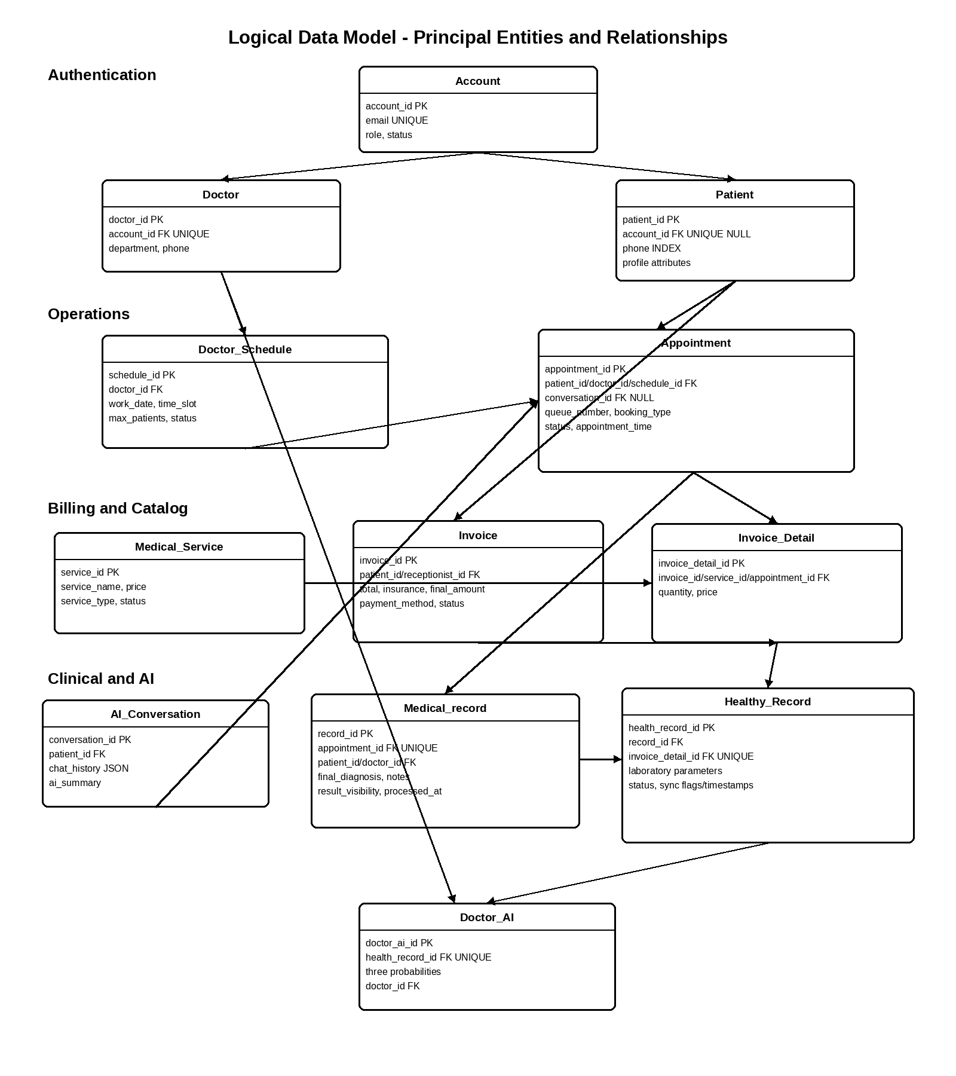
Logical Data Model - Authoritative Transaction and State Sequence
- 1. Appointment intake: Patient and Doctor_Schedule create an Appointment. The initial values are status = Waiting and queue_number assigned within the Doctor/work-date queue.
- 2. Pre-consultation billing: The examination charge is represented through Invoice and Invoice_Detail. BHYT is stored as insurance_deduction, and final_amount = total_amount - insurance_deduction. Doctor-room eligibility requires Invoice.status = Paid.
- 3. Clinical record creation: When the Doctor starts the visit, Appointment.status becomes In_Progress and one Medical_record is linked through the unique appointment_id.
- 4. Lab_Test order: Each ordered Lab_Test creates an Invoice_Detail and one linked Healthy_Record with status = Pending_Payment.
- 5. Payment-gated activation: A verified transition of the containing Invoice to Paid causes the linked Healthy_Record to move to Activated_Ready. This is the only state in which the analyzer ingestion gate is open.
- 6. Automated result transaction: The Background Worker validates identifiers and values, writes the biochemical measurements, and atomically changes Healthy_Record to Completed with is_synced_automatically = 1 and synced_at.
- 7. Doctor_AI trigger: A Completed Healthy_Record triggers exactly one Doctor_AI result containing diabetes_probability, pre_diabetes_probability, and normal_probability.
- 8. Privacy-controlled publication: Medical_record.result_visibility is controlled by the Doctor. Patient retrieval is permitted only through server-side ownership checks and WHERE result_visibility = 1.
- State summary: Appointment: Waiting -> In_Progress -> Completed, or Cancelled; Invoice: Pending -> Paid; Healthy_Record: Pending_Payment -> Activated_Ready -> Completed.

Core Entity Classes
- Authentication: Account, Doctor, and Patient manage login identity, professional information, personal information, and role-based access.
- Operations: Doctor_Schedule and Appointment control available capacity, appointment creation, queue_number, booking_type, and visit state.
- Billing & Catalog: Medical_Service, Invoice, and Invoice_Detail define services, point-in-time prices, insurance deduction, payment state, and billable items.
- Clinical & AI: AI_Conversation, Medical_record, Healthy_Record, and Doctor_AI store conversational context, final medical decisions, synchronized laboratory values, and AI decision-support probabilities.

Key Associations
- Account to Doctor is 1-to-0..1 through Doctor.account_id as a unique foreign key.
- Account to Patient is 1-to-0..1; Patient.account_id may be NULL for a walk-in patient.
- Doctor to Doctor_Schedule is 1-to-many.
- Doctor_Schedule to Appointment is 1-to-many and limited by max_patients.
- Patient to Appointment is 1-to-many.
- AI_Conversation to Appointment is 1-to-many through optional conversation_id.
- Appointment to Medical_record is 1-to-1 through unique appointment_id.
- Invoice to Invoice_Detail is 1-to-many.
- Invoice_Detail to Healthy_Record is 1-to-0..1 for Lab_Test items; the linked Healthy_Record begins at Pending_Payment and can become Activated_Ready only after the containing Invoice is Paid.
- Medical_record to Healthy_Record is 1-to-many.
- Healthy_Record to Doctor_AI is 1-to-1; creation or update of Doctor_AI is triggered only after the Healthy_Record transaction reaches Completed.

Data Dictionary

Authentication Group
- Account: account_id INT PK IDENTITY; full_name NVARCHAR(100) NOT NULL; password_hash VARCHAR(255) NOT NULL; email VARCHAR(100) UNIQUE NOT NULL; role VARCHAR(20) CHECK in Patient/Doctor/Receptionist/Admin; created_at DATETIME default GETDATE(); status VARCHAR(20) CHECK in Active/Locked.
- Doctor: doctor_id INT PK IDENTITY; full_name NVARCHAR(100) NOT NULL; phone VARCHAR(15) NOT NULL; email VARCHAR(100); department NVARCHAR(100); account_id INT UNIQUE FK NOT NULL.
- Patient: patient_id INT PK IDENTITY; full_name NVARCHAR(100) NOT NULL; date_of_birth DATE NOT NULL; gender NVARCHAR(10); phone VARCHAR(15) NOT NULL with INDEX; email VARCHAR(100); address NVARCHAR(255); account_id INT UNIQUE FK NULL.

Operations Group
- Doctor_Schedule: schedule_id INT PK IDENTITY; doctor_id INT FK NOT NULL; work_date DATE NOT NULL; time_slot VARCHAR(50) NOT NULL; max_patients INT NOT NULL and greater than zero; status VARCHAR(20) default Available and restricted to Available/Full/Cancelled.
- Appointment: appointment_id INT PK IDENTITY; patient_id, doctor_id, schedule_id INT FK NOT NULL; conversation_id INT FK NULL; appointment_time DATETIME NOT NULL; booking_type VARCHAR(20) restricted to Online/At_Counter; queue_number INT NOT NULL; status VARCHAR(20) default Waiting and restricted to Waiting/In_Progress/Completed/Cancelled; created_at DATETIME.

Billing & Catalog Group
- Medical_Service: service_id INT PK IDENTITY; service_name NVARCHAR(150) NOT NULL; price DECIMAL(18,2) NOT NULL; service_type VARCHAR(20) restricted to Examination/Lab_Test; status VARCHAR(20) default Active and restricted to Active/Inactive.
- Invoice: invoice_id INT PK IDENTITY; patient_id INT FK NOT NULL; receptionist_id INT FK NULL; total_amount DECIMAL(18,2) NOT NULL; insurance_deduction DECIMAL(18,2) default 0; final_amount DECIMAL(18,2) NOT NULL; payment_method VARCHAR(20) restricted to Cash/Momo/VNPay/Bank_Transfer; status VARCHAR(20) default Pending and restricted to Pending/Paid; created_at DATETIME; exported_at DATETIME NULL.
- Invoice_Detail: invoice_detail_id INT PK IDENTITY; invoice_id, service_id, appointment_id INT FK NOT NULL; quantity INT default 1; price DECIMAL(18,2) NOT NULL and retained as the price at billing time.

Clinical & AI Group
- AI_Conversation: conversation_id INT PK IDENTITY; patient_id INT FK NOT NULL; chat_history NVARCHAR(MAX) containing JSON; ai_summary NVARCHAR(MAX); created_at DATETIME.
- Medical_record: record_id INT PK IDENTITY; appointment_id INT UNIQUE FK NOT NULL; patient_id and doctor_id INT FK NOT NULL; final_diagnosis NVARCHAR(MAX) NULL; doctor_note NVARCHAR(MAX) NULL; result_visibility BIT default 1; processed_at DATETIME.
- Healthy_Record: health_record_id INT PK IDENTITY; record_id INT FK NOT NULL; invoice_detail_id INT UNIQUE FK NOT NULL; urea, cr, hba1c, chol, tg, hdl, ldl, vldl, bmi, weight, height DECIMAL fields NULL; other_information NVARCHAR(MAX); status restricted to Pending_Payment/Activated_Ready/Completed; is_synced_automatically BIT; created_at DATETIME; synced_at DATETIME NULL.
- Doctor_AI: doctor_ai_id INT PK IDENTITY; health_record_id INT UNIQUE FK NOT NULL; diabetes_probability, pre_diabetes_probability, normal_probability DECIMAL(5,2); doctor_id INT FK NOT NULL.

Reports
- Revenue Report: SUM(Invoice.final_amount) for Paid invoices, grouped by selected day, month, or year.
- Completed Visit Report: COUNT(Appointment.appointment_id) for Completed appointments, grouped by day, month, or year.
- Doctor Workload Report: Appointment counts by Doctor, work date, status, and schedule capacity.
- Laboratory Synchronization Report: Counts of Pending_Payment, Activated_Ready, and Completed records, including automatic synchronization timestamps and failures.
- Patient Medical History: Chronological appointments, visible diagnoses, prescriptions, and completed laboratory results for one Patient.

Data Acquisition, Integrity, Retention, and Disposal

Data Acquisition
- Patient and appointment data are acquired through the patient portal or reception dashboard.
- AI conversation data are acquired through text or supported voice interaction and stored as JSON plus ai_summary.
- Clinical diagnosis and notes are entered by the assigned Doctor.
- Laboratory values are acquired automatically from authorized devices through the Background Worker.
- Payment confirmations are acquired from the receptionist workflow or an integrated payment provider.

Data Integrity
- Appointment, invoice, activation, laboratory synchronization, AI generation, and completion updates shall use database transactions where multiple tables are changed.
- Foreign-key and unique constraints shall prevent orphan records and duplicate 1-to-1 relationships.
- Queue numbers shall be unique within the configured Doctor/work-date context.
- Invoice_Detail.price shall preserve the charged price even if Medical_Service.price changes later.
- Laboratory messages shall be validated and processed idempotently.
- Doctor-entered final diagnosis shall remain distinguishable from AI-generated suggestions.

Retention and Disposal
- Medical, appointment, billing, AI summary, and audit data shall be retained according to the healthcare organization’s approved retention policy and applicable regulations.
- Backups shall be encrypted and tested periodically for restoration.
- Deactivation or logical deletion shall be preferred for records that must remain auditable.
- Temporary integration payloads and error queues shall be disposed of after their configured retention period, provided the corresponding audit information is preserved.

External Interface Requirements

User Interfaces
The system shall provide role-specific responsive web interfaces for Patients, General Receptionists, Doctors, and Administrators.
- Patient Portal: AI chat/voice interaction, conversation history, doctor/time-slot selection, invoice payment, and electronic health record. Hidden records shall not appear in lists, details, downloads, or API responses.
- Receptionist Dashboard: A high-frequency workspace with indexed phone search, counter registration, queue panels, insurance fields, payment method selection, and an “Export Invoice” action with success notification and return navigation.
- Doctor Dashboard: A personal queue, patient summary, prior EMR, AI symptom summary, laboratory order selection, read-only real-time laboratory results, AI risk probabilities, final diagnosis, notes, prescription, and result_visibility control.
- Administrator Dashboard: Account/role management, service catalog, schedule capacity, and report filters for day/month/year.

Software Interfaces
- SQL Server: Stores all four database groups and enforces keys, status constraints, indexes, and transactions.
- AI Engine/API: Receives conversation input and clinical features; returns symptom summaries and risk probabilities with model/version metadata where available.
- Payment Gateways: Momo, VNPay, and banking services return verified payment status and a transaction reference.
- SignalR/WebSocket Service: Pushes laboratory-completion and AI-analysis events to authorized Doctor sessions.
- Background Worker: Consumes laboratory device messages, validates payment eligibility, writes Healthy_Record, and triggers downstream processing.

Hardware Interfaces
- Client Devices: Desktop PCs, laptops, tablets, and smartphones with supported browsers.
- Laboratory Devices: Authorized analyzers or an intermediate integration gateway capable of sending a stable identifier and supported measurement payload.
- Printers: Optional thermal or laser printers for physical invoice and prescription output.
- Network Infrastructure: Secure LAN/Wi-Fi and internet connectivity suitable for payment, AI, and real-time services.

Communications Interfaces
- All browser-to-server traffic shall use HTTPS with current TLS configuration.
- Real-time server-to-client notifications shall use authenticated SignalR/WebSocket connections.
- External API requests shall include timeouts, retry policy, correlation identifiers, and error logging.
- Laboratory messages shall use an agreed JSON, HL7-compatible, or vendor-specific interface contract that defines identifiers, units, value types, and timestamps.
- Payment callbacks shall be authenticated and verified before the Invoice is set to Paid.

Quality Attributes

Usability
- A trained Receptionist shall be able to locate an existing Patient by phone and open the profile within three user actions after entering the number.
- The booking interface shall clearly distinguish Available, Full, and Cancelled schedule slots.
- The invoice workflow shall display the original amount, insurance deduction, final amount, payment method, and payment status before export.
- The Doctor dashboard shall visually distinguish raw laboratory results, AI suggestions, and the doctor’s final diagnosis.
- Validation and failure messages shall identify the affected field or operation and provide a recoverable next action.

Performance
- NFR-PERF-01: For an exact normalized phone-number search over up to one million Patient records, the server-side query shall complete within 500 milliseconds at the 95th percentile under the agreed test environment.
- NFR-PERF-02: Standard authenticated pages shall return an initial usable response within 3 seconds at the 95th percentile under normal operating load.
- NFR-PERF-03: After a laboratory transaction is committed, the assigned Doctor dashboard shall receive the real-time completion event within 2 seconds at the 95th percentile.
- NFR-PERF-04: Day/month/year revenue and visit reports shall return within 5 seconds for the agreed production data volume.

Security
- NFR-SEC-01: The system shall enforce role-based access control for Patient, Doctor, Receptionist, and Admin functions.
- NFR-SEC-02: Passwords shall be stored using an approved salted one-way password-hashing algorithm and shall never be logged or returned by an API.
- NFR-SEC-03: All Patient-facing list, detail, download, and export operations shall enforce record ownership and a server-side condition equivalent to WHERE Medical_record.result_visibility = 1. Records with result_visibility = 0 shall not be serialized, cached, logged as response content, or returned to the Patient device; client-side concealment is prohibited as the sole control.
- NFR-SEC-04: Only the assigned or otherwise authorized Doctor shall view clinical details and update the final diagnosis.
- NFR-SEC-05: Laboratory values synchronized from devices shall be read-only to Patient and Receptionist roles and shall not be silently overwritten by a normal UI operation.
- NFR-SEC-06: The system shall log successful and failed authentication, account changes, payment-state changes, laboratory synchronization, result-visibility changes, and medical-record completion.
- NFR-SEC-07: All sensitive data in transit shall be protected by HTTPS/TLS, and backups containing medical data shall be encrypted.

Safety
- NFR-SAFE-01: AI consultation and Doctor_AI results shall be labeled as support information and shall not automatically finalize a diagnosis or prescription.
- NFR-SAFE-02: The system shall preserve the original synchronized laboratory values and record the source and synchronized timestamp for auditability.
- NFR-SAFE-03: Invalid, incomplete, duplicate, or unmapped laboratory payloads shall be quarantined or rejected without modifying a completed medical record.
- NFR-SAFE-04: The Doctor shall confirm the final diagnosis and record visibility before Appointment.status can be changed to Completed.
- NFR-SAFE-05: The system should highlight values outside configured reference ranges without modifying the raw values.

Availability, Reliability and Scalability
- NFR-REL-01: The operational web application shall achieve at least 99% availability during published working hours, excluding approved maintenance windows.
- NFR-REL-02: The Background Worker shall retry transient device, database, or network failures using bounded retries and shall place unrecoverable messages in an error queue for review.
- NFR-REL-03: Laboratory processing and payment callback handling shall be idempotent.
- NFR-REL-04: Database indexes shall support Patient.phone, common Appointment queue filters, Invoice status/date reporting, and Healthy_Record status/integration lookup.
- NFR-REL-05: The application architecture shall support horizontal scaling of stateless web/API components and controlled scaling of background workers.

Internationalization and Localization Requirements

Language Requirements
- LOC-01: The Release 1.0 user interface shall use Vietnamese as the primary language; English technical identifiers may remain in administrative or diagnostic logs.

Currency and Number Formatting
- LOC-02: All service prices, deductions, payments, and report totals shall be represented in Vietnamese Dong (VND).
- LOC-03: The user interface shall format monetary values using Vietnamese conventions and shall not display unnecessary decimal fractions for VND.

Date, Time, and Time Zone
- LOC-04: Dates shall be displayed in DD/MM/YYYY format and time shall be displayed in 24-hour format.
- LOC-05: Scheduling, logging, reporting, created_at, processed_at, exported_at, and synced_at shall use ICT (UTC+7) or be stored in UTC and consistently converted to ICT for display.

Contact Information Formatting
- LOC-06: Vietnamese mobile phone numbers shall be normalized for lookup and validated according to the organization’s approved format; the displayed local format shall contain 10 digits beginning with 0 where applicable.

Other Requirements

Business Rules and Operational Controls
- BR-01: A Doctor_Schedule shall not accept more active appointments than max_patients.
- BR-02: Appointment.status shall follow the permitted set Waiting, In_Progress, Completed, Cancelled; invalid direct transitions shall be rejected.
- BR-03: Invoice.status shall be Pending or Paid. Paid status requires verified collection or gateway confirmation.
- BR-04: A laboratory record shall receive device data only after the related Lab_Test invoice is Paid.
- BR-05: The Doctor controls Medical_record.result_visibility; Patient access requires result_visibility = 1.
- BR-06: A Patient may have multiple appointments, but each Appointment creates at most one Medical_record.
- BR-07: AI output is advisory and cannot replace the Doctor’s final diagnosis.
- BR-08: The Administrator configures resources and handles exceptions but does not perform routine bulk routing of normal visits.
- BR-09: queue_number shall be unique within the configured Doctor and work-date queue.
- BR-10: Invoice.final_amount equals total_amount minus insurance_deduction and shall not be negative.
- BR-11: Doctor_AI probabilities shall be stored with a defined scale and validation rule; the expected total should equal 100% within the configured rounding tolerance.
- BR-12: Completed automatically synchronized laboratory values are read-only in ordinary user interfaces.
- BR-13: Appointment completion requires a saved Medical_record, processed_at, and a Doctor-confirmed final diagnosis.

Privacy and Security Policies
- Patient records shall not be exposed through predictable identifiers without authorization checks.
- Result visibility shall be enforced in list, detail, export, notification, cache, and API endpoints through server-side ownership checks and WHERE result_visibility = 1.
- AI and external integration payloads shall contain only the minimum necessary patient information.
- Sensitive information shall not be written to standard application logs.
- Administrative and clinical changes shall be attributable to an authenticated account.

Backup, Monitoring and Auditing
- The database shall be backed up on an approved schedule and restoration shall be tested periodically.
- Application, payment, AI, WebSocket, and Background Worker health shall be monitored.
- Failed laboratory messages shall include a correlation identifier, source identifier, failure reason, and retry count.
- Audit records shall be protected against ordinary user modification and retained according to policy.
- Operational alerts shall be generated for repeated synchronization failures, payment-callback verification failures, and unavailable critical dependencies.

Appendix A: Glossary
- AI Engine: The component that processes patient conversation and generates clinical decision-support output.
- AI_Conversation: Database entity containing chat_history and an AI-generated symptom summary.
- Background Worker: A continuously running server-side process that receives and synchronizes laboratory device data.
- BHYT: Vietnamese Health Insurance; represented as an insurance deduction on an invoice.
- Doctor_AI: A one-to-one AI analysis record for a completed Healthy_Record.
- EMR: Electronic Medical Record.
- Healthy_Record: The project database entity that stores automatically synchronized laboratory and body measurements.
- NLP: Natural Language Processing.
- result_visibility: A BIT field in Medical_record that controls whether the Patient may view the result.
- SignalR/WebSocket: A real-time server-to-client communication mechanism.
- S-COMS: Smart Clinic Operating & Diabetes Monitoring System; the official project name and mandatory abbreviation used throughout this SRS.

Appendix B: Analysis Models
The primary analysis models included in this SRS are the use case diagram, system feature tree, context diagram, and logical data model. The step-by-step textual interpretations in Sections 3 and 4 are authoritative whenever an embedded image is unavailable, scaled incorrectly, or visually ambiguous. Detailed process models, API contracts, state-transition diagrams, and the physical ERD shall be maintained as controlled artifacts traced to the requirement identifiers in this document.

