**English Vocabulary**

**Software Requirement Specifications**

Project Code:

Document code: EnglishVocabulary_SRS_v1.0.1

Ho Chi Minh City, 17th December, 2018

# **Record of change**

**\*A – Added M – Modified D – Deleted**

|  |  |  |  |  |
| --- | --- | --- | --- | --- |
| Effective Date | Changed Items | A*  M, D | Change Description | New Version |
|  |  |  | The first version | 1.0 |
|  |  |  | Add more requirements | 1.0.1 |
|  |  |  |  |  |
|  |  |  |  |  |
|  |  |  |  |  |
|  |  |  |  |  |
|  |  |  |  |  |
|  |  |  |  |  |

# **SIGNATURE PAGE**

|  |  |  |  |  |
| --- | --- | --- | --- | --- |
| **AUTHOR:** |  | Name: Group 5  Title: |  | Signature:  Date: |
| **REVIEWERS:** |  | Name:  Title: |  | Signature:  Date: |
| **APPROVAL:** |  | Name:  Title: |  | Signature:  Date: |

# **Table of Contents**

**Contents**

Record of change 2

SIGNATURE PAGE 3

Table of Contents 4

1. Introduction 7

1.1 Purpose 7

1.2 Application Range 7

1.2.1 For Admin User 7

1.2.2 For Manager User 7

1.2.3 For Non- Registered Users 7

1.2.4 For Registered Users 8

1.3 Definitions, Acronyms, and Abbreviations 8

1.4 References 8

2. High Level Requirements 8

2.1 Product Perspective 9

2.2 Actor and Use Cases Descriptions 9

2.2.1 Diagram 9

2.2.2 Actor Description 14

2.2.3 Use Cases Description 14

2.2.4 Use Case & Actor mapping 17

2.3 Operating Environment 19

2.4 Assumption and Dependencies 19

3. Functional Requirements 19

3.1 Module UC01: Login 19

3.1.1 Use Case Description 19

3.1.2 Diagram 19

3.2 Module UC02: Manage users 20

3.2.1 Use Case Description 20

3.2.2 Diagram 21

3.3 Module UC03: Add, Delete user 21

3.3.1 Use Case Description 21

3.3.2 Diagram 22

3.4 Module UC04: Decentralization of users 23

3.4.1 Use Case Description 23

3.4.2 Diagram 24

3.5 Module UC05: Edit customer’s information 24

3.5.1 Use Case Description 24

3.5.2 Diagram 25

3.6 Module UC06: Manage staffs 26

3.6.1 Use Case Description 26

3.6.2 Diagram 26

3.7 Module UC07: Add, Delete Staffs 27

3.7.1 Use Case Description 27

3.7.2 Diagram 28

3.8 Module UC08: Decentralization of staffs. 29

3.8.1 Use Case Description 29

3.8.2 Diagram 30

3.9 Module UC09: Edit staffs 30

3.9.1 Use Case Description 30

3.5.2 Diagram 31

3.10 Module UC10: Manage database 32

3.10.1 Use Case Description 32

3.10.2 Diagram 32

3.11 Module UC11: Add, Delete, update database 33

3.11.1 Use Case Description 33

3.11.2 Diagram 34

3.12 Module UC12: Translate English - Vietnamese 35

3.12.1 Use Case Description 35

3.12.2 Diagram 36

3.13 Module UC13: Translate Vietnamese – English 37

3.13.1 Use Case Description 37

3.13.2 Diagram 38

3.14 Module UC14: Learning vocabulary 38

3.14.1 Use Case Description 38

3.14.2 Diagram 39

3.15 Module UC15: Test form 40

3.15.1 Use Case Description 40

3.15.2 Diagram 41

3.16 Module UC16: Assessment form 41

3.16.1 Use Case Description 41

3.16.2 Diagram 42

3.17 Module UC17: Feedback rating 42

3.17.1 Use Case Description 42

3.17.2 Diagram 43

3.18 Module UC18: Chat room 43

3.18.1 Use Case Description 43

3.18.2 Diagram 44

4. Non – functional Requirements 44

4.1 Correctness 44

4.2 Interoperability 44

4.3 Performance 45

4.4 Portability 45

4.5 Reliability 45

4.6 Reusability 45

5. Main Screen 46

1. **Introduction**
   1. **Purpose**

* The purpose of this document is to provide the requirements details of Learning English Vocabulary application. This document will describe and provide the detail of system's development. It will tell you all about the system's structure, user interface, and application interactive. This document is propose to customer to approve and it also be a reference in development stages (design, coding, testing,...).
  1. **Application Range**
     1. **For Admin User**
* Have all permissions in the system.
* Supervising and maintenance the system.
* Distributing the access and management of the application.
  + 1. **For Manager User**
* Supporting users.
* Add, delete, and modify user’s information.
* Distributing the access of customers.
* Modify and save user information.
  + 1. **For Non- Registered Users**
* English - Vietnamese Dictionary, Vietnamese - English Dictionary.
* Learning English Vocabularies (limit at word suggestions and have no reviews).
  + 1. **For Registered Users**
* English – Vietnamese Dictionary, Vietnamese – English Dictionary.
* Learning English Vocabularies (have no limit in word suggestions).
* The user can communicate with each other.
* Have routine tests and reviews.
  1. **Definitions, Acronyms, and Abbreviations**

|  |  |  |
| --- | --- | --- |
| # | Abbreviations / Terms | Explanation |
| 1 | SRS | Software Requirement Specification |
| 2 | BR | Business Rule |
| 3 | SC | Screen |
| 4 | UC | Use Case |
| 5 | CRUD | Create/Read/Update/Delete a record in database |

Table 1: Abbreviations & Terminologies

* 1. **References**

|  |  |  |
| --- | --- | --- |
| # | Name | Description |
|  |  |  |

Table 2: Reference

1. **High Level Requirements**
   1. **Product Perspective**

* This application is a web app which is made to help people, who need learn English vocabulary. The user can learn vocabulary exchange and take tests, assessing for their own hard work themselves.
  1. **Actor and Use Cases Descriptions**
     1. **Diagram**

|  |
| --- |
| Admin |
| Diagram 1: Admin roles |

|  |
| --- |
| Staff |
| Diagram 2: Satff roles |

|  |
| --- |
| Customer is member  Customer isn’t member |
| Diagram 3: Customer access |
| System    Staffs    Admin |

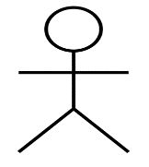System

 Customers  Staffs

Cancel

Cancel

X Terminate Admin X Terminate

**Terminate**

**Submitted**

Rejected

Approved / Rejected

Approved

### **Actor Description**

|  |  |  |  |
| --- | --- | --- | --- |
| No. | Actor name | Definition & Interests | Notes |
| 1 | Admin | Administrators of the software, have all rights on the system |  |
| 2 | Staffs | He is responsible for managing information, which is responsible for creating, updating, deleting customer’s account and authorization, edit, star save system data. |  |
| 3 | Customer(member) | People who interact with software applications and have the right to use all the functions that the software provides. |  |
| 4 | Customer( not a member) | People who interact with software applications and have access to a limited portion of the functionality that the software provides. |  |

Table 3: Actor Descriptions

### **2.2.3 Use Cases Description**

|  |  |  |  |  |
| --- | --- | --- | --- | --- |
| No. | Code | Name | Brief Description | Notes |
| 1 | UC01 | Login | Login into system |  |
| 2 | UC02 | Manage users | View customer’s information and permissions tool for each user group. | People who are the same level do not view each other’s information |
| 3 | UC03 | Add, Delete user | Allows administrators and managers to assign add, delete to specific users | When staffs adds or deletes, she/he must report to the admin first. |
| 4 | UC04 | Decentralization of users | Allows administrators and managers to assign permissions to specific users | When staffs decentralized for user, she/he must report to the admin first. |
| 5 | UC05 | Edit customer’s information | Allows administrators and managers to edit a specific customer’s information | When staffs edited customer’s information, she/he must report to the admin first. |
| 6 | UC06 | Manage staffs | Allows for administrators view customer’s information and permissions tool for each staffs group. | Admin who managed for staffs |
| 7 | UC07 | Add, Delete Staffs | Allows administrators to assign add, delete to specific staffs | Admin who add or delete for staffs |
| 8 | UC08 | Decentralization of staffs | Allows administrators to assign permissions to specific staffs | Admin who decentralized for staffs |
| 9 | UC09 | Edit staffs | Allows administrators to edit a specific staffs information | Admin who edited for staffs |
| 10 | UC10 | Manage database | Allows administrators and managers to view databases in the system | Both admin and staffs manage database |
| 11 | UC11 | Add, Delete, update database | Allows administrators and managers to assign add, delete, update to specific databases | When staffs adds or deletes, update she/he must report to the admin first. |
| 12 | UC12 | Translate English - Vietnamese | Allows users to search and translate words from English to Vietnamese. | Anyone can do it |
| 13 | UC13 | Translate Vietnamese - English | Allows users to search and translate words from Vietnamese to English | Anyone can do it |
| 14 | UC14 | Learning Vocabulary | Allows all people who are a member can learn vocabulary available from database | People who are member can do it |
| 15 | UC15 | Test form | Allows all people who are a member to take the test | People who are member can do it |
| 16 | UC16 | Assessment form | Allows all people who are a member can take an assessment form from the system after making test | People who are member can do it |
| 17 | UC17 | Feedback rating | Allows all people who are a member have a feedback rating from the system after a month | People who are member can do it |
| 18 | UC18 | Chat room | Allows all people who are a member can chat with each others though chat rooms | People who are member can do it |

Table 4: Use Cases Description

### **2.2.4 Use Case & Actor mapping**

|  |  |  |  |  |
| --- | --- | --- | --- | --- |
| Actor  Use Case | Admin | Staffs | Users(member) | Users(not a member) |
| UC01: Login | X | X | X |  |
| UC02: Manage users | X | X |  |  |
| UC03: Add, Delete user |  | X |  |  |
| UC04: Decentralization of users |  | X |  |  |
| UC05: Edit customer’s information |  | X |  |  |
| UC06: Manage staffs | X |  |  |  |
| UC07: Add, Delete Staffs | X |  |  |  |
| UC08: Decentralization of staffs. | X |  |  |  |
| UC09: Edit staffs | X |  |  |  |
| UC10: Manage database | X | X |  |  |
| UC11: Add, Delete, update database |  | X |  |  |
| UC12: Translate English - Vietnamese |  | X | X | X |
| UC13: Translate Vietnamese - English |  | X | X | X |
| UC14: Learn vocabulary |  | X | X |  |
| UC15: Test |  |  | X |  |
| UC16: Assessment form |  |  | X |  |
| UC17: Feedback rating |  |  | X |  |
| UC18: Chat room |  | X | X |  |

Table 5: Use Case & Actor mapping

* 1. **Operating Environment**
  2. **Assumption and Dependencies**

1. **Functional Requirements**

## **3.1 Module UC01: Login**

### **3.1.1 Use Case Description**

|  |  |
| --- | --- |
| Purpose | Ensure users authentication and secure system security as well as user hierarchy |
| Description | With each user account will be shared to three type is admin, managers and customers who are member, the following user type that will allowed to other systems. Want to use the permissions that the user must be logged in the system. |
| Agent | Admin, managers, customers who are member |
| Pre-conditions | User is already logged in account in the system |
| Event stream | * Show login form * Enter your login information * Send the login information to the system * Check the login information, if true, allow access, wrong, prompted re-enter |
| The following condition | Message successful login / failure |

### **3.1.2 Diagram**

Whether the check has been entered successfully or not

Show login form

Enter login information

Send login information to the system

Request to re-enter information

No

Yes

Check login information

Logged in successfully

## **3.2 Module UC02: Manage users**

### **3.2.1 Use Case Description**

|  |  |
| --- | --- |
| Purpose | Via the customer’s information, the administrators and managers can get the amount and cost collected through their payment |
| Description | Allows administrators and managers to view user information as well as can view the detail of each specific person. |
| Agent | Admin, managers |
| Pre-conditions | Select the user management function. |
| Event stream | * Show customer’s information form * Select function interact with the data |
| The following condition | Send messages you have already want to interact with data or not. |

### **3.2.2 Diagram**

Show customer’s information

Login

No

Check

Yes

Interact with database

## **3.3 Module UC03: Add, Delete user**

### **3.3.1 Use Case Description**

|  |  |
| --- | --- |
| Purpose | Licensed to operate in the system for a new user or to remove the privileges of the old user. |
| Description | When a new user wants to operate in the system, managers or administrator will use the add user function to grant access and active. The delete function will remove the user's rights from the system, ensuring security when users no longer work in the organization can not interact with the system. |
| Agent | Admin, managers |
| Pre-conditions | Select the user management function. |
| Event stream | Show customer’s information form   * Select user add function: * Show the form add user * Enter new username and password * Send information to the system to check whether the user exists or not * If this does not exist, the message to create the user is successful, if it exists * The message re-enter the username and password * Select user delete function: * Show user delete form * Select the user to delete * Send the request to the system * The user deletion message is now successful |
| Accessory thread | In the add new user function if the system checks if the login already exists, the user message already exists |
| The following condition | A newly licensed user active an old user is removed from the system. |

### **3.3.2 Diagram**

Add users

Show user add form

Enter name and password of new users

Send registration information to the system

The user testing system already exists or not

Delete users

Add new users into the system successfully

Show user delete form

Remove user from system

Send request to the system

## **3.4 Module UC04: Decentralization of users**

### **3.4.1 Use Case Description**

|  |  |
| --- | --- |
| Purpose | Ensure strict management of each customer in the system |
| Description | Each customer who is created user accounts will be given specific rights corresponding to the rights of the authorized user. |
| Agent | Admin, managers |
| Pre-conditions | User has been created account in the system. |
| Event stream | * Show manage users form * Select users in the user list * Select the delegate function * Complete decentralization process |
| Accessory thread | If the user chooses the decentralization function but does not want to proceed, then click the Exit button to cancel the process. |
| The following condition | Provide specific rights for each employee, ensuring accuracy in the work of employees. |

### **3.4.2 Diagram**

Show access permissions form

Select the delegate function

Select user in the user list

Select permissions that allow users to interact

Successful decentralization

Agree

Exit

## **3.5 Module UC05: Edit customer’s information**

### **3.5.1 Use Case Description**

|  |  |
| --- | --- |
| Purpose | Strictly manage the personal information of each user. |
| Description | The user can edit his or her personal information whenever there are any changes. Only users of the same account can edit their personal information, users of the same level can not see each other's personal information. |
| Agent | Admin, managers |
| Pre-conditions | The user has been created account in the system and select the user management function. |
| Event stream | * Show manage users form * In the user information section edit the information you want to change: * Full name * Date of birth * Sex * Phone * Address * Save your edited personal information |
| Accessory thread | * If users do not want to save their personal information after the edit can cancel action with the Cancel button * If the user is entering a different number, the message box will appear |
| The following condition | Correctly update each user's information so that management is more stringent. |

### **3.5.2 Diagram**

Send the modified information to the system

Edit customer’s information

Show manage users form

Invalid data

Check information

Cancel

Valid data

Save information which is edited

Change personal information in the system

## 

## **3.6 Module UC06: Manage staffs**

### **3.6.1 Use Case Description**

|  |  |
| --- | --- |
| Purpose | The administrators manage information of staffs |
| Description | Allows administrators to view user information as well as can view the detail of each specific staffs. |
| Agent | Admin |
| Pre-conditions | Select the user management function. |
| Event stream | * Show staff’s information form * Select function interact with the data |
| The following condition | Send messages you have already want to interact with data or not. |

### **3.6.2 Diagram**

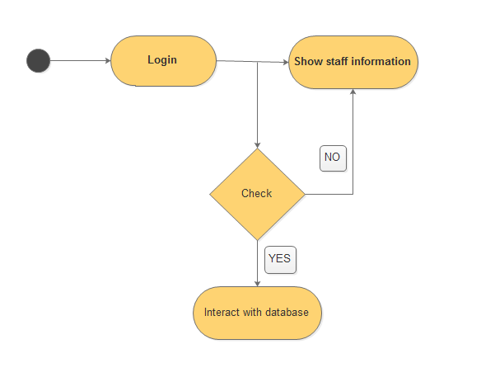

## **3.7 Module UC07: Add, Delete Staffs**

### **3.7.1 Use Case Description**

|  |  |
| --- | --- |
| Purpose | Licensed to operate in the system for a new staff or to remove the privileges of the old staff. |
| Description | When a new staff wants to operate in the system, managers and administrator will use the add staff function to grant access and active. The delete function will remove the staffs rights from the system, ensuring security when staffs no longer work in the organization can not interact with the system. |
| Agent | Admin |
| Pre-conditions | Select the staff management function. |
| Event stream | Show staff’s information form   * Select staff add function: * Show the form add staff * Enter new username and password * Send information to the system to check whether the staff exists or not * If this does not exist, the message to create the staff is successful, if it exists * The message re-enter the username and password * Select staff delete function: * Show staff delete form * Select the staff to delete * Send the request to the system * The user deletion message is now successful |
| Accessory thread | In the add new staff function if the system checks if the login already exists, the staff message already exists |
| The following condition | A newly licensed staff active an old staff is removed from the system. |

### **3.7.2 Diagram**

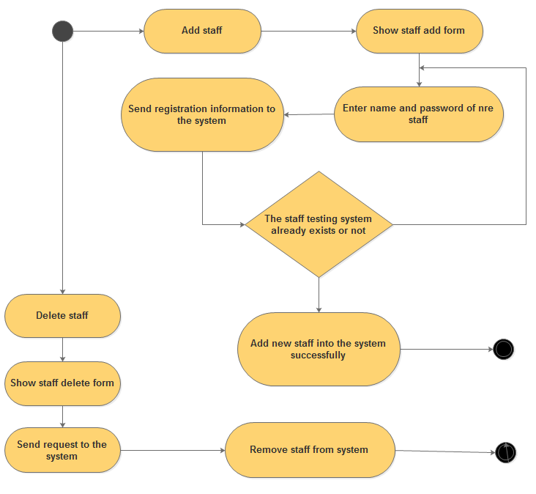

## **3.8 Module UC08: Decentralization of staffs.**

### **3.8.1 Use Case Description**

|  |  |
| --- | --- |
| Purpose | Ensure strict management of each customer in the system |
| Description | Each staff who is created staff accounts will be given specific rights corresponding to the rights of the authorized staff. |
| Agent | Admin |
| Pre-conditions | User has been created account in the system. |
| Event stream | * Show manage staff form * Select staff in the staff list * Select the delegate function * Complete decentralization process |
| Accessory thread | If the staff chooses the decentralization function but does not want to proceed, then click the Exit button to cancel the process. |
| The following condition | Provide specific rights for each staff, ensuring accuracy in the work of staff. |

### **3.8.2 Diagram**

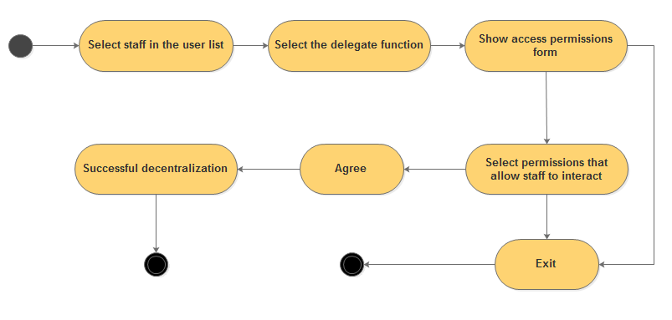

## **3.9 Module UC09: Edit staffs**

### **3.9.1 Use Case Description**

|  |  |
| --- | --- |
| Purpose | Strictly manage the personal information of each staff. |
| Description | The staff can edit his or her personal information whenever there are any changes. Only staff of the same account can edit their personal information, staffs of the same level can not see each other's personal information. |
| Agent | Admin |
| Pre-conditions | The staff has been created account in the system and select the staff management function. |
| Event stream | * Show manage staff form * In the staff information section edit the information you want to change: * Full name * Date of birth * Sex * Phone * Address * Save your edited personal information |
| Accessory thread | * If staff do not want to save their personal information after the edit can cancel action with the Cancel button * If the staff is entering a different number, the message box will appear |
| The following condition | Correctly update each staffs information so that management is more stringent. |

### **3.9.2 Diagram**

## 

## **3.10 Module UC10: Manage database**

### **3.10.1 Use Case Description**

|  |  |
| --- | --- |
| Purpose | The administrators and staffs manage information of database |
| Description | Allows administrators and staffs to view data information as well as can view the detail of each specific data. |
| Agent | Admin, managers |
| Pre-conditions | Select the data management function. |
| Event stream | * Show data information form * Select function interact with the data |
| The following condition | Send messages you have already want to interact with data or not. |

### **3.10.2 Diagram**

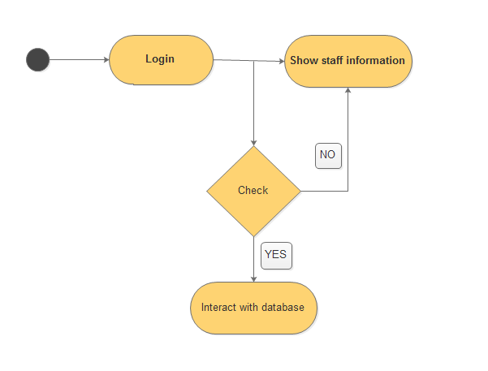

## **3.11 Module UC11: Add, Delete, update database**

### **3.11.1 Use Case Description**

|  |  |
| --- | --- |
| Purpose | Licensed to operate in the system for a new data or to remove the privileges of the old data as well as update data. |
| Description | When administrator or managers wants to change or delete, update the data in the system |
| Agent | Admin, managers |
| Pre-conditions | Select the data management function. |
| Event stream | Show data information form   * Select data add function: * Show the form add data * Enter new data * Send data information to the system to check whether the data exists or not * If it exists, the message to the system have to update data or not * If it wants, the message to create the data is updated successful, if it doesn’t want * The message re-enter the data * Select data delete function: * Show data delete form * Select the data to delete * Send the request to the system * The data deletion message is now successful |
| The following condition | A newly licensed data active an old data is removed from the system. |

### **3.11.2 Diagram**

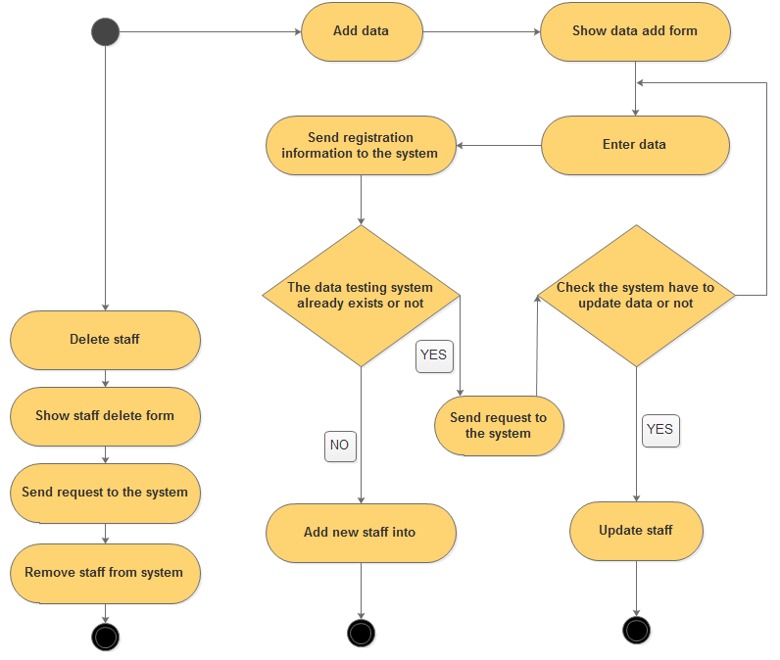

## **3.12 Module UC12: Translate English - Vietnamese**

### **3.12.1 Use Case Description**

|  |  |
| --- | --- |
| Purpose | Licensed to operate in the system for user to find out and translate words from English to Vietnamese. |
| Description | Allows users to search and translate words from English to Vietnamese. |
| Agent | Staff, User |
| Pre-conditions | User must input the word into the “finding box” |
| Event stream | * Show relation words with the word that the user have just entered. * Select function and data that fitting with action. And then showing the meaning of the word that the user entered. |
| The following condition | The word that user have entered must exist on the data. |

### **3.12.2 Diagram**

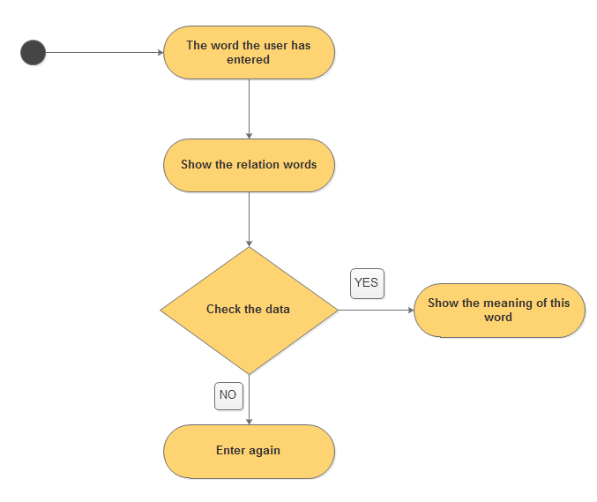

## **3.13 Module UC13: Translate Vietnamese – English**

### **3.13.1 Use Case Description**

|  |  |
| --- | --- |
| Purpose | Licensed to operate in the system for user to find out and translate words from Vietnamese to English. |
| Description | Allows users to search and translate words from Vietnamese to English. |
| Agent | Staff, User |
| Pre-conditions | User must input the word into the “finding box” |
| Event stream | * Show relation words with the word that the user have just entered. * Select function and data that fitting with action. And then showing the meaning of the word that the user entered. |
| The following condition | The word that user have entered must exist on the data. |

### **3.13.2 Diagram**

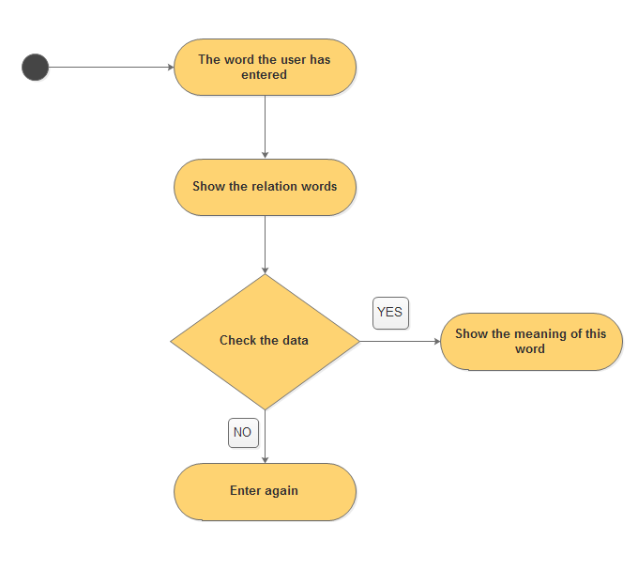

## **3.14 Module UC14: Learning vocabulary**

### **3.14.1 Use Case Description**

|  |  |
| --- | --- |
| Purpose | Licensed to operate in the system for user to find out and learn words from the data. |
| Description | Allows all people who are a member can learn vocabulary available from database. |
| Agent | Staff, User (members). |
| Pre-conditions | User must input the word into the “finding box” |
| Event stream | * Show relation words with the word that the user have just entered. * Select function and data that fitting with action. And then showing the meaning of the word that the user entered. |
| The following condition | The word that user have entered must exist on the data. |

### **3.14.2 Diagram**

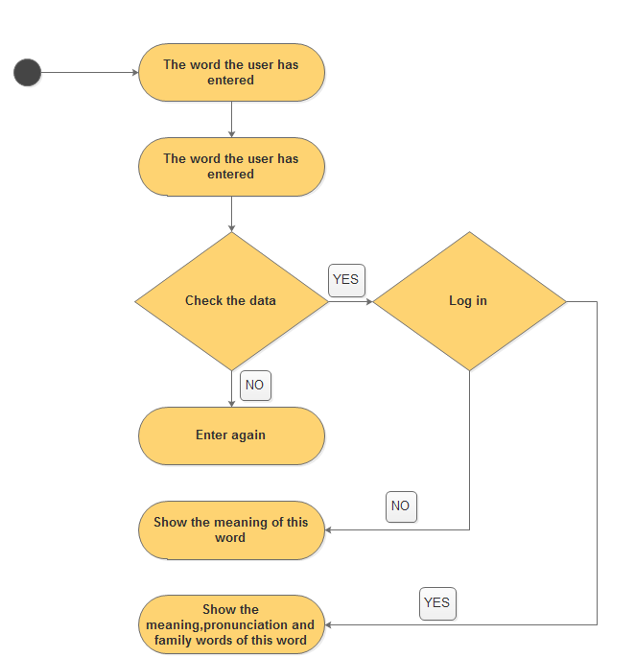

## **3.15 Module UC15: Test form**

### **3.15.1 Use Case Description**

|  |  |
| --- | --- |
| Purpose | Licensed to operate in the system for user to find out and take the test from the data. |
| Description | Allows all people who are a member can take the test that available from database. |
| Agent | User (members). |
| Pre-conditions | User must be a member. |
| Event stream | * Show the test for user that are the members to join in. * User can take the test from the system. |
| The following condition | User must entered into the “Test form” mode. |

### **3.15.2 Diagram**

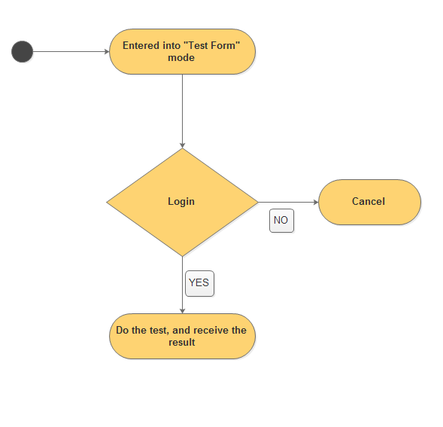

## **3.16 Module UC16: Assessment form**

### **3.16.1 Use Case Description**

|  |  |
| --- | --- |
| Purpose | Licensed to operate in the system for user to find out, take the test and then receive the result from the data. |
| Description | Allows all people who are a member can take an assessment form from the system after making test |
| Agent | User (members). |
| Pre-conditions | User must be a member. |
| Event stream | * Show result for user that are the members to join in and finish the test. * The system will show the mistake for user. |
| The following condition | User must finished the test form before. |

### **3.16.2 Diagram**

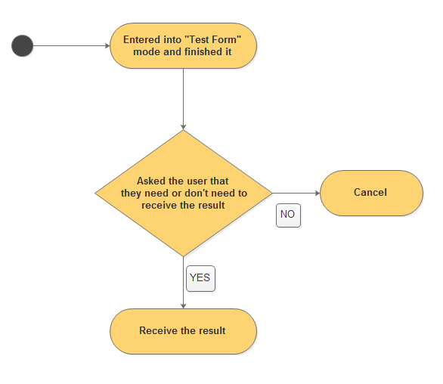

## **3.17 Module UC17: Feedback rating**

### **3.17.1 Use Case Description**

|  |  |
| --- | --- |
| Purpose | Licensed to operate in the system for user to give the feedback for the system. |
| Description | Allows all people who are a member have a feedback rating from the system after a month. |
| Agent | User (members). |
| Pre-conditions | User must be a member. |
| Event stream | * Before the system allow the user to log out and quit, they must be give the feedback for the system. * The system will check the information about user for how long did they become member of us. * Then if they are a member for at least 1 month, they will give the feedback rating. |
| The following condition | User must be a member for at least 1 month. |

### **3.17.2 Diagram**

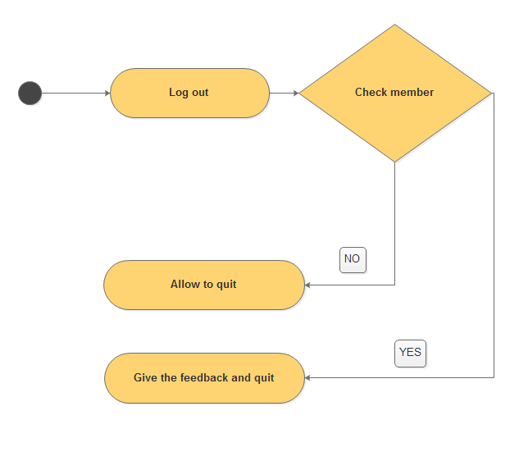

## **3.18 Module UC18: Chat room**

### **3.18.1 Use Case Description**

|  |  |
| --- | --- |
| Purpose | Licensed to operate in the system for user to use the chat room from the system. |
| Description | Allows all people who are a member can chat with each others though chat rooms. |
| Agent | User (members). |
| Pre-conditions | User must be a member. |
| Event stream | * User join in the “Chat room” mode. * Check for that they are the member. |
| The following condition | User must be join in the “Chat room” mode. |

### **3.18.2 Diagram**



1. **Non – functional Requirements**
   1. **Correctness**

* This subsection specifies the following requirements concerning the degree of correctness of the system’s outputs:
* The results must be accurate
* Values of time shall be correct to the nearest second.
  1. **Interoperability**
* This subsection specifies the following requirements associated with the ease with which the system can be integrated with other system (e.g., browsers, legacy applications, and required databases).
* The app shall interoperate with the following browsers:
* Internet Explorer 11
* Google Chrome 34
* Mozilla Firefox 12
  1. **Performance**
* This subsection specifies the following requirements concerning the minimum number of objects that the system can support:
* The system shall support a minimum of 15 employees.
* The system shall support a minimum of 500 users.
* The system shall support a minimum of 500 simultaneous interactions.
* All system responses shall occur within 15 seconds.
  1. **Portability**
* This subsection specifies the following requirements associated with the ease with which the system can be moved from one environment (e.g., hardware, operating system) to another.
* User Personal Computer: PC with minimum of Celeron chip, 2 GBs of RAM.
* Operating System:
* Windows 7
* Ubuntu 14
* Linux 16
  1. **Reliability**
* This subsection specifies the following requirements associated with the reliability:
* The account will be kept absolutely confidential
* Any account issues will be handled quickly
  1. **Reusability**
* This subsection specifies the following requirements associated with the degree to which the system can be used for purposes other than originally intended:
* The App shall reuse common classes such as name, address, telephone number, and currency.
* The CRM shall reuse software for sending emails.

1. **Main Screen**

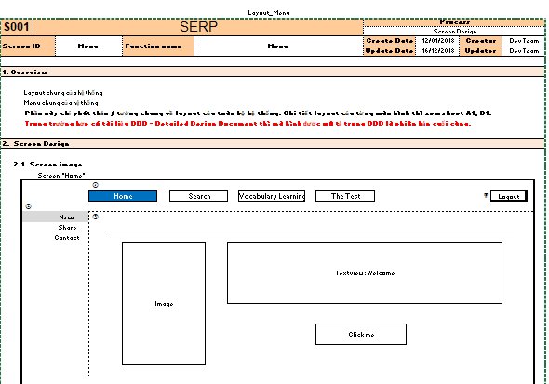

Image 1: Home screen

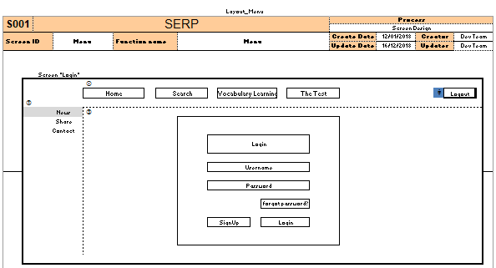

Image 2: Login screen

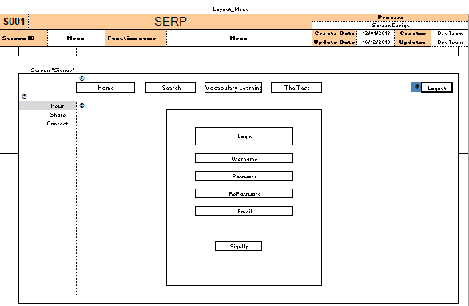

Image 3: Registration screen

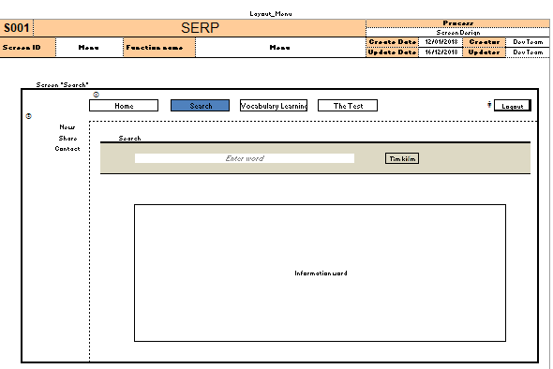

Image 4: Search screen

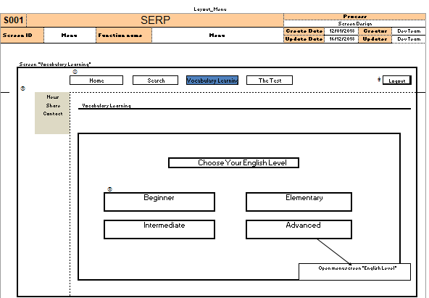

Image 5: Learning screen

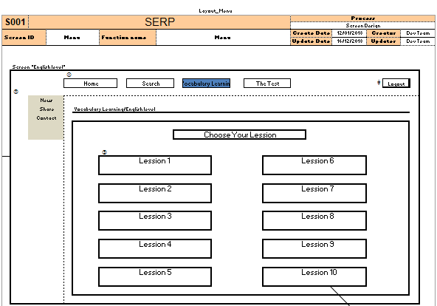

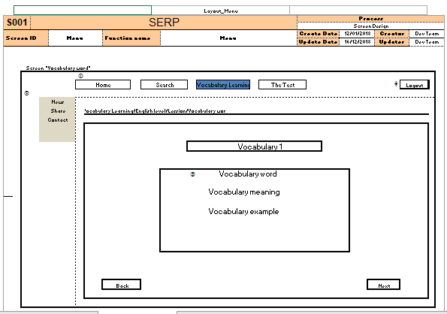

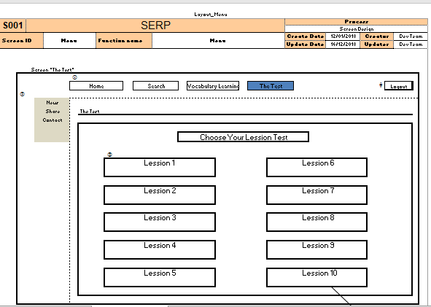

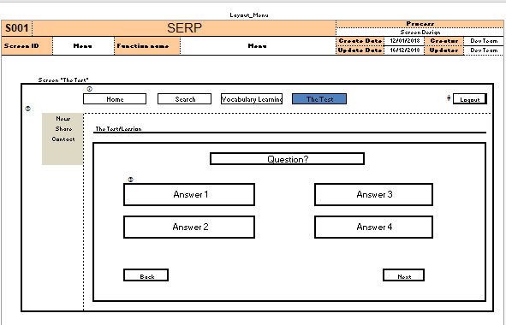

Image 6: Test screen