**T̀M HIỂU VÀ THỰC HÀNH HADOOP QUIZ**

<https://data-flair.training/blogs/big-data-hadoop-quiz-part-1/>

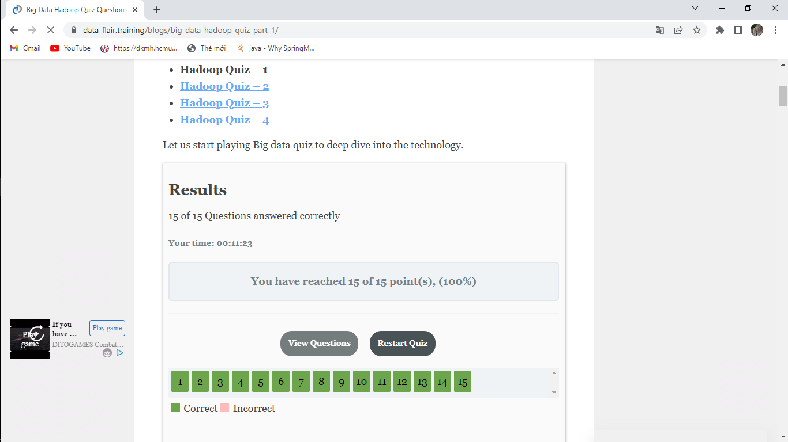

<https://data-flair.training/blogs/apache-hadoop-quiz-part-2/>

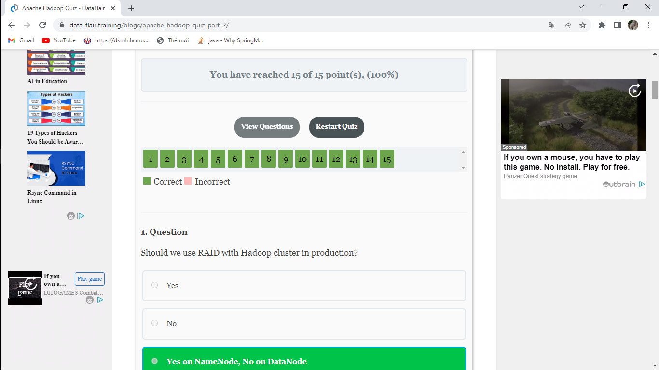

<https://data-flair.training/blogs/hadoop-quiz-questions-part-3/>

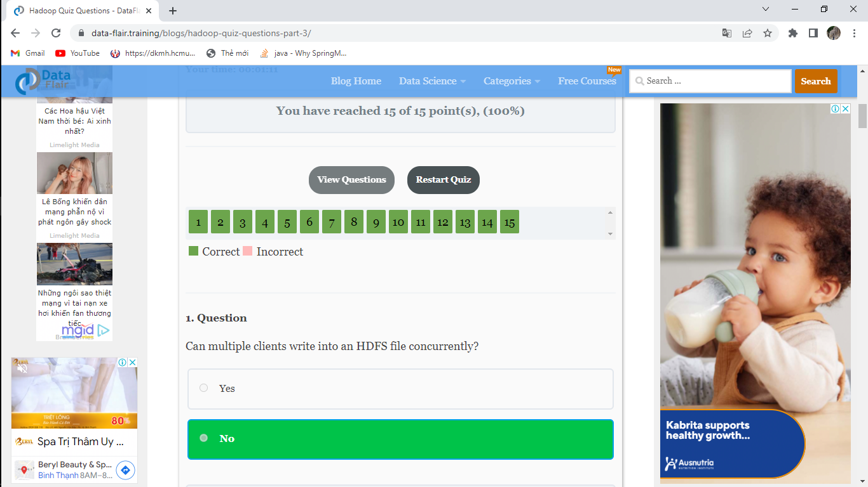

<https://data-flair.training/blogs/apache-hadoop-mcqs-part-4/>

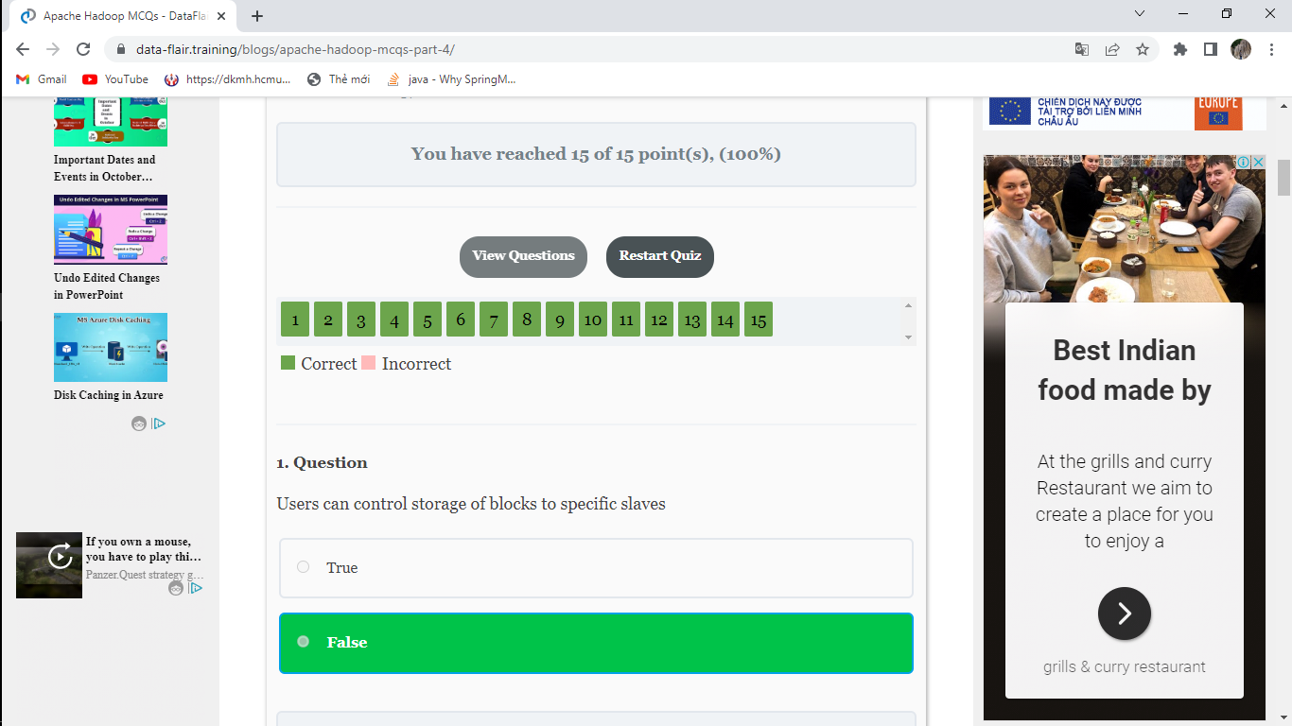

<https://data-flair.training/blogs/hadoop-online-quiz-part-5/>

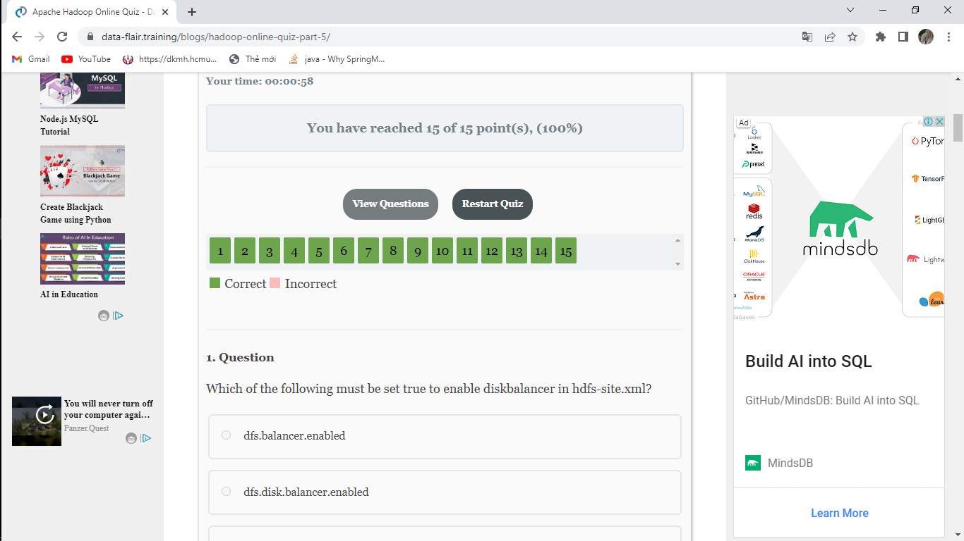

<https://data-flair.training/blogs/hadoop-objective-questions-part-6/>

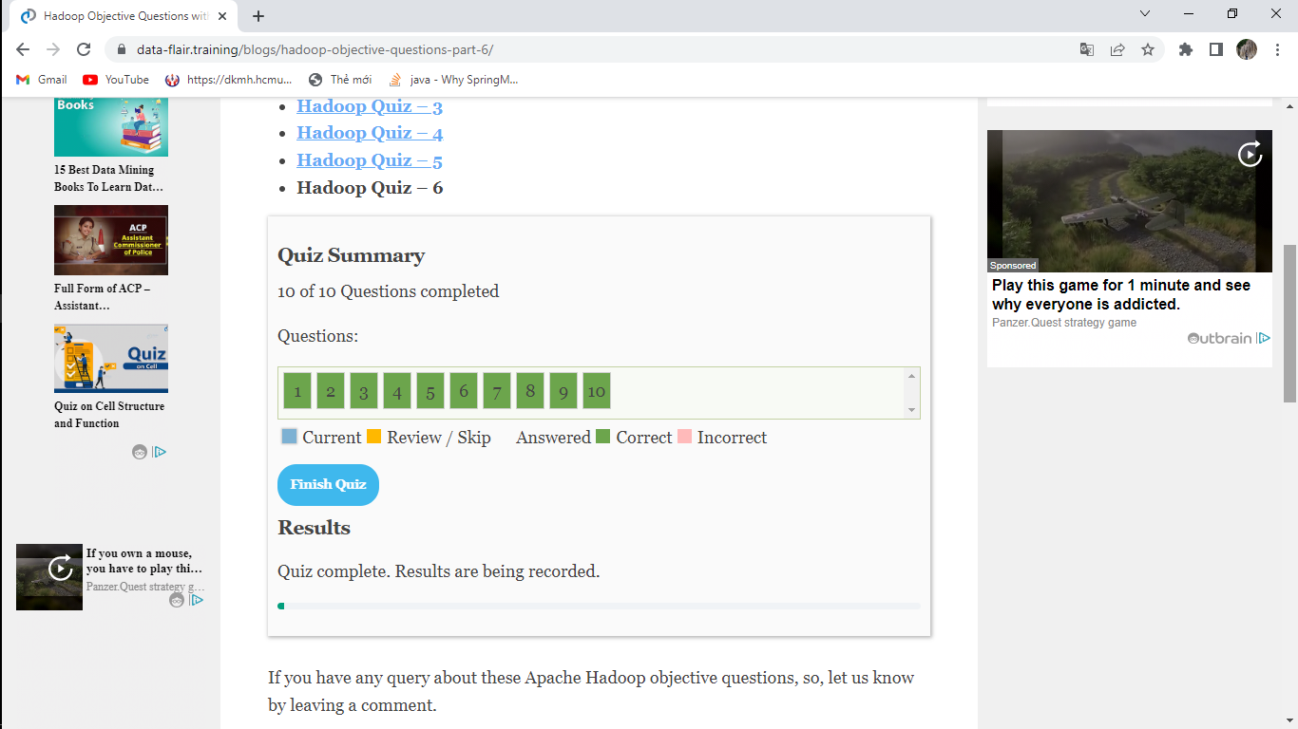

**[https://www.tutorialspoint.com](https://www.tutorialspoint.com/)**

[https://www.tutori](https://www.tutorialspoint.com/hadoop/hadoop_online_quiz.htm)**[alspoint.com/hadoop/hadoop_online_quiz.htm](https://www.tutorialspoint.com/hadoop/hadoop_online_quiz.htm)**

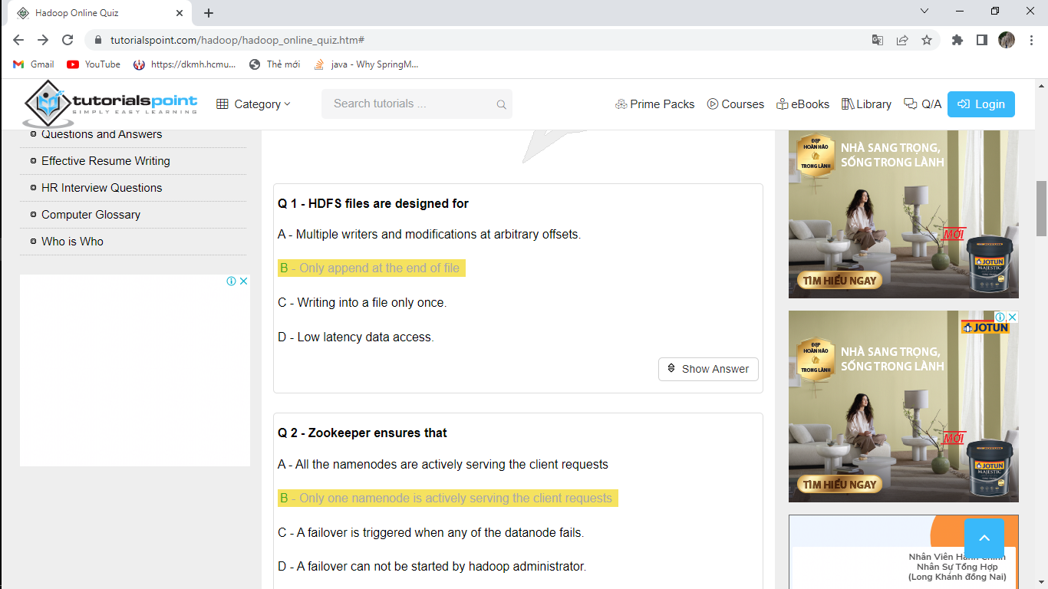

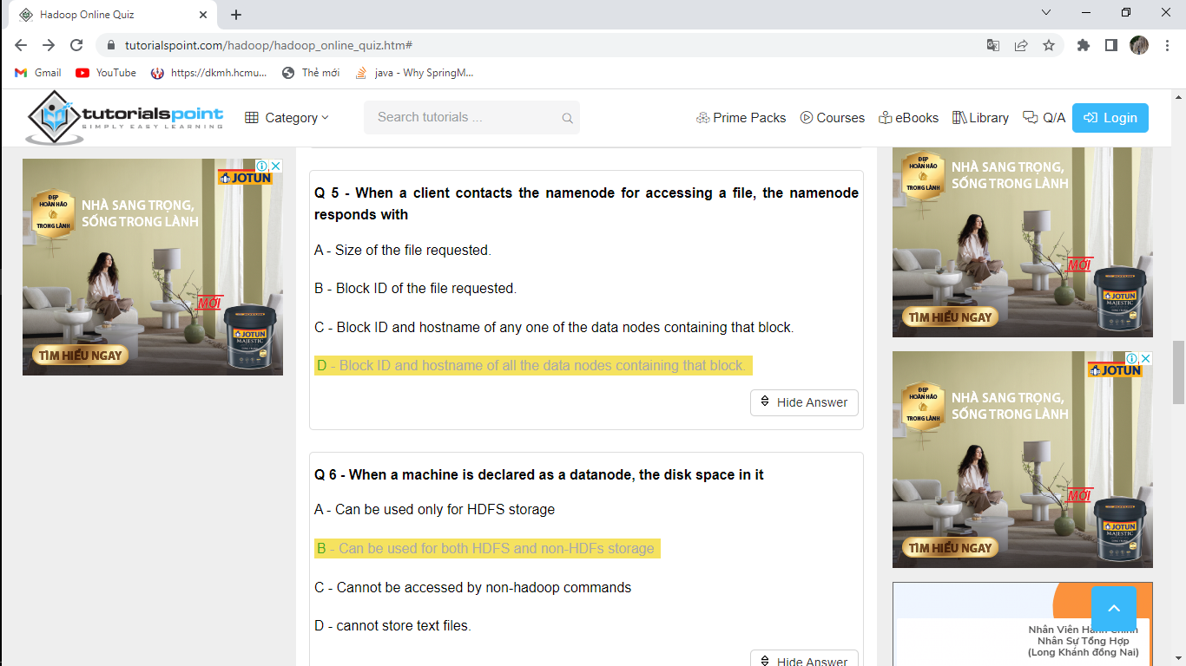

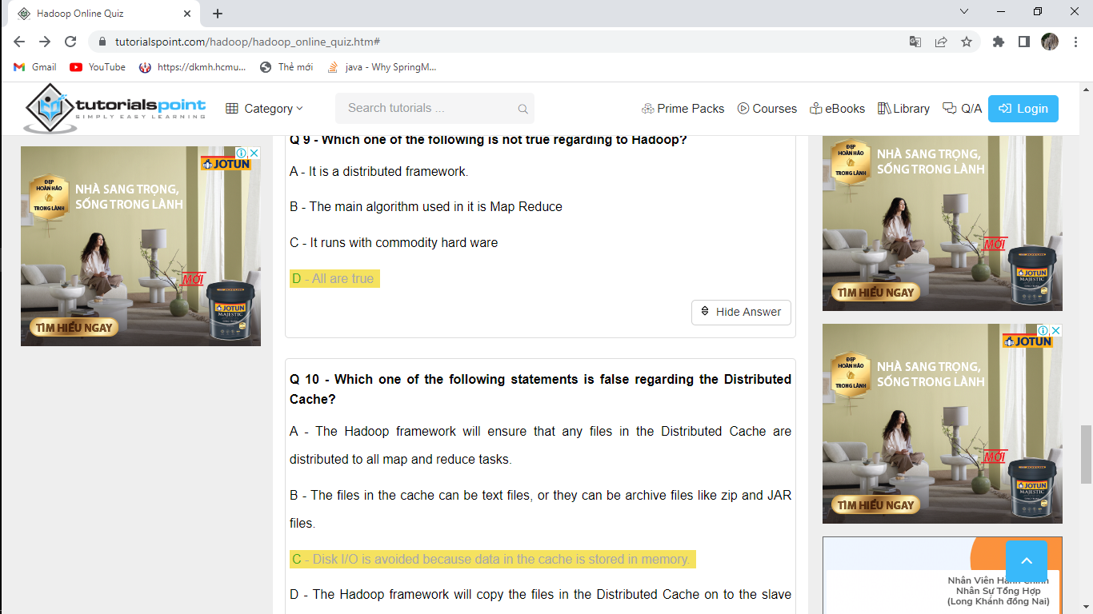

**<https://www.objectivequiz.com>**

[https://www.objectivequiz.com/ob](https://www.objectivequiz.com/objective-questions/computer-science/big-data-hadoop)**[jective-questions/computer-science/big-data-hadoop](https://www.objectivequiz.com/objective-questions/computer-science/big-data-hadoop)**

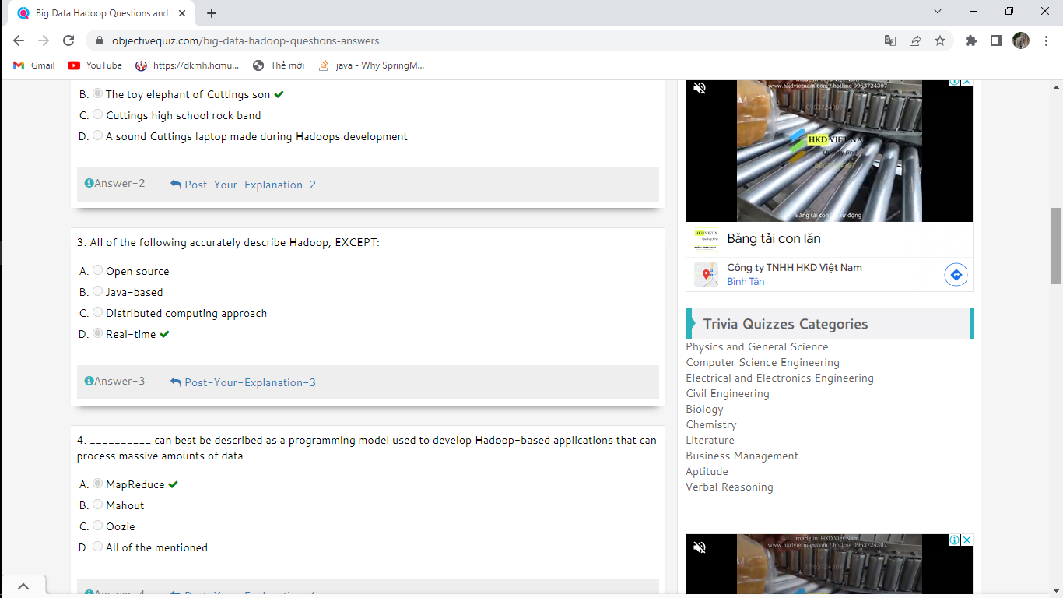

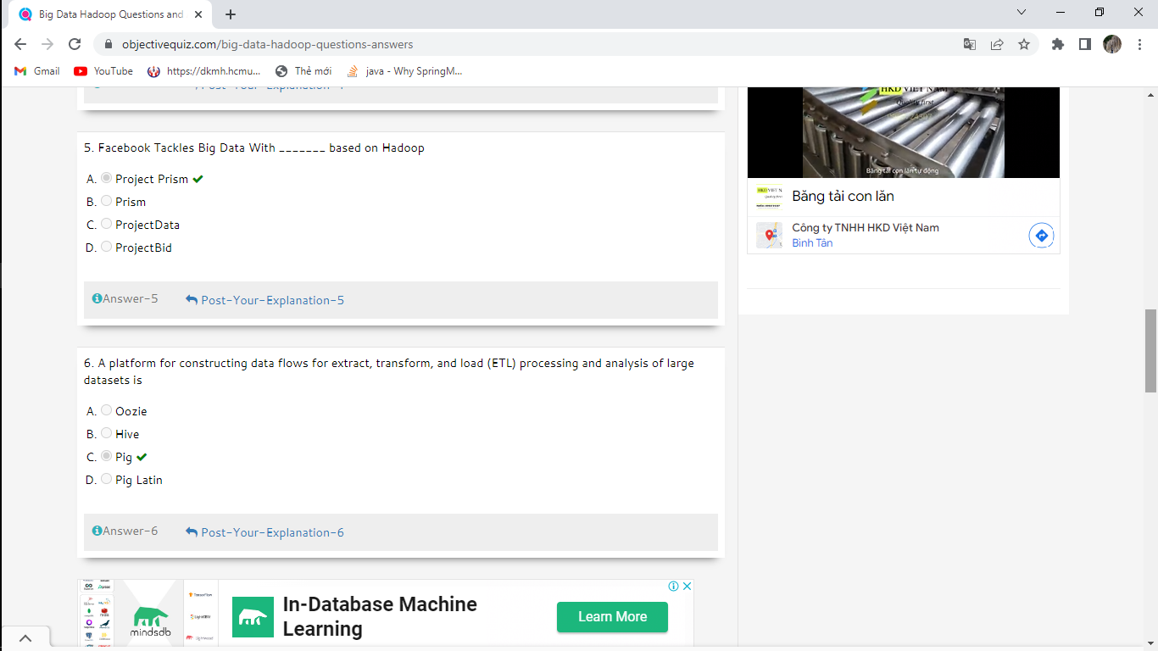

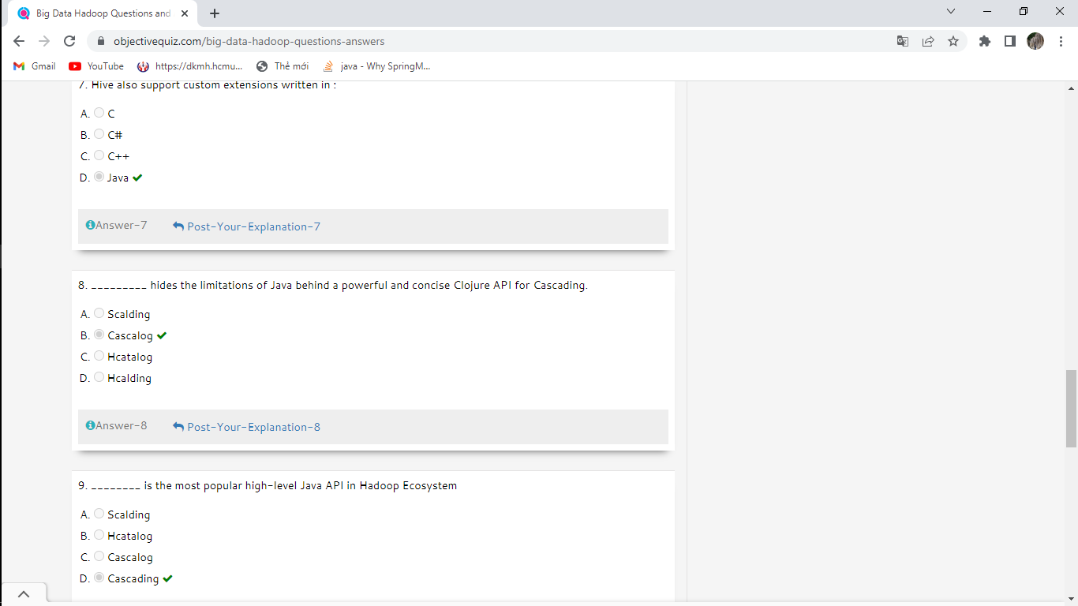

**<https://tutorialslink.com>**

[https://tutorialsl](https://tutorialslink.com/mcq-quiz/hadoop-mcq-quiz-multiple-choice-questions-and-answers?page=5)**[ink.com/mcq-quiz/hadoop-mcq-quiz-multiple-choice-questions-and-answers?page=5](https://tutorialslink.com/mcq-quiz/hadoop-mcq-quiz-multiple-choice-questions-and-answers?page=5)**

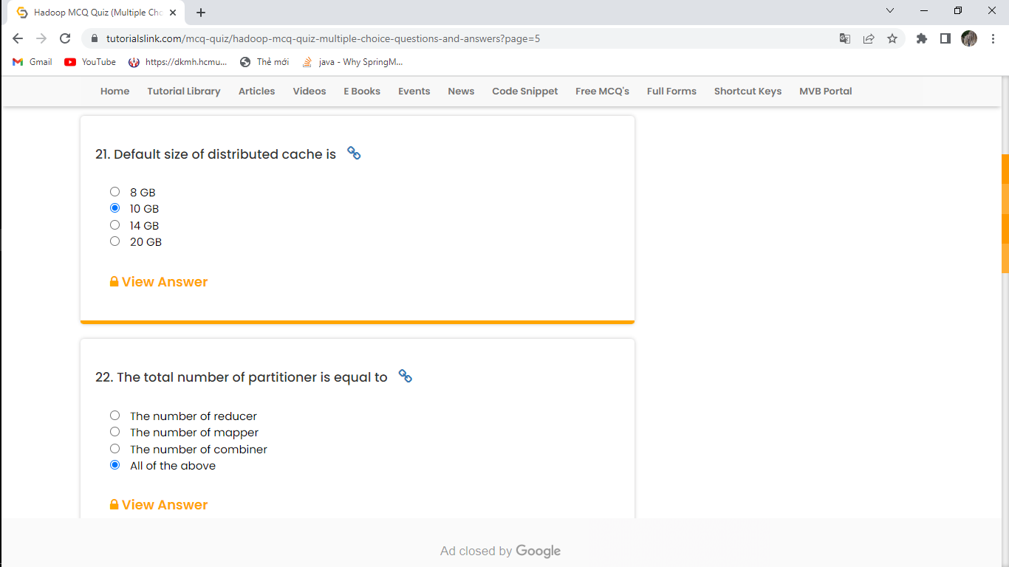

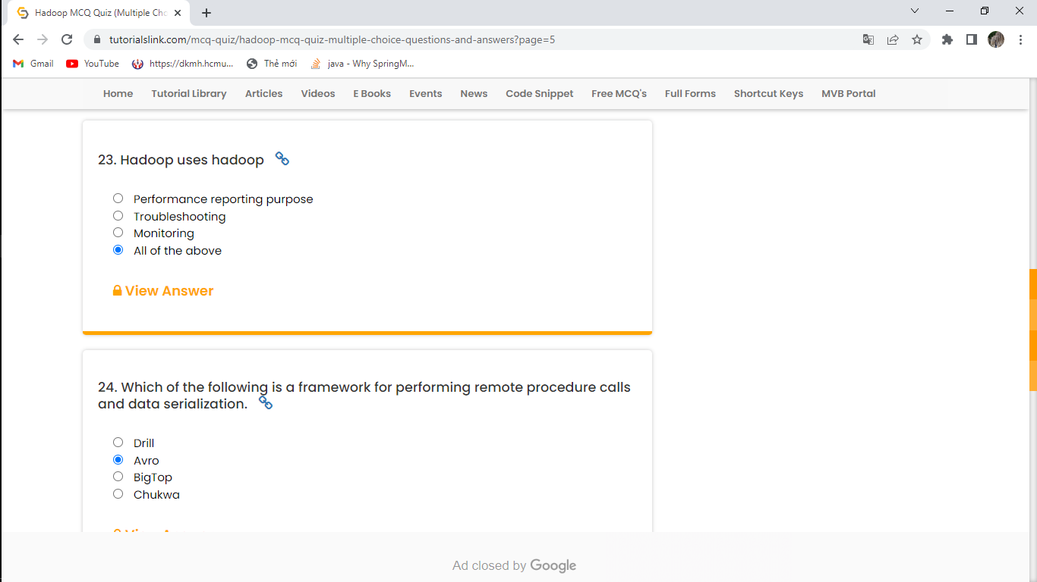

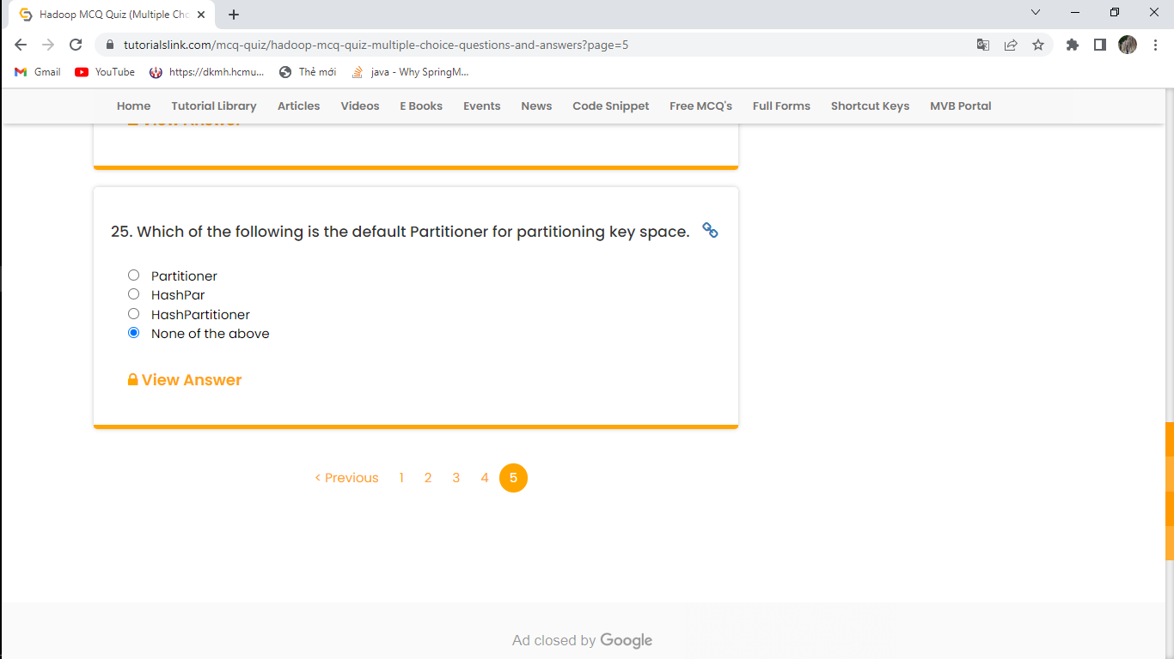

**<https://www.sanfoundry.com>**

[https://www.sanfound](https://www.sanfoundry.com/1000-hadoop-questions-answers/)**[ry.com/1000-hadoop-questions-answers/](https://www.sanfoundry.com/1000-hadoop-questions-answers/)**