RMIT International University Vietnam

Assignment Cover Page
Subject Code: | COSC2980
Subject Name: | Cloud Computing
Location & Campus (SGS or HN) where you study: | SGS
Title of Assignment: | Assignment 3 – AWS Cloud System Development
Student name: | Nguyen Quoc Trong Nghia
Student Number: | s3343711
Teachers Name: | Ginel Dorleon
Group Number:

Assignment due date: | 12th September, 2026
Date of Submission: | 12th September, 2026
Number of pages including this one:

Word Count:

AI use statement:  Please include a statement about which AI tools were used and for what purpose (e.g. brainstorming, drafting, editing, etc).  Refer to the RMIT AI use policy on your Canvas Assignments page for guidance. | I declare that ChatGPT has been utilized as a tool to support idea brainstorming for this assessment. All ideas generated by AI were reviewed carefully to ensure reliable information with research papers.

Assignment 3 – Solution Architecture

Link
Live URLS are only available while AWS Academy Learner session is running. Current names and endpoints are written to infra/aws-asm3-outputs.json

Item | URL / location
Donor UI | http://aws-asm3-donor-env.eba-dyvvtgm2.us-east-1.elasticbeanstalk.com
Admin UI | http://aws-asm3-admin-env.eba-wfmjwxjn.us-east-1.elasticbeanstalk.com
HTTP API | https://5e22ya16dc.execute-api.us-east-1.amazonaws.com (/health, /api/v1/...)
GitHub | https://github.com/NghiaNguyen170192/NetCore.Donation

Data sources for this assignment are generated with Bogus (fake data generator library), not third-party

Summary
In this assignment, I developed Hope and Help, a simulated charity donation system. Its purpose is to record donor contacts, single(one-off) and recurring gifts, payment outcomes, accounting journals, and tax receipts. The system demonstrates how a donation workflow can be implemented using AWS while maintaining a clear separation between the application, transactional data, document storage and analytics workloads.

The application allows public donors to submit single(one-off) or recurring donations. A donation records the donor’s contact information, payment method, transaction or payment schedule, and simulated payment outcome. For successful transactions, the system generates an accounting journal entry and a tax receipt in PDF format. Charity staff can use a separate Admin UI to review contacts, transactions, payment schedules, journals, receipts and donation flows.

Introduction

3.1 Motivation
Charity donation systems need to handle different workloads, including donation transactions, receipt generation, and reporting. Donation activity can also increase significantly during fundraising campaigns, emergencies, or other high-demand periods. Hope and Help was developed to explore how cloud computing can support these requirements through a flexible architecture that separates transactional processing, document storage, and analytical workloads.

3.2 High-level view
Hope and Help is a simulated charity donation platform that manages the donation lifecycle from submission to completion. Donors can submit single (one-off) or recurring donations through the public facing website Donation UI. The website records donor and transaction information processes the simulated payment outcome, and, for successful donations, generates an accounting journal and a PDF receipt. The Admin UI, the donation governance site, provides charity staff with an overview of contacts, transactions, payment schedules, journals, receipts, and donation flows.

3.3 Beneficiaries
The primary beneficiaries are:
- Donors, who submit donations and view their donation history.
- Charity staff, who monitor and govern donation information through Admin UI.
- Charitable organizations, which can benefit from a centralized platform for managing donation transactions, receipts, and related information.

Related work
Charity platforms such as Australian Red Cross already collect donations, store contacts, and issue receipts. Those products are far larger than an assignment demo: they include real card gateways, identity, compliance.
Hope and Help is intentionally smaller. It simulates payment success or failure instead of calling a processor, keeps journal entries in the same database as gifts, and uses a transactional outbox so each domain event becomes the next command. The point of difference for this course is leveraging AWS cloud services.

System architecture

5.1 Architectural diagram
The system is hosted primarily on AWS and consists of two separate .NET 10 applications deployed on Amazon Linux 2023 using Elastic Beanstalk: a Donor UI environment (aws-asm3-donor-env) and an Admin UI environment (aws-asm3-admin-env). Donors and administrators access their respective web applications through browsers, and both applications communicate over HTTPS using JSON requests with an Amazon API Gateway HTTP API (aws-asm3-http-api). API Gateway acts as the entry point for backend requests and proxies them to the aws-asm3-api AWS Lambda function, which implements the core application logic. The Lambda function connects to an Amazon RDS PostgreSQL 16 database (aws-asm3-postgres) for persistent application data and stores generated donation receipt PDFs in an Amazon S3 bucket. Amazon CloudWatch is used for centralized logging and monitoring across API Gateway, Lambda, Elastic Beanstalk, and RDS.

Figure 1 shows how browsers, AWS services and the application API communicate
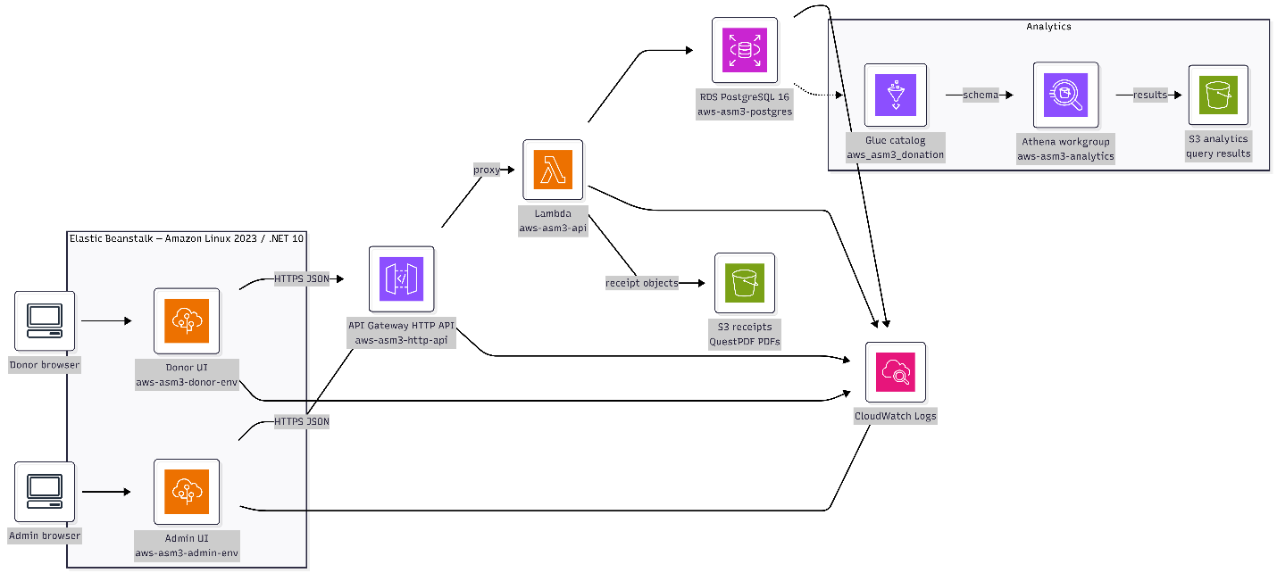

Figure 1 – Overall architecture design
The architecture also includes a serverless analytics layer. The PostgreSQL database provides data to the AWS Glue Data Catalog (aws_asm3_donation), which defines the schema used for analytical queries. Amazon Athena, through the aws-asm3-analytics workgroup, queries the cataloged data, with query results stored in an S3 analytics bucket. This separation allows the transactional application to use PostgreSQL for operational workloads while Athena and Glue support reporting and analytical workloads without directly affecting the application's primary database. Overall, the architecture follows a layered AWS design consisting of web presentation, API and compute services, transactional storage, document storage, centralized monitoring, and separate analytics pipeline.

5.2 System components
AWS Elastic Beanstalk
The donor and admin Blazor Server apps run as two single-instance environments (t3.small, Amazon Linux 2023 / .NET 10) with LabInstanceProfile. Beanstalk was a suitable choice for the UI because it provisions EC2, health checks, and log streaming without a custom AMI. Separate applications keep donor and staff traffic isolated.
AWS API Gateway (HTTP API)
A single HTTP API (aws-asm3-http-api) uses a $default catch-all route to the API Lambda (payload format 2.0, CORS enabled). This is the public edge for /health and /api/v1/*. Access logs go to CloudWatch.
AWS Lambda
aws-asm3-api hosts the ASP.NET Core 10 API (HTTP API events, 1024 MB, 60s timeout).
Amazon RDS (PostgreSQL 16)
aws-asm3-postgres (db.t3.micro, 20 GB gp2, publicly accessible for Learner Lab + laptop migration) holds the database schema: Countries, Contacts, PaymentMethods, PaymentSchedules, Transactions, Journals, Receipts, OutboxMessages. A single EF Core Initial migration creates tables and list-query indexes, including IX_Contacts_Email_Lower on lower("Email").
Amazon S3
Three buckets, all SSE-S3 and blocked public access:
- aws-asm3-receipts-{account} QuestPDF receipt objects (receipts/…)
- aws-asm3-deploy-{account} Lambda and Beanstalk zip artifacts
- aws-asm3-analytics-{account} Athena query results
AWS Glue and Amazon Athena
Glue database aws_asm3_donation and Athena workgroup aws-asm3-analytics support SQL over exported or catalogued donation data without querying RDS directly. Results land in the analytics bucket.
Amazon CloudWatch
Lambda, API Gateway, Beanstalk (web.stdout.log), and RDS PostgreSQL log groups use 7-day retention. Resource Group donation-asm3-rg filters tag Project=aws-asm3.

5.3 Data flow
Figure 2 illustrates the overall architecture of a donation management system. A user accesses either the Hope and Help donor interface or the donation administration interface, both implemented as Blazor Server websites and communicating with the browser through HTTP and SignalR. These web applications call the C# Donation API using JSON through DonationApiClient. Within the API, requests are handled by controllers under /api/v1, passed through MediatR using the CQRS pattern, and processed by command or query handlers. The handlers interact with Entity Framework repositories, which persist and retrieve donation-related data such as contacts, payment methods, payment schedules, transactions, journals, receipts, and outbox messages in PostgreSQL/RDS. The system also uses Redis for caching, while the API generates donation receipt PDFs and stores those files in either MinIO for local deployments or Amazon S3 in AWS. Overall, the architecture separates the presentation layer, API/business logic, data access, caching, and document storage into distinct components.
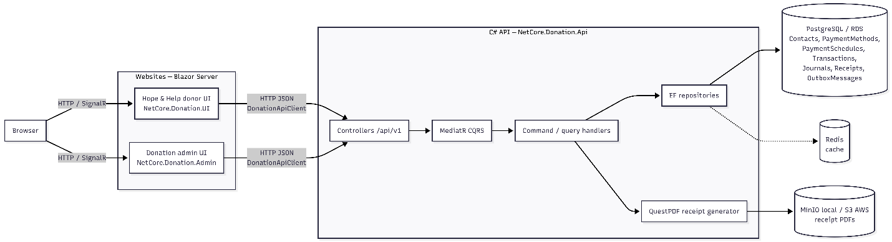
Figure 2 – Data flow
The Figure 3 describes the end-to-end donation workflow, from the donor submitting a donation form to the system processing the payment and generating the receipt. The donor submits either a one-time or recurring donation through the Donation.UI, which sends a single POST /api/v1/donations request to the Donation.Api using the UserMakesDonationCommand. The API then creates or reuses the donor’s Contact based on their email and always creates a Payment Method. For a one-time donation, the API creates a pending Transaction and records a TransactionCreated outbox event. For a recurring donation, it creates a Payment Schedule, records a PaymentScheduleCreated event, and the outbox process later creates the first transaction. These database changes and their corresponding outbox messages are stored together in PostgreSQL as one transaction, ensuring consistency. The UI immediately receives the created identifiers and shows the donor a Thank You message, while the actual payment-processing workflow happens asynchronously. A hosted OutboxProcessor polls for pending messages every five seconds in the local API, claims them, and triggers the appropriate MediatR commands. The events move the transaction through stages such as creating the transaction, queuing it as pending, and completing it. When payment succeeds, the API generates a receipt PDF and stores it in MinIO in local or Amazon S3 in production, while also creating the corresponding Receipt and Journal records in the database. The six individual REST write endpoints for contacts, payment methods, payment schedules, transactions, journals, and receipts remain available for administrative or step-by-step API usage, but the public donor interface now uses the single donation endpoint rather than calling those endpoints individually. Importantly, recurring donations only create the schedule and first transaction in this workflow; the generation of future recurring charges is outside its scope.
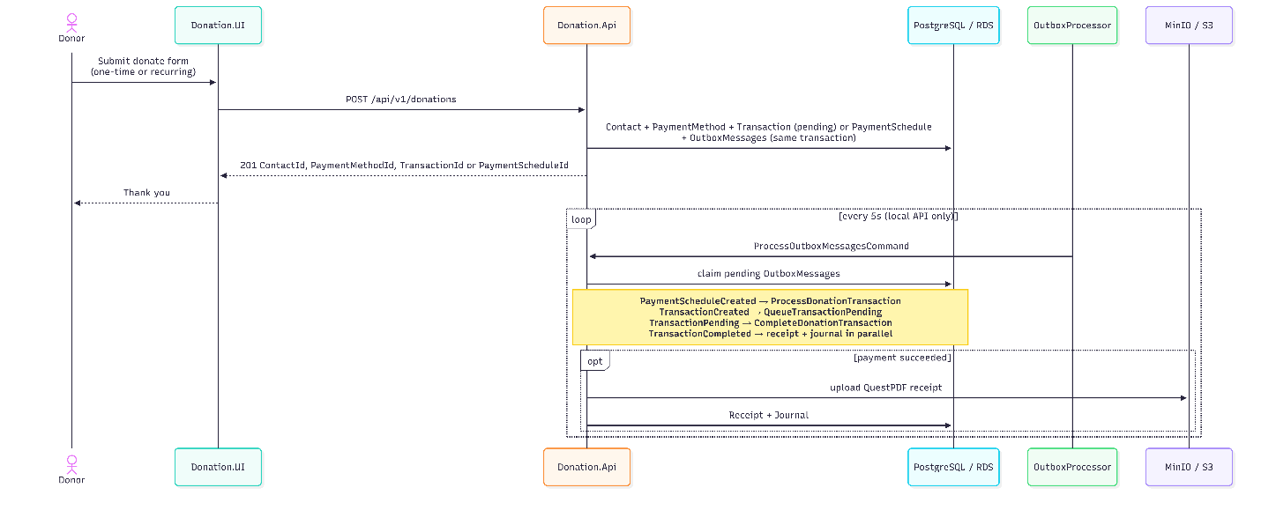

Appendix

6.1 Donation UI
Donor UI (NetCore.Donation.UI): public form posts POST /api/v1/donations with name, contact details, amount, payment type, and optional recurring interval. Include a screenshot of the live Beanstalk donor page in the submitted PDF.

6.2 Admin UI
Admin UI (NetCore.Donation.Admin): overview of recent transactions and navigation to contacts, journals, receipts, and money flow. Include a screenshot of the live Beanstalk admin page.

6.3 Receipt and Journal
Succeeded gifts produce a Journals row and a receipt file in the receipts bucket. Admin download uses GET /api/v1/receipts/{id} with Accept: application/pdf. Include a screenshot of receipt metadata and a sample PDF page.

6.4 Money flow
Admin UI (NetCore.Donation.Admin): money flow view shows pending and completed events with their associated domain events and transaction outcomes. This view demonstrates the event pipeline: one-off and recurring donations flowing through transaction states (pending → completed or failed), with parallel receipt generation and journal entries.

