**QoS related tool**

**BE ratio tool function specifications**

**(for Wed application)**

**Version 0.1.0**

Career

|  |  |  |  |  |  |  |
| --- | --- | --- | --- | --- | --- | --- |
| Change  Number | Date | Page | Content of change | Charge | Examination | Approval |
| 0.1.0 | 2018/03/05 | All chapters | New making | Nghia Tien | [Nghia Tien]  2018/03/05 |  |

Table of content

# Application

This book explains the specifications of the BE ratio tool function in the QoS related tool.

The meaning of the character color of this book is as follows.

Red color : modification from previous version.

# Function that BE ratio tool is achieved

BE ratio tool has the following functions.

1. Read input use case csv file function
2. Check the parameter option of application function
3. Calculate BE ratio function
4. Create new csv file function
5. Measure the BE effective bandwidth function
6. Check the BE bandwidth with selected ratio function

1) Preparing to measure effective bandwidth function

2) Measuring the effective bandwidth function

3) Determine the ratio of the effective bandwidth function

4) Create the list of candidates if the operation ratio.

5) Select the operation ratio

# Precondition

## Installing platform

The platform installed in the following Table 1 is show.

|  |  |  |
| --- | --- | --- |
| No. | Name | Content |
| 1 | Language | Java |
| 2 | IDE | Eclipse Java EE Development tools |
| 3 | Web sever environment | Apache Tomcat |

Table 1 – Installing platform

## Function and condition of requesting it outside

1. Get the input csv use case file from user, check use case file and display the information of use case.
2. It is necessary to choose the application which will be used by user and set a parameter option for application.
3. From the use case information and the application selected by user, BE ratio tool will link to A1 to create csv file based on user’s FIX value.
4. Base on the new csv file be created, link to B1 tool to measure the effective bandwidth of each BE IP.
5. With the result of effective bandwidth, determine candidate of the ratio operation.
6. After calculate BE ratio, display the recommend ratio table and propose the best ratio for the user’s use case.
7. User can choose measure and check the bandwidth with the recommend ratio or re-input the desired ratio.
8. Link to A1 tool to create new csv with all BE IP base on selected ratio, after that link to B1 tool to re-run use case and measure the BE bandwidth.
9. With the result of measuring bandwidth, check behavior with the BE calculate ratio and display the table of result.
10. Transfer the ratio to A1 to create new csv file with the BE selected ratio or user can re-select the BE ratio, measure and check the bandwidth again.

# Architecture

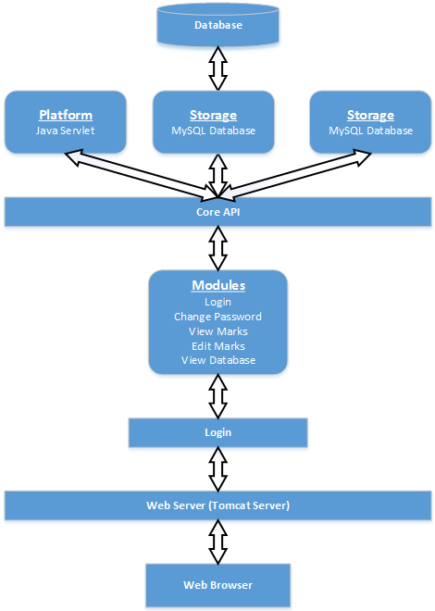

# System configuration example

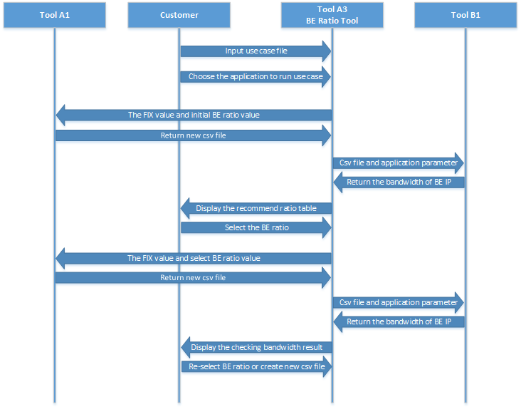The following Figure 5.1 show the system configuration example of BE ratio tool.

# Function

## Preparing to measure the effective bandwidth function

### Functional overview

Preparing to measure the effective bandwidth function means doing of the BE Ratio Tool task the following processing chiefly.

1. Get the information of target BE IP.

Base on the input information, determine the BE IP will be prepared to measure bandwidth.

1. Set the maximum ratio value for the target of BE IP.

Regarding the measured target of BE IP, the maximum value should be set as its operation ratio.

1. Disable the unused FIX and BE IP.

Regarding unused FIX IP, the setting bandwidth should be set 0 and with the unused BE IP, the setting bandwidth should be set 0 or “OFF”.

1. Set the maximum ratio value for CPU IP.

Regarding the operation ratio of CPU, the maximum value should be set as the operation ratio because CPU is always operated in all application.

1. Create csv file.

Link to A1 tool to create the csv file, prepare to measure the effective bandwidth for the target BE IP.

### Whole sequence

### Error processing

### Measuring the effective bandwidth function

### Functional overview

Measuring the effective bandwidth function means doing of the BE Ratio Tool task the following processing chiefly.

1. Get csv file and target BE IP

Receive the target BE IP need measure the effective bandwidth and the csv file of it.

1. Determine the BE test application

Base on the target BE IP, select the application will be execute with the csv file.

1. Measure the effective bandwidth

Link to B1 tool, transfer the csv file and application name to measure the effective bandwidth.

1. Get the effective bandwidth result.

Wait B1 tool execute application and get the effective bandwidth result.

### Whole sequence

### Error processing

### Calculate BE ratio function

### Functional overview

Calculate BE ratio function means doing of the BE Ratio Tool task the following processing chiefly.

1. Get the BE ratio calculator request from interface.
2. Check the target of BE bandwidth.
3. Check the option of application.
4. Determine initial ratio of each BE IP
5. Transfer the BE ratio to A1 tool to create new csv .
6. Receive new csv file.
7. Base on the application which will execute, prepare execute command and csv file for that case, link to B1 tool to measure the effective bandwidth of each BE IP.
8. Receive the effective bandwidth of each BE IP.
9. Determine candidates of BE ratio operation.
10. Select the best ratio for use case.
11. Display the table of result in web interface.

### Whole sequence

### Error processing

### Create new csv file function

### Functional overview

Create new csv file function means doing of the BE Ratio Tool task the following processing chiefly.

1. Check the operation status of A1 tool
2. Receive the response operation status from A1 tool.
3. Transfer BE ratio, user’s FIX value and the environment information of the use case.
4. Receive the csv file from A1 tool.

### Whole sequence

### Error processing

### Measure the effective BE bandwidth function

### Functional overview

Measure the effective BE bandwidth function means doing of the BE Ratio Tool task the following processing chiefly.

1. Check the operation status of B1 tool.
2. Receive the response operation status from B1 tool.
3. Transfer the csv file, environment information and execute command to B1 tool.
4. Get the bandwidth result from B1 tool.

### Whole sequence

### Error processing

### Check the BE bandwidth with selected ratio function

### Functional overview

Check the BE bandwidth with selected ratio function means doing of the BE Ratio Tool task the following processing chiefly.

1. Get the checking BE bandwidth request from interface.
2. Check the target of BE bandwidth.
3. Check application status.
4. Transfer the BE ratio to A1 tool to create new csv file.
5. Receive new csv file.
6. Base on the application which will execute, prepare execute command and csv file for that case, link to B1 tool to measure the effective bandwidth of each BE IP.
7. Receive the BE bandwidth from B1 tool.
8. Display the table of result in web interface.

### Whole sequence

### Error processing