# Topology

# Dockerfile web-golang

|  |
| --- |
| FROM golang:1.20-alpine  WORKDIR /app  COPY go.mod go.sum ./  RUN go mod tidy  COPY . .  RUN go build -o /web-golang  CMD ["/web-golang"] |

# Dockerfile web-python

|  |
| --- |
| FROM python:3.9-slim  WORKDIR /app  COPY requirements.txt requirements.txt  RUN pip install -r requirements.txt  COPY . .  CMD ["python", "app.py"] |

# Dockerfile web-nodejs

|  |
| --- |
| FROM node:18  WORKDIR /app  COPY package*.json ./  RUN npm install  COPY . .  EXPOSE 3000  CMD ["npm", "start"] |

# Dockerfile web-java

|  |
| --- |
| # Stage 1: Build the JAR file  FROM maven:3.8.1-openjdk-11 AS build  WORKDIR /app  COPY pom.xml .  COPY src ./src  RUN mvn clean package  # Stage 2: Create the final image  FROM openjdk:11  VOLUME /tmp  COPY --from=build /app/target/demo-0.0.1-SNAPSHOT.jar app.jar  ENTRYPOINT ["java","-jar","/app.jar"] |

# Docker compose

|  |
| --- |
| version: '3.8'  services:    mongo:      image: mongo:latest      ports:        - "27017:27017"      volumes:        - mongo-data:/data/db        - ./mongo-seed:/docker-entrypoint-initdb.d    web-node:      build: ./web-node      ports:        - "3000:3000"      volumes:        - ./web-node:/app      environment:        - NODE_ENV=development      depends_on:        - mongo    web-python:      build: ./web-python      ports:        - "3001:3001"      volumes:        - ./web-python:/app      environment:        - FLASK_ENV=development      depends_on:        - mongo    web-golang:      build: ./web-golang      ports:        - "3002:3002"      volumes:        - .:/app      environment:        - GO_ENV=development      depends_on:        - mongo    web-java:      build: ./web-java      ports:        - "3003:3003"      volumes:        - ./web-java:/app      environment:        - SPRING_PROFILES_ACTIVE=development      depends_on:        - mongo  volumes:    mongo-data: |

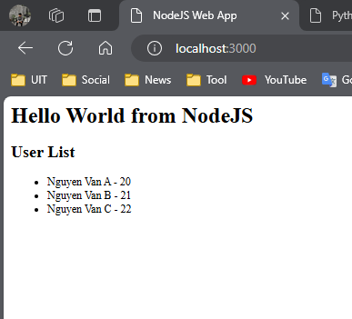

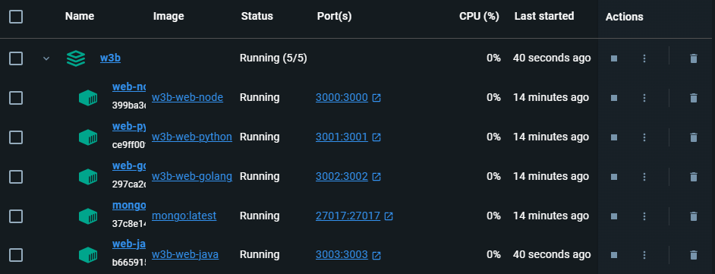

# Source code

https://github.com/NghiaVNM/DockerCompose_Web.git