SMART TICKETING
Software Engineering Lab · Assignment 1 · Semester 1 2026–2027
Phạm Trung Nghĩa · 524H0172
23 October 2026
https://github.com/Nghiaktvn
Verified work and pending group/lecturer evidence are explicitly separated. The full 3–5 member roster, contributions and genuine GitHub collaboration record must be supplied by the group.

Table of Contents

In Word, update fields to populate the contents and page numbers. All numbered headings are real Word headings.

Phạm Trung Nghĩa (524H0172) · 23 October 2026. Group number and remaining members await confirmation.

1. Introduction

1.1 Purpose and Scope
Specify a single-journey ticket vending machine and demonstrate it with C# WinForms and MSSQL. The delivered prototype loads active routes, fixes the fare for an attempt, supports card/bank-QR/wallet simulators, saves paid tickets idempotently, displays a unique barcode, and offers printer recovery, simulated refund and print preview. No real bank, wallet or physical print result is claimed.

1.2 Problem Statement in Our Own Words
Passengers need a clear route-to-ticket interaction. A declined payment, unknown result and printer failure need distinct guidance. A lost save acknowledgement must not create a second charge or usable ticket. Operators need a transaction identity to resolve interruptions.

1.3 Team and Roles
Member | Student ID | Actual responsibilities | Contribution
Phạm Trung Nghĩa | 524H0172 | Confirmed submission contact; feature ownership pending group confirmation | Pending
Remaining 2–4 members | Not supplied | Group must provide real names and ownership | Pending

2. Phase 1: Requirements Engineering (20 marks)

2.1 Clarification Q&A (5 marks)
ID | Question | Assumed answer | Design impact | Requirement IDs
Q1 | Which passenger types, routes, and fares are sold? | Adult single journey; operator-maintained route and fare catalogue. | Destination and fare snapshot in each ticket transaction. | FR-01, DR-02
Q2 | Are card and wallet integrations live? | Production uses certified providers; current demo is simulation only. | Adapter boundaries; no real charge or credentials in demo. | FR-02, NFR-06
Q3 | How are declined, timed-out, and duplicate payments handled? | Decline permits retry; timeout remains unknown until reconciliation; callbacks are idempotent. | No ticket until confirmed; unique idempotency reference. | FR-03, DR-03, DR-05
Q4 | When is a ticket valid and how is it checked? | Single journey valid for the service day; barcode holds an opaque unique ticket ID. | Unique ticket identity; no personal data in barcode. | FR-04, DR-04
Q5 | Are refund and cancellation supported? | Cancel before payment; after capture use operator-audited reversal/refund. | Transaction state and compensation record. | FR-07, DR-07
Q6 | Which accessibility and language requirements apply? | Vietnamese/English, high contrast, large touch targets, accessible timeout. | Bilingual UI and accessibility acceptance criteria. | NFR-07
Q7 | What payment data is retained? | Never retain PAN, CVV, wallet credentials, or raw QR; retain masked provider reference. | Data minimization and secure audit log. | NFR-06
Q8 | What availability and response time are required? | 99.5% monthly kiosk availability; UI p95 <=1s; routes <=2s; payment timeout 15s. | Measurable NFRs; monitor availability and latency. | NFR-01..05
Q9 | Is cash payment required? | Out of scope; brief specifies card, QR, and wallet. | No cash hardware or cash reconciliation. | FR-02
Q10 | What if network or printer fails? | Fail safely; no ticket before confirmed payment; reconcile, reprint, or compensate. | Fault state and recovery workflow. | FR-07, FR-08
Q11 | Which external systems are integrated? | Route/fare API, card acquirer, Momo/VNPay/ZaloPay, validator, monitoring. | Deployment and activity diagram actors. | FR-02, FR-03
Q12 | How long are records retained? | Non-sensitive transaction events retained 12 months, subject to operator policy. | Retention configurable; audit policy requires approval. | FR-06, NFR-06

Hidden complexities: timeout differs from decline; SQL commit may precede a lost acknowledgement; duplicate callbacks require idempotency; printer failure needs compensation; public kiosks need measurable response and accessibility criteria.

2.2 Requirements Specification (15 marks)

2.2.1 Functional Requirements
ID | Requirement | Acceptance target | Priority / source
FR-01 | Start a purchase and show active destinations and fares. | Route list response <=2 seconds; inactive routes cannot be selected. | Must / Q1/Q8 → UC-01/06
FR-02 | Select destination and card, bank QR or wallet QR payment. | Fare and route remain visible until confirmation. | Must / Q2/Q9 → UC-02/03/07
FR-03 | Authorize using an idempotency key and handle all outcomes. | Approve/decline/pending/timeout handled with no duplicate charge. | Must / Q3/Q7 → UC-02/03/05
FR-04 | Print a barcode ticket only after confirmed payment. | Exactly one usable ticket per paid transaction. | Must / Q4/Q10 → UC-08
FR-05 | Display route, fare, time, and masked reference on receipt. | No sensitive payment credential appears. | Must / Q4/Q7 → UC-09
FR-06 | Audit payment, transaction, print, and status events. | Searchable by transaction ID; excludes PAN/CVV. | Must / Q7/Q12 → UC-04/05
FR-07 | Recover and reconcile after interruption. | Unresolved transaction reconciled before issue/retry. | Must / Q3/Q5/Q10 → UC-05
FR-08 | Expose operator diagnostics and kiosk out-of-service status. | Timestamped fault visible to monitoring. | Must / Q10/Q11 → UC-04

2.2.2 Non-Functional Requirements
ID / area | Requirement | Measurable target | Measurement method
NFR-01 / Reliability | Monthly service availability excluding planned maintenance. | >=99.5%; available scheduled minutes / total scheduled minutes. | Timed trials/logs for latency; scheduled-minute observation for availability; accessibility and security review for relevant controls
NFR-02 / Performance | Local input and screen transition. | p95 <=1 second; p99 <=2 seconds. | Timed trials/logs for latency; scheduled-minute observation for availability; accessibility and security review for relevant controls
NFR-03 / Performance | Route/fare catalogue load. | p95 <=2 seconds; cached data timestamped, max age 24 hours. | Timed trials/logs for latency; scheduled-minute observation for availability; accessibility and security review for relevant controls
NFR-04 / Performance | Payment completion or safe timeout. | 95% <=8 seconds; timeout at 15 seconds; reconcile unknown result. | Timed trials/logs for latency; scheduled-minute observation for availability; accessibility and security review for relevant controls
NFR-05 / Reliability | Print after confirmed authorization. | Print starts <=2 seconds; failure initiates alert and compensation. | Timed trials/logs for latency; scheduled-minute observation for availability; accessibility and security review for relevant controls
NFR-06 / Security | Protect payment and service data. | TLS 1.2+, encrypted secrets, least privilege, no PAN/CVV, signed callbacks. | Timed trials/logs for latency; scheduled-minute observation for availability; accessibility and security review for relevant controls
NFR-07 / Accessibility | Support public touchscreen use. | Large targets >=44 px, readable contrast, bilingual UI, timeout extension. | Timed trials/logs for latency; scheduled-minute observation for availability; accessibility and security review for relevant controls
NFR-08 / Maintainability | Isolate routes, gateways, persistence, and printer. | Ports/adapters, structured logs, documented config, automated tests. | Timed trials/logs for latency; scheduled-minute observation for availability; accessibility and security review for relevant controls

These figures are acceptance requirements, not measured production results. The classroom build/tests do not prove monthly uptime, payment provider response times or WCAG conformance.

2.2.3 Domain Requirements
ID | Rule | Acceptance
DR-01 | At most one ticket per confirmed payment. | Duplicate callbacks and ticket issue are idempotent.
DR-02 | The active route fare is captured once. | Immutable FareSnapshot.
DR-03 | Payment references and barcodes are unique. | SQL UNIQUE constraints and same-reference retry.
DR-04 | Ticket QR uses an opaque ID and service-day validity. | No personal data; expiry displayed.
DR-05 | Unknown payments reconcile before a new attempt. | Unknown state cannot be silently cancelled.
DR-06 | Payment QR binds transaction, amount and method and expires. | Demo QR expires after three minutes.
DR-07 | Printer failure requires compensation. | Same-ticket reprint or recorded simulated refund.

3. Phase 2: UML Modeling & System Design (35 marks)

3.1 Use Case Modeling (10 marks)

3.1.1 Use Case Diagram
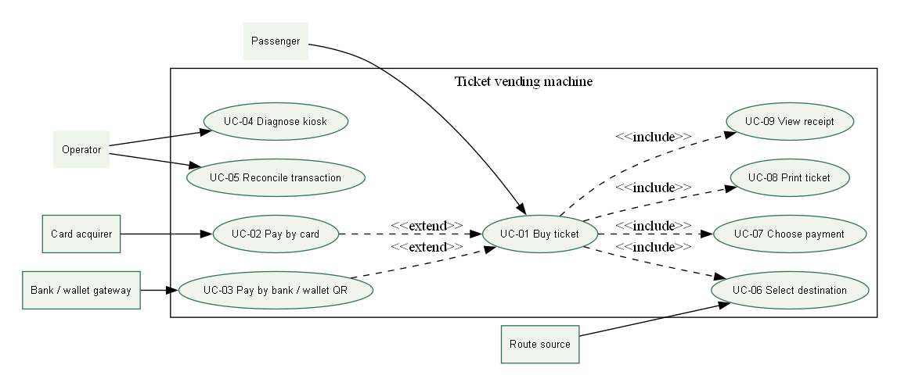
Nine registered use cases and their actors

3.1.2 Actors and Use Case List
Actor | Responsibility
Passenger | Choose destination/payment; buy and view a ticket
Operator | Diagnose and supervise reconciliation or compensation
Card / bank / wallet gateway | Production payment boundary; simulated in demo
Route source | Active route catalogue; SQL in this demo

Use case | Scope
UC-01 Buy ticket | Designed; prototype scope stated below
UC-02 Pay by card | Designed; prototype scope stated below
UC-03 Pay by bank / wallet QR | Designed; prototype scope stated below
UC-04 Diagnose kiosk | Designed; prototype scope stated below
UC-05 Reconcile transaction | Designed; prototype scope stated below
UC-06 Select destination | Designed; prototype scope stated below
UC-07 Choose payment | Designed; prototype scope stated below
UC-08 Print ticket | Designed; prototype scope stated below
UC-09 View receipt | Designed; prototype scope stated below

3.1.3 Use Case Descriptions

UC-01 Buy ticket
Field | Description
Actor | Passenger
Trigger | Passenger requests the journey action
Preconditions | Kiosk ready, route data and printer available.
Main success flow | Start; select route; confirm fare; choose method; authorize; persist; print; show receipt.
Alternate / exception | Decline allows retry; timeout requires reconciliation; print fault creates compensation case.
Postcondition | At most one delivered ticket for a paid transaction.

UC-02 Pay by card
Field | Description
Actor | Passenger
Trigger | Passenger requests the journey action
Preconditions | Route and fare confirmed.
Main success flow | Prompt tap or insert; send tokenized authorization; verify outcome.
Alternate / exception | Decline, cancel, or timeout returns a safe status.
Postcondition | Payment reference linked to transaction.

UC-03 Pay by bank / wallet QR
Field | Description
Actor | Passenger
Trigger | Passenger requests the journey action
Preconditions | Route and fare confirmed.
Main success flow | Create expiring amount-bound QR; display; await signed callback.
Alternate / exception | Expiry or cancellation invalidates QR; late callback requires reconciliation.
Postcondition | A confirmed capture or no issued ticket.

UC-04 Diagnose kiosk
Field | Description
Actor | Operator
Trigger | A fault or unknown transaction needs resolution
Preconditions | Authenticated operator and service mode.
Main success flow | Check printer, network, gateway, and recent faults.
Alternate / exception | Failed self-test sets out-of-service state.
Postcondition | Audited diagnostic event.

UC-05 Reconcile transaction
Field | Description
Actor | Operator
Trigger | A fault or unknown transaction needs resolution
Preconditions | Payment result unknown or print compensation pending.
Main success flow | Query gateway; compare capture; retry print or refund.
Alternate / exception | Gateway unavailable remains queued.
Postcondition | No duplicate charge or ticket.

UC-06 Select destination
Field | Description
Actor | Passenger
Trigger | Passenger requests the journey action
Preconditions | Active fare catalogue available.
Main success flow | Show active routes; select destination and fare snapshot.
Alternate / exception | Missing or stale catalogue shows unavailable guidance.
Postcondition | Valid route and fare assigned.

UC-07 Choose payment
Field | Description
Actor | Passenger
Trigger | Passenger requests the journey action
Preconditions | Route and fare confirmed.
Main success flow | Choose card, bank QR, or wallet.
Alternate / exception | Cancel or timeout discards pending selection.
Postcondition | One method set for the attempt.

UC-08 Print ticket
Field | Description
Actor | Passenger
Trigger | Passenger requests the journey action
Preconditions | Confirmed payment and working printer.
Main success flow | Generate unique opaque barcode; print route, fare, validity, and barcode.
Alternate / exception | Printer fault creates reprint or refund case.
Postcondition | Ticket linked to one paid transaction.

UC-09 View receipt
Field | Description
Actor | Passenger
Trigger | Passenger requests the journey action
Preconditions | Payment and print results known.
Main success flow | Show route, fare, time, reference, and support guidance.
Alternate / exception | Unknown payment shows pending guidance, not success.
Postcondition | Passenger can identify transaction for support.

3.2 Activity Diagrams (10 marks)

3.2.1 Passenger Buys a Ticket at the TVM
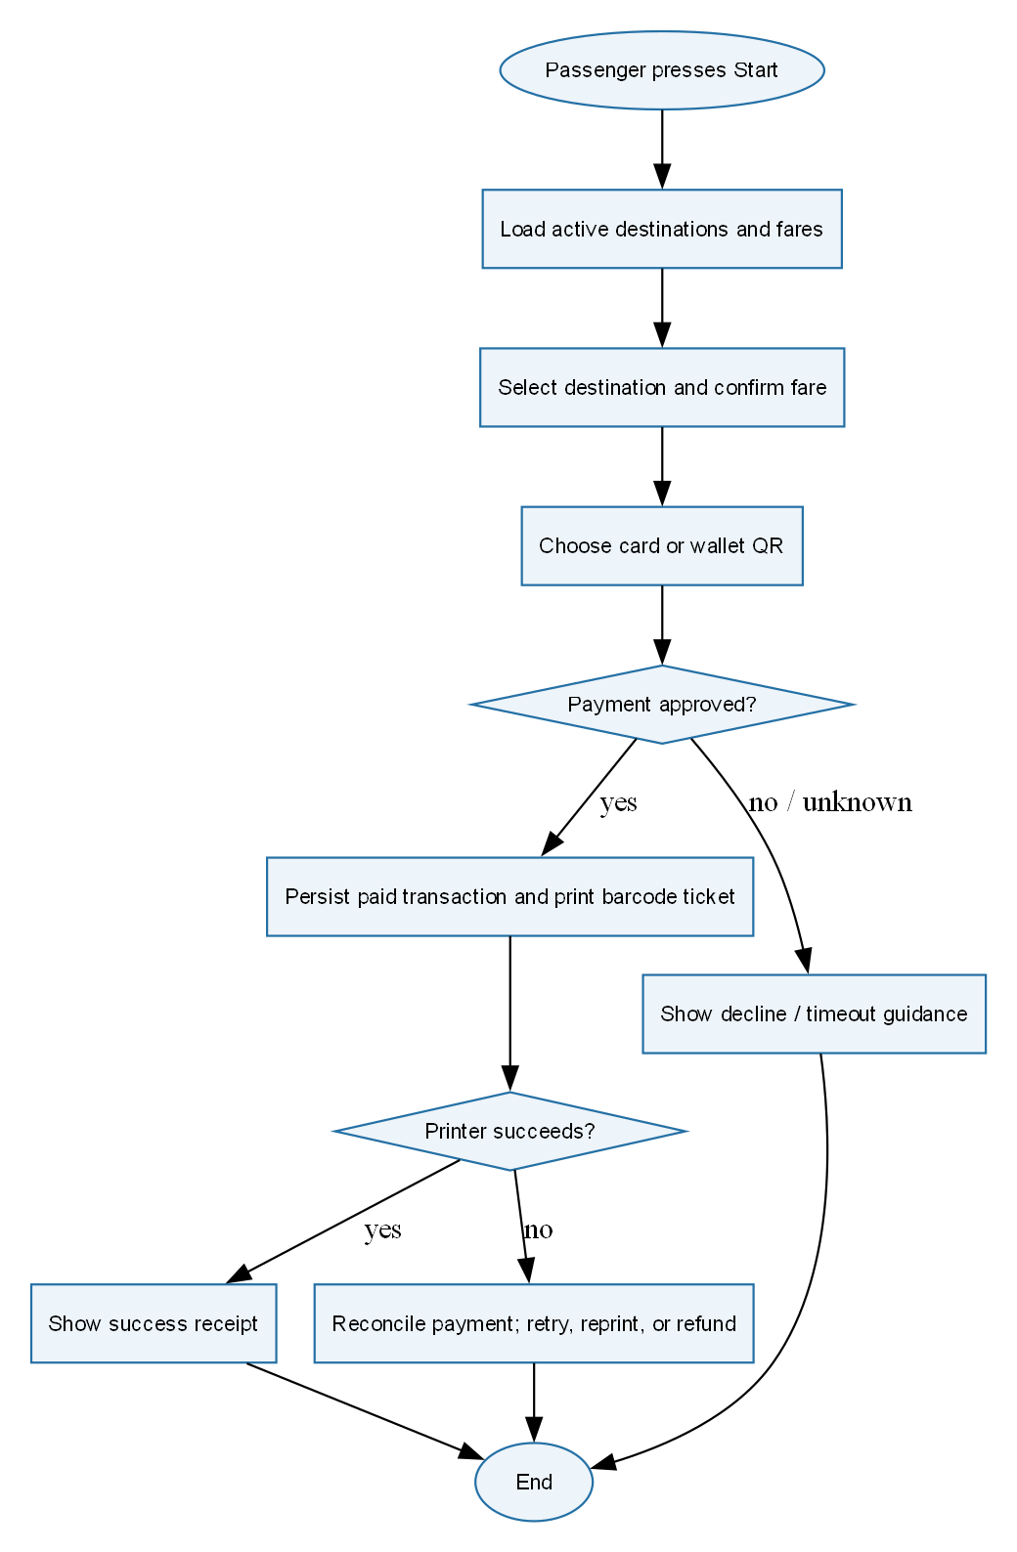
Passenger purchase and compensation activity

3.2.2 Communication with External Payment Gateways
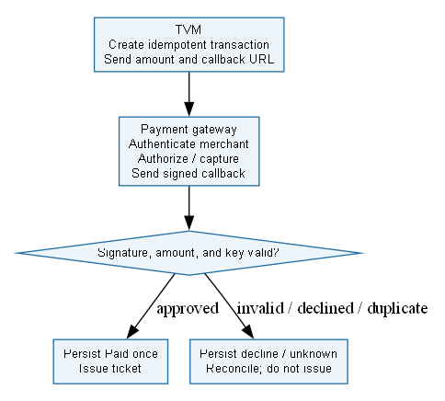
Production external gateway activity; outcomes simulated in prototype

3.3 Detailed System Modeling: Main Use Case "Buy a Ticket" (15 marks)

3.3.1 Sequence Diagram
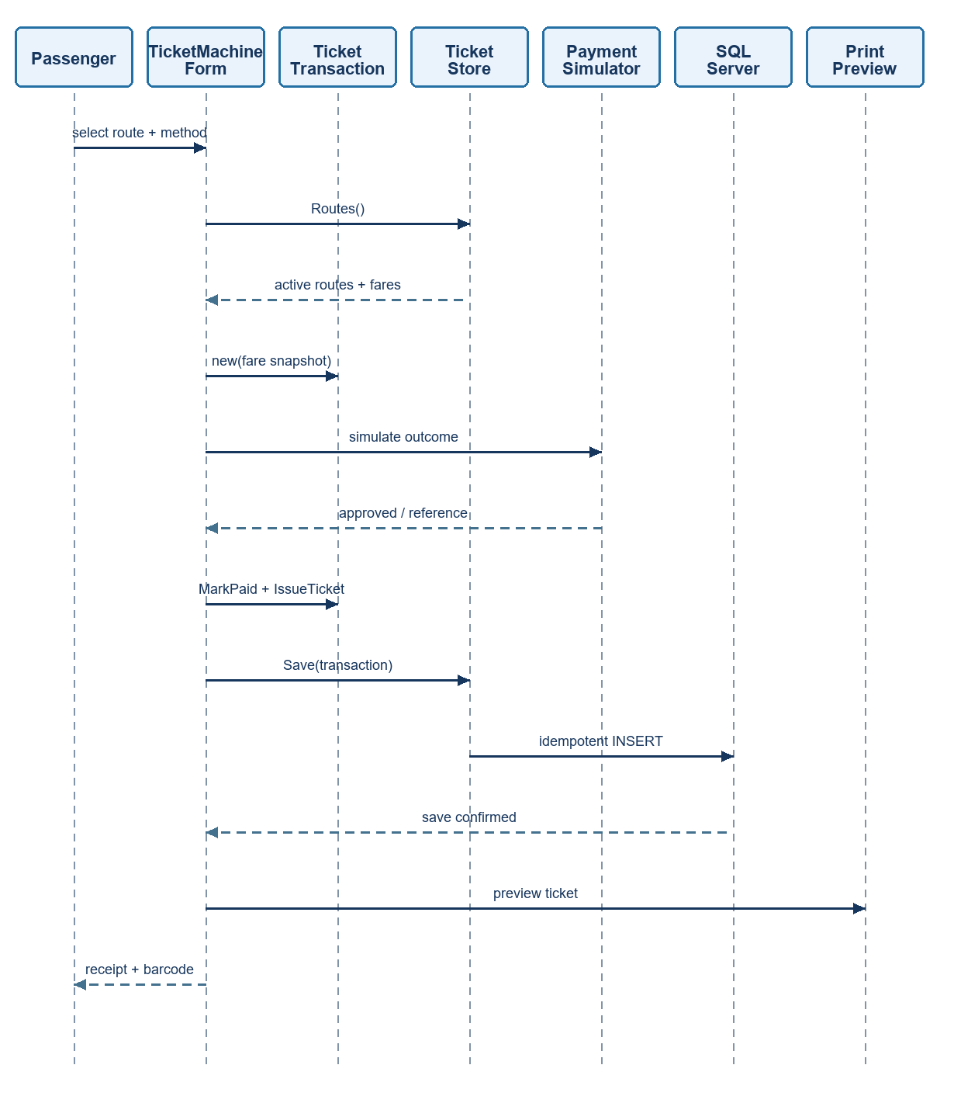
Current application purchase sequence

3.3.2 State Chart Diagram
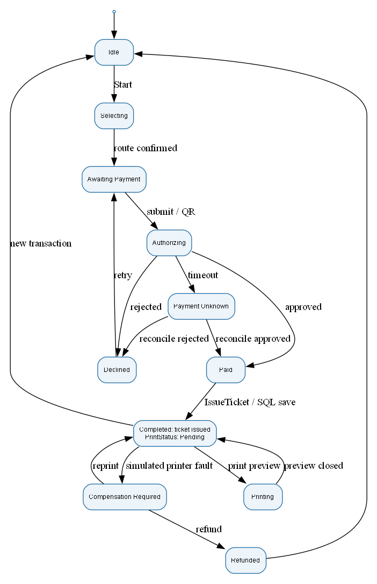
Transaction states; issued and physically printed are distinct

3.3.3 Class Diagram (Domain Model)
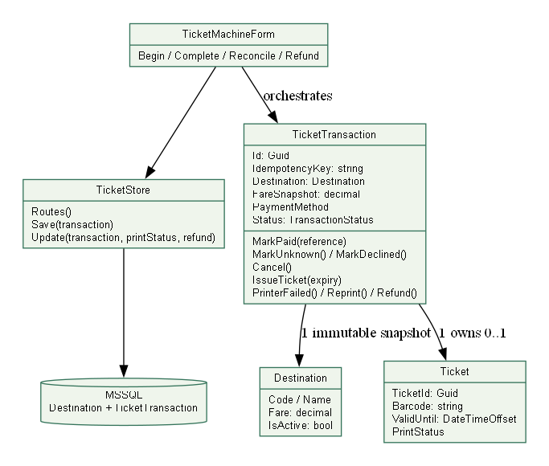
Current classes and methods

3.4 Model Consistency Check
Cross-check | Evidence / result
Requirements → use cases | UC-01 and FR-01..07 cover route, payment, ticket and recovery
Class → code | TicketTransaction, Destination, Ticket, TicketStore and current methods match the implementation
State → tests | Unknown cannot issue; duplicate payment is idempotent; reprint retains barcode
Payment choices | Card, BankQr and Wallet are present in enum, UI and SQL constraint
Architecture → scope | Signed callbacks, live providers, startup reconciliation and authenticated diagnostics are production extensions
Printing | Preview does not claim physical delivery; failed printer simulation enters compensation

4. Phase 3: UI/UX & Architecture (15 marks)

4.1 UI/UX Design (5 marks)
The interface presents a three-step progress indicator, large selectors, persistent fare, explicit error/unknown guidance and a separate ticket surface. The visual upgrade adds original 3D artwork, pastel colors and a silent 30-second motion graphic with a pause control. Payment and recovery controls remain available independently of animation. An unavailable route catalogue exposes Retry connection. An unconfirmed SQL save blocks reset and a new journey until the same reference is resolved.
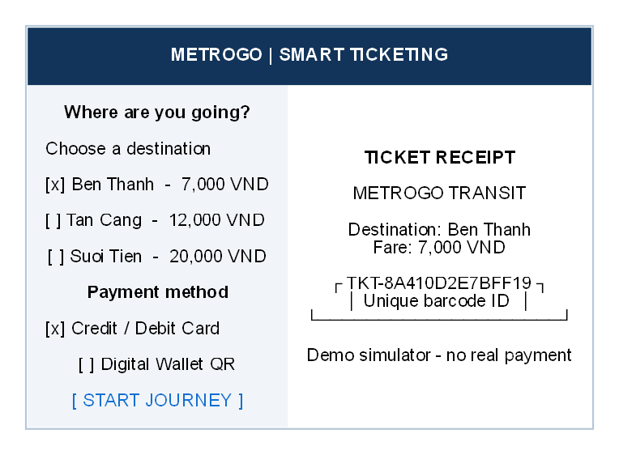
Touchscreen wireframe
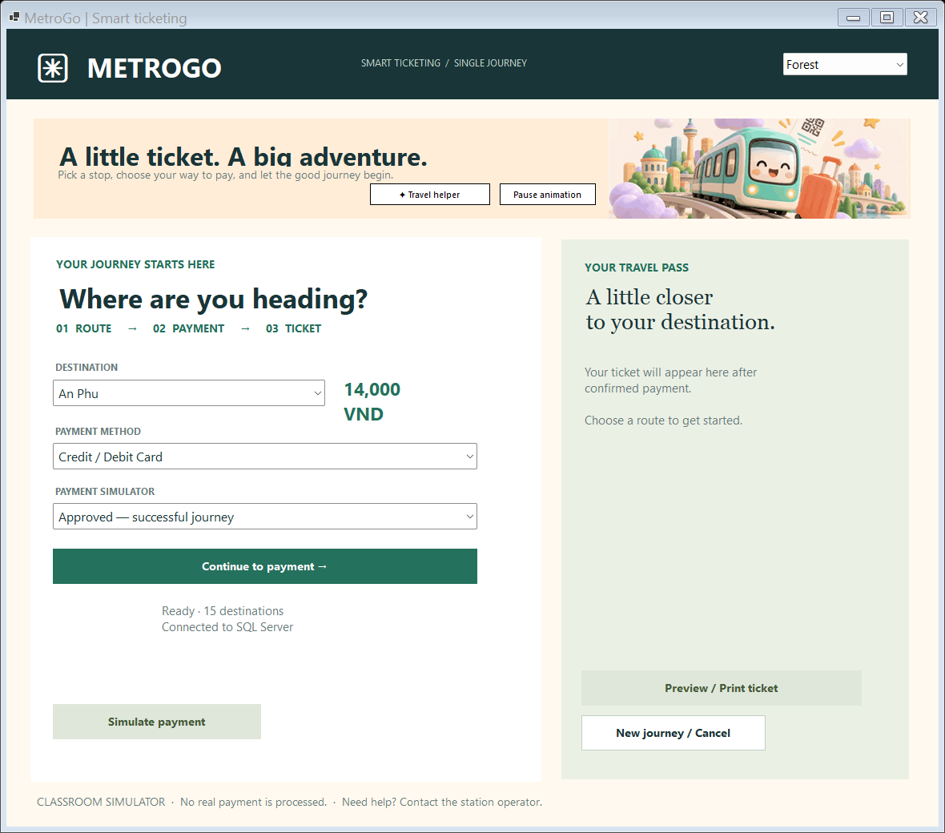
Actual upgraded kiosk connected to SQL Server
The optional local AI guide uses TF-IDF retrieval over curated English and Vietnamese workflow answers. Forest, Sunset and Lilac palettes change action colors. The guide cannot charge money or alter transactions. Seven additional tests verify the local assistant.

4.2 Architectural Design (10 marks)

4.2.1 Architecture Diagram
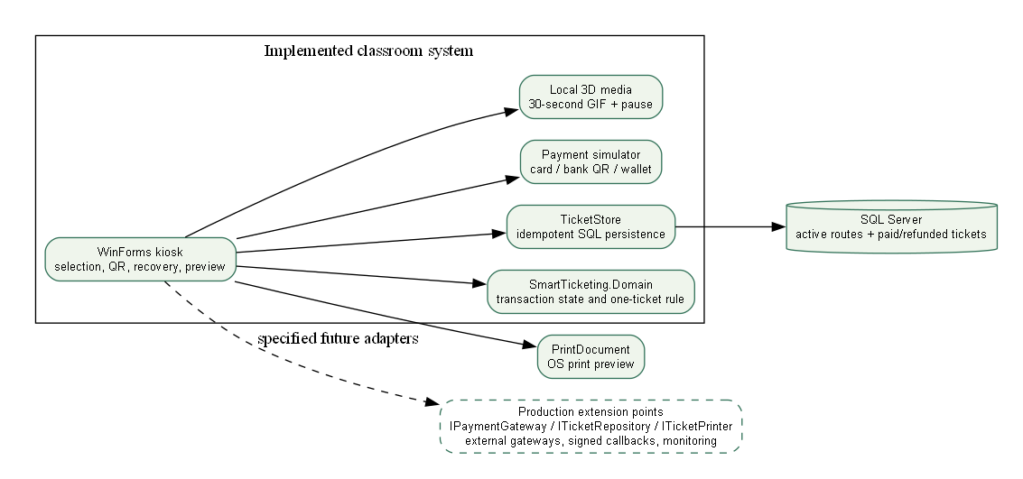
Implemented architecture and production extension points
SmartTicketing.Domain owns transaction transitions and unique ticket identity. TicketStore loads active routes and saves with a serializable same-reference check. TicketMachineForm orchestrates simulator outcomes and displays the QR/receipt only when persistence confirms. IPaymentGateway, ITicketRepository and ITicketPrinter specify production adapter boundaries.

4.2.2 Deployment Diagram
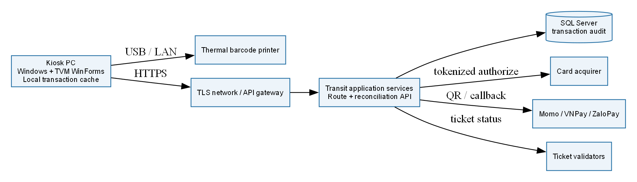
Production deployment design; external services are not live in demo

5. Phase 4: Implementation, Tooling & Demo (30 marks)

5.1 Visual Studio Engineering: Model-to-Code (10 marks)

5.1.1 Forward Engineering (Model to Code)
tools/ModelEngineering reads domain-model.json and writes engineering/ModelSkeletons.cs. This is a reproducible forward-engineering artifact. It does not claim the Visual Studio designer command was executed.

5.1.2 Backward Engineering (Code to Model)
The tool reflects the compiled domain assembly into engineering/CodeToModel.json. The current immutable properties and state/recovery methods can be compared with the forward model.

5.1.3 Code Map
engineering/DomainCodeMap.dgml contains reflected property dependencies from the actual assembly. Open it in supporting Visual Studio graph tooling. Actual Visual Studio operations and screenshots still require capture in a supporting installed edition; see docs/visual-studio-demo.md.

5.2 GitHub & AI Tooling (10 marks)

5.2.1 Source Control
Confirmed GitHub account: https://github.com/Nghiaktvn. The account URL is not a project repository. No genuine group repository, branch/PR history or contribution figures have been supplied. Local main has no commits. The proposed workflow uses feature branches, student-authored commits, peer review and Pull Requests into main; no historical teamwork is invented.

5.2.2 AI Assistance: Copilot Prompt Documentation
Tool / date | Actual request summary | Kept / changed | Validation
Codex / 23 Oct 2026 | Complete PDFs and rubric | Code, tests, workbook and numbered report | Build, MSTest and SQL demo
Codex / 23 Oct 2026 | Upgrade all UI/UX and functional demos | Three application interfaces and safe workflow states | Native and browser captures
image_gen / 23 Oct 2026 | Joyful MetroGo 3D transit scene | Original art + 30-second motion graphics | Image inspection; video metadata

5.2.3 Reflection on AI Use
AI accelerated scaffolding, but review exposed account lockout, cancellation, stale-stock and template-compliance gaps. These were corrected and tested. Students must understand the submitted code; prompts, assumptions and generated art are declared.

5.3 Demo Application (10 marks)
Input / action | Observed or enforced result
Route choice | Active SQL catalogue and immutable fare snapshot
Card / Bank QR / Wallet | Labeled simulator terminal or transaction-bound QR
Approved | One saved ticket and barcode
Declined | No usable ticket; retry possible
Timeout | Unknown state; reconcile before a fresh payment
Uncertain save | Retry the same reference without duplicate ticket
Printer fault | Same-ticket recovery or recorded simulated refund
Print | PrintDocument preview; optional OS print

21 meaningful domain tests passed. Build and SQL-connected screenshots provide local demo evidence. Card/bank/wallet authorization, reconciliation and refund remain simulations. Physical paper output is not tested.
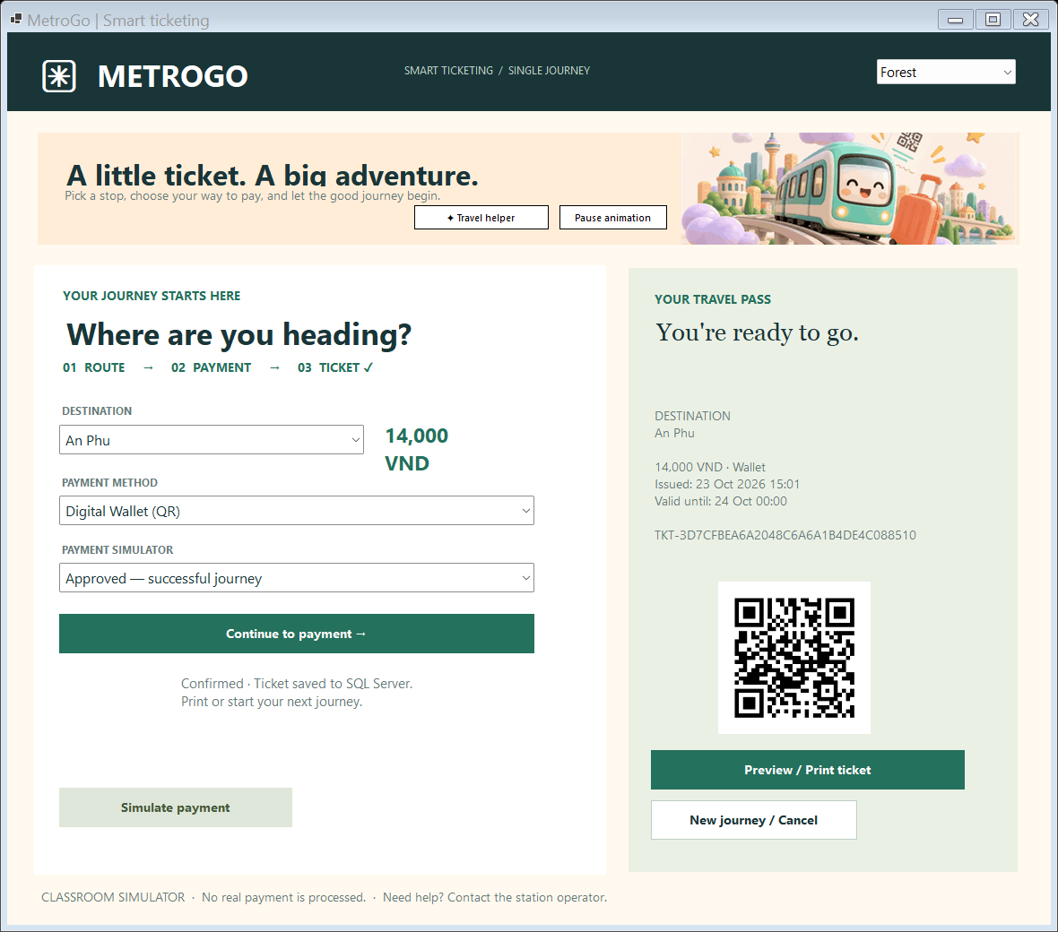
Actual successful SQL ticket demo
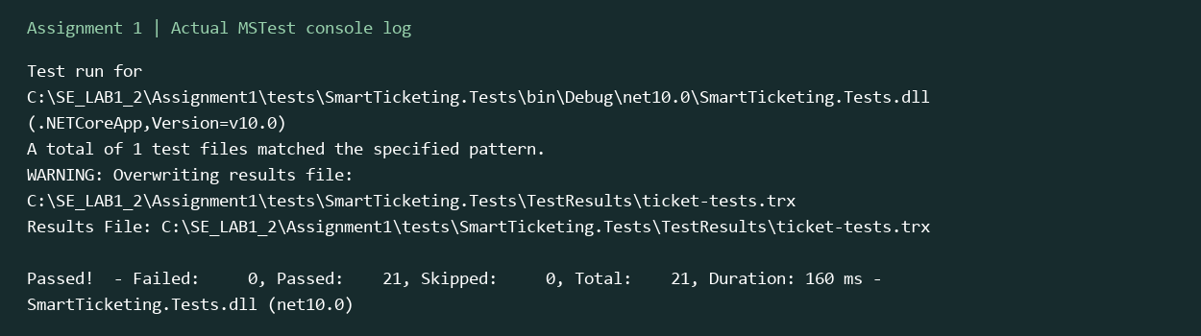
Recorded MSTest console output rendered for readability

6. Checklist for "LabGroup_QT2_Assignment1.pdf"
Supplied rubric task | Section | Status
Clarification Q&A | 2.1 | Artifact verified
Requirements specification | 2.2 | Artifact verified
Use cases | 3.1 | Artifact reviewed
Activity diagrams | 3.2 | Artifact reviewed
Detailed system modeling | 3.3 | Current class/state/sequence reviewed
UI/UX | 4.1 | Built and visually checked
Architecture | 4.2 | Demo/production boundaries stated
Visual Studio engineering | 5.1 | Generated artifacts; actual VS captures pending
GitHub and AI tooling | 5.2 | AI log supplied; genuine group GitHub history pending
C# and MSSQL demo | 5.3 | 21 domain tests; SQL-connected demo

The separate Assignment 1 brief referenced by the template was not among the five supplied files. This checklist audits the supplied report/workbook templates and does not assert review of an unavailable additional brief.

7. Contribution of Each Member
Member | Student ID | Actual responsibilities | Contribution
Phạm Trung Nghĩa | 524H0172 | Confirmed submission contact; feature ownership pending group confirmation | Pending
Remaining 2–4 members | Not supplied | Group must provide real names and ownership | Pending

Percentages must total 100% across 3–5 actual members and match readme.txt. Only one confirmed member was provided, so the remaining names and percentages are left for the group.

References
Supplied assignment/report/workbook PDFs; submitted C# source, SQL script and actual evidence. The design folder records original image prompts, media source and photo credits.

Appendix A: readme.txt
SMART TICKETING — ASSIGNMENT 1
Confirmed member: Phạm Trung Nghĩa — 524H0172
GitHub account: https://github.com/Nghiaktvn
Project repository: pending (an account profile is not a repository/PR record).
Group number, remaining 2–4 real members, actual feature ownership, contribution percentages: pending group confirmation.
The contribution percentages must total 100% and match the report and A1_Team_Workbook.xlsx.
Setup:
1. Install .NET SDK 10, Windows Desktop runtime and SQL Server.
2. Run database/01_create_database.sql using sqlcmd or SSMS. It is repeatable and preserves existing records.
3. Set ConnectionStrings:Ticketing in src/SmartTicketing.WinForms/appsettings.json, or environment ConnectionStrings__Ticketing.
4. dotnet build SmartTicketing.sln
5. dotnet run --project src/SmartTicketing.WinForms
6. dotnet test tests/SmartTicketing.Tests
7. dotnet run --project tools/ModelEngineering -- <absolute Assignment1 folder>
All card, bank-QR, wallet, timeout, reconciliation and refund outcomes are simulations. No real payment occurs.
The 30-second MP4/GIF and original artwork are local assets. Pause animation in the kiosk when desired.
Actual Visual Studio model/code operations and Code Map screenshots still require capture on a supporting installed edition.
Report.docx is also supplied as 524H0172_PhamTrungNghia.docx.
SourceCode.zip excludes bin, obj, TestResults and local secrets; saved evidence is under docs/evidence.

Appendix B: Full-size Diagrams
Full-size PNG and editable DOT sources are under docs/diagrams; the production PlantUML specification is in docs/uml.md. Original art and 30-second MP4/GIF media are under assets.

