Smart Ticketing System Assignment 1
Smart Ticketing System | Assignment 1
QT2 · Semester 1 2026–2027
Requirements, UML, architecture, implemented demo, verification, and honest submission status.
Phạm Trung Nghĩa (524H0172) · 23 October 2026. Group number and remaining members await confirmation.

1. Introduction

1.1 Purpose and Scope
Specify a single-journey ticket vending machine and demonstrate it with C# WinForms and MSSQL. The delivered prototype loads active routes, fixes the fare for an attempt, supports card/bank-QR/wallet simulators, saves paid tickets idempotently, displays a unique barcode, and offers printer recovery, simulated refund and print preview. Payment outcomes have distinct visual feedback, and an inactive QR disappears after failure. Twenty-one unit tests and five isolated SQL checks passed; the SQL fixture was removed afterward. No real bank, wallet or physical print result is claimed.

1.2 Problem Statement in Our Own Words
Passengers need a clear route-to-ticket interaction. A declined payment, unknown result and printer failure need distinct guidance. A lost save acknowledgement must not create a second charge or usable ticket. Operators need a transaction identity to resolve interruptions.

1.3 Team and Roles
Member | Student ID | Actual responsibilities | Contribution
Phạm Trung Nghĩa | 524H0172 | Confirmed submission contact; feature ownership pending group confirmation | Pending
Remaining 2–4 members | Not supplied | Group must provide real names and ownership | Pending

2. Phase 1: Requirements Engineering (20 marks)

2.1 Clarification Q&A (5 marks)
ID | Question | Assumed answer | Design impact | Requirement IDs
Q1 | Which passenger types, routes, and fares are sold? | Adult single journey; operator-maintained route and fare catalogue. | Destination and fare snapshot in each ticket transaction. | FR-01, DR-02
Q2 | Are card and wallet integrations live? | Production uses certified providers; current demo is simulation only. | Adapter boundaries; no real charge or credentials in demo. | FR-02, NFR-06
Q3 | How are declined, timed-out, and duplicate payments handled? | Decline permits retry; timeout remains unknown until reconciliation; callbacks are idempotent. | No ticket until confirmed; unique idempotency reference. | FR-03, DR-03, DR-05
Q4 | When is a ticket valid and how is it checked? | Single journey valid for the service day; barcode holds an opaque unique ticket ID. | Unique ticket identity; no personal data in barcode. | FR-04, DR-04
Q5 | Are refund and cancellation supported? | Cancel before payment; after capture use operator-audited reversal/refund. | Transaction state and compensation record. | FR-07, DR-07
Q6 | Which accessibility and language requirements apply? | Vietnamese/English, high contrast, large touch targets, accessible timeout. | Bilingual UI and accessibility acceptance criteria. | NFR-07
Q7 | What payment data is retained? | Never retain PAN, CVV, wallet credentials, or raw QR; retain masked provider reference. | Data minimization and secure audit log. | NFR-06
Q8 | What availability and response time are required? | 99.5% monthly kiosk availability; UI p95 <=1s; routes <=2s; payment timeout 15s. | Measurable NFRs; monitor availability and latency. | NFR-01..05
Q9 | Is cash payment required? | Out of scope; brief specifies card, QR, and wallet. | No cash hardware or cash reconciliation. | FR-02
Q10 | What if network or printer fails? | Fail safely; no ticket before confirmed payment; reconcile, reprint, or compensate. | Fault state and recovery workflow. | FR-07, FR-08
Q11 | Which external systems are integrated? | Route/fare API, card acquirer, Momo/VNPay/ZaloPay, validator, monitoring. | Deployment and activity diagram actors. | FR-02, FR-03
Q12 | How long are records retained? | Non-sensitive transaction events retained 12 months, subject to operator policy. | Retention configurable; audit policy requires approval. | FR-06, NFR-06

Hidden complexities: timeout differs from decline; SQL commit may precede a lost acknowledgement; duplicate callbacks require idempotency; printer failure needs compensation; public kiosks need measurable response and accessibility criteria.

2.2 Requirements Specification (15 marks)

2.2.1 Functional Requirements
ID | Requirement | Acceptance target | Priority / source
FR-01 | Start a purchase and show active destinations and fares. | Route list response <=2 seconds; inactive routes cannot be selected. | Must / Q1/Q8 → UC-01/06
FR-02 | Select destination and card, bank QR or wallet QR payment. | Fare and route remain visible until confirmation. | Must / Q2/Q9 → UC-02/03/07
FR-03 | Authorize using an idempotency key and handle all outcomes. | Approve/decline/pending/timeout handled with no duplicate charge. | Must / Q3/Q7 → UC-02/03/05
FR-04 | Print a barcode ticket only after confirmed payment. | Exactly one usable ticket per paid transaction. | Must / Q4/Q10 → UC-08
FR-05 | Display route, fare, time, and masked reference on receipt. | No sensitive payment credential appears. | Must / Q4/Q7 → UC-09
FR-06 | Audit payment, transaction, print, and status events. | Searchable by transaction ID; excludes PAN/CVV. | Must / Q7/Q12 → UC-04/05
FR-07 | Recover and reconcile after interruption. | Unresolved transaction reconciled before issue/retry. | Must / Q3/Q5/Q10 → UC-05
FR-08 | Expose operator diagnostics and kiosk out-of-service status. | Timestamped fault visible to monitoring. | Must / Q10/Q11 → UC-04

2.2.2 Non-Functional Requirements
ID / area | Requirement | Measurable target | Measurement method
NFR-01 / Reliability | Monthly service availability excluding planned maintenance. | >=99.5%; available scheduled minutes / total scheduled minutes. | Timed trials/logs for latency; scheduled-minute observation for availability; accessibility and security review for relevant controls
NFR-02 / Performance | Local input and screen transition. | p95 <=1 second; p99 <=2 seconds. | Timed trials/logs for latency; scheduled-minute observation for availability; accessibility and security review for relevant controls
NFR-03 / Performance | Route/fare catalogue load. | p95 <=2 seconds; cached data timestamped, max age 24 hours. | Timed trials/logs for latency; scheduled-minute observation for availability; accessibility and security review for relevant controls
NFR-04 / Performance | Payment completion or safe timeout. | 95% <=8 seconds; timeout at 15 seconds; reconcile unknown result. | Timed trials/logs for latency; scheduled-minute observation for availability; accessibility and security review for relevant controls
NFR-05 / Reliability | Print after confirmed authorization. | Print starts <=2 seconds; failure initiates alert and compensation. | Timed trials/logs for latency; scheduled-minute observation for availability; accessibility and security review for relevant controls
NFR-06 / Security | Protect payment and service data. | TLS 1.2+, encrypted secrets, least privilege, no PAN/CVV, signed callbacks. | Timed trials/logs for latency; scheduled-minute observation for availability; accessibility and security review for relevant controls
NFR-07 / Accessibility | Support public touchscreen use. | Large targets >=44 px, readable contrast, bilingual UI, timeout extension. | Timed trials/logs for latency; scheduled-minute observation for availability; accessibility and security review for relevant controls
NFR-08 / Maintainability | Isolate routes, gateways, persistence, and printer. | Ports/adapters, structured logs, documented config, automated tests. | Timed trials/logs for latency; scheduled-minute observation for availability; accessibility and security review for relevant controls

These figures are acceptance requirements, not measured production results. The classroom build/tests do not prove monthly uptime, payment provider response times or WCAG conformance.

2.2.3 Domain Requirements
ID | Rule | Acceptance
DR-01 | At most one ticket per confirmed payment. | Duplicate callbacks and ticket issue are idempotent.
DR-02 | The active route fare is captured once. | Immutable FareSnapshot.
DR-03 | Payment references and barcodes are unique. | SQL UNIQUE constraints and same-reference retry.
DR-04 | Ticket QR uses an opaque ID and service-day validity. | No personal data; expiry displayed.
DR-05 | Unknown payments reconcile before a new attempt. | Unknown state cannot be silently cancelled.
DR-06 | Payment QR binds transaction, amount and method and expires. | Demo QR expires after three minutes.
DR-07 | Printer failure requires compensation. | Same-ticket reprint or recorded simulated refund.

3. Phase 2: UML Modeling & System Design (35 marks)

3.1 Use Case Modeling (10 marks)

3.1.1 Use Case Diagram

3.1.2 Actors and Use Case List
Actor | Responsibility
Passenger | Choose destination/payment; buy and view a ticket
Operator | Diagnose and supervise reconciliation or compensation
Card / bank / wallet gateway | Production payment boundary; simulated in demo
Route source | Active route catalogue; SQL in this demo

Use case | Scope
UC-01 Buy ticket | Designed; prototype scope stated below
UC-02 Pay by card | Designed; prototype scope stated below
UC-03 Pay by bank / wallet QR | Designed; prototype scope stated below
UC-04 Diagnose kiosk | Designed; prototype scope stated below
UC-05 Reconcile transaction | Designed; prototype scope stated below
UC-06 Select destination | Designed; prototype scope stated below
UC-07 Choose payment | Designed; prototype scope stated below
UC-08 Print ticket | Designed; prototype scope stated below
UC-09 View receipt | Designed; prototype scope stated below

3.1.3 Use Case Descriptions

UC-01 Buy ticket
Field | Description
Actor | Passenger
Trigger | Passenger requests the journey action
Preconditions | Kiosk ready, route data and printer available.
Main success flow | Start; select route; confirm fare; choose method; authorize; persist; print; show receipt.
Alternate / exception | Decline allows retry; timeout requires reconciliation; print fault creates compensation case.
Postcondition | At most one delivered ticket for a paid transaction.

UC-02 Pay by card
Field | Description
Actor | Passenger
Trigger | Passenger requests the journey action
Preconditions | Route and fare confirmed.
Main success flow | Prompt tap or insert; send tokenized authorization; verify outcome.
Alternate / exception | Decline, cancel, or timeout returns a safe status.
Postcondition | Payment reference linked to transaction.

UC-03 Pay by bank / wallet QR
Field | Description
Actor | Passenger
Trigger | Passenger requests the journey action
Preconditions | Route and fare confirmed.
Main success flow | Create expiring amount-bound QR; display; await signed callback.
Alternate / exception | Expiry or cancellation invalidates QR; late callback requires reconciliation.
Postcondition | A confirmed capture or no issued ticket.

UC-04 Diagnose kiosk
Field | Description
Actor | Operator
Trigger | A fault or unknown transaction needs resolution
Preconditions | Authenticated operator and service mode.
Main success flow | Check printer, network, gateway, and recent faults.
Alternate / exception | Failed self-test sets out-of-service state.
Postcondition | Audited diagnostic event.

UC-05 Reconcile transaction
Field | Description
Actor | Operator
Trigger | A fault or unknown transaction needs resolution
Preconditions | Payment result unknown or print compensation pending.
Main success flow | Query gateway; compare capture; retry print or refund.
Alternate / exception | Gateway unavailable remains queued.
Postcondition | No duplicate charge or ticket.

UC-06 Select destination
Field | Description
Actor | Passenger
Trigger | Passenger requests the journey action
Preconditions | Active fare catalogue available.
Main success flow | Show active routes; select destination and fare snapshot.
Alternate / exception | Missing or stale catalogue shows unavailable guidance.
Postcondition | Valid route and fare assigned.

UC-07 Choose payment
Field | Description
Actor | Passenger
Trigger | Passenger requests the journey action
Preconditions | Route and fare confirmed.
Main success flow | Choose card, bank QR, or wallet.
Alternate / exception | Cancel or timeout discards pending selection.
Postcondition | One method set for the attempt.

UC-08 Print ticket
Field | Description
Actor | Passenger
Trigger | Passenger requests the journey action
Preconditions | Confirmed payment and working printer.
Main success flow | Generate unique opaque barcode; print route, fare, validity, and barcode.
Alternate / exception | Printer fault creates reprint or refund case.
Postcondition | Ticket linked to one paid transaction.

UC-09 View receipt
Field | Description
Actor | Passenger
Trigger | Passenger requests the journey action
Preconditions | Payment and print results known.
Main success flow | Show route, fare, time, reference, and support guidance.
Alternate / exception | Unknown payment shows pending guidance, not success.
Postcondition | Passenger can identify transaction for support.

3.2 Activity Diagrams (10 marks)

3.2.1 Passenger Buys a Ticket at the TVM

3.2.2 Communication with External Payment Gateways

3.3 Detailed System Modeling: Main Use Case "Buy a Ticket" (15 marks)

3.3.1 Sequence Diagram

3.3.2 State Chart Diagram

3.3.3 Class Diagram (Domain Model)

3.4 Model Consistency Check
Cross-check | Evidence / result
Requirements → use cases | UC-01 and FR-01..07 cover route, payment, ticket and recovery
Class → code | TicketTransaction, Destination, Ticket, TicketStore and current methods match the implementation
State → tests | Unknown cannot issue; duplicate payment is idempotent; reprint retains barcode
Payment choices | Card, BankQr and Wallet are present in enum, UI and SQL constraint
Architecture → scope | Signed callbacks, live providers, startup reconciliation and authenticated diagnostics are production extensions
Printing | Preview does not claim physical delivery; failed printer simulation enters compensation

4. Phase 3: UI/UX & Architecture (15 marks)

4.1 UI/UX Design (5 marks)
The interface presents a three-step progress indicator, large selectors, persistent fare, explicit error/unknown guidance and a separate ticket surface. The visual upgrade adds original 3D artwork, a subtle seven-color animated frame, three coordinated palettes, gentle button feedback and a silent 30-second motion graphic with a pause control. Payment and recovery controls remain available independently of animation. An unavailable route catalogue exposes Retry connection. An unconfirmed SQL save blocks reset and a new journey until the same reference is resolved. The refreshed Forest theme was launched against SQLEXPRESS for the final demo capture and displayed all 15 active destinations.
The optional local AI guide uses TF-IDF retrieval over curated English and Vietnamese workflow answers. Forest, Sunset and Lilac palettes update the banner, labels, receipt surface and action buttons together. Hover and pressed feedback do not change fare or payment behavior. The guide cannot charge money or alter transactions. Seven additional tests verify the local assistant. An editable MetroGo frame and both Lab 2 sign-in frames are in the Figma handoff: https://www.figma.com/design/XJaFLoJzp8NrexLNmOHBAk.

4.2 Architectural Design (10 marks)

4.2.1 Architecture Diagram
SmartTicketing.Domain owns transaction transitions and unique ticket identity. TicketStore loads active routes and saves with a serializable same-reference check. TicketMachineForm orchestrates simulator outcomes and displays the QR/receipt only when persistence confirms. IPaymentGateway, ITicketRepository and ITicketPrinter specify production adapter boundaries.

4.2.2 Deployment Diagram

5. Phase 4: Implementation, Tooling & Demo (30 marks)

5.1 Visual Studio Engineering: Model-to-Code (10 marks)

5.1.1 Forward Engineering (Model to Code)
tools/ModelEngineering reads domain-model.json and writes engineering/ModelSkeletons.cs. This is a reproducible forward-engineering artifact. It does not claim the Visual Studio designer command was executed.

5.1.2 Backward Engineering (Code to Model)
The tool reflects the compiled domain assembly into engineering/CodeToModel.json. The current immutable properties and state/recovery methods can be compared with the forward model.

5.1.3 Code Map
engineering/DomainCodeMap.dgml contains reflected property dependencies from the actual assembly. Open it in supporting Visual Studio graph tooling. Actual Visual Studio operations and screenshots still require capture in a supporting installed edition; see docs/visual-studio-demo.md.

5.2 GitHub & AI Tooling (10 marks)

5.2.1 Source Control
Confirmed GitHub account: https://github.com/Nghiaktvn. The account URL is not a project repository. No genuine group repository, branch/PR history or contribution figures have been supplied. Local main has no commits. The proposed workflow uses feature branches, student-authored commits, peer review and Pull Requests into main; no historical teamwork is invented.

5.2.2 AI Assistance: Copilot Prompt Documentation
Tool / date | Actual request summary | Kept / changed | Validation
Codex / 23 Oct 2026 | Complete PDFs and rubric | Code, tests, workbook and numbered report | Build, MSTest and SQL demo
Codex / 23 Oct 2026 | Upgrade all UI/UX and functional demos | Three application interfaces and safe workflow states | Native and browser captures
image_gen / 23 Oct 2026 | Joyful MetroGo 3D transit scene | Original art + 30-second motion graphics | Image inspection; video metadata

5.2.3 Reflection on AI Use
AI accelerated scaffolding, but review exposed account lockout, cancellation, stale-stock and template-compliance gaps. These were corrected and tested. Students must understand the submitted code; prompts, assumptions and generated art are declared.

5.3 Demo Application (10 marks)
Input / action | Observed or enforced result
Route choice | Active SQL catalogue and immutable fare snapshot
Card / Bank QR / Wallet | Labeled simulator terminal or transaction-bound QR
Confirm payment | Explicit confirmation saves one Paid ticket; no external provider or real charge
Approved | One saved ticket and barcode
Declined | No usable ticket; retry possible
Timeout | Unknown state; reconcile before a fresh payment
Uncertain save | Retry the same reference without duplicate ticket
Printer fault | Same-ticket recovery or recorded simulated refund
Print | PrintDocument preview; optional OS print

21 meaningful domain tests passed. The live simulator demo confirmed An Phu at 14,000 VND and saved one Paid ticket with a valid expiry. The captured screen shows the confirmation state and ticket barcode. Card/bank/wallet authorization, reconciliation and refund remain simulations. Physical paper output is not tested.
The final 18-check WinForms button audit exercised the actual event handlers offline, including card success, both QR methods, decline, timeout reconciliation, printer-fault refund/recovery, reset, pause/theme and guide opening. The separate 5-check SQL harness proved ticket persistence and fixture cleanup. SQL Express AUTO_CLOSE was disabled after the Windows log showed repeated database recovery; the final combined test passed at a 15-second connection timeout. Evidence is in docs/evidence/tvm-button-audit.json and the integration log. The print control was checked as enabled with a paid ticket; physical print output was not tested.

6. Checklist for "LabGroup_QT2_Assignment1.pdf"
Supplied rubric task | Section | Status
Clarification Q&A | 2.1 | Artifact verified
Requirements specification | 2.2 | Artifact verified
Use cases | 3.1 | Artifact reviewed
Activity diagrams | 3.2 | Artifact reviewed
Detailed system modeling | 3.3 | Current class/state/sequence reviewed
UI/UX | 4.1 | Built and visually checked
Architecture | 4.2 | Demo/production boundaries stated
Visual Studio engineering | 5.1 | Generated artifacts; actual VS captures pending
GitHub and AI tooling | 5.2 | AI log supplied; genuine group GitHub history pending
C# and MSSQL demo | 5.3 | 21 domain tests; SQL-connected demo

The separate Assignment 1 brief referenced by the template was not among the five supplied files. This checklist audits the supplied report/workbook templates and does not assert review of an unavailable additional brief.

7. Contribution of Each Member
Member | Student ID | Actual responsibilities | Contribution
Phạm Trung Nghĩa | 524H0172 | Confirmed submission contact; feature ownership pending group confirmation | Pending
Remaining 2–4 members | Not supplied | Group must provide real names and ownership | Pending

Percentages must total 100% across 3–5 actual members and match readme.txt. Only one confirmed member was provided, so the remaining names and percentages are left for the group.

References
Supplied assignment/report/workbook PDFs; submitted C# source, SQL script and actual evidence. The design folder records original image prompts, media source and photo credits.

Appendix A: readme.txt
SMART TICKETING — ASSIGNMENT 1
Confirmed member: Phạm Trung Nghĩa — 524H0172
GitHub account: https://github.com/Nghiaktvn
Project repository: pending (an account profile is not a repository/PR record).
Group number, remaining 2–4 real members, actual feature ownership, contribution percentages: pending group confirmation.
The contribution percentages must total 100% and match the report and A1_Team_Workbook.xlsx.
Setup:
- Install .NET SDK 10, Windows Desktop runtime and SQL Server.
- Run database/01_create_database.sql using sqlcmd or SSMS. It is repeatable and preserves existing records.
- Set ConnectionStrings:Ticketing in src/SmartTicketing.WinForms/appsettings.json, or environment ConnectionStrings__Ticketing.
- dotnet build SmartTicketing.sln
- dotnet run --project src/SmartTicketing.WinForms
- dotnet test tests/SmartTicketing.Tests
- dotnet run --project tools/ModelEngineering -- <absolute Assignment1 folder>
All card, bank-QR, wallet, timeout, reconciliation and refund outcomes are simulations. No real payment occurs.
The 30-second MP4/GIF and original artwork are local assets. Pause animation in the kiosk when desired.
Actual Visual Studio model/code operations and Code Map screenshots still require capture on a supporting installed edition.
Report.docx is also supplied as 524H0172_PhamTrungNghia.docx.
SourceCode.zip excludes bin, obj, TestResults and local secrets; saved evidence is under docs/evidence.

Appendix B: Full-size Diagrams
Full-size PNG and editable DOT sources are under docs/diagrams; the production PlantUML specification is in docs/uml.md. Original art and 30-second MP4/GIF media are under assets.

Verification — 23 October 2026
SmartTicketing.sln builds with zero compiler errors. The offline environment returned NU1900 because NuGet's vulnerability-data endpoint was unreachable. All 21 MSTest cases pass, covering invalid routes/fares, payment transitions, duplicate approvals, timeouts, declines, cancellation, same-ticket reprint and simulated refunds.
The WinForms application loads 15 active routes from SQL Server and persists transactions by default. The final classroom demonstration selected An Phu for 14,000 VND, confirmed the Wallet simulator payment and displayed the paid ticket, QR barcode and New journey action. SQL recorded TransactionId 15 as Paid with a valid expiry. No real payment occurred.
The application includes Card, BankQr and Wallet simulators, declined/unknown/printer-failure paths, retry with the same save identity, and PrintDocument preview. The 30-second local motion assets are silent animations of original 3D artwork and timed captions. Domain forward/backward artifacts and a reflected DGML graph are generated by tools/ModelEngineering.
Four pre-existing ticket rows still have a null ValidUntilUtc from earlier data. The new demo ticket has a valid expiry; no older ticket was changed. Actual Visual Studio designer operations/Code Map captures, physical printing, full team roster and real GitHub collaboration remain manual evidence items.

Additional verification — 24 October 2026
The opt-in tests/SmartTicketing.IntegrationTests harness passed 5/5 checks against SQL Server: active routes, one persisted ticket, idempotent save retry with the same barcode, simulated refund retaining the original fare and barcode, and fixture cleanup restoring the ticket count. Run dotnet run --project tests/SmartTicketing.IntegrationTests -- <absolute Assignment1 directory> after database setup. The 21 unit tests still pass. A fresh kiosk launch connected to all 15 routes; its start screen is saved at docs/evidence/tvm-start-final.png. Declined, timed-out and failed-save states use distinct status colors and hide inactive payment QR images; docs/evidence/tvm-declined-final.png shows the final declined state. Paper printing remains unverified.
The 24 October button audit invoked actual WinForms button handlers in an offline fixture, without writing demo tickets to SQL. Its 18/18 checks cover pause/resume, theme, helper opening, route/payment selection, card success, bank/wallet QR, decline, timeout reconciliation, refund, recovery of the same ticket, reset and the paid ticket's enabled print-preview control. The exact result is docs/evidence/tvm-button-audit.json. The separate 5/5 SQL harness still verifies persistence and cleanup. Reproduce the combined test with Run-Demo.ps1 -App Test -ButtonTest from the workspace root. The physical printer and print dialog were not driven by this automated audit.
SQL Express had AUTO_CLOSE enabled, causing repeated database startup and a 66-second recovery in the Windows event log. The local databases now have AUTO_CLOSE off, and database/01_create_database.sql applies the same setting for repeat setup. After this change, the combined unit, SQL and native-button run passed with the normal 15-second connection timeout. No ticket rows were changed by this database setting.

TVM Requirements and Assumptions

Clarification questions and assumed answers
ID | Stakeholder question | Assumption used in the prototype
Q1 | Which passenger types, routes, and fares are sold? | Adult single journey; an editable destination and fare catalogue is held in the database.
Q2 | Are cards and wallets real integrations? | Use PCI-compliant acquirer and wallet APIs in production; demo uses a deterministic sandbox simulator only.
Q3 | What happens on a declined, timed-out, or duplicate payment? | Do not issue a ticket; allow retry, use an idempotency reference, and show a plain-language error.
Q4 | When is a ticket valid and how is it validated? | One journey, valid for the service day; barcode encodes an opaque unique ticket ID, not personal data.
Q5 | Are refunds, cancellation, and change supported? | Before payment: cancel. After payment: operator-assisted refund, logged and linked to original payment.
Q6 | What accessibility and language support is required? | Vietnamese and English, high contrast, large touch targets, keyboard/service assistance option.
Q7 | Which personal/payment data may be retained? | Never store PAN, CVV, wallet credentials, or QR payload; retain token/reference and transaction audit only.
Q8 | What uptime and response targets apply? | Monthly 99.5% kiosk service availability; local UI response p95 <= 1 second; route list <= 2 seconds; payment response <= 15 seconds before safe timeout.
Q9 | How is cash handled? | Cash is out of scope because only card, QR, and wallet channels are specified.
Q10 | What should happen if network or printer fails? | Fail safely, issue no ticket without confirmed payment, show retry/help; printer failure triggers void/refund workflow.
Q11 | Which external systems are in scope? | Route/fare service, card acquirer, wallet gateway (Momo/VNPay/ZaloPay), ticket validator, monitoring.
Q12 | What retention and audit rules apply? | Retain non-sensitive transaction events for 12 months, subject to operator policy and applicable law.

Functional requirements
ID | Requirement | Acceptance measure
FR-01 | Start a new transaction and display active destinations and fares. | Route list appears within 2 seconds; unavailable routes cannot be selected.
FR-02 | Let the passenger select destination and card, bank QR, or wallet QR payment. | Selection and fare remain visible through confirmation.
FR-03 | Authorize payment through the selected external gateway using an idempotency key. | Approved, declined, pending, and timeout outcomes are handled without duplicate charges.
FR-04 | Issue a paper ticket with unique machine-readable barcode only after confirmed payment. | One successful payment maps to exactly one ticket ID and print attempt.
FR-05 | Show a success receipt with route, fare, time, masked payment reference, and support guidance. | Receipt contains no raw card, bank QR, or wallet credentials.
FR-06 | Record transaction, gateway reference, printer result, and status for reconciliation. | Audit record is queryable by transaction ID; sensitive authentication data is absent.
FR-07 | Recover safely after interruption. | At startup, unresolved transactions are reconciled before retrying ticket issue.
FR-08 | Provide operator diagnostics and out-of-service state for printer, network, or gateway faults. | Fault is timestamped and surfaced to the monitoring service.

Non-functional requirements
ID | Requirement | Target
NFR-01 Reliability | Monthly availability per kiosk, excluding planned maintenance. | >= 99.5%; measured as available minutes / scheduled service minutes.
NFR-02 UI performance | Local input acknowledgement and screen transition. | p95 <= 1 s, p99 <= 2 s.
NFR-03 Route performance | Route/fare catalogue load from cache or service. | p95 <= 2 s; stale cache visibly timestamped and maximum age 24 h.
NFR-04 Payment performance | Gateway completion or safe timeout. | 95% response <= 8 s; timeout at 15 s; no ticket on unknown result until reconciliation.
NFR-05 Printing | Ticket print after confirmed authorization. | Start within 2 s; printer failure must trigger alert and compensation path.
NFR-06 Security | Payment and service data protection. | TLS 1.2+, encrypted secrets, least privilege, no PAN/CVV storage, signed gateway callbacks, audit logs.
NFR-07 Accessibility | Touch use in public environment. | WCAG-aligned contrast, >= 44 px targets, readable text, bilingual labels and timeout extension.
NFR-08 Maintainability | Route, fare, gateway, and printer boundaries. | Ports/adapters, documented configuration, structured logs, automated unit/integration tests.

Domain rules
- A paid transaction has exactly one ticket; no pending/declined transaction has a usable ticket.
- A fare is taken from the selected active route at checkout and recorded as an immutable snapshot.
- Transaction IDs and gateway idempotency keys are unique. Repeated callbacks must not issue duplicate tickets.
- A barcode contains an opaque ticket identifier and is unique across all kiosks.
- Reconciliation governs ambiguous gateway outcomes. A timeout is not a decline and is never silently charged again.
- Wallet QR codes are short-lived, single-use, bound to amount and transaction, and invalidated on cancellation/expiry.
- Printer failure after successful capture creates a compensation case; it never marks a ticket delivered.

Detailed use case descriptions
Use case | Preconditions | Main flow | Alternate or error flow | Postcondition
UC-01 Buy ticket | Kiosk ready, route data and printer available. | Start; select route; confirm fare; choose method; authorize; persist; print; show receipt. | Decline allows retry; timeout requires reconciliation; print fault creates compensation case. | At most one delivered ticket for a paid transaction.
UC-02 Pay by card | Route and fare confirmed. | Prompt tap or insert; send tokenized authorization; verify outcome. | Decline, cancel, or timeout returns a safe status. | Payment reference linked to transaction.
UC-03 Pay by bank / wallet QR | Route and fare confirmed. | Create expiring amount-bound QR; display; await signed callback. | Expiry or cancellation invalidates QR; late callback requires reconciliation. | A confirmed capture or no issued ticket.
UC-04 Diagnose kiosk | Authenticated operator and service mode. | Check printer, network, gateway, and recent faults. | Failed self-test sets out-of-service state. | Audited diagnostic event.
UC-05 Reconcile transaction | Payment result unknown or print compensation pending. | Query gateway; compare capture; retry print or refund. | Gateway unavailable remains queued. | No duplicate charge or ticket.
UC-06 Select destination | Active fare catalogue available. | Show active routes; select destination and fare snapshot. | Missing or stale catalogue shows unavailable guidance. | Valid route and fare assigned.
UC-07 Choose payment | Route and fare confirmed. | Choose card, bank QR, or wallet. | Cancel or timeout discards pending selection. | One method set for the attempt.
UC-08 Print ticket | Confirmed payment and working printer. | Generate unique opaque barcode; print route, fare, validity, and barcode. | Printer fault creates reprint or refund case. | Ticket linked to one paid transaction.
UC-09 View receipt | Payment and print results known. | Show route, fare, time, reference, and support guidance. | Unknown payment shows pending guidance, not success. | Passenger can identify transaction for support.

AI assistance and validation record
The following are actual user instructions given to Codex, an AI coding tool used to prepare this prototype. They are not presented as GitHub Copilot transcripts.
Actual prompt or instruction | Assistance received | Human-review and verification status
“hãy giúp tôi hoàn tất cả yêu cầu trong này ... tách ra làm 2 file riêng ...” | Created separate C# solutions, SQL scripts, requirements, diagrams, and report files for both briefs. | Requirements were compared with each supplied PDF; both solutions were built with dotnet.
“chạy ngay trực tiếp cho tôi và cho tôi thấy được những gì bạn làm ...” | Ran solution builds, inspected local SQL availability, and attempted direct UI/web demos. | Builds passed; the first sandboxed SQL attempt failed. A later SQLEXPRESS run outside the sandbox verified database persistence.
“tiếp tục xem xét và cải thiện hết tất cả yêu cầu ... kiểm tra báo cáo 1 lần nữa ...” | Improved the wallet QR, ticket barcode and print preview, multi-line order transaction, Razor Pages, admin CRUD, and report coverage. | Builds passed; one ticket was persisted to SQL, one two-line order was placed with correct stock deductions, and 8/8 unit tests passed.
“kiểm tra và test tất cả chức năng đồng thời kiểm tra báo cáo cũng phải đạt đầy đủ như bảng rubric trong pdf đó” | Re-read both supplied PDF rubrics, rebuilt the A2 solution to an isolated output folder, reran its unit suite, and checked the current SQL demo records. | Both solution builds and eight MSTest cases passed; current SQL record counts and demo ticket/order values were checked with read-only queries. Visual Studio/GitHub/group evidence remains a team-supplied requirement.

No real payment credentials or live payment calls were generated. The team should review every AI-produced artifact and add its genuine Copilot prompt history if Copilot was used. The SQL-connected ticket insert was verified with SQLEXPRESS; payment and printing remain simulated.

Visual Studio model-to-code and Code Map demo
- Open `SmartTicketing.sln` in Visual Studio 2022 and build `SmartTicketing.WinForms`.
- Open `docs/uml.md`, select the class diagram block, and import/paste into the UML designer available in the installed Visual Studio edition or a PlantUML extension. Keep `TicketTransaction`, `Destination`, `Ticket`, `PurchaseService`, `IPaymentGateway`, `ITicketRepository`, and `ITicketPrinter` aligned with the C# implementation.
- Forward engineering: in the class designer, use **Generate Code** for the domain classes and interfaces, then compare with the source under `src/SmartTicketing.WinForms`.
- Backward engineering: add a property or method to a C# domain class, refresh the model from code, and capture the reflected member.
- Code Map: right-click the solution or a project and select **Show on Code Map**. Expand `TicketMachineForm`, persistence, and gateway dependencies; capture the map.
- Add the forward/backward/code-map screenshots to the report. Tool availability varies by Visual Studio edition and installed extensions, so use the equivalent UML extension if the built-in designer is absent.

TVM start screen connected to SQL Server
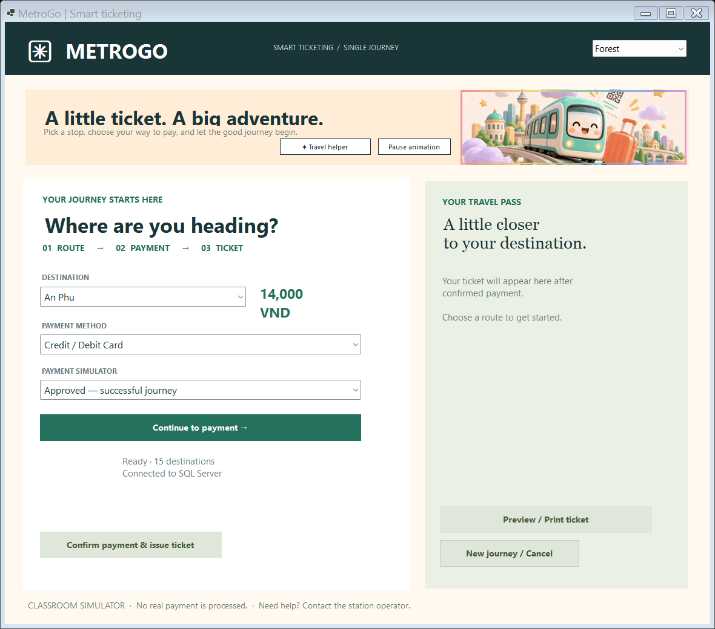
Actual application screenshot captured from the compiled WinForms program.

Scannable wallet demo QR before payment
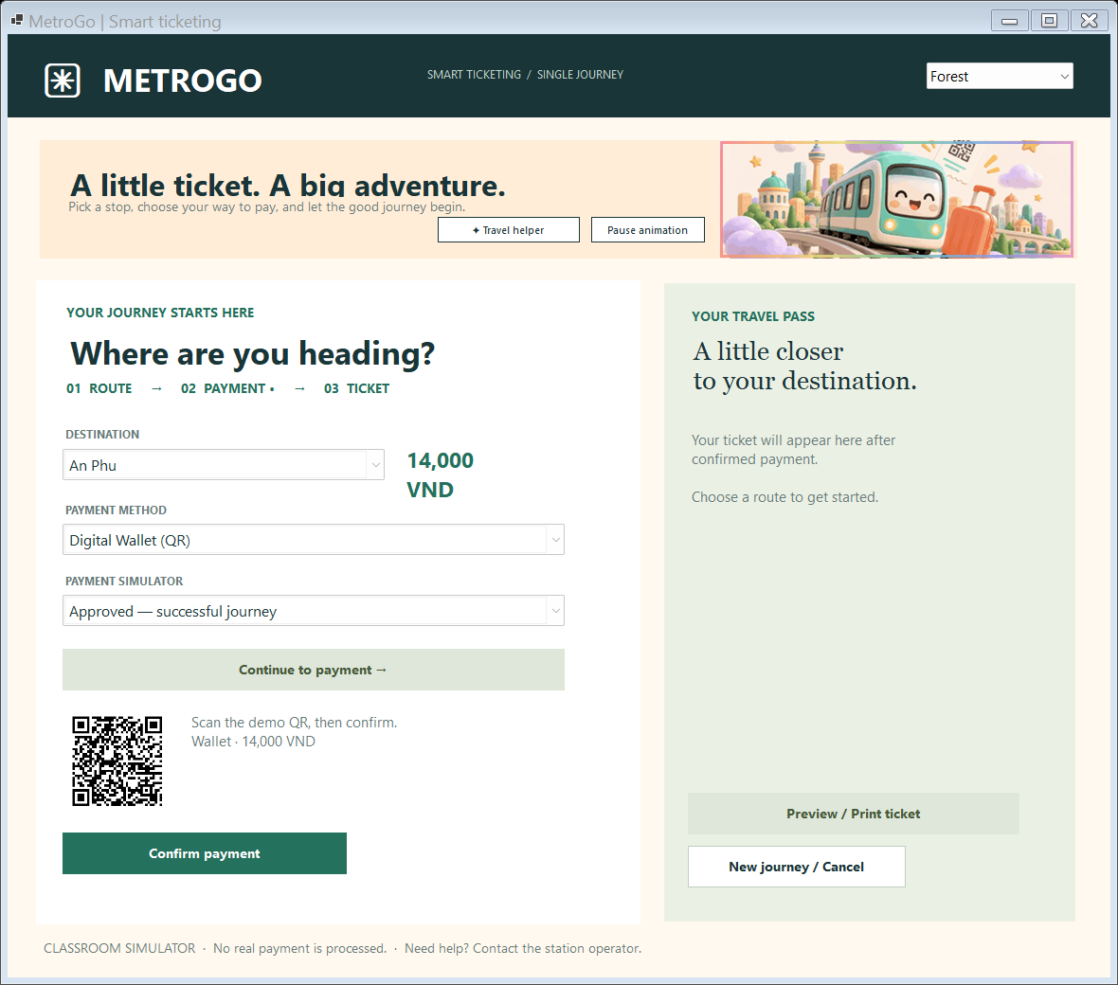
Actual application screenshot captured from the compiled WinForms program.

Final payment confirmation and saved ticket
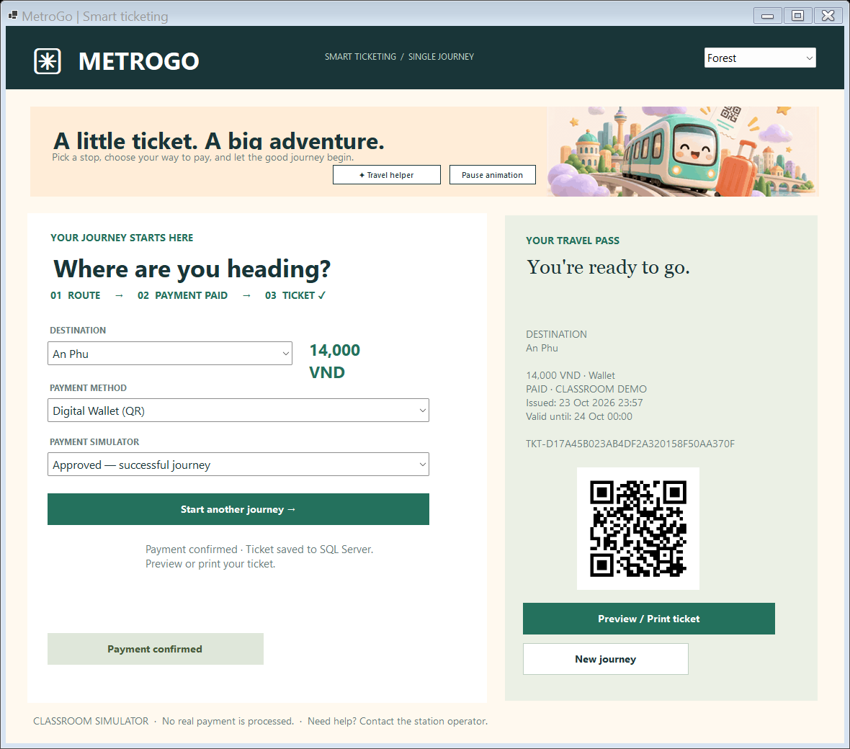
Actual SQL-connected WinForms result: the confirmed Wallet ticket is saved as Paid with a valid expiry; the next-journey action is available.

Design diagrams and UI wireframe

Use case diagram
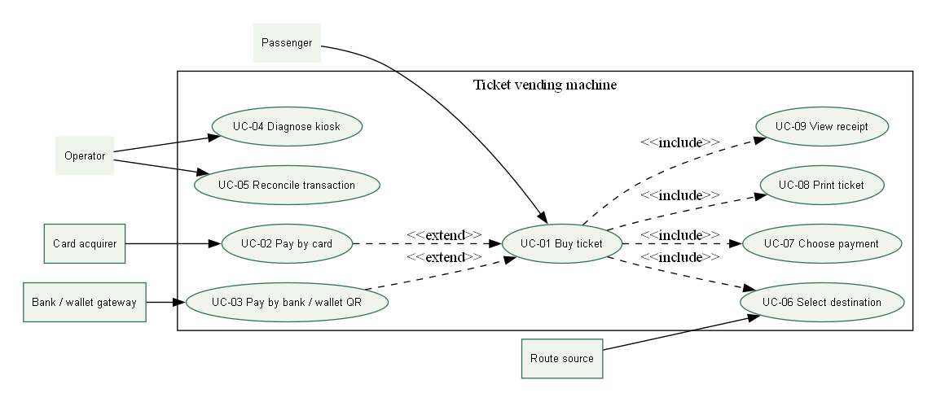
Figure 1. Use case diagram.

Passenger purchase activity
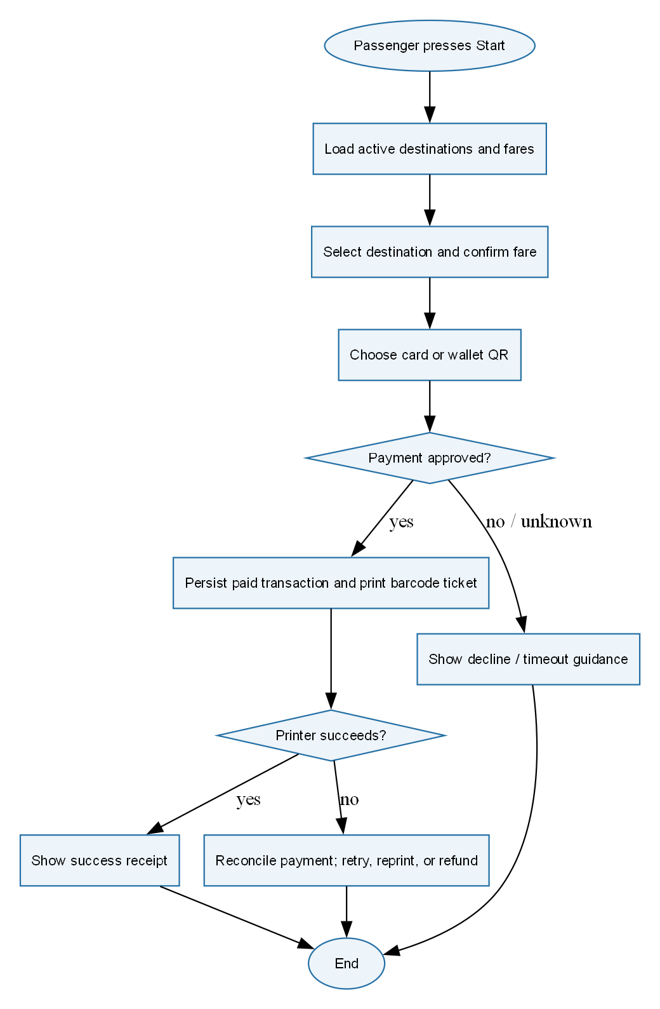
Figure 2. Passenger purchase activity.

Payment gateway activity
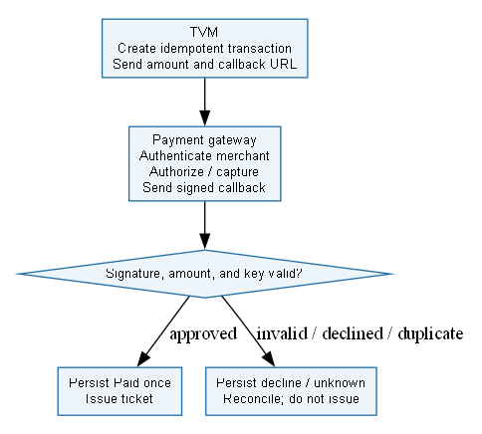
Figure 3. Payment gateway activity.

Purchase sequence diagram
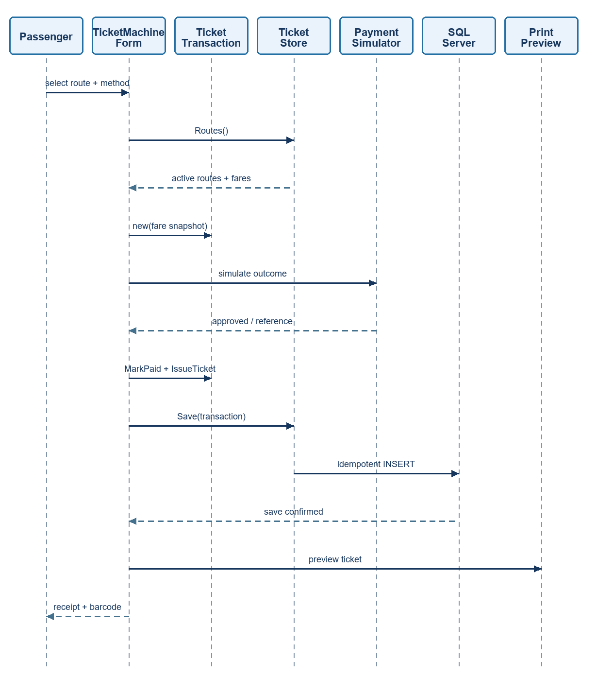
Figure 4. Purchase sequence diagram.

Transaction state chart
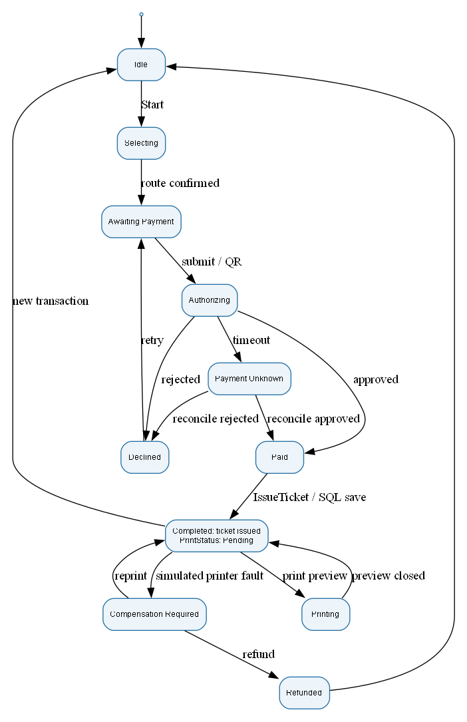
Figure 5. Transaction state chart.

Domain class diagram
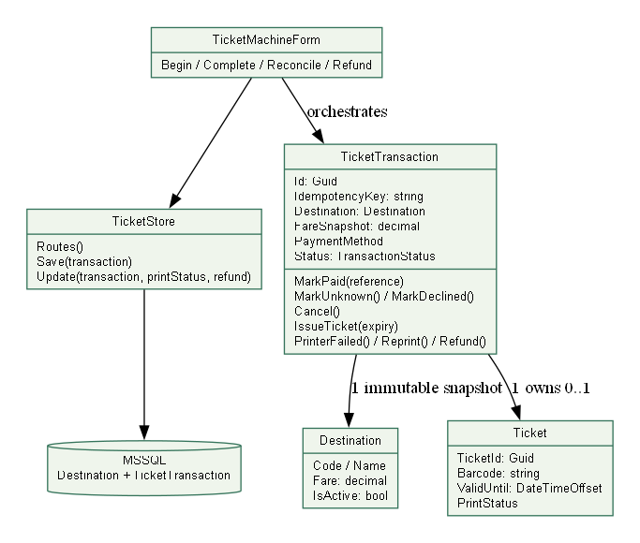
Figure 6. Domain class diagram.

System architecture
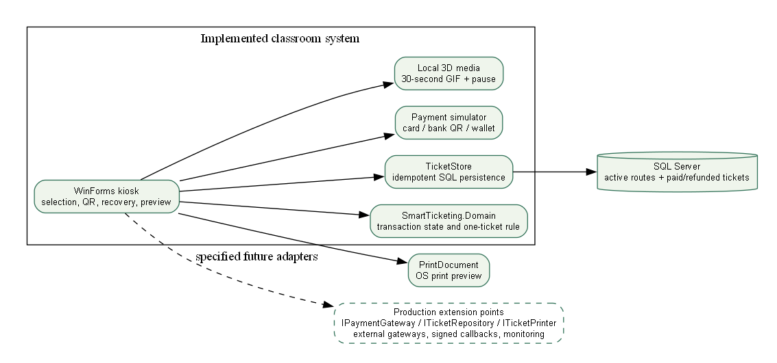
Figure 7. System architecture.

Deployment diagram
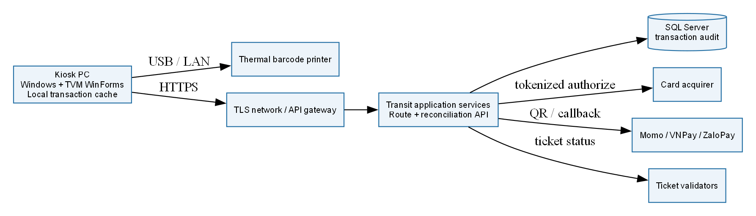
Figure 8. Deployment diagram.

TVM touchscreen wireframe
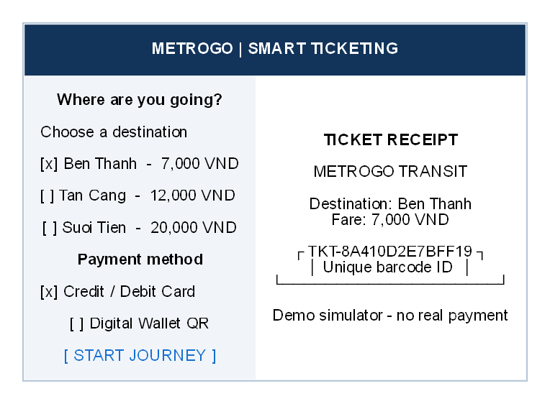
Figure 9. TVM touchscreen wireframe.

