B2B Wholesale Management System
Assignment 2 · QT2 · Semester 1 2026–2027
Database, desktop administration, Razor Pages portal, transaction integrity, tests, and submission evidence.
Phạm Trung Nghĩa (524H0172) · 23 October 2026. Full group roster and contributions await confirmation.

1. Introduction

1.1 System Overview
Northstar Wholesale connects an Admin WinForms warehouse workspace, an ASP.NET Core Razor Pages Agent Portal and MSSQL. Admins manage stock, partners and dispatch; agents place multi-product orders, follow statuses and print invoices. A classroom-only invoice action records payment state without contacting a provider or moving money. The visual upgrade adds an original public collection page, 3D art, local ingredient photography and optional silent 30-second motion graphics.

1.2 Tasks and Division of Labor
Task | Feature | Actual owner | Evidence
DB | Database and integrity | Pending group confirmation | Schema/seed and SQL verified
1.1 | Admin login | Pending group confirmation | Role and lockout SQL checks
1.2 | Item, Agent and Order management | Pending group confirmation | CRUD, row version and stock SQL checks
1.3 | Shipping manifest | Pending group confirmation | HTML export and print stylesheet verified
1.4 | Dashboard and filters | Pending group confirmation | SQL agent/date filters verified
3.1 | Agent login | Pending group confirmation | Browser and SQL checks
3.2 | Master-detail transaction | Pending group confirmation | Rollback/replay/concurrency verified
3.3 | My Orders and invoice | Pending group confirmation | Browser, ownership, paid-status and invoice checks
3.4 | Responsive UI | Pending group confirmation | Desktop and 304px view checked
5.1 | Meaningful unit tests | Pending group confirmation | 26/26 passed
6a | Configuration | Pending group confirmation | External config files used
6b | Git collaboration | Pending group confirmation | Actual repository and PR history pending
6c | Professional report | Pending group confirmation | Generated; full team record pending

1.3 Team Members
Member | Student ID | Actual responsibilities | Contribution
Phạm Trung Nghĩa | 524H0172 | Confirmed submission contact; feature ownership pending group confirmation | Pending
Remaining 2–4 members | Not supplied | Group must provide real names and ownership | Pending

2. Environment and How to Run
Item | Configuration / command
Runtime | Windows; .NET SDK 10 with Desktop and ASP.NET runtime
Database | SQL Server / SQLEXPRESS; WholesaleManagement
Setup script | database/01_create_database.sql; repeatable additive upgrade preserving existing records
Admin config | src/Wholesale.AdminWinForms/App.config
Portal config | src/AgentPortal/appsettings.json; environment override ConnectionStrings__Wholesale
Startup | Wholesale.AdminWinForms; AgentPortal at http://127.0.0.1:5400
Demo Admin | admin / Demo123! (classroom account)
Demo Agent | agent01@wholesale.local / Demo123! (classroom account)
Unit tests | dotnet test tests/Wholesale.Tests
SQL integration | dotnet run --project tests/Wholesale.IntegrationTests -- <absolute Assignment2 directory>

3. Database Configuration & Seed Data (10 marks)

3.1 Database Diagram

3.2 Schema
Table | Columns and types | Keys / checks
Item | ItemID int; ItemName nvarchar(120); Size nvarchar(30); Price decimal(12,2); StockQuantity int; IsActive bit; RowVersion rowversion | PK; positive price; nonnegative stock
Agent | AgentID int; AgentName nvarchar(120); Address nvarchar(250); Phone nvarchar(25); IsActive bit | PK; unique phone
Order | OrderID int; OrderDate datetime2 UTC; AgentID int; OrderStatus nvarchar(20); RequestKey uniqueidentifier nullable; PaymentStatus nvarchar(16); PaidAtUtc datetime2 nullable; PaymentReference nvarchar(80) nullable | PK; FK Agent; status/payment CHECKs; unique RequestKey and payment reference when set
OrderDetail | ID int; OrderID int; ItemID int; Quantity int; UnitAmount decimal(12,2) | PK; two FKs; unique order/item; positive qty/price
Users | UserID int; UserName nvarchar(80); Email nvarchar(254); PasswordHash nvarchar(255); IsLocked bit; Role nvarchar(20); AgentID int nullable; FailedLoginCount int | PK; unique account/email; FK Agent; role-agent compatibility CHECK

3.3 Seed Data (5 marks)
Table | Seed rows | Realistic variation
Item | 15 | Coffee, tea, pantry goods; cashews at 8 for low-stock warning
Agent | 15 | Vietnamese retailer names, delivery addresses and dummy unique phones
Order | 15 | Varied dates and Pending/Processing/Shipped statuses
OrderDetail | 15 | Price snapshots and positive quantities
Users | 16 | 1 Admin + 15 Agents; salted PBKDF2 hashes

Every table has 15–30 rows in the seed script. Live counts grow when demo orders are placed. The multi-item browser order #23 contains two lines totaling 1,045,000 VND and now has a Paid classroom-simulator reference. The one-product payment demonstration is order #55: one Arabica Coffee Beans line at 245,000 VND, also marked Paid. Uniquely named SQL test fixtures are cleaned up after verification; rolled-back transactions can still advance identity numbers.

3.4 Integrity (5 marks)
Rule | Implementation | Reason
Order → Agent | FK, no cascade delete; soft deactivation | Retain order history
Detail → Order | FK ON DELETE CASCADE | Master/detail lifecycle
Detail → Item | FK restrict delete; soft deactivation | Preserve historic product references
Stock / money | CHECK stock >=0; quantity, price and amount >0 | Reject invalid values
Accounts | Unique username/email; role-agent CHECK | Prevent duplicate identity and invalid role association
Duplicate checkout | Unique RequestKey when non-null | One order per submission reference
Demo payment | Status CHECK, audit CHECK, unique payment reference, and locked owner-only update | One paid invoice per classroom confirmation; cancellation records Refunded
Stale editor | RowVersion compare-and-update | Do not overwrite concurrent web stock deductions
Cancellation | Status and stock restoration in one transaction | Return reservations once only

4. Exercise 1: Back-Office Windows Application (25 marks)

4.1 Task 1.1: Secure Login Form (5 marks)
Only unlocked Admin users authenticate. Both applications use a shared salted PBKDF2 SHA-256 verifier with bounded hash parameters and constant-time comparison. A serializable login update increments failures and locks on the fifth incorrect password. Integration tests use a separate Admin fixture, leaving the seeded Admin available.

4.2 Task 1.2: Item, Agent and Order Management (10 marks)
Sidebar navigation, KPI cards, searchable grids and explicit actions support product add/edit/deactivation, signed stock adjustments, transactional company-and-login registration, company editing, Agent unlock and safe deactivation. Pending → Processing → Shipped transitions and pre-shipment cancellation are validated. Cancellation restores every line atomically and a repeated/stale cancellation cannot return stock twice.

4.3 Task 1.3: Shipping Manifest Report (5 marks)
Selected orders have details and native multi-page print preview. HTML export includes escaped delivery name, address, phone, status, date, product quantities, unit prices, amounts, total and signature lines. Open the export and choose Print / Save as PDF. A verified sample is bundled in docs/evidence/sample-shipping-manifest.html; the SQL harness checks address, total and print stylesheet.

4.4 Task 1.4: Data Filter and Dashboard (5 marks)
Filters select an agent and inclusive date range. Best sellers aggregate non-cancelled ordered quantities; low stock lists active products at ten units or below; revenue aggregates shipped orders only. SQL is parameterized, and the revenue definition is stated in the view.

5. Web Application: Agent Portal (35 marks)

5.1 Option Chosen
Option B (Exercise 3): ASP.NET Core Razor Pages. Server-rendered forms and built-in antiforgery handling fit this workflow. Projects target .NET 10; Microsoft.Data.SqlClient is pinned at 6.1.3. Unit tests use MSTest 3.10.2.

5.2 Task 3.1: Web Login Form (5 marks)
Only active unlocked Agent users sign in. Admin credentials and wrong passwords receive a generic rejection. Five failures lock an account. Sessions are revalidated against the signed-in account/agent and cleared on logout. Forms use antiforgery tokens; session cookies are HttpOnly and SameSite Lax.
The final sign-in view follows the supplied Notezy reference's two-panel composition, with a seven-color NORTHSTAR wordmark, a 30-second Nova product film and a separate credential card. The final branding removes the previous logo icon and subtitle. The film's pause control, password visibility toggle, demo-access disclosure, theme selector and global motion pause were checked in the local browser after the final rebuild. Authentication, validation and role checks remain unchanged. Native editable screens for the portal and WinForms Admin are in the Figma handoff: https://www.figma.com/design/XJaFLoJzp8NrexLNmOHBAk.

5.3 Task 3.2: Catalog and Master-Detail Order (15 marks, core business logic)
Card/list views, category and text filters, quantity steppers and a live summary help build multi-product orders. The server validates all quantities again, reads SQL prices and snapshots them; it never trusts the client total.
Transaction logic
await using var tx = (SqlTransaction)await connection.BeginTransactionAsync(IsolationLevel.Serializable);
// Verify active agent and look up a previous RequestKey.
// Lock selected items with UPDLOCK,HOLDLOCK in ascending ItemID order.
// Read prices and verify every stock quantity.
// Insert the Order, every OrderDetail, and conditionally deduct each stock.
// Any error rolls back all of these changes.
await tx.CommitAsync();
Scenario | Expected | Actual evidence
Enough stock | One master, all details and all stock deductions | SQL fixture total 425; browser #23 total 1,045,000 VND
Insufficient stock | No saved header/detail or changed stock | Before/after SQL counts and stocks verified
Failure in the middle | Undo header, first detail and first stock deduction | Controlled second-detail trigger failure; temporary trigger removed
Duplicate request | Same order; no second deduction | Replayed RequestKey check
Concurrent last unit | Exactly one order succeeds | Two simultaneous checkout calls; final stock zero
Repeated cancellation | Restore stock once only | Status compare-and-update + SQL assertions

Full implementation: WholesaleStore.PlaceOrderAsync. The integration harness source is included; it creates uniquely named QA fixtures, verifies the actual database behavior and removes only those fixtures in finally.

5.4 Task 3.3: My Orders and Printable Invoice (10 marks)
History and invoice SQL always filter by authenticated AgentID. An agent cannot retrieve another agent’s invoice. History shows order and payment state; an Unpaid invoice places Print invoice / Save PDF above the invoice and a classroom-only Confirm payment action below the lines. Confirmation stores PaidAtUtc and a unique DEMO reference, then returns the invoice with a visible Paid success result. Repeated confirmation returns the original reference. Admin cancellation of a paid unshipped order marks the classroom state Refunded in the same stock-restoration transaction. No card/bank provider is contacted and no real money moves. Invoice lines use immutable checkout prices and line/total amounts. The printed invoice now includes the registered agent address, phone, Paid timestamp and demo payment reference. Narrow screens display all values in mobile cards without a floating helper covering payment details, while print CSS hides navigation and repeats headers for multi-page output. Browser automation exported and inspected an A4 PDF; physical printer output remains unverified.

5.5 Task 3.4: Responsive UI (5 marks)
The original CSS design system includes responsive navigation, photography cards, list tables, status badges, focus states, errors, empty states and an accessible live summary. Broad hero/category/collection layout inspiration came from the user-supplied MilkyBloom site; no source or brand assets were copied. The local 30-second motion graphic is optional, pausable and respects prefers-reduced-motion. Photography represents ingredients; it does not claim branded package appearance.
Nova is an optional local AI helper using TF-IDF retrieval and budget/product matching, not a cloud language model. Signed-in recommendations use current SQL prices and positive stock, while history uses the current AgentID. Unknown questions receive a safe fallback. No API key is required; responses cannot place or cancel orders. Forest, Sunset and Lilac themes persist locally. Home category and product links preserve selection through sign-in.

6. Exercise 5: Unit Testing (15 marks)
Wholesale.Tests contains 26 meaningful tests; all passed. They cover totals, invalid quantities/prices, exact stock, insufficient stock, immutable deduction, lock threshold, status/cancellation rules and password hash verification, plus local AI normalization, fallback and product recommendation rules.
Test | Actual result
WrongPasswordDoesNotMatch | Passed
RejectsEmptyHashPayload | Passed
AllowsOnlyValidOrderTransitions | Passed
VietnameseProductRecommendationUsesRealPrice | Passed
AllowsExactStockAndBlocksOversell | Passed
NeverRecommendsUnavailableStock | Passed
RejectsNegativePrice | Passed
CannotCancelShippedOrder | Passed
ZeroStockCannotBeDeducted | Passed
UnknownQuestionDoesNotInventAnswer | Passed
LocksAtFiveFailedAttempts | Passed
RejectsEmptyOrder | Passed
DeductsStockWithoutMutatingOriginal | Passed
RejectsZeroQuantity | Passed
AnswersStockFromSuppliedKnowledge | Passed
CorrectPasswordMatches | Passed
RejectsUnboundedIterations | Passed
RejectsShortPasswordAtCreation | Passed
CanCancelOnlyUnshippedOrders | Passed
UnderstandsVietnameseWithoutAccentMismatch | Passed
RecommendationsRespectBudget | Passed
RejectsMalformedBase64 | Passed
SaltMakesHashesUnique | Passed
CalculatesMasterDetailTotal | Passed
EmptyQuestionReturnsSafeFallback | Passed
ThrowsWhenDeductionWouldGoNegative | Passed

The final SQL integration harness passed 46/46 checks with an isolated Chrome checkout, covering role/lockout behavior, registration rollback, master/detail atomicity, mid-transaction rollback, request replay, invoice ownership, payment confirmation and retry, Paid state in history, refund and stock restoration, concurrent last-unit orders, row-version protection, company editing, product deactivation, reports and manifest export. Chrome signed in as a temporary agent, ordered two products, confirmed payment and verified My Orders, A4 invoice output and the 304px layout. The 26/26 unit-test run passed as well. After fixture cleanup, the database contained the same 15 Agents, 15 Items, 19 Orders, 22 OrderDetails and 16 Users as before the run. Evidence is saved in docs/evidence/integration-results.txt and .json, browser-fixture-print.pdf and paid-invoice-print.pdf.
The final interface audit passed 33 Chrome button/route checks on the seeded account and 32 in the isolated checkout, plus 3 native Admin login and 24 dashboard checks. Native editor/details dialogs were opened and dismissed without modifying seed data; SQL fixtures verified the mutation paths. An observed connection timeout was traced to SQL Express AUTO_CLOSE, confirmed by Windows recovery events. Both live lab databases and repeatable setup scripts now set AUTO_CLOSE off. The combined tests passed afterward with a 15-second local connection timeout. Logs are in docs/evidence/*button-audit.json and *smoke.json. Physical printer output is still unverified.

7. System Configuration (5 marks)
Application | External configuration | Reading API
Admin | App.config / connectionStrings[name=Wholesale] | XML configuration in SqlAdminStore
Portal | appsettings.json; ConnectionStrings__Wholesale override | IConfiguration.GetConnectionString
SQL harness | Portal config or environment override | ConfigurationBuilder; no hardcoded C# connection

The classroom connection uses Windows integrated authentication. No real account password or payment secret is embedded. Local Data Protection keys, bin, obj and TestResults folders are excluded from the source package; saved verification evidence remains under docs/evidence.

8. Source Control & Teamwork (5 marks)
Confirmed GitHub account: https://github.com/Nghiaktvn. A project repository, real feature branches, student commits, reviews and Pull Requests remain required. Local main has no commits. Workbook branch names are explicitly proposed workflow, not fabricated historical evidence.

9. Contribution of Each Member
Member | Student ID | Actual responsibilities | Contribution
Phạm Trung Nghĩa | 524H0172 | Confirmed submission contact; feature ownership pending group confirmation | Pending
Remaining 2–4 members | Not supplied | Group must provide real names and ownership | Pending

The group must supply actual names, IDs, feature ownership and percentages totaling 100%, matching Readme.txt.

10. Conclusion and Lessons Learnt
The dual-platform system has working warehouse and Agent workflows, real SQL persistence, safe master-detail ordering and a coherent visual upgrade. Review found missing Admin lockout, cancellation restoration and stale-stock protection; these were corrected and tested. Physical printing and authentic group collaboration evidence remain manual evidence tasks.

Appendix A: Readme.txt
NORTHSTAR WHOLESALE — ASSIGNMENT 2
Confirmed member: Phạm Trung Nghĩa — 524H0172
GitHub account: https://github.com/Nghiaktvn
Project repository: pending (an account profile is not a repository/PR record).
Group number, remaining 2–4 real members, actual feature ownership, contribution percentages: pending group confirmation.
Percentages must total 100% and match Report.docx and A2_Team_Workbook.xlsx.
Setup:
1. Install .NET SDK 10 with Windows Desktop and ASP.NET runtimes, and SQL Server.
2. Run database/01_create_database.sql in sqlcmd or SSMS. The script is repeatable and preserves current records.
3. Configure src/Wholesale.AdminWinForms/App.config and src/AgentPortal/appsettings.json.
4. dotnet build WholesaleManagement.sln
5. dotnet run --project src/Wholesale.AdminWinForms
6. dotnet run --project src/AgentPortal --urls http://127.0.0.1:5400
7. dotnet test tests/Wholesale.Tests
8. SQL integration checks: dotnet run --project tests/Wholesale.IntegrationTests -- <absolute Assignment2 directory>
Demo Admin: admin / Demo123!
Demo Agent: agent01@wholesale.local / Demo123!
These are dummy classroom credentials. No public deployment is included.
Portal config supports environment ConnectionStrings__Wholesale.
The SQL harness creates uniquely named fixtures and removes only its own fixtures in finally. Identity values can advance on rollback.
The shipped-revenue dashboard excludes pending and cancelled orders; cancellation restores reservations once only.
30-second MP4/GIF and product photographs are bundled locally; motion can be paused. Photograph licenses/sources are recorded in design documentation.
SourceCode.zip excludes bin, obj, TestResults and local Data Protection keys. Saved evidence is under docs/evidence.
Optional hosted video demo link: pending.

Appendix B: Generative AI Use (if any)
Tool / date | Actual request summary | Kept / changed | Validation
Codex / 24 Oct 2026 | Complete PDFs and upgrade all UI/function demos | Domain, SQL, UI, tests and documents | Build; 26 MSTest tests; 46 SQL/browser checks; two-product temporary checkout and paid-invoice PDF
image_gen / 23 Oct 2026 | Joyful 3D grocery delivery scene | Original artwork + timed motion graphics | Visual inspection and 30-second metadata
Plugin discovery / 23 Oct 2026 | Use tools such as Figma | Figma suggested; no connection confirmed; importable SVG supplied | No Figma file edit claimed

Photo source/license links and original art prompts are recorded in the design folder. The video is a silent motion graphic with camera movement over original 3D art and three timed captions, not a claim of generated character-motion footage.

Verification

Earlier verification — 23 October 2026
The WholesaleManagement solution builds with zero warnings and errors. All 26 MSTest business-rule, password and local assistant tests pass.
The earlier SQL integration harness passed 42/42 checks. In addition to registration, roles, inventory, request replay, concurrency and rollback, it verified a one-product cart, an unpaid invoice, ownership checks, a persisted Paid timestamp/reference, idempotent confirmation, My Orders payment status, and Refunded state plus exactly-once stock restoration on cancellation. Its uniquely named fixtures and temporary trigger were removed; the five-table counts returned to the baseline 15/15/19/22/16. The later run below supersedes this count.
The live browser demo placed one Arabica Coffee Beans item on order #55 for 245,000 VND and confirmed the classroom payment. A final browser pass also confirmed the existing two-line order #23 for 1,045,000 VND: its invoice now shows “Paid · demo”, a timestamp and unique DEMO reference. Both orders remain visible in the classroom database. No real payment occurred. The 304px invoice now presents every line price and total in mobile cards.
The local web portal was also checked at 304 CSS pixels without document horizontal overflow. The welcome animation is 30 seconds, with pause and reduced-motion support. No physical printer output, real provider payment, group PR history or Figma file edit is claimed.

Additional verification — 24 October 2026
The updated SQL harness passed 45/45 checks without a browser and 46/46 with its isolated Chrome checkout: the browser signed in as a temporary agent, placed a two-product order, confirmed the demo payment, checked My Orders and the printable invoice, and inspected the 304px layout. Fixture cleanup restored all five table counts to 15/15/19/22/16. The 26 unit tests passed. A separate Chrome smoke check opened the existing paid order #55 and generated an A4 PDF. Its one page contains the address, phone, Paid status, reference and 245,000 VND total. The 304px invoice has no horizontal overflow or floating assistant over payment details; zero page JavaScript errors were observed. The shipping-manifest test fixture also exported as a one-page A4 PDF with address and total. Re-run browser checks with tools/verify-portal-ui.cjs or the SQL harness --browser mode while the portal is serving at PORTAL_URL (default http://127.0.0.1:5400); they require Playwright and Chrome. Generated artifacts are under docs/evidence/. These browser and PDF checks do not prove physical printer output.
The final button pass recorded 33/33 Chrome checks against the seeded Agent portal and 32/32 in the isolated two-product checkout. It clicked navigation, animation/theme controls, login show/hide, assistant send and four suggestions, category/search/card/list, quantity steppers, clear, empty-cart prevention, order status filter, invoice print action, back navigation and sign-out. The isolated checkout also clicked Place order and Confirm payment and checked Paid history and printable details. Native WinForms audits recorded 3/3 Admin login and 24/24 Admin dashboard checks. The dashboard audit opened and dismissed editor/details dialogs without saving; destructive commands were covered by the SQL fixture harness rather than clicked against seeded records. Physical paper printing remains untested. See docs/evidence/paid-invoice-smoke.json, browser-fixture-smoke.json, admin-login-button-audit.json and admin-button-audit.json.
SQL Express initially had AUTO_CLOSE enabled and repeatedly restarted both lab databases. Windows logged a 66-second SmartTicketing recovery, which caused intermittent post-login timeouts. Both local databases now have AUTO_CLOSE off, and both repeatable setup scripts apply the setting. The combined tests then passed with a 15-second local connection timeout; the final fixture again restored all five Lab 2 row counts.

Testing

Reproducing tests
Run dotnet test tests/Wholesale.Tests from Assignment2: 26 meaningful business-rule, password and local assistant tests.
Run dotnet run --project tests/Wholesale.IntegrationTests -- <absolute Assignment2 folder> for 45 MSSQL checks. Add --browser while the portal is running to execute the 46th check: Chrome signs in as an isolated test agent, orders two products, confirms the demo payment, verifies My Orders and the printable invoice, and checks the 304px layout. This opt-in executable reads the configured classroom DB, creates uniquely named fixture agents/users/items/orders, briefly installs a trigger that fails only on its own test item, and removes its fixtures/trigger in finally. Baseline and final table counts are compared. Payment checks include a single-product invoice, owner-only confirmation, idempotent retry, Paid timestamp/reference, My Orders status and cancellation/refund stock restoration. Invoice checks also cover the registered agent's print contact. Fixture checks now include company editing and safe product deactivation.
Results are saved in docs/evidence/integration-results.txt and .json. Domain test TRX files are copied into docs/evidence by the packaging step.
The browser demo created one Arabica order (#55, 245,000 VND) and confirmed its classroom-only payment. This visible example remains in the classroom database and consumes one unit of stock; no real payment is processed.
For repeatable browser and print inspection, start the portal and run tools/verify-portal-ui.cjs with Playwright and Chrome available. By itself, it checks sign-in, catalog, an existing paid invoice, 304px layout, browser errors, and exports the invoice plus the synthetic shipping-manifest fixture to A4 PDF without modifying an order. The --browser integration mode supplies temporary credentials and product IDs to the same script; its created order is removed by the SQL harness.
The expanded browser script verifies 33 public/Agent controls on the seeded account, or 32 plus an isolated two-line checkout and payment when called by the integration harness. From the workspace root, Run-Demo.ps1 -App Test -BrowserTest -ButtonTest runs both unit suites, both SQL harnesses, Chrome checkout and native button audits while the portal serves at PORTAL_URL. The native Admin audit opens add/edit/details dialogs and closes them without saving; SQL fixtures verify changes, cancellation, status, rollback and stock safety. On the local SQLEXPRESS instance, AUTO_CLOSE is disabled by both setup scripts to prevent repeated database recovery. Printed PDFs are inspected; a physical printer is outside this automated check.

Demo Checklist

Dual-platform demonstration
1. Run the repeatable SQL setup and configure App.config/appsettings.json.
2. Launch Admin and Portal. Show 3D welcome graphics, product photographs and pause control.
3. Verify wrong-role rejection, then Admin and Agent sign-in with the classroom accounts.
4. Admin: add/edit a product, enter an arbitrary stock adjustment, register an agent and its portal account together, edit an agent, and demonstrate safe deactivation.
5. Portal: switch cards/list; filter category; search; select two products; confirm live total.
6. Place a multi-product order and show the invoice and My Orders. Use Print invoice / Save PDF to prepare a copy, then press Confirm payment. Verify the Paid timestamp/reference on the invoice and the Paid badge in My Orders. The one-product order #55 and two-line order #23 are saved examples. Explain that this is a classroom simulation only; no real money moves.
7. Admin: refresh incoming orders; view details; advance Pending → Processing → Shipped; export a shipping manifest with address and totals.
8. Create a separate demo order and cancel it before shipment; show restored stock and rejection of a second cancellation.
9. Filter the dashboard by dates and agent; explain shipped revenue, non-cancelled best sellers and low-stock definition.
10. Run 26 MSTest cases and the 45-check SQL harness, or 46 checks with --browser while the portal is running. Explain payment replay/owner checks, controlled second-detail rollback, refund stock restoration and last-unit concurrency. Show the one-page A4 invoice and shipping-manifest PDFs from docs/evidence/.
11. Show real group GitHub branch/PR evidence and matching 100% contributions before submission.
12. For repeatable button evidence, run Run-Demo.ps1 -App Test -BrowserTest -ButtonTest with the portal serving at PORTAL_URL. Review docs/evidence/*button-audit.json and both *smoke.json files. The native audit dismisses editor dialogs without saving; SQL fixtures safely test the actual database changes.

Verified application screenshots

Agent Portal login page
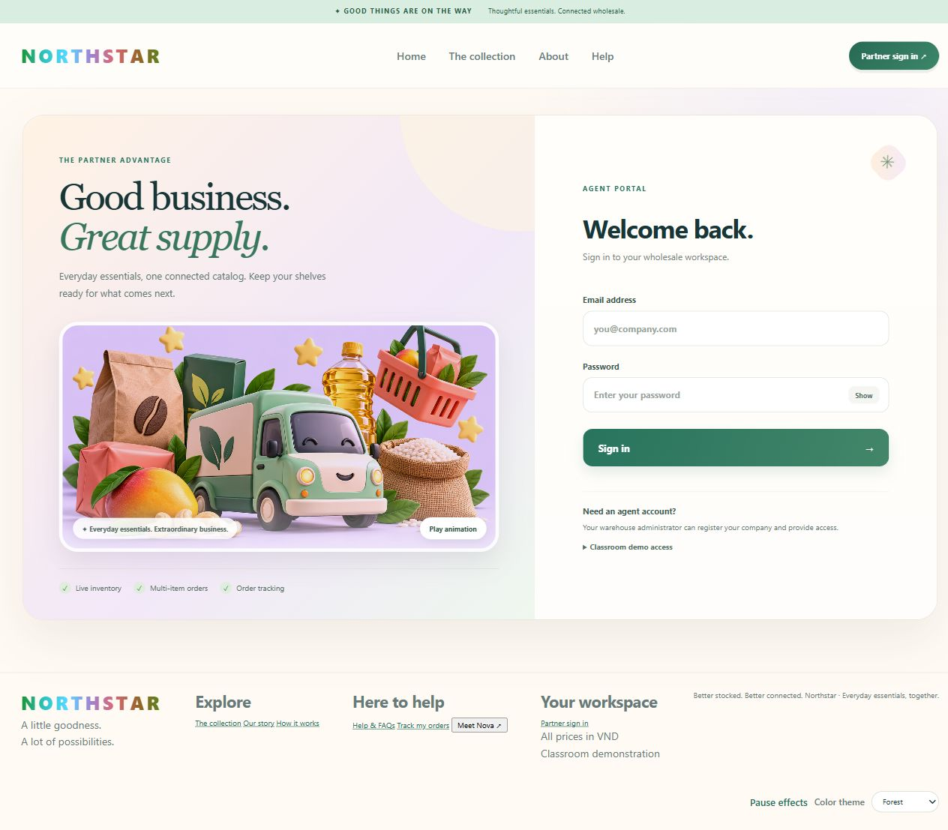
Actual final Agent sign-in screen with seven-color NORTHSTAR wordmark, 3D product artwork and a 30-second optional animation.

Back-office Admin login form
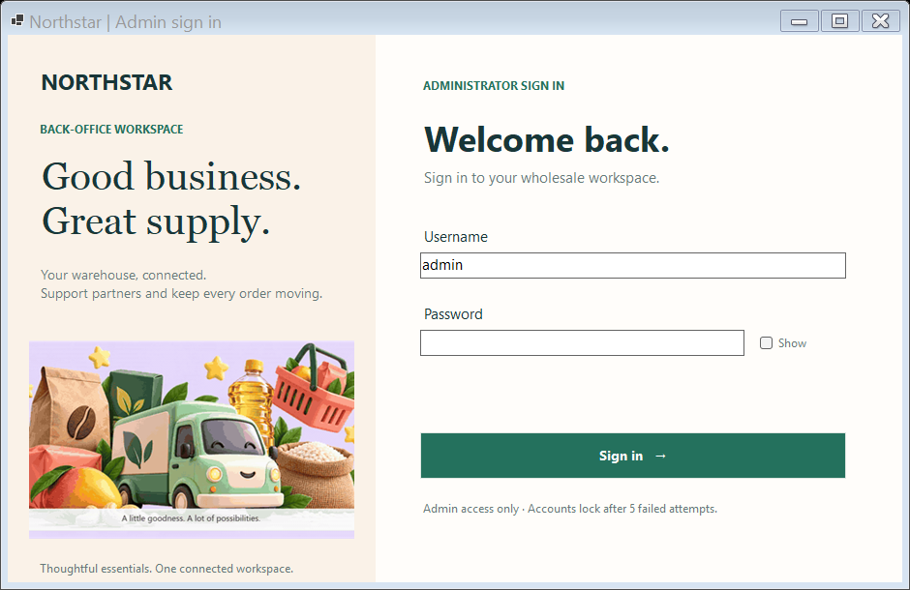
Actual compiled WinForms Admin login form. The seeded Admin account authenticated successfully; the SQL-backed inventory and dashboard screens are shown below.

Unit and SQL integration test runs
The final MSTest run passed all 26 unit tests. The SQL integration harness passed all 46 checks with an isolated two-product browser checkout and restored the starting table row counts. Current logs are saved in docs/evidence/unit-results.txt and docs/evidence/integration-results.txt.

Agent catalog with seeded SQL products
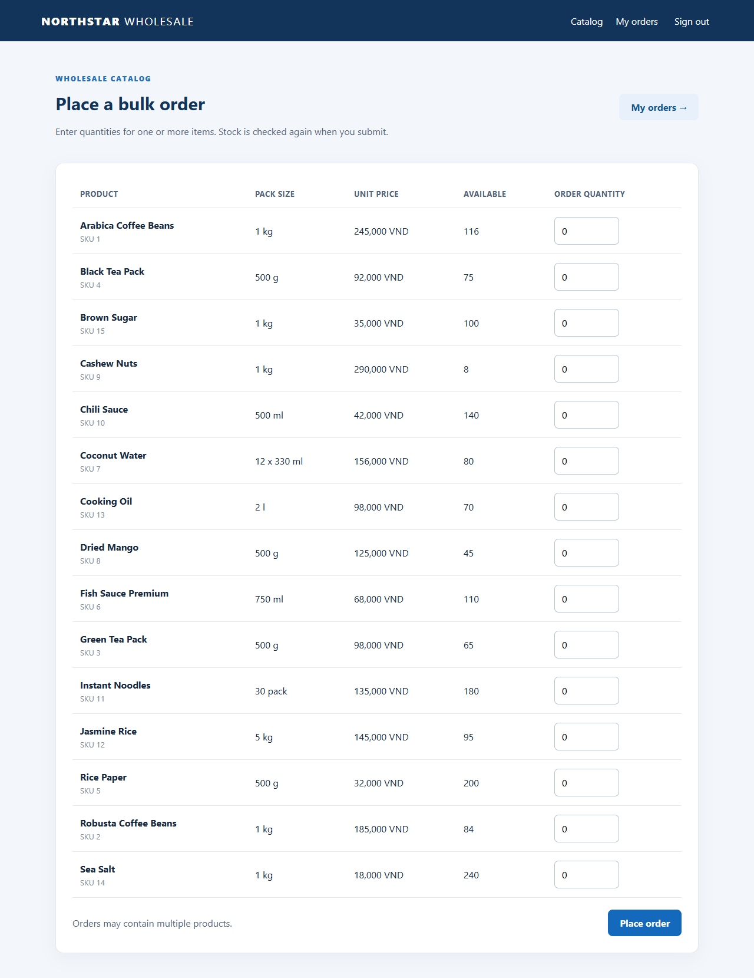
Actual authenticated Agent catalog with 15 seeded products and quantity inputs for a multi-item order.

Two-line order invoice
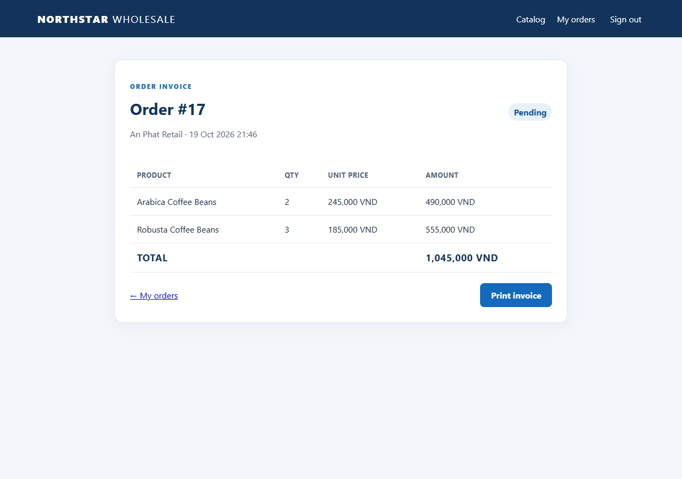
Actual order 16 after one transaction: two details totaling 1,045,000 VND.

Paid classroom invoice on desktop
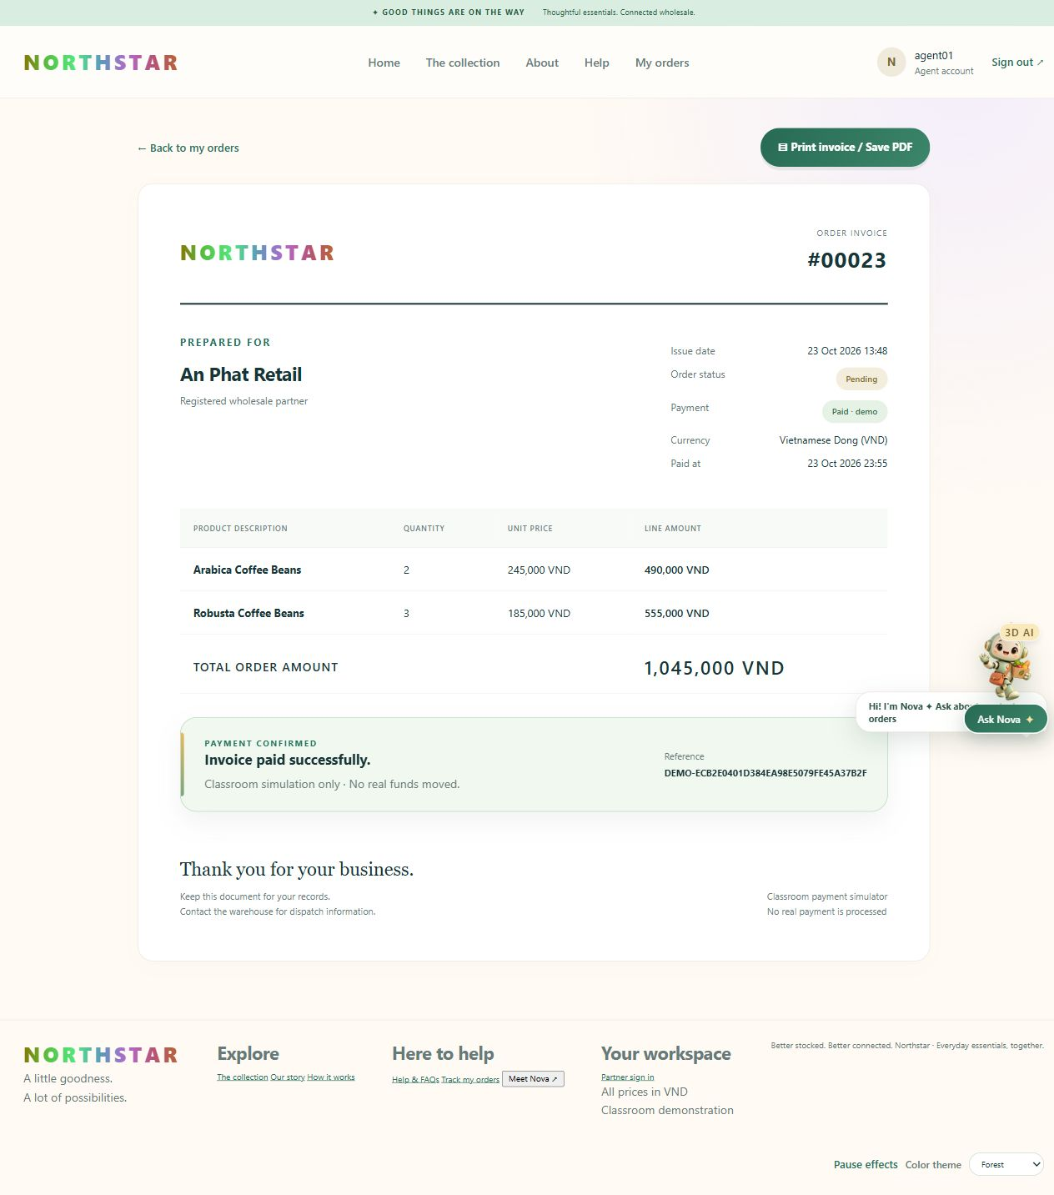
Actual order 23 after simulated confirmation: two product lines, Paid timestamp, unique reference and printable invoice.

Printable paid invoice with registered contact
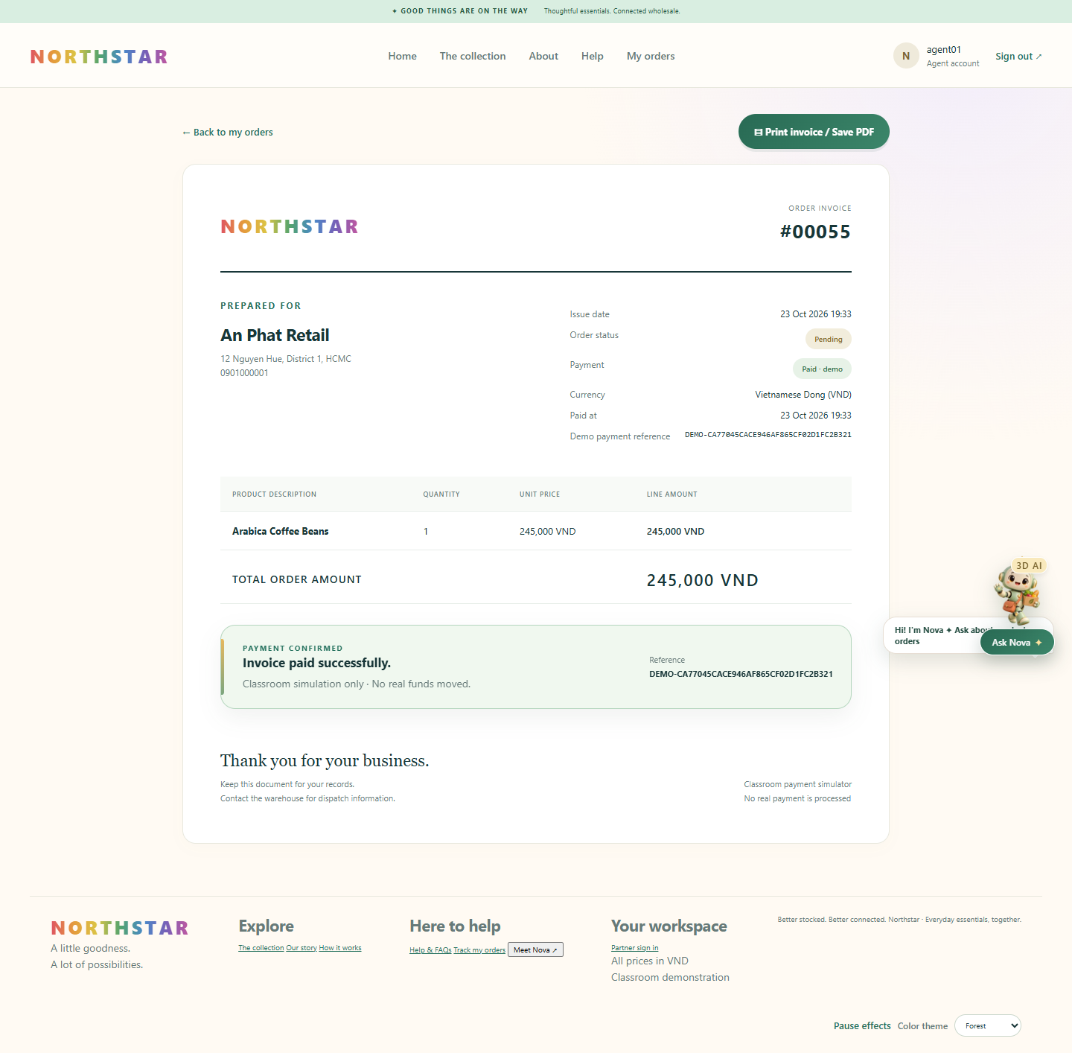
Actual order 55 after simulated confirmation: registered address and phone, Paid timestamp, unique reference and printable invoice.

Admin item inventory
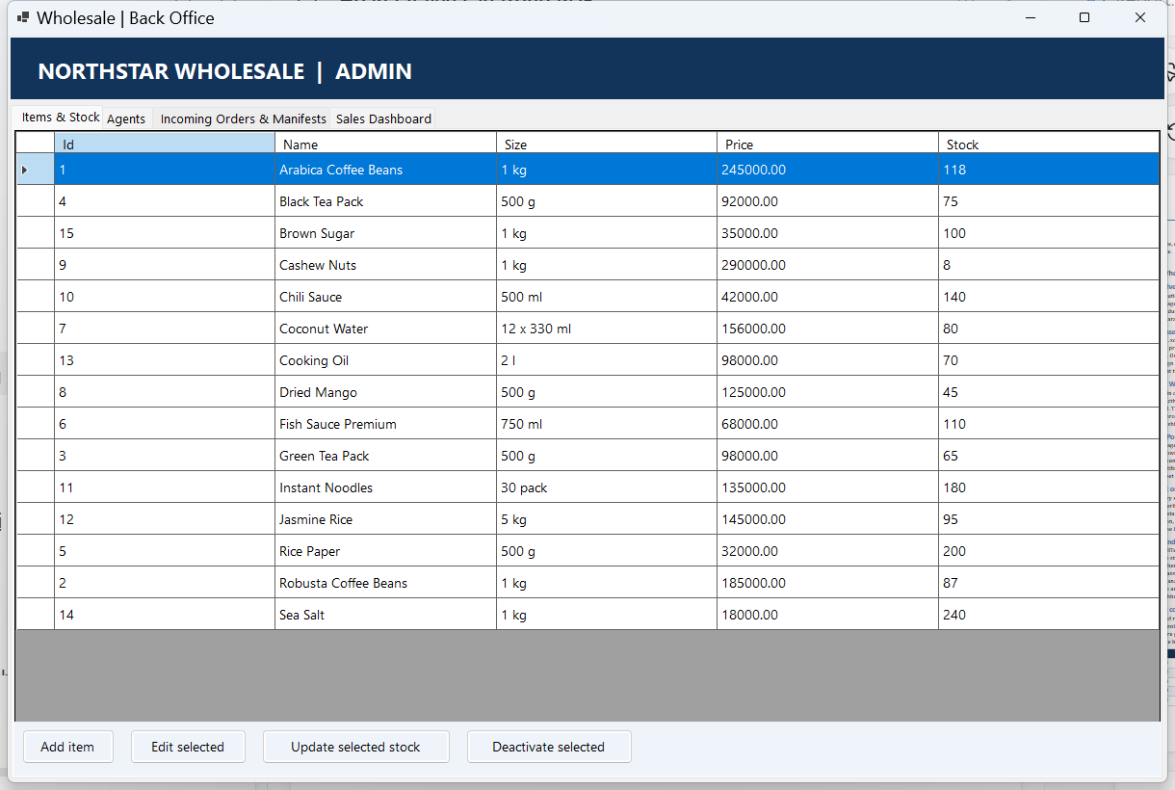
Actual Admin login and SQL-backed item grid after the two-item order.

Incoming orders and status
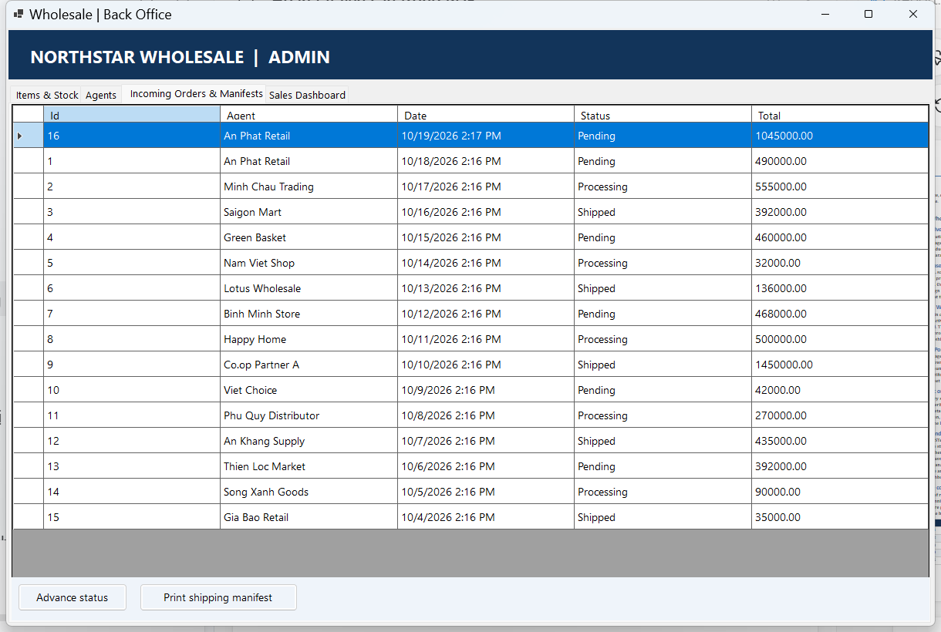
Actual Admin order grid showing order 16 as Pending.

Sales and low-stock dashboard
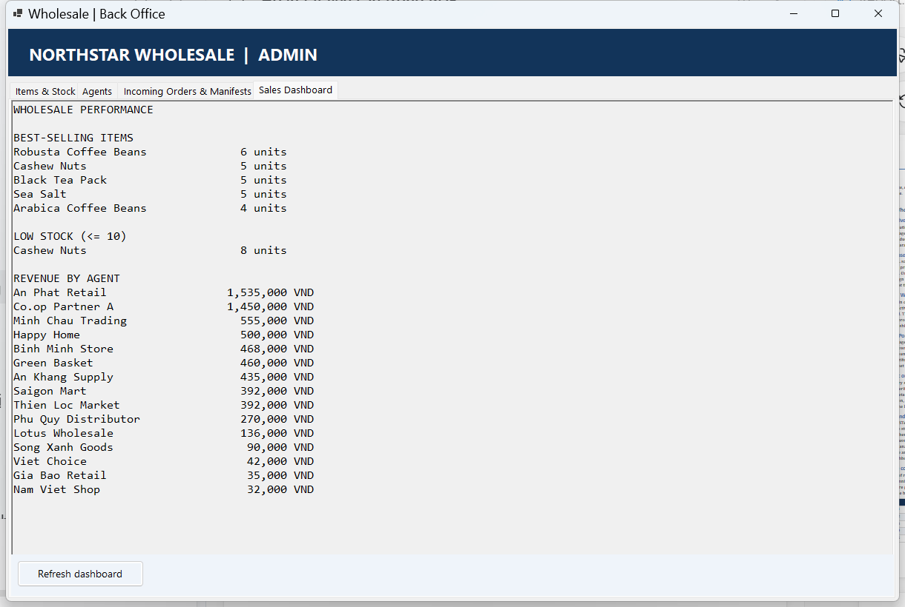
Actual SQL-backed best sellers, Cashew Nuts low-stock warning, and agent revenue.

Database and system diagrams

Database entity relationship diagram
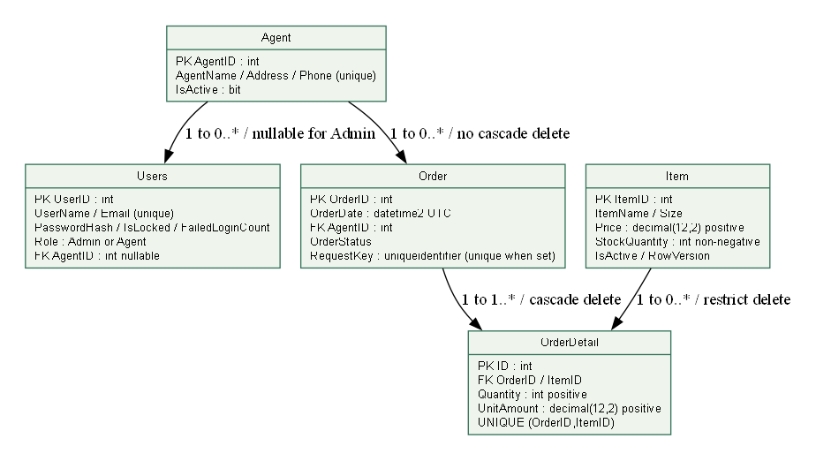
Figure 1. Database entity relationship diagram.
Order to OrderDetail and Item to OrderDetail are one-to-many relationships. OrderDetail cascades when its Order is deleted; referenced agents and items remain protected.

System architecture and deployment boundary
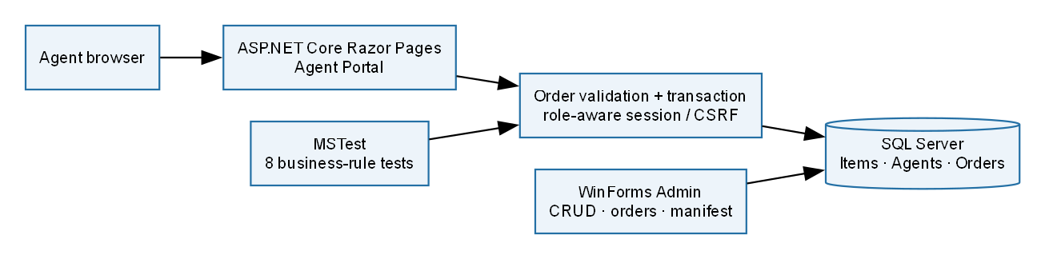
Figure 2. System architecture and deployment boundary.

