SE LAB GROUP ASSIGNMENT 1 REPORT TEMPLATE
Software Engineering | Smart Ticketing System (Ticket Vendor Machine) | Sem 1_2627 | Template for the file [YourID]_[YourStudentName].docx
Marking of this report
No. | Task | Marks | Section in this report
1 | Clarification Q&A (Excel) | 5 | 2.1
2 | Requirements Specification | 15 | 2.2
3 | Use Case Modeling | 10 | 3.1
4 | Activity Diagrams | 10 | 3.2
5 | Detailed System Modeling: "Buy a Ticket" | 15 | 3.3
6 | UI/UX Design | 5 | 4.1
7 | Architectural Design | 10 | 4.2, 4.3
8 | Visual Studio Engineering (Model-to-Code) | 10 | 5.1
9 | GitHub & AI Tooling (Copilot) | 10 | 5.2
10 | Demo Application (C# and MSSQL) | 10 | 5.3
Total |  | 100 | Weight: 20% of QT2 (plus 1 bonus point towards the Final Project for exceptional work)

How to use this template
- Keep all titles and numbering. Replace every blue [bracketed placeholder] with your own content, and delete all grey "Guidance" paragraphs, unused figure frames and this instruction page before you submit.
- Keep the headings as real Word headings (the navigation pane must work). Update the table of contents before submitting (right-click, Update Field).
- Group of 3 to 5 students. Section 7 must list the % contribution of each member (total 100%) and must match your readme.txt.
- Submit [YourID]_[YourStudentName].docx, readme.txt (GitHub link and other links such as Figma and database script instructions) and the % contribution of each member. All final artifacts are also uploaded to the shared GitHub repository.
- The report must also address the content of "LabGroupAssignment1.pdf". Use the checklist in section 6 to show where each item is covered.
- Keep your diagrams consistent with each other: the rubric rewards diagrams that are syntactically correct, logically sound and aligned. Use the consistency table in section 3.4.
- The workbook A1_Team_Workbook (Q&A, requirements, prompt log, commit log, progress log) is your working record and the source for several tables here.

Smart Ticketing System
Ticket Vendor Machine (TVM)
Software Engineering Lab Group Assignment 1 – Sem 1_2627
1. 519H0245 : Trần Gia Triều
2. 524H0172 : Phạm Trung Nghĩa
3. 524H0044: Lê Đạt

GitHub repository | Figma / other link | Date submitted
https://github.com/Nghiaktvn/SE-Lab-QT2-Assignments | https://drive.google.com/drive/folders/19tkScB0Gk-tfQjQj-tIVnnN_HRKUxZRU?usp=sharing | 25th October 2026

Table of Contents
Table of Contents 4
1. Introduction 6
1.1 Purpose and Scope 6
1.2 Problem Statement in Our Own Words 6
1.3 Team and Roles 6
2. Phase 1: Requirements Engineering (20 marks) 7
2.1 Clarification Q&A (5 marks) 7
2.2 Requirements Specification (15 marks) 8
2.2.1 Functional Requirements 8
2.2.2 Non-Functional Requirements 8
2.2.3 Domain Requirements 9
3. Phase 2: UML Modeling & System Design (35 marks) 11
3.1 Use Case Modeling (10 marks) 11
3.1.1 Use Case Diagram 11
3.1.2 Actors and Use Case List 11
3.1.3 Use Case Descriptions 11
3.2 Activity Diagrams (10 marks) 13
3.2.1 Passenger Buys a Ticket at the TVM 13
3.2.2 Communication with External Payment Gateways 15
3.3 Detailed System Modeling: Main Use Case "Buy a Ticket" (15 marks) 15
3.3.1 Sequence Diagram 15
3.3.2 State Chart Diagram 16
3.3.3 Class Diagram (Domain Model) 18
3.4 Model Consistency Check 19
4. Phase 3: UI/UX & Architecture (15 marks) 20
4.1 UI/UX Design (5 marks) 20
4.2 Architectural Design (10 marks) 20
4.2.1 Architecture Diagram 20
4.2.2 Deployment Diagram 21
5. Phase 4: Implementation, Tooling & Demo (30 marks) 23
5.1 Visual Studio Engineering: Model-to-Code (10 marks) 23
5.1.1 Forward Engineering (Model to Code) 23
5.1.3 Code Map 24
5.2 GitHub & AI Tooling (10 marks) 25
5.2.1 Source Control 25
5.2.2 AI Assistance: Copilot Prompt Documentation 25
5.2.3 Reflection on AI Use 25
5.3 Demo Application (10 marks) 26
6. Checklist for "LabGroup_QT2_Assignment1.pdf" 30
7. Contribution of Each Member 30
8. Conclusion and Lessons Learnt 30
Appendix 31
Appendix A: readme.txt 31
Appendix B: Full-size Diagrams 34

1. Introduction

1.1 Purpose and Scope
This is an automatic system to issue transportation tickets (train, bus, …). The system allows customer to choose their destination and payment method support card, bank (QR) or digital wallet, and print out the ticket. This system works in conjunction with a database for its functions, for the product our team deliver, we don’t support cash for in our program because of practicality reasons (in the limit of a mock product that isn’t required us to implement with real world hardwares)

1.2 Problem Statement in Our Own Words
Customers need to input a clear chain of interactions following the UI prompts. They are to choose payment method and complete the transactions, upon finish, the system will print out the ticket. Depending on chosen payment method, system either ask users to provide credit card or scan QR code

1.3 Team and Roles
No. | Name | Student ID | Main responsibilities
1 | Trần Gia Triều | 519H0245 | Documentation Summary
2 | Phạm Trung Nghĩa | 524H0172 | Coding and documentation Assignment 2
3 | Lê Đạt | 524H0044 | Documentation Asignment 1

2. Phase 1: Requirements Engineering (20 marks)

2.1 Clarification Q&A (5 marks)
ID | Question | Assumed answer | Design impact | Requirement IDs
Q1 | Which passenger types, routes, and fares are sold? | Adult single journey; operator-maintained route and fare catalogue. | Destination and fare snapshot in each ticket transaction. | FR-01, DR-02
Q2 | Are card and wallet integrations live? | Production uses certified providers; (our apps is simulation only.) | Adapter boundaries; no real charge or credentials in the product. | FR-02, NFR-06
Q3 | How are declined, timed-out, and duplicate payments handled? | Decline permits retry; timeout remains unknown until reconciliation; callbacks are idempotent. | No ticket until confirmed; unique idempotency reference. | FR-03, DR-03, DR-05
Q4 | When is a ticket valid and how is it checked? | Single journey valid for the service day; barcode holds an opaque unique ticket ID. | Unique ticket identity; no personal data in barcode. | FR-04, DR-04
Q5 | Are refund and cancellation supported? | Cancel before payment; after capture use operator-audited reversal/refund. | Transaction state and compensation record. | FR-07, DR-07
Q6 | Which accessibility and language requirements apply? | Vietnamese/English, high contrast, large touch targets, accessible timeout. | Bilingual UI and accessibility acceptance criteria. | NFR-07
Q7 | What payment data is retained? | Never retain PAN, CVV, wallet credentials, or raw QR; retain masked provider reference. | Data minimization and secure audit log. | NFR-06
Q8 | What availability and response time are required? | 99.5% monthly kiosk availability; UI p95 <=1s; routes <=2s; payment timeout 15s. | Measurable NFRs; monitor availability and latency. | NFR-01..05
Q9 | Is cash payment required? | Out of scope; brief specifies card, QR, and wallet. | No cash hardware or cash reconciliation. | FR-02
Q10 | What if network or printer fails? | Fail safely; no ticket before confirmed payment; reconcile, reprint, or compensate. | Fault state and recovery workflow. | FR-07, FR-08
Q11 | Which external systems are integrated? | Route/fare API, card acquirer, Momo/VNPay/ZaloPay, validator, monitoring. | Deployment and activity diagram actors. | FR-02, FR-03
Q12 | How long are records retained? | Non-sensitive transaction events retained 12 months, subject to operator policy. | Retention configurable; audit policy requires approval. | FR-06, NFR-06

Hidden complexities we uncovered
It is Q3 4 and 7 that required us to reconsider how we should approach building the program

2.2 Requirements Specification (15 marks)

2.2.1 Functional Requirements
ID | Requirement ("The system shall…") | Priority | Use case | Source (Q&A)
FR-01 | Start a purchase and show active destinations and fares. | Route list response <=2 seconds; inactive routes cannot be selected. | Must / Q1/Q8 → UC-01/06 | FR-01
FR-02 | Select destination and card, bank QR or wallet QR payment. | Fare and route remain visible until confirmation. | Must / Q2/Q9 → UC-02/03/07 | FR-02
FR-03 | Authorize using an idempotency key and handle all outcomes. | Approve/decline/pending/timeout handled with no duplicate charge. | Must / Q3/Q7 → UC-02/03/05 | FR-03
FR-04 | Print a barcode ticket only after confirmed payment. | Exactly one usable ticket per paid transaction. | Must / Q4/Q10 → UC-08 | FR-04
FR-05 | Display route, fare, time, and masked reference on receipt. | No sensitive payment credential appears. | Must / Q4/Q7 → UC-09 | FR-05
FR-06 | Audit payment, transaction, print, and status events. | Searchable by transaction ID; excludes PAN/CVV. | Must / Q7/Q12 → UC-04/05 | FR-06
FR-07 | Recover and reconcile after interruption. | Unresolved transaction reconciled before issue/retry. | Must / Q3/Q5/Q10 → UC-05 | FR-07
FR-08 | Expose operator diagnostics and kiosk out-of-service status. | Timestamped fault visible to monitoring. | Must / Q10/Q11 → UC-04 | FR-08

2.2.2 Non-Functional Requirements
ID | Category | Measurable requirement | Measurement method | Related FR
NFR-01 / Reliability | Monthly service availability excluding planned maintenance. | >=99.5%; available scheduled minutes / total scheduled minutes. | Timed trials/logs for latency; scheduled-minute observation for availability; accessibility and security review for relevant controls | NFR-01 / Reliability
NFR-02 / Performance | Local input and screen transition. | p95 <=1 second; p99 <=2 seconds. | Timed trials/logs for latency; scheduled-minute observation for availability; accessibility and security review for relevant controls | NFR-02 / Performance
NFR-03 / Performance | Route/fare catalogue load. | p95 <=2 seconds; cached data timestamped, max age 24 hours. | Timed trials/logs for latency; scheduled-minute observation for availability; accessibility and security review for relevant controls | NFR-03 / Performance
NFR-04 / Performance | Payment completion or safe timeout. | 95% <=8 seconds; timeout at 15 seconds; reconcile unknown result. | Timed trials/logs for latency; scheduled-minute observation for availability; accessibility and security review for relevant controls | NFR-04 / Performance
NFR-05 / Reliability | Print after confirmed authorization. | Print starts <=2 seconds; failure initiates alert and compensation. | Timed trials/logs for latency; scheduled-minute observation for availability; accessibility and security review for relevant controls | NFR-05 / Reliability
NFR-06 / Security | Protect payment and service data. | TLS 1.2+, encrypted secrets, least privilege, no PAN/CVV, signed callbacks. | Timed trials/logs for latency; scheduled-minute observation for availability; accessibility and security review for relevant controls | NFR-06 / Security
NFR-07 / Accessibility | Support public touchscreen use. | Large targets >=44 px, readable contrast, bilingual UI, timeout extension. | Timed trials/logs for latency; scheduled-minute observation for availability; accessibility and security review for relevant controls | NFR-07 / Accessibility
NFR-08 / Maintainability | Isolate routes, gateways, persistence, and printer. | Ports/adapters, structured logs, documented config, automated tests. | Timed trials/logs for latency; scheduled-minute observation for availability; accessibility and security review for relevant controls | NFR-08 / Maintainability

2.2.3 Domain Requirements
ID | Domain requirement | Domain / source | Related FR / NFR
DR-01 | At most one ticket per confirmed payment. | Duplicate callbacks and ticket issue are idempotent. | DR-01
DR-02 | The active route fare is captured once. | Immutable FareSnapshot. | DR-02
DR-03 | Payment references and barcodes are unique. | SQL UNIQUE constraints and same-reference retry. | DR-03
DR-04 | Ticket QR uses an opaque ID and service-day validity. | No personal data; expiry displayed. | DR-04
DR-05 | Unknown payments reconcile before a new attempt. | Unknown state cannot be silently cancelled. | DR-05
DR-06 | Payment QR binds transaction, amount and method and expires. | Demo QR expires after three minutes. | DR-06
DR-07 | Printer failure requires compensation. | Same-ticket reprint or recorded simulated refund. | DR-07

3. Phase 2: UML Modeling & System Design (35 marks)

3.1 Use Case Modeling (10 marks)

3.1.1 Use Case Diagram

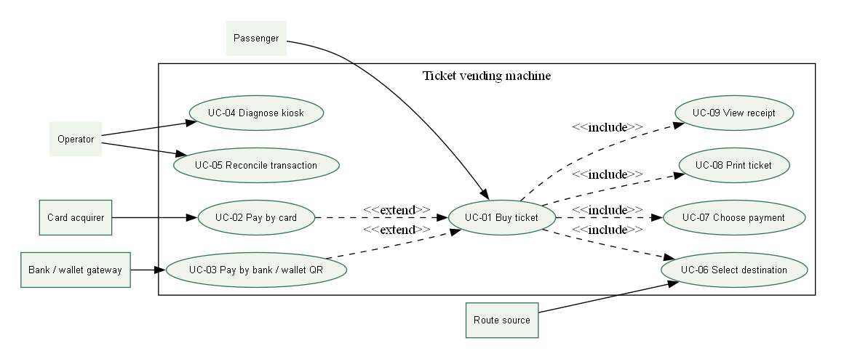3.1.2 Actors and Use Case List
Actor | Responsibility
Passenger | Choose destination/payment; buy and view a ticket
Operator | Diagnose and supervise reconciliation or compensation
Card / bank / wallet gateway | Production payment boundary; simulated in demo
Route source | Active route catalogue; SQL in this demo

Use case | Scope
UC-01 Buy ticket | Designed; prototype scope stated below
UC-02 Pay by card | Designed; prototype scope stated below
UC-03 Pay by bank / wallet QR | Designed; prototype scope stated below
UC-04 Diagnose kiosk | Designed; prototype scope stated below
UC-05 Reconcile transaction | Designed; prototype scope stated below
UC-06 Select destination | Designed; prototype scope stated below
UC-07 Choose payment | Designed; prototype scope stated below
UC-08 Print ticket | Designed; prototype scope stated below
UC-09 View receipt | Designed; prototype scope stated below

3.1.3 Use Case Descriptions
UC01: Buy ticket
Field | Description
Actor | Passenger
Trigger | Passenger requests the journey action
Preconditions | Kiosk ready, route data and printer available.
Main success flow | Start, select route, confirm fare, choose method, authorize, persist, print, show receipt.
Alternate / exception | Decline allows retry; timeout requires reconciliation; print fault creates compensation case.
Postcondition | At most one delivered ticket for a paid transaction.
UC02: Pay by card
Field | Description
Actor | Passenger
Trigger | Passenger requests the journey action
Preconditions | Route and fare confirmed.
Main success flow | Prompt tap or insert; send tokenized authorization; verify outcome.
Alternate / exception | Decline, cancel, or timeout returns a safe status.
Postcondition | Payment reference linked to transaction.

UC03: Pay by bank/digital wallet
Field | Description
Actor | Passenger
Trigger | Passenger requests the journey action
Preconditions | Route and fare confirmed.
Main success flow | Create expiring amount-bound QR; display; await signed callback.
Alternate / exception | Expiry or cancellation invalidates QR; late callback requires reconciliation.
Postcondition | A confirmed capture or no issued ticket.

UC04: Diagnose kiosk
Field | Description
Actor | Operator
Trigger | A fault or unknown transaction needs resolution
Preconditions | Authenticated operator and service mode.
Main success flow | Check printer, network, gateway, and recent faults.
Alternate / exception | Failed self-test sets out-of-service state.
Postcondition | Audited diagnostic event.

UC05: Reconcile Transaction
Field | Description
Actor | Operator
Trigger | A fault or unknown transaction needs resolution
Preconditions | Payment result unknown or print compensation pending.
Main success flow | Query gateway; compare capture; retry print or refund.
Alternate / exception | Gateway unavailable remains queued.
Postcondition | No duplicate charge or ticket.

UC06: Select destination
Field | Description
Actor | Passenger
Trigger | Passenger requests the journey action
Preconditions | Active fare catalogue available.
Main success flow | Show active routes; select destination and fare snapshot.
Alternate / exception | Missing or stale catalogue shows unavailable guidance.
Postcondition | Valid route and fare assigned.

UC07: Choose payment
Field | Description
Actor | Passenger
Trigger | Passenger requests the journey action
Preconditions | Route and fare confirmed.
Main success flow | Choose card, bank QR, or wallet.
Alternate / exception | Cancel or timeout discards pending selection.
Postcondition | One method set for the attempt.

UC08: Print ticket
Field | Description
Actor | Passenger
Trigger | Passenger requests the journey action
Preconditions | Confirmed payment and working printer.
Main success flow | Generate unique opaque barcode; print route, fare, validity, and barcode.
Alternate / exception | Printer fault creates reprint or refund case.
Postcondition | Ticket linked to one paid transaction.
UC09: View Receipt
Field | Description
Actor | Passenger
Trigger | Passenger requests the journey action
Preconditions | Payment and print results known.
Main success flow | Show route, fare, time, reference, and support guidance.
Alternate / exception | Unknown payment shows pending guidance, not success.
Postcondition | Passenger can identify transaction for support.

3.2 Activity Diagrams (10 marks)

3.2.1 Passenger Buys a Ticket at the TVM
[ Activity diagram: buy a ticket ]
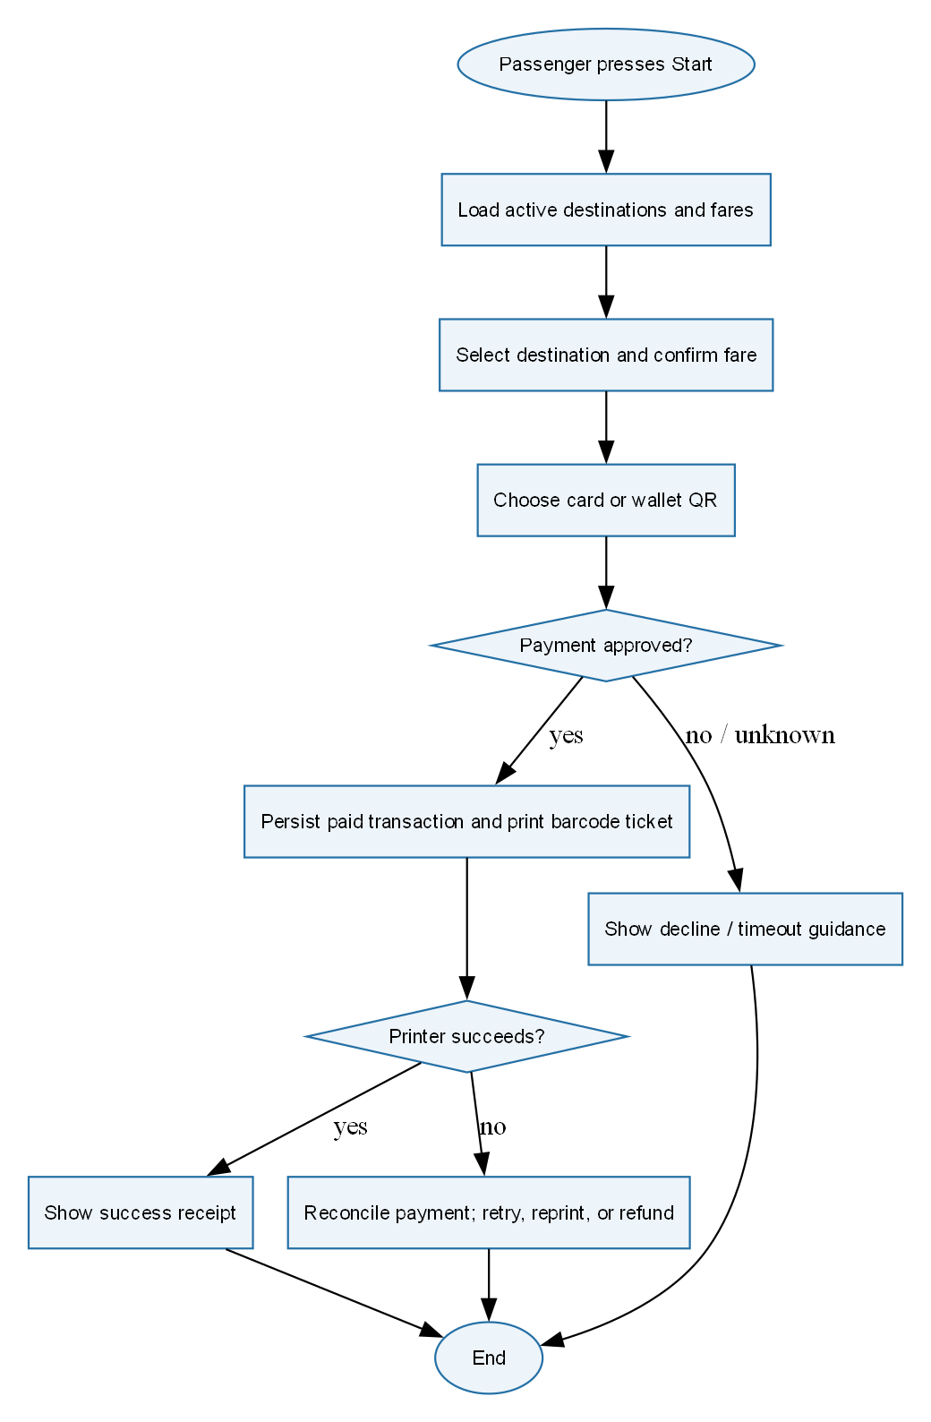

3.2.2 Communication with External Payment Gateways
[ Activity diagram: payment gateway integration ]
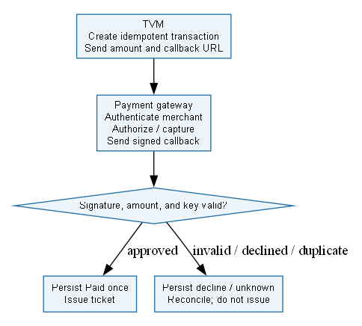

3.3 Detailed System Modeling: Main Use Case "Buy a Ticket" (15 marks)

3.3.1 Sequence Diagram
[ Sequence diagram: Buy a Ticket ]
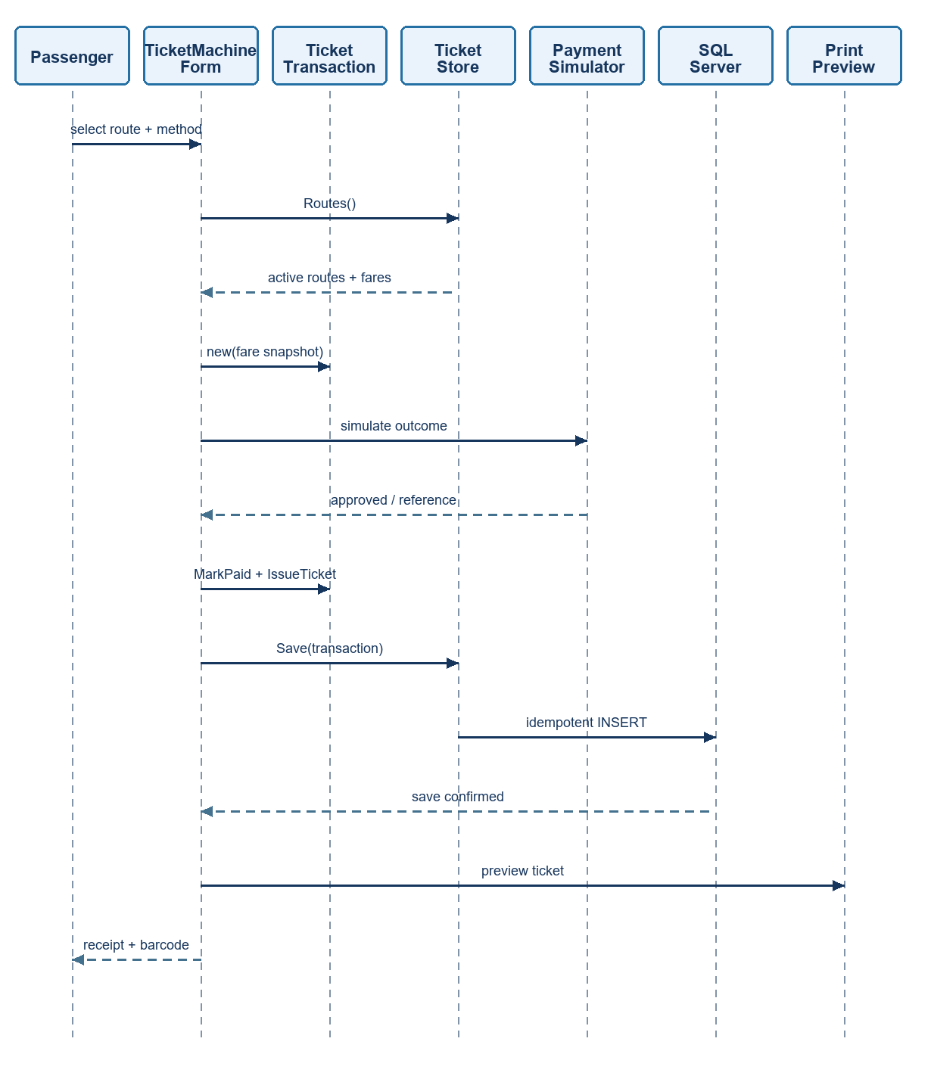

3.3.2 State Chart Diagram
[ State chart diagram ]
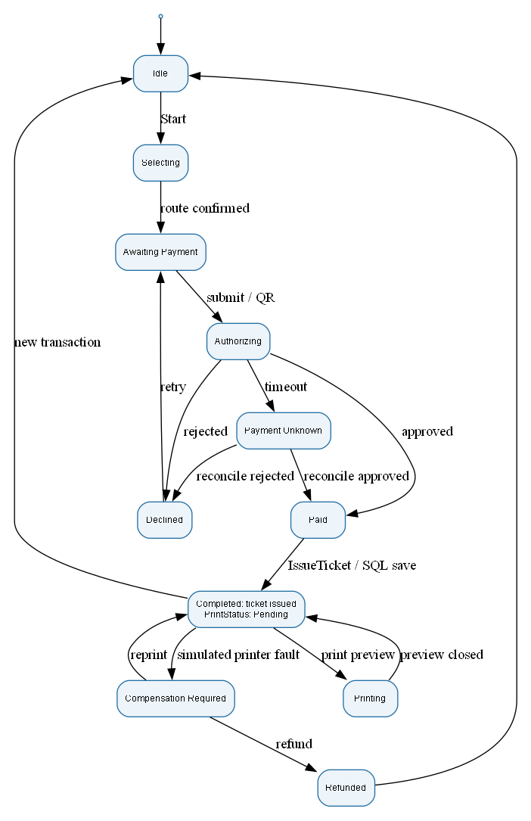

3.3.3 Class Diagram (Domain Model)
[ Class diagram ]
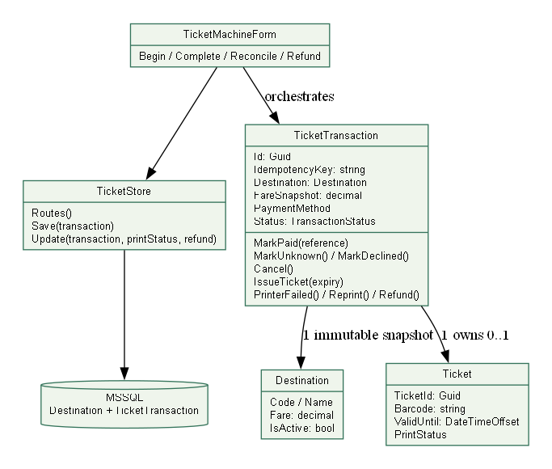
Class | Key attributes | Key methods | Relationships
TicketMachineForm |  | Begin(), Complete(), Reconcile(), Refund() | Orchestrates TicketTransaction; also connects to TicketStore.
TicketStore |  | Routes(), Save(transaction), Update(transaction, printStatus, refund) | Persists destination and transaction data to MSSQL.
TicketTransaction | Id: Guid; IdempotencyKey: string; Destination: Destination; FareSnapshot: decimal; PaymentMethod; Status: TransactionStatus | MarkPaid(reference), MarkUnknown(), MarkDeclined(), Cancel(), IssueTicket(expiry), PrinterFailed(), Reprint(), Refund() | Has one immutable Destination snapshot; owns zero or one Ticket.
Destination | Code, Name; Fare: decimal; IsActive: bool |  | Used by TicketTransaction as an immutable snapshot.
Ticket | TicketId: Guid; Barcode: string; ValidUntil: DateTimeOffset; PrintStatus |  | Owned by a TicketTransaction (zero or one ticket per transaction).

3.4 Model Consistency Check

Consistency check | Diagrams involved | Done
Every use case in the diagram has a description, and every description is in the diagram | Use case diagram / descriptions | done
Every step of the main flow appears in the activity diagram | Descriptions / activity | done
Objects and messages in the sequence diagram exist as classes and methods in the class diagram | Sequence / class | done
State names and transitions match the events in the sequence diagram | State chart / sequence | done
Payment gateway steps match between the two activity diagrams and the sequence diagram | Activity / sequence | done
Requirement IDs are cited in the use cases | Requirements / use cases | done
The class diagram matches the C# code generated in 5.1 | Class / code | done

4. Phase 3: UI/UX & Architecture (15 marks)

4.1 UI/UX Design (5 marks)
Screen | Name / purpose | Linked use case step | Tool and link
Purchase screen | Lets passengers select a destination and fare, choose card or digital wallet payment, and start the journey. The adjacent receipt panel shows the destination, fare, barcode, and demo payment notice. | UC-01 Buy ticket: start, select route, confirm fare, choose method, print, show receipt. UC-06 Select destination: select destination and fare. UC-07 Choose payment: choose a payment method. UC-08 Print ticket and UC-09 View receipt: barcode and receipt details. | Graphviz DOT
[ Wireframes or mockups of the screens (one per screen) ]
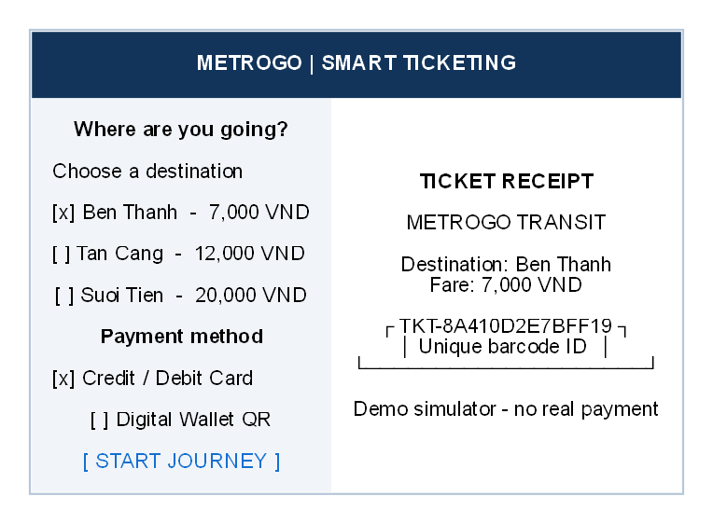

4.2 Architectural Design (10 marks)

4.2.1 Architecture Diagram
[ Architecture diagram ]
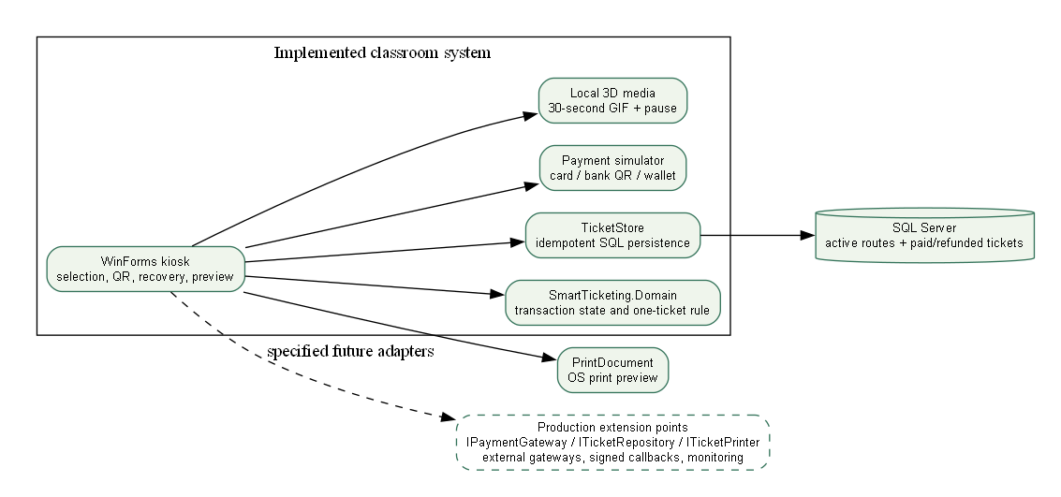
- WinForms kiosk handles destination and payment selection, QR display, recovery, and receipt preview.
- SmartTicketing.Domain controls transaction states and the one-ticket-per-paid-transaction rule, helping prevent duplicate or unpaid tickets
- Payment simulator (we only simulate it here) demonstrates card, bank QR, and wallet flows safely, the diagram marks real payment gateways and signed callbacks as future extensions
- TicketStore and SQL Server save route and ticket records idempotently, supporting recovery when an operation is retried.
- PrintDocument provides a print preview for the demo, a real ticket printer is another extension that we do not intergrate into this project

4.2.2 Deployment Diagram
[ Deployment diagram ]
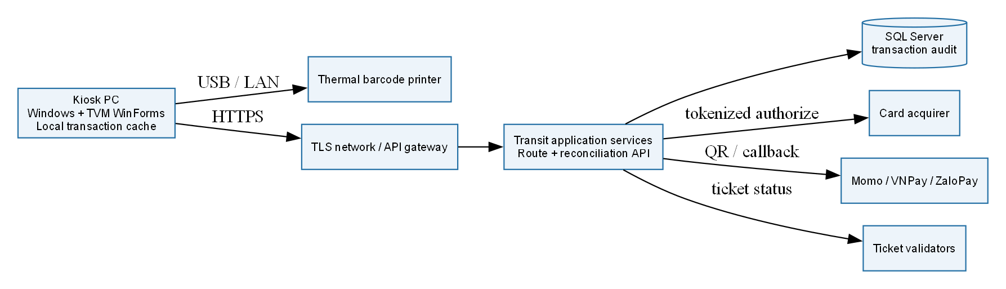
Node / component | Description | Connection (protocol, direction)
Kiosk PC | Windows PC running the TVM WinForms application, with a local transaction cache | Outbound: USB/LAN → Thermal barcode printer; HTTPS → TLS network/API gateway.
Thermal barcode printer | Prints the passenger’s barcode ticket | Inbound: USB/LAN ← Kiosk PC.
TLS network / API gateway | Secure network path between the kiosk and transit services | Inbound: HTTPS ← Kiosk PC; outbound: → Transit application services (protocol not specified).
Transit application services | Provides the route and reconciliation APIs | Inbound: ← API gateway (protocol not specified). Outbound: → SQL Server (protocol not specified); tokenized authorize → Card acquirer; QR / callback → Momo, VNPay, or ZaloPay; ticket status → Ticket validators.
SQL Server | Stores the transaction audit data | Inbound: ←Transit application services (protocol not specified).
Card acquirer | Processes card authorization requests. | Inbound: tokenized authorize ← Transit application services. The response path is not shown.
Momo / VNPay / ZaloPay | Digital wallet and QR payment providers. | Connection labeled QR / callback from Transit application services. The arrow points toward the providers; a separate callback return path is not drawn.
Ticket validators | Validate ticket status | Inbound: ticket status ← Transit application services.

5. Phase 4: Implementation, Tooling & Demo (30 marks)

5.1 Visual Studio Engineering: Model-to-Code (10 marks)

5.1.1 Forward Engineering (Model to Code)
[ Class diagram in Visual Studio and the generated C# skeleton ]
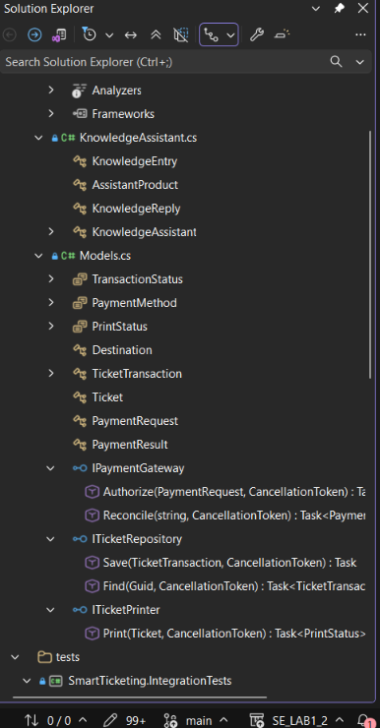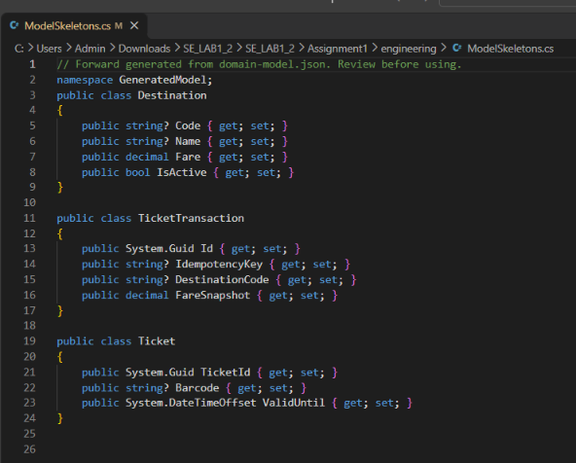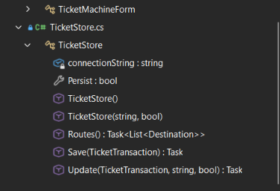

5.1.3 Code Map
[ Visual Studio Code Map ]
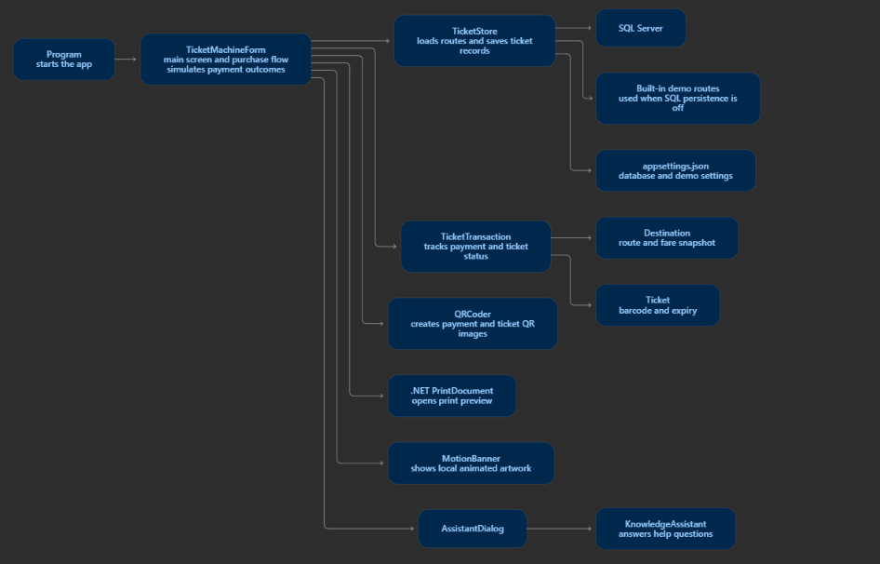
It shows thatkiosk screen coordinates the purchase, updates a ticketTransaction, and asks ticketStore to load routes or save records, the transaction holds the selected destination and, after successful payment, its ticket. This gives us a clear look back at how the code base process its tasks and how each chunk interact with another

5.2 GitHub & AI Tooling (10 marks)

5.2.1 Source Control
Item | Your answer
Repository link | https://github.com/Nghiaktvn/SE-Lab-QT2-Assignments

5.2.2 AI Assistance: Copilot Prompt Documentation
Tool / date | Actual request summary | Kept / changed | Validation
Codex / 23 Oct 2026 | Complete PDFs and rubric | Code, tests, workbook and numbered report | Build, MSTest and SQL demo
Codex / 23 Oct 2026 | Upgrade all UI/UX and functional demos | Three application interfaces and safe workflow states | Native and browser captures
image_gen / 23 Oct 2026 | Joyful MetroGo 3D transit scene | Original art + 30-second motion graphics | Image inspection; video metadata

5.2.3 Reflection on AI Use
AI accelerated scaffolding, but review exposed account lockout, cancellation, stale-stock and template-compliance gaps. These were corrected and tested

5.3 Demo Application (10 marks)
Guidance (delete before submitting): A functional prototype of the main use case using Visual Programming C# and MSSQL, with an input form and an output report (or success screen).
Item | Your answer
Technology and versions | C#, .NET 10.0, Windows Forms (WinForms), Visual Studio, Microsoft SQL Server, Microsoft.Data.Sq1Client 6.1.3, QRCoder 1.8.1, MSTest 3.10.2, Microsoft.NET.Test.Sdk 17.14.1, T-SQL, Graphviz DOT, PlantUML, HTML/CSS mockup, PNG, GIF, MP4
Database script location and how to run it | https://github.com/Nghiaktvn/SE-Lab-QT2-Assignments/blob/main/Assignment1/database/01_create_database.sql (import query in MSSQL and run)
How to run the application | https://github.com/Nghiaktvn/SE-Lab-QT2-Assignments [readme file]
Input form
[ Screenshot: input form (destination and payment mode) ]
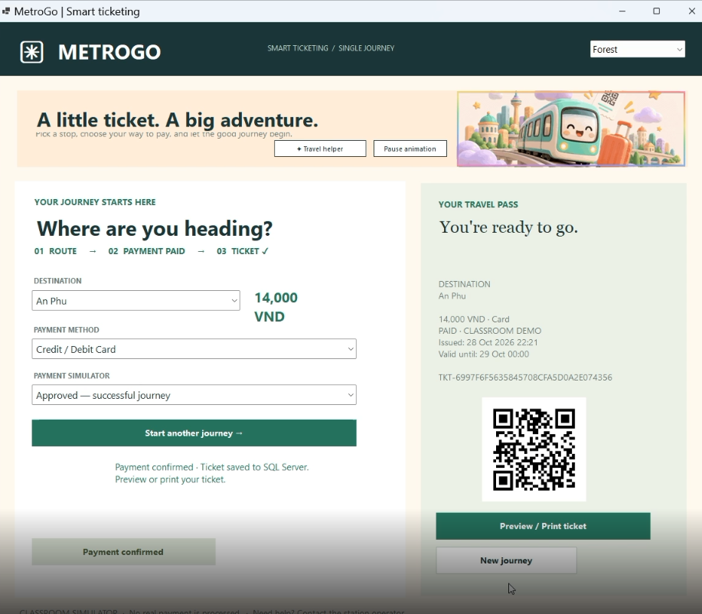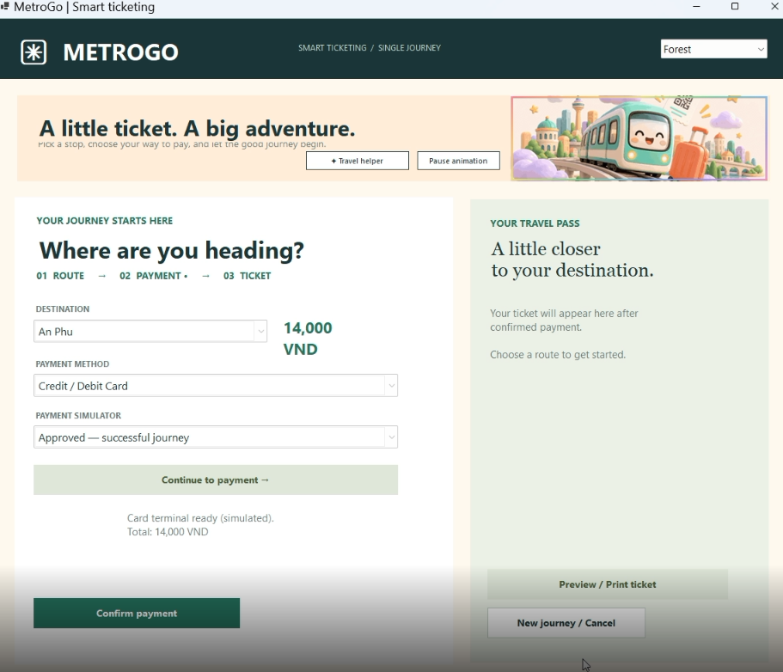
Output report or success screen
[ Screenshot: ticket issued / output report ]
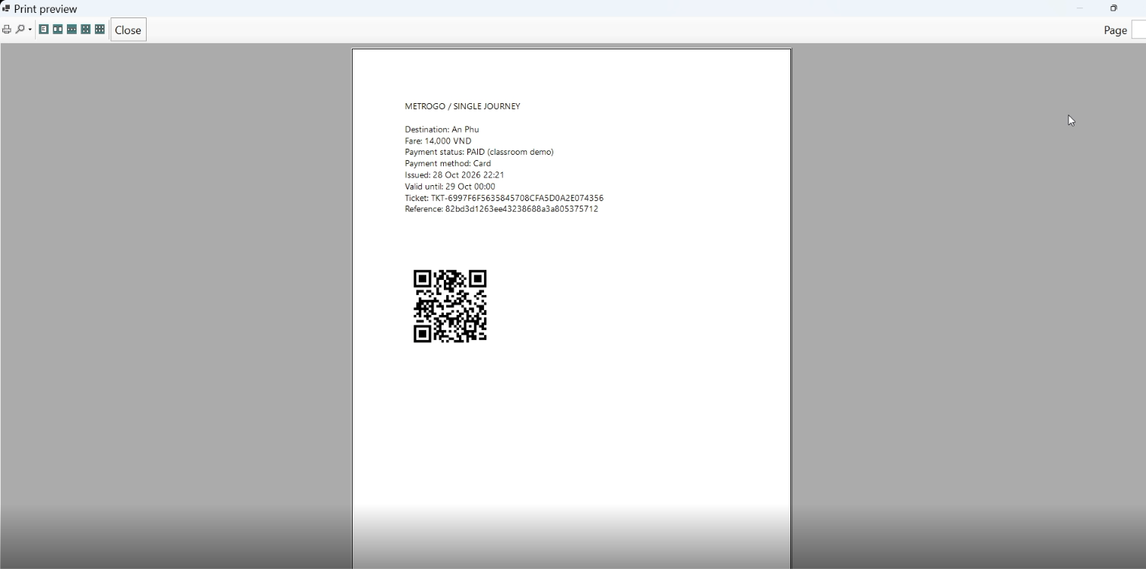
Test scenarios
No. | Scenario | Input | Expected result | Result
1 | [Successful purchase] | Simulate success payment | success | correct
2 | [Payment declined] | Simulate declined payment | fail | correct
Known limitations
We only simulate the scenarios, thus cant say for certain if there are hidden bugs when deploy into live environment

6. Checklist for "LabGroup_QT2_Assignment1.pdf"
Guidance (delete before submitting): The submission must address the content of LabGroupAssignment1.pdf (initial context and submission guidelines). List each item of that document, where this report covers it, and tick it.
Clarification Q&A | 2.1 | Artifact verified | Clarification Q&A
Requirements specification | 2.2 | Artifact verified | Requirements specification
Use cases | 3.1 | Artifact reviewed | Use cases
Activity diagrams | 3.2 | Artifact reviewed | Activity diagrams
Detailed system modeling | 3.3 | Artifact verified | Detailed system modeling
Clarification Q&A | 2.1 | Artifact verified | Clarification Q&A
Requirements specification | 2.2 | Artifact verified | Requirements specification
Use cases | 3.1 | Artifact reviewed | Use cases
Activity diagrams | 3.2 | Artifact reviewed | Activity diagrams

7. Contribution of Each Member
Guidance (delete before submitting): The % contribution of each member must total 100% and match readme.txt.
Member | Student ID | Work products and tasks | % contribution
Trần Gia Triều | 519H0245 | Documentation | 30%
Phạm Trung Nghĩa | 524H0172 | Coding and documentation | 40%
Lê Đạt | 524H0044 | Documentation | 30%
Total |  |  | 100%

8. Conclusion and Lessons Learnt
The prototype demonstrates route selection, three simulated payment methods, SQL ticket persistence, payment reconciliation, print recovery and classroom refunds. The design separates unknown payment results from declines and preserves the same ticket identity on retry. Measured checks are recorded under docs/evidence. Live payment providers, physical printer output, long-term availability and restart reconciliation remain outside the verified classroom demonstration

Appendix

Appendix A: readme.txt
# QT2 Software Engineering Lab — Complete Working Package
Prepared for **Phạm Trung Nghĩa — 524H0172**. Updated **24 October 2026**.

Project repository: [Nghiaktvn/SE-Lab-QT2-Assignments](https://github.com/Nghiaktvn/SE-Lab-QT2-Assignments). The two assignments remain separate solutions and submission folders.

The workspace contains two independent Visual Studio solutions, their SQL scripts, tests, numbered Word/PDF reports, team workbooks, original design assets, and locally generated submission archives. The archives are excluded from Git to avoid duplicate binaries; run `python tools/package_submissions.py` to regenerate them.

## Run
Use .NET SDK 10 on Windows, with Windows Desktop and ASP.NET runtime support and SQL Server.
From this folder:
```powershell
.\Run-Demo.ps1 -SetupDatabase -App All
```
The SQL scripts are repeatable and preserve existing classroom records. Before running on another computer, configure the SQL connections in the files listed below. The portal uses http://127.0.0.1:5400.
Individual commands and demo accounts are in each assignment's readme.txt.

## Assignment 1 — MetroGo Smart Ticketing
- Solution: Assignment1/SmartTicketing.sln.
- Native WinForms kiosk + domain library + MSSQL persistence.
- Card / bank QR / wallet simulators, approved/declined/unknown outcomes, same-reference save retry, same-ticket printer recovery, simulated refund, service-day barcode ticket, print preview.
- Local 3D art, optional 30-second motion banner and pause control.
- Config: Assignment1/src/SmartTicketing.WinForms/appsettings.json; optional ConnectionStrings__Ticketing override.
- Tests: 21 meaningful MSTest cases and 5 isolated SQL ticket checks.
- Engineering: model-to-code skeletons, compiled-code-to-model JSON and reflected DGML graph under Assignment1/engineering.
- Reports: Report.docx, 524H0172_PhamTrungNghia.docx, Report.pdf.
- Full workbook: A1_Team_Workbook.xlsx (11 sheets).

## Assignment 2 — Northstar Wholesale
- Solution: Assignment2/WholesaleManagement.sln.
- Admin WinForms workspace + ASP.NET Core Razor Pages Agent Portal (Option B) + MSSQL.
- Role-restricted sign-in with five-failure lockout, item/agent management, transactional partner/account registration, arbitrary stock adjustment, stale-editor protection, status changes, exactly-once cancellation restoration, manifest export/print, date/agent sales filters.
- Portal collection landing page, product photographs, card/list catalog, search/category filters, quantity steppers, live cart, atomic master/detail checkout, request replay protection, My Orders and ownership-protected printable invoice.
- Original 3D art and silent 30-second welcome clip. Pause/play and reduced-motion support.
- Config: Assignment2/src/Wholesale.AdminWinForms/App.config and Assignment2/src/AgentPortal/appsettings.json.
- Classroom Admin: admin / Demo123!; Agent: agent01@wholesale.local / Demo123!.
- Tests: 26 MSTest cases and 46 SQL/browser integration checks, including an isolated two-product checkout.
- Reports: Report.docx and Report.pdf.
- Full workbook: A2_Team_Workbook.xlsx (12 sheets).

## Verification
Both solutions built successfully in the final local pass. All 47 unit tests, 5 Lab 1 SQL checks, and 46 Lab 2 SQL/browser checks passed. Checks include controlled failure on the second order detail, request replay, concurrent last-unit checkout, ownership, cancellation, lockout and RowVersion conflicts. Fixtures were removed and baseline/final table counts matched. The GitHub workflow builds both solutions and runs their unit tests on Windows; SQL/browser integration still requires the documented local environment.
The actual upgraded browser demo created order #23 with 2 Arabica and 3 Robusta, total 1,045,000 VND. Real screenshots and saved evidence are under each assignment's docs folder.
Run the test workflow with:
```powershell
.\Run-Demo.ps1 -App Test
```
For the optional browser checkout, run the Agent Portal at `http://127.0.0.1:5400` and use `.\Run-Demo.ps1 -App Test -BrowserTest` with Playwright and Chrome available. The printed invoice PDF includes registered agent contact and a persisted classroom payment reference.

## Design and media
design/MetroGo_Northstar_Design_System.svg can be imported into Figma as vector layers and embedded original art. An editable design handoff is linked in DELIVERY_NOTES.md; access should be checked before presentation.
design/image-prompts.md records the built-in image_gen prompts. design/photo-sources.json records the bundled real photograph sources and license pages.
The 30-second MP4/GIF clips are silent motion graphics with camera movement over original 3D artwork and three timed captions. They are not external live-action or character-motion footage.

## Submission files
Assignment1_Submission.zip and Assignment2_Submission.zip each contain the report, workbook, readme and clean SourceCode.zip.
Complete_Lab_Package.zip contains the two assignments, design resources and build/package helpers.
Build outputs, test-run folders, local Data Protection keys and caches are excluded; saved evidence is retained.

## Human evidence still required
Only one confirmed team member and an account profile were supplied. Add the real group number, other 2–4 students, feature ownership and contribution percentages totaling 100%. A repository upload creates genuine commit history, but feature branches and reviewed Pull Requests must reflect actual team activity.
Assignment 1 also needs actual Visual Studio model/code-operation and Code Map UI screenshots on a supporting installed edition.
No full-score guarantee is made. Lecturer marks remain blank in both workbooks.

Appendix B: Full-size Diagrams

