Lab 1 – Hoang Duy Vu - 986170

1. Did you setup Cloudera VM on your machine? You just need to write yes or no.

Yes

1. What is the meaning of $HOME in your VM environment?

An environment variable that hold directory serves as the repository for a user's personal files, in this case it holds a /home/cloudera

1. What is the meaning of SUDO in Unix/Linux environment?

The sudo command stands for "superuser do" as a Linux system administrator or power user, it's one of the most important commands in linux.

1. Write and briefly explain any 5 Unix/Linux commands.

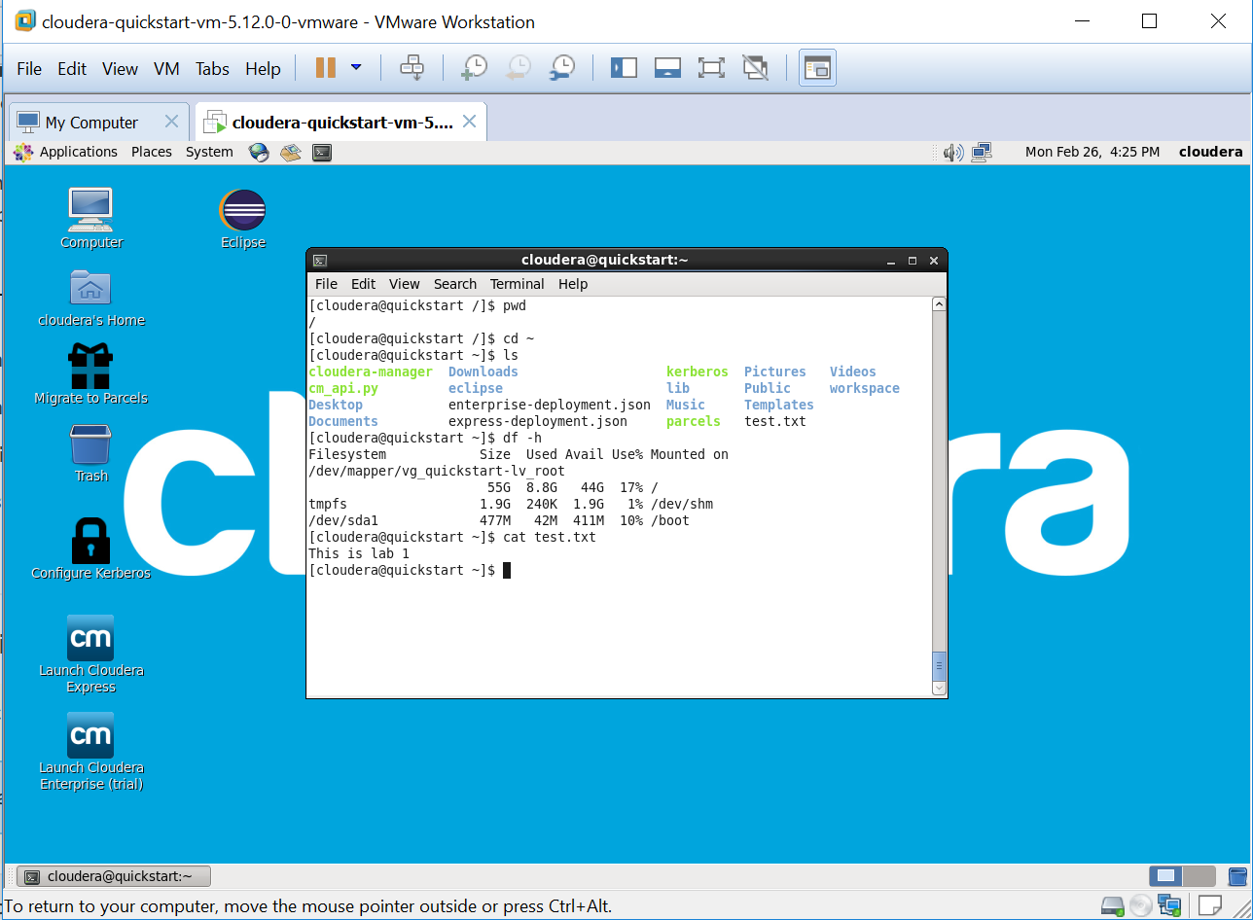

**pwd** – **pwd** command gives the absolute path, which means the path that starts from the root.

**ls** – **ls** command give us know what files are in the directory you are in.

**cd** – **cd** command use to go to a directory or change directory.

**cat** - Use thecat command to display the contents of a file.

**df** - Use the df command to see the available disk space in each of the partitions in your system.