Lab 3

1.

[cloudera@quickstart ~]$ hadoop jar /home/cloudera/Desktop/averagetemp.jar AverageTemp /user/cloudera/input/NCDC-Weather.txt /user/cloudera/output

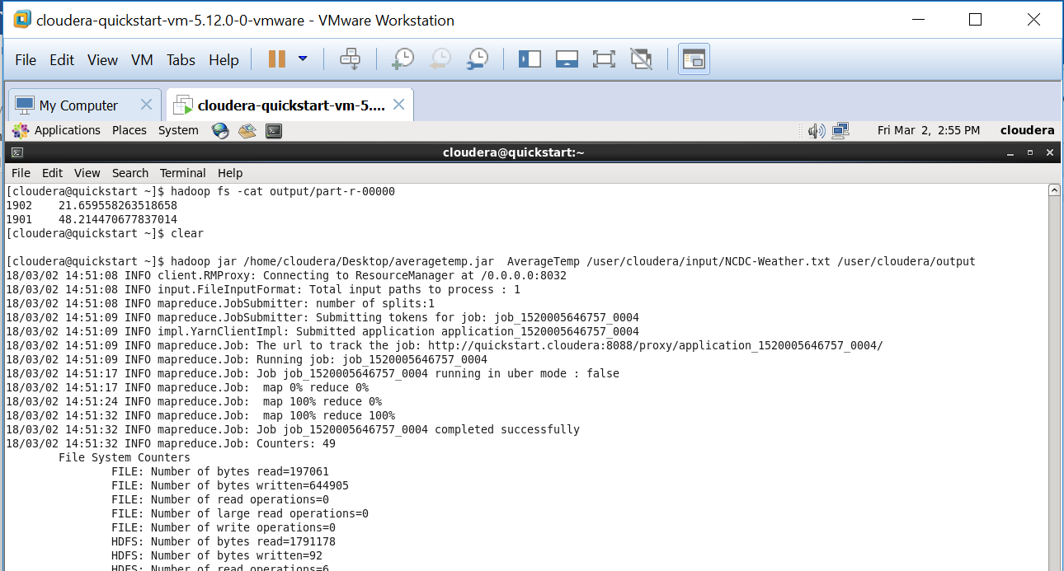

2

[cloudera@quickstart ~]$ hadoop jar /home/cloudera/Desktop/averagetemp.jar AverageTempWithCombiner /user/cloudera/input/NCDC-Weather.txt /user/cloudera/output

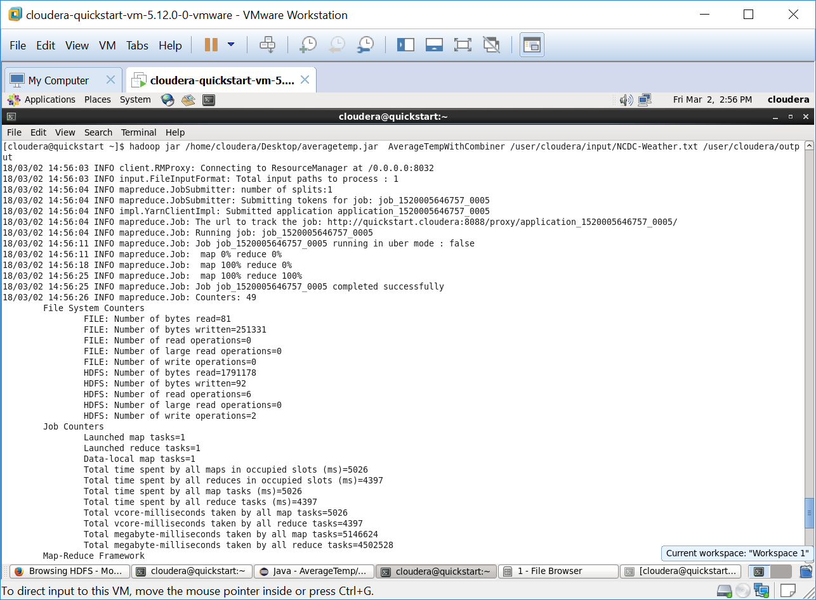

3.

[cloudera@quickstart ~]$ hadoop jar /home/cloudera/Desktop/averagetemp.jar AverageTempInMapper /user/cloudera/input/NCDC-Weather.txt /user/cloudera/output

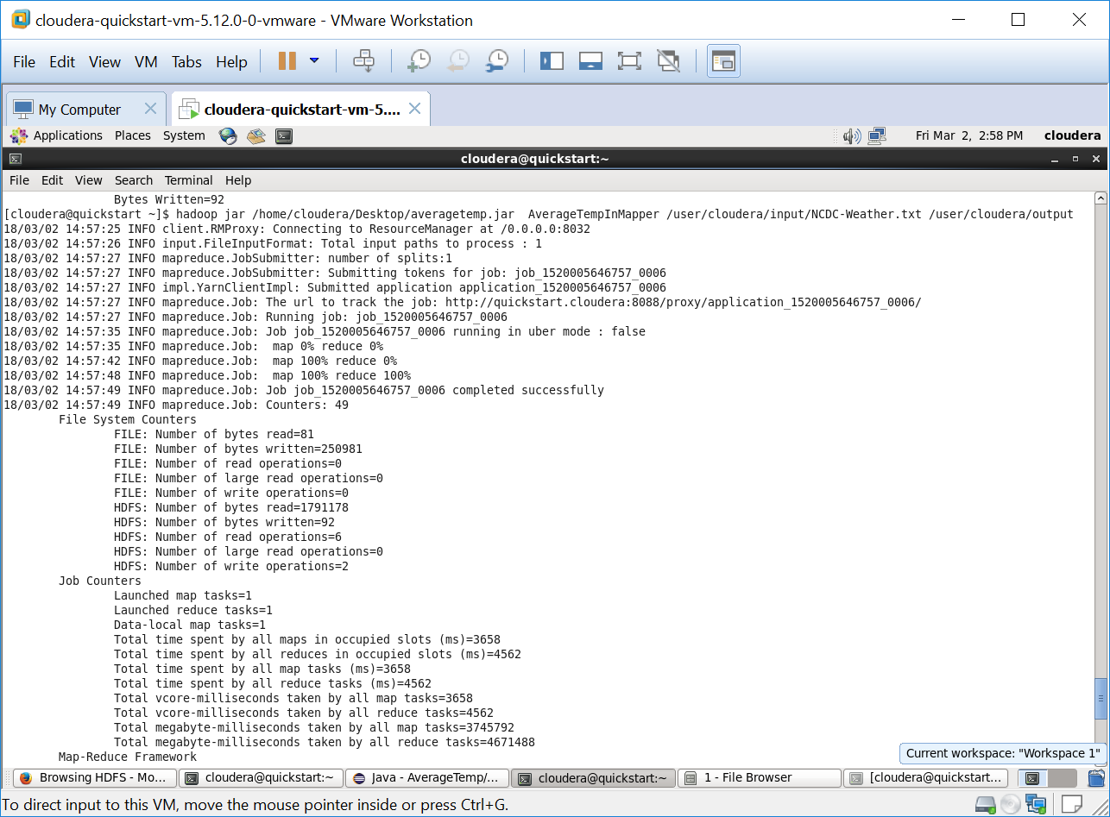

4.

[cloudera@quickstart ~]$ hadoop jar /home/cloudera/Desktop/averagetemp.jar AverageTempSort /user/cloudera/input/NCDC-Weather.txt /user/cloudera/output

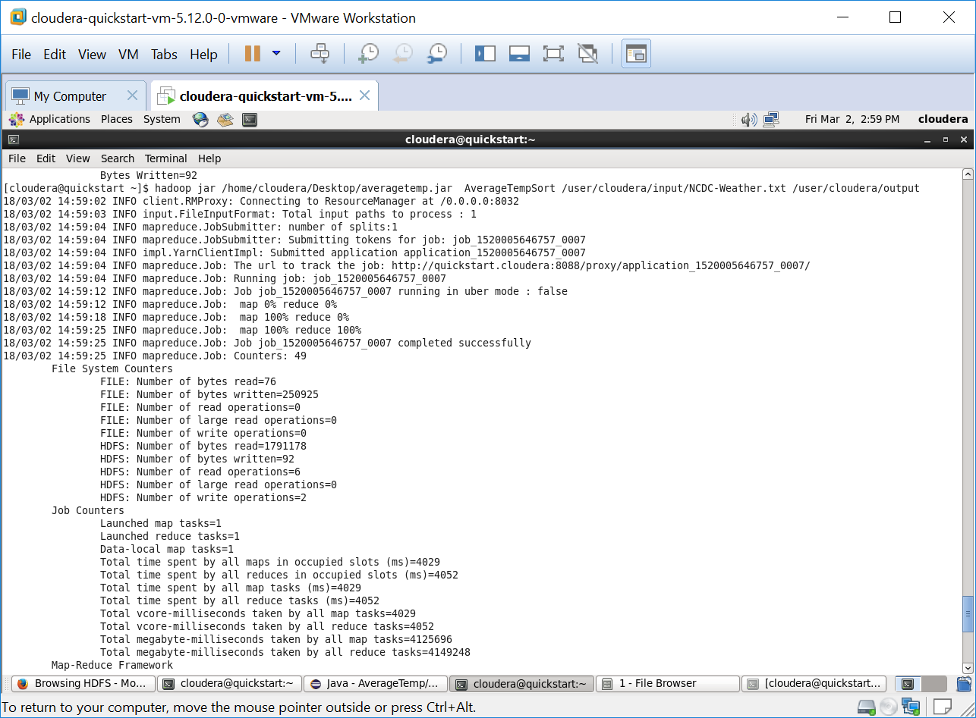

5.

[cloudera@quickstart ~]$ hadoop jar /home/cloudera/Desktop/averagetemp.jar AverageTemp2Reducer /user/cloudera/input/NCDC-Weather.txt /user/cloudera/output