Lab 4 – Hoang Duy Vu – 986170

1

Output from WordCountAvroOutput

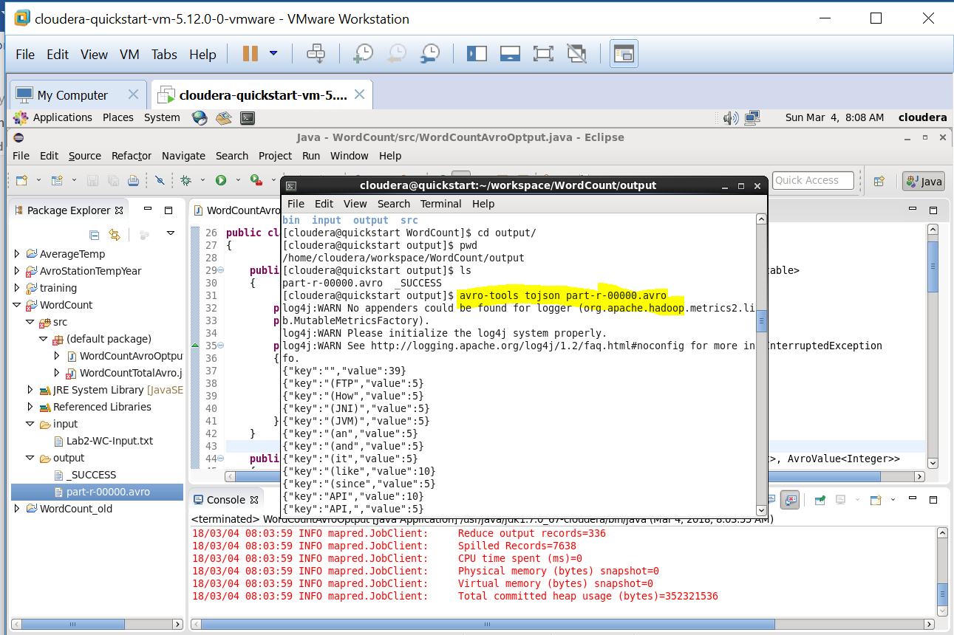

Output from WordCountAvroOutput

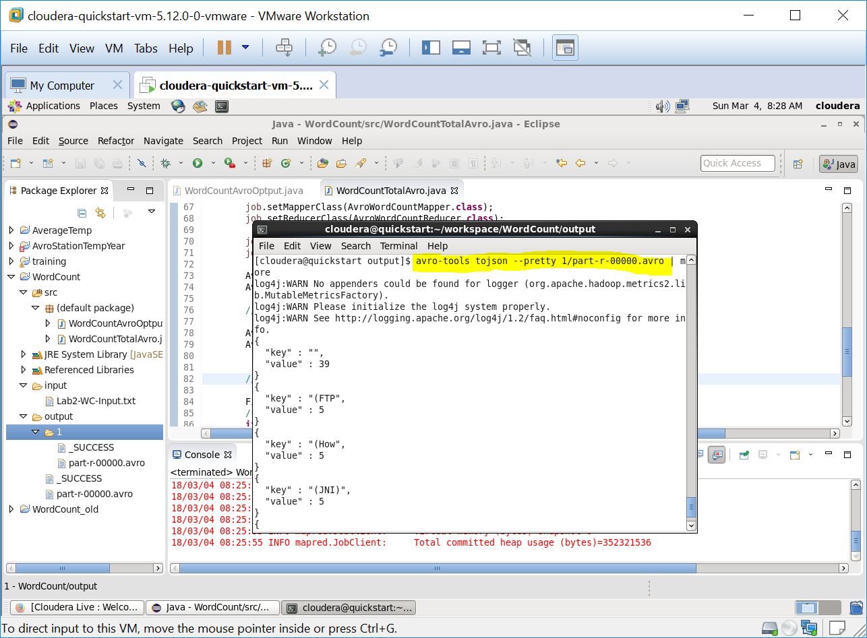

2

Output with defined schema

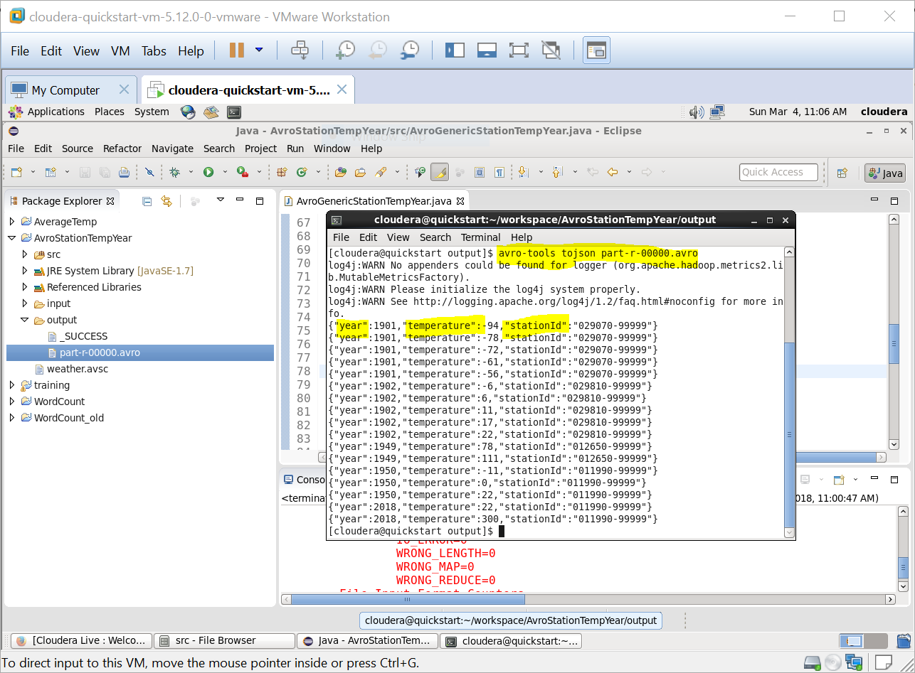

Output with changed schema with StationID: ascending, Temperature: descending

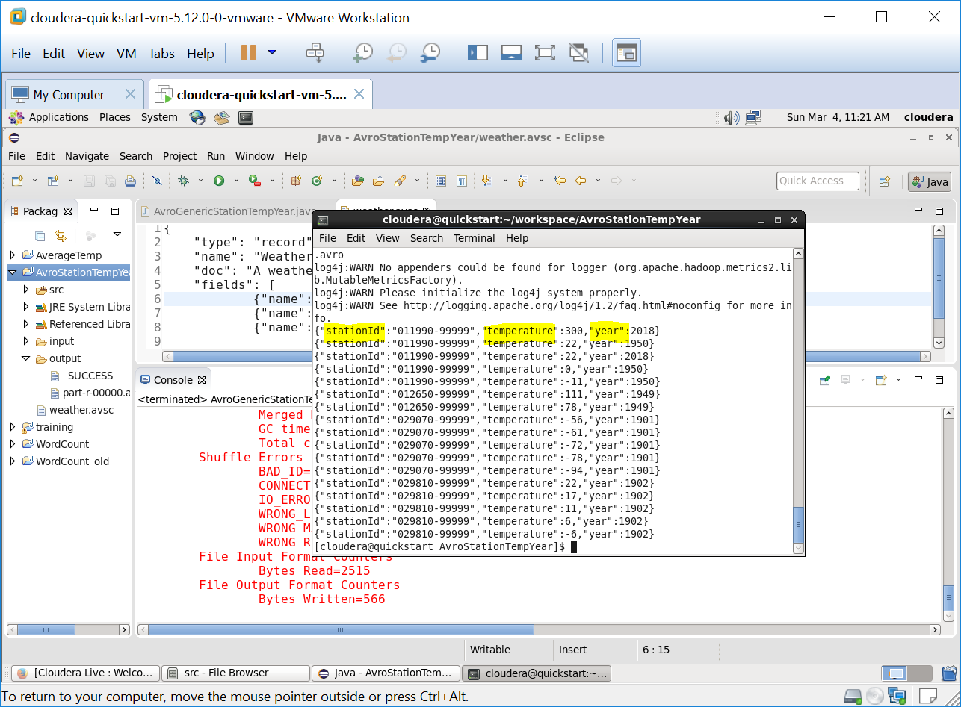

3

Output Max Temperature

