Lab 5 – Hoang Duy Vu – 986170

1 WordCount output

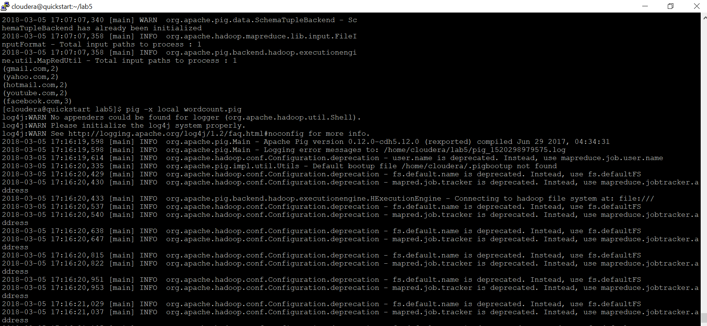



2 Join in Pig – Top 5 most visited sites

