**Harsha Changed this file**

**PRODUCT BACKLOG**

1. The team contributions should be displayed in the form of a graphical representation, preferably pie charts
   * What the client means by contributions is to be decided by the developers. For instance, whether the developers decide to consider deletion as a form of contribution is up to them. But the preferable method is as shown below.
   * Optionality to enable and disable graphs.

**Corresponding User Story**:

As a user, I want the contributions represented in the form of a pie chart so that I can review my contribution and other team members’ contributions easily, just by looking at the chart.

**Effort**: L

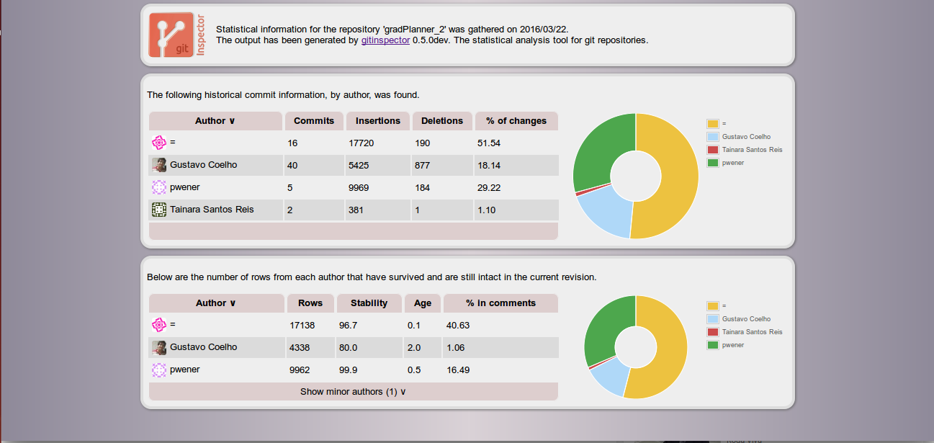

<https://upload.wikimedia.org/wikipedia/commons/8/8e/Resultado_gitinspector.png>

1. The application should be a web application

**Corresponding User Story**:

As a user, I want the app to be a web based app so that I don’t have to download any software in order to access and use the application.

**Effort**: M

1. Insertion, deletion, edits and comments should be considered as actions that should be taken into account when considering and calculating the individual contribution of the team

**Corresponding User Story**:

As a user, I want the app to show the number of actions such as insertion or deletion undertaken by others using the app so that I have an idea as to what a team member has done and how he/she has done it.

**Effort**: M

1. The client has stated explicitly that the interface of the app should be clean. This means that the spacing of the components on the interface of the app should be enough so that the interface does not feel clustered. The image shown above is a good example of a clean interface (the client presented the above image as a sample).

**Corresponding User Story**:

As a user, I want the interface to look neat and clean so that I can look at the contents easily and understand the data presented.

**Effort**: M

1. There has to be a Google Authentication for the employees of the company (which the client is representing) so that they can access the git inspector app.

**Corresponding User Story**:

As a user, I want there to be a Google Authentication to access the app so that I know how much my contribution is and so that the system can identify who I am.

**Effort**: L

1. A timeline describing the action taken by an individual/group of individuals at a particular time.
   * Actions include addition, deletion and comments.

**Corresponding User Story:**

As a user, I want there to be a timeline, which shows the action taken by each person at a particular time, so that I can review all the actions done up until a particular date or time.

**Effort:** L