Databases Coursework Write-Up

Logical Data Structure / Normalisation

|  |  |  |  |  |  |
| --- | --- | --- | --- | --- | --- |
| Invoice number | Customer ID | Barber ID | Appointment Date | Style | Cost |
| 12345 | Jim35 | JM | 01/02/19 | Haircut & Beard trim | £27.50 |
| Additional products | | | | | |
| **[Barbers Shaving & Styling Products](https://www.directsalonsupplies.co.uk/shop/237/419/index.htm)** | | Product description | Product barcode | Number required | Product price |
| Fudge Structure Wax 75g |  | 1 | £11.50 |
| Amargan Beard Oil 50ml |  | 1 | £10.00 |
| Hemo-Stop Styptic Pencil |  | 1 | £5.00 |
| Total = £54.00 | | Thanks for your custom – come again soon! | | | |
| VAT at 17.5 % = £9.45 | |
| Grand Total = £63.45 | | You were seen today by Jules | | | |

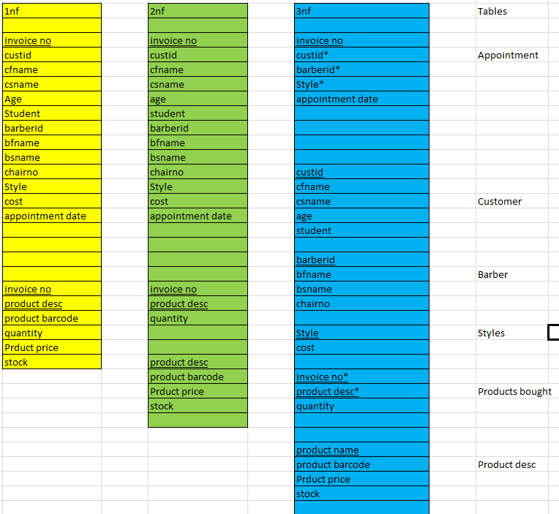

Left – Customer Invoice Normalisation to 3NF

Bottom – Shop Order Normalisation to 3NF

Underline = Primary key

Asterisk* = Foreign key

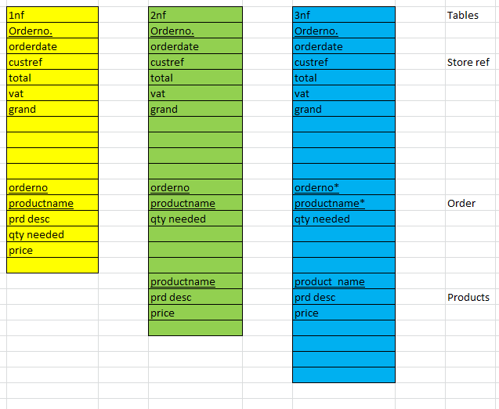

Logical Data Dictionary

|  |
| --- |
| Customer |
| Cust_id |
| C_F_Name |
| C_S_Name |
| Age |
| Student |

|  |
| --- |
| Appointment |
| Invoice_no |
| Cust_id |
| Barber_id |
| Style |
| Appointment_date |

|  |
| --- |
| Products_Bought |
| Invoice_no |
| Product_name |
| Quantity |
|  |
|  |

|  |
| --- |
| Product_Desc |
| Product_name |
| Product_barcode |
| Product_price |
| Stock |
| Vat |

|  |
| --- |
| Products |
| Product_name |
| Product_description |
| Price |

|  |
| --- |
| Store_Reference |
| Order_no |
| Order_date |
| Customer_referernce |
| Total  Vat |
| Grand_total |

|  |
| --- |
| Barber |
| Barber_id |
| B_F_Name |
| B_S_Name |
| Chair_no |
| Absences |

|  |
| --- |
| Order |
| Order_no |
| Product_name |
| Quantity_needed |

|  |
| --- |
| Styles |
| Style |
| Cost |

|  |  |  |  |  |  |
| --- | --- | --- | --- | --- | --- |
| Entities  Data Dictionary | Data type | Validation rule | Key | Required | Defult |
| **Customer Haircut** | | | | | |
|
|  |  |  |  |  |  |
| Entity: Appointment | | | | | |
| Invoice_no. | INT |  | PK | REQ, INDEXED, NO DUPLICATES |  |
| Cust_id* | VARCHAR(16) |  | FK | REQ, INDEXED, NO DUPLICATES |  |
| Barber_id* | VARCHAR(2) |  | FK | REQ, INDEXED, NO DUPLICATES |  |
| Style* | VARCHAR(32) | "HC" OR "HC&BT" OR "WS" OR "CHILD" OR "CREW" OR "OAP" OR "BT" OR "STUDENT" | FK | REQ |  |
| Appointment_date | DATE |  |  | REQ |  |
|  |  |  |  |  |  |
| Entity: Customer | | | | | |
| cust_id | VARCHAR(16) |  | PK | REQ, INDEXED, NO DUPLICATES |  |
| c_f_name | VARCHAR(16) |  |  | REQ |  |
| c_s_name | VARCHAR(16) |  |  |  |  |
| age | INT |  |  | REQ |  |
| student | VARCHAR(3) | "YES" OR "NO" |  | REQ |  |
|  |  |  |  |  |  |
| Entity: Barber | | | | | |
| barber_id | VARCHAR(8) |  | PK | REQ, INDEXED, NO DUPLICATES |  |
| b_f_name | VARCHAR(16) |  |  | REQ |  |
| b_s_name | VARCHAR(16) |  |  |  |  |
| chair_no | TINYINT | "1" OR "2" OR "3" OR "4" OR "5" OR "6" |  | REQ |  |
| Abscences | TINYINT |  |  | REQ | 0 |
| Entity: Styles | | | | | |
| Style | VARCHAR(32) | "HC" OR "HC&BT" OR "WS" OR "CHILD" OR "CREW" OR "OAP" OR "BT" OR "STUDENT" | PK | REQ |  |
| Cost | CURRENCY |  |  | REQ |  |
|  |  |  |  |  |  |
| Entity: Products Bought | | | | | |
| invoice no | INT |  | PK/FK | REQ |  |
| product name | VARCHAR(34) |  | PK/FK | REQ |  |
| quantity | INT |  |  | REQ |  |
|  |  |  |  |  |  |
| Entity: Product Desc | | | | | |
| product name | VARCHAR(34) |  | PK | REQ, INDEXED, NO DUPLICATES |  |
| product barcode | INT |  |  | REQ |  |
| Prduct price | CURRENCY |  |  | REQ |  |
| Stock | INT |  |  | REQ |  |
| Vat | Decimal |  |  | REQ | 17.5 |
|  |  |  |  |  |  |
| **Store Order** | | | | | |
|
|  |  |  |  |  |  |
| Entity: Store Ref | | | | | |
| Order_no. | INT |  | PK | REQ, INDEXED, NO DUPLICATES |  |
| order_date | DATE |  |  | REQ |  |
| cust_ref | VARCHAR(8) |  |  | REQ, INDEXED, NO DUPLICATES |  |
| total | CURRENCY |  |  |  |  |
| vat | Decimal |  |  |  | 17.5 |
| grand | CURRENCY |  |  | REQ |  |
|  |  |  |  |  |  |
| Entity: Order | | | | | |
| order_no | INT |  | PK/FK | REQ, INDEXED, NO DUPLICATES |  |
| product_name | VARCHAR(34) |  | PK/FK | REQ |  |
| qty_needed | INT | "12" OR "24" OR "36" OR "48" OR "60" |  | REQ | 12 |
|  |  |  |  |  |  |
| Entity: Products | | | | | |
| product_name | VARCHAR(34) |  | PK | REQ |  |
| prd_desc | VARCHAR(64) |  |  |  |  |
| price | CURRENCY |  |  | REQ |  |
|  |  |  |  |  |  |

Screenshots – Prototype Database

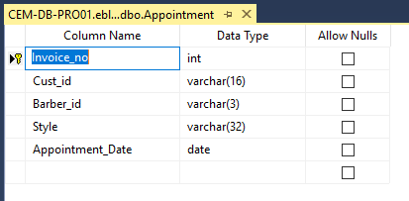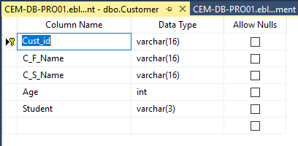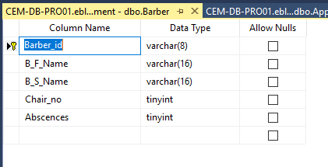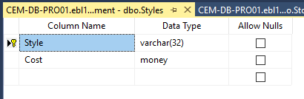

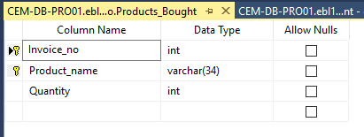

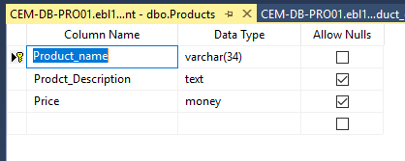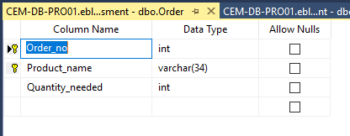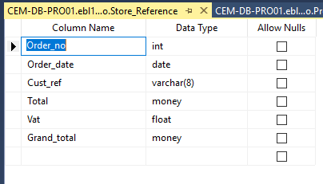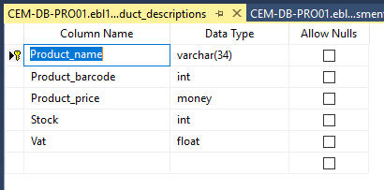

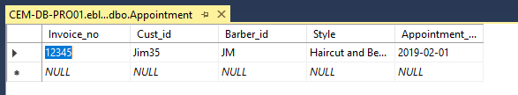

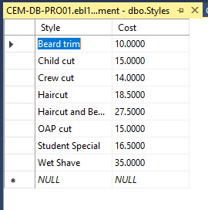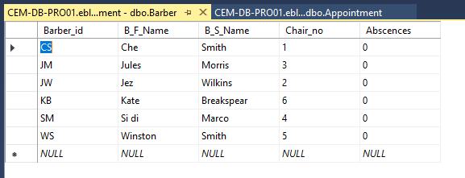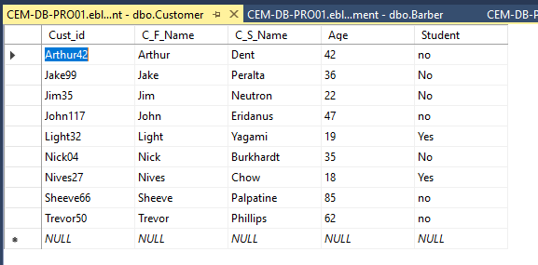

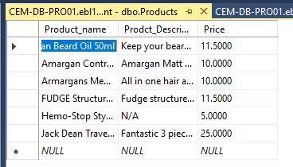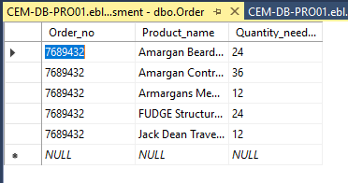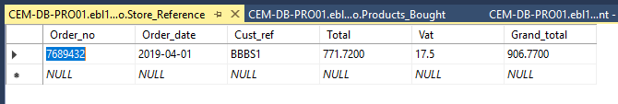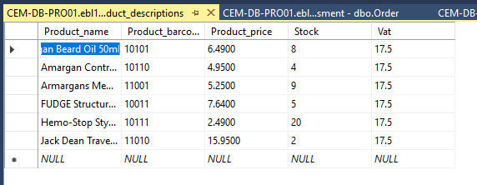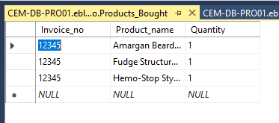

Prototype database Queries

***Query One - Current appointments with responsible barber and customer details***

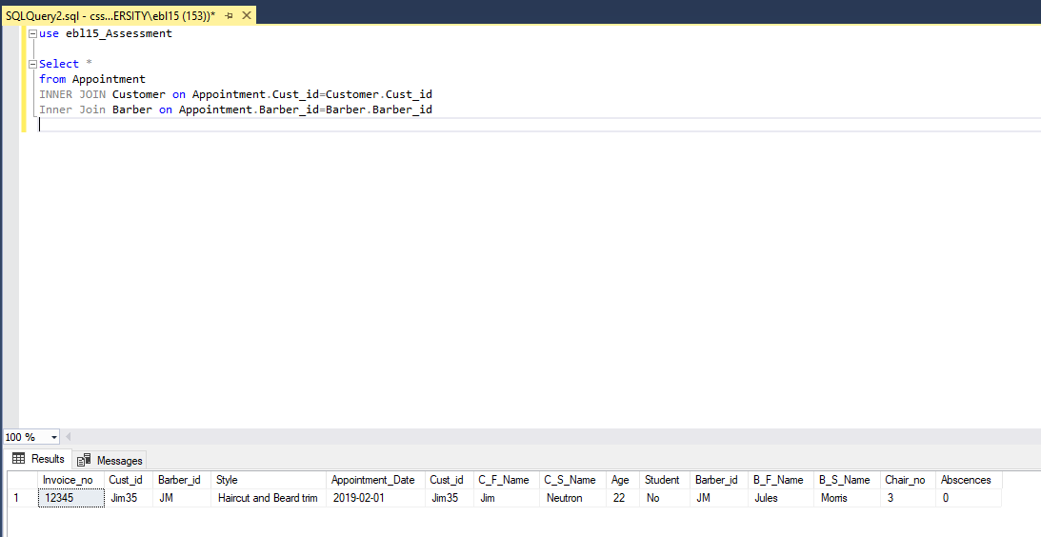

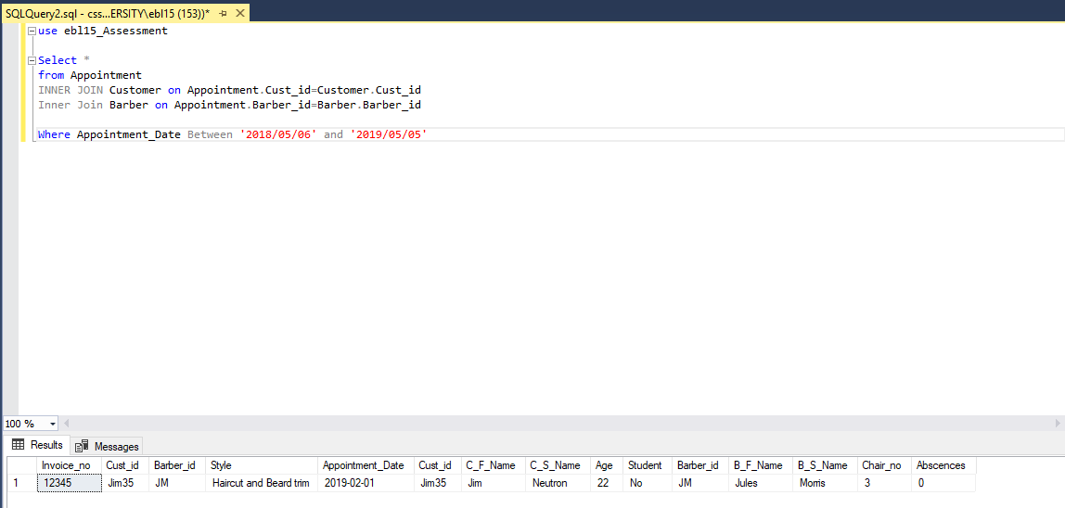***Query Two - Appointment rates by month/week over the past year per barber***