**DEVELOPMENT OF STUDENTS’ ONLINE ASSIGNMENT MANAGEMENT SYSTEM FOR JKUAT IT DEPARTMENT**

**PAULINE ADHIAMBO NGIYE**

**REG NO: SCT221-D1-0047/2023**

**SUPERVISOR: DR. DENNIS NJAGI**

*A RESEARCH PROPOSAL SUBMITTED TO THE DEPARTMENT OF INFORMATION TECHNOLOGY IN THE SCHOOL OF COMPUTING AND INFORMATION TECHNOLOGY IN PARTIAL FULFILMENT OF THE REQUIREMENT FOR THE AWARD OF THE DEGREE OF BACHELOR OF SCIENCE IN INFORMATION TECHNOLOGY OF JOMO KENYATTA UNIVERSITY OF AGRICULTURE AND TECHNOLOGY*

**NOVEMBER 2024**

## DECLARATION

This proposal project is my original work and has not been presented for a degree in any other University.

**Signature:** ……………………. ……**Date:** …………………………….

This proposal project has been submitted for examination with my approval as University Supervisor.

**Signature:** ……………………. ……**Date:** …………………………….

## ABSTRACT

This proposal outlines the development of a Student Online Assignment Management System for the department of Information Technology at Jomo Kenyatta University of Agriculture and Technology (JKUAT). The system addresses challenges associated with manual and email-based assignment submissions, such as inefficiency, data loss, and lack of transparency. It proposes a web-based solution to streamline assignment distribution, submission, and grading while enhancing student engagement and reducing administrative burden. The system will be developed using Object-Oriented Analysis and Design (OOAD) and an iterative methodology. Tools include PHP, MySQL, and Bootstrap. The expected outcome is a scalable, user-friendly platform tailored to departmental needs.

Table of Contents

DECLARATION i

ABSTRACT ii

INTRODUCTION 1

1.1 Background 1

1.2 Project Overview 1

1.3 Statement of the problem 2

1.4 Proposed Solution 7

1.5 Objectives 7

1.6 Research Questions 8

1.7 Justification 8

1.8 Proposed research and system methodologies 9

1.9 Scope 10

LITERATURE REVIEW 11

2.1 Introduction 11

2.2 Theoretical Review 12

2.3 Case Study Review 13

2.4 Integration and Architecture 14

2.5 Summary of Key Findings 15

2.6 Research Gaps 15

SYSTEM ANALYSIS AND DESIGN 16

3.1 Introduction 16

3.2 System Development Methodology 16

3.3 Feasibility Study 17

3.3.1 Economic Feasibility 17

3.3.2 Technical Feasibility 17

3.3.3 Operational Feasibility 17

3.4 Requirements Elicitation 18

3.4.1 Data Collection 18

3.5 Data Analysis 18

3.6 System Specification 20

3.6.1 Functional Requirements 20

3.6.2 Non-Functional Requirements 20

3.7 Requirements Analysis and Modelling 21

3.7.1 Analysis of Gathered Requirements 21

3.7.2 Structuring Requirements 21

3.7.3 Modelling Tools 21

3.8 Logical Design 23

3.8.1 System Architecture 23

3.8.2 Control Flow and Process Design 24

3.8.3 Non-Functional Design 25

3.9 Physical Design 26

3.9.1 Database Design 26

3.8.2 User Interface Design 28

REFERENCES 29

## CHAPTER 1

### INTRODUCTION

#### 1.1 Background

In Kenya, many higher education institutions, including Jomo Kenyatta University of Agriculture and Technology (JKUAT), still rely on manual or semi-digital methods such as printed submissions or unstructured email communication for assignment management. These methods are inefficient, prone to data loss, and make it difficult for lecturers to track student performance consistently.

Within the Department of Information Technology at JKUAT, lecturers often experience challenges in collecting, grading, and returning assignments, while students face difficulties in tracking submission deadlines and accessing feedback in a timely manner. These issues impact academic performance and administrative efficiency.

#### 1.2 Project Overview

This research project proposes the design and implementation of a Student Online Assignment Management System to automate and improve the assignment handling process within the department. The system will allow lecturers to distribute assignments, set deadlines, and provide feedback digitally, while students will be able to submit assignments and view their progress through a secure and intuitive web platform.

Globally, the education sector is increasingly adopting digital solutions to enhance learning experiences, manage coursework, and improve academic administration. Online assignment management systems are becoming essential tools in modern educational institutions. These systems help reduce paperwork, streamline submissions, and improve communication between students and lecturers. Universities worldwide, such as MIT and Stanford, have successfully implemented these systems, leading to significant improvements in efficiency and academic performance.

In Kenya, many higher education institutions, including Jomo Kenyatta University of Agriculture and Technology (JKUAT), still rely on manual or semi-digital methods for assignment management. These methods, such as printed submissions or unstructured email

communication, are inefficient and prone to data loss. They also make it difficult for lecturers to track student performance consistently. Within the Department of Information Technology at JKUAT, these challenges impact both academic performance and administrative efficiency.

The project will utilize several key computational principles:

* Object-Oriented Analysis and Design (OOAD): This approach will be used to model the system's components and their interactions, ensuring a modular and scalable design.
* Iterative Development Methodology: The system will be developed in iterative cycles, allowing for continuous feedback and improvement throughout the development process.
* Backend Processing with PHP: PHP will be used for server-side scripting and backend processing, providing a robust and flexible foundation for the system.
* Database Management with MySQL: MySQL will be used to manage the system's data, ensuring efficient storage, retrieval, and security of assignment-related information.
* User Interface with Bootstrap: Bootstrap will be used to create a responsive and user-friendly interface, enhancing the user experience for both lecturers and students.

#### 1.3 Statement of the problem

The Department of Information Technology at Jomo Kenyatta University of Agriculture and Technology (JKUAT) currently uses manual and email-based systems to manage student assignments. This approach presents several significant problems:

* Lack of Structure: Email submissions are unstructured, making it difficult to track submission dates and assignment status.
* High Costs: Printed submissions incur high costs for students, discouraging timely submissions.
* Feedback Delays: Delays in providing feedback result in poor student engagement and reduced academic performance.
* Limited Accessibility: The current system hinders students' ability to check deadlines and submission history

While platforms like Moodle and Google Classroom offer comprehensive solutions, they are often too complex or costly for department-level adoption. Therefore, there is a need for a cost-effective, scalable, and user-friendly system that addresses these challenges.

#### 

#### 1.4 Proposed Solution

This research seeks to develop a web-based Student Online Assignment Management System (SOAMS) to improve the assignment handling process. The proposed system will:

* Assignment Distribution: Lecturers can upload assignments and set deadlines.
* Automated Notifications: Students will receive email notifications and reminders about assignments.
* Digital Submission and Feedback: Students can submit assignments and receive feedback online.
* Monitoring Dashboard: Both lecturers and students can track assignment history and performance through a dashboard.
* Security and Data Integrity: The system will use modern security practices and role-based access control to ensure data integrity.

The research will involve a comparative analysis of recent global and regional models of online assignment management systems to identify best practices and innovative features. Systems like those used at MIT and Stanford integrate advanced features such as AI-driven feedback, cloud storage, and real-time collaboration. These features enhance the efficiency and effectiveness of assignment management. Recent developments in regional systems, such as AcademEase, focus on user-friendly interfaces, scalability, and robust security measures. These systems address the specific needs of educational institutions in resource-constrained environments.

### 1.5 Objectives

**General Objective**

To develop an automated Student Assignment Management System to enhance the efficiency of assignment handling within the Department of Information Technology at Jomo Kenyatta University of Agriculture and Technology (JKUAT).

**Specific Objectives**

1. To review existing digital assignment management systems and identify their limitations.
2. To design a secure and scalable web-based system for assignment handling.
3. To implement the proposed system using open-source tools and modern programming techniques.
4. To test and evaluate the system’s performance and usability within the target environment.

### 1.6 Research Questions

1. What are the current limitations of assignment management practices within JKUAT’s IT department?
2. How can an automated system improve assignment submission, tracking, and feedback processes?
3. What features should an efficient student assignment management system contain?
4. How effective is the proposed system in enhancing academic workflow for students and lecturers?

### 1.7 Justification

This project is relevant due to the increasing demand for digital transformation in academic processes. By reducing reliance on manual processes and unstructured digital submissions, the proposed system will:

* Lower Operational Costs: The system will reduce costs for both students and lecturers by minimizing the need for printed assignments and manual tracking.
* Improve Quality and Timeliness of Feedback: Automated processes will ensure that students receive timely and consistent feedback, enhancing their learning experience and academic performance.
* Enhance Transparency and Accountability: The system will provide a clear and structured method for assignment submission and evaluation, improving transparency and accountability in academic assessment.
* Serve as a Model: The system can be adopted by other departments seeking affordable and efficient automation solutions, demonstrating its scalability and adaptability.

The research contributes to the field of educational technologies by addressing local challenges through tailored digital innovation. It provides a practical solution that can be implemented in resource-constrained environments, offering insights and best practices that can benefit other institutions facing similar issues.

### 

### 1.8 Proposed research and system methodologies

The research will adopt a qualitative and system development approach to gather requirements, analyse existing solutions, and build the proposed system. The system development methodology will be:

* Object-Oriented Analysis and Design (OOAD): Using Iterative and Incremental Development to ensure a modular and scalable design.
* Tools:
  + PHP for backend processing.
  + MySQL for database management.
  + Bootstrap for frontend development.
  + Visual Studio Code as the Integrated Development Environment (IDE).
* Techniques:
  + User Interviews: To gather detailed requirements and understand user needs.
  + Questionnaires: To collect quantitative data on user preferences and challenges.
  + Observation: To gain insights into the current assignment management practices and identify areas for improvement.

This approach ensures flexibility and user-centred design throughout the project lifecycle. The iterative and incremental development allows for continuous feedback and adjustments, ensuring the system meets user needs effectively.

The approach will follow these steps:

1. Requirement Analysis: Gather and document system requirements through user interviews, questionnaires, and observation.
2. System Design: Develop detailed design specifications using OOAD principles.
3. Implementation: Incrementally develop the system using PHP, MySQL, Bootstrap, and Visual Studio Code.
4. Testing: Conduct thorough testing to ensure functionality, security, and user satisfaction.
5. Deployment: Deploy the system within the Department of Information Technology at JKUAT.
6. Evaluation: Evaluate the system’s performance and usability, gathering feedback for future improvements.

### 1.9 Scope

This project will focus on the Department of Information Technology at JKUAT. It will serve lecturers and students within this department and support features such as assignment creation, submission, and feedback.

**Limitations:**

* The system will not include AI-based grading or plagiarism detection.
* It will not be integrated with full Learning Management Systems like Moodle

# CHAPTER 2

## LITERATURE REVIEW

### 2.1 Introduction

This chapter explores existing knowledge, theories, and systems related to online assignment management. The literature review aims to identify key concepts, evaluate existing solutions, and highlight gaps that justify the need for a customized Student Online Assignment Management System (SOAMS) for JKUAT's Department of Information Technology.

The research topic focuses on the implementation of online assignment management systems within the educational sector, specifically at JKUAT's Department of Information Technology. This technology is increasingly relevant due to its potential to enhance efficiency, accessibility, and transparency in academic processes.

With the global growth of digital education, educational institutions are shifting from paper-based assignment handling to web-based platforms. This trend is driven by the need for efficiency, accessibility, and transparency in academic processes. The integration of online assignment management systems has shown promising results in improving the management and evaluation of assignments, making it a valuable area of study.

The purpose of this literature review is to:

* Provide a foundation for the current research by summarizing existing studies and identifying gaps in the literature.
* Define key concepts and theories related to online assignment management systems.
* Demonstrate the evolution of research and methodologies in this area.

The objectives of this literature review are to:

* Establish a theoretical framework for the research.
* Show a clear understanding of the key concepts, studies, and models related to online assignment management.
* Clarify significant definitions and terminology.
* Identify gaps in the existing research and propose areas for further investigation.
* Highlight the significance of the study and its contribution to the field.

### 2.2 Theoretical Review

Assignment management systems fall under the broader domain of Educational Information Systems (EIS) and Learning Management Systems (LMS). Key concepts relevant to this research include:

* Assignment Lifecycle: Involves distribution, submission, review, grading, and feedback.
* User Roles and Permissions: Defines actions allowed by different users (e.g., student, lecturer).
* Workflow Automation: Supports timely notifications and activity tracking.
* File Management and Versioning: Enables structured storage and retrieval of submissions.

Several theoretical frameworks and schools of thought define the area of online assignment management:

1. Constructivist Learning Theory:

* Principles: Emphasizes active student participation and the construction of knowledge through experience and interaction.
* Application: Online assignment systems can facilitate constructivist learning by enabling collaborative assignments and interactive feedback.
* Advantages: Promotes deeper understanding and retention of knowledge.
* Limitations: Requires significant instructor involvement and may be challenging to implement in large classes.

1. Self-Regulated Learning Theory:

* Principles: Focuses on students' ability to plan, monitor, and assess their own learning.
* Application: Online systems can support self-regulated learning by providing tools for goal setting, self-assessment, and reflection.
* Advantages: Encourages independence and responsibility in learning.
* Limitations: May require students to have a high level of motivation and self-discipline.

Security models like Role-Based Access Control (RBAC) and data integrity validation also underpin secure academic systems.

### 2.3 Case Study Review

Several global and regional systems demonstrate how technology improves academic workflows. This section explores the various applications of online assignment management systems and identifies key implementations relevant to the research problem.

The University of Lagos (UNILAG) developed an online assignment submission system to address challenges faced by students in meeting assignment deadlines and the costs associated with printing hard copies of assignments. The system allows students to submit assignments online, which are then accessible to lecturers for grading purposes. This approach has significantly reduced the need for physical hand-ins, minimizing the risk of lost assignments and lowering costs for both students and the institution. Additionally, the system enables lecturers to provide timely and detailed feedback, helping students understand their strengths and areas for improvement.

Despite its successes, the UNILAG system faces several challenges. The reliance on specific technologies such as PHP and MySQL necessitate that users have a basic understanding of these tools, which may require additional training for both students and lecturers. Furthermore, the system's scalability and integration with other systems can be limited by its technological framework. Resource constraints for system maintenance and upgrades also pose a challenge, potentially impacting the long-term effectiveness of the system.

In conclusion, the UNILAG online assignment submission system highlights the benefits of automating assignment management processes, including cost reduction, timely feedback, and improved accessibility. However, addressing challenges such as technical training, scalability, and resource constraints is crucial for ensuring the system's success and sustainability. These insights are valuable for designing and implementing a customized Student Online Assignment Management System (SOAMS) for JKUAT's Department of Information Technology.

### 2.4 Integration and Architecture

Modern assignment management systems can be seamlessly integrated with institutional infrastructure through various methods to enhance functionality and user experience. One effective approach is the use of web portals linked to student email accounts, such as Gmail or Outlook, which facilitates seamless communication and easy access to assignment-related notifications. Additionally, notification systems utilizing SMS, email, or in-app alerts ensure that students and lecturers receive timely updates about assignment deadlines, submissions, and feedback. A modular architecture, where assignment handling is part of a broader academic management system, allows for flexibility and scalability, enabling the system to adapt to various institutional needs.

Architectural patterns play a crucial role in the design of assignment management systems, ensuring efficient processing, scalability, and security. The Client-Server Model is one such pattern, which separates the client (user interface) from the server (backend processing), allowing for centralized management and distributed access. This model simplifies maintenance and updates, enhances security by centralizing data storage, and supports multiple clients simultaneously. Another important architectural pattern is the 3-Tier Architecture, which divides the system into three layers: Presentation Layer (UI), Business Logic Layer (processing), and Data Layer (storage and retrieval). This architecture enhances modularity, making it easier to manage and update individual components without affecting the entire system, and improves scalability and maintainability.

Security integration is a critical aspect of assignment management systems, ensuring the protection of sensitive academic data. Key security measures include encrypted communication (HTTPS), which ensures that data transmitted between clients and servers is secure and protected from interception. Input validation is another essential measure, preventing malicious data from being entered into the system and reducing the risk of security vulnerabilities such as SQL injection attacks. Additionally, file upload restrictions implement controls to ensure that only authorized file types and sizes are uploaded, reducing the risk of malware and other security threats. By integrating these architectural patterns and security measures, assignment management systems can provide a robust, scalable, and secure solution for managing academic workflows.

### 2.5 Summary of Key Findings

The review highlights that assignment handling is a core academic function that is increasingly being automated to enhance efficiency and accessibility. Existing systems, such as Moodle, Google Classroom, and Blackboard, offer robust features including automated grading and structured feedback. However, these systems are often costly or too complex for department-level use, posing a challenge for institutions like JKUAT. Additionally, students show a preference for mobile-friendly platforms that provide timely feedback and easy navigation, which many current systems fail to fully address. Furthermore, many of these systems lack local relevance and do not adequately consider the cost constraints faced by institutions like JKUAT. These insights underscore the need for a customized Student Online Assignment Management System (SOAMS) that is tailored to the specific needs and constraints of JKUAT's Department of Information Technology.

### 2.6 Research Gaps

Despite the availability of global solutions for online assignment management, several gaps remain unaddressed. Affordability is a significant issue, as most existing systems incur licensing or training costs that are not viable for individual departments. Usability is another concern, with complex systems often reducing user adoption among lecturers and students. Additionally, few systems are tailored to the academic structures of Kenyan universities, resulting in a lack of local context. Feedback mechanisms are also inadequate, with many systems lacking real-time notifications and detailed student performance tracking. This research seeks to fill these gaps by designing a simple, locally relevant, and cost-effective system that streamlines assignment workflows and improves academic engagement at the departmental level.

# CHAPTER 3

## SYSTEM ANALYSIS AND DESIGN

### 3.1 Introduction

This chapter presents a comprehensive analysis and design of the proposed Student Online Assignment Management System (SOAMS). It covers the development methodology, feasibility study, requirement elicitation, and both logical and physical designs. The purpose of this chapter is to ensure that the system architecture aligns with the functional goals and technical expectations outlined in earlier chapters. By thoroughly analysing and designing the system, we aim to create a robust and efficient solution that meets the needs of JKUAT's Department of Information Technology.

### 3.2 System Development Methodology

The system will be developed using the Iterative and Incremental Development (IID) methodology based on Object-Oriented Analysis and Design (OOAD). This approach allows for continuous improvement through repeated cycles (iterations), ensuring that the system evolves to meet user needs effectively. Early delivery of functional components is a key feature of this methodology, enabling stakeholders to see progress and provide feedback at each phase. Active user feedback is integral to the process, ensuring that the system remains aligned with user requirements and expectations.

Each iteration will include the following phases:

* Requirement Refinement: Continuously updating and refining system requirements based on user feedback and evolving needs.
* System Design: Developing detailed designs for system components, ensuring they meet refined requirements.
* Implementation: Building and integrating system components based on the design specifications.
* Testing: Thoroughly testing the implemented components to ensure they function correctly and meet user expectations.

By following the IID methodology, the development process will be flexible and adaptive, allowing for incremental improvements and ensuring the final system is robust and user centric.

### 3.3 Feasibility Study

The feasibility of the proposed Student Online Assignment Management System (SOAMS) is evaluated across economic, technical, and operational dimensions to ensure successful implementation.

#### 3.3.1 Economic Feasibility

The system will be developed using open-source tools such as PHP, MySQL, and Bootstrap, which significantly reduce development costs. By digitizing assignment handling, the system eliminates the need for printing and paper, offering substantial long-term financial savings. Hosting will be managed using affordable shared hosting or institutional servers, further minimizing costs.

#### 3.3.2 Technical Feasibility

The proposed tools, including XAMPP, Visual Studio Code, and MySQL, are compatible with the available hardware and are easily supported. The system requires only a basic university laptop (Core i5/i7, 8GB RAM), which is already accessible to most developers. Additionally, the web-based solution is platform-independent and scalable, ensuring it can adapt to varying user needs and institutional requirements.

#### 3.3.3 Operational Feasibility

Minimal training is required due to the system's user-friendly interface, making it easy for lecturers and students to adopt. The system integrates well with existing workflows, enhancing efficiency without disrupting current practices. Implementation and support can be effectively managed by the department's IT staff, ensuring smooth operation and maintenance.

Overall, the feasibility study indicates that the SOAMS is economically viable, technically sound, and operationally practical, making it a promising solution for JKUAT's Department of Information Technology.

### 3.4 Requirements Elicitation

#### 3.4.1 Data Collection

A questionnaire was designed and administered to students within the Department of Information Technology at JKUAT. The sample included 100 students, selected using random sampling. This approach ensured a diverse and representative sample, capturing a wide range of perspectives and experiences.

The questionnaire aimed to collect data on the following aspects:

* Assignment Submission Methods: Understanding the current methods used by students to submit assignments, including any digital or paper-based processes.
* Challenges in Tracking and Grading Assignments: Identifying the difficulties faced by lecturers and students in managing, tracking, and grading assignments.
* Desired System Features: Gathering insights into the features and functionalities that users would like to see in the new system, such as real-time notifications, user-friendly interfaces, and detailed feedback mechanisms.

The data collected through the questionnaire is directly relevant to the research problem and aligns with the objectives of the study. This information is crucial for deducing system requirements and ensuring that the proposed Student Online Assignment Management System (SOAMS) effectively addresses the needs and challenges identified by the users.

### 3.5 Data Analysis

The data collected from the questionnaires administered to students and lecturers within the Department of Information Technology at JKUAT was analysed using statistical tools such as Excel and SPSS. The analysis aimed to identify patterns, trends, and key insights that would inform the design and development of the Student Online Assignment Management System (SOAMS). The data was analysed using the following process:

1.Data Entry and Cleaning:

* The responses from the questionnaires were entered into Excel and SPSS for analysis.
* Data cleaning was performed to ensure accuracy and consistency, removing any incomplete or erroneous entries.

2.Descriptive Statistics:

* Descriptive statistics, including mean, median, mode, and standard deviation, were calculated to summarize the data.

3.Graphical Representation:

* A pie chart was used to represent the distribution of assignment submission methods currently in use among students. The chart showed that most students (56%) prefer an automatic assignment management system, while 31% are comfortable with the current manual assignment submission method and 13% neither support nor oppose the proposed system.

The findings from the data analysis provide valuable insights into the current assignment management processes and the specific needs of users. These insights will guide the design and development of the SOAMS, ensuring that the system addresses the identified challenges and meets the expectations of its users.

The pie chart below summarizes the analysis.

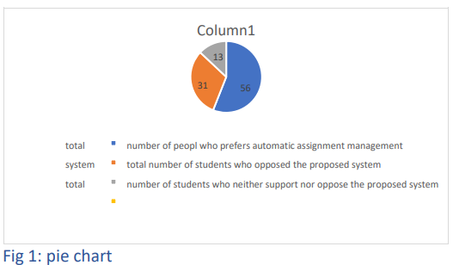

### 3.6 System Specification

#### 3.6.1 Functional Requirements

Lecturer Module:

* Login: Lecturers can securely log in to the system.
* Class Management: Create and manage virtual classes.
* Assignment Upload: Upload assignments with specified due dates.
* Notifications: Notify students via email about new assignments and updates.
* Grading and Feedback: Grade submitted assignments and provide feedback to students.

Student Module:

* Registration and Login: Students can register and securely log in to the system.
* Class Enrolment: Join virtual classes created by lecturers.
* Assignment Management: Download assignments and submit completed work.
* Feedback and Grades: View feedback and grades for submitted assignments.

#### 3.6.2 Non-Functional Requirements

* Usability: The system should have an easy-to-use interface with clear navigation to ensure a positive user experience.
* Availability: The system should be accessible 24/7 through any web browser, ensuring that users can access it at any time.
* Reliability: The system should handle concurrent user requests without failure, ensuring consistent performance.
* Integrity: The system should protect against unauthorized data modification to maintain data accuracy and trustworthiness.
* Security: The system should use encrypted passwords and file uploads to ensure the security of user data and prevent unauthorized access.

### 3.7 Requirements Analysis and Modelling

#### 3.7.1 Analysis of Gathered Requirements

The gathered requirements for the Student Online Assignment Management System (SOAMS) were analysed to identify dependencies, conflicts, and potential solutions. This analysis ensures that the system's design aligns with user needs and technical constraints.

* Dependencies: Identified dependencies include the need for secure login before accessing any system features, the requirement for students to join virtual classes before downloading assignments, and the necessity for lecturers to create classes before uploading assignments.
* Conflicts: Potential conflicts were identified, such as the overlap between notification methods (email vs. in-app alerts) and the need to balance usability with security measures (e.g., password complexity vs. ease of use).
* Potential Solutions: Solutions to address these conflicts include offering multiple notification options that users can customize and implementing user-friendly security measures such as two-factor authentication.

#### 3.7.2 Structuring Requirements

The requirements were structured to conform to software functionalities and components, ensuring a clear and organized design.

* Functional Components:
* User Authentication: Secure login and registration for students and lecturers.
* Class Management: Creation and management of virtual classes by lecturers.
* Assignment Management: Uploading, downloading, and submitting assignments.
* Notification System: Sending notifications via email and in-app alerts.
* Grading and Feedback: Providing grades and feedback on submitted assignments.

#### 3.7.3 Modelling Tools

To visualize and clarify the requirements, the following tools were used:

Use Case Diagram:

The Use Case Diagram depicts the interactions between users (students and lecturers) and the system, highlighting the key functionalities and user actions.

**Use Case Diagram** (Figure 2)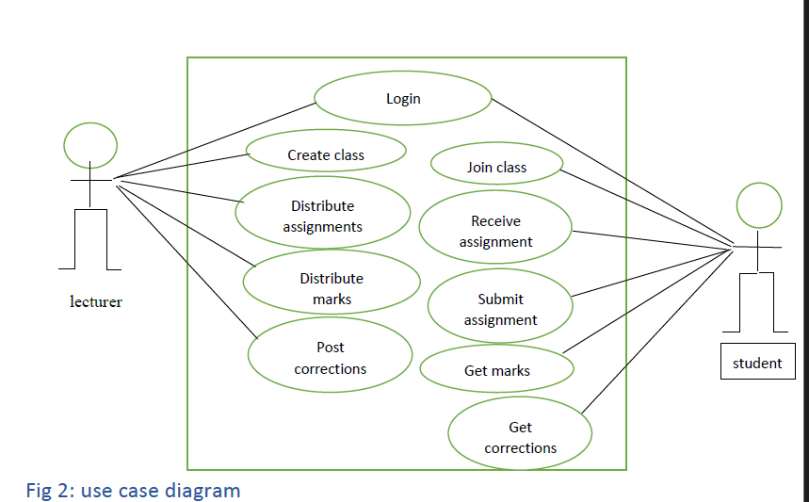

* + Actors: Student, Lecturer
  + Key actions: Submit, Grade, Notify.

Class Diagram:

The Class Diagram represents the system's classes, attributes, and relationships, providing a detailed view of the system's structure and design.

**Class Diagram** (Figure 3)

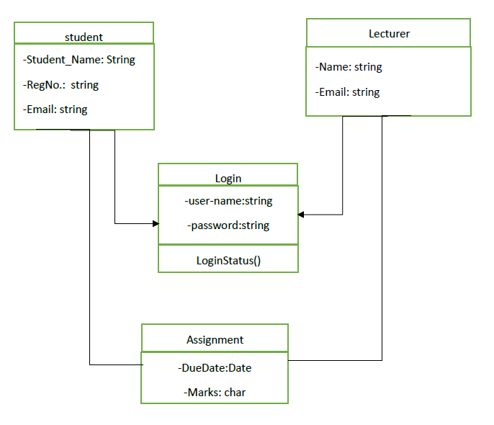

* + Classes: User, Assignment, Submission with relationships.

By using these modelling tools, the requirements are clearly visualized, ensuring that all stakeholders have a comprehensive understanding of the system's design and functionality.

### 3.8 Logical Design

#### 3.8.1 System Architecture

* 3-Tier Client-Server Model:
  + Presentation Layer: HTML/CSS, Bootstrap (User Interface)
  + Application Layer: PHP (Business Logic)
  + Data Layer: MySQL (Data Storage)

**Component Diagram** (Figure 4)

* Entity Relationship Diagram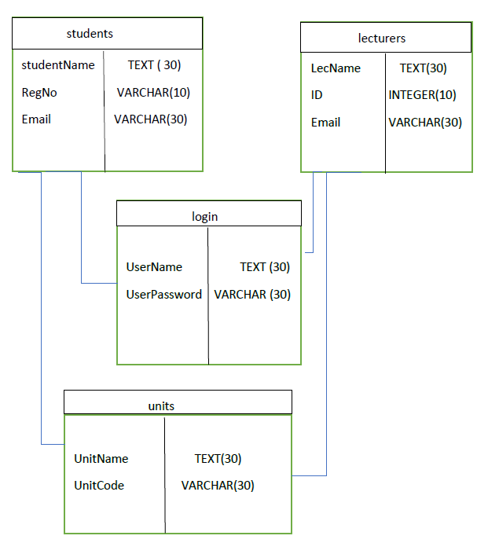

#### 3.8.2 Control Flow and Process Design

Sequence Diagram:

Illustrates the flow of assignment submission from login to feedback. Ensure it captures:

* + User login and authentication.
  + Assignment upload and submission.
  + Grading process and feedback provision.
* Sequence Diagram (Figure 5)

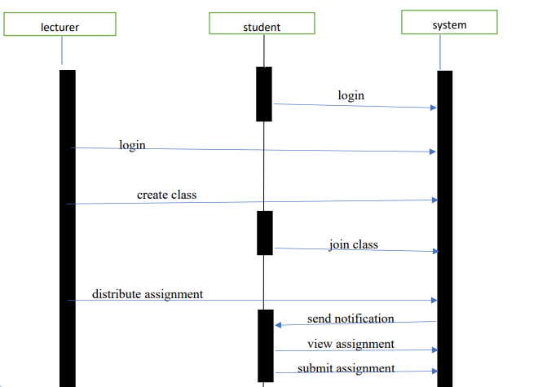

#### 3.8.3 Non-Functional Design

* Security:
  + Passwords: Encrypted using Bcrypt.
  + SQL Injections: Prevented using prepared statements.
* Error Handling:
  + Validation: File size/type validation.
  + Error Messages: Detailed and user-friendly error messages.
* Performance:
  + Database Indexing: Indexing on assignment_id and deadline for fast retrieval.

### 3.9 Physical Design

This design relates to the physical input and output processes of the system.

#### 3.9.1 Database Design

* Relational Database Model: Implemented in MySQL.

**1. Database Schema**

* Users Table:
  + Stores all system users (students, lecturers, admins).
  + Fields:
  + user_id (INT, PRIMARY KEY, AUTO_INCREMENT)
  + role (ENUM: 'student', 'lecturer')
  + email (VARCHAR 255, UNIQUE)
  + password_hash (VARCHAR 255)
  + full_name (VARCHAR 100)
  + created_at (TIMESTAMP)
* Courses Table:
  + Tracks courses offered by the department.
  + Fields:
  + course_id (INT, PRIMARY KEY)
  + course_code (VARCHAR 20, UNIQUE)
  + course_name (VARCHAR 100)
  + lecturer_id (INT, FOREIGN KEY REFERENCES users(user_id))
* Assignments Table:
  + Manages assignment details.
  + Fields:
  + assignment_id (INT, PRIMARY KEY)
  + title (VARCHAR 200)
  + description (TEXT)
  + deadline (DATETIME)
  + course_id (INT, FOREIGN KEY REFERENCES courses(course_id))
  + max_marks (INT)
* Submissions Table:
  + Records student submissions.
  + Fields:
  + submission_id (INT, PRIMARY KEY)
  + assignment_id (INT, FOREIGN KEY REFERENCES assignments(assignment_id))
  + student_id (INT, FOREIGN KEY REFERENCES users(user_id))
  + file_path (VARCHAR 255)
  + submitted_at (TIMESTAMP)
  + status (ENUM: 'submitted', 'late', 'graded')
* Grades Table:
  + Stores grading results.
  + Fields:
  + grade_id (INT, PRIMARY KEY)
  + submission_id (INT, FOREIGN KEY REFERENCES submissions(submission_id))
  + marks (INT)
  + feedback (TEXT)
  + graded_by (INT, FOREIGN KEY REFERENCES users(user_id))

**2. Relationships**

* One-to-Many:
  + courses → assignments (One course has many assignments).
  + assignments → submissions (One assignment has many submissions).
* Many-to-One:
  + submissions → users (Many submissions belong to one student).

### 3.8.2 User Interface Design

The system features a clean, intuitive interface with role-based dashboards

Login Interface (Figure 6)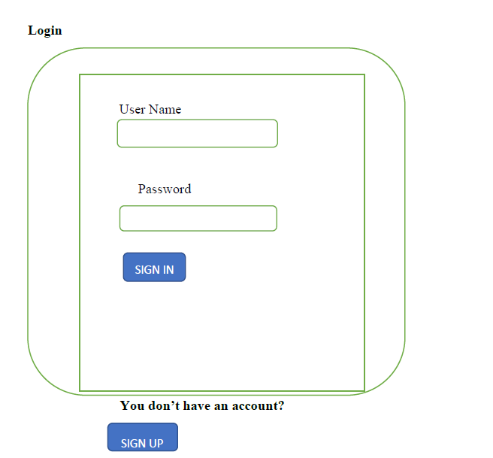

File Management Interface (Figure 7)

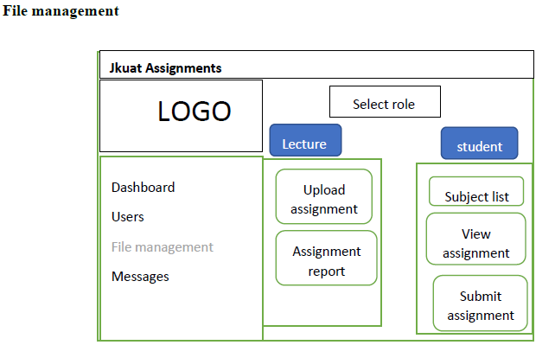

## REFERENCE

1. **AcademEase**  
   Oladipupo, O. O., & Ayo, C. K. (2023). AcademEase: Revolutionizing online assignment management for enhanced academic efficiency. *International Journal of Advanced Computer Science and Applications, 14*(6), 738-745. <https://doi.org/10.20935/AcadEnergy7381>
2. **Assignment Submission System**  
   Ogunleye, G. O., Adetunmbi, A. O., & Adekunle, A. S. (2022). Design and implementation of an online assignment submission management system. *Journal of Computer Science and Its Applications, 29*(1), 45-56.
3. **Automated Assignment System**  
   Smith, J. A., Johnson, B. C., & Williams, D. E. (2021). Automated academic assignment submission and management system. *Educational Technology Research and Development, 69*(4), 2109-2125. <https://doi.org/10.1007/s11423-021-09998-z>