BALANCED DIET MEALS
1. Githeri ,Water ,Fruit and Vegetables
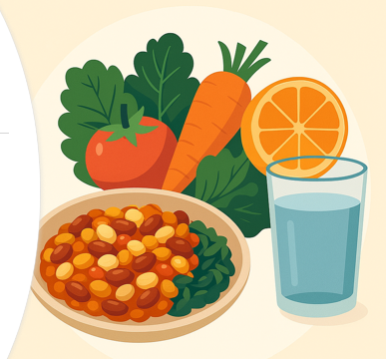

2.Ugali, Chicken, Sukuma wiki
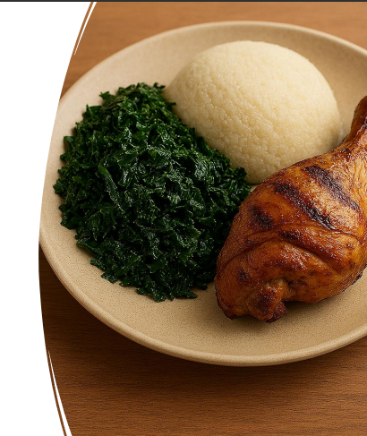
- 3. Rice, Tilapia, Vegetable, fruit
