PE_SWD392
Foodie Hub
Question 1: Class Diagram
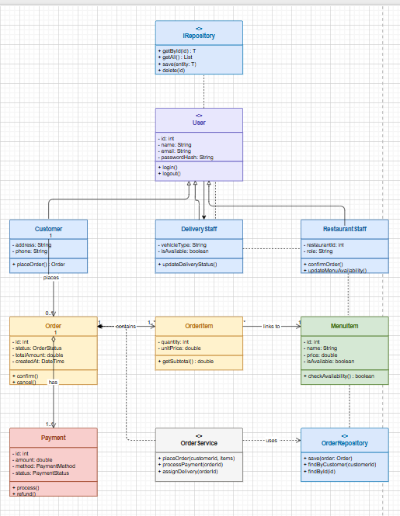
Question 2: Sequence Diagram
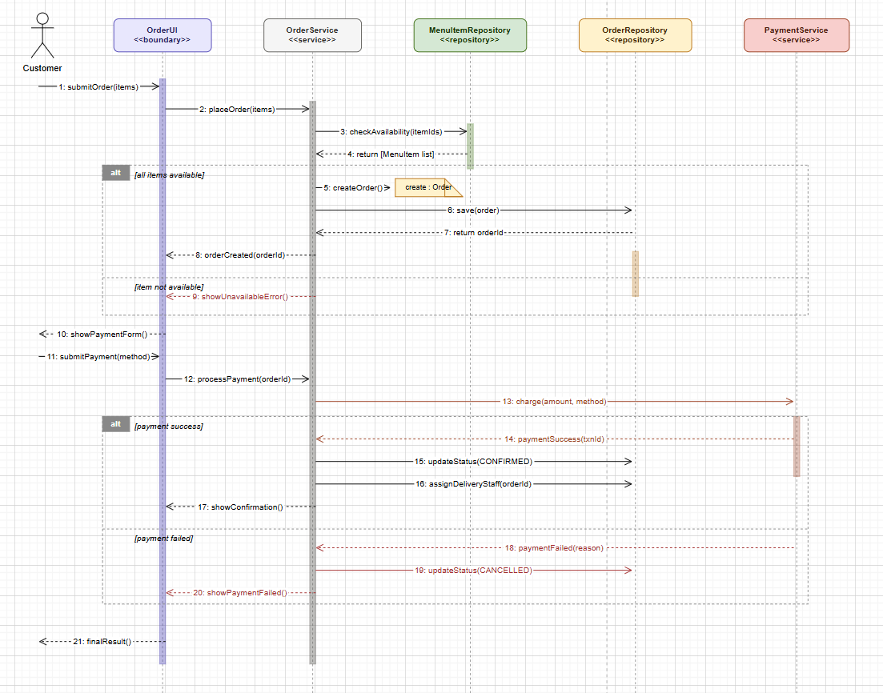
Question 3: Activity Diagram
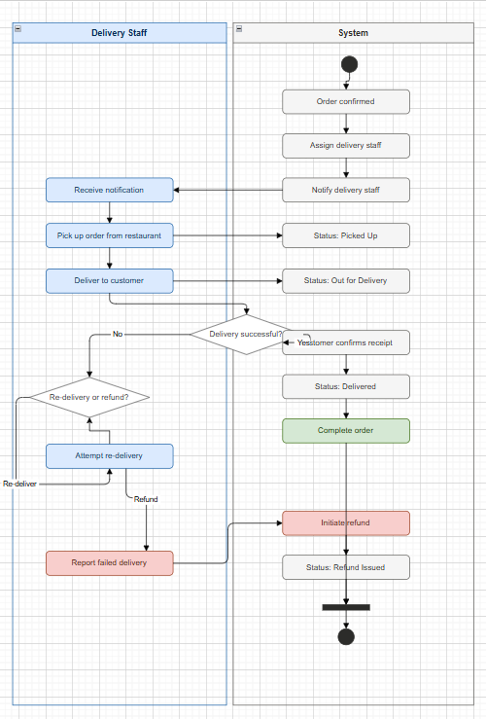
Question 4: State Diagram
