Practices _ Chapter 8- 9-11
Sequence Diagram:
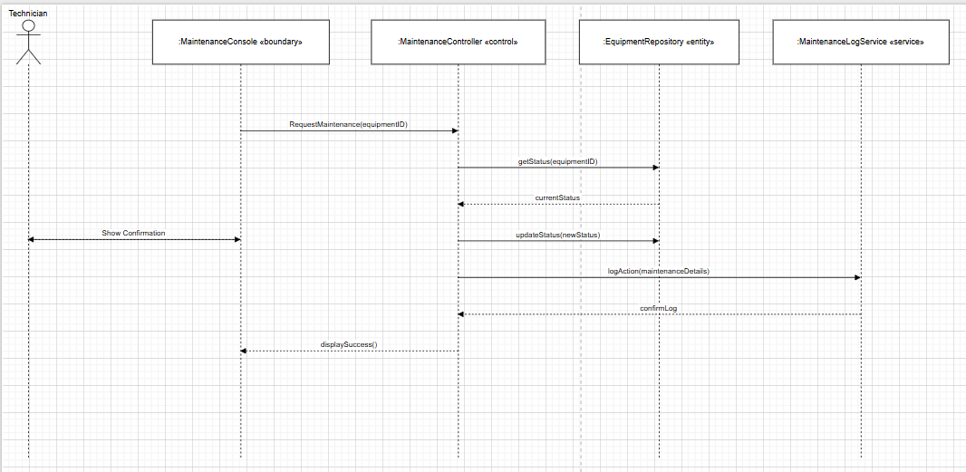
Statechart Diagram:
