**2. IBM Power E1080 Hardware System**

**2.1. Processor (CPU)**

**Processor name:** IBM Power10 Processor – the latest generation of IBM Power Systems processors, designed to optimize AI, hybrid cloud and large-scale enterprise workloads.

**Clock speed:** From 3.6 GHz to 4.15 GHz, depending on configuration and workload.

**Processor architecture:**

Manufactured on Samsung's 7nm process technology.

Each socket uses 1 Power10 SCM (Single Chip Module) chip.

Each chip can be configured from 15 to 30 cores, supporting SMT8 (8 processing threads per core).

Up to 4 sockets on a system.

**Maximum number of cores:** Supports up to 240 physical cores (4 sockets x 60 cores).

Special features:

Integrated AI Acceleration directly in each core thanks to Matrix Math Accelerator (MMA).

Supports Secure Execution, protecting data according to each workload.

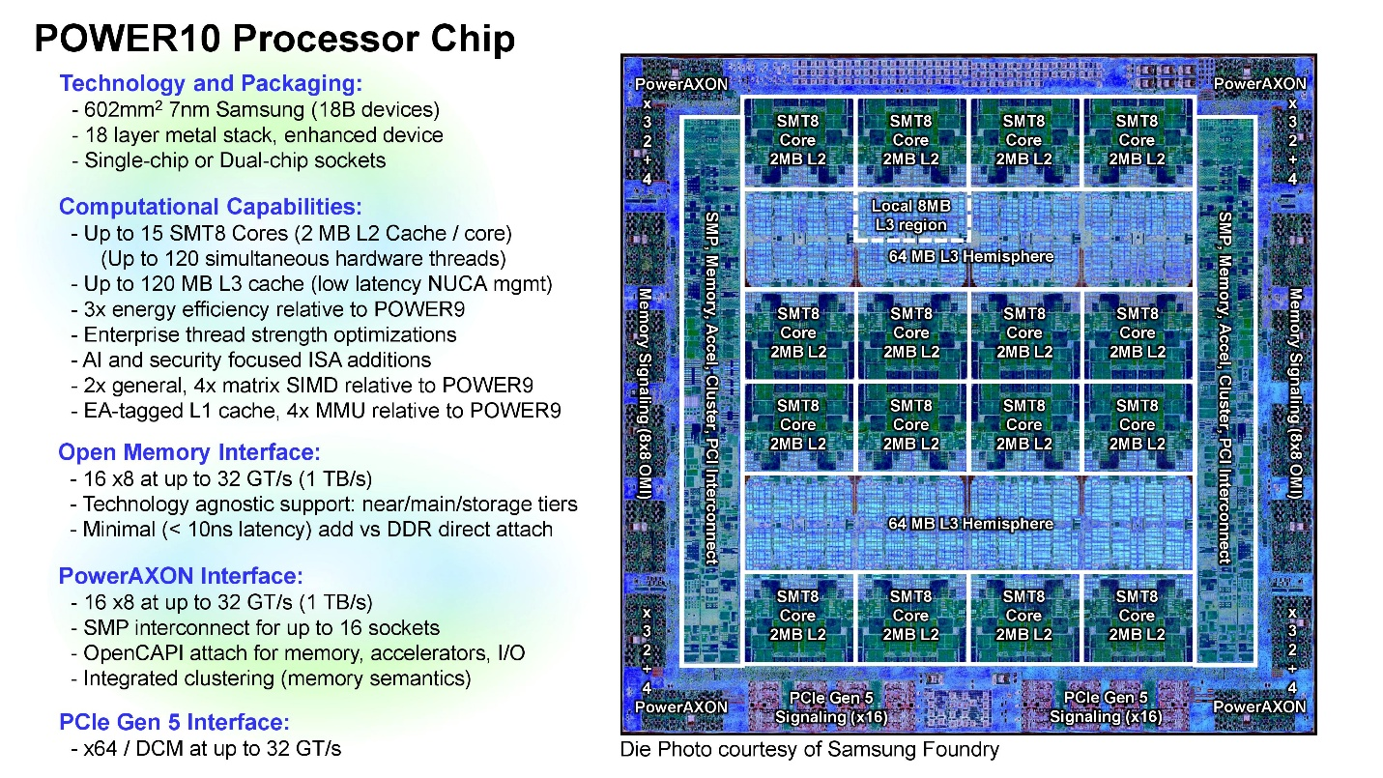

https://images.anandtech.com/doci/16936/2%20-%20HotChips2020_Server_Processors_IBM_Starke_POWER10_v33-page-005.jpg

**2.2. Memory (RAM, Cache, OMI)**

**RAM (Main Memory):**

Supports up to 64 TB of physical memory.

Uses OMI (Open Memory Interface) memory technology – separates the memory controller from the CPU, increasing bandwidth and reducing latency.

Supports a variety of OMI DIMMs from multiple vendors.

**Cache:**

L1 Cache: 32 KB (Instruction) + 48 KB (Data) per core. L2 Cache: 2 MB per core. L3 Cache: 120 MB shared per SCM chip. L4 Cache: Removed from Power9 due to new design efficiency with OMI.

Highlights:

Memory bandwidth optimization design, serving high-speed analytics, database and AI workloads.

OMI technology helps avoid bottlenecks due to simultaneous RAM access from multiple cores.

**2.3. Storage**

The IBM Power E1080 supports connectivity to a wide range of high-performance and flexible storage systems:

**NVMe SSD (Non-Volatile Memory Express):** Full support for NVMe SSDs via PCIe Gen5 interface.

Provides high data retrieval speed, suitable for AI and large databases.

**SAS/SATA:**

Support via expansion adapter (RAID, HBA).

**SAN (Storage Area Network):**

Integrate with external storage systems such as IBM FlashSystem, DS8000, etc.

Communication via Fibre Channel or NVMe over Fabrics.

**Expandability:**

Storage system can be externally attached on demand, supporting expansion of hundreds of TB of data.

Support RAID, snapshots and enterprise data protection..

**2.4. Networking and Expansion**

IBM Power E1080 supports many advanced networking and I/O expansion standards:

**Ethernet:**

Supports 10 Gigabit Ethernet (10 GbE), 25 Gigabit Ethernet (25 GbE) or higher speed standards.

Flexible networking, configurable for failover, teaming.

**PCIe Gen5:**

The system is equipped with multiple PCI Express Gen5 slots, providing double the bandwidth of Gen4.

Used to connect I/O devices, GPUs, NVMe or high-speed network cards.

**OpenCAPI:**

High-speed communication between CPU and peripherals such as FPGA, AI accelerator, expandable memory.

**CXL Ready (Compute Express Link):**

New communication standard for next-generation distributed/memory interconnect, increasing performance when processing AI and cloud-native workloads.

**Management and security:**

Support remote management via BMC, secure boot, and encryption of each workload.