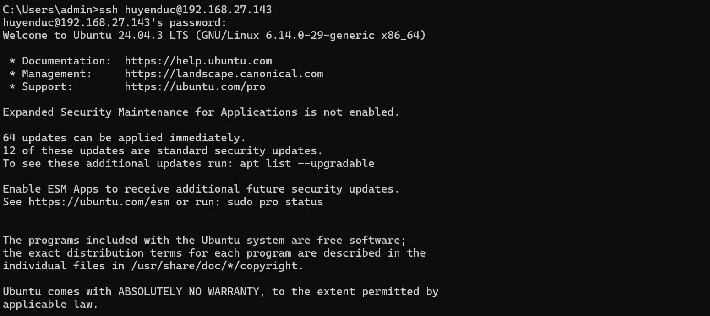
Hình 1- 1
Hình 1- 2
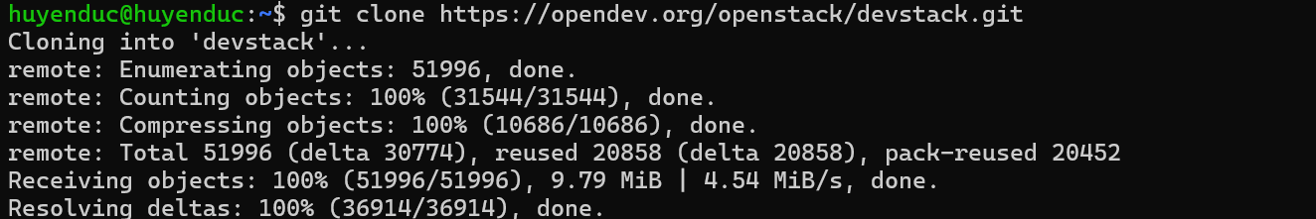
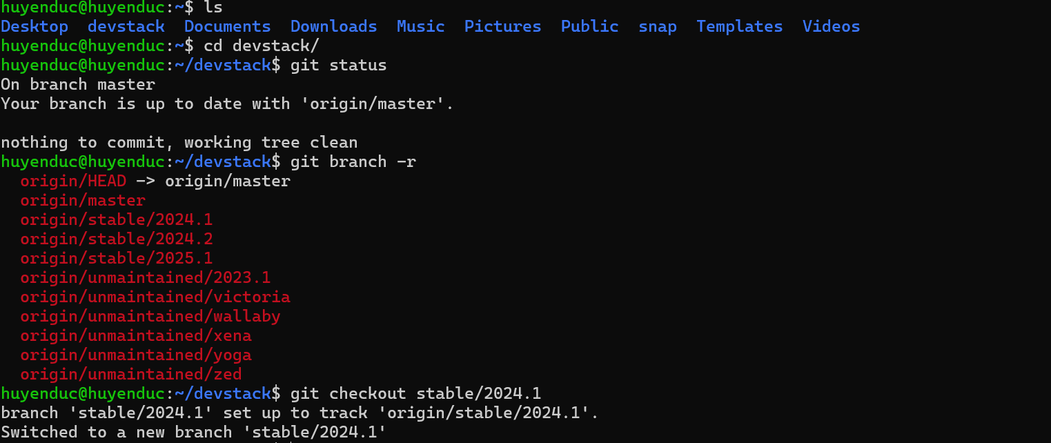
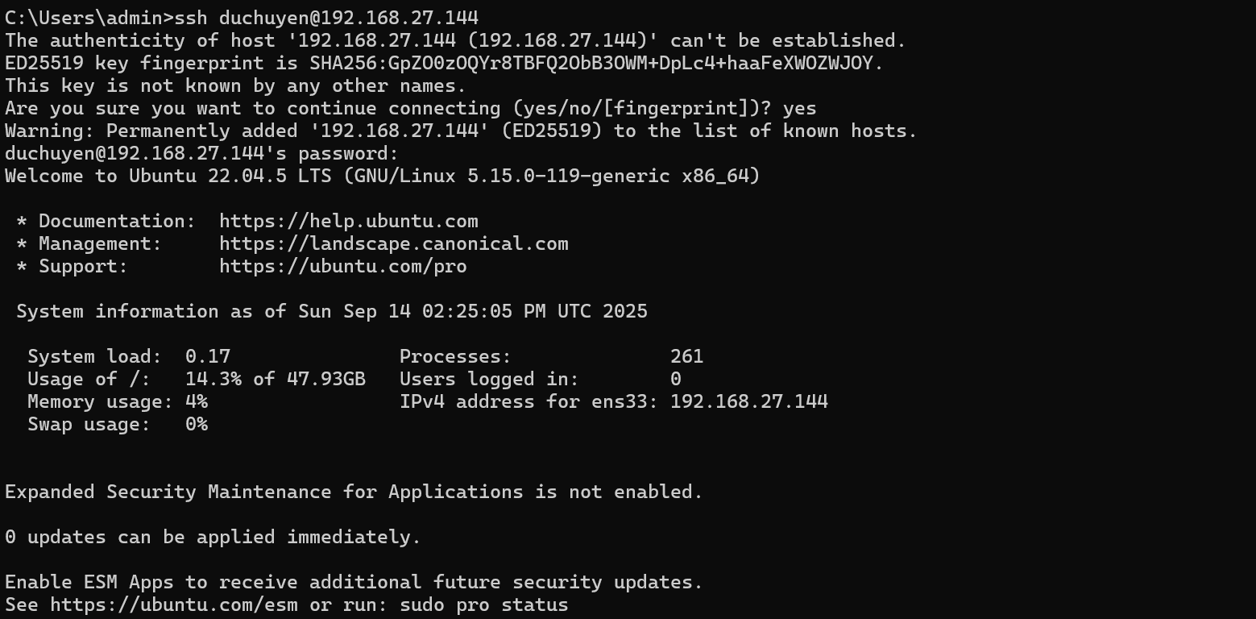
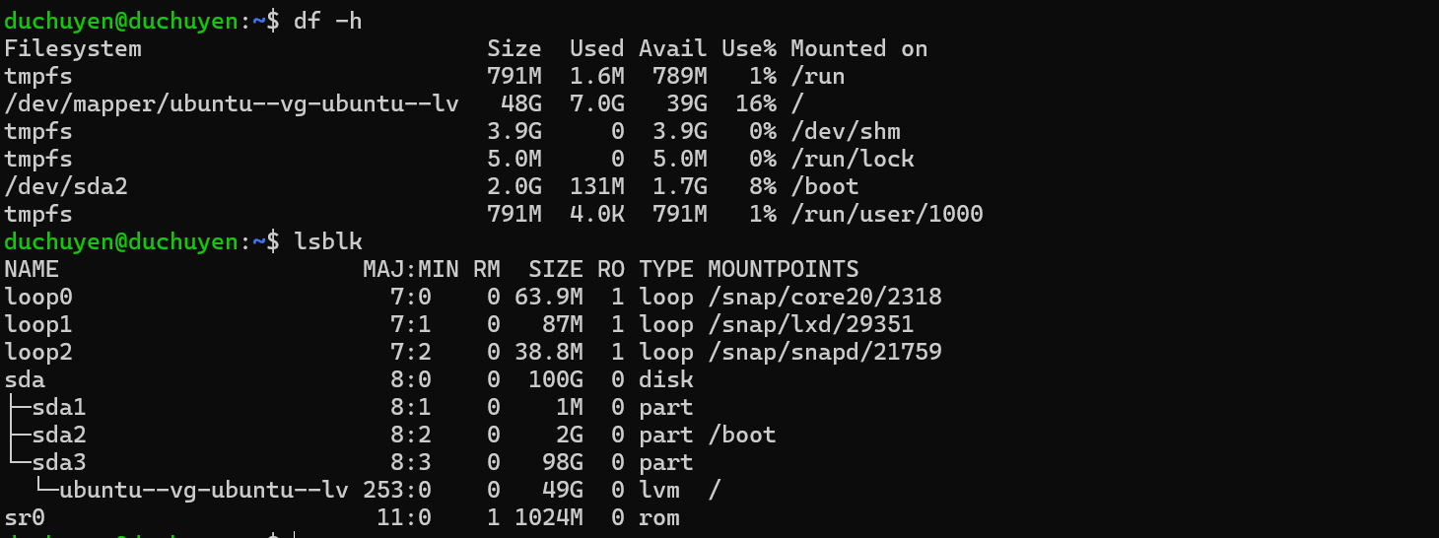
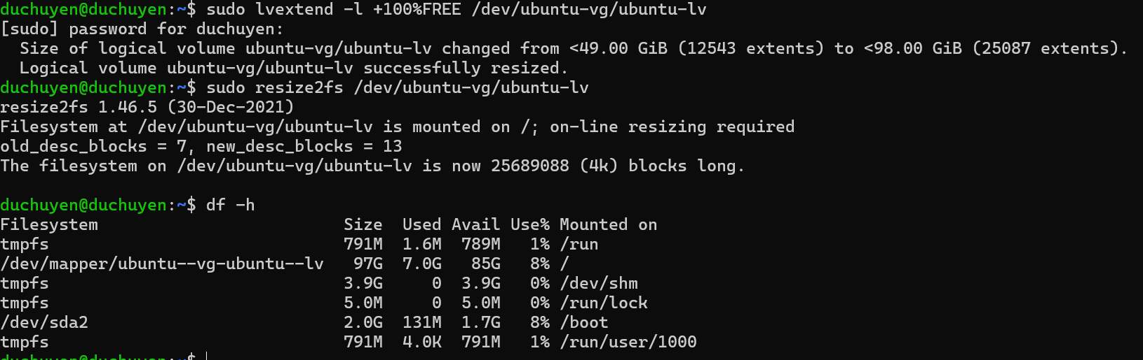
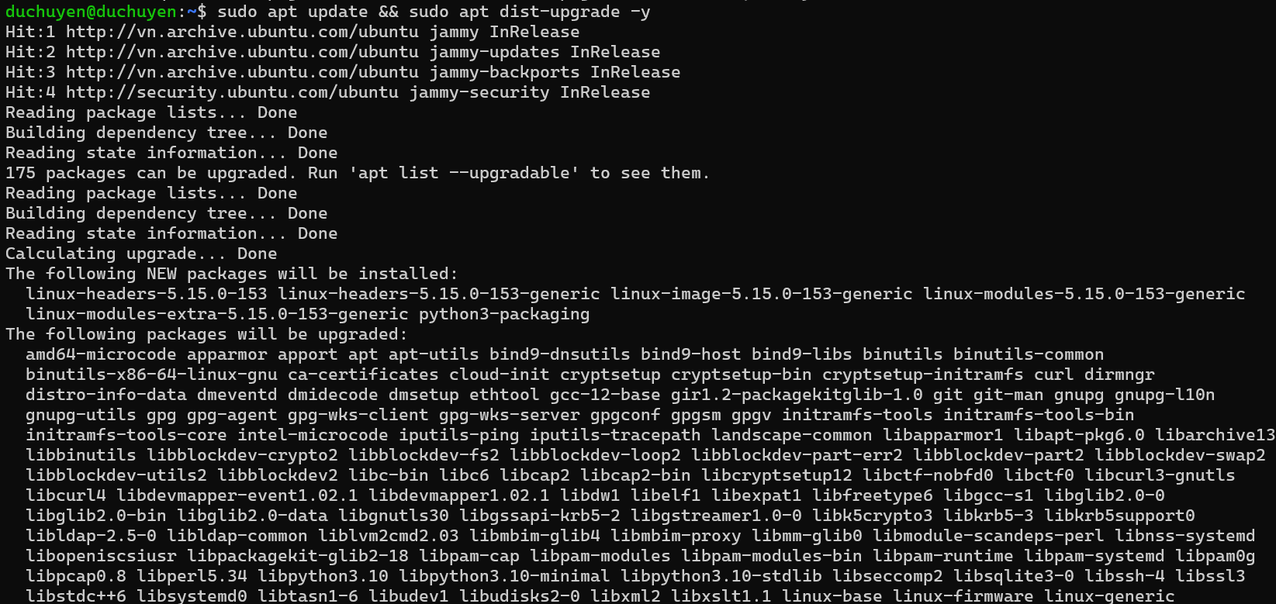
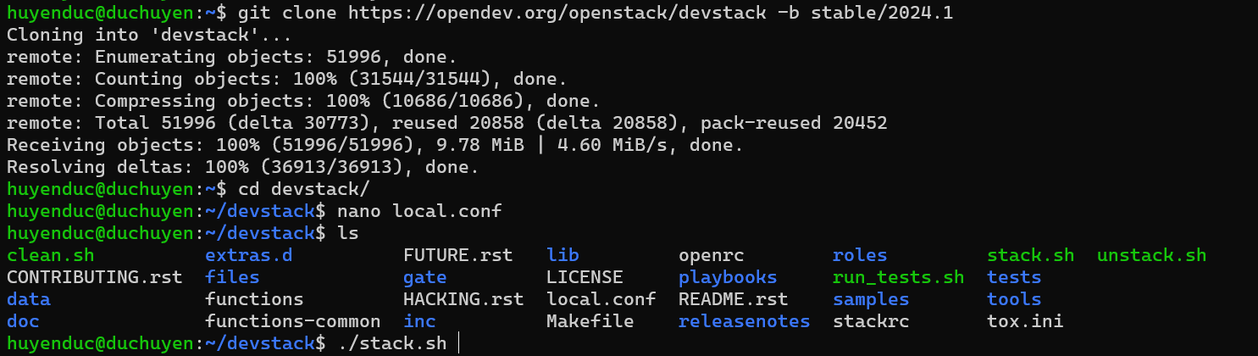
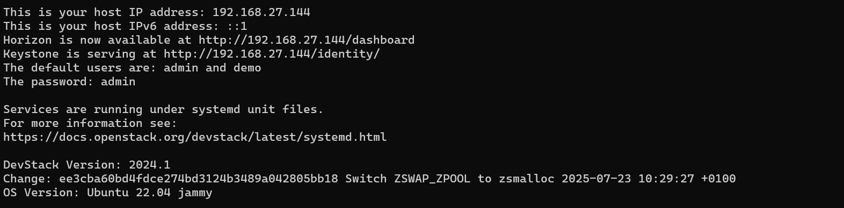
Thay lại như này
huyenduc@duchuyen:~/devstack$ source ~/devstack/openrc admin admin
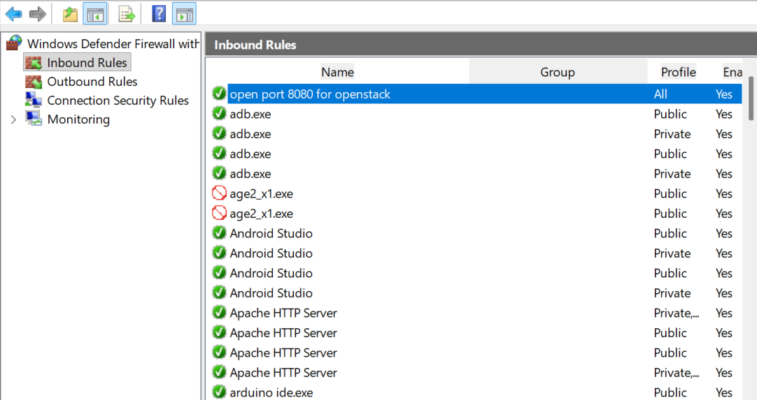
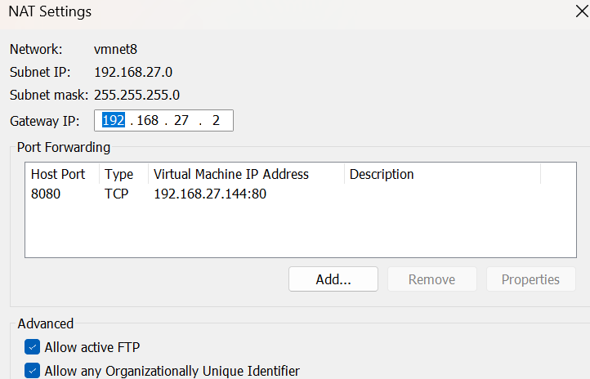
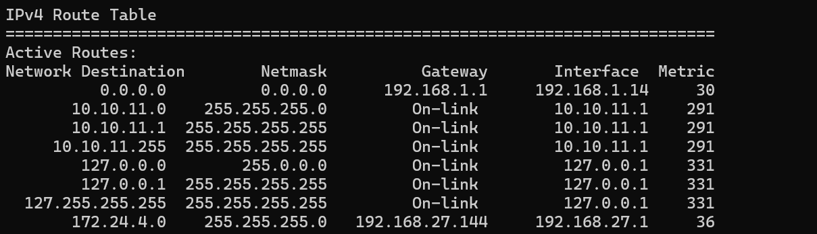
Sauk hi cài xong thì ip a phải như thế này
CHÚ Ý: NẾU PAUSE VM THÌ OPENSTACK CÓ THỂ BỊ LỖI BR-EX TRONG IP A
duchuyen@duchuyen:~$ ip a
1: lo: <LOOPBACK,UP,LOWER_UP> mtu 65536 qdisc noqueue state UNKNOWN group default qlen 1000
link/loopback 00:00:00:00:00:00 brd 00:00:00:00:00:00
inet 127.0.0.1/8 scope host lo
valid_lft forever preferred_lft forever
inet6 ::1/128 scope host
valid_lft forever preferred_lft forever
2: ens33: <BROADCAST,MULTICAST,UP,LOWER_UP> mtu 1500 qdisc fq_codel state UP group default qlen 1000
link/ether 00:0c:29:a8:ff:83 brd ff:ff:ff:ff:ff:ff
altname enp2s1
inet 192.168.27.144/24 metric 100 brd 192.168.27.255 scope global dynamic ens33
valid_lft 1771sec preferred_lft 1771sec
inet6 fe80::20c:29ff:fea8:ff83/64 scope link
valid_lft forever preferred_lft forever
3: ovs-system: <BROADCAST,MULTICAST> mtu 1500 qdisc noop state DOWN group default qlen 1000
link/ether 42:6d:2e:65:4d:cb brd ff:ff:ff:ff:ff:ff
4: br-int: <BROADCAST,MULTICAST> mtu 1500 qdisc noop state DOWN group default qlen 1000
link/ether a2:6a:35:29:b1:1a brd ff:ff:ff:ff:ff:ff
5: virbr0: <NO-CARRIER,BROADCAST,MULTICAST,UP> mtu 1500 qdisc noqueue state DOWN group default qlen 1000
link/ether 52:54:00:9d:e2:5c brd ff:ff:ff:ff:ff:ff
inet 192.168.122.1/24 brd 192.168.122.255 scope global virbr0
valid_lft forever preferred_lft forever
6: br-ex: <BROADCAST,MULTICAST,UP,LOWER_UP> mtu 1500 qdisc noqueue state UNKNOWN group default qlen 1000
link/ether 46:98:1a:11:04:4e brd ff:ff:ff:ff:ff:ff
inet 172.24.4.1/24 scope global br-ex
valid_lft forever preferred_lft forever
inet6 2001:db8::2/64 scope global
valid_lft forever preferred_lft forever
inet6 fe80::4498:1aff:fe11:44e/64 scope link
valid_lft forever preferred_lft forever

// vào /etc/netplan rồi chỉnh file
network:
version: 2
ethernets:
ens33:
dhcp4: true
bridges:
br-ex:
addresses: [172.24.4.1/24]
interfaces: []
dhcp4: no
fix lỗi br ex không tự gán ip
duchuyen@duchuyen:/etc/netplan$ sudo nano /etc/systemd/system/fix-br-ex.service
[Unit]
Description=Reassign IP to br-ex after resume
After=network-online.target openvswitch-switch.service
Requires=openvswitch-switch.service

[Service]
Type=oneshot
ExecStartPre=/bin/sleep 5
ExecStart=/bin/bash -c '/sbin/ip addr show br-ex | grep -q "172.24.4.1" || /sbin/ip addr add 172.24.4.1/24 dev br-ex'
ExecStartPost=/sbin/ip link set br-ex up
RemainAfterExit=true

[Install]
WantedBy=multi-user.target
duchuyen@duchuyen:/etc/netplan$ sudo systemctl daemon-reload
duchuyen@duchuyen:/etc/netplan$ sudo systemctl restart fix-br-ex.service
duchuyen@duchuyen:/etc/netplan$ sudo systemctl status fix-br-ex.service
sudo nano /lib/systemd/system-sleep/fix-br-ex
#!/bin/bash
case $1/$2 in
post/*)
systemctl start fix-br-ex.service
;;
esac
sudo chmod +x /lib/systemd/system-sleep/fix-br-ex

Fix lỗi không ping được ra net, do openstack bị mất NAT. thêm cái này vào openstack
huyenduc@duchuyen:~/devstack$ sudo iptables -t nat -A POSTROUTING -s 172.24.4.0/24 -o ens33 -j MASQUERADE
Fix không resolve được tên miền, do máy ảo không được gán DNS server
Fix không chạy được web app: DO chưa cài được requirements.txt
cd /opt/flask_app
sudo -u flaskuser venv/bin/pip install --upgrade pip
sudo -u flaskuser venv/bin/pip install -r requirements.txt
# Kiểm tra lại
ls -la venv/bin/gunicorn
# Restart supervisor
sudo supervisorctl restart flask_app
#dùng để auth
source admin-openrc.sh
# cài agent
sudo apt update
sudo apt install zabbix-agent –y
sudo nano /etc/zabbix/zabbix_agentd.conf
Server=<IP_ZABBIX_SERVER>
ServerActive=<IP_ZABBIX_SERVER>
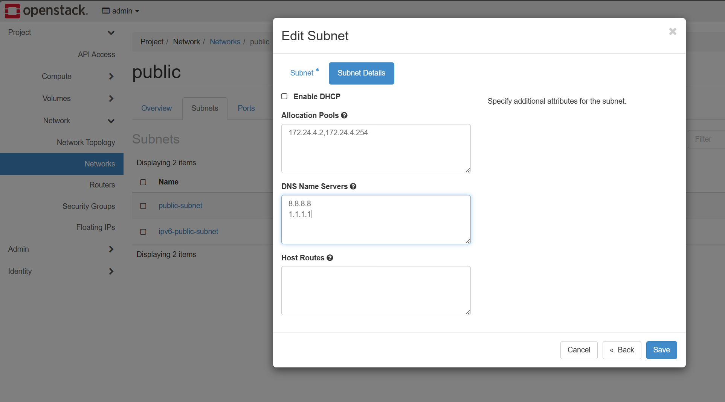
Xem log balancer: tail -f /var/log/haproxy.log

