**UML diagrams for ATM1 application**

# Use case diagram

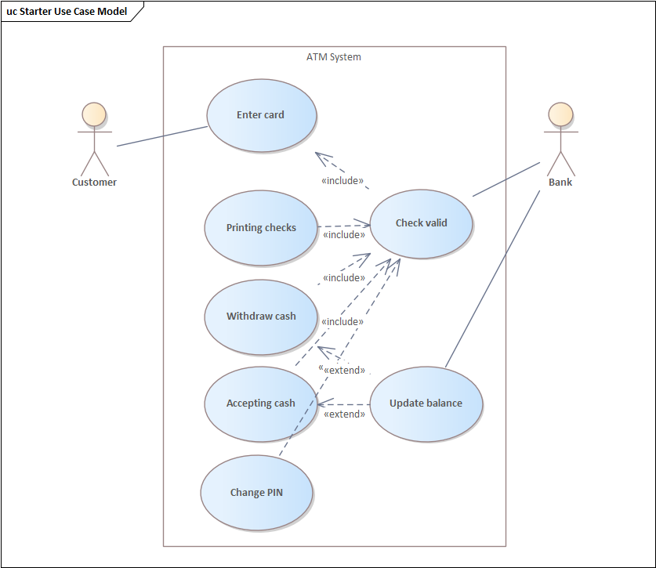

# Class diagram

# Sequence diagram

# Statechart diagram

# Activity diagram

