Tên: Ngô Phạm Tú Uyên

MSSV: 1910155

**BÀI THỰC HÀNH SỐ 1_LAB1**

**Thực hành trên SQL Server**

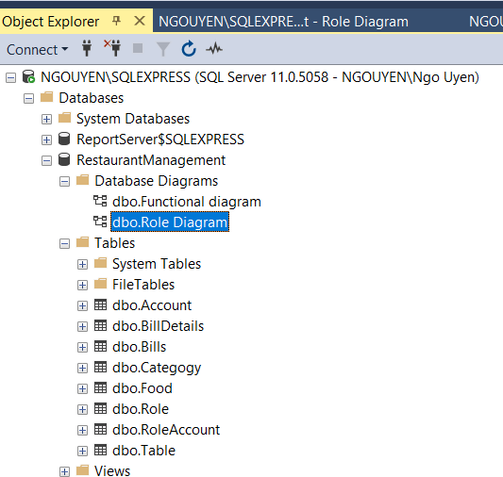

**Tạo các bảng có tên bảng, tên cột, kiểu dữ liệu**

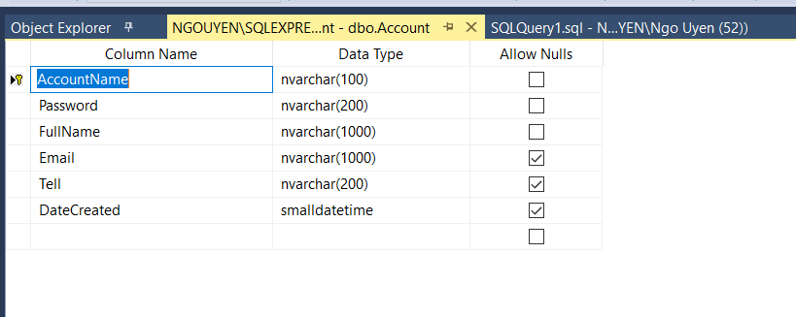

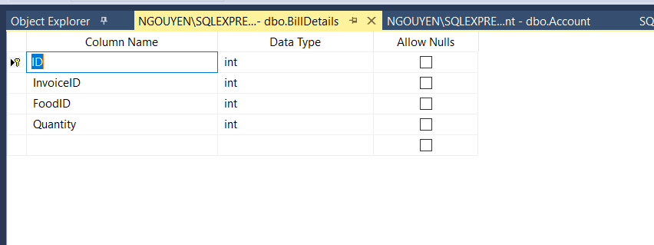

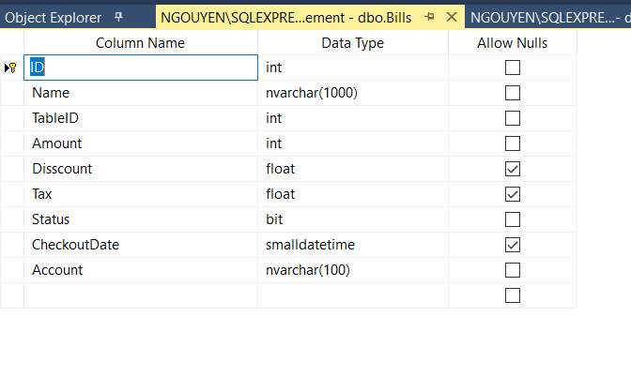

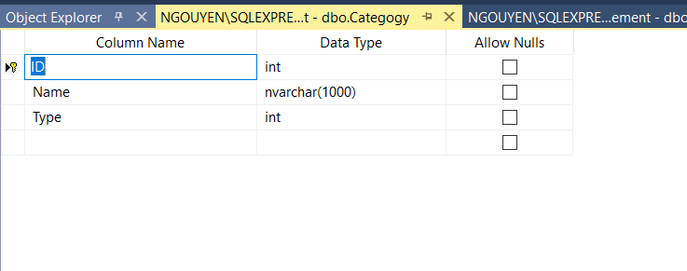

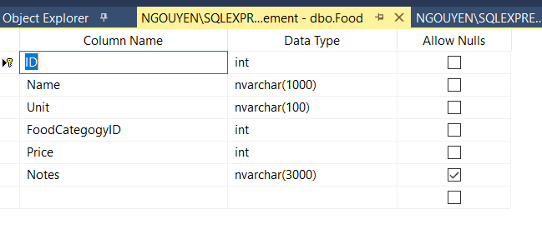

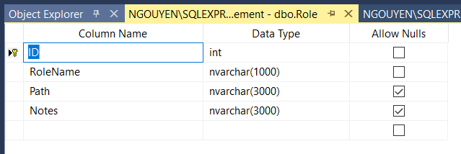

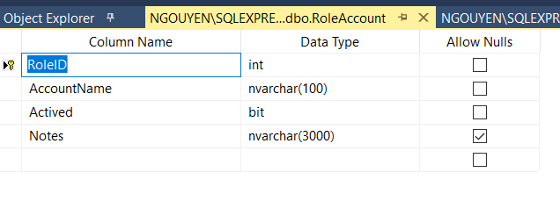

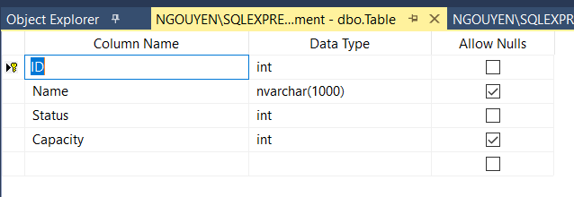

**Tạo lược đồ quan hệ**

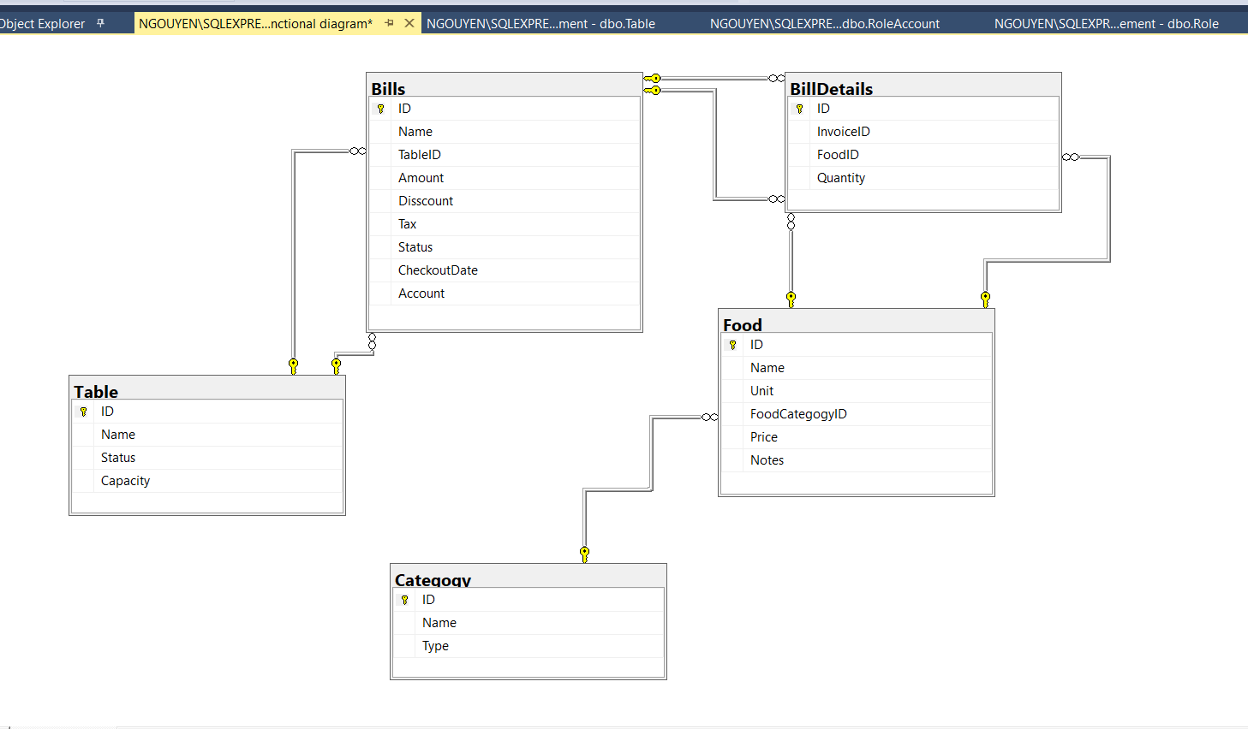

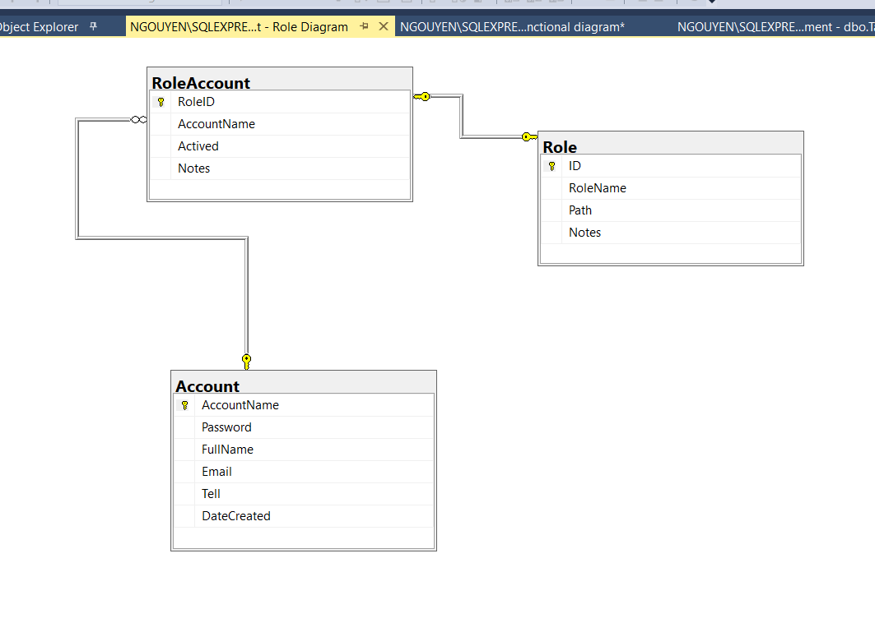

**CODE**

USE [RestaurantManagement]

GO

/****** Object: Table [dbo].[Account] Script Date: 6/4/2020 9:31:10 AM ******/

SET ANSI_NULLS ON

GO

SET QUOTED_IDENTIFIER ON

GO

CREATE TABLE dbo.Account_(

[AccountName] [nvarchar](100) NOT NULL,

[Password] [nvarchar](200) NOT NULL,

[FullName] [nvarchar](1000) NOT NULL,

[Email] [nvarchar](1000) NULL,

[Tell] [nvarchar](200) NULL,

[DateCreated] [smalldatetime] NULL,

CONSTRAINT [PK_Account_1] PRIMARY KEY CLUSTERED

(

[AccountName] ASC

)WITH (PAD_INDEX = OFF, STATISTICS_NORECOMPUTE = OFF, IGNORE_DUP_KEY = OFF, ALLOW_ROW_LOCKS = ON, ALLOW_PAGE_LOCKS = ON) ON [PRIMARY]

) ON [PRIMARY]

GO

/****** Object: Table [dbo].[BillDetails] Script Date: 6/4/2020 9:31:10 AM ******/

SET ANSI_NULLS ON

GO

SET QUOTED_IDENTIFIER ON

GO

CREATE TABLE dbo.BillDetails_(

[ID] [int] IDENTITY(1,1) NOT NULL,

[InvoiceID] [int] NOT NULL,

[FoodID] [int] NOT NULL,

[Quantity] [int] NOT NULL,

CONSTRAINT [PK_InvoiceInfo] PRIMARY KEY CLUSTERED

(

[ID] ASC

)WITH (PAD_INDEX = OFF, STATISTICS_NORECOMPUTE = OFF, IGNORE_DUP_KEY = OFF, ALLOW_ROW_LOCKS = ON, ALLOW_PAGE_LOCKS = ON) ON [PRIMARY]

) ON [PRIMARY]

GO

/****** Object: Table [dbo].[Bills] Script Date: 6/4/2020 9:31:10 AM ******/

SET ANSI_NULLS ON

GO

SET QUOTED_IDENTIFIER ON

GO

CREATE TABLE dbo.Bills_(

[ID] [int] IDENTITY(1,1) NOT NULL,

[Name] [nvarchar](1000) NOT NULL,

[TableID] [int] NOT NULL,

[Amount] [int] NOT NULL,

[Discount] [float] NULL,

[Tax] [float] NULL,

[Status] [bit] NOT NULL,

[CheckoutDate] [smalldatetime] NULL,

[Account] [nvarchar](100) NOT NULL,

CONSTRAINT [PK_Invoice] PRIMARY KEY CLUSTERED

(

[ID] ASC

)WITH (PAD_INDEX = OFF, STATISTICS_NORECOMPUTE = OFF, IGNORE_DUP_KEY = OFF, ALLOW_ROW_LOCKS = ON, ALLOW_PAGE_LOCKS = ON) ON [PRIMARY]

) ON [PRIMARY]

GO

/****** Object: Table [dbo].[Category] Script Date: 6/4/2020 9:31:10 AM ******/

SET ANSI_NULLS ON

GO

SET QUOTED_IDENTIFIER ON

GO

CREATE TABLE [dbo].[Category](

[ID] [int] IDENTITY(1,1) NOT NULL,

[Name] [nvarchar](1000) NOT NULL,

[Type] [int] NOT NULL,

CONSTRAINT [PK_FoodCategory] PRIMARY KEY CLUSTERED

(

[ID] ASC

)WITH (PAD_INDEX = OFF, STATISTICS_NORECOMPUTE = OFF, IGNORE_DUP_KEY = OFF, ALLOW_ROW_LOCKS = ON, ALLOW_PAGE_LOCKS = ON) ON [PRIMARY]

) ON [PRIMARY]

GO

/****** Object: Table [dbo].[Food] Script Date: 6/4/2020 9:31:10 AM ******/

SET ANSI_NULLS ON

GO

SET QUOTED_IDENTIFIER ON

GO

CREATE TABLE dbo.Food_(

[ID] [int] IDENTITY(1,1) NOT NULL,

[Name] [nvarchar](1000) NOT NULL,

[Unit] [nvarchar](100) NOT NULL,

[FoodCategoryID] [int] NOT NULL,

[Price] [int] NOT NULL,

[Notes] [nvarchar](3000) NULL,

CONSTRAINT [PK_FoodStuffs] PRIMARY KEY CLUSTERED

(

[ID] ASC

)WITH (PAD_INDEX = OFF, STATISTICS_NORECOMPUTE = OFF, IGNORE_DUP_KEY = OFF, ALLOW_ROW_LOCKS = ON, ALLOW_PAGE_LOCKS = ON) ON [PRIMARY]

) ON [PRIMARY]

GO

/****** Object: Table [dbo].[Role] Script Date: 6/4/2020 9:31:10 AM ******/

SET ANSI_NULLS ON

GO

SET QUOTED_IDENTIFIER ON

GO

CREATE TABLE dbo.Role_(

[ID] [int] IDENTITY(1,1) NOT NULL,

[RoleName] [nvarchar](1000) NOT NULL,

[Path] [nvarchar](3000) NULL,

[Notes] [nvarchar](3000) NULL,

CONSTRAINT [PK_Role] PRIMARY KEY CLUSTERED

(

[ID] ASC

)WITH (PAD_INDEX = OFF, STATISTICS_NORECOMPUTE = OFF, IGNORE_DUP_KEY = OFF, ALLOW_ROW_LOCKS = ON, ALLOW_PAGE_LOCKS = ON) ON [PRIMARY]

) ON [PRIMARY]

GO

/****** Object: Table [dbo].[RoleAccount] Script Date: 6/4/2020 9:31:10 AM ******/

SET ANSI_NULLS ON

GO

SET QUOTED_IDENTIFIER ON

GO

CREATE TABLE dbo.RoleAccount_(

[RoleID] [int] NOT NULL,

[AccountName] [nvarchar](100) NOT NULL,

[Actived] [bit] NOT NULL,

[Notes] [nvarchar](3000) NULL,

CONSTRAINT [PK_RoleAccount] PRIMARY KEY CLUSTERED

(

[RoleID] ASC,

[AccountName] ASC

)WITH (PAD_INDEX = OFF, STATISTICS_NORECOMPUTE = OFF, IGNORE_DUP_KEY = OFF, ALLOW_ROW_LOCKS = ON, ALLOW_PAGE_LOCKS = ON) ON [PRIMARY]

) ON [PRIMARY]

GO

/****** Object: Table [dbo].[Table] Script Date: 6/4/2020 9:31:10 AM ******/

SET ANSI_NULLS ON

GO

SET QUOTED_IDENTIFIER ON

GO

CREATE TABLE dbo.Table_(

[ID] [int] IDENTITY(1,1) NOT NULL,

[Name] [nvarchar](1000) NULL,

[Status] [int] NOT NULL,

[Capacity] [int] NULL,

CONSTRAINT [PK_Table] PRIMARY KEY CLUSTERED

(

[ID] ASC

)WITH (PAD_INDEX = OFF, STATISTICS_NORECOMPUTE = OFF, IGNORE_DUP_KEY = OFF, ALLOW_ROW_LOCKS = ON, ALLOW_PAGE_LOCKS = ON) ON [PRIMARY]

) ON [PRIMARY]

GO

INSERT [dbo].[Account] ([AccountName], [Password], [FullName], [Email], [Tell], [DateCreated]) VALUES (N'lgcong', N'legiacong', N'Lê Gia Công', N'conglg@dlu.edu.vn', NULL, NULL)

INSERT [dbo].[Account] ([AccountName], [Password], [FullName], [Email], [Tell], [DateCreated]) VALUES (N'pttnga', N'phanthithanhnga', N'Phan Thị Thanh Nga', N'ngaptt@dlu.edu.vn', NULL, CAST(N'2020-06-04T00:00:00' AS SmallDateTime))

INSERT [dbo].[Account] ([AccountName], [Password], [FullName], [Email], [Tell], [DateCreated]) VALUES (N'tdquy', N'thaiduyquy', N'Thái Duy Quý', N'quytd@dlu.edu.vn', NULL, NULL)

INSERT [dbo].[Account] ([AccountName], [Password], [FullName], [Email], [Tell], [DateCreated]) VALUES (N'ttplinh', N'tranthiphuonglinh', N'Trần Thị Phương Linh', N'linhttp@dlu.edu.vn', NULL, NULL)

SET IDENTITY_INSERT [dbo].[BillDetails] ON

INSERT [dbo].[BillDetails] ([ID], [InvoiceID], [FoodID], [Quantity]) VALUES (1, 1, 3, 2)

INSERT [dbo].[BillDetails] ([ID], [InvoiceID], [FoodID], [Quantity]) VALUES (2, 1, 4, 1)

SET IDENTITY_INSERT [dbo].[BillDetails] OFF

SET IDENTITY_INSERT [dbo].[Bills] ON

INSERT [dbo].[Bills] ([ID], [Name], [TableID], [Amount], [Disscount], [Tax], [Status], [CheckoutDate], [Account]) VALUES (1, N'Hóa đơn thanh toán', 5, 150000, 0.05, 0, 1, NULL, N'tdquy')

SET IDENTITY_INSERT [dbo].[Bills] OFF

SET IDENTITY_INSERT [dbo].[Category] ON

INSERT [dbo].[Category] ([ID], [Name], [Type]) VALUES (1, N'Khai vị', 1)

INSERT [dbo].[Category] ([ID], [Name], [Type]) VALUES (2, N'Hải sản', 1)

INSERT [dbo].[Category] ([ID], [Name], [Type]) VALUES (3, N'Gà', 1)

INSERT [dbo].[Category] ([ID], [Name], [Type]) VALUES (4, N'Cơm', 1)

INSERT [dbo].[Category] ([ID], [Name], [Type]) VALUES (5, N'Thịt', 1)

INSERT [dbo].[Category] ([ID], [Name], [Type]) VALUES (6, N'Rau', 1)

INSERT [dbo].[Category] ([ID], [Name], [Type]) VALUES (8, N'Canh', 1)

INSERT [dbo].[Category] ([ID], [Name], [Type]) VALUES (9, N'Lẩu', 1)

INSERT [dbo].[Category] ([ID], [Name], [Type]) VALUES (10, N'Bia', 0)

INSERT [dbo].[Category] ([ID], [Name], [Type]) VALUES (11, N'Nước ngọt', 0)

INSERT [dbo].[Category] ([ID], [Name], [Type]) VALUES (12, N'Cà phê', 0)

INSERT [dbo].[Category] ([ID], [Name], [Type]) VALUES (13, N'Trà đá', 0)

SET IDENTITY_INSERT [dbo].[Category] OFF

SET IDENTITY_INSERT [dbo].[Food] ON

INSERT [dbo].[Food] ([ID], [Name], [Unit], [FoodCategogyID], [Price], [Notes]) VALUES (1, N'Rau muống xào tỏi', N'Đĩa', 6, 20000, NULL)

INSERT [dbo].[Food] ([ID], [Name], [Unit], [FoodCategogyID], [Price], [Notes]) VALUES (2, N'Cơm chiên Dương châu', N'Đĩa nhỏ', 4, 35000, N'3 người ăn')

INSERT [dbo].[Food] ([ID], [Name], [Unit], [FoodCategogyID], [Price], [Notes]) VALUES (3, N'Cơm chiên Dương châu', N'Đĩa lớn', 4, 40000, N'4 người ăn')

INSERT [dbo].[Food] ([ID], [Name], [Unit], [FoodCategogyID], [Price], [Notes]) VALUES (4, N'Ếch thui rơm', N'Đĩa', 2, 70000, NULL)

INSERT [dbo].[Food] ([ID], [Name], [Unit], [FoodCategogyID], [Price], [Notes]) VALUES (5, N'Sò lông nướng mỡ hành', N'Đĩa', 2, 80000, NULL)

INSERT [dbo].[Food] ([ID], [Name], [Unit], [FoodCategogyID], [Price], [Notes]) VALUES (6, N'Càng cua hấp', N'Đĩa', 2, 100000, NULL)

INSERT [dbo].[Food] ([ID], [Name], [Unit], [FoodCategogyID], [Price], [Notes]) VALUES (7, N'Canh cải', N'Tô', 8, 20000, NULL)

INSERT [dbo].[Food] ([ID], [Name], [Unit], [FoodCategogyID], [Price], [Notes]) VALUES (8, N'Gà nướng muối ớt', N'Con', 3, 180000, NULL)

INSERT [dbo].[Food] ([ID], [Name], [Unit], [FoodCategogyID], [Price], [Notes]) VALUES (9, N'Bia 333', N'Chai', 10, 12000, NULL)

INSERT [dbo].[Food] ([ID], [Name], [Unit], [FoodCategogyID], [Price], [Notes]) VALUES (10, N'Bia Heniken', N'Chai', 10, 20000, NULL)

INSERT [dbo].[Food] ([ID], [Name], [Unit], [FoodCategogyID], [Price], [Notes]) VALUES (11, N'Súp cua', N'Tô', 1, 15000, NULL)

INSERT [dbo].[Food] ([ID], [Name], [Unit], [FoodCategogyID], [Price], [Notes]) VALUES (12, N'Thịt kho', N'Đĩa', 5, 25000, N'Theo thời giá')

SET IDENTITY_INSERT [dbo].[Food] OFF

SET IDENTITY_INSERT [dbo].[Role] ON

INSERT [dbo].[Role] ([ID], [RoleName], [Path], [Notes]) VALUES (1, N'Adminstrator', NULL, NULL)

INSERT [dbo].[Role] ([ID], [RoleName], [Path], [Notes]) VALUES (2, N'Kế toán', NULL, NULL)

INSERT [dbo].[Role] ([ID], [RoleName], [Path], [Notes]) VALUES (3, N'Nhân viên thanh toán', NULL, NULL)

INSERT [dbo].[Role] ([ID], [RoleName], [Path], [Notes]) VALUES (4, N'Nhân viên phục vụ', NULL, NULL)

SET IDENTITY_INSERT [dbo].[Role] OFF

INSERT [dbo].[RoleAccount] ([RoleID], [AccountName], [Actived], [Notes]) VALUES (1, N'lgcong', 1, NULL)

INSERT [dbo].[RoleAccount] ([RoleID], [AccountName], [Actived], [Notes]) VALUES (1, N'pttnga', 1, NULL)

INSERT [dbo].[RoleAccount] ([RoleID], [AccountName], [Actived], [Notes]) VALUES (1, N'tdquy', 1, NULL)

INSERT [dbo].[RoleAccount] ([RoleID], [AccountName], [Actived], [Notes]) VALUES (1, N'ttplinh', 1, NULL)

INSERT [dbo].[RoleAccount] ([RoleID], [AccountName], [Actived], [Notes]) VALUES (3, N'lgcong', 0, NULL)

INSERT [dbo].[RoleAccount] ([RoleID], [AccountName], [Actived], [Notes]) VALUES (3, N'pttnga', 0, NULL)

INSERT [dbo].[RoleAccount] ([RoleID], [AccountName], [Actived], [Notes]) VALUES (3, N'tdquy', 1, NULL)

INSERT [dbo].[RoleAccount] ([RoleID], [AccountName], [Actived], [Notes]) VALUES (3, N'ttplinh', 1, NULL)

SET IDENTITY_INSERT [dbo].[Table] ON

INSERT [dbo].[Table] ([ID], [Name], [Status], [Capacity]) VALUES (1, N'01', 0, 4)

INSERT [dbo].[Table] ([ID], [Name], [Status], [Capacity]) VALUES (2, N'02', 0, 4)

INSERT [dbo].[Table] ([ID], [Name], [Status], [Capacity]) VALUES (4, N'03', 0, 4)

INSERT [dbo].[Table] ([ID], [Name], [Status], [Capacity]) VALUES (5, N'04', 0, 6)

INSERT [dbo].[Table] ([ID], [Name], [Status], [Capacity]) VALUES (6, N'05', 0, 8)

INSERT [dbo].[Table] ([ID], [Name], [Status], [Capacity]) VALUES (8, N'06', 0, 8)

INSERT [dbo].[Table] ([ID], [Name], [Status], [Capacity]) VALUES (1002, N'07', 0, 8)

INSERT [dbo].[Table] ([ID], [Name], [Status], [Capacity]) VALUES (1003, N'08', 0, 12)

INSERT [dbo].[Table] ([ID], [Name], [Status], [Capacity]) VALUES (1004, N'09', 0, 12)

INSERT [dbo].[Table] ([ID], [Name], [Status], [Capacity]) VALUES (1005, N'10', 0, 15)

INSERT [dbo].[Table] ([ID], [Name], [Status], [Capacity]) VALUES (1006, N'VIP.1', 0, 20)

INSERT [dbo].[Table] ([ID], [Name], [Status], [Capacity]) VALUES (1007, N'VIP.2', 0, 20)

INSERT [dbo].[Table] ([ID], [Name], [Status], [Capacity]) VALUES (1008, N'VIP.3', 0, 10)

SET IDENTITY_INSERT [dbo].[Table] OFF

ALTER TABLE [dbo].[BillDetails] ADD CONSTRAINT [DF_InvoiceDetails_Amount] DEFAULT ((0)) FOR [Quantity]

GO

ALTER TABLE [dbo].[Food] ADD CONSTRAINT [DF_Food_Price] DEFAULT ((0)) FOR [Price]

GO

ALTER TABLE [dbo].[BillDetails] WITH CHECK ADD CONSTRAINT [FK_InvoiceInfo_FoodStuffs] FOREIGN KEY([FoodID])

REFERENCES [dbo].[Food] ([ID])

GO

ALTER TABLE [dbo].[BillDetails] CHECK CONSTRAINT [FK_InvoiceInfo_FoodStuffs]

GO

ALTER TABLE [dbo].[BillDetails] WITH CHECK ADD CONSTRAINT [FK_InvoiceInfo_Invoice] FOREIGN KEY([InvoiceID])

REFERENCES [dbo].[Bills] ([ID])

GO

ALTER TABLE [dbo].[BillDetails] CHECK CONSTRAINT [FK_InvoiceInfo_Invoice]

GO

ALTER TABLE [dbo].[Bills] WITH CHECK ADD CONSTRAINT [FK_Invoice_Table] FOREIGN KEY([TableID])

REFERENCES [dbo].[Table] ([ID])

GO

ALTER TABLE [dbo].[Bills] CHECK CONSTRAINT [FK_Invoice_Table]

GO

ALTER TABLE [dbo].[Food] WITH CHECK ADD CONSTRAINT [FK_FoodStuffs_FoodCategory] FOREIGN KEY([FoodCategoryID])

REFERENCES [dbo].[Category] ([ID])

GO

ALTER TABLE [dbo].[Food] CHECK CONSTRAINT [FK_FoodStuffs_FoodCategory]

GO

ALTER TABLE [dbo].[RoleAccount] WITH CHECK ADD CONSTRAINT [FK_RoleAccount_Account] FOREIGN KEY([AccountName])

REFERENCES [dbo].[Account] ([AccountName])

GO

ALTER TABLE [dbo].[RoleAccount] CHECK CONSTRAINT [FK_RoleAccount_Account]

GO

ALTER TABLE [dbo].[RoleAccount] WITH CHECK ADD CONSTRAINT [FK_RoleAccount_Role] FOREIGN KEY([RoleID])

REFERENCES [dbo].[Role] ([ID])

GO

ALTER TABLE [dbo].[RoleAccount] CHECK CONSTRAINT [FK_RoleAccount_Role]

GO

CREATE PROCEDURE InsertFood

@ID int output,

@Name nvarchar(3000),

@Unit nvarchar(3000),

@FoodCategoryID int,

@Price int,

@Notes nvarchar(3000)

AS

INSERT INTO Food (Name, Unit, FoodCategogyID, Price, Notes)

VALUES ( @Name, @Unit, @FoodCategoryID, @Price, @Notes)

SELECT @ID = SCOPE_IDENTITY()

go

select f.Name, f.Price, bd.Quantity, f.Price * bd.Quantity as Amount from Food f, BillDetails bd, Bills b

where bd.FoodID = f.ID and bd.InvoiceID = b.ID and bd.InvoiceID = 1

select sum(f.Price * bd.Quantity) from Food f, BillDetails bd, Bills b

where bd.FoodID = f.ID and bd.InvoiceID = b.ID and bd.InvoiceID = 1

GO

----/*Câu 2:Viết một thủ tục _GetAll để lấy dữ liệu của tất cả các bảng, truyền vào tên bảng. */

Create procedure [dbo].[GetAll]

(

@TableName Nvarchar(200)

)

AS

Begin

Declare @sql nvarchar(1000)

Set @sql = 'select * from'+@TableName

EXEC (@sql)

END

EXEC [dbo].[GetAll] 'Account'

EXEC [dbo].[GetAll] 'BillDetails'

EXEC [dbo].[GetAll] 'Bills'

EXEC [dbo].[GetAll] 'Category'

EXEC [dbo].[GetAll] 'Role'

EXEC [dbo].[GetAll] 'Food'

EXEC [dbo].[GetAll] 'RoleAccount'

EXEC [dbo].[GetAll] 'Table'

---/*Câu 3: Viết một thủ tục _GetByID để lấy dữ liệu của tất cả các bảng có ID là kiểu int, khóa chính và tự tăng. Tham số truyền vào ID và tên bảng.*/

Create procedure [_GetByID_]_ @ID_ int

as

begin

select * from dbo.Account, dbo.BillDetails, dbo.Bills, dbo.Category, dbo.Food, dbo.Role, dbo.RoleAccount

end

go