# Phần 1:

## 1.1

- Truy vấn:

select id_a, id_b

from a

inner join b

on a.id_a=b.id_b

- Kết quả:

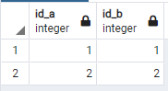

## 1.2

- Truy vấn:

select id_a, id_b

from a

left join b

on a.id_a=b.id_b

- Kết quả:

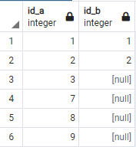

## 1.3

- Truy vấn:

select id_a, id_b

from a

right join b

on a.id_a=b.id_b

- Kết quả:

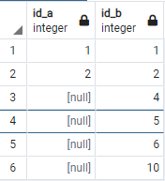

## 1.4

- Truy vấn:

select *

from a

left join b

on a.id_a=b.id_b

where b.id_b is null

- Kết quả:

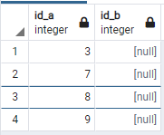

## 1.5

- Truy vấn:

select *

from a

right join b

on a.id_a=b.id_b

where a.id_a is null

- Kết quả:

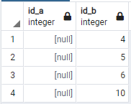

## 1.6

- Truy vấn:

select id_a, id_b

from a

full outer join b

on a.id_a=b.id_b

- Kết quả:

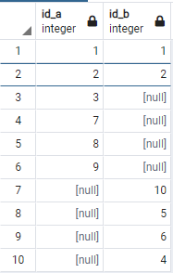

## 1.7

- Truy vấn:

select *

from a

full join b

on a.id_a=b.id_b

where a.id_a is null or b.id_b is null

- Kết quả:

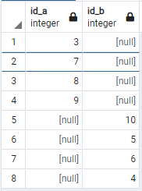

# Phần 2:

- Truy vấn:

With total as (

select user_id, likes_count from comments

union all

select user_id, likes_count from posts

)

select total.user_id, SUM(likes_count) from total

group by total.user_id

order by total.user_id ASC;

- Kết quả:

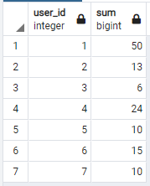

# Phần 3:

- Truy vấn:

select *

from students

order by

(CASE

When department='A' then math

When department='C' then literature

When department='D' then language

END) desc, (math + literature + language) desc;

- kết quả:

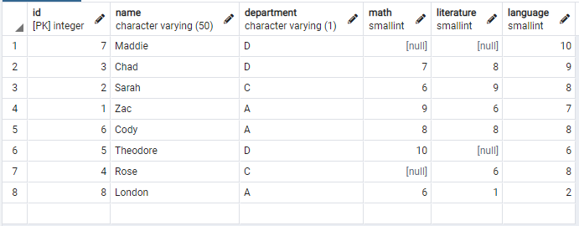

# Phần 4:

## 4.1

- Truy vấn:

select team, max(grade) as grademax

from classroom

group by team

- Kết quả:

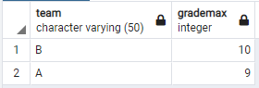

## 4.2