For the following requests, pack your answers into the zip file Assignment1_AccountName.zip, then handle to the evaluator via email ([XYZ@fsoft.com.vn](mailto:XYZ@fsoft.com.vn))

Barem: Q1-30%, Q2.1-40%, Q2.2-30%

## Question 1

Consider the following relations for a database that keeps track of student enrollment in courses and the books adopted for each course (Primary Key is mark post-fix with #):

STUDENT(SSN#, Name, Major, Bdate)

COURSE(Course#, Cname, Dept)

ENROLL(SSN, Course#, Quarter, Grade)

BOOK_ADOPTION(Course#, Quarter, Book_ISBN)

TEXT(Book_ISBN#, Book_Title, Publisher, Author)

Draw a relational schema diagram specifying the foreign keys for this schema.

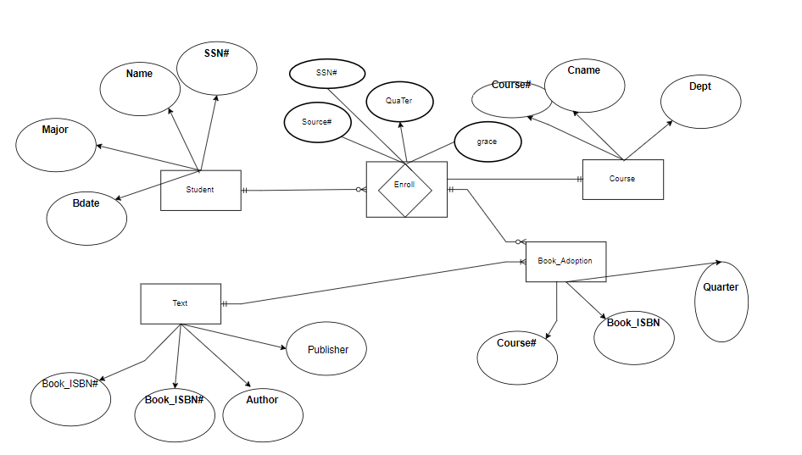

## Question 2

Given the Invoice table with following initial structure (Primary Key is mark post-fix with #)

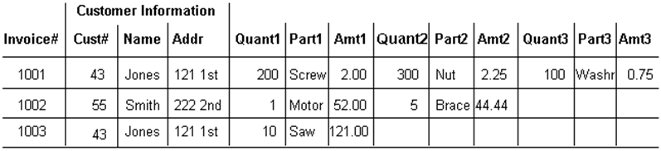

Please:

1. Normalize that table structure to the first, second and third normalization forms

**First normalization forms:**

|  |  |  |  |  |  |
| --- | --- | --- | --- | --- | --- |
| **Invoice#** | **Cust** | **Addr** | **Quant** | **Part** | **Amt** |
| 1001 | Jones | 121 1st | 200 | Scew | 2 |
| 1001 | Jones | 121 1st | 300 | Nut | 2.25 |
| 1001 | Jones | 121 1st | 100 | Washr | 0.75 |
| 1002 | Smith | 222 2nd | 1 | Motor | 52 |
| 1002 | Smith | 222 2nd | 5 | Brace | 44.44 |
| 1003 | Jones | 121 1st | 10 | Saw | 121 |

**Second normalization forms:**

* **Customer table:**

|  |  |  |
| --- | --- | --- |
| **Cust#** | **Name** | **Addr** |
| 43 | Jones | 121 1st |
| 55 | Smith | 222 2nd |

* **invoice details table:**

|  |  |  |  |  |
| --- | --- | --- | --- | --- |
| **Invoice#** | **Cust#** | **Quant** | **Part** | **Amt** |
| 1 | 43 | 200 | Scew | 2 |
| 1 | 43 | 300 | Nut | 2.25 |
| 1 | 43 | 100 | Washr | 0.75 |
| 2 | 55 | 1 | Motor | 52 |
| 2 | 55 | 5 | Brace | 44.44 |
| 3 | 43 | 10 | Saw | 121 |

**Third normalization forms:**

* **Customer table:**

|  |  |  |
| --- | --- | --- |
| **Cust#** | **Name** | **Addr** |
| 43 | Jones | 121 1st |
| 55 | Smith | 222 2nd |

**\* invoice details table:**

|  |  |  |  |  |
| --- | --- | --- | --- | --- |
| **Invoice#** | **Cust#** | **Quant** | **Part** | **Amt** |
| 1 | 43 | 200 | Scew | 2 |
| 1 | 43 | 300 | Nut | 2.25 |
| 1 | 43 | 100 | Washr | 0.75 |
| 2 | 55 | 1 | Motor | 52 |
| 2 | 55 | 5 | Brace | 44.44 |
| 3 | 43 | 10 | Saw | 121 |

1. Draw relational schema diagram for the tables defined in the third normalization form above

