1.2

2.2

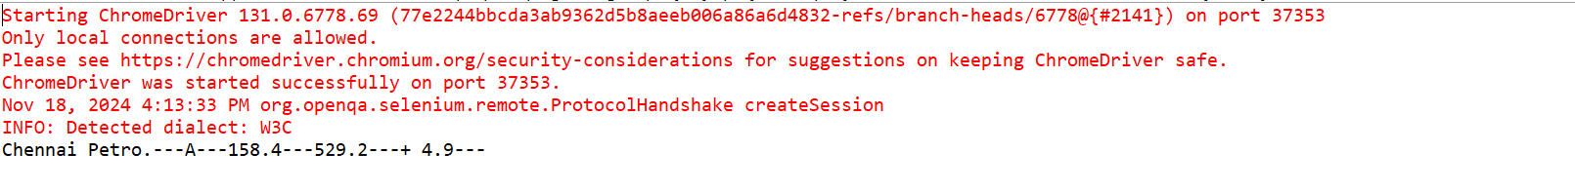

3

