VIETNAM GENERAL CONFEDERATION OF LABOR
TON DUC THANG UNIVERSITY
FACULTY OF INFORMATION TECHNOLOGY



Ngô Tuấn Tú – 52400061
Võ Quốc Bảo – 52400171

MIDTERM ESSAY

WEB PROGRAMING AND APLICATION

HO CHI MINH CITY, 2026
VIETNAM GENERAL CONFEDERATION OF LABOR
TON DUC THANG UNIVERSITY
FACULTY OF INFORMATION TECHNOLOGY

Ngô Tuấn Tú – 52400061
Võ Quốc Bảo – 52400171

MIDTERM ESSAY

WEB PROGRAMING AND APLICATION

Advised by
Dr. Trinh Hung Cuong

HO CHI MINH CITY, 2026
ACKNOWLEDGEMENT
We would like to express our sincere gratitude to Mr. Trinh Hung Cuong, our instructor and mentor, for his valuable guidance and support throughout the mid-term report of our project on Building a book management and ordering system on the MERN stack platform. He has been very helpful and patient in providing us with constructive feedback and suggestions to improve our work. He has also encouraged us to explore new technologies and techniques to enhance our system's functionality and performance. We have learned a lot from his expertise and experience in web development and software engineering. We are honored and privileged to have him as our teacher and supervisor.

Ho Chi Minh city, 3rd September 2023.
Author
(Signature and full name)

Tu
Ngo Tuan Tu

Bao
Vo Quoc Bao

DECLARATION OF AUTHORSHIP
We hereby declare that this is our own project and is guided by Mr. Trinh Hung Cuong; The content research and results contained herein are central and have not been published in any form before. The data in the tables for analysis, comments and evaluation are collected by the main author from different sources, which are clearly stated in the reference section.
In addition, the project also uses some comments, assessments as well as data of other authors, other organizations with citations and annotated sources.
If something wrong happens, We’ll take full responsibility for the content of my project. Ton Duc Thang University is not related to the infringing rights, the copyrights that We give during the implementation process (if any).
Ho Chi Minh city, 3rd September 2023
Author
(Signature and full name)

Tu
Ngo Tuan Tu

Bao
Vo Quoc Bao

BUILDING A BOOKS MANAGEMENT AND ORDERING SYSTEM ON THE MERN STACK PLATFORM
ABSTRACT
Modern web applications are composed of several cooperating components, such as a web server, an application back end, a database, and a message broker. Deploying them consistently on every developer machine, test server, and production host is difficult when each component depends on its own runtime and configuration. This project investigates how containers, and Docker in particular, address this problem. The report first reviews the theory of containerization, covering Linux namespaces and control groups, images and layers, networking, data persistence, Docker Compose, and container security. It then explains container orchestration and scalability and compares virtual machines with containers, container tools, orchestration platforms, reverse proxies, and strategies for sharing real-time events between server instances.
The practical part designs, containerizes, and deploys Docker Task Board, a real-time Kanban application built with Node.js, Express, Socket.IO, and PostgreSQL. In the first phase, a multi-stage Dockerfile based on a minimal Alpine image reduced the application image from 1.66 GB to 252 MB (about 85 %) and shortened the rebuild after a code change from 3.7 s to 1.2 s. The container runs as an unprivileged user, the database is not published to the host, and the data survives the removal of the containers through a named volume. In the second phase, an Nginx reverse proxy and a Redis service were added so that several identical application replicas can run behind one entry point, while the Socket.IO Redis adapter keeps real-time updates synchronized across replicas. The system was evaluated by the distribution of requests among replicas, real-time synchronization between clients attached to different replicas, the behavior when one replica is stopped, and a load test with k6. Add one sentence with the main benchmark result, for example the throughput and p95 latency of 1 versus 3 replicas.
The results show that Docker and Docker Compose make a multi-component web application reproducible, portable, and easy to scale on a single host, while also revealing the design constraints of scaling, namely stateless services, shared state, and event distribution. The limits of the single-host deployment and directions such as Kubernetes are discussed as future work.
Keywords: Docker, containerization, Docker Compose, Nginx, Redis, Socket.IO, horizontal scaling, load balancing.

TABLE OF CONTENT
LIST OF FIGURES vi
LIST OF TABLES vii
ABBREVIATIONS viii
CHAPTER 1. Introduction 1
1.1 Background 1
1.2 Problem Statement 2
1.3 Objectives 2
1.4 Scope 3
1.5 Report Structure 3
CHAPTER 2. Theoretical Background 4
2.1 Overview of Containerization 4
2.2 Virtual Machines versus Containers 6
2.3 Docker Architecture 7
2.4 Images, Layers and Dockerfile 9
2.5 Container Networking 11
2.6 Data Persistence: Volumes and Bind Mounts 12
2.7 Docker Compose 14
2.8 Container Security 14
CHAPTER 3. Container Orchestration and Scalability 16
CHAPTER 4. Comparative Analysis 17
CHAPTER 5. Requirement Analysis and System Design 18
5.1 Demo Overview 18
5.2 Functional Requirements 18
5.3 Non-Functional Requirements 20
5.4 System Architecture 21
5.5 Deployment Architecture 24
5.6 Database Design 26
5.7 Technology Stack 27
CHAPTER 6. Implementation 29
6.1 Project Structure 29
6.2 Containerizing the Application 31
6.2.1 Baseline and optimized images 31
6.2.2 Measured effect of the optimization 34
6.2.3 Verification of the hardened image 35
6.3 Orchestrating the Application and the Database with Docker Compose 36
6.4 Configuration and Secrets 39

LIST OF FIGURES
Figure 1-1 . Traditional deployment versus containerized deployment. 2
Figure 2-1 . Timeline of containerization technologies. 4
Figure 2-2 . Namespaces and cgroups around a container process. 5
Figure 2-3 . Virtual machine stack versus container stack. 7
Figure 2-4 . Docker architecture. 8
Figure 2-5 . Sequence of the docker run command. 9
Figure 2-6 . Image layers and the container's writable layer. 10
Figure 5-1 . System architecture. Components drawn with dashed outlines are added in the scaling phase (Phase 2). 22
Figure 5-2 . Deployment architecture: services, network, volumes, and configuration. Dashed components belong to Phase 2. 24
Figure 5-3 . Entity-relationship diagram of the database. 26
Figure 6-1 . Structure of the repository. 29
Figure 6-2 . Multi-stage build of the application image. 32
Figure 6-3 . Sizes of the baseline (taskboard:naive) and optimized (taskboard:optimized) images. 35
Figure 6-4 . Output of docker compose ps and docker compose exec app whoami: both containers are healthy, the application runs as user node, and PostgreSQL is not published to the host. 36
Figure 6-5 . Data survives docker compose down followed by docker compose up -d because it is stored in the named volume. 39

LIST OF TABLES

ABBREVIATIONS
Abbreviation | Full form
API | Application Programming Interface
cgroups | Control Groups
CLI | Command-Line Interface
CPU | Central Processing Unit
CSS | Cascading Style Sheets
DNS | Domain Name System
ERD | Entity-Relationship Diagram
FR | Functional Requirement
HTML | HyperText Markup Language
HTTP | Hypertext Transfer Protocol
I/O | Input/Output
ID | Identifier
IP | Internet Protocol
IPC | Inter-Process Communication
JSON | JavaScript Object Notation
JWT | JSON Web Token
LXC | Linux Containers
MNT | Mount (namespace)
NAT | Network Address Translation
NET | Network (namespace)
NFR | Non-Functional Requirement
NIST | National Institute of Standards and Technology
OCI | Open Container Initiative
OS | Operating System
OverlayFS | Overlay File System
PID | Process Identifier
pub/sub | Publish/Subscribe
REST | Representational State Transfer
SQL | Structured Query Language
TCP | Transmission Control Protocol
tmpfs | Temporary File System
TLS | Transport Layer Security
UI | User Interface
UTS | UNIX Time-sharing System (namespace)
VM | Virtual Machine
YAML | YAML Ain't Markup Language

INTRODUCTION

Background
Modern web applications are rarely a single program. A typical application combines a web server, an application back end, a database, and often a cache or message broker, each with its own runtime, libraries, and configuration. Traditionally, these components were installed directly on a physical or virtual server, and the same installation steps had to be repeated by hand on every developer laptop, test machine, and production host. Small differences between these environments, such as a different language version, a missing system library, or a changed configuration file, often caused an application that worked in development to fail after deployment. This is commonly summarized as the “it works on my machine” problem. Figure 1.1 contrasts this traditional deployment model with deployment based on containers.
Virtual machines (VMs) addressed part of the problem by packaging an entire operating system together with the application. However, every VM carries its own guest operating system, which makes it large, slow to start, and costly in memory and disk space. Containerization takes a lighter approach. A container packages an application together with its dependencies but shares the kernel of the host operating system, relying on Linux features such as namespaces and control groups to isolate processes and limit resources. Docker, released in 2013, made this idea practical by providing a simple workflow for building images, distributing them through registries, and running them as containers. It has since become one of the most widely used container platforms in web development.

Figure 1-1. Traditional deployment versus containerized deployment.
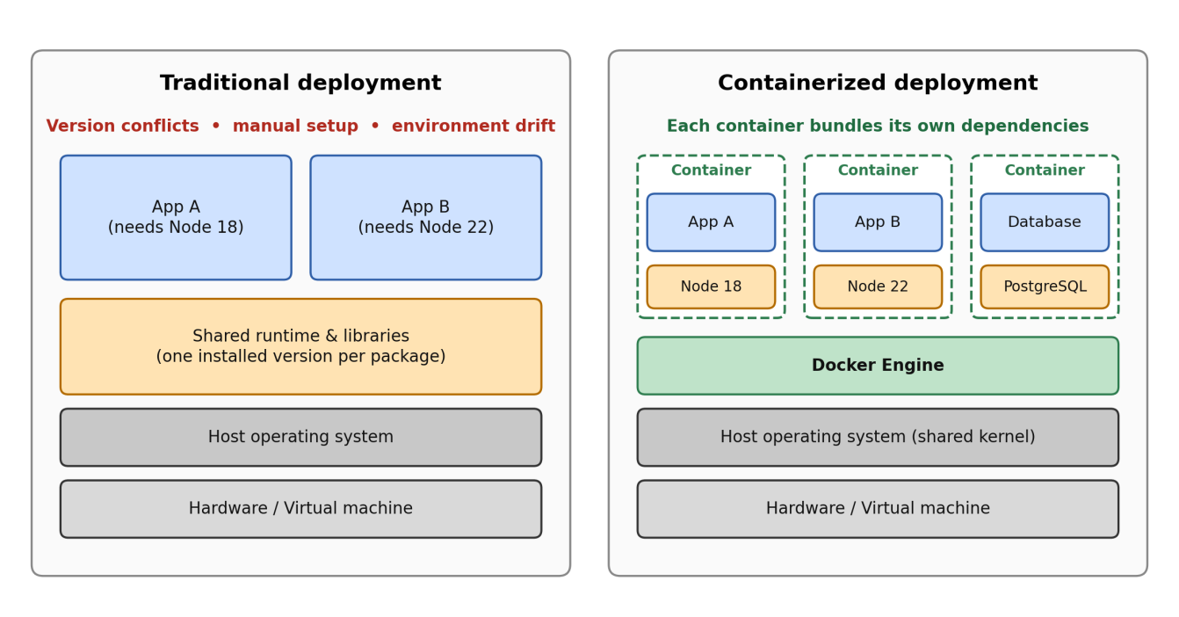

Problem Statement
Deploying a multi-component web application raises several concerns that containers are meant to address. First, the application must behave identically across development, testing, and production environments. Second, its components must be isolated from each other so that a change to one does not break another. Third, the system must be easy to start, stop, and reproduce, ideally with a single command. Finally, as the number of users grows, the application must be able to scale horizontally by running several instances of the same service behind a load balancer.
This report investigates how Docker and related tools respond to these needs. In particular, it asks how a web application and its database can be packaged and deployed in containers, which design decisions make the resulting images small, secure, and maintainable, and what additional considerations arise when the application runs as multiple replicas.

Objectives
The objectives of this project are both theoretical and practical. On the theoretical side, the report surveys container technology, covering the architecture of Docker, images, networking, data persistence, and security, and it explains container orchestration and scalability by comparing containers with virtual machines and Docker Compose with Docker Swarm and Kubernetes. On the practical side, the project designs, containerizes, and deploys a demonstration application, a real-time task board called Docker Task Board, and evaluates the result using measurements such as image size, rebuild time, and behavior under multiple replicas.

Scope
The demonstration application is a Kanban-style task board. Users register and log in, manage boards, columns, and tasks, and see changes made by other users in real time. The system consists of a Node.js back end built with Express and Socket.IO, a PostgreSQL database, a Redis service that shares real-time events between application replicas, and Nginx as a reverse proxy and load balancer. All components are deployed with Docker Compose on a single host.
The report focuses on Docker and Docker Compose. Docker Swarm and Kubernetes are discussed conceptually and compared with Compose, but they are not the main deployment target of the demonstration. Production concerns such as TLS certificates, cloud hosting, monitoring, and multi-host clustering are outside the scope of this work and are mentioned as future work.

Report Structure
The remainder of this report is organized as follows. Chapter 2 presents the theoretical background of containerization and Docker. Chapter 3 covers container orchestration and scalability. Chapter 4 provides a comparative analysis of virtual machines and containers, of container tools, and of orchestration platforms. Chapter 5 describes the requirements and system design of the demonstration application. Chapter 6 explains how the application was containerized and scaled. Chapter 7 presents the results and evaluation, and Chapter 8 concludes the report and outlines future work.

THEORICAL BACKGROUND

Overview of Containerization
A container is an isolated environment in which one or more processes run with their own view of the file system, network, process table, and hostname, while still sharing the kernel of the host operating system. Unlike a virtual machine, a container does not boot a separate operating system. It is an ordinary Linux process whose visibility and resource consumption are restricted by the kernel, which is why containers start quickly and consume little memory compared with virtual machines.
The ideas behind containers developed gradually over several decades. The chroot system call, introduced in Version 7 Unix in 1979, allowed a process to see a different directory as its root, which was the first form of file system isolation. FreeBSD Jails (2000) and Solaris Zones (2004) extended this idea to isolate users, processes, and networking. In Linux, control groups (cgroups) were developed by Google engineers and merged into the kernel in 2007, and the various namespace types were added progressively between 2002 and 2013. LXC (2008) combined these kernel features into a usable container manager. Docker, released as open source in 2013, built on the same kernel features but added a developer-friendly workflow: a simple image format, a build tool, and a public registry for sharing images. In 2015, Docker and other vendors founded the Open Container Initiative (OCI) under the Linux Foundation to standardize the image and runtime formats, so that containers are no longer tied to a single vendor.
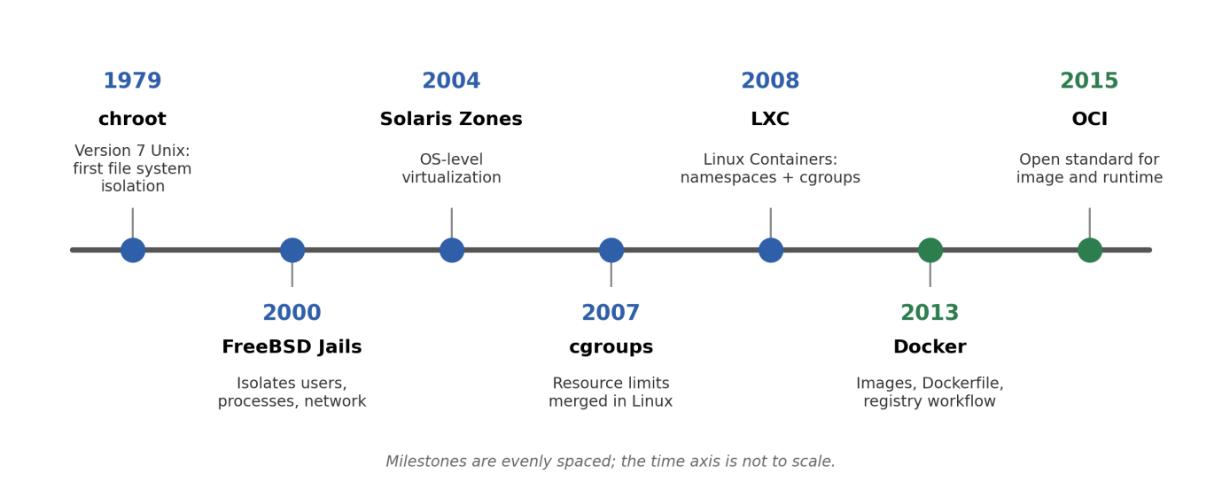
Figure 2-1. Timeline of containerization technologies.

Two Linux kernel mechanisms provide the core of container isolation. Namespaces limit what a process can see. Each namespace type virtualizes one kind of global resource, as summarized in Table 2.1. Control groups (cgroups) limit what a process can use, by restricting and accounting for resources such as CPU time, memory, block I/O, and the number of processes. A third mechanism, the union file system (OverlayFS in current Docker installations), stacks read-only layers and a writable layer into a single file system view, which makes images compact and shareable. Together, namespaces provide isolation, cgroups provide resource control, and the union file system provides efficient storage.
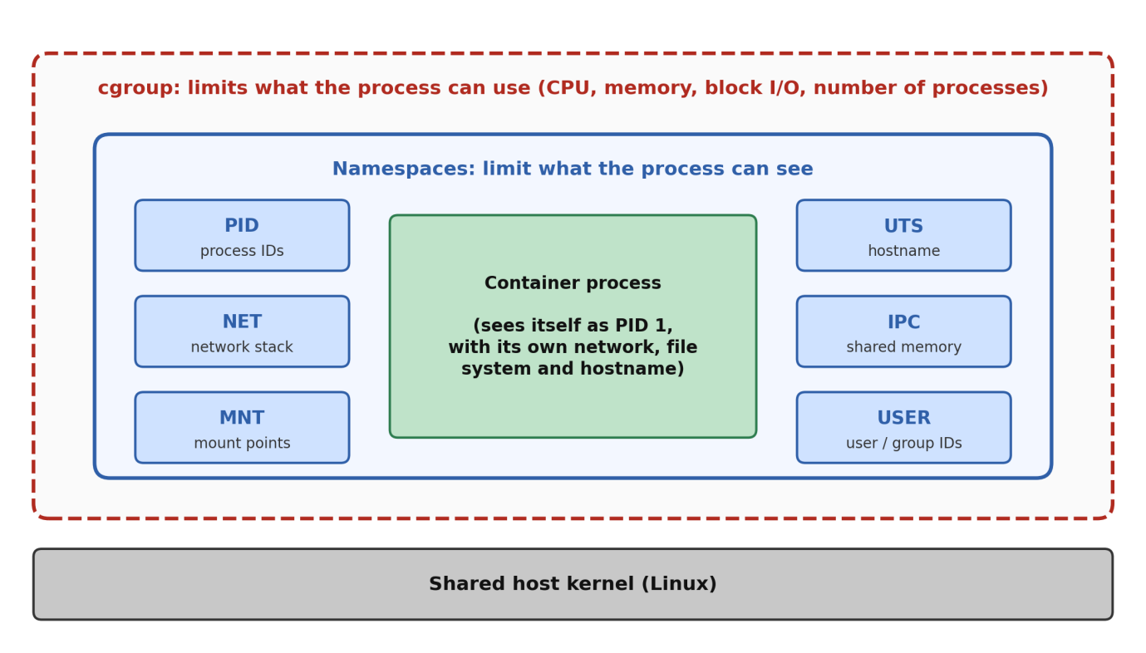
Figure 2-2. Namespaces and cgroups around a container process.
Table 2.1. Linux namespaces used by containers.
Namespace | Isolates | Effect inside a container
PID | Process IDs | The main process appears as PID 1, and other containers' processes are invisible
NET | Network interfaces, routing tables, ports | Each container has its own network stack and IP address
MNT | Mount points | The container sees its own root file system
UTS | Hostname and domain name | Each container can have its own hostname
IPC | Inter-process communication | Shared memory and message queues are not shared with other containers
USER | User and group IDs | A user inside the container can be mapped to an unprivileged user on the host
CGROUP | View of the cgroup hierarchy | The container sees only its own resource-control group

Virtual Machines versus Containers
Both virtual machines and containers isolate workloads, but they do so at different levels of the technology stack. A virtual machine virtualizes hardware. A hypervisor, running either directly on the hardware or on top of a host operating system, creates virtual machines, each of which runs a complete guest operating system with its own kernel. A container virtualizes the operating system instead. The container engine runs on a single host kernel, and every container is an isolated group of processes using that kernel, as shown in Figure 2.3.
This architectural difference explains most of the practical differences between the two technologies. Because a container does not include a guest operating system, its image is typically tens to hundreds of megabytes rather than gigabytes, it starts in a fraction of a second rather than a minute, and many more containers than virtual machines can run on the same hardware. The trade-off is weaker isolation, since all containers on a host share one kernel, and a restriction that Linux containers require a Linux kernel. A more detailed comparison is presented in Chapter 4.

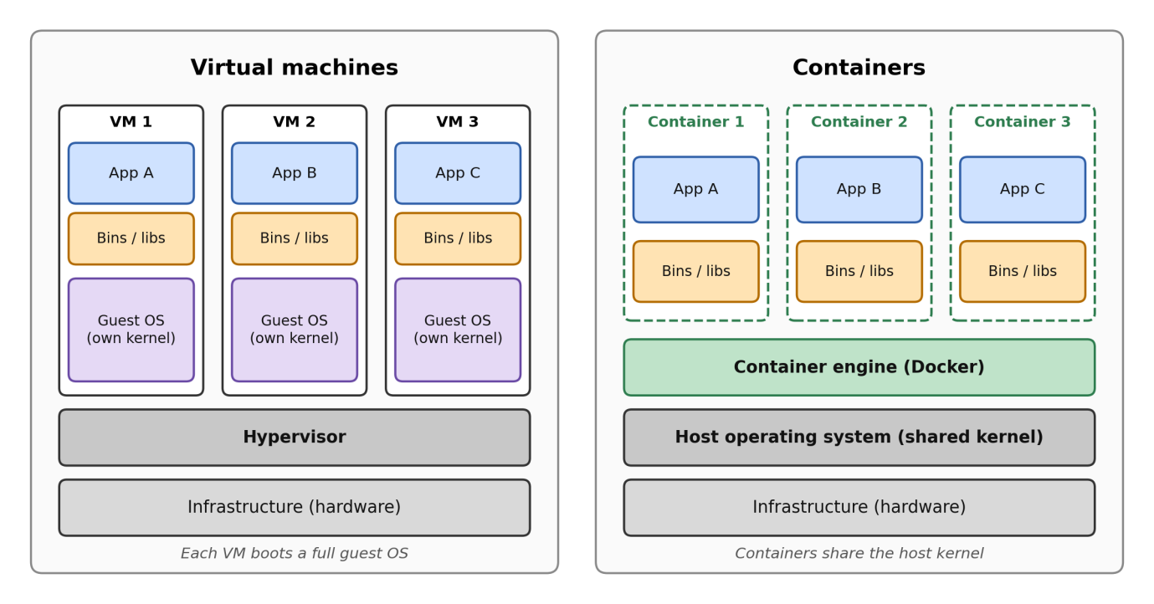
Figure 2-3. Virtual machine stack versus container stack.

Docker Architecture
Docker uses a client-server architecture composed of several cooperating components, shown in Figure 2.4. The Docker client (docker) is the command-line tool with which users issue commands such as docker build and docker run. The client does not perform the work itself. It sends requests through a REST API to the Docker daemon (dockerd), a background service that builds images, manages networks and volumes, and supervises containers. The client and daemon can run on the same machine, communicating over a UNIX socket, or on different machines.
Below the daemon, the actual management of container lifecycles is delegated to containerd, a high-level container runtime that pulls and stores images, manages snapshots, and starts and stops containers. For each container, containerd uses a low-level OCI-compliant runtime, usually runc, which implements the OCI Runtime Specification and performs the final step of creating the namespaces and cgroups and starting the container's process. A small helper process called a shim keeps each container running independently of the daemon, which allows the daemon to be restarted without stopping running containers. Finally, a registry stores and distributes images. Docker Hub is the default public registry, and organizations may also run private registries. On Windows and macOS, Docker Desktop runs these Linux components inside a lightweight virtual machine, because containers depend on the Linux kernel.

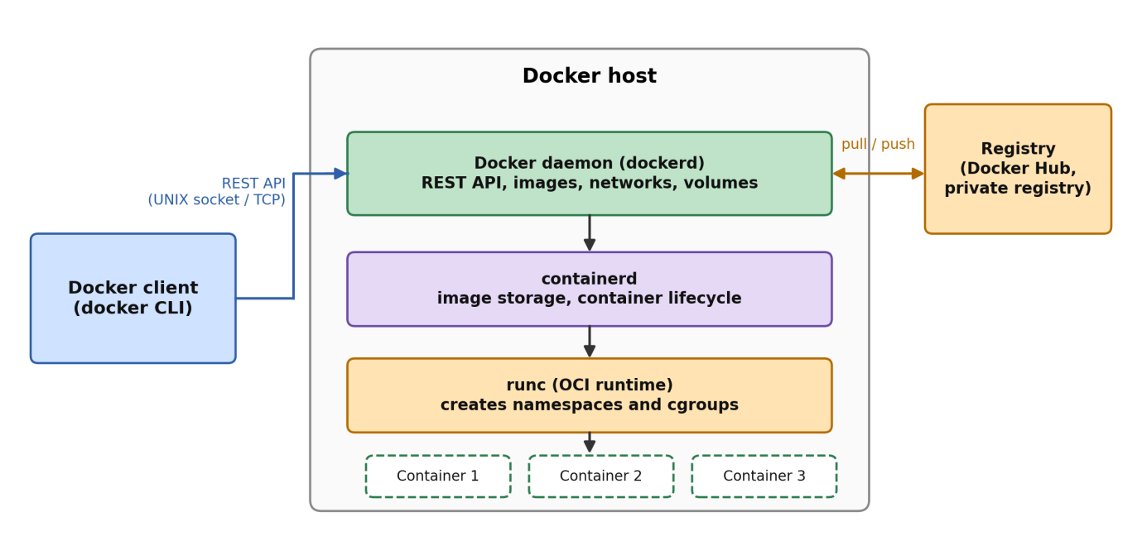
Figure 2-4. Docker architecture.
The relationship between these components becomes clear by following a single command, docker run, which is illustrated in Figure 2.5. The client first sends the request to the daemon. The daemon checks whether the requested image exists locally and, if it does not, pulls it from the registry. It then asks containerd to create a container from the image, which includes adding a thin writable layer on top of the image layers and attaching the container to a network. Finally, runc sets up the namespaces and cgroups and starts the container's main process, and the output is streamed back to the client.

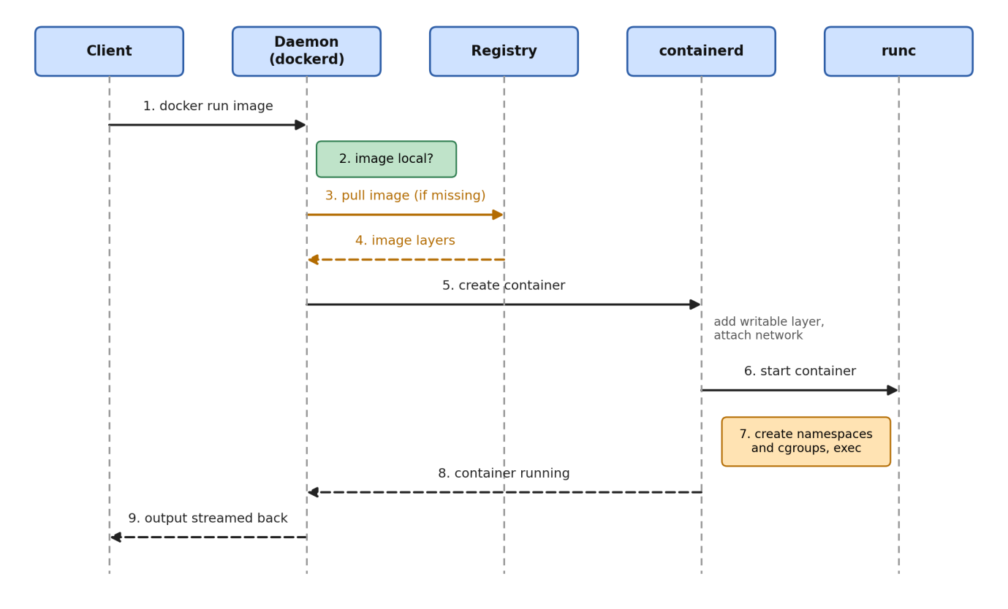
Figure 2-5. Sequence of the docker run command.

Images, Layers and Dockerfile
A Docker image is a read-only template that contains everything needed to run an application: the file system content, the runtime, the libraries, and the default start command. An image is built from a sequence of layers. Each filesystem-modifying instruction in a Dockerfile, such as COPY, ADD, or RUN, creates a new layer that records only the changes relative to the previous one. When a container starts, Docker adds a thin writable layer on top of the read-only image layers, using a copy-on-write strategy: a file from a lower layer is copied into the writable layer only when the container modifies it. This design lets many containers share the same image layers on disk and makes images fast to distribute, since only layers that are missing from the target machine need to be transferred.

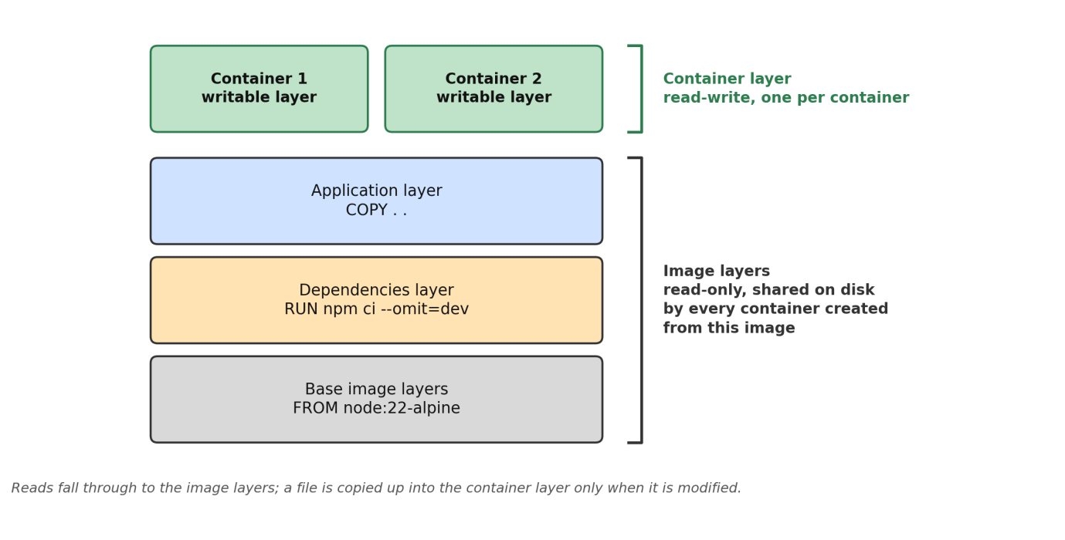
Figure 2-6. Image layers and the container's writable layer.
Images are built from a text file called a Dockerfile, which lists the instructions in order. The most important instructions are summarized in Table 2.2.
Table 2.2. Main Dockerfile instructions.
Instruction | Purpose
FROM | Selects the base image; in a multi-stage build, starts a new stage
WORKDIR | Sets the working directory for the following instructions
COPY | Copies files from the build context (or from another stage) into the image
RUN | Executes a command at build time, such as installing dependencies
ENV | Sets an environment variable in the image
EXPOSE | Documents the port on which the application listens
USER | Sets the user under which the container runs
HEALTHCHECK | Defines a command Docker uses to test whether the container is healthy
ENTRYPOINT / CMD | Defines the command that runs when the container starts; CMD provides default arguments that can be overridden
Docker uses a build cache to speed up image creation. For every instruction, Docker checks whether a layer already exists that was created from the same instruction and the same inputs, and reuses it if so. When an instruction or one of its input files changes, the cache of that layer and of all layers after it is invalidated. As a result, the order of instructions strongly affects build time, and instructions that change rarely, such as installing dependencies, should appear before instructions that change often, such as copying source code.
Several best practices follow from this layered design. Multi-stage builds use separate stages for building and for running, and copy only the necessary artifacts into the final stage, so that build tools and temporary files never reach the production image. Small base images, such as Alpine-based or "slim" variants, reduce image size and the number of packages that may contain vulnerabilities. A .dockerignore file keeps irrelevant or sensitive files, such as node_modules and .env, out of the build context. Layer ordering makes the best use of the build cache. Running the application as a non-root user limits the damage if the process is compromised. These practices are applied in the demonstration application, as described in Section 6.2.

Container Networking
Docker networking provides containers with connectivity to each other and to the outside world through pluggable network drivers, summarized in Table 2.3. The default bridge driver creates a virtual switch on the host, and containers attached to it receive private IP addresses and can communicate with each other. A user-defined bridge network adds an important feature: an embedded DNS server resolves container and service names to IP addresses, so that containers can reach one another by name, for example db, instead of by IP address, which changes every time a container is recreated. The host driver removes network isolation and lets a container use the host's network stack directly, and the none driver disables networking. The overlay driver connects containers running on different hosts and is used by Docker Swarm.
Table 2.3. Main Docker network drivers.
Driver | Scope | Typical use
bridge | Single host | Default; user-defined bridges provide name resolution between containers
host | Single host | Maximum network performance; no network isolation
none | Single host | Fully isolated container without network access
overlay | Multiple hosts | Communication between containers in a Swarm cluster
To make a service reachable from outside the host, Docker supports port mapping, written as host_port:container_port. Docker configures network address translation (NAT) rules so that traffic arriving at the host port is forwarded to the container port. Ports that are not published remain reachable only from other containers on the same network, which is a simple but effective way to keep internal services, such as a database, hidden from the outside.

Data Persistence: Volumes and Bind Mounts
The writable layer of a container is ephemeral: when the container is removed, its contents are lost, and data written there is also difficult to share and slower than direct file system access. Applications that must keep data, such as databases, therefore store it outside the container's writable layer, using one of three mechanisms compared in Table 2.4.
Volumes are storage areas created and managed by Docker, stored in a dedicated location on the host, and mounted into containers. They exist independently of any container, can be shared between containers, and are the recommended mechanism for persistent data. Bind mounts map a specific directory or file of the host into the container. They are convenient during development, for example to mount source code into a running container, but they depend on the host's directory structure and permissions. tmpfs mounts store data in the host's memory only and are suitable for temporary or sensitive data that must not be written to disk.
Table 2.4. Docker storage options.
Type | Managed by | Persistence | Typical use
Volume | Docker | Survives container removal | Databases and production data
Bind mount | The user (host path) | Lives on the host file system | Development, configuration files
tmpfs | Host memory | Lost when the container stops | Temporary or sensitive data

Docker Compose
Real applications usually consist of several containers that must be built, configured, and started together. Docker Compose addresses this by describing the whole application in a single YAML file, conventionally named docker-compose.yml. The file declares services (each corresponding to one container image and its configuration), the networks that connect them, and the volumes that hold their data. Compose follows the Compose Specification and is used through the docker compose command.
A service definition can specify the image or build context, environment variables (directly or through an env_file), published ports, attached volumes and networks, and a restart policy. Startup order can be controlled with depends_on, and when combined with a healthcheck and the condition service_healthy, a service starts only after the services it depends on are actually ready rather than merely started. Profiles allow optional services to be enabled selectively.
Compose is operated through a small set of commands: docker compose up builds, creates, and starts all services; docker compose down stops and removes the containers and networks (and, with the -v option, the volumes); docker compose ps and docker compose logs show status and output; and the --scale option of up runs several instances of a service, which is used in Chapter 6. Because the entire environment is described declaratively and can be recreated with one command, Compose gives developers a reproducible setup that is identical on every machine.

Container Security
Containers provide process-level isolation, but they do not offer the same strength of isolation as virtual machines, because all containers on a host share a single kernel. A vulnerability in the kernel or a misconfigured container can therefore affect the host and other containers. Security guidance for containers, such as NIST Special Publication 800-190, groups the main risks into those related to images, registries, orchestrators, containers, and the host operating system.
Several concrete risks are particularly common. Images may contain known vulnerabilities in outdated packages, or may be malicious if they come from untrusted sources. Containers that run as the root user, in privileged mode, or with unnecessary Linux capabilities give an attacker far more power if the application is compromised. Secrets such as passwords and API keys can be leaked when they are written into images, committed to a repository, or exposed through environment variables. Exposing the Docker daemon socket to a container, or publishing internal services such as databases on public ports, enlarges the attack surface. Finally, containers without resource limits can exhaust the host's CPU or memory and cause a denial of service.
The corresponding countermeasures are well established and are summarized in Table 2.5. Most of them are inexpensive to apply, which is why a basic level of container hardening should be part of every deployment, including the demonstration application of this project.
Table 2.5. Container security risks and mitigations.
Risk | Mitigation
Vulnerable or malicious images | Use official or verified images, pin versions, scan images with tools such as Trivy or Docker Scout, rebuild regularly
Large attack surface of the image | Use minimal base images and multi-stage builds
Running as root or privileged | Use a non-root USER, drop unneeded capabilities, avoid privileged mode
Leaked secrets | Keep secrets out of images and repositories; supply them at runtime through environment files or a secrets manager
Exposed internal services | Publish only the ports that must be public; keep databases on an internal network
Resource exhaustion | Set CPU and memory limits for containers
Modification of the container file system | Run containers with a read-only root file system where possible

CONTAINER ORCHESTRATION AND SCALEBABILITY
A single container started with docker run is easy to manage, but a real system consists of many containers that must be started in the right order, connected to each other, restarted when they fail, and multiplied when the load grows. Doing this by hand does not scale beyond a handful of containers. This chapter explains how this work is automated by orchestration, which requirements a web application must satisfy to be scaled horizontally, why real-time applications need additional care, and which orchestration platforms exist. It provides the concepts that are applied in Chapter 6 and compared in Chapter 4.

From Single Containers to Orchestration
Container orchestration is the automated management of the life cycle of containers across one or more hosts. An orchestrator takes a declarative description of the desired state, for example "run three copies of the application and one database, connected by a private network", and continuously works to make the real state match it. The main functions of an orchestrator are summarized in Table 3.1, together with the way each function is provided in this project, which uses Docker Compose on a single host.
Table 3.1. Main functions of a container orchestrator.
Function | Description | In this project
Scheduling | Decides on which host each container runs | Not needed: all containers run on one Docker host
Service discovery | Lets services find each other by name instead of by changing IP addresses | Docker embedded DNS on the network backend (db, redis, app)
Load balancing | Distributes requests among the instances of a service | Nginx in front of the application replicas
Scaling | Changes the number of instances of a service | docker compose up --scale app=3, changed manually
Self-healing | Replaces or restarts failed instances | Restart policy unless-stopped restarts containers that exit; the health check only reports the state
Rolling updates | Replaces instances gradually without downtime | Not provided by Compose; containers are recreated
Configuration and secrets | Supplies settings and credentials at run time | .env file and env_file
Storage | Attaches persistent storage to services | Named volumes pgdata and redisdata

The table also shows the limits of Compose. A plain Docker engine, and therefore Compose, restarts a container when its main process exits, but it does not restart a container only because its health check reports "unhealthy"; the status is visible, but replacing the container requires an orchestrator such as Docker Swarm or Kubernetes. These platforms are described in Section 3.5.

Scalability: Vertical and Horizontal
Scalability is the ability of a system to handle a growing load by adding resources. There are two basic strategies, shown in Figure 3.1. Vertical scaling (scaling up) gives a single server more CPU, memory, or disk. It is simple because the application does not change, but it is limited by the largest available machine, it usually needs a restart, and the server remains a single point of failure. Horizontal scaling (scaling out) adds more instances of the same service and distributes the load among them with a load balancer. It has no fixed upper limit and tolerates the loss of an instance, but it requires an application that can run as several independent copies.
- Vertical Scaling:
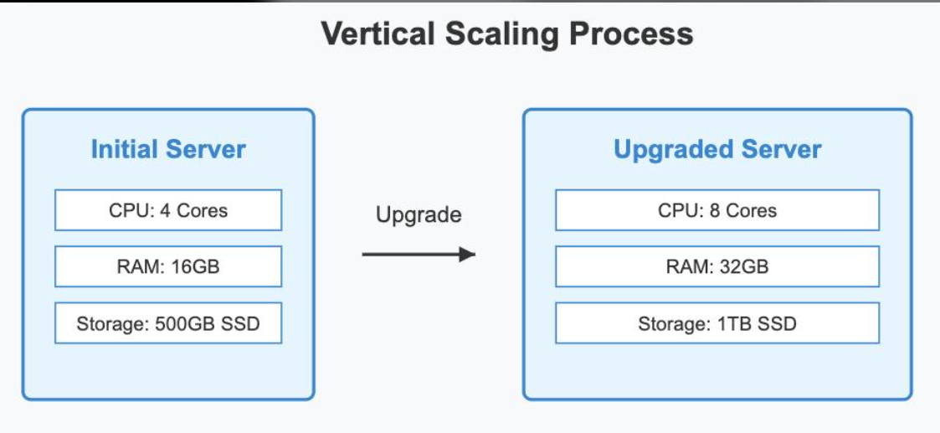

Horizontal Scaling:
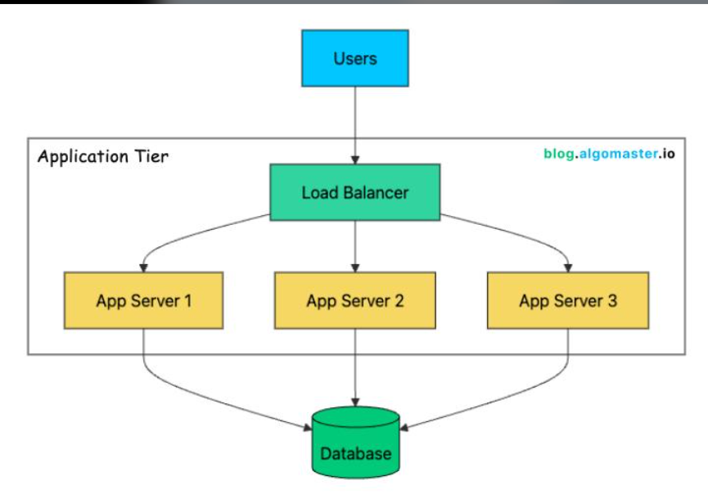
Figure 3-1. Vertical scaling versus horizontal scaling.
Containers are well suited to horizontal scaling. An image is a fixed, self-contained package, so every replica started from it is identical, and a container starts in a fraction of a second. Starting another replica is therefore a matter of running the same image once more. The demonstration application follows this strategy: the number of application containers is changed with a single option, and Nginx distributes the traffic.

Requirements for Horizontal Scaling of a Web Application
Adding replicas does not help unless the application is designed for it. Five requirements are relevant for the demonstration application.
Stateless instances. An instance must not keep data in its own memory that another instance would need. If a user logs in on replica A and the session is stored in the memory of A, the next request that reaches replica B is rejected. The application therefore authenticates every request with a signed JSON Web Token (JWT), which any replica can verify, and keeps all persistent data in PostgreSQL.
Shared configuration. All replicas are started from the same image and the same .env file. This is essential for the signing key: a token signed with JWT_SECRET by one replica can be verified by another only if both use the same secret.
Load balancing. A load balancer receives all client requests and forwards each of them to one replica. The most common algorithms are compared in Table 3.2.
Table 3.2. Common load-balancing algorithms.
Algorithm | Principle | Suited to | Drawback
Round robin | Sends requests to the servers in turn | Requests of similar cost | Ignores the current load of each server
Least connections | Sends the request to the server with the fewest active connections | Long-lived connections such as WebSocket | Needs the balancer to track connections
IP hash | Maps the client address to a fixed server | Applications that need the same server for a client | Uneven load behind shared addresses (NAT, proxies)
Random | Chooses a server at random | Large clusters with many balancers | Short-term imbalance is possible

Service discovery. The load balancer must know which replicas exist. When a service has several containers, the Docker DNS server returns the addresses of all of them for the service name. A load balancer that resolves this name only once, at start-up, will not see replicas that are added or removed later; it must resolve the name again at run time. This point is addressed in Section 6.5.
Coordinated start-up. Actions that must happen only once, such as creating the demo data, must be safe when several replicas start at the same time. The application uses a database advisory lock for this purpose (requirement FR13 of Section 5.2).

Scaling Real-Time Applications
WebSocket connections are long-lived: after the initial HTTP handshake, a client keeps one connection open to one server instance, and that instance holds the connection and its room memberships in memory. This creates two problems that do not exist for plain REST requests, summarized in Table 3.3.
Table 3.3. Problems of scaling real-time communication and the solutions used in this project.
Problem | Cause | Solution used
Requests of one session reach different servers | Socket.IO may fall back to HTTP long polling, which sends several requests per session | Clients use the WebSocket transport only, so a session is one connection and no sticky sessions are needed
Events do not reach clients on other servers | Rooms and sockets exist only in the memory of one process, so an emit reaches only local clients | The Socket.IO Redis adapter forwards every emit to all replicas through Redis publish/subscribe
A server stops and its clients are disconnected | The connections of that server are closed | Socket.IO clients reconnect automatically; the interface joins the board room again after each connection
Events may be lost | Redis publish/subscribe does not store messages | The database is the source of truth; clients reload the board when an event arrives and when they reconnect

The second problem is illustrated in Figure 3.2. Without an adapter, a user connected to replica A never sees the change made by a user connected to replica B, because replica B emits the event only to its own clients. With the adapter, the emit is published to Redis, every replica receives it, and each replica delivers it to its own clients in the room.
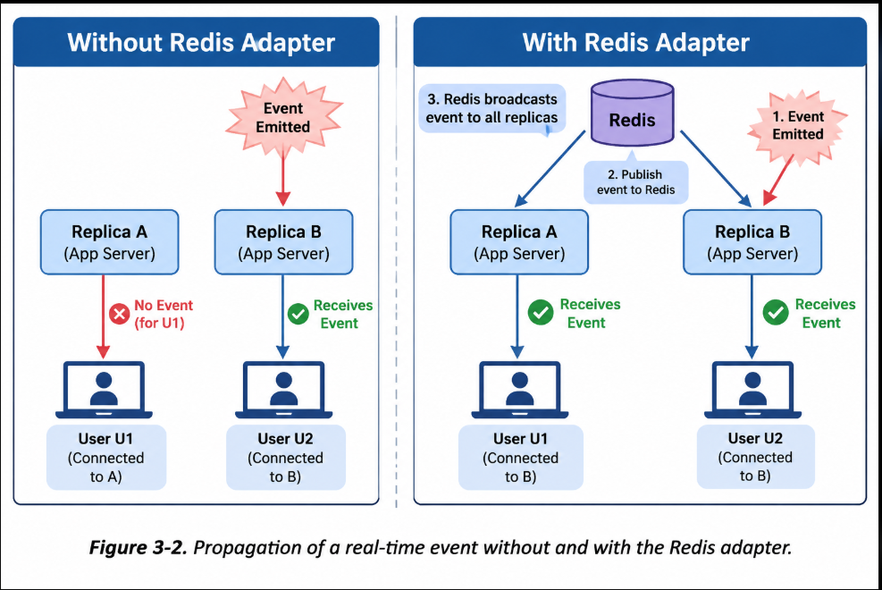

Orchestration Platforms
Three platforms from the Docker ecosystem are relevant for this report. They differ in the size of system they target and in the functions they automate.

Docker Compose
Docker Compose describes a multi-container application in one YAML file and runs it on a single Docker host (Section 2.7). It starts services in the order given by depends_on, can run several instances of a service with the --scale option, and restarts exited containers according to the restart policy. It has no scheduler, no automatic scaling, and no rolling updates, but its simplicity makes it the usual tool for development, testing, demonstrations, and small deployments.

Docker Swarm
Docker Swarm mode is built into Docker Engine and turns several hosts into one cluster. Manager nodes hold the cluster state, which is kept consistent with the Raft consensus algorithm, and worker nodes run the containers. The user declares a service with a number of replicas, and Swarm creates the tasks (one container each), places them on the nodes, and replaces tasks that fail. A built-in routing mesh publishes a service port on every node and balances connections among the replicas, overlay networks connect containers on different hosts, and services can be updated with a rolling strategy. Compose files can be deployed to a swarm as a stack. Swarm is easier to learn than Kubernetes but has a smaller ecosystem.

Kubernetes
Kubernetes is an open-source orchestration platform originally designed at Google and now maintained by the Cloud Native Computing Foundation. A cluster consists of a control plane, which includes the API server, the scheduler, the controllers, and the key-value store etcd, and of worker nodes, which run the kubelet agent and a container runtime. The smallest deployable unit is the Pod, which contains one or more containers. A Deployment declares how many replicas of a Pod are wanted and manages rolling updates and rollbacks, a Service gives a group of Pods a stable name and address and balances the traffic among them, and an Ingress exposes HTTP services to the outside. Configuration and secrets are supplied through ConfigMaps and Secrets, liveness and readiness probes control restarts and traffic, and a HorizontalPodAutoscaler changes the number of replicas according to measured load. Kubernetes is the most powerful of the three platforms and the de facto industry standard, at the price of a steep learning curve and a considerable operational effort.
Table 3.4 relates the concepts used in this project to their counterparts in Swarm and Kubernetes. It shows that the design of the demonstration, with a stateless application, a shared database, a message channel, and a single entry point, can be transferred to a cluster platform with little conceptual change.
Table 3.4. Concepts of this project and their counterparts in Swarm and Kubernetes.
Concept | Docker Compose (this project) | Docker Swarm | Kubernetes
Replicas | --scale app=3 | Service with replicas: 3 | Deployment with replicas: 3
Service discovery | Docker DNS name app | Service name and virtual IP | Service name (cluster DNS)
Entry point | Nginx container publishes one port | Routing mesh or a proxy service | Ingress or Service of type LoadBalancer
Configuration | .env and env_file | Configs and secrets | ConfigMap and Secret
Health | HEALTHCHECK, depends_on | HEALTHCHECK, task replacement | Liveness and readiness probes
Persistent data | Named volume pgdata | Volumes | PersistentVolumeClaim

Position of This Project
The demonstration uses Docker Compose on a single host. Compose is sufficient to show the essential ideas of this chapter, namely replication of a stateless service, load balancing, sharing of real-time events, and restart after failure, and it can be reproduced on any machine with one command, which supports the requirements NFR1 and NFR2. Swarm and Kubernetes were not deployed because their main benefits, multi-host scheduling, automatic replacement of unhealthy instances, and automatic scaling, require a cluster, which is outside the scope defined in Section 1.4. They are discussed as future work in Chapter 8. The following chapter compares the technologies involved in more detail.

Comparative Analysis
The design of the demonstration involves several technology choices: containers instead of virtual machines, Docker as the container tool, Docker Compose as the orchestrator, Nginx as the load balancer, and the Redis adapter for sharing real-time events. This chapter compares each choice with its main alternatives, one criterion table at a time, and summarizes the decisions at the end. The comparisons are qualitative and based on the properties of the technologies as described in Chapters 2 and 3; the only quantitative data come from the measurements of Chapter 6 and Chapter 7.

Virtual Machines versus Containers
Section 2.2 explained that a virtual machine virtualizes hardware and a container virtualizes the operating system. Table 4.1 compares the two technologies by the criteria that matter for deploying a web application.
Table 4.1. Virtual machines compared with containers.
Criterion | Virtual machine | Container
Virtualization level | Hardware, through a hypervisor | Operating system, through the host kernel
Operating system | Complete guest OS with its own kernel | Shares the host kernel; contains only the user-space files
Typical image size | Gigabytes | Tens to hundreds of megabytes (62.7 MB content size for the optimized image of this project)
Start-up time | Tens of seconds to minutes | A fraction of a second to a few seconds
Resource overhead | High: memory and disk for every guest OS | Low: only the application processes
Density per host | Tens of machines | Hundreds of containers
Isolation | Strong: separate kernels | Weaker: one shared kernel, hardened with namespaces, cgroups, and security options
Operating systems supported | Any guest OS, independent of the host | Linux containers need a Linux kernel (Docker Desktop uses a lightweight VM on Windows and macOS)
Portability | Large disk images, tied to the hypervisor format | Small layered images, shared through registries, standardized by the OCI
Typical use | Strong isolation, different operating systems, legacy applications | Microservices, continuous delivery, reproducible development environments

For a web application whose components are all Linux processes, containers are the better choice: they start quickly, use little memory, and make the whole environment reproducible from a text file. The weaker isolation is acceptable for a trusted demonstration and is reduced by the measures of Section 6.2, such as the unprivileged user. The two technologies are also complementary: containers frequently run inside virtual machines, as in Docker Desktop and in most cloud platforms, which combines the isolation of the VM with the agility of containers.

Container Tools
Docker is not the only way to run containers. Table 4.2 compares it with the main alternatives at the engine and runtime level.
Table 4.2. Container tools and runtimes.
Tool | Architecture | Strengths | Limitations
Docker Engine | Client and daemon (dockerd) on top of containerd and runc | Largest ecosystem: Docker Hub, Compose, Docker Desktop, extensive documentation | Central daemon; rootless mode exists but is not the default
Podman | Daemonless; each container is a child process of the user | Rootless by default; CLI largely compatible with Docker; supports Pods | Smaller tooling ecosystem; Compose support depends on an external provider
LXC / LXD | System containers that behave like light virtual machines | Full operating-system environment with an init system | Not designed for packaging single applications; no layered image standard comparable to OCI images
containerd | High-level runtime used by Docker and Kubernetes | Lightweight, stable, industry standard runtime | Not aimed at developers; no build tool or Compose
CRI-O | Runtime that implements only the Kubernetes Container Runtime Interface | Minimal, focused on Kubernetes | Cannot be used without Kubernetes

Docker was chosen for this project because the topic of the course is Docker, because Compose offers the declarative multi-container workflow needed for the demonstration, and because its documentation and base images are the most widely available. Podman would be a reasonable alternative for environments that require rootless operation without a daemon, and the images built in this project follow the OCI format and could be run by it. containerd and CRI-O are runtimes that appear below Docker or Kubernetes rather than substitutes for the developer workflow.

Orchestration Platforms
Chapter 3 introduced Docker Compose, Docker Swarm, and Kubernetes. Table 4.3 compares them with respect to the functions of Table 3.1.
Table 4.3. Docker Compose, Docker Swarm, and Kubernetes compared.
Criterion | Docker Compose | Docker Swarm | Kubernetes
Scope | One host | A cluster of Docker hosts | A cluster of any size
Set-up effort | Minimal: one YAML file | Low: docker swarm init | High: control plane, networking, and storage plugins
Scaling | Manual (--scale) | Manual (docker service scale) | Manual or automatic (HorizontalPodAutoscaler)
Self-healing | Restart policy for exited containers | Failed tasks are replaced, also on other nodes | Failed or unhealthy Pods are restarted and rescheduled
Load balancing | External proxy needed (Nginx here) | Built-in routing mesh | Service and Ingress
Rolling updates | Not provided | Supported | Supported, with rollback
Configuration and secrets | Environment files | Configs and secrets | ConfigMaps and Secrets
Learning curve | Low | Medium | High
Typical use | Development, tests, small deployments | Small and medium clusters | Large production systems

The comparison shows a trade-off between simplicity and functionality. Compose is the lightest option and has the shortest path from the source code to a running system, but it offers neither multi-host operation nor automatic recovery beyond restarting. Kubernetes provides every function of Table 3.1 but needs the most effort to install and operate. For a single-host demonstration whose goal is to understand containers and the principles of scaling, Compose is the appropriate level; the application is stateless and uses standard components, so it could be moved to Swarm or Kubernetes later.

Reverse Proxies and Load Balancers
The entry point of the scaled deployment can be implemented with several products. Table 4.4 compares the three that are most often used with containers.
Table 4.4. Nginx, HAProxy, and Traefik compared.
Criterion | Nginx | HAProxy | Traefik
Main role | Web server, reverse proxy, and load balancer | Dedicated TCP and HTTP load balancer | Edge router designed for containers
Configuration | Static configuration files | Static configuration file | Dynamic, taken from Docker labels or other providers
Discovery of replicas | DNS name resolved at run time (parameter resolve, available in the open-source version since 1.27.3) | DNS resolvers and server templates | Automatic through the Docker provider
Algorithms | Round robin, least connections, IP hash, hash, random | Many, including round robin, least connections, and source hash | Weighted round robin, with further strategies in recent versions
WebSocket | Supported with the Upgrade and Connection headers | Supported | Supported automatically
Active health checks | Only in the commercial edition; passive checks in the open-source version | Supported | Supported
Familiarity and documentation | Very widespread | Widespread for load balancing | Common in container environments

Nginx was chosen because it is the most widely used reverse proxy, its configuration is short and easy to read in a report, it can proxy WebSocket connections, and recent versions can re-resolve the name of the application service while running, which is what is needed to follow the scaled replicas (Section 6.5). Traefik would reduce the configuration further because it discovers containers by itself, but it adds a further abstraction; HAProxy would be preferable when active health checks and detailed traffic control are priorities.

Strategies for Sharing Real-Time Events between Replicas
A scaled Socket.IO application needs a mechanism that carries events between the server instances (Section 3.4). Table 4.5 compares the main options.
Table 4.5. Options for sharing real-time events between application replicas.
Option | How it works | Advantages | Drawbacks
Sticky sessions only | The balancer always sends a client to the same replica | No extra component | Does not deliver events to clients on other replicas; not sufficient alone
Redis publish/subscribe adapter | Each replica publishes emitted events to Redis and subscribes to those of the others | Simple, fast, officially maintained, one small service | Messages are not stored; Redis is an additional component and a single point of failure
Redis Streams adapter | Events are written to a Redis stream | Events are kept for a time, so missed events can be recovered | Slightly more complex; requires Redis 5 or later
PostgreSQL adapter | Uses LISTEN and NOTIFY of the existing database | No new service | Limited message size and throughput; adds load to the database
Dedicated message broker | RabbitMQ, Kafka, or NATS carry the events | Rich delivery guarantees and routing | Considerably more complex than needed for this application

The Redis publish/subscribe adapter offers the best balance for this project: it requires one small, official service, it needs no change to the code that emits the events, and the weaker delivery guarantee is acceptable because every client reloads the board from the database when an event arrives. The Streams adapter would be the next step if the loss of events during a Redis outage had to be avoided (Section 8.2).

Summary of Design Decisions
Table 4.6. Technology decisions of the project.
Decision | Choice | Main alternatives | Main reason
Isolation technology | Containers | Virtual machines | Light, fast, reproducible (Table 4.1)
Container tool | Docker | Podman, LXC | Compose workflow, ecosystem, course topic (Table 4.2)
Orchestrator | Docker Compose | Swarm, Kubernetes | Sufficient for one host, minimal effort (Table 4.3)
Entry point | Nginx | HAProxy, Traefik | Widespread, short configuration, run-time DNS resolution (Table 4.4)
Event sharing | Socket.IO Redis adapter | Streams or PostgreSQL adapter, broker | Simplest solution that meets the requirements (Table 4.5)
Real-time transport | WebSocket only | Long polling with sticky sessions | No sticky sessions needed, simple balancer (Table 3.3)

Continue Chapter 6 here, after Section 6.4 (the numbers 6.5 to 6.8 are set by the list override; after pasting with "Use Destination Styles" they follow the document automatically).

Reverse Proxy and Load Balancing with Nginx
The second phase of the implementation adds the components that make it possible to run several replicas of the application. The first of them is Nginx, which becomes the single entry point of the system. Browsers no longer connect to the application containers directly. They connect to Nginx, which forwards each HTTP request and each WebSocket connection to one of the replicas over the internal network backend, as shown in Figure 6.6. Because Nginx is the only service that publishes a port to the host, the application replicas, PostgreSQL, and Redis cannot be reached from outside the Docker network, which satisfies the isolation requirement NFR4.
[FIGURE TO INSERT] Request path. Browser, then Nginx (published port 8080, container port 80), then application replicas app-1, app-2, app-3 on the network "backend"; replicas connect to PostgreSQL (db) and Redis (redis). Show one HTTP arrow and one WebSocket arrow; mark that only Nginx publishes a port.
Figure 6-6. Path of requests through Nginx to the application replicas.
The core of the configuration is the definition of the upstream group, the set of servers among which Nginx distributes the requests. The relevant part of nginx/default.conf is shown below.
resolver 127.0.0.11 valid=5s ipv6=off;

upstream task_board_app {
zone task_board_app 64k;
least_conn;
server app:3000 resolve;
keepalive 32;
}
Several decisions in this file deserve explanation.
Discovery of replicas. When the service app runs as several containers, the embedded DNS server of Docker, which listens at the address 127.0.0.11 inside every container, returns the addresses of all of them for the name app. In a default configuration Nginx resolves the name of an upstream server only once, when it reads the configuration, so replicas added or removed later would remain unknown until Nginx is restarted. The parameter resolve of the server directive makes Nginx resolve the name again while it is running, and the resolver directive tells it to ask the Docker DNS server and to keep an answer for at most five seconds. The zone directive allocates the shared memory that this feature requires. The resolve parameter is available in the open-source version of Nginx from release 1.27.3, which is why the image nginx:1.29-alpine is used. With this configuration a change of the number of replicas is noticed within a few seconds and no restart of Nginx is necessary.
Balancing algorithm. The directive least_conn sends each new connection to the replica that currently has the fewest active connections. This suits an application whose connections differ greatly in duration: a short REST request and a WebSocket connection that stays open for hours both count as connections, and the long-lived ones should not accumulate on a single replica (Table 3.2).
WebSocket support. A WebSocket connection starts as an ordinary HTTP request that asks the server to switch protocols with the headers Upgrade and Connection. A proxy does not forward these headers by default, so the configuration sets them explicitly and uses HTTP version 1.1 towards the application. A map block sets the Connection header to upgrade when the client sent an Upgrade header and to close otherwise. The timeouts proxy_read_timeout and proxy_send_timeout are raised to one hour, because Nginx closes a connection on which nothing is transmitted for the default sixty seconds, and proxy_buffering off passes data to the client immediately instead of collecting it. The directives of the location block are summarized in Table 6.6.
Table 6.6. Main directives of the Nginx configuration.
Directive | Value | Purpose
resolver | 127.0.0.11 valid=5s ipv6=off | Uses the Docker DNS server and refreshes the answer every five seconds
upstream with zone | task_board_app, 64 KB | Names the group of replicas and shares its state between Nginx worker processes
server ... resolve | app:3000 | Resolves the service name at run time, so that scaled replicas are found
least_conn | – | Chooses the replica with the fewest active connections
map $http_upgrade | upgrade or close | Sets the Connection header according to the presence of Upgrade
proxy_http_version | 1.1 | Required for WebSocket and for keep-alive connections
proxy_set_header | Upgrade, Connection, Host, X-Forwarded-* | Forwards the protocol switch and the original client information
proxy_read_timeout, proxy_send_timeout | 3600 s | Keeps idle WebSocket connections open
proxy_buffering | off | Forwards real-time data without delay
client_max_body_size | 2 MB | Limits the size of a request body

The application restricts Socket.IO to the WebSocket transport, both on the server (transports: ["websocket"] in app/server.js) and in the browser (io({ auth: { token }, transports: ["websocket"] })). By default Socket.IO starts with HTTP long polling and upgrades to WebSocket later. Long polling sends several independent requests during one session, and all of them must reach the same replica, which would require sticky sessions in the load balancer (Table 3.3). With the WebSocket transport only, a session is a single connection that remains attached to one replica for its lifetime, and the balancer can distribute connections freely. All browsers that are relevant today support WebSocket, so the restriction has no practical disadvantage for this application.
Two limits of this configuration should be noted. First, the open-source version of Nginx only checks the replicas passively: a replica that fails to answer is skipped for a short period, and a replica that has been stopped disappears from the DNS answer and receives no new requests after the next resolution, but Nginx does not actively probe the /health endpoints of the replicas. Second, because the Connection header is set to close for ordinary requests, Nginx does not reuse its connections to the application for REST calls, so the keepalive directive has little effect for them; the WebSocket connections are not affected. Nginx itself is a single container and therefore a single point of failure, which is acceptable for a single-host demonstration.

Real-Time Synchronization with Redis
The second component of Phase 2 is Redis, which solves the problem of Figure 3.2. In the application, every change of a task or a column is announced with io.to("board:<id>").emit(...). Socket.IO keeps its rooms in the memory of the process in which it runs, so with several replicas the emit reaches only the clients connected to the replica that processed the change. The adapter package @socket.io/redis-adapter replaces this in-memory mechanism: it publishes every emit to Redis, and every replica subscribes to the same Redis channels and delivers the events to its own clients in the room.
The adapter requires two Redis connections per replica, one that publishes and one that subscribes, because a connection in subscriber mode cannot issue other commands. The following excerpt of app/server.js shows how they are created and attached.
const redisPubClient = createClient({ url: REDIS_URL });
const redisSubClient = redisPubClient.duplicate();

async function start() {
await Promise.all([redisPubClient.connect(),
redisSubClient.connect()]);
io.adapter(createAdapter(redisPubClient, redisSubClient));
await seed();
server.listen(PORT, "0.0.0.0", () => { /* log */ });
}
The adapter is attached once, after both connections are established and before the server starts to accept requests. The code that emits events, the helper emit(boardId, event, payload) in app/routes.js, did not need any change, because it calls the same io.to(...).emit(...) interface that the adapter implements. Redis itself runs from the official image redis:7-alpine as a service without a published port. The address redis://redis:6379 is supplied through the variable REDIS_URL, and the service name redis is resolved by the Docker DNS server like db.
The sequence of a real-time update with two replicas is shown in Figure 6.7. A user connected to replica 1 moves a task. The request reaches replica 2 through Nginx, which updates the row in PostgreSQL and emits task:updated to the room of the board. The adapter on replica 2 publishes the event to Redis, and Redis delivers it to the subscribers on both replicas. Each replica sends the event to the members of the room that are connected to it. The browsers then reload the board with GET /api/boards/:id, a request that can be served by any replica and that reads the current state from the database. This design keeps the events small and makes the database the single source of truth, as explained in Section 5.4.
[FIGURE TO INSERT] Sequence diagram with lifelines: Browser A (on replica 1), Browser B (on replica 2), Nginx, Replica 1, Replica 2, PostgreSQL, Redis. Steps: 1 PUT /api/tasks/:id via Nginx to a replica; 2 UPDATE in PostgreSQL; 3 emit task:updated to room board:id; 4 PUBLISH to Redis; 5 Redis delivers to both replicas; 6 both replicas send the event to their clients; 7 both browsers call GET /api/boards/:id.
Figure 6-7. Sequence of a real-time update that crosses two replicas.
Table 6.7 lists the events and the room handling of the application. Every WebSocket connection is authenticated during the handshake: the browser sends the JWT in the field auth.token, and each replica verifies it with the same JWT_SECRET, so a connection is accepted by whichever replica Nginx selects. A user joins a room with board:join when opening a board and leaves it with board:leave. When a connection is lost and re-established, for example after a replica was stopped, the browser joins the current board room again in its connect handler, so no manual action is needed.
Table 6.7. Socket.IO events and rooms of the application.
Event | Direction and moment | Reaction
board:join, board:leave | Browser to server when a board is opened or closed, and after every (re)connection | The server adds the socket to the room board:<id> or removes it
task:created, task:updated, task:deleted | Server to the room after the change was written to the database | Each browser reloads the board through the REST API
column:created, column:deleted | Server to the room after the change was written to the database | Each browser reloads the board through the REST API

The delivery semantics should be understood. Redis publish/subscribe does not store messages: an event is delivered to the replicas that are subscribed at that moment, and it is lost for a replica that is disconnected from Redis. In this application a lost event means that a browser shows the previous state of the board until the next event or the next reload; no data is lost, because the change was already committed to PostgreSQL before the event was emitted. To make such problems visible, the endpoint /health now also checks Redis with a PING command and returns HTTP status 503 with "redis": "down" when Redis cannot be reached. Redis is started with the append-only file enabled and a named volume redisdata; the adapter itself does not need persistence, so this setting only keeps the Redis data across restarts and is not required for the function of the system.

Scaling with Docker Compose
With Nginx and Redis in place, the application can run as several replicas of the same service. Table 6.8 lists the changes that the second phase made to docker-compose.yml. The services db and app keep the settings of Table 6.4, with the exceptions noted in the table.
Table 6.8. Configuration of the Compose services added or changed in Phase 2.
Service | Setting | Purpose
redis | Image redis:7-alpine, command with --appendonly yes, named volume redisdata | Message channel between the replicas
redis | Health check with redis-cli ping (every 5 s, timeout 3 s, up to 10 retries), no published port, restart: unless-stopped | Reports readiness; keeps Redis internal
app | ports and container_name removed | A fixed host port or a fixed name would prevent a second replica from starting
app | depends_on with condition: service_healthy for db and redis | A replica starts only when both services are ready
nginx | Image nginx:1.29-alpine, ${PUBLIC_PORT:-8080}:80 | Only public entry point; host port 8080 unless changed in .env
nginx | Configuration file mounted read-only from nginx/default.conf | Configuration separated from the image
nginx | depends_on the service app with service_healthy; health check with wget on /health through itself | Starts after the replicas are healthy and verifies the whole path
benchmark | Image grafana/k6, profile tools, variables BASE_URL, VUS, DURATION | Load generator started only on demand (Section 6.8)

The number of replicas is chosen when the stack is started, with the option --scale. The command docker compose up --build -d --scale app=3 builds the image, creates one database, one Redis, one Nginx, and three application containers named after the project and the service (for example docker-task-board-app-1 to docker-task-board-app-3). Running the same command later with another number adds or removes replicas without touching the other services. Figure 6.8 shows the result of docker compose ps for three replicas, and Table 6.9 summarizes the commands used to operate and test the scaled system.
[FIGURE TO INSERT] Screenshot of the output of "docker compose ps" after "docker compose up --build -d --scale app=3": three app containers (healthy), nginx (healthy, 0.0.0.0:8080->80/tcp), redis (healthy), db (healthy).
Figure 6-8. Output of docker compose ps with three application replicas; only Nginx publishes a port.
Table 6.9. Commands for running, scaling, and testing the system.
Command | Purpose
docker compose up --build -d --scale app=1 | Starts the system with one application replica
docker compose up --build -d --scale app=3 | Starts or scales to three application replicas
docker compose ps | Shows the state and health of all containers
curl.exe http://localhost:8080/health | Returns status, db, redis, and the host of the replica that answered
docker stop <app-container> | Simulates the failure of one replica
docker compose up -d --scale app=3 | Restores the intended number of replicas
docker compose logs -f app nginx redis db | Follows the logs of all services
docker compose --profile tools run --rm benchmark | Runs the k6 load test inside the network backend
docker compose down and docker compose down -v | Removes the containers; the second form also removes the volumes

Several properties of the application make this scaling safe. All replicas start in parallel, and each of them runs the seed script. The advisory lock pg_advisory_lock ensures that the demo accounts and the sample board are created exactly once. Every replica reads the same .env file, so the database credentials and the JWT_SECRET are identical, and a token issued by one replica is valid on all the others. The replicas share no files and no memory, so none of them needs to know how many others exist.
The behavior at shutdown matters as soon as replicas are stopped, updated, or removed. The application handles the signals SIGTERM and SIGINT: it closes the Socket.IO server, which disconnects its clients, quits the two Redis connections, closes the database pool, and exits; if this takes longer than ten seconds, it exits with an error code. This is the same order of magnitude as the default grace period of Docker, which sends SIGKILL ten seconds after SIGTERM. Because the start command uses the exec form (Section 6.2), the Node.js process is the main process of the container and receives the signal. The disconnected browsers reconnect automatically, and Nginx directs the new connections to the remaining replicas.
Recovery has limits that should be stated precisely. The restart policy unless-stopped restarts a replica that exits because of an error, but it does not restart a container that an operator stopped deliberately with docker stop; in that case the replica is restored with docker compose up -d --scale app=3. The health check only reports the state, and Compose does not replace a container because it is unhealthy. Finally, scaling with Compose is manual and limited to one host: all replicas share the CPU and memory of the same machine, and PostgreSQL, Redis, and Nginx remain single instances. The performance effect of these limits is examined in Chapter 7.

Verification Tooling: Configuration Tests and Load Test
Two tools were added to the repository to verify the second phase. The first is a small set of automated configuration tests in app/test/config.test.js, run with npm test, which executes the built-in Node.js test runner. The tests read the configuration files and check three properties: that the service app has no ports entry while nginx does, and that health-based depends_on conditions are used; that the Nginx configuration contains the Docker resolver, the resolve parameter, HTTP version 1.1, and the headers Upgrade and Connection; and that the packages @socket.io/redis-adapter and redis are declared in package.json. These tests protect the design decisions of Sections 6.5 to 6.7 against accidental changes, for example when someone adds a port mapping to the application service. They only inspect text, however, and do not replace running the containers, which is done in Chapter 7.
The second tool is a load test written for k6, an open-source tool in which the scenario is written in JavaScript. The script scripts/benchmark.js sends repeated requests to GET /health through Nginx and checks each response: the status code must be 200, the database and Redis must be reported as up, and the field host must be present. The test runs in a container of the profile tools on the network backend, so it addresses Nginx by its service name and needs no published port. Its parameters are summarized in Table 6.10.
Table 6.10. Parameters of the k6 load test.
Parameter | Value | Meaning
Scenario | Constant number of virtual users | Each virtual user repeats the request loop for the whole duration
Virtual users | 20 by default, set with BENCHMARK_VUS | Number of simulated clients that run in parallel
Duration | 60 s by default, set with BENCHMARK_DURATION | Length of one measurement
Request | GET /health through http://nginx | Runs SELECT 1 on PostgreSQL and PING on Redis; creates and modifies no data
Pause | 0.1 s between requests of a virtual user | Simulates a short think time
Thresholds | Failed requests below 5 %, 95th percentile (p95) of the duration below 1000 ms | The test is marked as failed when exceeded
Reported values | http_reqs, http_req_duration (average, p95), http_req_failed | Throughput, latency, and error rate

The design of the load test limits what it can show, and these limits determine how the measurements of Chapter 7 are taken. Because every virtual user waits 0.1 s after each response, one virtual user can send at most ten requests per second, so the default 20 virtual users cannot exceed about 200 requests per second no matter how many replicas exist. If a single replica answers faster than this, the load generator, not the application, is the limiting factor, and one replica and three replicas would produce the same throughput. The number of virtual users is therefore increased with BENCHMARK_VUS until a single replica is saturated before the comparison is made. In addition, /health is a light request that exercises the complete path through Nginx, the application, PostgreSQL, and Redis, but it is not a model of the real use of a task board with its writes and WebSocket traffic, and the load generator, all replicas, and both data services share the processor of one machine. These factors are discussed together with the results in Section 7.8.

Requirement Analysis and System Design

Demo Overview
The demonstration application of this project is Docker Task Board, a web-based Kanban board in the style of Trello. Users sign in, open a board that is divided into columns such as To Do, In Progress, and Done, and manage tasks by creating them, moving them between columns, and deleting them. When several users have the same board open, a change made by one user appears on the screens of the others without reloading the page.
The purpose of the application is not to compete with existing task-management tools but to serve as a realistic workload for the topic of this report: deploying a multi-component web application with containers. It was chosen for three reasons. First, it contains the typical tiers of a web system, namely a browser-based user interface, an application server with a REST API, and a relational database, so that containerizing it exercises images, networking, persistent storage, and service orchestration. Second, it requires authentication and authorization, which brings configuration and secret handling into the design. Third, its users share mutable state in real time over WebSocket connections, which makes horizontal scaling non-trivial: when the application runs as several identical containers, an event produced on one container must still reach users who are connected to another. This property is what allows the demonstration to show the benefits and the design constraints of scaling containers, as discussed in Chapter 3.
The intended users are small teams or individuals who organize their work visually, and, for the purposes of this course, the lecturers and students who evaluate or reproduce the deployment. The system distinguishes two roles: an administrator, who may remove any board, and a member, who may use boards and remove only the boards he or she created. For demonstration purposes, the application creates one administrator account, two member accounts, and a sample board on its first start; the credentials are documented in the README file and the appendix.

Functional Requirements
The functional requirements, derived from the use cases above, are listed in Table 5.1. The implementation of every requirement is exposed through a REST API; the browser interface covers all of them except column management (FR7), which is available only through the API, and it moves tasks between columns with buttons instead of drag and drop.
Table 5.1. Functional requirements.
ID | Requirement | Description
FR1 | Registration | A visitor can register with an email address and a password of at least six characters. Duplicate emails are rejected. New accounts receive the member role.
FR2 | Authentication | A user can log in with email and password and receives a signed JSON Web Token (JWT) valid for eight hours. Requests to protected endpoints without a valid token are rejected with HTTP 401.
FR3 | List boards | An authenticated user can list all boards.
FR4 | Create board | An authenticated user can create a board; three default columns (To Do, In Progress, Done) are created together with it in a single database transaction.
FR5 | View board | An authenticated user can load a board together with its columns and tasks.
FR6 | Delete board | Only the owner of a board or an administrator can delete it; other users receive HTTP 403. Deleting a board also removes its columns and tasks.
FR7 | Manage columns | An authenticated user can add a column to a board and delete a column (API only).
FR8 | Create task | An authenticated user can add a task with a title and optional description to a column.
FR9 | Update and move task | An authenticated user can change the title or description of a task and move it to another column.
FR10 | Delete task | An authenticated user can delete a task.
FR11 | Real-time synchronization | Changes to tasks and columns are pushed to all users who are viewing the same board. Each WebSocket connection is authenticated with the JWT, and every board corresponds to one room.
FR12 | Health reporting | The endpoint GET /health reports whether the application can reach the database and returns the hostname of the serving container; it answers HTTP 503 when the database is unreachable.
FR13 | Demo data | On start-up the application creates the demo accounts and a sample board if they do not exist. The operation is guarded by a database advisory lock, so that only one replica performs it when several start at the same time.
Passwords are never stored in plain text: they are hashed with bcrypt before being written to the database, and the JWT secret is read from the environment rather than from the source code.

Non-Functional Requirements
Because the objective of the project is the deployment rather than the business logic, the non-functional requirements shown in Table 5.2 carry more weight than the functional ones. They are the criteria against which the containerized system is evaluated in Chapter 7.
Table 5.2. Non-functional requirements.
ID | Category | Requirement | How it is addressed
NFR1 | Portability | The whole system must start on any machine with Docker by a single command, without installing Node.js or PostgreSQL locally. | Docker Compose file that defines all services
NFR2 | Reproducibility | The same sources must produce the same environment on every machine. | Dockerfile with official base images, dependencies installed from the lock file, configuration in environment variables
NFR3 | Persistence | Data must survive the removal and re-creation of containers. | Named volume for the database
NFR4 | Security and isolation | Only the entry point may be reachable from outside; the application must not run as root; secrets must not be baked into images. | Internal network for backend services, non-root user, .dockerignore, .env file kept out of version control, hashed passwords
NFR5 | Scalability | Application instances must be replaceable and replicable behind a load balancer. | Stateless application (JWT instead of server-side sessions); shared state in PostgreSQL and Redis
NFR6 | Observability and recovery | The state of each service must be visible, and failed services must be restarted automatically. | Health checks, depends_on with service_healthy, restart policy

System Architecture
The logical architecture is shown in Figure 5.1. A browser loads the single-page interface and communicates with the system over HTTP for the REST API and over a WebSocket connection for real-time events. In the scaled deployment, all traffic first reaches Nginx, which acts as a reverse proxy and load balancer and distributes requests among several replicas of the application. Because the interface relies on WebSocket, the proxy must also forward the protocol upgrade headers. Each application replica is an Express server that exposes the REST API, serves the static user interface, and hosts a Socket.IO server. PostgreSQL stores all persistent data, and Redis is used as a message channel through which the replicas share real-time events with each other.

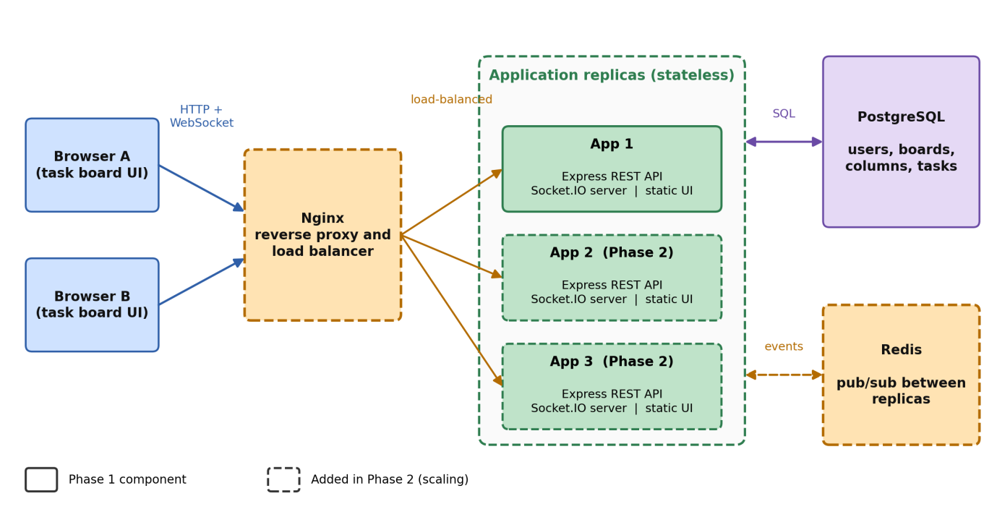
Figure 5-1. System architecture. Components drawn with dashed outlines are added in the scaling phase (Phase 2).
The system was built in two phases. Phase 1 containerizes a single application instance together with its database. Phase 2 adds Nginx and Redis and runs several replicas. Table 5.3 summarizes the role of each component.
Table 5.3. Components of the system.
Component | Role | Phase
Browser (HTML, CSS, JavaScript) | Displays boards, sends API requests, receives real-time events | 1
Application (Express and Socket.IO) | REST API, authentication, authorization, event emission, static files | 1
PostgreSQL | Persistent storage of users, boards, columns, and tasks | 1
Nginx | Reverse proxy, load balancing, WebSocket forwarding, single public entry point | 2
Redis | Publish/subscribe channel that connects the Socket.IO servers of all replicas | 2
Several design decisions follow from the requirement to scale.
The application is stateless. The server keeps no session data in memory. Authentication relies on a signed token that the client sends with every request, so any replica can serve any request. This is the property that makes it possible to add or remove replicas freely.
The database is the single source of truth. Every change is first written to PostgreSQL and only then announced. When a client receives an event, it reloads the board through the REST API instead of patching its local state. This design is simple and guarantees that all clients converge to the state stored in the database, at the price of one extra request per event, which is acceptable for a board of this size.
Events are scoped to rooms and shared through Redis. After each change, the server emits an event to the room of the affected board, and only clients that joined that room receive it. A user connected to replica A and another connected to replica B may be viewing the same board; the Socket.IO Redis adapter forwards every emitted event through Redis so that the clients on both replicas are notified. Without it, an event would reach only the clients attached to the replica that produced it.
WebSocket is used as the only transport. Socket.IO may fall back to HTTP long polling, which sends several requests per session and therefore requires every request of a session to reach the same replica (sticky sessions). Restricting clients to WebSocket keeps the load balancer simple. The configuration is described in Section 6.5.
The sequence of interactions during a typical real-time update is presented in Section 6.6.

Deployment Architecture
The deployment architecture is shown in Figure 5.2. All services run as containers on one Docker host and are defined in a single Compose file. They are attached to a user-defined bridge network named backend, on which Docker's embedded DNS resolves service names, so that the application reaches the database simply as db. Only one service is published to the host: in Phase 1 this is the application port, and in the scaled deployment it is Nginx alone. PostgreSQL and Redis publish no ports and are therefore unreachable from outside the Docker network.
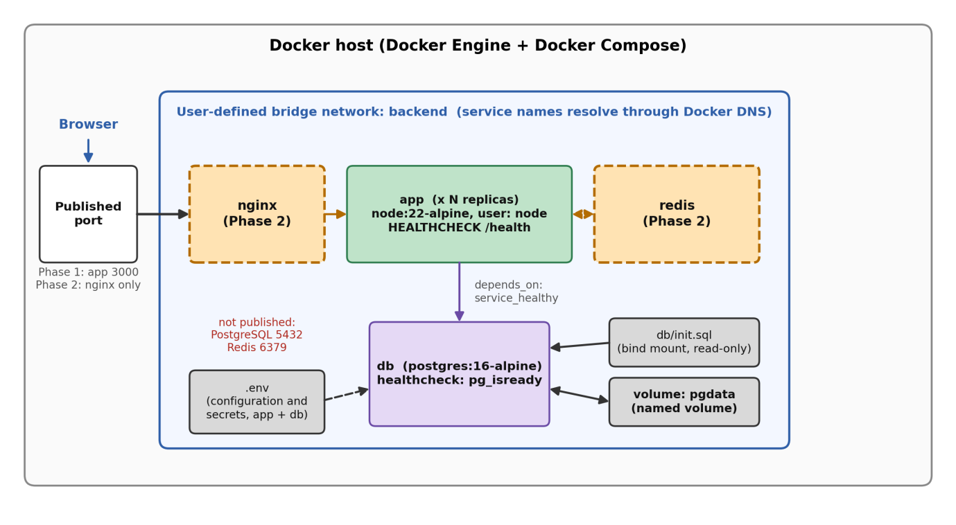
Figure 5-2. Deployment architecture: services, network, volumes, and configuration. Dashed components belong to Phase 2.
Table 5.4 lists the services and their main properties.
Table 5.4. Services of the Compose deployment.
Service | Image | Exposed to the host | Storage and configuration | Health and start-up
app | Built from ./app on node:22-alpine; runs as the non-root user node | Phase 1: configured port (3000); Phase 2: none | Environment variables from .env | HEALTHCHECK calls /health; starts after db is healthy; restart policy unless-stopped
db | postgres:16-alpine | None | Named volume pgdata; db/init.sql mounted read-only into the initialization directory | Health check with pg_isready
nginx (Phase 2) | Official Nginx image | The public port | Configuration file mounted from nginx/ | Starts after the application
redis (Phase 2) | Official Redis image | None | – | Health check with redis-cli ping
Configuration is separated from the images. The .env file defines the database credentials, the connection strings, the port, and the JWT secret; the repository contains only the template .env.example, while .env itself is excluded from version control and from the build context. Persistence relies on the named volume pgdata: removing the containers with docker compose down does not delete it, whereas docker compose down -v does. The SQL script that creates the schema is mounted into the initialization directory of the PostgreSQL image, which executes it only when the data directory is empty, that is, the first time the volume is used.

Database Design
The data model, shown in Figure 5.3, has four tables. A user owns boards, a board contains columns, and a column contains tasks. A task may optionally refer to a user as its assignee.
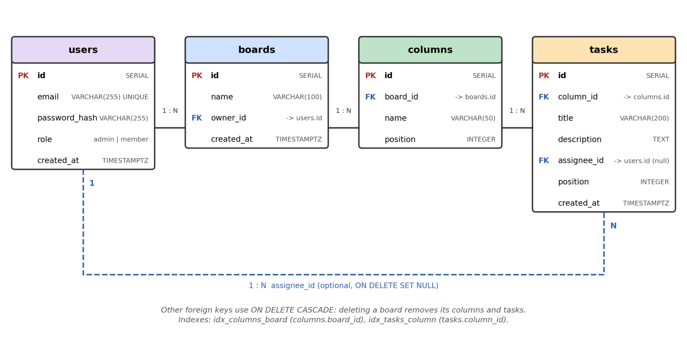
Figure 5-3. Entity-relationship diagram of the database.
Table 5.5. Tables of the database.
Table | Purpose | Main constraints
users | Accounts with hashed password and role | email is unique; role is restricted to admin or member (default member)
boards | Boards with name and owner | owner_id references users; deleting a user deletes the user's boards
columns | Ordered columns of a board | board_id references boards with cascade delete; position defines the order
tasks | Tasks in a column | column_id references columns with cascade delete; assignee_id references users and is set to null if the user is deleted
Foreign keys with cascading deletes keep the data consistent: removing a board removes its columns and tasks in one operation, with no orphaned rows. Two indexes, on columns.board_id and on tasks.column_id, support the queries that load a board. Moving a task is a single update of its column_id. The columns assignee_id and position are part of the schema for future extensions, namely task assignment and manual ordering, but the current interface does not use them.

Technology Stack
The technologies used are summarized in Table 5.6. The choices favor widely used, officially maintained components that have small official container images, so that the focus of the project remains on containerization.
Table 5.6. Technology stack.
Layer | Technology | Version or image | Purpose and reason for the choice
Runtime | Node.js | node:22-alpine | One language for server and browser code; its event-driven model suits many concurrent WebSocket connections; small Alpine-based image
Web framework | Express | npm package | Minimal framework for the REST API and static files
Real-time | Socket.IO | npm package | WebSocket communication with rooms, authentication hooks, and a Redis adapter for multiple servers
Authentication | JWT, bcrypt | jsonwebtoken, bcryptjs | Stateless authentication and password hashing; bcryptjs is pure JavaScript, which avoids native build tools in the image
Database | PostgreSQL | postgres:16-alpine | Relational model with foreign keys, transactions, and advisory locks
Message channel (Phase 2) | Redis | Official image | Lightweight publish/subscribe for sharing events between replicas
Reverse proxy (Phase 2) | Nginx | Official image | Load balancing, WebSocket forwarding, single entry point
Containerization | Docker, Docker Compose | Docker Engine, Compose plugin | Packaging and orchestration of all services
The next chapters describe how this design is implemented: Section 6.2 and Section 6.3 explain the containerization of the application and its database, and Sections 6.5 to 6.7 explain the load balancing, real-time synchronization, and scaling of the application.

Implementation
This chapter explains how the design described in Chapter 5 was turned into a running system. Sections 6.1 to 6.4 cover the first phase of the implementation: the structure of the project, the containerization of the application, its orchestration together with the database using Docker Compose, and the handling of configuration and secrets. Sections 6.5 to 6.8 cover the second phase, in which the system is extended with a load balancer and a message channel and is scaled to several replicas.

Project Structure
The whole system is kept in a single Git repository named docker-task-board, hosted on GitHub. The two phases of the work were developed on separate branches (phase1 and phase2) and merged into the main branch, and both members of the group committed to the same repository. Figure 6.1 shows the layout of the repository, and Table 6.1 describes the role of each item.
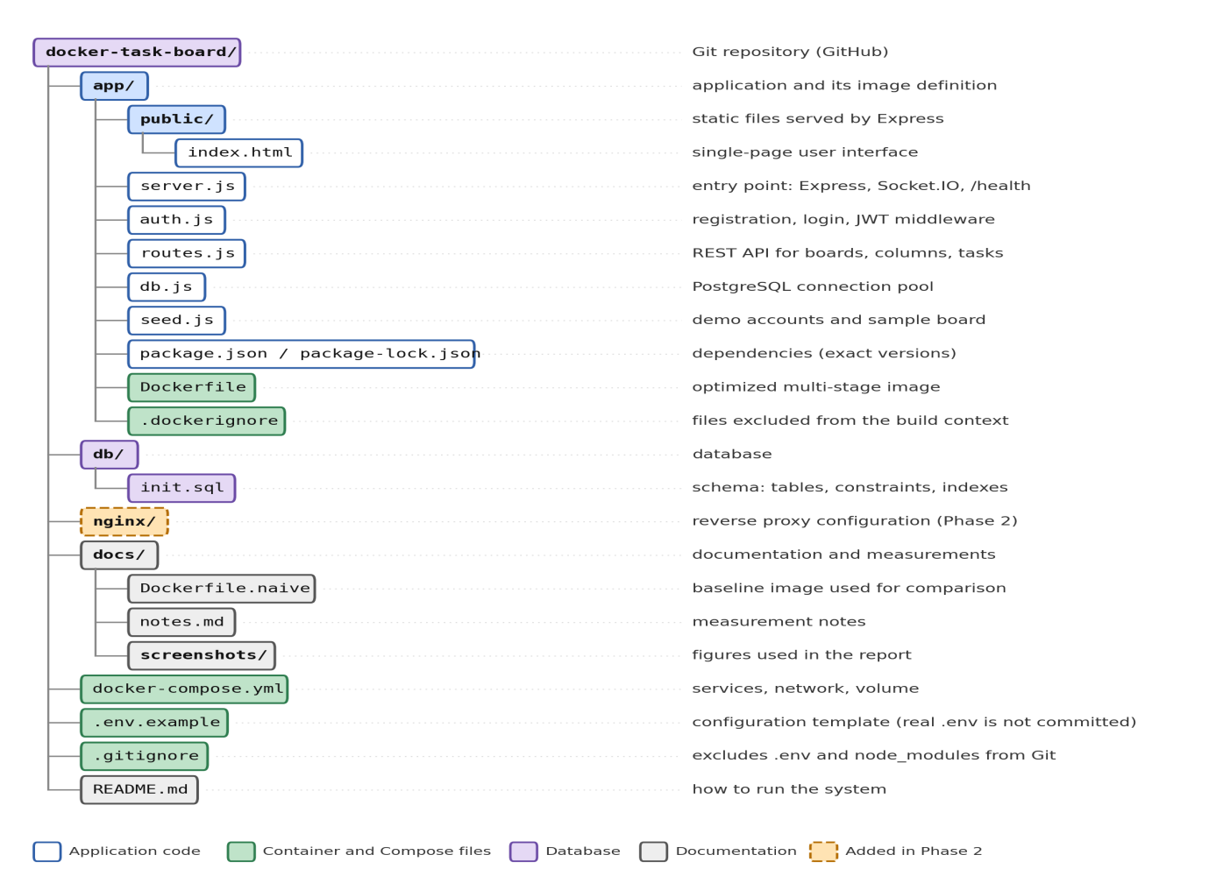
Figure 6-1. Structure of the repository.
Table 6.1. Main items of the repository and their roles.
Item | Role
app/ | Source code of the application and the files that define its container image (Dockerfile, .dockerignore)
app/server.js | Starts the Express server, attaches Socket.IO, exposes GET /health, runs the seed script before accepting requests
app/auth.js, app/routes.js | Authentication and the REST API; every change of a task or column also emits a Socket.IO event
app/seed.js | Creates demo accounts and a sample board if they do not exist
db/init.sql | Creates the tables, constraints, and indexes of Section 5.6
nginx/ | Configuration of the reverse proxy added in Phase 2
docs/ | Baseline Dockerfile, measurement notes, and screenshots used in this report
docker-compose.yml | Declares the services, the network, and the volume
.env.example | Documents every configuration variable with placeholder values; the real .env file is excluded from version control

The application code and the infrastructure code live side by side, but they are separated by directory: everything that is copied into the image is under app/, whereas the files that describe how the containers are connected and configured are at the root of the repository. This separation also determines the build context of the image (the app/ directory), which keeps unrelated files such as the database script and the documentation out of the image.

Containerizing the Application

Baseline and optimized images
The application image was written twice. The first version, kept in docs/Dockerfile.naive, is the shortest definition that works: it starts from the full node:22 image, copies the whole build context, installs the dependencies, and starts the server. It served as a baseline against which the optimized version could be measured. The second version, app/Dockerfile, applies the practices described in Section 2.4. Table 6.2 compares the two.
Table 6.2. Baseline and optimized Dockerfile.
Aspect | Baseline (docs/Dockerfile.naive) | Optimized (app/Dockerfile)
Base image | node:22 (full Debian-based image) | node:22-alpine (minimal Alpine-based image)
Number of stages | 1 | 2 (deps and runtime)
Order of instructions | COPY . . before npm install | package*.json copied first, dependencies installed, source copied last
Dependency installation | npm install | npm ci --omit=dev (exact versions from the lock file, no development packages)
User | root (default) | node (unprivileged user provided by the official image)
Environment | none | NODE_ENV=production
Health check | none | HEALTHCHECK that calls /health
The build flow of the optimized image is shown in Figure 6.2.
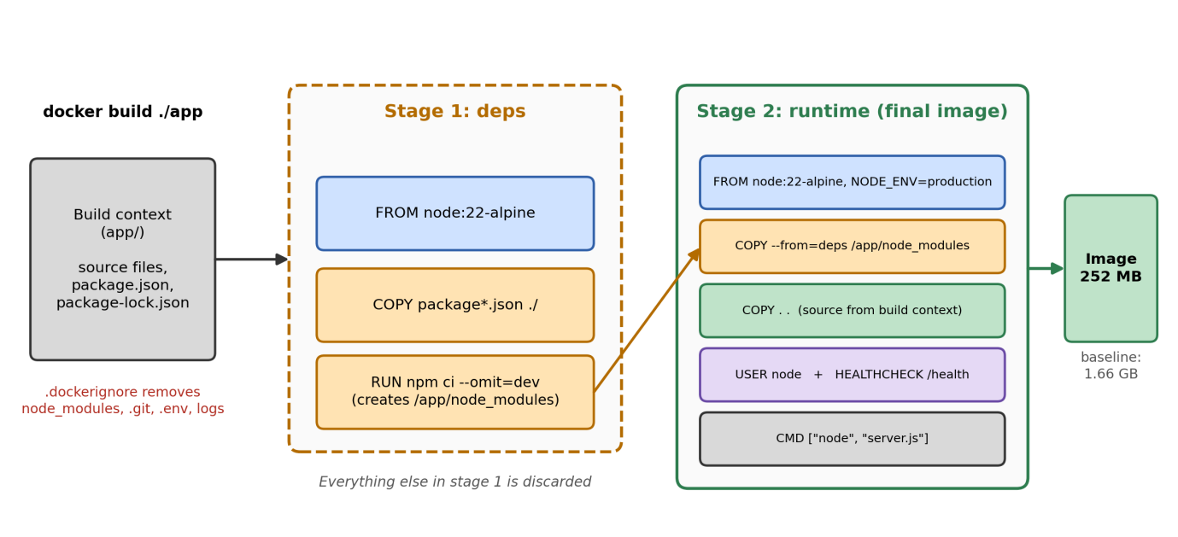
Figure 6-2. Multi-stage build of the application image.
The first stage, deps, starts from node:22-alpine, copies only package.json and package-lock.json, and runs npm ci --omit=dev. It produces a node_modules directory that contains the production dependencies and nothing else. The second stage starts again from node:22-alpine, copies that directory from the first stage, and then copies the application source. The relevant part of the file is shown below.
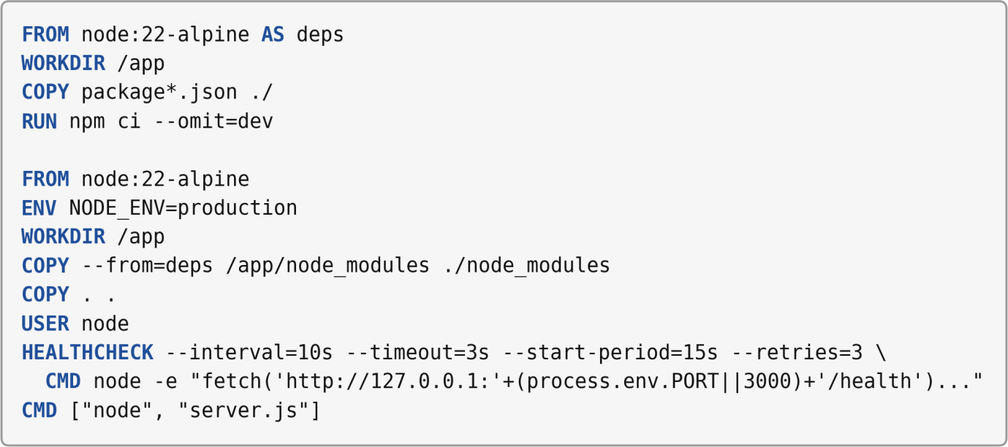
Several decisions in this file deserve explanation.
Layer order and the build cache. Docker reuses a cached layer only if the instruction and its inputs are unchanged, and it invalidates all layers that follow a changed one. In the baseline, COPY . . comes before npm install, so any change to a source file invalidates the dependency layer and forces all packages to be installed again. In the optimized file the dependency layer depends only on package.json and package-lock.json; after a source change, Docker reuses the cached dependency layer and rebuilds only the last copy step.
Reproducible dependencies. npm ci installs exactly the versions recorded in the lock file and fails if the lock file and package.json disagree, which gives the same result on every machine. The option --omit=dev keeps development-only packages out of the image.
Choice of dependencies compatible with a minimal image. Alpine Linux uses a different C library from Debian, and packages with native extensions would need a compiler toolchain to be built inside the image. For this reason the password hashing library bcryptjs, a pure JavaScript implementation, was chosen instead of the native bcrypt package. This avoids installing build tools and keeps the image small.
Role of the two stages. Because the application is written in JavaScript and has no compilation step, the second stage does not discard compilers or intermediate artifacts as it would for a compiled language. In this project the multi-stage structure serves to separate the installation of dependencies from the final image and to make the layer boundaries explicit. The main reduction in size comes from the minimal base image, as the measurements below show.
Security measures. The final stage switches to the unprivileged user node, so that a compromised process does not run with root privileges. The .dockerignore file excludes node_modules, .git, .env, and log files from the build context. Excluding node_modules is necessary for correctness as well as for size, because otherwise COPY . . would overwrite the dependencies installed for Linux in the first stage with the directory from the developer's Windows machine. Excluding .env keeps secrets out of the image.
Health check. The image defines its own health check, which requests /health from inside the container. Alpine-based images do not contain curl, so the check uses the global fetch function of Node.js 22 and reads the port from the environment. Docker reports the result as healthy or unhealthy, and the state is visible in docker ps and docker compose ps.
Start command. The start command uses the exec form (["node", "server.js"]), so that the Node.js process runs directly as the main process of the container and receives stop signals from Docker.

Measured effect of the optimization
Both images were built from the same source code and the same build context, with the base images already pulled so that download time does not distort the results. The image sizes were read from docker images, which reports two figures: the disk usage of the image and its content size. The cold build was measured with docker build --no-cache. The rebuild time was measured after adding a single comment line to server.js, without --no-cache, to simulate a typical code change. Times were measured with the PowerShell Measure-Command cmdlet on the development machine of the group, with Docker Desktop on Windows. Table 6.3 summarizes the results, and Figure 6.3 shows the image sizes as reported by Docker.
Table 6.3. Baseline versus optimized image.
Metric | Baseline | Optimized | Change
Image size, disk usage | 1.66 GB | 252 MB | −85 % (about 6.6 times smaller)
Image size, content size | 415 MB | 62.7 MB | −85 % (about 6.6 times smaller)
Cold build (--no-cache) | 4.3 s | 3.9 s | −9 % (practically unchanged)
Rebuild after a source change | 3.7 s | 1.2 s | −68 % (about 3.1 times faster)
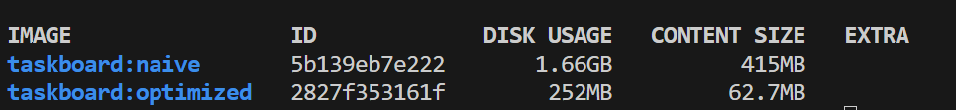
Figure 6-3. Sizes of the baseline (taskboard:naive) and optimized (taskboard:optimized) images.
The results confirm what the design predicts, and they also show the limits of the optimization. The image shrank by about 85 %, almost entirely because of the Alpine base image. Rebuilding after a code change became about three times faster, because the cached dependency layer is reused. The cold build, in contrast, did not improve noticeably: with the base images already available locally and only a few dependencies to install, both builds take only a few seconds, and the extra stage of the optimized file offsets the smaller download. Each value was measured once, so the figures are indicative rather than statistically representative. Because the application has few dependencies, the absolute differences in time are small; the advantage of the layer order would be expected to grow with the number of dependencies.

Verification of the hardened image
After the optimized image was deployed, the user of the main process and the health status were checked. The command docker compose exec app whoami returned node, which confirms that the application does not run as root. docker ps reported the application container as healthy after the start-up period of the health check, and it listed the port mapping of the application only; the database container shows its internal port 5432/tcp without any mapping to the host, which confirms that the database is not reachable from outside the Docker network. Figure 6.4 shows the output.
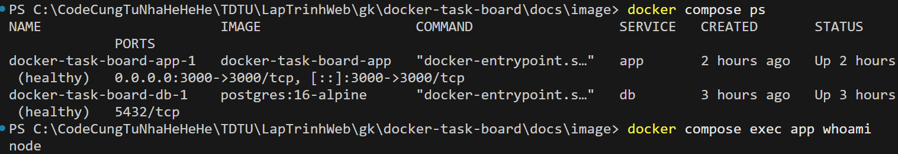
Figure 6-4. Output of docker compose ps and docker compose exec app whoami: both containers are healthy, the application runs as user node, and PostgreSQL is not published to the host.

Orchestrating the Application and the Database with Docker Compose
The application and its database are started together by a single Compose file, which defines two services, one user-defined network, and one named volume. Table 6.4 lists the main settings of each service and the reason for each setting.
Table 6.4. Configuration of the Compose services (Phase 1).
Service | Setting | Purpose
db | Image postgres:16-alpine | Official, minimal PostgreSQL image
db | Variables POSTGRES_USER, POSTGRES_PASSWORD, POSTGRES_DB taken from .env | Creates the database and its owner when the data directory is initialized
db | Named volume pgdata mounted at /var/lib/postgresql/data | Keeps the data when the container is removed
db | db/init.sql mounted read-only into /docker-entrypoint-initdb.d/ | Creates the schema automatically on the first start
db | Health check with pg_isready (every 5 s, timeout 3 s, up to 10 retries) | Reports when the database accepts connections
db | No published port | Makes the database reachable only from the internal network
app | build: ./app and env_file: .env | Builds the image from the Dockerfile of Section 6.2 and passes the configuration
app | depends_on with condition: service_healthy | Starts the application only after the database is ready
app | restart: unless-stopped | Restarts the application if it stops unexpectedly
app | Published port ${PORT}:${PORT} | Exposes the application to the host in Phase 1
both | Network backend | Lets the services reach each other by name
Start-up order. A container that has started is not necessarily ready to work: PostgreSQL needs several seconds to initialize its data directory and to run the schema script. The application runs queries and the seed script as soon as it starts, so it would fail if it started too early. For this reason the database defines a health check and the application waits for the state healthy through depends_on. In the test run shown in Figure 6.5, the database became healthy after about 6.0 s and the application started a fraction of a second later. As an additional safety net, the restart policy restarts the application if it still terminates because of a temporary error.
The health check of the database was refined during testing. The official image first starts a temporary server that listens only on a local socket while it runs the initialization scripts, and then restarts PostgreSQL for normal operation. A check without a host name can therefore report success during this temporary phase, before the database accepts network connections. Adding -h localhost to pg_isready makes the check use a TCP connection and succeed only when the final server is ready.
Network. Compose creates the user-defined bridge network backend (prefixed with the project name) and attaches both services to it. Inside this network the application reaches the database simply as db, the name of the service, which is how the connection string in the configuration is written. Only the application port is published to the host in Phase 1; the database publishes nothing. In the scaled deployment of Phase 2 the application port is no longer published, and Nginx becomes the only entry point (Section 6.5).
Persistence. The data of PostgreSQL is stored in the named volume pgdata, which is managed by Docker and exists independently of the containers. Two behaviors follow from this design and are worth knowing when operating the system. First, docker compose down removes the containers and the network but not the volume, whereas docker compose down -v also removes the volume and therefore all data. Second, the files in /docker-entrypoint-initdb.d/ and the database credentials are used only when the data directory is empty, so a change to init.sql or to the database variables in .env takes effect only after the volume has been removed.
This behavior was verified with a simple test: tasks were created and moved through the API, then docker compose down and docker compose up -d were executed, and the board was read again. As Figure 6.5 shows, the containers and the network were removed and created again, and the board still contained the same tasks in the same columns.

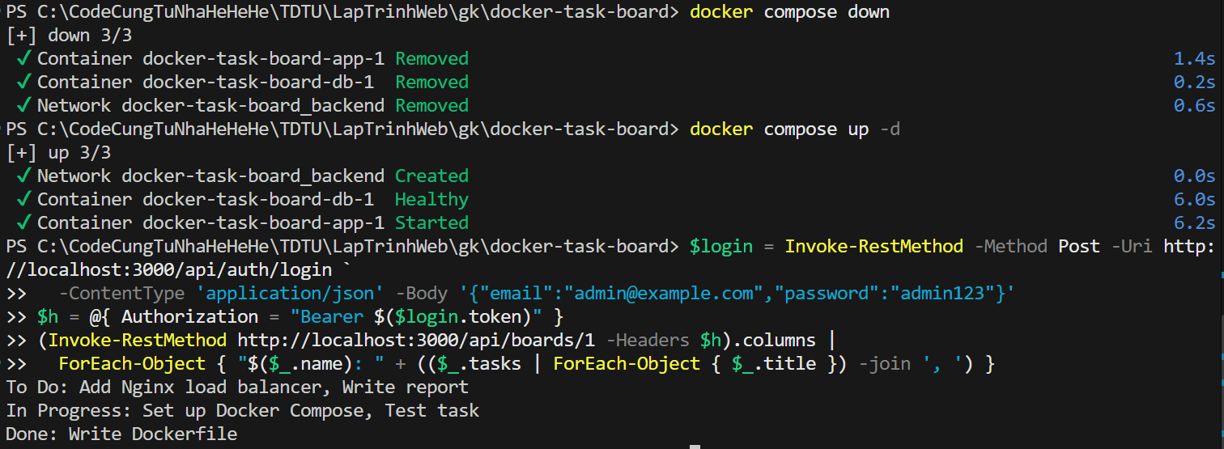
Figure 6-5. Data survives docker compose down followed by docker compose up -d because it is stored in the named volume.
The entire environment, consisting of the image build, the network, the volume, the schema, and the demo data, is reproduced by one command, docker compose up --build, on any machine with Docker. This satisfies the portability and reproducibility requirements NFR1 and NFR2 of Section 5.3.

Configuration and Secrets
All settings that differ between environments are kept out of the image and the source code and are supplied at run time through environment variables. Table 6.5 lists the variables.
Table 6.5. Configuration variables.
Variable | Used by | Purpose
PORT | app, Compose | Port on which the application listens and which is published in Phase 1
NODE_ENV | app | Run mode of the Node.js application (production in the deployment)
POSTGRES_USER, POSTGRES_PASSWORD, POSTGRES_DB | db, Compose | Name and credentials of the database created on the first start
DATABASE_URL | app | Connection string; the host name is the service name db
REDIS_URL | app | Address of Redis, used in Phase 2
JWT_SECRET | app | Secret key used to sign and verify the authentication tokens
The variables are defined in a file named .env at the root of the repository. Compose reads this file for two purposes: to substitute ${...} placeholders in docker-compose.yml (for example the database credentials and the published port), and, through env_file, to pass the variables to the application container. One consequence is that variables from env_file take precedence over ENV instructions of the Dockerfile at run time. This was relevant for NODE_ENV: the image sets it to production, but the value in .env is the one the container actually receives, so .env was updated to the same value.
Three mechanisms keep secrets out of the places where they could leak. The .gitignore file excludes .env from version control, so passwords and the JWT secret are never committed. The .dockerignore file excludes .env from the build context, so they are never baked into an image layer. The repository contains instead the template .env.example, which lists every variable with placeholder values (for example change_me), so that a new user knows what to define and copies the file to .env before the first start.
This approach has limits, which should be understood. Environment variables can be read by anyone who has access to the Docker daemon (for example with docker inspect), and the demo accounts created by the seed script have simple passwords that are documented for demonstration purposes. For a production deployment, the placeholders must be replaced by strong secrets, the demo accounts must be removed or changed, and the secrets should be provided by a dedicated mechanism such as Docker secrets or an external secret manager, as noted in Section 2.8.

Results and Evaluation
This chapter evaluates the deployment described in Chapter 6. The evaluation has four parts: a check that the application works as a whole, a test of load balancing, a test of real-time synchronization across replicas, and a test of the behavior when one replica fails. It ends with a load test that compares one replica with three replicas, an assessment of the requirements of Chapter 5, and a discussion of the limits of the results. The values and observations marked in yellow are to be replaced with the data of the final test run.

Test Environment and Method
All Phase 2 tests were run on one development machine whose configuration is given in Table 7.1. The system was started from a clean state with docker compose down -v followed by docker compose up --build -d, so that every test began with the demo data created by the seed script. The version of the repository used for the tests is identified by the commit commit hash on the branch main.
Table 7.1. Test environment.
Item | Value
Processor and memory | CPU model, number of cores, RAM
Operating system | for example Windows 11, version
Docker | Docker Desktop version, Docker Engine version, Compose version
Resources given to Docker | CPUs and memory configured in Docker Desktop or WSL 2
Images | node:22-alpine, postgres:16-alpine, redis:7-alpine, nginx:1.29-alpine, grafana/k6:version
Browsers | browser names and versions

Demonstration of the Application
Figure 7.1 shows the user interface in the scaled deployment, reached through Nginx at http://localhost:8080. The user signed in as a member and opened the sample board with its three columns. Each task card has buttons to move it to the previous or next column and to delete it, and each column has a field for a new task. The header shows two items that were added for the evaluation: the label "served by", which displays the hostname of the container that answered the last request to /health, and the indicator "live", which shows that the WebSocket connection is open.
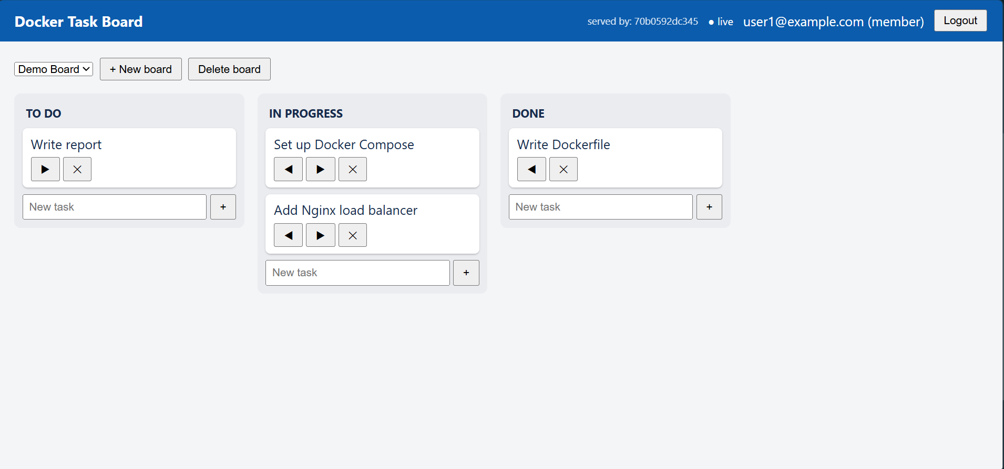
Figure 7-1. User interface of Docker Task Board with the "served by" and "live" indicators.

Load Balancing across Replicas
To check that Nginx distributes requests among the replicas, the system was scaled to three replicas and thirty requests were sent to /health, one after another, with the command of Section 6.7. Every response contains the field host, the hostname of the container that served the request, so counting the values shows how the requests were distributed. Figure 7.2 shows the output, and Table 7.2 summarizes it.
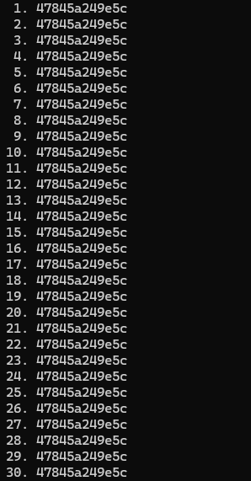
Figure 7-2. Hostnames returned by 30 requests to /health through Nginx with three replicas.
Table 7.2. Distribution of 30 requests among three replicas.
Replica (value of host) | Requests | Share
hostname of replica 1 | n | %
hostname of replica 2 | n | %
hostname of replica 3 | n | %

All three replicas answered requests, and the distribution was close to even. With sequential requests, each replica has no active connection when the next request arrives, so least_conn chooses among equal candidates in turn, and a nearly even distribution is expected. Under concurrent load the share of a replica depends on its number of open connections. After the number of replicas was raised from one to three while Nginx was running, all new replicas appeared in the responses after about N seconds, without restarting Nginx; this confirms the effect of the resolve parameter and the five-second resolver validity of Section 6.5.

Real-Time Synchronization across Replicas
The synchronization was tested with three replicas and two or more browser sessions, as described in the README. Two users, user1@example.com and user2@example.com, signed in in separate browser profiles and opened the same board. In one window a task was created, moved to the next column, and deleted; in the other window the observer watched the board without reloading the page. The test cases and results are listed in Table 7.3, and Figure 7.3 shows the two windows.
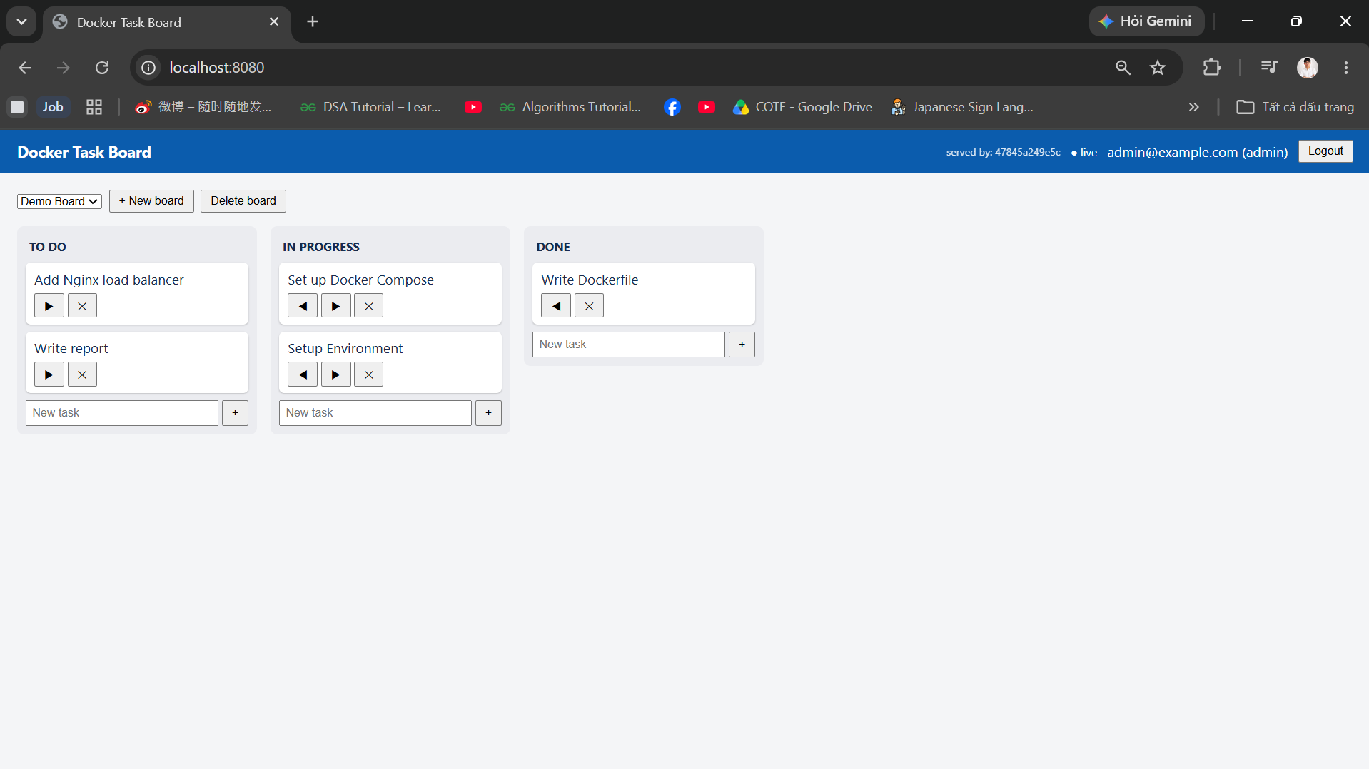

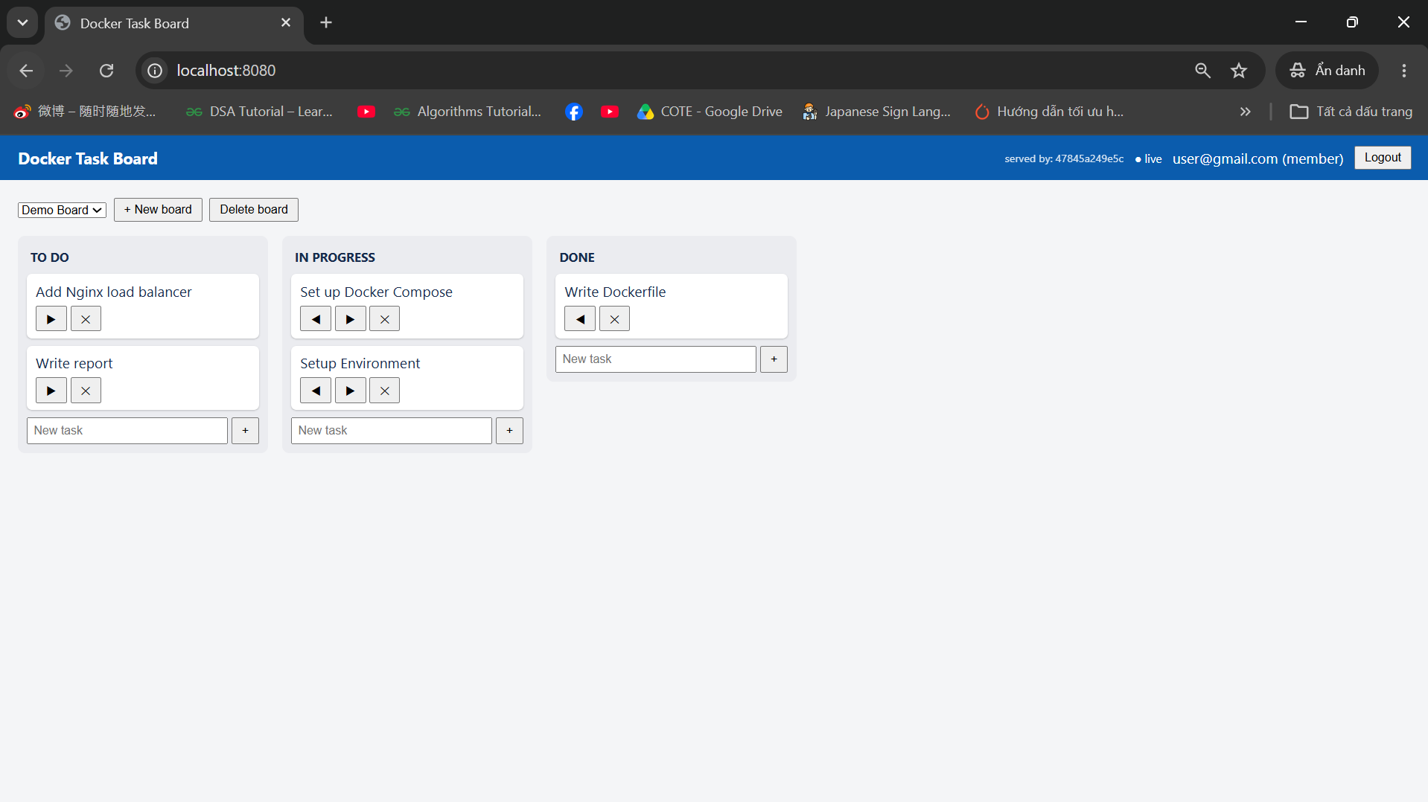
Figure 7-3. Two browser sessions on the same board; a change in one window appears in the other.
Table 7.3. Test cases for real-time synchronization with three replicas.
Case | Action in window A | Result in window B (no reload)
Create | Add the task "title" to To Do | The task appeared within about one second
Move | Move the task to In Progress | The task changed column
Delete | Delete the task | The task disappeared
Reverse direction | Repeat the three actions in window B and watch window A | Same result

An important detail is where the connections were placed. The application does not log which replica holds which WebSocket connection, and the label "served by" shows the replica that answered a REST request, not the replica of the socket. Therefore the test was repeated with number browser sessions, and Nginx, which assigns each new connection to the replica with the fewest connections, spreads them over the three replicas. Because the sessions of a test of this size are distributed over several replicas, a change made in one session that reaches all the others is evidence that the events crossed the boundaries between replicas through Redis; without the adapter, only the sessions on the same replica would have been updated. Optional: if a log line with the hostname was added to the connection handler, cite its output here as direct evidence.

Behavior when a Replica Stops
The resilience test follows Section 6.7. With three replicas running and a browser session open, one application container was stopped with docker stop, while /health was requested repeatedly and the board was used. Afterwards the replica was restored with docker compose up -d --scale app=3. Table 7.4 lists the steps and observations, and Figure 7.4 shows the container state after the failure.
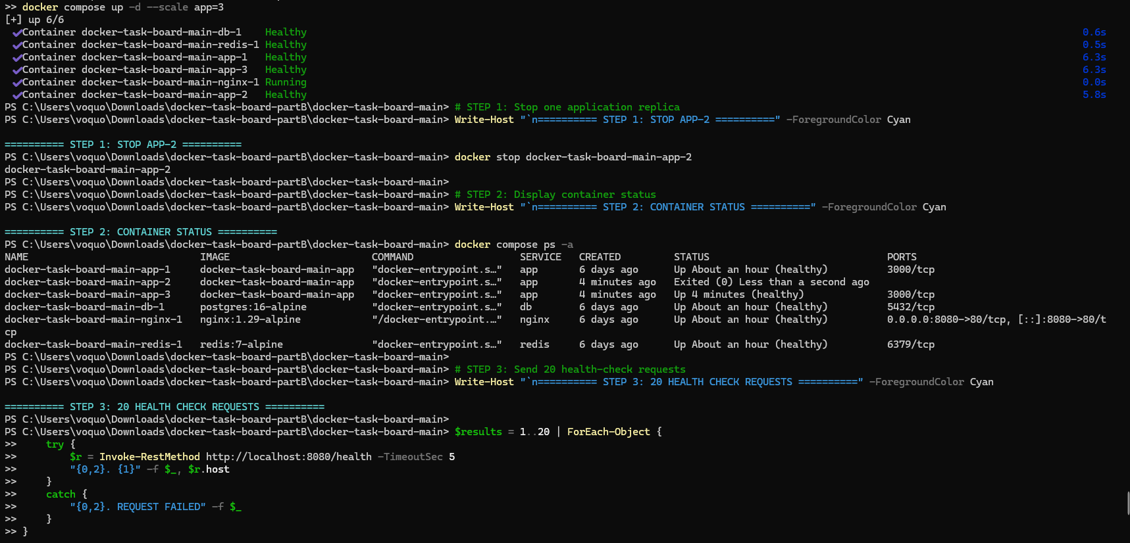
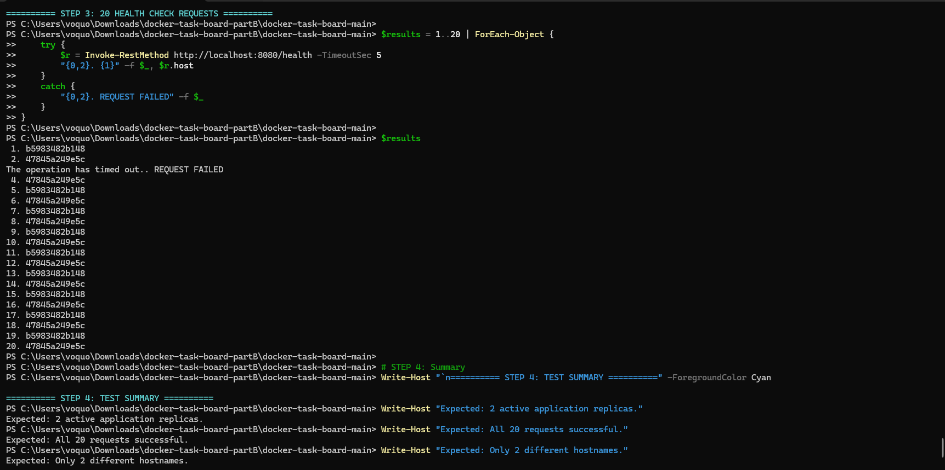
Figure 7-4. State of the system after one application replica was stopped.
Table 7.4. Failure and recovery of one application replica.
Step | Action | Observation
1 | docker stop on one app container | Requests to /health kept returning HTTP 200; N requests failed before Nginx stopped using the stopped replica
2 | Browser session that was connected to the stopped replica | Indicator changed to "offline" and back to "live" within about N seconds; the board stayed usable
3 | Create a task in another session | The task appeared in the reconnected session
4 | docker compose up -d --scale app=3 | Three host values appeared again after about N seconds

The behavior agrees with the design. Requests are not sent to the stopped replica once the DNS answer of Docker no longer contains it, which takes at most the validity of five seconds configured for the resolver, and a request that was in flight on the stopped replica can fail during this short period. The Socket.IO client reconnects automatically, Nginx assigns the new connection to a remaining replica, and the interface joins the board room again in its connect handler, so real-time updates resume. Because the replica was stopped by an operator, the restart policy did not restart it; it had to be restored with the scale command (Section 6.7).

Performance of One versus Three Replicas
The load test of Section 6.8 was run for one replica and for three replicas under the same conditions. Each configuration was measured three times with N virtual users for 60 s, and the mean of the runs is reported in Table 7.5 together with the range. The number of virtual users was chosen so that one replica was saturated, as explained in Section 6.8. Between the two configurations only the number of replicas changed, with docker compose up -d --scale app=N.
Table 7.5. Load test results for one and three application replicas.
Metric | 1 replica | 3 replicas | Change
Throughput (requests per second) | value | value | %
Mean response time (ms) | value | value | %
95th percentile of response time (ms) | value | value | %
Failed requests (%) | value | value | –
Failed checks | value | value | –
First time:
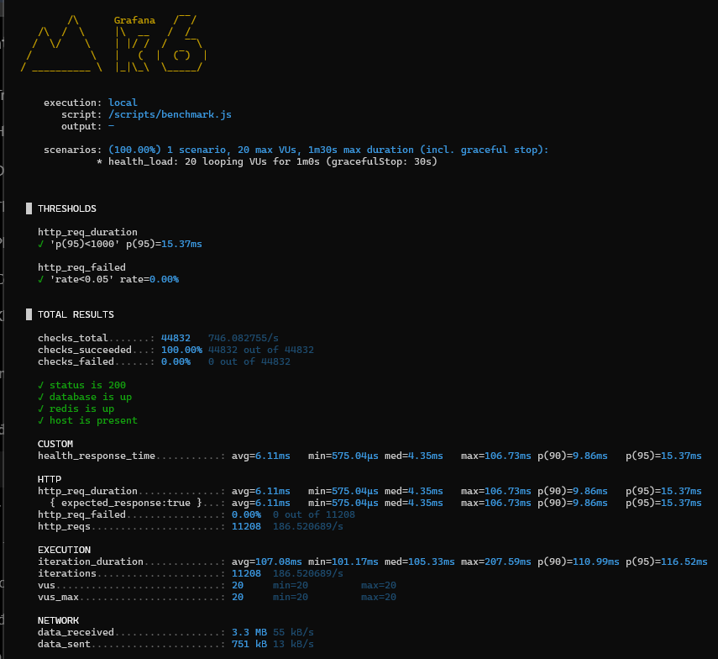
Second time:
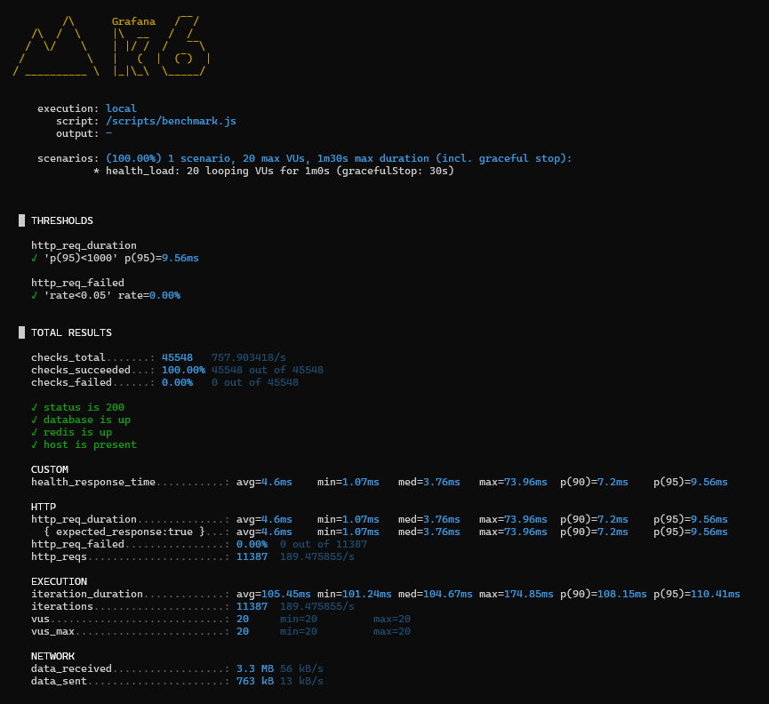
Third time:
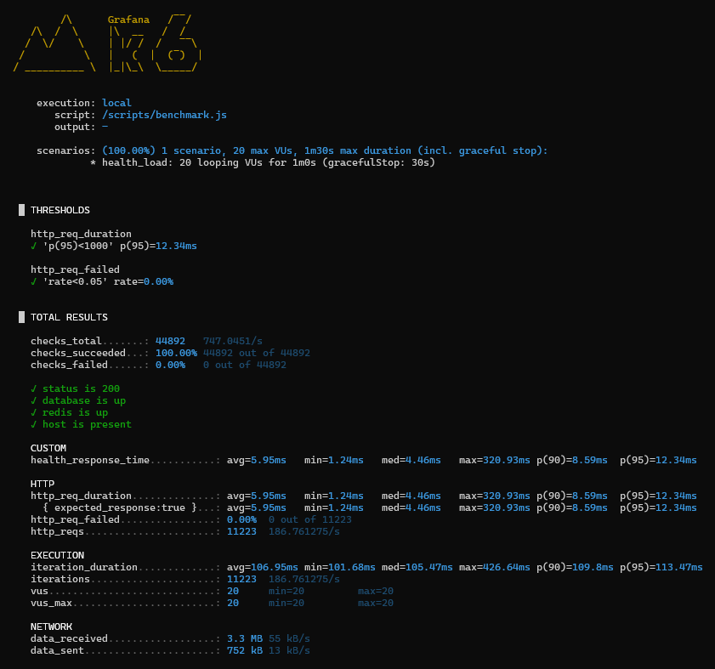
Figure 7-5. Summary printed by k6 for a run with three replicas.
Replace with the observed outcome, for example: With three replicas the throughput increased from X to Y requests per second and the 95th percentile of the response time fell from A to B ms; no request failed. The size of the improvement must be interpreted with the conditions of the test in mind. A Node.js process runs the application code on a single thread, so additional replicas can use additional processor cores, but only if the machine has free cores. In this test the load generator, Nginx, three replicas, PostgreSQL, and Redis all ran on the same machine and in the same virtual machine of Docker Desktop, so they competed for the same processor. Moreover, every request of /health also queries PostgreSQL and Redis, which are single instances shared by all replicas. A result with a small or no improvement therefore would not mean that the deployment is wrong; it would show that another component, here the shared processor or the database, became the bottleneck. Horizontal scaling gives the largest gain when the replicas run on separate hosts and the shared services are not saturated.

Evaluation against the Requirements
Table 7.6 compares the results with the non-functional requirements of Section 5.3 and with the functional requirements that are affected by Phase 2.
Table 7.6. Fulfilment of the requirements.
ID | Requirement | Evidence | Result
FR11 | Real-time synchronization | Sessions on different replicas stayed synchronized (Section 7.4, Table 7.3) | Met
FR12 | Health reporting | /health reports database, Redis, and hostname, and answers 503 on failure (Sections 6.6, 7.3) | Met
FR13 | Demo data | Three replicas started at once; the advisory lock created the demo data once (confirm: one admin, two members, one board) | Met
NFR1 | Portability | One command, docker compose up --build, starts all services without a local Node.js or PostgreSQL | Met
NFR2 | Reproducibility | Official base images, configuration in environment variables, one repository | Met
NFR3 | Persistence | Data survived docker compose down and up -d (Figure 6.5) | Met
NFR4 | Security and isolation | Only Nginx publishes a port (Figure 6.8); application runs as node (Figure 6.4); .env kept out of images and Git | Met
NFR5 | Scalability | Stateless replicas behind Nginx with Redis (Sections 7.3, 7.4, 7.6) | Met
NFR6 | Observability and recovery | Health checks and depends_on; the restart policy restarts exited containers, but an unhealthy container is only reported | Partly met

Only NFR6 is not fully met, because Compose reports an unhealthy container but does not replace it, and a replica stopped by an operator is not restarted automatically. Both functions are provided by Swarm and Kubernetes, which supports the discussion of Chapter 3.

Limitations and Threats to Validity
The results should be read with several limits in mind. All tests ran on one machine, so the measurements show the behavior of the deployment on that machine only, and the numbers of Phase 1 (Section 6.2.2) were measured on a different machine than those of Phase 2 and should not be compared with them. Each Phase 1 value was measured once, and the Phase 2 values come from a small number of runs, so the figures are indicative rather than statistically representative. The load test requests only /health; it does not include writes, authentication, or WebSocket traffic, so it does not predict the capacity of the application under real use.
The architecture has three single points of failure: Nginx, Redis, and PostgreSQL each run as one container, so the loss of any of them stops the application or its real-time function, although the data in PostgreSQL remain safe in the volume. Redis publish/subscribe does not store events, so a replica that is disconnected from Redis can miss updates until the browser reloads the board. Transport security is not implemented: traffic between the browser and Nginx is unencrypted HTTP, and the demo accounts and the example secrets in .env.example are suitable only for a local demonstration. Finally, the evaluation covers Docker Compose only; Kubernetes and an automated build pipeline were not implemented, as stated in Section 1.4.

Conclusion and Future Work

Conclusion
This project studied how containers support the development and deployment of a multi-component web application. The theoretical chapters showed that containers combine the isolation mechanisms of the Linux kernel with a layered image format and a simple workflow, and that orchestration tools extend this workflow to the management of several services and replicas. The comparative analysis justified the choices of containers over virtual machines, Docker over other tools, Compose over Swarm and Kubernetes for a single host, Nginx as the entry point, and the Redis adapter for sharing real-time events.
The practical part confirmed these ideas with the Docker Task Board application. In the first phase, a multi-stage build on a minimal base image reduced the application image by about 85 %, from 1.66 GB to 252 MB, and shortened the rebuild after a code change from 3.7 s to 1.2 s because the dependency layer is cached. The container runs as an unprivileged user, the database is reachable only inside the Docker network, secrets are kept out of images and the repository, and the whole system, including the schema and the demo data, starts with one command and keeps its data in a named volume.
The second phase showed that scaling is a property of the whole design and not only of the number of containers. The application had to be stateless, to keep its state in PostgreSQL, and to share its real-time events through Redis, and Nginx had to discover replicas at run time and proxy WebSocket connections. With these elements, three replicas served requests behind one entry point, clients attached to different replicas stayed synchronized, and the system continued to work when one replica was stopped. Add one sentence with the main performance result of Section 7.6. The evaluation also showed the limits of the approach: Compose scales manually and on one host, shared services remain single points of failure, and only some failures are repaired automatically.
Overall, the objectives of Section 1.3 were achieved. The report documented the theory, the design, the implementation, and the evaluation of a containerized web application, and the repository allows every result to be reproduced on any machine with Docker.

Future Work
Several extensions would address the limits found in this work. The first is to deploy the application on Kubernetes, with a Deployment for the application, a Service and an Ingress for the entry point, ConfigMaps and Secrets for configuration, probes for health, and a HorizontalPodAutoscaler for automatic scaling; because the application is stateless and uses standard components, the images would remain unchanged. The second is a continuous integration (CI) pipeline, for example with GitHub Actions, that runs the tests, builds the image, scans it for vulnerabilities with a tool such as Trivy, and publishes it to a registry.
The third group concerns reliability and security: replication or managed services for PostgreSQL and Redis, the Redis Streams adapter so that events missed during an outage can be recovered, TLS termination in Nginx, Docker secrets or an external secret manager instead of environment variables, resource limits and a read-only root file system for the containers, and removal of the demo accounts. The fourth is observability, with metrics from the application and Nginx collected by Prometheus and shown in Grafana, and structured logs. Finally, the evaluation could be extended with a load test that includes authenticated writes and WebSocket clients and is run on several hosts, and the application could be extended with drag and drop, a user interface for column management, and the task assignment that is already prepared in the database schema.

REFERENCES
[1] B. Burns, B. Grant, D. Oppenheimer, E. Brewer, and J. Wilkes, "Borg, Omega, and Kubernetes," ACM Queue, vol. 14, no. 1, pp. 70–93, 2016.
[2] Docker Inc., "Docker Compose overview," Docker Docs. [Online]. Available: https://docs.docker.com/compose/
[3] Docker Inc., "Swarm mode overview," Docker Docs. [Online]. Available: https://docs.docker.com/engine/swarm/
[4] I. Fette and A. Melnikov, "The WebSocket Protocol," IETF, RFC 6455, Dec. 2011.
[5] Grafana Labs, "Grafana k6 documentation." [Online]. Available: https://grafana.com/docs/k6/latest/
[6] HAProxy Technologies, "HAProxy documentation." [Online]. Available: https://docs.haproxy.org/
[7] D. Merkel, "Docker: Lightweight Linux containers for consistent development and deployment," Linux Journal, no. 239, Mar. 2014.
[8] NGINX, "Module ngx_http_upstream_module." [Online]. Available: https://nginx.org/en/docs/http/ngx_http_upstream_module.html
[9] NGINX, "NGINX as a WebSocket proxy." [Online]. Available: https://nginx.org/en/docs/http/websocket.html
[10] NGINX, "Using nginx as HTTP load balancer." [Online]. Available: https://nginx.org/en/docs/http/load_balancing.html
[11] Podman Project, "Podman documentation." [Online]. Available: https://podman.io/docs
[12] PostgreSQL Global Development Group, "NOTIFY," PostgreSQL Documentation. [Online]. Available: https://www.postgresql.org/docs/current/sql-notify.html
[13] Redis Ltd., "Pub/sub," Redis Documentation. [Online]. Available: https://redis.io/docs/latest/develop/interact/pubsub/
[14] Socket.IO, "Using multiple nodes," Socket.IO Documentation. [Online]. Available: https://socket.io/docs/v4/using-multiple-nodes/
[15] Socket.IO, "Redis adapter," Socket.IO Documentation. [Online]. Available: https://socket.io/docs/v4/redis-adapter/
[16] The Kubernetes Authors, "Kubernetes documentation: Concepts." [Online]. Available: https://kubernetes.io/docs/concepts/
[17] Traefik Labs, "Docker provider," Traefik Documentation. [Online]. Available: https://doc.traefik.io/traefik/providers/docker/

