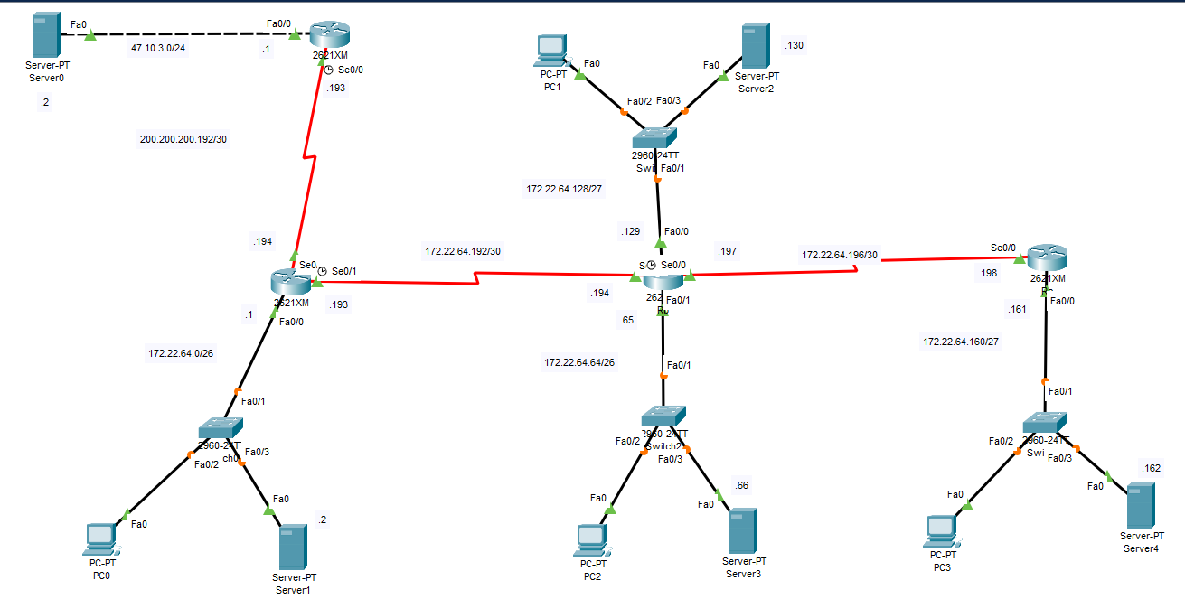
Routing case study1 : Private address: 172.22.64.0/18
Net1 40 hosts 172.22.64.0/26 255.255.255.192
Net2 40 hosts 172.22.64.64/26 255.255.255.192
Net3 20 hosts 172.22.64.128/27 255.255.255.224
Net4 20 hosts 172.22.64.160/27 255.255.255.224
Net5 2 hosts 172.22.64.192/30 255.255.255.252
Net6 2 hosts 172.22.64.196/30 255.255.255.252
CẤU HÌNH ROUTER ISP
enable
conf t
hostname ISP
interface fa0/0
ip address 47.10.3.1 255.255.255.0
no shutdown
interface s0/0
ip address 200.200.200.193 255.255.255.252
clock rate 2000000
no shutdown
ip route 172.22.64.0 255.255.192.0 200.200.200.194
CẤU HÌNH ROUTER Ra
enable
conf t
hostname Ra
interface fa0/0
ip address 172.22.64.1 255.255.255.192
no shutdown
interface s0/0
ip address 200.200.200.194 255.255.255.252
no shutdown
interface s0/1
ip address 172.22.64.193 255.255.255.252
clock rate 2000000
no shutdown
! Default route ra ISP
ip route 0.0.0.0 0.0.0.0 200.200.200.193
router rip
version 2
network 172.22.0.0
default-information originate
CẤU HÌNH ROUTER Rb
enable
conf t
hostname Rb
interface fa0/0
ip address 172.22.64.129 255.255.255.224
no shutdown
interface fa0/1
ip address 172.22.64.65 255.255.255.192
no shutdown
interface s0/1
ip address 172.22.64.194 255.255.255.252
no shutdown
interface s0/0
ip address 172.22.64.197 255.255.255.252
clock rate 2000000
no shutdown
router rip
version 2
network 172.22.0.0
CẤU HÌNH ROUTER Rc
enable
conf t
hostname Rc
interface fa0/0
ip address 172.22.64.161 255.255.255.224
no shutdown
interface s0/0
ip address 172.22.64.198 255.255.255.252
no shutdown
router rip
version 2
network 172.22.0.0
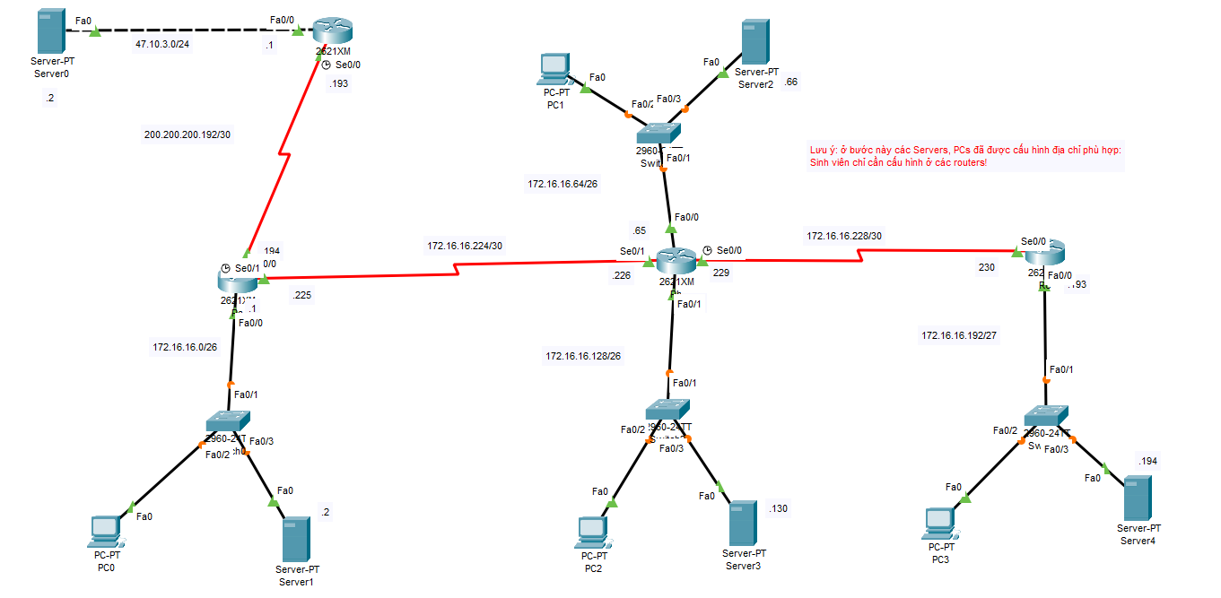
Routing case study2 : Private address: 172.16.16.0/24
Net1 40 hosts 172.22.64.0 /26 255.255.255.192
Net2 40 hosts 172.22.64.64 /26 255.255.255.192
Net3 20 hosts 172.22.64.128 /27 255.255.255.224
Net4 20 hosts 172.22.64.160 /27 255.255.255.224
Net5 2 hosts 172.22.64.192 /30 255.255.255.252
Net6 2 hosts 172.22.64.196 /30 255.255.255.252
CẤU HÌNH ROUTER ISP
enable
conf t
hostname ISP
interface fa0/0
ip address 47.10.3.1 255.255.255.0
no shutdown
interface s0/0
ip address 200.200.200.193 255.255.255.252
clock rate 2000000
no shutdown
ip route 172.16.16.0 255.255.255.0 200.200.200.194
CẤU HÌNH ROUTER Ra
enable
conf t
hostname Ra
interface fa0/0
ip address 172.16.16.1 255.255.255.192
no shutdown
interface s0/0
ip address 200.200.200.194 255.255.255.252
no shutdown
interface s0/1
ip address 172.16.16.225 255.255.255.252
clock rate 2000000
no shutdown
! Default route ra ISP
ip route 0.0.0.0 0.0.0.0 200.200.200.193
router rip
version 2
network 172.16.16.0
default-information originate
CẤU HÌNH ROUTER Rb
enable
conf t
hostname Rb
interface fa0/0
ip address 172.16.16.65 255.255.255.192
no shutdown
interface fa0/1
ip address 172.16.16.129 255.255.255.192
no shutdown
interface s0/1
ip address 172.16.16.226 255.255.255.252
no shutdown
interface s0/0
ip address 172.16.16.229 255.255.255.252
clock rate 2000000
no shutdown
router rip
version 2
network 172.16.16.0
CẤU HÌNH ROUTER Rc
enable
conf t
hostname Rc
interface fa0/0
ip address 172.16.16.193 255.255.255.224
no shutdown
interface s0/0
ip address 172.16.16.230 255.255.255.252
no shutdown
router rip
version 2
network 172.16.16.0

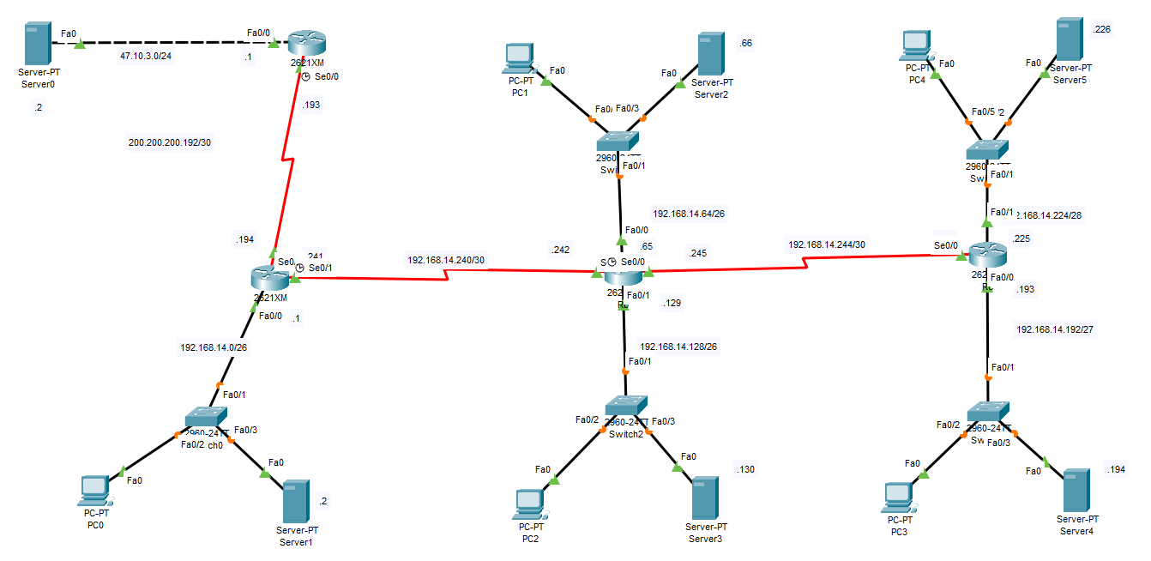
Routing case study3 : Private address: 192.168.14.0/24
Net1 55 hosts 192.168.14.0/26 255.255.255.192
Net2 50 hosts 192.168.14.64/26 255.255.255.192
Net3 45 hosts 192.168.14.128/26 255.255.255.192
Net4 25 hosts 192.168.14.192/27 255.255.255.224
Net5 14 hosts 192.168.14.224/28 255.255.255.240
Net6 2 hosts 192.168.14.240/30 255.255.255.252
Net7 2 hosts 192.168.14.244/30 255.255.255.252
CẤU HÌNH ROUTER ISP
enable
conf t
hostname ISP
interface fa0/0
ip address 47.10.3.1 255.255.255.0
no shutdown
interface s0/0
ip address 200.200.200.193 255.255.255.252
clock rate 2000000
no shutdown
ip route 192.168.14.0 255.255.255.0 200.200.200.194
CẤU HÌNH ROUTER Ra
enable
conf t
hostname Ra
interface fa0/0
ip address 192.168.14.1 255.255.255.192
no shutdown
interface s0/0
ip address 200.200.200.194 255.255.255.252
no shutdown
interface s0/1
ip address 192.168.14.241 255.255.255.252
clock rate 2000000
no shutdown
! Default route ra ISP
ip route 0.0.0.0 0.0.0.0 200.200.200.193
router rip
version 2
network 192.168.14.0
default-information originate
CẤU HÌNH ROUTER Rb
enable
conf t
hostname Rb
interface fa0/0
ip address 192.168.14.65 255.255.255.192
no shutdown
interface fa0/1
ip address 192.168.14.129 255.255.255.192
no shutdown
interface s0/1
ip address 192.168.14.242 255.255.255.252
no shutdown
interface s0/0
ip address 192.168.14.245 255.255.255.252
clock rate 2000000
no shutdown
router rip
version 2
network 192.168.14.0
CẤU HÌNH ROUTER Rc
enable
conf t
hostname Rc
interface fa0/0
ip address 192.168.14.193 255.255.255.240
no shutdown
interface fa0/1
ip address 192.168.14.225 255.255.255.240
no shutdown
interface s0/0
ip address 192.168.14.246 255.255.255.252
no shutdown
router rip
version 2
network 192.168.14.0

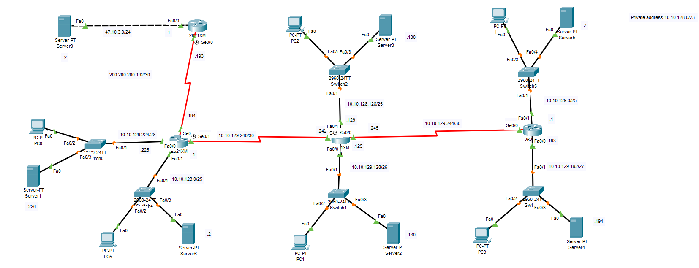
Routing case study4 : Private address: 10.10.128.0/23
Net1 125 hosts 10.10.128.0/25 255.255.255.128
Net2 125 hosts 10.10.128.128/25 255.255.255.128
Net3 120 hosts 10.10.129.0/25 255.255.255.128
Net4 60 hosts 10.10.129.128/26 255.255.255.192
Net5 30 hosts 10.10.129.192/27 255.255.255.224
Net6 14 hosts 10.10.129.224/28 255.255.255.240
Net7 2 hosts 10.10.129.240/30 255.255.255.252
Net8 2 hosts 10.10.129.244/30 255.255.255.252
CẤU HÌNH ROUTER ISP
enable
conf t
hostname ISP
interface fa0/0
ip address 47.10.3.1 255.255.255.0
no shutdown
interface s0/0
ip address 200.200.200.193 255.255.255.252
clock rate 2000000
no shutdown
ip route 10.10.128.0 255.255.254.0 200.200.200.194
CẤU HÌNH ROUTER Ra
enable
conf t
hostname Ra
interface fa0/1
ip address 10.10.128.1 255.255.255.128
no shutdown
interface fa0/0
ip address 10.10.129.225 255.255.255.240
no shutdown
interface s0/0
ip address 200.200.200.194 255.255.255.252
no shutdown
interface s0/1
ip address 10.10.129.241 255.255.255.252
clock rate 2000000
no shutdown
! Default route ra ISP
ip route 0.0.0.0 0.0.0.0 200.200.200.193
router rip
version 2
network 10.0.0.0
default-information originate
CẤU HÌNH ROUTER Rb
enable
conf t
hostname Rb
interface fa0/1
ip address 10.10.128.129 255.255.255.128
no shutdown
interface fa0/0
ip address 10.10.129.129 255.255.255.192
no shutdown
interface s0/1
ip address 10.10.129.242 255.255.255.252
no shutdown
interface s0/0
ip address 10.10.129.245 255.255.255.252
clock rate 2000000
no shutdown
router rip
version 2
network 10.0.0.0
CẤU HÌNH ROUTER Rc
enable
conf t
hostname Rc
interface fa0/1
ip address 10.10.129.1 255.255.255.128
no shutdown
interface fa0/0
ip address 10.10.129.193 255.255.255.224
no shutdown
interface s0/0
ip address 10.10.129.246 255.255.255.252
no shutdown
router rip
version 2
network 10.0.0.0

