1. RightTriangle
a) Problem Analysis Chart (PAC)
Given Data | Required Results
Length of side a  Length of side b | Perimeter  Area
Processing Required | Solution Alternative
c = sqrt(a*a + b*b)  Perimeter = a + b + c  Area = 0.5 * a * b | 1. Define the length of two sides (a and b) as constants.  2. Define the length of two sides (a and b) as input values.

b) Input Process Output (IPO)
Input | Processing | Module Reference | Output
a  b | 1. Enter a  2. Enter b  3. Calculate c  4. Calculate Perimeter  5. Calculate Area  6. Print Perimeter  7. Print Area  8. End | - | Perimeter  Area

c) Flowchart
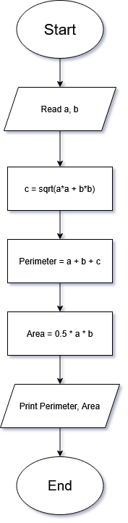
d) Pseudocode

Start
Read a, b
c = sqrt((a*a) + (b*b))
Perimeter = a + b + c
Area = 0.5 * a * b
Print Perimeter, Area
End

e) Java code
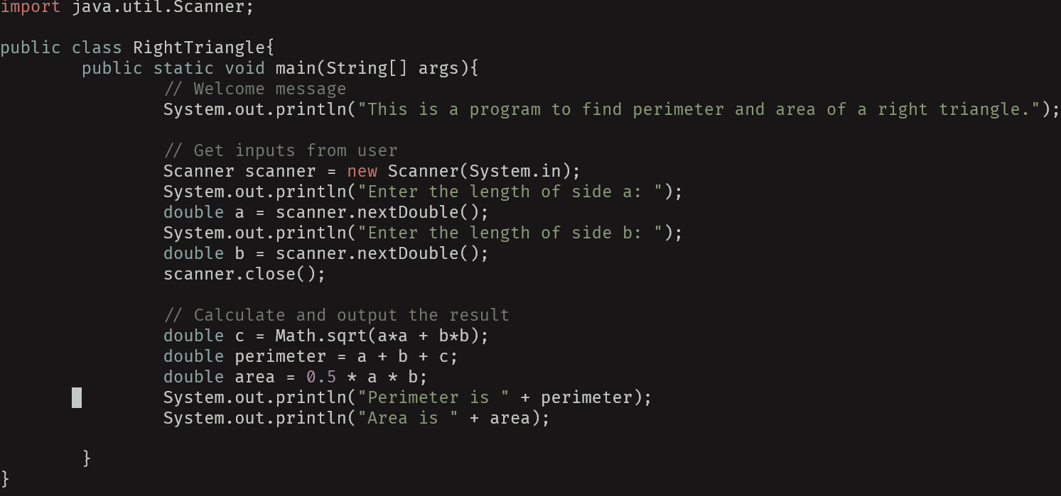

2. Rectangle
a) Java code
