RateItAll — User Help Guide
1. Introduction
Welcome to RateItAll, a platform where you can share opinions, post reviews with media, and interact with other users. This guide will help you navigate the website, understand its features, and use it safely.

2. Getting Started
2.1 Creating an Account
- Go to the Login page and click Sign up.
- Fill in your details:
  - Email
  - Full Name
  - Date of Birth
  - Username
  - Phone Number
  - Password and Confirm Password
- Click Sign Me Up! to create your account.
Tip: Use a strong password: uppercase, lowercase, number, and special character.
Security: Your password is securely stored using hashing. Inputs are validated to prevent malicious attacks
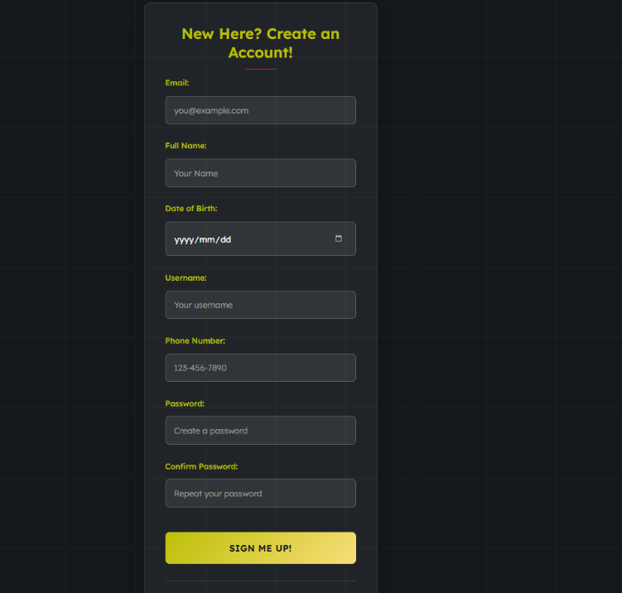

2.2 Logging In
- Go to the Login page.
- Enter your Email/Username and Password.
- Click Login.
Security: Sessions track logged-in users and prevent unauthorized access. Invalid credentials are rejected safely.
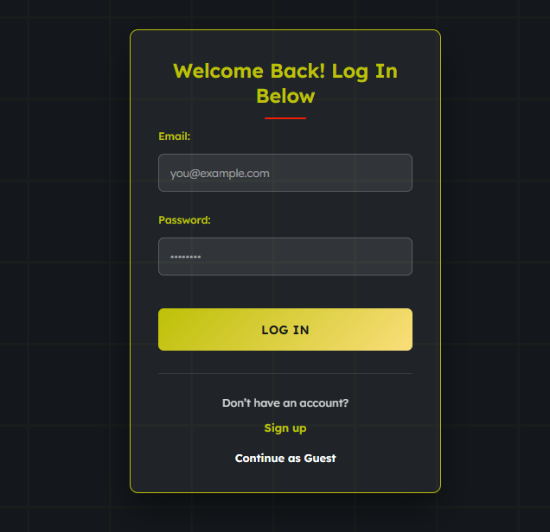
2.3 Continue as Guest
- Click Continue as Guest to browse content without signing up.
- Guest users can view reviews but cannot comment, like, or create posts.

3. Profile Management
Your profile allows you to manage your personal information, view your posts, and control account settings.

3.1 Viewing Your Profile
- Click your username →Profile in the navigation bar to access your profile.
- Your Profile Header shows:
  - Profile Picture (default avatar if none uploaded)
  - Username
  - Bio
  - Account Status (Active, Deactivated)
  - Statistics: Reviews posted, followers, following
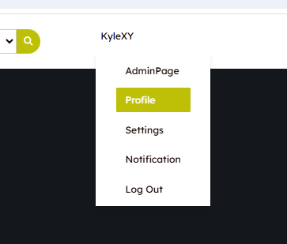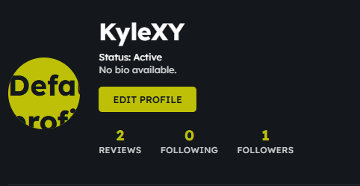

3.2 Editing Your Profile
- Click EDIT PROFILE on your profile page.
- You can update:
  - Full Name
  - Username
  - Email
  - Phone Number
  - Bio
  - Profile Picture
Important Security Notes:
- Only you can update your profile.
- Profile pictures are validated to ensure:
  - Allowed types: JPEG, PNG, GIF
  - Maximum size: 5MB
  - Actual image content (to prevent malicious uploads)
- Old profile pictures are safely removed after successful upload.
Steps to Edit Profile:
- Update the fields you wish to change.
- If uploading a new picture, select a valid image.
- Click Save Changes.
- A confirmation popup will notify you of success or errors (e.g., invalid email, duplicate username/email, file issues).
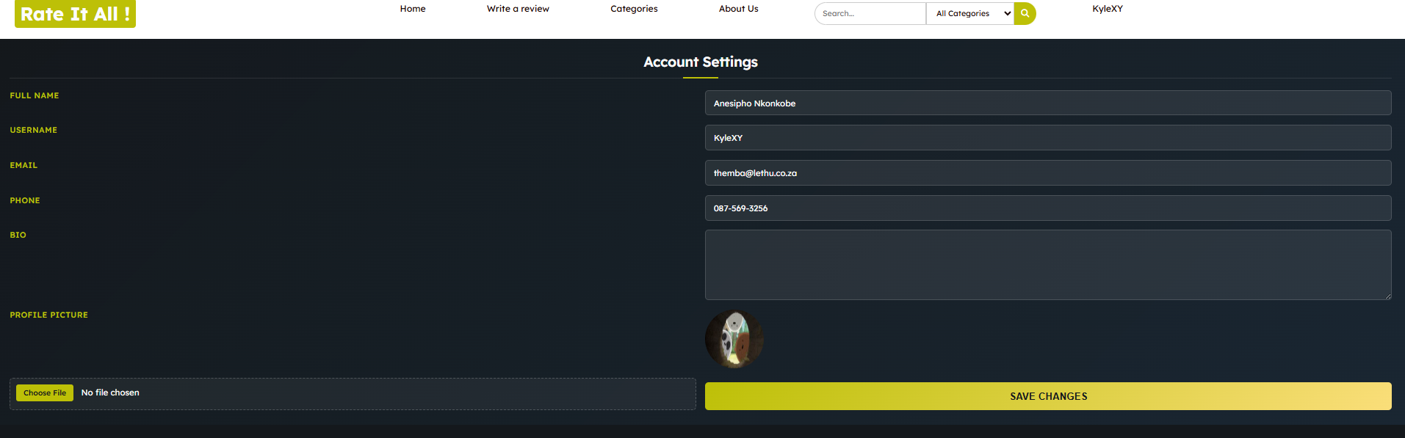
3.3 Deactivating Your Account
- Go to Settings → Account Settings.
- Click Deactivate Account.
- Confirm the action in the popup.
- Your profile becomes inactive but all data is securely stored.
Reactivation:
- If your account is deactivated, a Reactivate Account button will appear in Settings.
- Click it to restore access and all your posts.
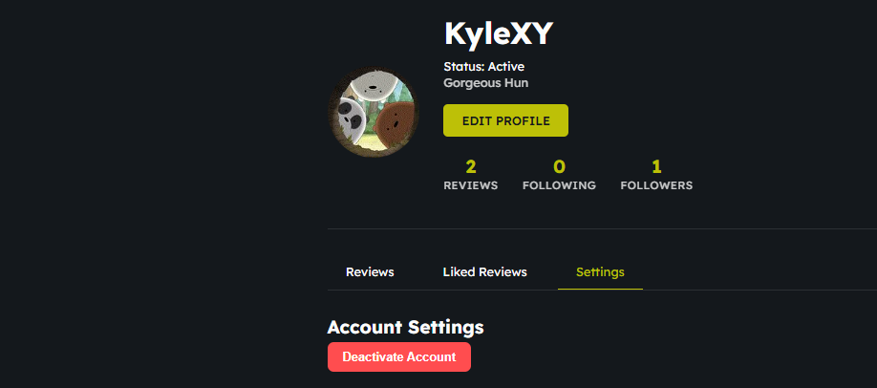
3.4 Security & Validation Highlights
- Session Protection: Only logged-in users can access and edit profile pages.
- Input Validation: Email, username, and phone are validated for proper format.
- Database Safety: All updates use prepared statements to prevent SQL injection.
- Media Security: Profile pictures are verified for type, size, and content.

3.5 Troubleshooting
Issue | Solution
Profile picture fails to upload | Ensure file is JPEG, PNG, or GIF and under 5MB.
Changes not saving | Confirm all fields are valid; check for duplicate email/username.
Cannot access profile | Make sure you are logged in; session may have expired.
Deactivation not working | Refresh the page or contact admin if persistent.

4. Creating & Managing Reviews
4.1 Creating a Post
- Click the “Write a Review” button on the nav bar.
- A modal form will appear allowing you to input your review details.
Form Details:
- Title: Enter a concise title for your review. (Required)
- Content: Write your review text. Use line breaks for paragraphs. (Required)
- Category: Select the appropriate category from the dropdown (Place, Food, Media, Concept, Everything Else). (Required)
- Rating: Select a star rating (1–5). By default, 5 stars are selected.
- Upload Media: Add images, video, or audio to your review. Multiple files are allowed. Only supported formats will be accepted.
- Tags: Add keywords for your review. Type and press Enter, or select from suggested tags. Tags help other users find your review easily.
Posting the Review:
- Once all fields are filled, click “Post Review”.
- Your review will appear in your profile and on the main feed.
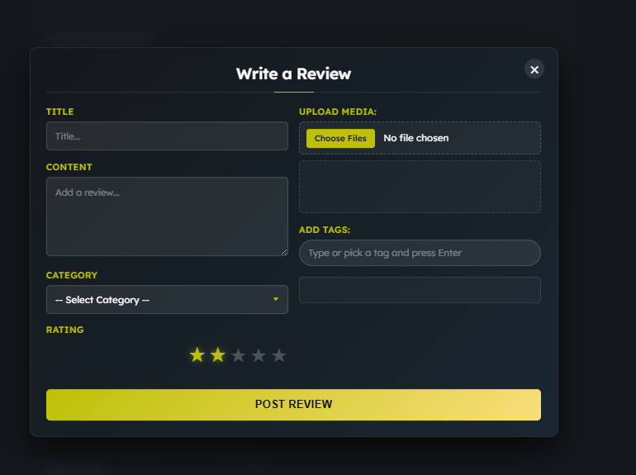

4.2 Editing or Deleting Posts
- Only posts you created can be edited or deleted.
- Navigate to your profile → Reviews → click Edit or Delete.
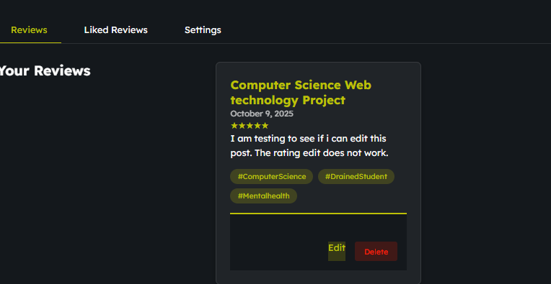
- Users can edit their own reviews via an Edit Review page.
- All review fields (title, content, category, rating, media, tags) can be updated.
- Existing media files can be replaced or marked as archived.
- Tags can be added, removed, or modified.
- Changes are saved when the Save Changes button is clicked.
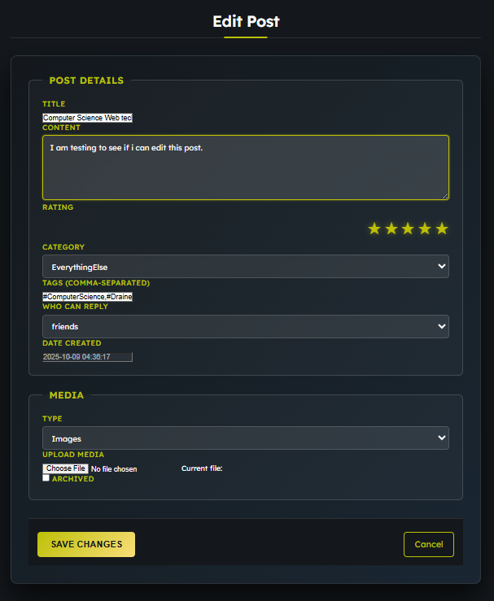

4.3 Review Display
- Reviews display the following information:
  - Title, content, author, date created.
  - Star rating and category.
  - Media (images, video, audio) and tags.
- The first image uploaded is displayed as a poster image.
- Additional media is shown below the content.
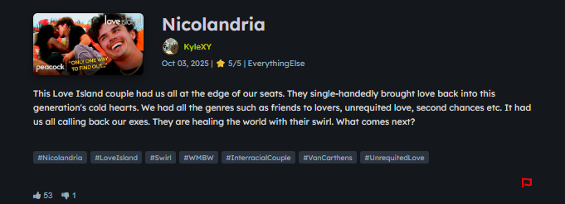
4.4 Interacting with Reviews
- Likes/Dislikes: Users can upvote or downvote reviews. Each user can only like or dislike once.
- Reporting: Users may report a review for issues such as spam, offensive content, or copyright violation by clicking the red flag. Reported reviews are flagged for moderation. Users can report a review once.
- Comments: Users can add comments and reply to others’ comments. Replies are nested below the original comment.
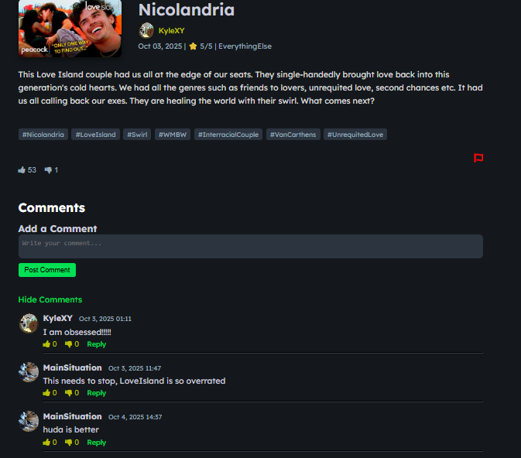
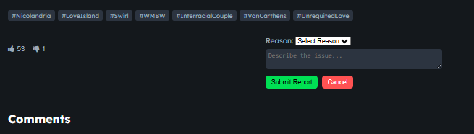
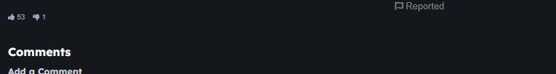
4.5 Best Practices
- Keep the title concise and relevant.
- Provide detailed content to help others understand your experience.
- Use appropriate media to support your review.
- Add relevant tags to improve discoverability.
- Review guidelines:
  - Avoid offensive language.
  - Ensure originality—do not copy content.
  - Use accurate categories and ratings.

5. Reviews & Social Interaction
The platform allows users to explore reviews, interact with other users, and engage in private messaging. This section details all features related to creating, viewing, and interacting with reviews and social activities.
5.1 Searching and Browsing Reviews
Purpose:
- Enables users to search for reviews using keywords, categories, and filters.
- Users can interact with reviews by liking or disliking them.
Key Features:
- Search Bar
  - Enter keywords to search within review titles and tags.
  - Optionally filter by category: Places, Food, Media, Concepts, Everything Else.
- Filters & Sorting
  - Category Filters: Quickly browse reviews in a specific category.
  - Sort Options:
    - Newest
    - Most Liked
    - Top Rated
  - Minimum Rating: Use a slider to show only reviews above a certain rating.
- Search Results
  - Each review displays:
    - Title, author, date created
    - Star rating
    - Preview of content
    - Tags
    - Optional media (images)
    - Like/Dislike buttons with counts
  - Users can click “Read Full Review” to access the full review page.
- Sidebar Features
  - Top Rated Reviews: Quick access to the highest-rated reviews.
  - Recent Reviews: Newly posted reviews.
  - Most Reviewed: Reviews with the highest number of comments.
- Interactions
  - Users must be logged in to like or dislike reviews.
  - Likes and dislikes are mutually exclusive; liking a review automatically removes any existing dislike and vice versa.
  - Interaction counts update in real-time after user actions.
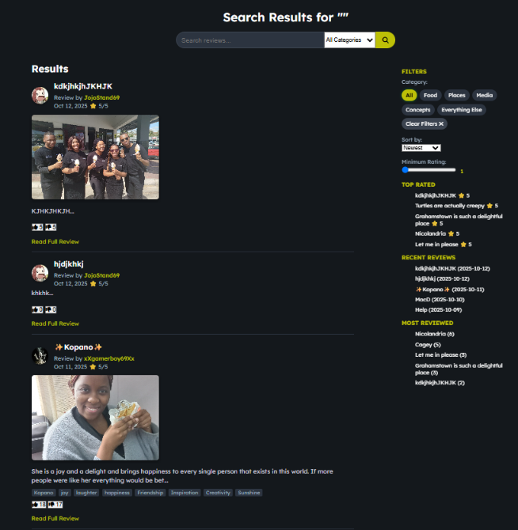
5.2 User Profiles
Purpose:
- Provides a detailed view of any user including their reviews, social activity, and engagement statistics.
Profile Components:
- Profile Header
  - Displays profile picture, username, bio, follow/unfollow button, and messaging button.
  - Shows statistics: total reviews, average rating, followers, following.
- Navigation Tabs
  - Reviews: All reviews posted by the user.
  - Liked Reviews: Reviews the user has liked.
  - Activity: Chronological feed of user activity including writing reviews, liking, commenting, and following others.
  - Socials: Users the profile owner is following.
  - Stats for Nerds: Detailed metrics like total likes, dislikes, posts with media, category breakdown, comments received.
- Reviews Display
  - Shows title, content preview, star rating, date, media (if available), tags, and like/comment buttons.
  - Supports viewing full content on a separate review page.
- Liked Reviews
  - Displays content the user has liked, similar in layout to the reviews section.
- Activity Feed
  - Highlights all recent user actions.
  - Activities are categorized (review, like, comment, follow) with timestamps.
- Followers & Following
  - Followers list: users who follow this profile.
  - Following list: users this profile is following.
- Stats for Nerds
  - Provides advanced metrics for power users or administrators:
    - Total reviews, likes, dislikes
    - Average rating
    - Posts with media
    - Comments received
    - Followers/following counts
    - Category-wise review breakdown
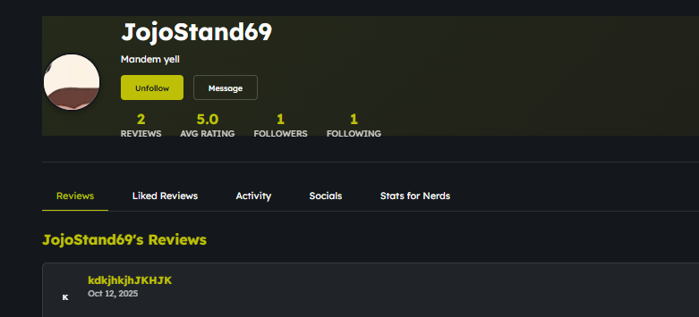
5.3 Private Messaging
Purpose:
- Allows users to communicate privately with other users.
Messaging Workflow:
- Access Control
  - Must be logged in to send or view messages.
  - Users cannot message themselves.
- CSRF Protection
  - Every session generates a unique CSRF token to secure message submissions.
- Message Retrieval
  - Displays the last 50 messages between the logged-in user and the profile user.
  - Messages are ordered chronologically.
- Message Display
  - Messages differentiate between sender and receiver.
  - Shows message content, timestamp, and sent status.
  - Includes ARIA attributes for accessibility.
- Typing Indicator
  - Real-time indicator shows when the other user is typing.
- Message Form
  - Users type messages into a textarea with a 5000-character limit.
  - Messages are submitted securely using the CSRF token.
  - Accessible buttons include screen-reader-friendly labels.
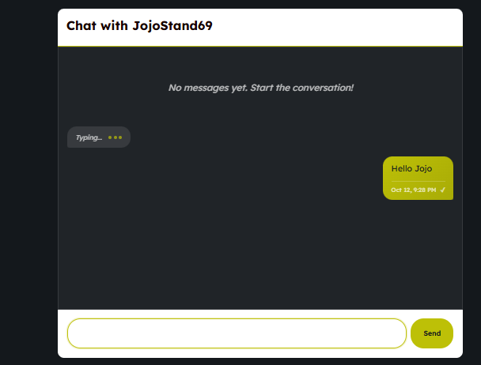
6.1. Reporting Content
- Click red flag on inappropriate posts, comments, or users.
- Fill in the reason and submit.
- Admins will review and take action.



6.2 Notifications
Purpose:
- Keeps users informed about activities related to their account:
  - Likes, comments, and replies on their reviews.
  - New followers.
  - System alerts or promotional updates.
Features:
- Notification Types
  - System: Updates from the platform (e.g., maintenance, policy changes).
  - Alerts: Urgent notifications (e.g., content violations, account warnings).
  - User-Based: Social interactions like likes, follows, or comments.
  - Promotional: Offers, contests, or new features.
- Notification Display
  - Each notification shows:
    - Title
    - Category badge (color-coded for easy recognition)
    - Date and time
    - Content or description
  - Notifications are displayed in reverse chronological order (latest first).
  - If no notifications exist, a friendly empty state informs the user.
- Styling & Accessibility
  - Color-coded badges indicate the type of notification.
  - Hover effects provide visual feedback.
  - Mobile-responsive layout ensures readability on all devices.
  - ARIA roles can be added for screen readers.
