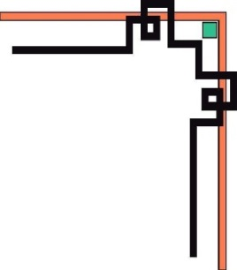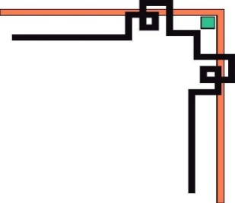

**DANANG SOFTWARE CORPORATION**

**SOFTECH-APTECH**





EProject:

Guiding faculty: LE QUOC DUNG.

Member:

* NGO ANH HAO
* PHAM PHU CUONG

Group: 04

Batch: 172

Project Document

**ZaraTherapyClinic**

|  |  |
| --- | --- |
| **GROUP 1** | |
| **Instructor** | Mr. Le Quoc Dung |
| **Group Members** | Ngo Anh Hao (Leader)  Pham Phu Cuong |
| **Batch** | 172 |
| **Semester** | 1 |

**TEACHER’S EVALUATION**

**Table of Contents**

1. ACKNOWLEDGEMENTS
2. INTRODUCTION
3. PROBLEM DEFINITION
4. **Homepage**
5. **Problem We Treat page**
6. **Combined Therapies page**
7. **About page**
8. **Service page**
9. **Massage page**
10. **Products page**
11. **Product information page**
12. **Cart page**
13. **Login page**
14. **Contact page**
15. USECASE & SITE MAP
16. **Use case diagram**
17. **Use Case Specification**
18. TECHNICAL
19. REFERENCES
20. CHECK LIST
21. **Check List of Validation**
22. **Submission Checklist**
23. PROJECT PLANNING

**I. ACKNOWLEDGEMENTS**

We would like to sincerely acknowledge the kindness of all the people who have given us moral support and helped us make a successful project.

We wish to express our deep gratitude to the e-Project Team at the Head office, who guided and helped us. Particular thanks to Mr. Le Quoc Dung who suggested the “form validation” and help us connect storage to our project, develop the analysis proceeding from it, and debugging code. We also would like to express our great gratitude to all the student members of our center (Softech Aptech).

Although we have made many attempts, because of the limited time, the practice could not be able to avoid the mistakes and missions. We hope that our project will be considered and evaluated. And finally, we would like to offer many thanks to all our friends for their valuable suggestions and constructive feedback.

**II. INTRODUCTION**

ZaraTherapyClinic is a place for the evaluation and treatment of disorders of the human body mainly by physical means for people with disorders or functional impairments associated with the musculoskeletal system, neurological, cardiopulmonary and visceral (cutaneous) due to injury, disease or other causes. Besides, ZaraTherapyClinic also has relaxing services such as massage, yoga,... Come to us, you will have moments of relaxation and enjoyment after long days of hard work through our relaxing services, we are committed to giving you the most different experience.

III. **PROBLEM DEFINITION**

1. **Homepage**

This is the page to which the user will be navigated after a successful visit to the site. The home page gives us an overview of the information doctors, tells us about the journeys they have gone through. On the main page we briefly present some common pathologies, people can see brief details there,on each brief detail the user can move the cursor to the content, they can click to read all the details about that content. Besides, the homepage also provides a number of products, introducing some of the lotions that ZaraTherapyClinic deals in and on the homepage also provide customer feedback after they experience the service here.

Finally, ZaraTherapyClinic's logo, direct link, locations, phone number, ascess, online, and link to the fan page of Facebook, Instagram are display in the footer.

1. **Problem We Treat page**

This page will provide detailed information about the ZaraTherapyClinic disease that will cure and provides a lot of important information regarding the disease that the patient has, the page will provide the necessary information such as pathological information, causes, necessary treatment, predisposed complications, treatment methods,… and this page also provides actual images taken from patients to help users understand their medical condition.

1. **Combined Therapies page**

The Combined Therapies page will provide information on the treatment that ZaraTherapyClinic is being used for, a detailed description of the treatment and an explanation of the principle of operation of such treatment to so that the patient has an overview of the treatment process carried out here and gives the patient more peace of mind during the treatment process

This page will cite studies of the methods used here and the leading doctors in the field, patients will be advised how to achieve the best results of treatment.

1. **About page**

Đây là trang giới thiệu tổng quát về ZaraTherapyClinic, giới thiệu về nhóm bác sĩ nơi đây, hướng dẫn bệnh nhân cách khám bệnh và những đối tác của ZaraTherapyClinic

1. **Service page**

This website was created with the aim of helping customers relax and beautify, the website is arranged with vivid, beautiful images and shows information about the services of ZaraTherapyClinic, with which customers want to see details of massage information and procedures, customers can click the mouse pointer on the massage modes shown below.

1. **Massage page**

The massage page is directly linked to the service page, in order for customers to refer to ZaraTherapyClinic's massage process, , here customers can also book massage schedules during the time frame displayed on the website.

1. **Products page**

Products page is an online sales website developed by ZaraTherapyClinic that aims to bring customers the best genuine products serve the beauty process along with equipment to support the treatment of diseases and relax.

Here the user can move the mouse to the image of the product with the necessary information briefly displayed to help the user understand the product, users can click on the image to switch to the product information page

This website offers 2 types of products from 2 brands Murad and Environ. And other types of machinery and equipment. Users can change different types of products through the option in the right corner of the screen, on the left, users can search for other products by searching.

Users can also click on add to card to add the product they want to buy to the cart, when the user clicks on add to card will display a message and along with that the cart icon in the upper corner will appear the number of selected items, then the product will be added to your cart.

1. **Product information page**

The product information page is linked directly to the product so that users can better understand the details about the product and its uses and ingredients, recommendations on ingredients in the product to help users have the best experience when using the product.

1. **Cart page**

Cart page is a page used to summarize the customer's preferences in the Products page section. Here will display detailed information about the number of products, the price of the product and the total. Users can press the buy button to buy the product.

10. **Login Page**

On the login page, users can log in to ZaraTherapyClinic for advice along with the staff here, if the user does not have an account, they can click on the registration button to proceed with creating an account, here the user must enter detailed information for the staff to select the information and advise what is right for you. when the user logs in on on the right corner of the screen will appear avatar and moving the mouse to it will appear name, information, shopping cart, and account logout button, besides there is also a forgot password item for users to retrieve the password when needed.

11**. Contact page**

Contact page is a page that helps users enter the information needed for direct advice, Contact page is created to help older people who do not want to have to go through the steps of creating an account, logging in, registering, causing loss of time, You have reached your daily translation maximum - please come back tomorrow, where the user simply enters the information and the counselor will call directly into your phone. and here also provides a site map to help users know the location of ZaraTherapyClinic on google map.

IV. **USECASE & SITE MAP**

## **Use case diagram**

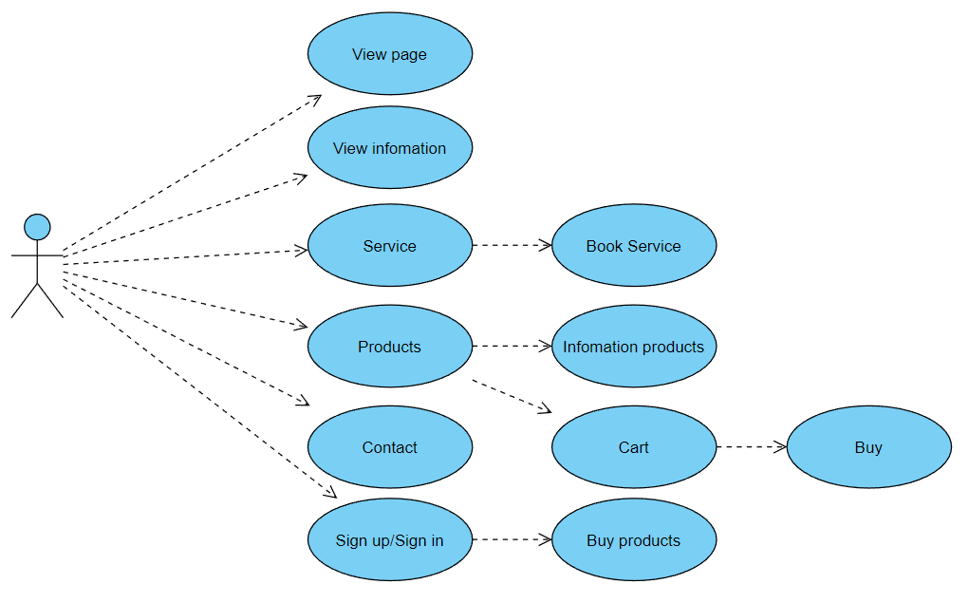

## **Use Case Specification**

|  |  |  |  |
| --- | --- | --- | --- |
| **USE CASE SPECIFICATION** | | | |
| **Use-case No.** | UC01 | **Use-case Version** | 1.0 |
| **Use-case Name** | *Login/Register* | | |
| **Purpose:**  **Input:**  **Output:** | | | |

|  |  |  |  |
| --- | --- | --- | --- |
| **USE CASE SPECIFICATION** | | | |
| **Use-case No.** | UC02 | **Use-case Version** | 1.0 |
| **Use-case Name** | *Products* | | |
| **Purpose:**  **Input:**  **Output:** | | | |