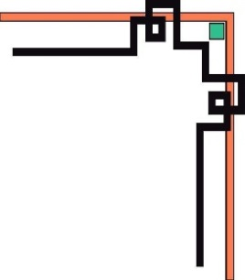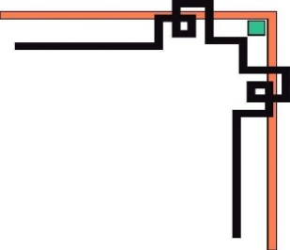

**DANANG SOFTWARE CORPORATION**

**SOFTECH-APTECH**





EProject:

Guiding faculty: LE QUOC DUNG.

Member:

* NGO ANH HAO
* PHAM PHU CUONG

Group: 04

Batch: 172

Project Document

**ZaraTherapyClinic**

|  |  |
| --- | --- |
| **GROUP 1** | |
| **Instructor** | Mr. Le Quoc Dung |
| **Group Members** | Ngo Anh Hao (Leader)  Pham Phu Cuong |
| **Batch** | 172 |
| **Semester** | 1 |

**TEACHER’S EVALUATION**

**Table of Contents**

1. ACKNOWLEDGEMENTS
2. INTRODUCTION
3. PROBLEM DEFINITION
4. **Homepage**
5. **Problem We Treat page**
6. **Combined Therapies page**
7. **About page**
8. **Products page**
9. **Product information page**
10. **Cart page**
11. **Login page**
12. **Contact page**
13. USECASE & SITE MAP
14. **Use case diagram**
15. **Use Case Specification**
16. TECHNICAL
17. REFERENCES
18. CHECK LIST
19. **Check List of Validation**
20. **Submission Checklist**
21. PROJECT PLANNING

**I. ACKNOWLEDGEMENTS**

We would like to sincerely acknowledge the kindness of all the people who have given us moral support and helped us make a successful project.

We wish to express our deep gratitude to the e-Project Team at the Head office, who guided and helped us. Particular thanks to Mr. Le Quoc Dung who suggested the “form validation” and help us connect storage to our project, develop the analysis proceeding from it, and debugging code. We also would like to express our great gratitude to all the student members of our center (Softech Aptech).

Although we have made many attempts, because of the limited time, the practice could not be able to avoid the mistakes and missions. We hope that our project will be considered and evaluated. And finally, we would like to offer many thanks to all our friends for their valuable suggestions and constructive feedback.

**II. INTRODUCTION**