Họ và tên: Nguyễn Ngọc Minh
MSSV:1150070029
Máy 36
11ĐH_TMĐT

Lap 5
Bước 1:Tạo Project
Chọn New projaect->Empty Views Activity đặt tên là Lap5_TH_LTMB,ngôn ngữ đẻ là Java
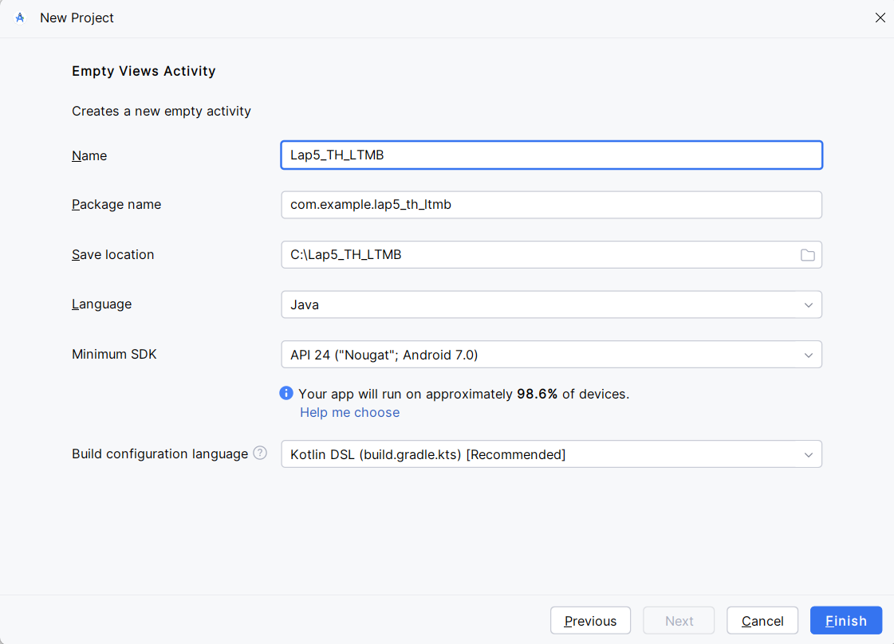
Phần 1:Thiết kế giao diện login/Register
Bước 1: Chuẩn bị file (colors, drawable, strings)
Mở Android Studio → trong thư mục:
app/src/main/res/values/
1.1 colors.xml
<?xml version="1.0" encoding="utf-8"?>
<resources>
<color name="purple_200">#FFBB86FC</color>
<color name="purple_500">#FF6200EE</color>
<color name="purple_700">#F4511E</color>
<color name="teal_200">#FF03DAC5</color>
<color name="teal_700">#FF018786</color>
<color name="black">#FF000000</color>
<color name="white">#FFFFFFFF</color>
<color name="orange">#FB8C00</color>
<color name="gray">#EAE5E3</color>
<color name="orangeMid">#F4511E</color>
</resources>
1.2. strings.xml
<?xml version="1.0" encoding="utf-8"?>
<resources>
<string name="app_name">Login</string>
<string name="txt_login">Login</string>
<string name="hint_email">Email</string>
<string name="hint_password">Password</string>
<string name="txt_forgot_pass">Forgot password?</string>
<string name="txt_no_account">Don</string>
<string name="txt_register">Register</string>
</resources>
1.3. Tạo drawable
app/src/main/res/drawable/
Rồi tạo 3 file:
bg_radius.xml
<?xml version="1.0" encoding="utf-8"?>
<layer-list xmlns:android="http://schemas.android.com/apk/res/android">
<item android:drawable="@drawable/bg_rect" />
<item android:bottom="3dp">
<shape>
<corners android:radius="20dp"/>
<solid android:color="#ffffff" />
</shape>
</item>
</layer-list>
bg_login.xml
<?xml version="1.0" encoding="utf-8"?>
<layer-list xmlns:android="http://schemas.android.com/apk/res/android">
<item android:drawable="@drawable/bg_rect" />
<item android:bottom="3dp">
<shape>
<corners android:radius="20dp"/>
<gradient
android:angle="180"
android:endColor="@color/orange"
android:startColor="@color/orangeMid"/>
</shape>
</item>
</layer-list>
bg_top.xml
<?xml version="1.0" encoding="utf-8"?>
<shape xmlns:android="http://schemas.android.com/apk/res/android">
<corners android:bottomLeftRadius="100dp" />
<gradient
android:angle="145"
android:endColor="@color/orange"
android:startColor="@color/orangeMid"/>
</shape>

Tiếp theo tạo 3 icon email / key / back
- Right-click drawable → New → Vector Asset
- Chọn “Local file (SVG)”
- Chọn icon phù hợp
- Đặt tên như sau:
- ic_email.xml
- ic_key.xml
- ic_back.xml
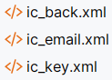
Bước 2: Tạo giao diện Login (m000_frg_login.xml)
Tạo file:
res/layout/m000_frg_login.xml
Bước 3: Tạo giao diện Register (m001_frg_register.xml)
<?xml version="1.0" encoding="utf-8"?>
<LinearLayout xmlns:android="http://schemas.android.com/apk/res/android"
xmlns:app="http://schemas.android.com/apk/res-auto"
xmlns:tools="http://schemas.android.com/tools"
android:layout_width="match_parent"
android:layout_height="match_parent"
android:background="@color/gray"
android:orientation="vertical">
<FrameLayout
android:layout_width="match_parent"
android:layout_height="wrap_content">
<View
android:layout_width="match_parent"
android:layout_height="300dp"
android:background="@drawable/bg_top" />
<ImageView
android:id="@+id/iv_back"
android:layout_width="56dp"
android:layout_height="56dp"
android:padding="10dp"
android:src="@drawable/ic_back"
app:tint="@color/white"
tools:ignore="ContentDescription" />
<TextView
android:layout_width="wrap_content"
android:layout_height="wrap_content"
android:layout_gravity="end"
android:layout_marginTop="220dp"
android:layout_marginRight="30dp"
android:text="@string/txt_register"
android:textColor="@color/white"
android:textSize="20sp" />
</FrameLayout>
<EditText
android:id="@+id/edt_email"
android:layout_width="match_parent"
android:layout_height="50dp"
android:layout_marginHorizontal="30dp"
android:layout_marginTop="50dp"
android:layout_marginBottom="3dp"
android:autofillHints="Email"
android:background="@drawable/bg_radius"
android:drawableLeft="@drawable/ic_email"
android:drawablePadding="10dp"
android:hint="@string/hint_email"
android:inputType="textEmailAddress"
android:padding="10dp"
android:textSize="18sp" />
<EditText
android:id="@+id/edt_pass"
android:layout_width="match_parent"
android:layout_height="50dp"
android:layout_marginHorizontal="30dp"
android:layout_marginTop="10dp"
android:layout_marginBottom="3dp"
android:autofillHints="Password"
android:background="@drawable/bg_radius"
android:drawableLeft="@drawable/ic_key"
android:drawablePadding="10dp"
android:hint="@string/hint_password"
android:inputType="textPassword"
android:padding="10dp"
android:textSize="18sp" />
<EditText
android:id="@+id/edt_re_pass"
android:layout_width="match_parent"
android:layout_height="50dp"
android:layout_marginHorizontal="30dp"
android:layout_marginTop="10dp"
android:layout_marginBottom="3dp"
android:autofillHints="Password"
android:background="@drawable/bg_radius"
android:drawableLeft="@drawable/ic_key"
android:drawablePadding="10dp"
android:hint="@string/hint_password"
android:inputType="textPassword"
android:padding="10dp"
android:textSize="18sp" />
<TextView
android:id="@+id/tv_register"
android:layout_width="match_parent"
android:layout_height="50dp"
android:layout_gravity="end"
android:layout_marginHorizontal="30dp"
android:layout_marginTop="20dp"
android:background="@drawable/bg_login"
android:gravity="center"
android:padding="10dp"
android:text="@string/txt_register"
android:textColor="@color/white"
android:textSize="18sp" />
</LinearLayout>
Bước 4: Tạo activity_main.xml
<LinearLayout xmlns:android="http://schemas.android.com/apk/res/android"
android:id="@+id/ln_main"
android:layout_width="match_parent"
android:layout_height="match_parent"
android:orientation="vertical">
</LinearLayout>
Phần 2-code Login vs Register
Bước 5: Tạo Fragment Login (M000LoginFragment.java)
package com.example.lap5_th_ltmb;
import android.content.Context;
import android.content.SharedPreferences;
import android.os.Bundle;
import android.view.LayoutInflater;
import android.view.View;
import android.view.ViewGroup;
import android.view.animation.AnimationUtils;
import android.widget.EditText;
import android.widget.Toast;
import androidx.fragment.app.Fragment;
public class M000LoginFragment extends Fragment implements View.OnClickListener {
private EditText edtEmail, edtPass;
private Context mContext;
@Override
public View onCreateView(LayoutInflater inflater, ViewGroup container, Bundle savedInstanceState) {
View rootView = inflater.inflate(R.layout.m000_frg_login, container, false);
initView(rootView);
return rootView;
}
@Override
public void onAttach(Context context) {
super.onAttach(context);
mContext = context;
}
private void initView(View v) {
edtEmail = v.findViewById(R.id.edt_email);
edtPass = v.findViewById(R.id.edt_pass);
v.findViewById(R.id.tv_login).setOnClickListener(this);
v.findViewById(R.id.tv_register).setOnClickListener(this);
}
@Override
public void onClick(View v) {
v.startAnimation(AnimationUtils.loadAnimation(
mContext,
androidx.appcompat.R.anim.abc_fade_in
));
if (v.getId() == R.id.tv_login) {
login(
edtEmail.getText().toString(),
edtPass.getText().toString()
);
} else if (v.getId() == R.id.tv_register) {
gotoRegisterScreen();
}
}
private void gotoRegisterScreen() {
((MainActivity) mContext).gotoRegisterScreen();
}
private void login(String mail, String pass) {
if (mail.isEmpty() || pass.isEmpty()) {
Toast.makeText(mContext, "Empty value", Toast.LENGTH_SHORT).show();
return;
}
SharedPreferences pref = mContext.getSharedPreferences(
MainActivity.SAVE_PREF,
Context.MODE_PRIVATE
);
String savedPass = pref.getString(mail, null);
if (savedPass == null) {
Toast.makeText(mContext, "Email is not existed!", Toast.LENGTH_SHORT).show();
return;
}
if (!pass.equals(savedPass)) {
Toast.makeText(mContext, "Password is not correct!", Toast.LENGTH_SHORT).show();
return;
}
Toast.makeText(mContext, "Login account successfully!", Toast.LENGTH_SHORT).show();
}
}
Bước 6: Tạo Fragment Register (M001RegisterFragment.java)
package com.example.lap5_th_ltmb;
import android.content.Context;
import android.content.SharedPreferences;
import android.os.Bundle;
import android.view.LayoutInflater;
import android.view.View;
import android.view.ViewGroup;
import android.view.animation.AnimationUtils;
import android.widget.EditText;
import android.widget.Toast;
import androidx.fragment.app.Fragment;
public class M001RegisterFragment extends Fragment implements View.OnClickListener {
private EditText edtEmail, edtPass, edtRepass;
private Context mContext;
@Override
public View onCreateView(LayoutInflater inflater, ViewGroup container, Bundle savedInstanceState) {
View rootView = inflater.inflate(R.layout.m001_frg_register, container, false);
initView(rootView);
return rootView;
}
@Override
public void onAttach(Context context) {
super.onAttach(context);
mContext = context;
}
private void initView(View v) {
edtEmail = v.findViewById(R.id.edt_email);
edtPass = v.findViewById(R.id.edt_pass);
edtRepass = v.findViewById(R.id.edt_re_pass);
v.findViewById(R.id.tv_register).setOnClickListener(this);
v.findViewById(R.id.iv_back).setOnClickListener(this);
}
@Override
public void onClick(View v) {
v.startAnimation(AnimationUtils.loadAnimation(mContext,
androidx.appcompat.R.anim.abc_fade_in));
if (v.getId() == R.id.iv_back) {
gotoLoginScreen();
} else if (v.getId() == R.id.tv_register) {
register(
edtEmail.getText().toString(),
edtPass.getText().toString(),
edtRepass.getText().toString()
);
}
}
private void gotoLoginScreen() {
((MainActivity) mContext).gotoLoginScreen();
}
private void register(String mail, String pass, String repass) {
if (mail.isEmpty() || pass.isEmpty() || repass.isEmpty()) {
Toast.makeText(mContext, "Empty value", Toast.LENGTH_SHORT).show();
return;
}
if (!pass.equals(repass)) {
Toast.makeText(mContext, "Password is not match", Toast.LENGTH_SHORT).show();
return;
}
SharedPreferences pref = mContext.getSharedPreferences(MainActivity.SAVE_PREF,
Context.MODE_PRIVATE);
String savedPass = pref.getString(mail, null);
if (savedPass != null) {
Toast.makeText(mContext, "Email is existed!", Toast.LENGTH_SHORT).show();
return;
}
// Save email + password
pref.edit().putString(mail, pass).apply();
Toast.makeText(mContext, "Register account successfully!", Toast.LENGTH_SHORT).show();
gotoLoginScreen();
}
}
Bước 7: Tạo MainActivity.java để quản lý Fragment
package com.example.lap5_th_ltmb;
import android.os.Bundle;
import androidx.activity.EdgeToEdge;
import androidx.appcompat.app.AppCompatActivity;
import androidx.core.graphics.Insets;
import androidx.core.view.ViewCompat;
import androidx.core.view.WindowInsetsCompat;
public class MainActivity extends AppCompatActivity {
public static final String SAVE_PREF = "save_pref";
@Override
protected void onCreate(Bundle savedInstanceState) {
super.onCreate(savedInstanceState);
setContentView(R.layout.activity_main);
gotoLoginScreen();
}
public void gotoRegisterScreen() {
getSupportFragmentManager().beginTransaction()
.replace(R.id.ln_main, new M001RegisterFragment())
.commit();
}
public void gotoLoginScreen() {
getSupportFragmentManager().beginTransaction()
.replace(R.id.ln_main, new M000LoginFragment())
.commit();
}
}
Kết quả chạy được:
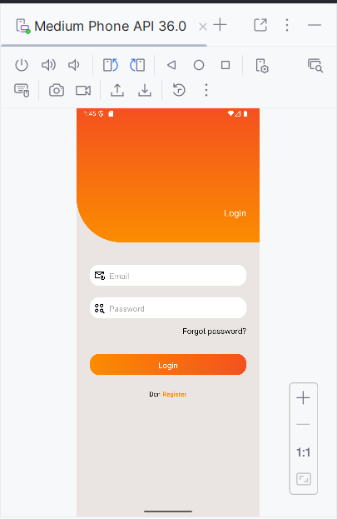
Mở app -> thấy màn Login
Nhấn “Register” -> sang màn Register
Nhập email + password ->Lưu bằng SharedPreferences
Quay lại Login -> Đăng nhập ->Toast “successfully”
Bước 8:Ta kết nối cơ sở dữ liệu SQL Server, Android App -> REST API -> SQL Server
A. Cấu trúc hệ thống gồm 2 phần:
1. Backend API
Dùng ASP.NET Web API (chuẩn nhất cho SQL Server),API sẽ nhận request từ Android → truy vấn SQL Server → trả JSON.
2. Android App
Dùng Retrofit để gọi API.
B. Bắt đầu làm api (ASP.NET Web API + SQL Server)
Bước 1:Tạo bảng đặt tên là TH5_LTMB
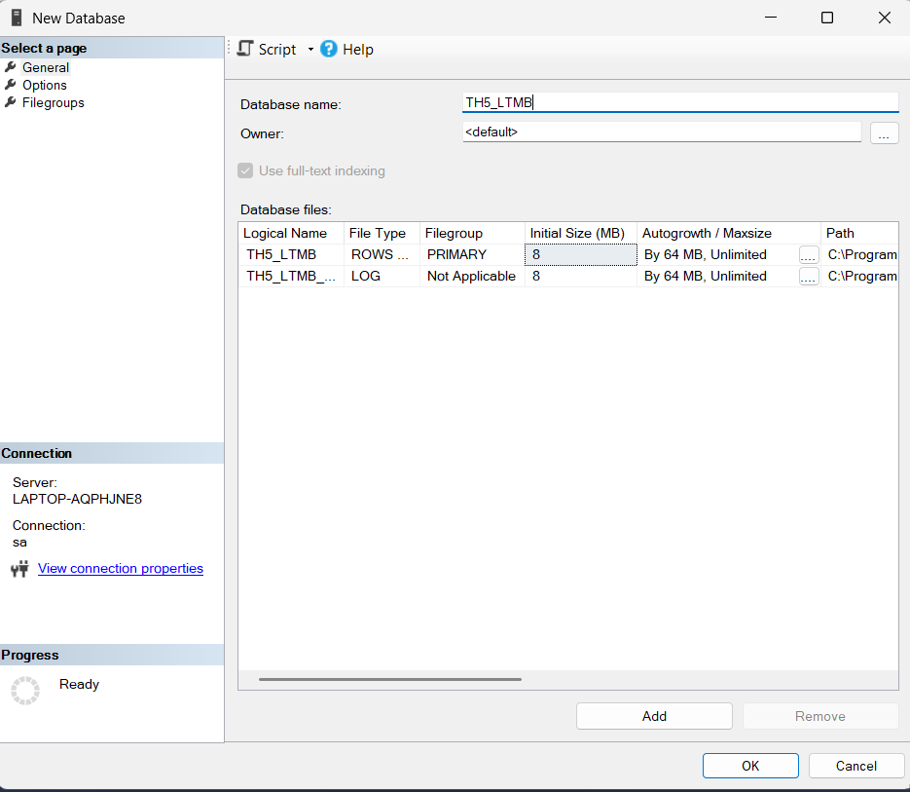
Tiếp theo ta tạo bảng User
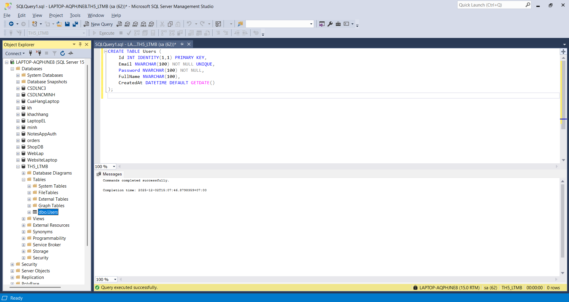
Bước 2: Tạo Models
Tiếp theo chuột phải vào dự án chọn add chọn class tạo thư mục đặt tên là user.cs
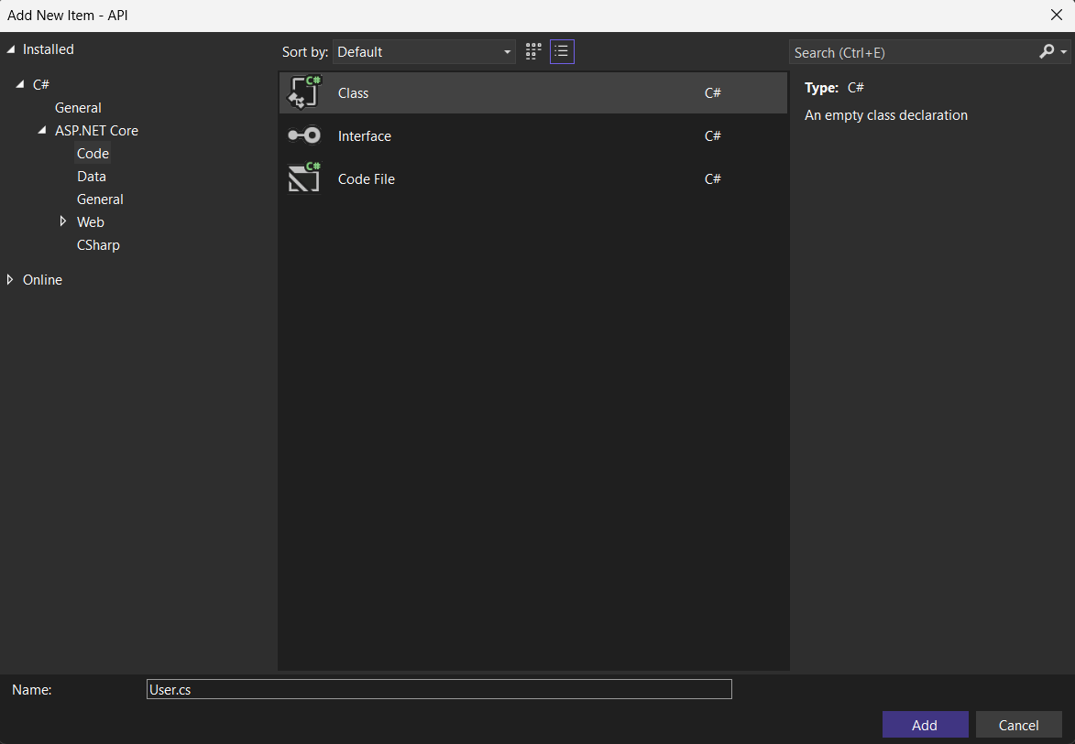
Ta cấu gõ đoạn code sau:
using System.ComponentModel.DataAnnotations;

namespace API.Models
{
public class User
{
[Required(ErrorMessage = "Email là bắt buộc")]
[EmailAddress(ErrorMessage = "Email không hợp lệ")]
public string Email { get; set; }

[Required(ErrorMessage = "Password là bắt buộc")]
public string Password { get; set; }
}

// DTO cho Response
public class UserResponseDto
{
public int Id { get; set; }
public string Email { get; set; }
public string? FullName { get; set; }
public DateTime CreatedAt { get; set; }
}

// Response chung
public class ApiResponse<T>
{
public bool Success { get; set; }
public string Message { get; set; }
public T? Data { get; set; }
}
}
Bước 3: Tạo DbContext
Tạo thư mục Data và file ApplicationDbContext.cs:
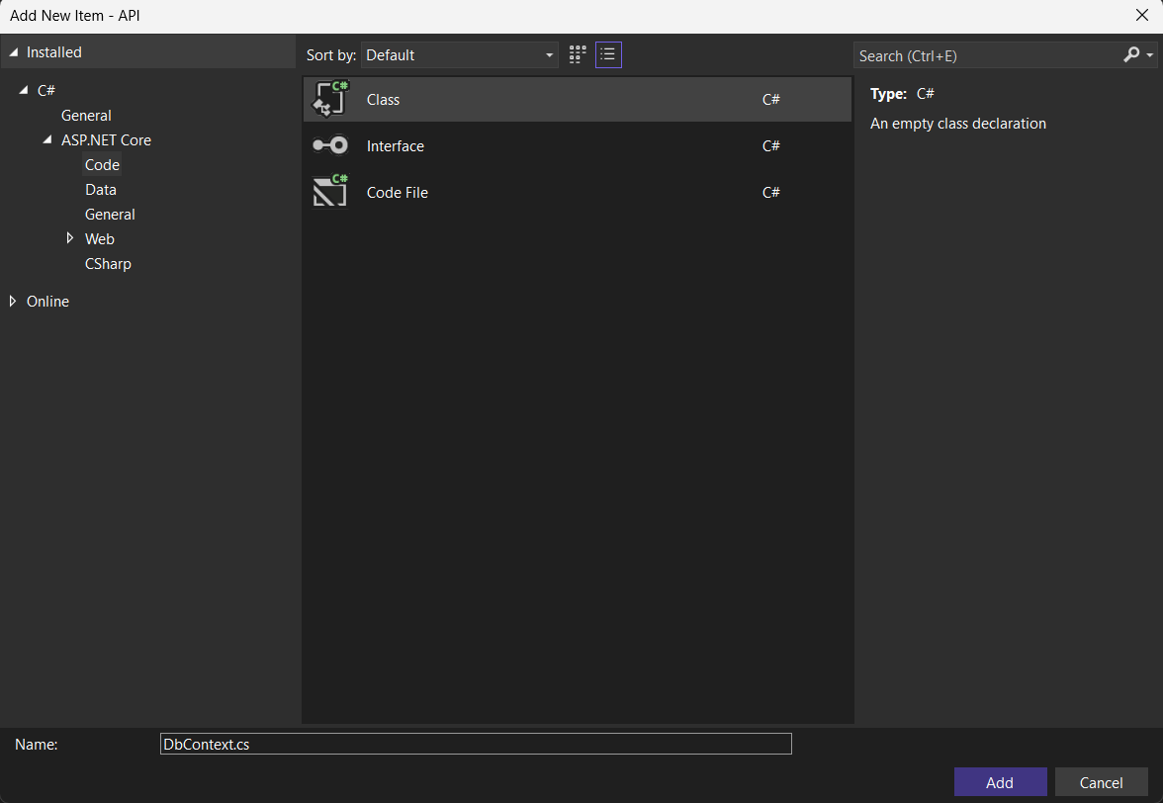
Ta gõ đoạn code:
using Microsoft.EntityFrameworkCore;
using MyAPI.Models;

namespace MyAPI.Data
{
public class ApplicationDbContext : DbContext
{
public ApplicationDbContext(DbContextOptions<ApplicationDbContext> options)
: base(options)
{
}

public DbSet<User> Users { get; set; }

protected override void OnModelCreating(ModelBuilder modelBuilder)
{
base.OnModelCreating(modelBuilder);

// Cấu hình cho User
modelBuilder.Entity<User>(entity =>
{
entity.HasKey(e => e.Id);
entity.Property(e => e.Email).IsRequired().HasMaxLength(100);
entity.Property(e => e.Password).IsRequired().HasMaxLength(100);
entity.Property(e => e.FullName).HasMaxLength(100);
entity.Property(e => e.CreatedAt).HasDefaultValueSql("GETDATE()");

// Tạo unique index cho Email
entity.HasIndex(e => e.Email).IsUnique();
});
}
}
}
Bước 5: Cấu hình appsettings.json
{
"Logging": {
"LogLevel": {
"Default": "Information",
"Microsoft.AspNetCore": "Warning"
}
},

"ConnectionStrings": {
"DefaultConnection": "Server=LAPTOP-AQPHJNE8;Database=TH5_LTMB;User Id=sa;Password=123;TrustServerCertificate=True"
},

"AllowedHosts": "*"
}
Bước 6: Cấu hình Program.cs
using Microsoft.EntityFrameworkCore;
using MyAPI.Data;

var builder = WebApplication.CreateBuilder(args);

// Add services to the container.
builder.Services.AddControllers();

// Cấu hình DbContext
builder.Services.AddDbContext<ApplicationDbContext>(options =>
options.UseSqlServer(builder.Configuration.GetConnectionString("DefaultConnection")));

// Cấu hình CORS cho phép Android kết nối
builder.Services.AddCors(options =>
{
options.AddPolicy("AllowAll",
builder =>
{
builder.AllowAnyOrigin()
.AllowAnyMethod()
.AllowAnyHeader();
});
});

// Swagger/OpenAPI
builder.Services.AddEndpointsApiExplorer();
builder.Services.AddSwaggerGen();

var app = builder.Build();

// Configure the HTTP request pipeline.
if (app.Environment.IsDevelopment())
{
app.UseSwagger();
app.UseSwaggerUI();
}

// Sử dụng CORS
app.UseCors("AllowAll");

app.UseHttpsRedirection();

app.UseAuthorization();

app.MapControllers();

app.Run();
Bước 7: Tạo Controller
Đặt tên là UsersController.cs
Ta gõ đoạn code
using Microsoft.AspNetCore.Mvc;
using Microsoft.EntityFrameworkCore;
using MyAPI.Data;
using MyAPI.Models;
using BCrypt.Net;

namespace MyAPI.Controllers
{
[Route("api/[controller]")]
[ApiController]
public class UsersController : ControllerBase
{
private readonly ApplicationDbContext _context;

public UsersController(ApplicationDbContext context)
{
_context = context;
}

// GET: api/Users
[HttpGet]
public async Task<ActionResult<ApiResponse<List<UserResponseDto>>>> GetUsers()
{
try
{
var users = await _context.Users
.Select(u => new UserResponseDto
{
Id = u.Id,
Email = u.Email,
FullName = u.FullName,
CreatedAt = u.CreatedAt
})
.ToListAsync();

return Ok(new ApiResponse<List<UserResponseDto>>
{
Success = true,
Message = "Lấy danh sách user thành công",
Data = users
});
}
catch (Exception ex)
{
return StatusCode(500, new ApiResponse<List<UserResponseDto>>
{
Success = false,
Message = $"Lỗi: {ex.Message}",
Data = null
});
}
}

// GET: api/Users/5
[HttpGet("{id}")]
public async Task<ActionResult<ApiResponse<UserResponseDto>>> GetUser(int id)
{
try
{
var user = await _context.Users.FindAsync(id);

if (user == null)
{
return NotFound(new ApiResponse<UserResponseDto>
{
Success = false,
Message = "Không tìm thấy user",
Data = null
});
}

var userResponse = new UserResponseDto
{
Id = user.Id,
Email = user.Email,
FullName = user.FullName,
CreatedAt = user.CreatedAt
};

return Ok(new ApiResponse<UserResponseDto>
{
Success = true,
Message = "Lấy thông tin user thành công",
Data = userResponse
});
}
catch (Exception ex)
{
return StatusCode(500, new ApiResponse<UserResponseDto>
{
Success = false,
Message = $"Lỗi: {ex.Message}",
Data = null
});
}
}

// POST: api/Users/register
[HttpPost("register")]
public async Task<ActionResult<ApiResponse<UserResponseDto>>> Register(RegisterDto registerDto)
{
try
{
// Kiểm tra email đã tồn tại
if (await _context.Users.AnyAsync(u => u.Email == registerDto.Email))
{
return BadRequest(new ApiResponse<UserResponseDto>
{
Success = false,
Message = "Email đã tồn tại",
Data = null
});
}

// Hash password
string hashedPassword = BCrypt.Net.BCrypt.HashPassword(registerDto.Password);

// Tạo user mới
var user = new User
{
Email = registerDto.Email,
Password = hashedPassword,
FullName = registerDto.FullName,
CreatedAt = DateTime.Now
};

_context.Users.Add(user);
await _context.SaveChangesAsync();

var userResponse = new UserResponseDto
{
Id = user.Id,
Email = user.Email,
FullName = user.FullName,
CreatedAt = user.CreatedAt
};

return CreatedAtAction(nameof(GetUser), new { id = user.Id },
new ApiResponse<UserResponseDto>
{
Success = true,
Message = "Đăng ký thành công",
Data = userResponse
});
}
catch (Exception ex)
{
return StatusCode(500, new ApiResponse<UserResponseDto>
{
Success = false,
Message = $"Lỗi: {ex.Message}",
Data = null
});
}
}

// POST: api/Users/login
[HttpPost("login")]
public async Task<ActionResult<ApiResponse<UserResponseDto>>> Login(LoginDto loginDto)
{
try
{
// Tìm user theo email
var user = await _context.Users
.FirstOrDefaultAsync(u => u.Email == loginDto.Email);

if (user == null)
{
return BadRequest(new ApiResponse<UserResponseDto>
{
Success = false,
Message = "Email hoặc mật khẩu không đúng",
Data = null
});
}

// Verify password
if (!BCrypt.Net.BCrypt.Verify(loginDto.Password, user.Password))
{
return BadRequest(new ApiResponse<UserResponseDto>
{
Success = false,
Message = "Email hoặc mật khẩu không đúng",
Data = null
});
}

var userResponse = new UserResponseDto
{
Id = user.Id,
Email = user.Email,
FullName = user.FullName,
CreatedAt = user.CreatedAt
};

return Ok(new ApiResponse<UserResponseDto>
{
Success = true,
Message = "Đăng nhập thành công",
Data = userResponse
});
}
catch (Exception ex)
{
return StatusCode(500, new ApiResponse<UserResponseDto>
{
Success = false,
Message = $"Lỗi: {ex.Message}",
Data = null
});
}
}

// PUT: api/Users/5
[HttpPut("{id}")]
public async Task<ActionResult<ApiResponse<UserResponseDto>>> UpdateUser(int id, RegisterDto updateDto)
{
try
{
var user = await _context.Users.FindAsync(id);

if (user == null)
{
return NotFound(new ApiResponse<UserResponseDto>
{
Success = false,
Message = "Không tìm thấy user",
Data = null
});
}

// Kiểm tra email mới có trùng với user khác không
if (await _context.Users.AnyAsync(u => u.Email == updateDto.Email && u.Id != id))
{
return BadRequest(new ApiResponse<UserResponseDto>
{
Success = false,
Message = "Email đã tồn tại",
Data = null
});
}

user.Email = updateDto.Email;
user.FullName = updateDto.FullName;

if (!string.IsNullOrEmpty(updateDto.Password))
{
user.Password = BCrypt.Net.BCrypt.HashPassword(updateDto.Password);
}

await _context.SaveChangesAsync();

var userResponse = new UserResponseDto
{
Id = user.Id,
Email = user.Email,
FullName = user.FullName,
CreatedAt = user.CreatedAt
};

return Ok(new ApiResponse<UserResponseDto>
{
Success = true,
Message = "Cập nhật thành công",
Data = userResponse
});
}
catch (Exception ex)
{
return StatusCode(500, new ApiResponse<UserResponseDto>
{
Success = false,
Message = $"Lỗi: {ex.Message}",
Data = null
});
}
}

// DELETE: api/Users/5
[HttpDelete("{id}")]
public async Task<ActionResult<ApiResponse<object>>> DeleteUser(int id)
{
try
{
var user = await _context.Users.FindAsync(id);

if (user == null)
{
return NotFound(new ApiResponse<object>
{
Success = false,
Message = "Không tìm thấy user",
Data = null
});
}

_context.Users.Remove(user);
await _context.SaveChangesAsync();

return Ok(new ApiResponse<object>
{
Success = true,
Message = "Xóa user thành công",
Data = null
});
}
catch (Exception ex)
{
return StatusCode(500, new ApiResponse<object>
{
Success = false,
Message = $"Lỗi: {ex.Message}",
Data = null
});
}
}
}
}
Bước 8: Chạy và Test API
- Nhấn F5 để chạy project
- Trình duyệt sẽ mở Swagger UI
- URL API sẽ là: https://localhost:5174
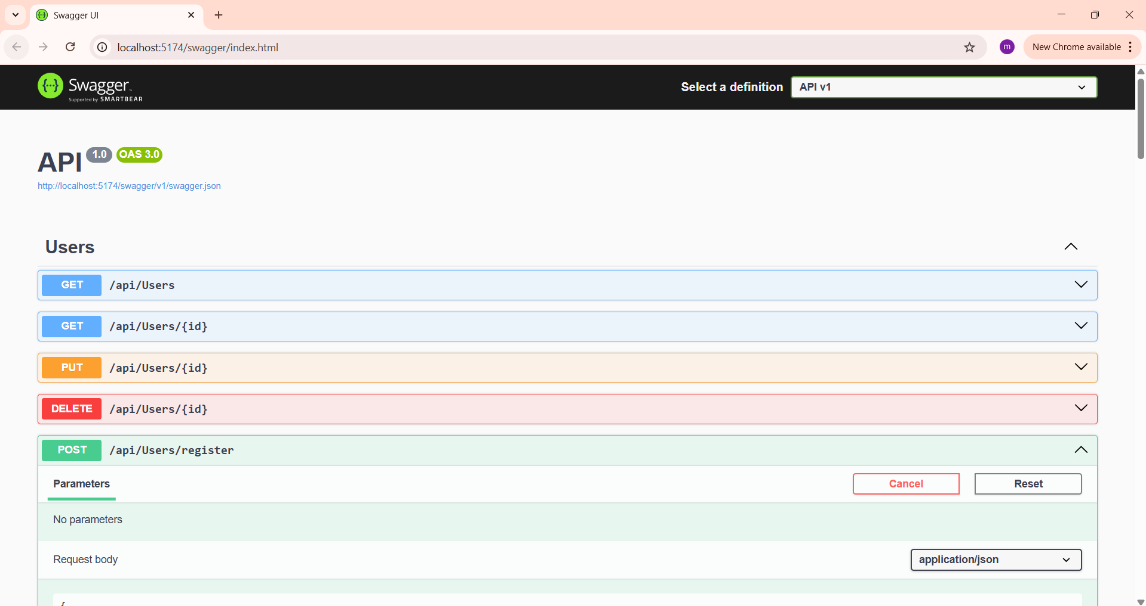
Kết quả chạy được:
