SETUP Spark Cluster

# 1. Installing environments

## 1.1 Installing Java 11

Spark uses JDK 11, installs Java 11 packages and sets environment variables

Open the "edit environment variable" tool

## 1.2 Installing Python

Download python from <https://www.python.org/downloads/> website and install them. Then open "edit environment variable" tool and declare environment variable

# 2. Installing Spark

## 2.1 Download Spark

Download spark at the following address <https://www.apache.org/dyn/closer.lua/spark/spark-3.5.3/spark-3.5.3-bin-hadoop3.tgz>

After downloading, we unzip the folder

## 2.2 Setup Spark

Next we need to open the "edit environment variable " tool and declare environment variables for spark



# 3. Testing spark

Use the command cd %SPARK_HOME% to move to the Spark directory and type the command "Spark-Shell"

# 4. Spark Cluster

## 4.1 Connecting to a common network (master and workers)

Master's ip address

Slave's ip address

## 4.2 Renaming the hosts

Rename the host file of the master and slave machines for easy management (perform on master and workers)

Run command prompt as admin

To easily manage slave machine addresses by name instead of numbers. Type the command “notepad C:\Windows\System32\drivers\etc\hosts” to name each ip

This will help us manage the machine easily when pinging or checking. Instead of pinging the machine address directly, we only need to ping the machine name.

## 4.3 Turning off the firewall

Turn off the firewall of the master and slave machines (master and workers)

Open “Control Panel”

Click “System and Security”

Click “Windows Defender Firewall”

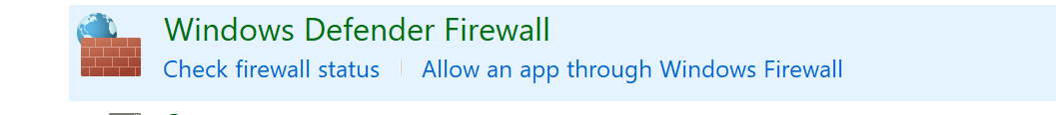

Click “Turn Windows Defender Firewall on or off”

Turn off and click ok

## 4.4 Check connection

Use the ngocphung-master machine to ping the ngocphung-slave machine

Use the ngocphung-slave machine to ping the ngocphung-master machine

## 4.5 Deploy on the master machine (execute on the master machine)

Navigate to Spark_Home using the following command “cd %SPARK_HOME%\bin”

Start the master machine using the following command “spark-class2.cmd org.apache.spark.deploy.master.Master”

## 4.6 Deploy on the slave machine (execute on the slave machine)

Navigate to Spark_Home using the following command “cd %SPARK_HOME%\bin”

Start the master machine using the following command “spark-class2.cmd org.apache.spark.deploy.worker.Worker spark://192.168.1.129:7077”

## 4.7 Checking on master