**Installation Hive Guide**

# 1. Installation Java

- Check Java first JDK 1.8 must be installed to run Hive processes smoothly.

|  |
| --- |
| Java -version |

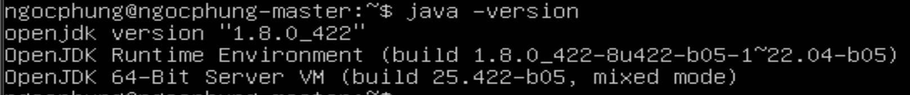

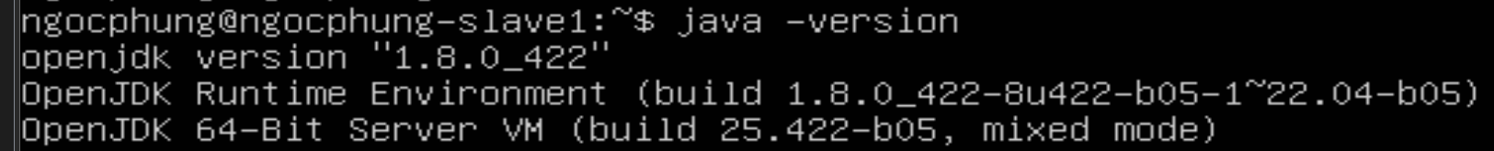

# 2. Installation Hadoop

- A Hadoop multi-node cluster must be installed and running stably.

# 3. Installation Hive

## 3.1. Download Hive

|  |
| --- |
| wget https://dlcdn.apache.org/hive/hive-4.0.1/apache-hive-4.0.1-bin.tar.gz |

|  |
| --- |
| tar -xzf apache-hive-4.0.1-bin.tar.gz |
| mv apache-hive-4.0.1-bin hive |

## 3.2. Set up environment variables

|  |
| --- |
| nano ~/.bashrc |
| #HIVE  export HIVE_HOME=/home/hadoopngocphung/tools/hive/hive  export PATH=$PATH:$HIVE_HOME/bin  export CLASSPATH=$CLASSPATH:/home/hadoopngocphung/tools/hive/hive/lib/*:.  export CLASSPATH=$CLASSPATH:/home/hadoopngocphung/tools/hive/hadoop/lib/*:. |

|  |
| --- |
| source ~/.bashrc |



## 3.3. Hive configuration

### 3.3.1 Create file hive-site.xml

|  |
| --- |
| cd hive/conf |
| cp hive-default.xml.template hive-site.xml |

### 3.3.2 Change the temporary directory path for Hive

|  |
| --- |
| nano hive-site.xml |

- Change ${system:java.io.tmpdir} to /tmp/hive in the hive-site.xml file to modify the temporary directory path that Hive uses during operation. By default, Hive uses Java's system temporary directory (java.io.tmpdir) to store temporary data, such as intermediate SQL query results or intermediate data generated during MapReduce jobsA screen shot of a computer code

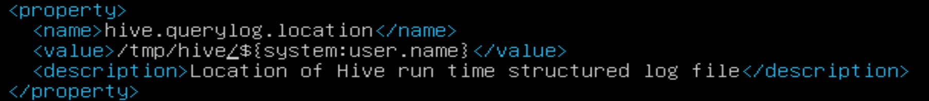



### 3.3.3 Change Hive’s default user

|  |
| --- |
| nano hive-site.xml |

- Change ${system:user.name} to hadoopngocphung in the hive-site.xml file to modify the default username that Hive will use when performing tasks on HDFS (Hadoop Distributed File System) or executing queries.A black background with white text

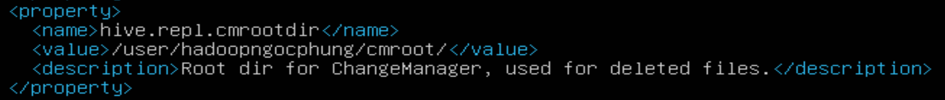



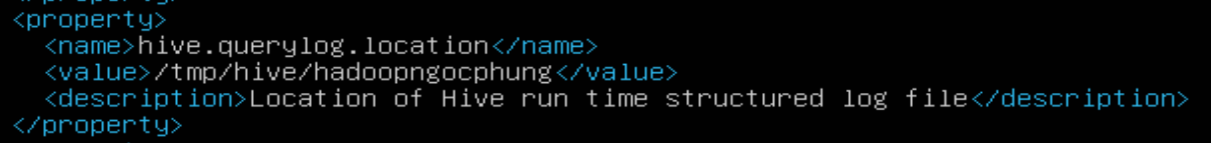



## 3.4 Hive Database warehouse

|  |
| --- |
| nano hive-site.xml |

- By default, Hive stores the data warehouse location at /user/hive/warehouse in hdfs. Find hive.metastore.warehouse.dir and change the user to hadoopngocphung.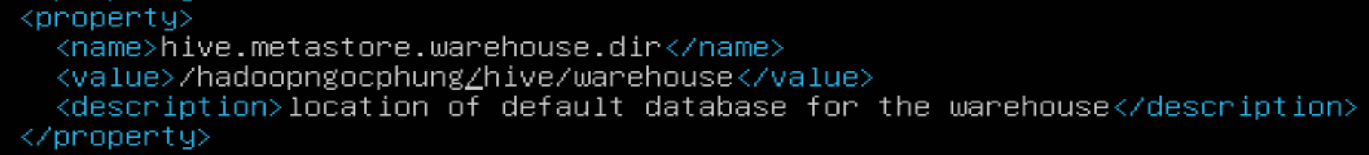

- Create Hive Warehouse Directories

|  |
| --- |
| hdfs dfs -mkdir /hadoopngocphung |
| hdfs dfs -mkdir /hadoopngocphung/hive |
| hdfs dfs -mkdir /hadoopngocphung/hive/warehouse |
| hdfs dfs -mkdir /hadoopngocphung/tmp |
| hdfs dfs -chmod g+w /hadoopngocphung/tmp |
| hdfs dfs -chmod g+w /hadoopngocphung/hive/warehouse |

## 3.5 Hive Metastore Derby Database

|  |
| --- |
| schematool -initSchema -dbType derby |

## 3.6 Beeline trong Embedded Mode

|  |
| --- |
| hive |

|  |
| --- |
| !connect jdbc:hive2:// |

- Login with username and password

|  |
| --- |
| !quit |

