1. Apache Pig - Reading Data
- Chạy trên local
grunt> student = LOAD 'Apache_Pig/Pig_Input/Student.txt'
USING PigStorage(',')
as ( id:int, firstname:chararray, lastname:chararray, phone:chararray, city:chararray );

2. Apache Pig - Storing Data
- Chạy trên local
grunt> STORE student INTO ' Apache_Pig/Pig_Output/ ' USING PigStorage (',');
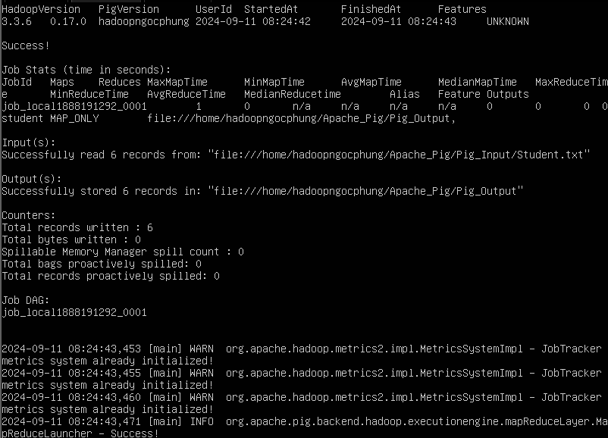
- Kiểm tra
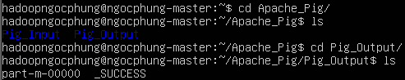

3. Apache Pig - Diagnostic Operators
grunt> Dump student
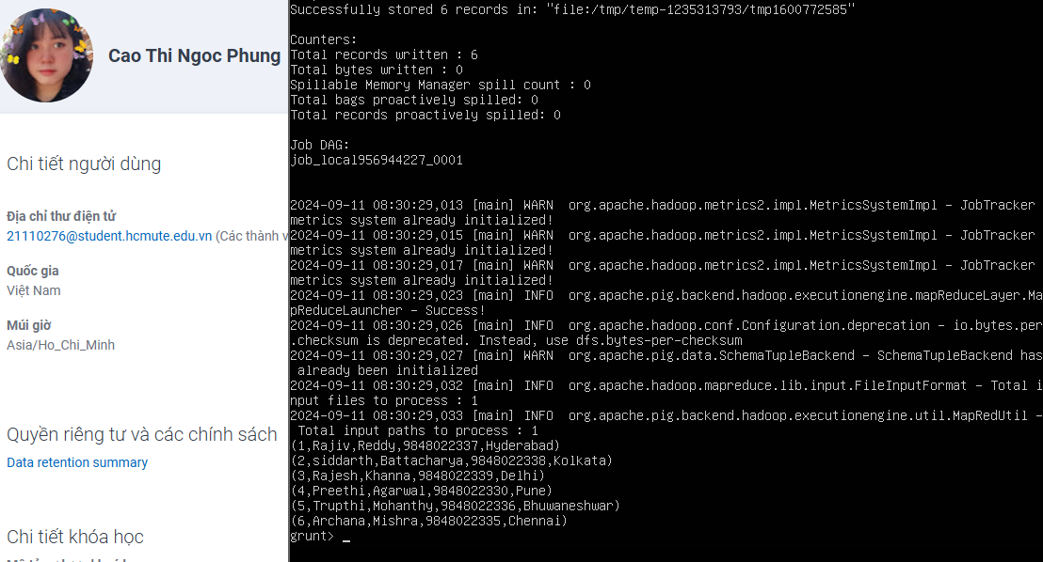

4. Apache Pig - Describe Operator
grunt> describe student;


5. Apache Pig - Explain Operator
grunt> explain student;
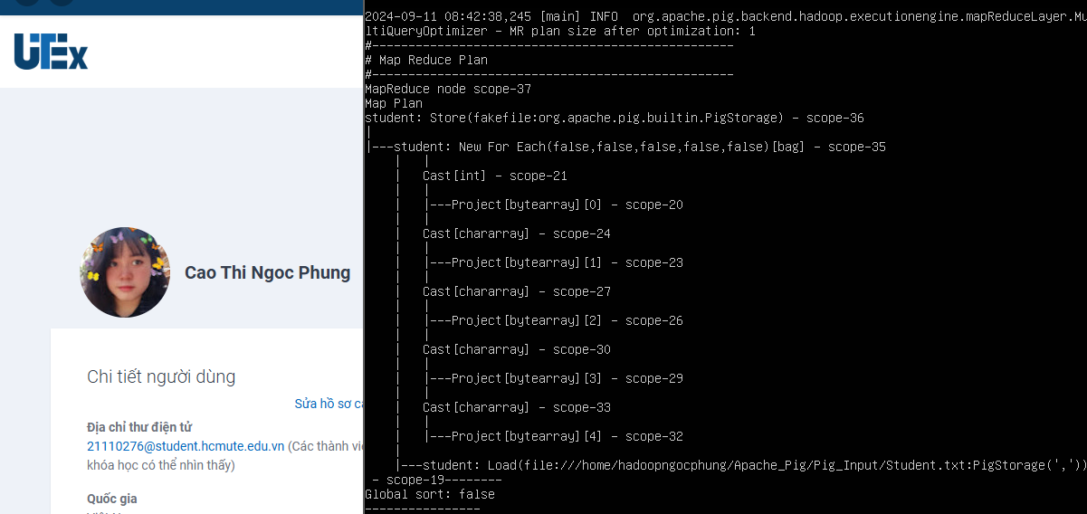

6. Apache Pig - Illustrate Operator
grunt> illustrate student;
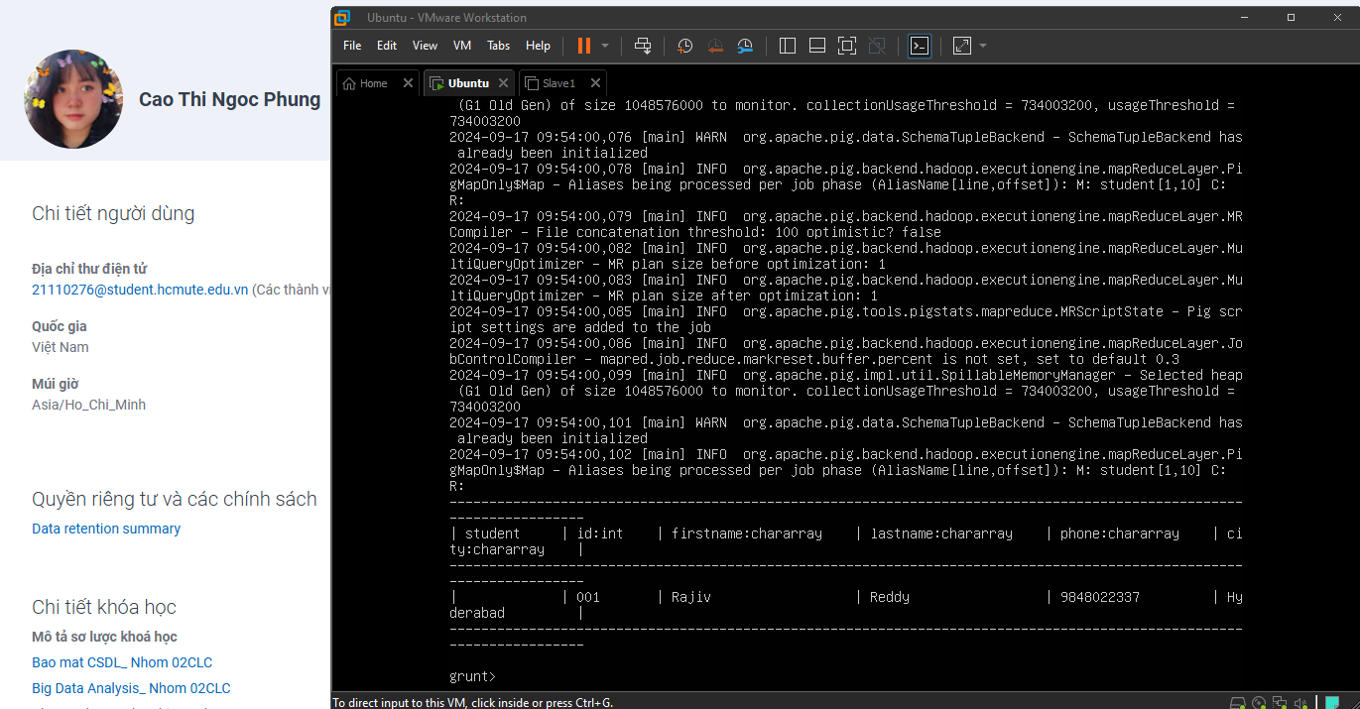

7. Apache Pig - Group Operator
Tạo file Student_Details.txt chứa nội dung sauls
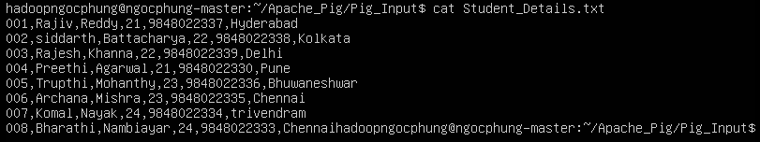
grunt> student_details = LOAD 'Apache_Pig/Pig_Input/Student_Details.txt'
USING PigStorage(',')
as ( id:int, firstname:chararray, lastname:chararray, age:int, phone:chararray, city:chararray );
grunt> group_data = GROUP student_details BY age;
grunt> Dump group_data
grunt> descirbe group_data
grunt> illustrate group_data
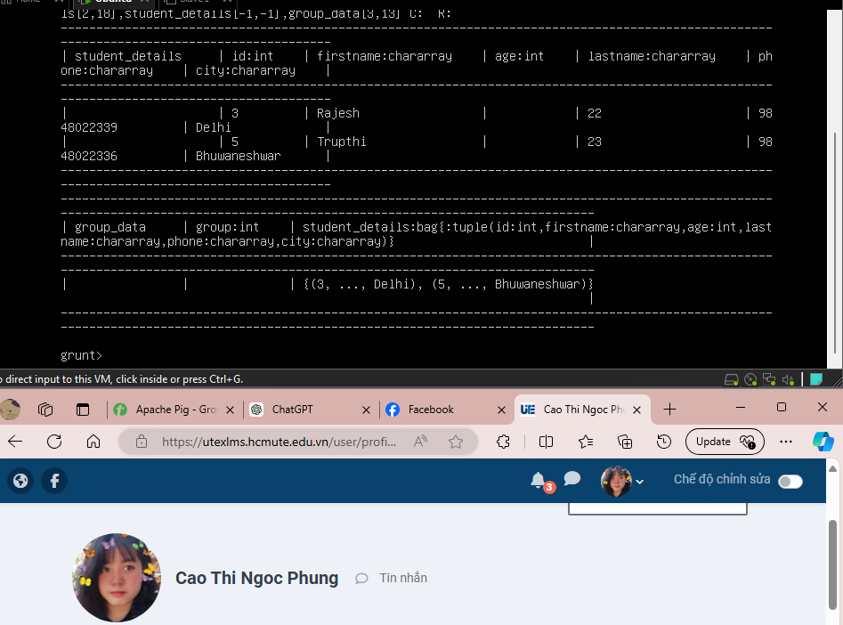

Group_multiple = GROUP student_details by (age,city);
Dump group_multiple;
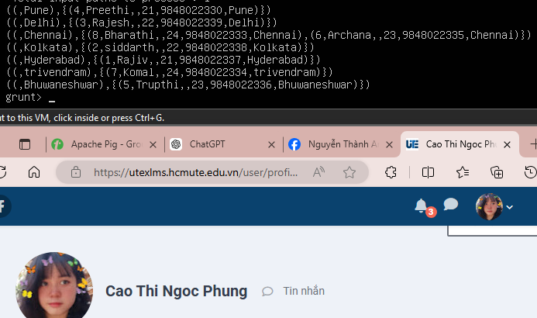
group_all = GROUP student_details All;
dump group_all


8. Apache Pig - Cogroup Operator
grunt> student_detail= LOAD 'Apache_Pig/Pig_Input/Student_Details.txt'
USING PigStorage(',')
as ( id:int, firstname:chararray, lastname:chararray, age:int, phone:chararray, city:chararray );
grunt> employee_details = LOAD 'Apache_Pig/Pig_Input/Employee_Details.txt'
USING PigStorage(',')
as ( id:int, name:chararray, age:int, city:chararray );
cogroup_data = COGROUP student_details by age, employee_details by age;
dump cogroup_data;
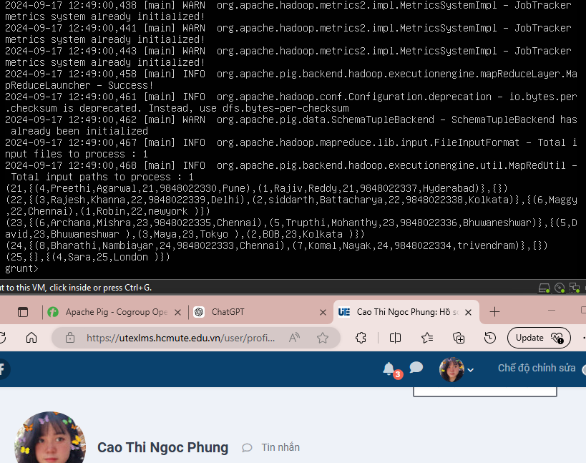

9. Apache Pig – Join Operator
grunt> customers = LOAD 'Apache_Pig/Pig_Input/Customers.txt'
USING PigStorage(',')
as ( id:int, name:chararray, age:int, address:chararray, city:chararray );
grunt> orders = LOAD 'Apache_Pig/Pig_Input/Orders.txt'
USING PigStorage(',')
as ( oid:int, date:chararray, customer_id:int, amount:int );

9.1 Self-join
grunt> customers1 = LOAD 'Apache_Pig/Pig_Input/Customers.txt' USING PigStorage(',')
as ( id:int, name:chararray, age:int, address:chararray, salary:chararray );
grunt> customers2 = LOAD 'Apache_Pig/Pig_Input/Customers.txt' USING PigStorage(',')
as ( id:int, name:chararray, age:int, address:chararray, salary:chararray );
grunt> customers3 = JOIN customers1 BY id, customers2 BY id;
grunt> dump customers3;
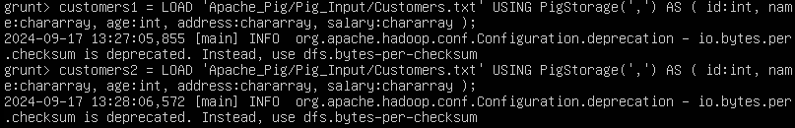
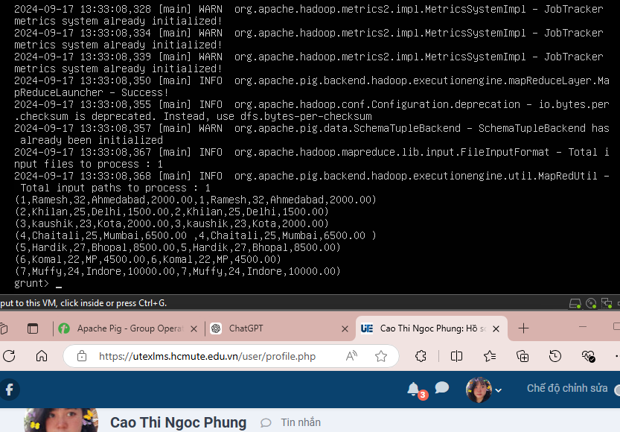

9.2 Inner Join
grunt> customer_order = JOIN customers BY id, orders BY customer_id;
grunt> dump customer_order;
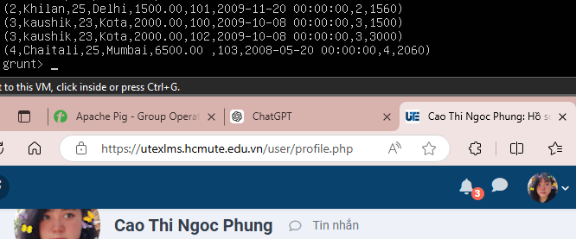

9.3 Left Outer Join
grunt> customer_order_LO = JOIN customers BY id LEFT OUTER, orders BY customer_id;
grunt> dump customer_order_LO;
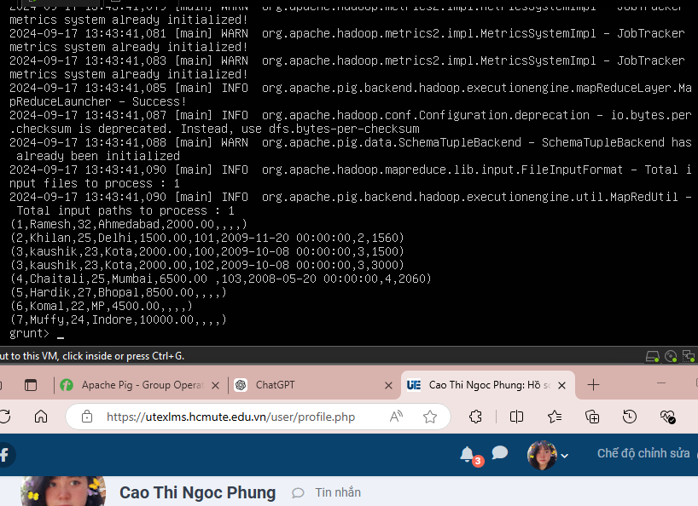

9.4 Right Outer Join
grunt> customer_order_R = JOIN customers BY id RIGHT, orders BY customer_id;
grunt> dump customer_order_R;
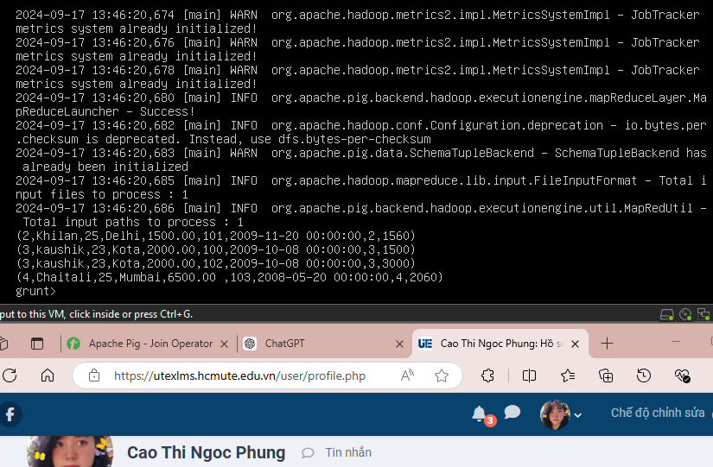

9.5 Full Outer Join
grunt> customer_order_FO = JOIN customers BY id FULL OUTER, orders BY customer_id;
grunt> dump customer_order_FO;
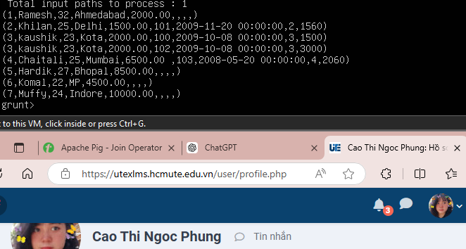

10. Apache Pig – Cross Operator
grunt> customers = LOAD 'Apache_Pig/Pig_Input/Customers.txt' USING PigStorage(',')
as ( id:int, name:chararray, age:int, address:chararray, salary:int );
grunt> orders = LOAD 'Apache_Pig/Pig_Input/Orders.txt' USING PigStorage(',')
as ( oid:int, date:chararray, customer_id:int, amount:int );
grunt> cross_data = CROSS customers, orders;
grunt> dump cross_data;
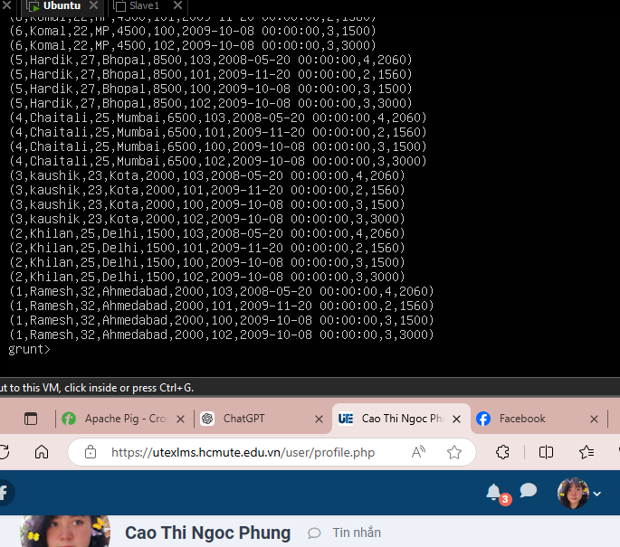

11. Apache Pig – Union Operator
grunt> students_data1 = LOAD 'Apache_Pig/Pig_Input/Students_Data1.txt' USING PigStorage(',') AS ( id:int, firstname:chararray, lastname:chararray, phone:chararray, city:chararray );
grunt> students_data2 = LOAD 'Apache_Pig/Pig_Input/Students_Data2.txt' USING PigStorage(',') AS ( id:int, firstname:chararray, lastname:chararray, phone:chararray, city:chararray );
grunt> students_union = UNION students_data, students_data2;
grunt> dump students_union
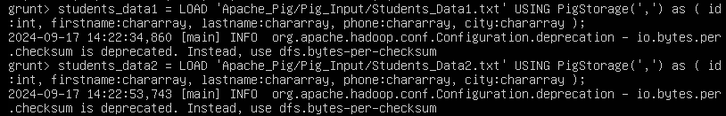
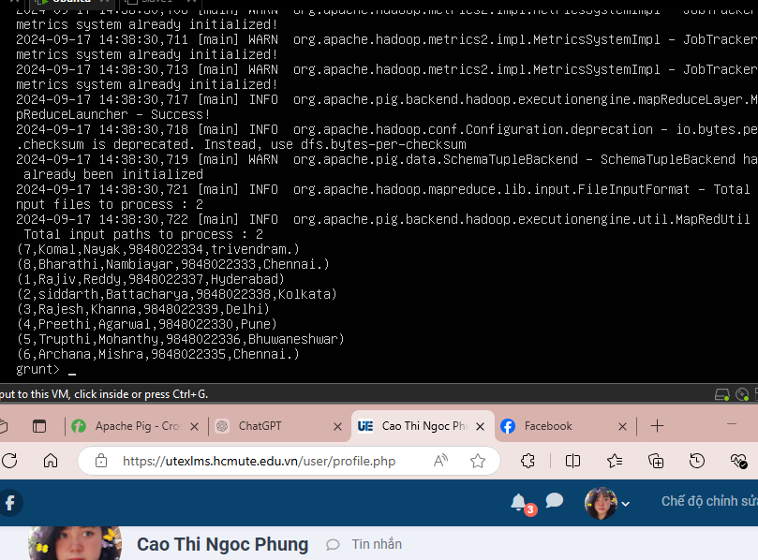

12. Apache Pig – Split Operator
grunt> student_details = LOAD 'Apache_Pig/Pig_Input/Student_Details.txt'
USING PigStorage(',') AS ( id:int, firstname:chararray, lastname:chararray, age:int, phone:chararray, city:chararray );
grunt> SPLIT student_details into student_details23 if age<23, student_details22 if age<22 and age>25);
grunt> student_details
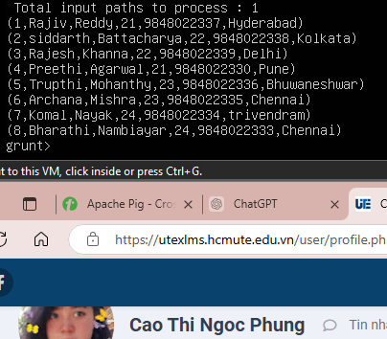

13. Apache Pig – Filter Operator
grunt> filter_data = FILTER student_details BY city == 'Hyderabad';
grunt> dump filter_data;
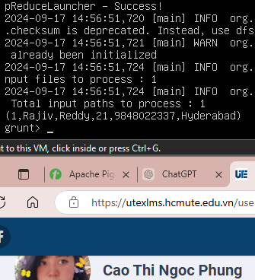

14. Apache Pig – Distinct Operator
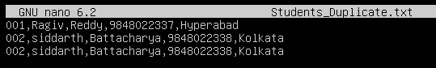
grunt> student_duplication = LOAD 'Apache_Pig/Pig_Input/Students_ Duplicate.txt'
USING PigStorage(',') AS ( id:int, firstname:chararray, lastname:chararray, phone:chararray, city:chararray );
grunt> distinct_data = DISTINCT student_duplication;
grunt> dump distinct_data;
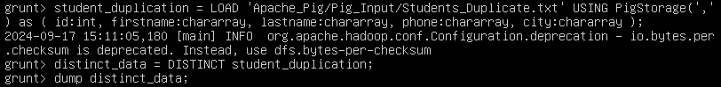
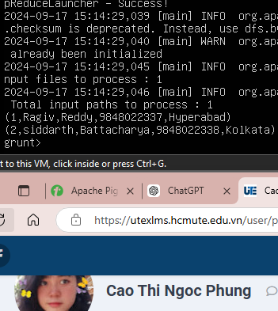

15. Apache Pig - Foreach Operator
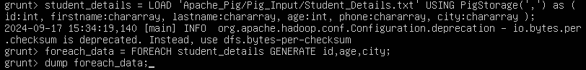
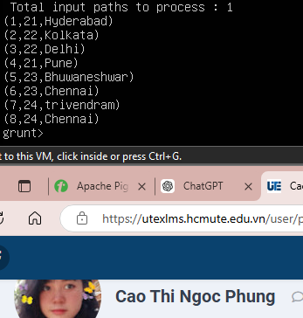

16. Apache Pig - Order By
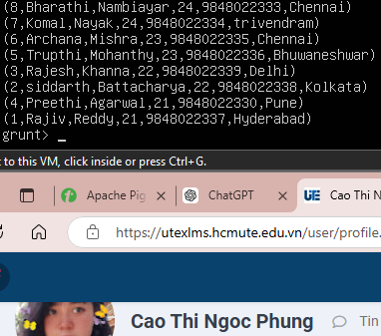

17. Apache Pig - Limit Operator
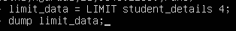
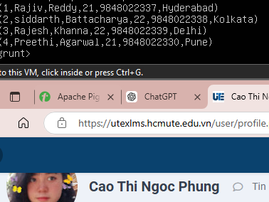
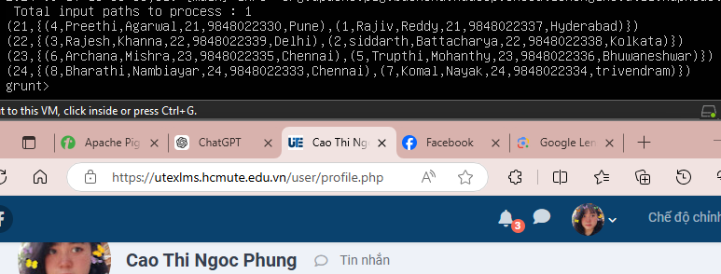

17. Apache Pig – User Defined Function
Tạo fie chứa dữ liệu và file đó và file jar pig
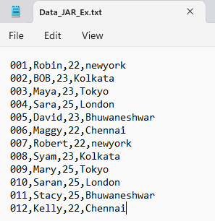
grunt> REGISTER /home/hadoopngocphung/Apache_Pig/Pig_Input/sample_udf.jar;
grunt> DEFINE sample_eval mypack.Sample_Eval();
grunt> emp_data = LOAD '/home/hadoopngocphung/Apache_Pig/Pig_Input/Data_JAR_Ex.txt USING PigStorage (',') AS (id:int, name: chararray, age:int, city:chararray);
grunt> Upper_case = FOREACH emp_data GENERATE sample_eval (name);
grunt> dump Upper_case;
