Cao Thị Ngọc Phụng
21110276
Lab 8. Applied Cryptography
Lab 1. Telnet & SSH

Telnet:
- Configure IP addresses
- Configure telnet (Router)
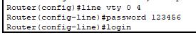

- Enable password:
Ssh:

- Configure IP addresses
- Configure hostname & domain-name
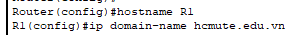
- Set console and enable password
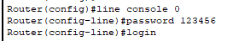
- Tạo khóa (RSA)
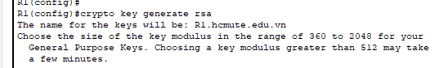
- Setup line vty
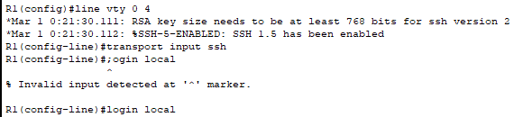

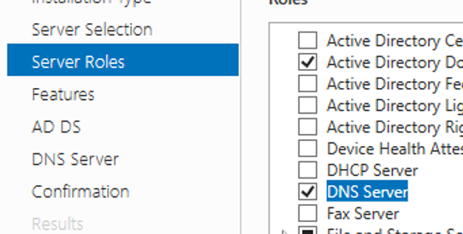
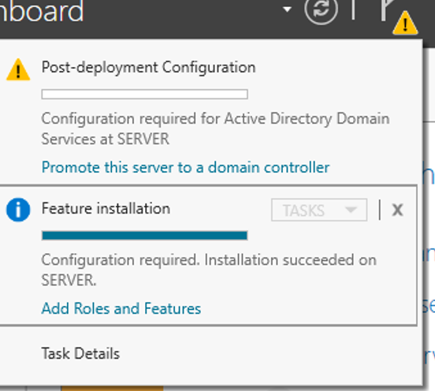
2. Cài Active Directory Certificate Services
