OrientDB Installation Guide

1. Download OrientDB
- Access the link below and select the version compatible with your operating system to download OrientDB
https://orientdb.org/download
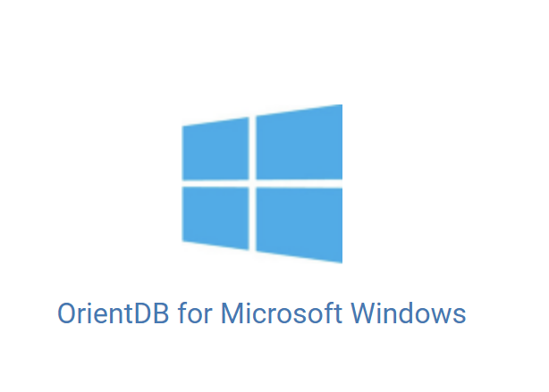

2. Configuration
- After downloading, we have a .zip file, which we then extract into a folder.
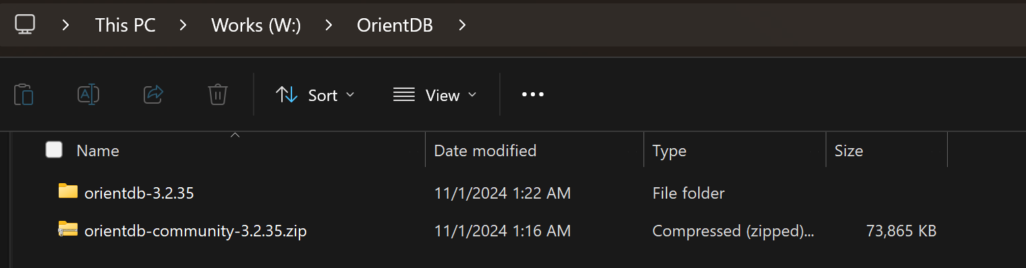
- Remember the folder path to declare it as an environment variable in “Environment Variables”.
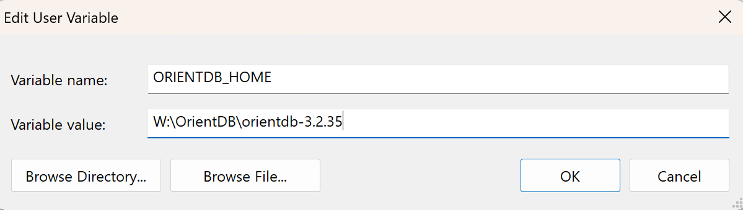
- declare in “Path”

3. Start server
- Open Command Prompt and start the server.bat file in the OrientDB directory.
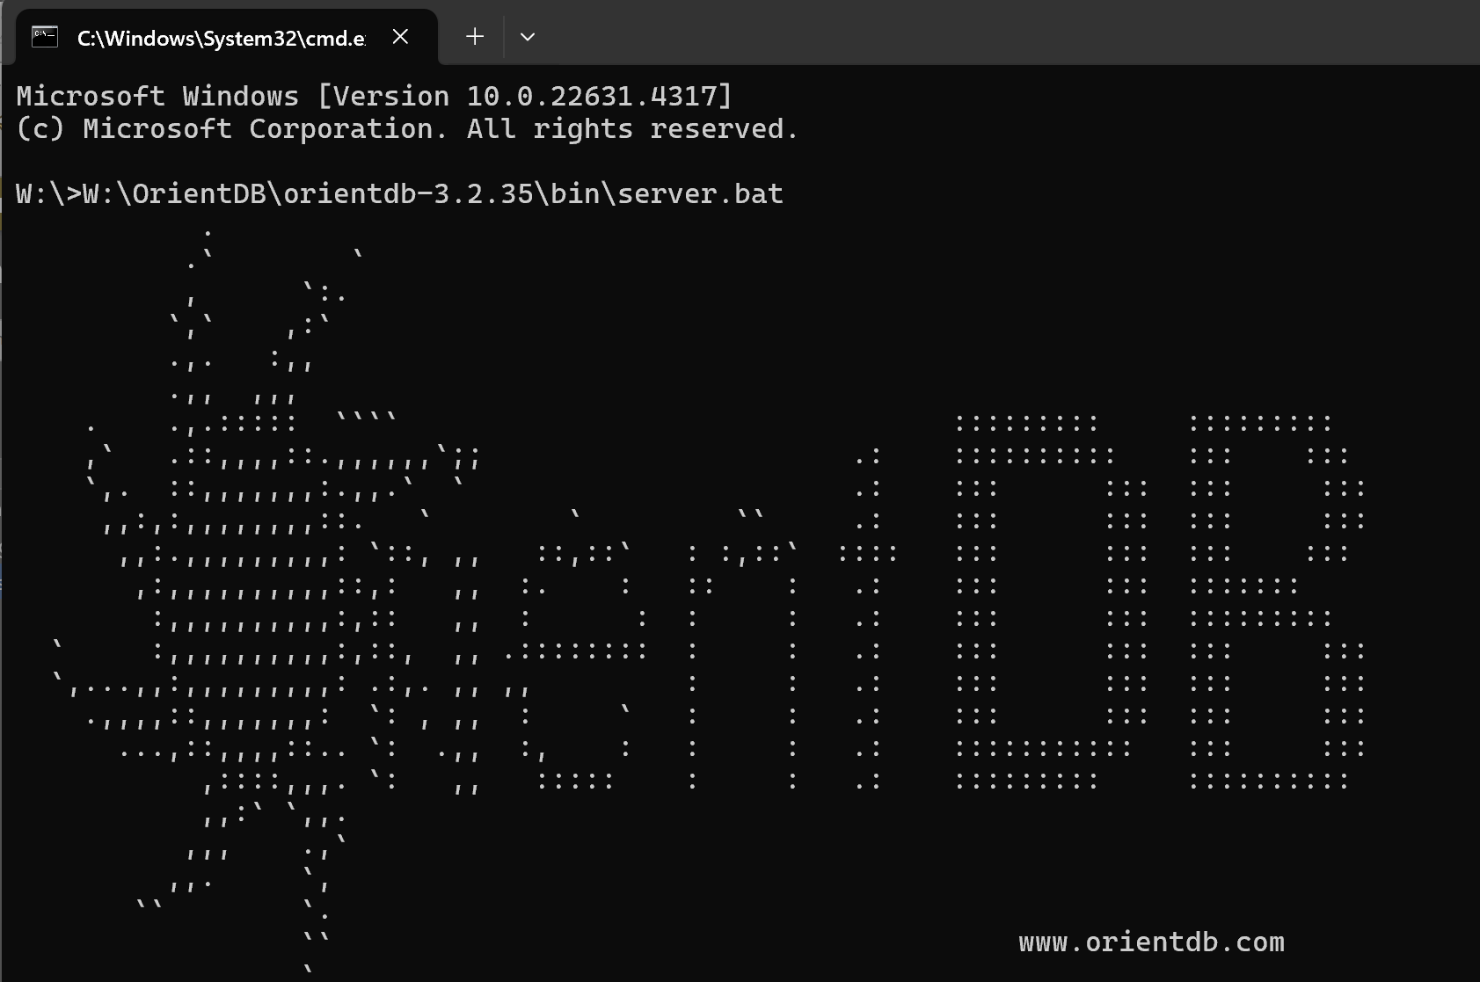
- This message appears when you start OrientDB for the first time.
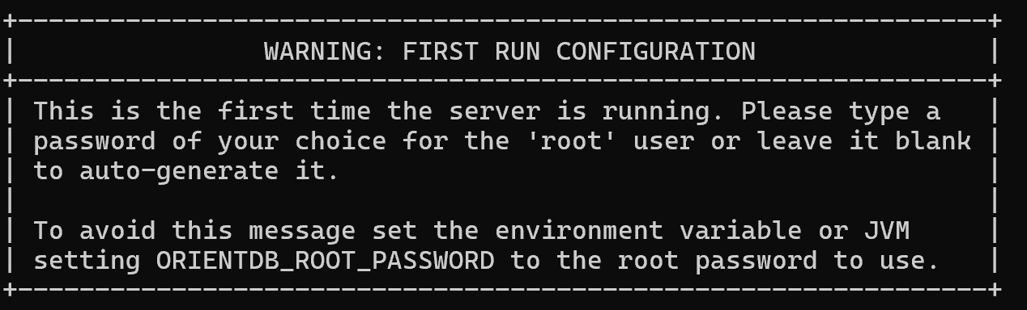
- It prompts you to set a password for the root account. This is an important password for administrative access in OrientDB, so you should choose a password that is memorable but also secure. If you leave it blank and press Enter, the system will automatically generate a password.
- There is an asterisk (*) in front by default, it is not something you enter.
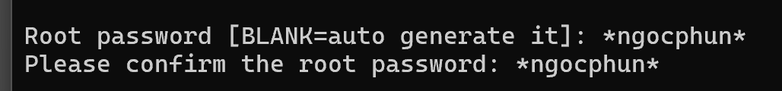

4. OrientDB UI
- Access the link http://localhost:2480/studio/index.html#/ and log in with the root account